**Running title:** Accuracy of runoff sampling methods

**Manuscript category:** Soils and Plant Nutrition

**Accuracy and variability of runoff sampling methods**

Alessandro Samuel-Rosa1*, Jean Michel Moura-Bueno2, Ricardo Simão Diniz Dalmolin3

1 Universidade Tecnológica Federal do Paraná – Curso de Agronomia – Prolongamento da Rua Cerejeira, s/n – 85892-000 – Santa Helena, PR – Brasil.

2 Universidade Federal de Pelotas – Programa de Pós-Graduação em Manejo e Conservação do Solo e da Água – Campus Universitário, s/n – 96010-610 – Capão do Leão, RS – Brasil.

3 Universidade Federal de Santa Maria – Departamento de Solos – Av. Roraima 1000, Prédio 42, Sala 3309 – 97105-900 – Santa Maria, RS – Brasil.

* Corresponding author [alessandrorosa@utfpr.edu.br](mailto:alessandrorosa@utfpr.edu.br)

**ACCURACY AND VARIABILITY OF RUNOFF SAMPLING METHODS**

**ABSTRACT**

The method used to obtain runoff samples in soil erosion monitoring studies is an important source of data variability. In this study, we evaluated the manual sampling method used in Brazil. We present as an alternative the prototype of a sample splitter for suspensions with high concentration of total solids. Using soil material with 583 g kg-1 of sand and 89 g kg-1 of clay, the manual method and the sample splitter were tested for their ability to produce representative samples of suspensions with a concentration of 2, 10 and 50 g L -1 of total solids. An underestimation of 30% or more of the concentration of total solids was observed using the manual method, with a variation of the same magnitude (CV between 20 and 45%). The splitter was efficient in producing samples representative of the suspension – even without altering the particle size distribution of the total solids. Both absolute percentage errors (|<5%|) and the variation between replicates (CV <3%) were small. The problems with the manual method are due to the inefficient homogenization that facilitates the differential sedimentation of the particles of different sizes. If these problems are also found in other studies, then the prototype that we developed is a reasonable alternative.

**Keywords:** Erosion monitoring, Soil loss, Sandy soil, Sample splitter, Uncertainty.

# INTRODUCTION

Soil erosion is one of the major concerns of soil scientists (Panagos et al., 2017). Proof of this are the many soil erosion monitoring plots distributed around the globe (Anache et al., 2017; García-Ruiz et al., 2015). One of the main difficulties encountered in soil erosion research is the great variability of the data, which results from the diversity of methods and monitoring strategies employed (Boix-Fayos et al., 2006; García-Ruiz et al., 2015; Nearing et al., 1999; Poesen, 2018). Lack of resources for monitoring longer than 5-10 years to obtain more consistent data is also detrimental (Anache et al., 2017). The greater the variability of the data, the greater our uncertainty about the magnitude of soil losses (García-Ruiz et al., 2015).

An important source of variation in soil loss data is the method of sampling the runoff collected in erosion plots (Kinnell, 2016). A runoff sample should be as representative as possible of reality. This requires the collected runoff be perfectly homogenized. Such homogeneity is difficult to achieve when particles of different sizes and densities are present in the sediment (Ciesiolka et al., 2006; Kinnell, 2016; Todisco et al., 2012). Previous studies suggested that manual sampling methods are among those that suffer the most from this problem, commonly resulting in underestimates of soil losses (Ciesiolka et al., 2006; Lang, 1992; Zöbisch et al., 1996). For this reason, more elaborate sampling methods were proposed (Todisco et al., 2012). But they still require the suspension to be homogenized beforehand. An alternative is to use sample splitters such as the cone and churn splitters, widely used for sampling suspensions with low concentration of total solids (Capel et al., 1995; Horowitz et al., 2001). Sample splitters produce samples with constitution very similar to the original suspension without human intervention.

Erosion monitoring studies in Brazil indicate that soil losses range from 0.1 to 136 Mg ha-1 year-1 (Anache et al., 2017). For sandy soil, soil losses can easily reach over 150 Mg ha-1 year-1 (Lanzanova et al., 2013). However, since a large part of the Brazilian estimates is based on the use of a manual sampling method (Amado et al., 2002; Cardoso et al., 2012; Corrêa et al., 2016; Eltz et al., 2001; Silva et al., 2005; Tengberg et al., 1997; Veiga and Wildner, 1993; Volk and Cogo, 2009), it is possible that soil losses are even greater.

The objective of this study is twofold. First, to evaluate if the manual method of runoff sampling used in Brazil underestimates soil losses and quantify the magnitude of this underestimate. Second, to develop and test a prototype sample splitter that can be used with suspensions with high concentration of total solids collected in erosion monitoring plots.

# MATERIAL AND METHODS

## Soil material

The two sample splitting methods – manual and splitter – were evaluated in a controlled laboratory experiment using suspensions, composed of distilled water and fine soil material, created to simulate runoff samples. The soil material was collected from the upper part (0–20 cm depth) of the A horizon of a soil profile derived from sedimentary rocks of the Santa Maria Formation. Located at -29°42’47.01“N and -53°42’43.36”E, the profile had no apparent anthropic use, and was classified as an Argissolo Vermelho-Amarelo Distrófico típico in the Brazilian classification and as a Rhodic Acrisol in the international classification. With an A-E-Bt-C horizon sequence, the clay content is very low in the topsoil and increases considerably with depth, with a direct effect on the soil bulk density and porosity. The low content of basic cations, phosphorus and organic matter reflect the small availability of plant nutrients in the soil parent material (Tables 1 and 2) – the analytic data are available in the Free Brazilian Repository for Open Soil Data (febr, www.ufsm.br/febr), dataset ctb0013. Similar characteristics are found in the topsoil of a large portion of the Central Depression region of the Rio Grande do Sul state (Figure 1), having been the target of many erosion monitoring studies (Amado et al., 2002; Cogo et al., 1984; Eltz et al., 2001; Volk and Cogo, 2009).

**(Table 1 near here)**

**(Table 2 near here)**

**(Figure 1 near here)**

The collected soil material was air-dried, crushed and passed through a 2-mm sieve. The particle size distribution of the resulting fine soil material was determined using three samples of about 20 g each. The total clay content (<0.002 mm diameter) was determined via the pipette method after chemical dispersion and mechanical disintegration. The first was achieved using 1 mol L-1 sodium hydroxide (NaOH). The latter consisted of horizontal stirring for 4 hours at 120 cycles per minute in the presence of two nylon spheres (diameter: 1.71 cm; mass: 3.04 g; density 1.11 g cm-1). The total sand content (0.053–2.00 mm diameter) was determined via wet sieving. The total silt (0.002–0.053 mm diameter) content was determined by difference. According to these analyzes, the particle size distribution of the fine soil material (0–20 cm) consists of 583 g kg-1 of total sand, 89 g kg-1 of total sand, and 328 g kg-1 of total silt.

## Manual sampling method

The first experiment carried out aimed at assessing the efficiency of the manual method, that is, its ability to produce representative samples of the artificial suspensions (runoff). The samples were expected to have a concentration of total solids (sediment) approximately equivalent to that of the suspension from which they were obtained. Three concentrations of total solids were used: 2, 10 and 50 g L-1. They were prepared by adding the necessary mass of fine soil material to 3 L of distilled water in 10 L plastic containers (buckets), that is, 6, 30, and 150 g, respectively. Five buckets (replicates) were prepared for each concentration. In each bucket, one person homogenized/stirred the suspension with one hand. After 10 seconds, without stopping the homogenization, another person collected a sample by immersing a 250 mL beaker into the suspension. The concentration of total solids in the samples of each suspension was determined as a function of the sample volume and the mass of total solids measured after oven drying at 105 °C until complete evaporation of the water.

The five samples from each of the three artificial suspensions were summarized by computing the mean, standard deviation, and coefficient of variation. The estimation error, eij, was computed as the difference between the concentration of total solids in a suspension j as estimated by a sample i, ŷij, and the true concentration, yj, that is,

eij = ŷij - yj

where i = 1, 2, …, n, with n = 5, and j is one of the three artificial suspensions. The percent mean estimation error (pME), defined as the percentage magnitude of the estimation error in relation to the true concentration in a suspension j, was calculated with

$${\text{pME}}_{j}=\sum_{i=1}^{n=5}{e_{ij}/y_{j}}×100$$

Finally, the estimation errors were submitted to a one sample, two-tailed t-test to test if its mean was equal to zero (H0: *μ* = 0) or, alternatively, less or greater than zero (H1: *μ* ≠ 0). The t-statistic was given by

$$t_{j}=\frac{{e̅}_{j}}{s_{j}\sqrt{5}}$$

where sj is the sample standard deviation of the estimation error. The exact p-value of the t-test was obtained from the Student’s t cumulative distribution function (CDF) with n - 1 degree of freedom.

## Sample splitter method

The prototype sample splitter was constructed with polyvinyl chloride (PVC) and wooden parts (Figure 2). It is composed of a suspension reservoir, located on the upper part, which consists of a 300-mm long, 75-mm diameter PVC plastic pipe with a maximum net capacity of 1 L of suspension. The bottom of the reservoir consists of a PVC internal domed end cap. A 15-mm diameter hole was drilled on the center of the cap to connect a 300-mm long, 15-mm diameter PVC plastic pipe. The dome shaped end cap helps directing the reservoir suspension to the smaller diameter pipe connected to the lower end. The function of this smaller diameter pipe is to direct the suspension in a continuous and concentrated flow to the splitting device, a Y-connector placed at its lower end. All parts are glued to each other using PVC-specific adhesive material. Since the splitter has two outlets, A and B, it produces two samples of the suspension at each splitting operation. Finally, the PVC parts were fixated on a wooden platform, leveled with both horizontal and vertical planes. The investment made to build the splitter was about 40 US dollars.

The sample splitter method was submitted to three tests. The first test aimed at evaluating if the volume of the suspension affects the performance of the splitter, specifically, its capacity to produce pairs of samples with approximately equivalent volumes. Four volumes of distilled water were evaluate – 100, 300, 500, and 1000 mL – using five replicates. At each repetition, the total volume of distilled water was poured into the splitter’s reservoir at one time. The two resulting samples, A and B, were collected in beakers and their volume determined using calibrated graduated cylinders. The estimation error and its ratio to the true value (half of the total volume of distilled water), both defined above, were calculated for both samples. Estimation errors were submitted to the one sample, two-tailed t-test as described for the manual method. In addition, the estimation errors of outlets A and B were tested for equality using the paired samples, two-tailed t-test. The t-statistic was given by

$$t_{j}=\frac{{d̅}_{j}}{s_{dj}\sqrt{5}}$$

where ${d̅}_{j}$ is the mean of differences between estimation errors of outlets A and B, sdj is the sample standard deviation of the differences, and j is one of the four volumes tested.

The second test to which the splitter method was submitted was the same applied to the manual method, that is, regarding its ability to produce a representative sample of a suspension. The same concentrations used to evaluate the manual method were employed, also with five replicates each. The artificial suspensions were prepared in 500-mL plastic containers. After vigorous shaking for 10 seconds, each suspension was poured into the splitter’s reservoir at one time and both samples, A and B, collected in 250-mL beakers. The splitter was washed with distilled water after each repetition. The concentration of total solids in the samples was determined as described for the manual method. The estimation errors were submitted to one and paired samples, two-tailed t-tests as above.

Finally, the total solids contained in the samples produced by outlets A and B of the splitter were analyzed for particle size distribution. The same method used for the analysis of the soil material employed to produce the suspensions was used. The aim of this test was to evaluate the capacity of the splitter to produce samples where the total solids have a size distribution approximately equivalent to that observed in the total solids of the suspension. The one and paired samples, two-tailed t-tests were used to evaluate the estimation errors of the clay and sand content.

**(Figure 2 near here)**

# RESULTS AND DISCUSSION

## Manual sampling method

The test performed with the manual runoff sampling method showed that the resulting samples were not representative of the artificial suspensions used (Table 3). A statistically significant underestimate of 30% or more of the concentration of total solids was observed for all three suspensions evaluated (2, 10 and 50 g L-1). In addition, we observed a somewhat large variation among the five replicates. These empirical findings corroborate the initial hypothesis of the present study – raised from the reports presented in similar works developed in other parts of the world (Ciesiolka et al., 2006; Kinnell, 2016; Lang, 1992; Todisco et al., 2012; Zöbisch et al., 1996) – that the manual runoff sampling method used in Brazil is inconsistent and inefficient.

**(Table 3 near here)**

Our findings suggest that the annual soil losses in areas of southern Brazil with coarse texture soil – < 100 g kg-1 of clay and > 500 g kg-1 of sand – could be up to 30% higher than the values reported in the literature. For example, according to Lanzanova et al. (2013), a standard (bare) soil erosion monitoring plot (width = 3.5 m, length = 22 m, slope = 0.055 m m-1) located near the place where we collected the soil material for this study lost about 2.5 Gg ha-1 of soil in 16 years. Based on the results of our study, the most likely amount of soil lost in this plot could be 3.6 Gg ha-1. However, attention must be paid to the fact that our results are based on one-person sampling. Zöbisch et al. (1996) evaluated five experienced professionals and observed estimation errors between 5 and 83%. This means that our tests need to be repeated by others to produce more representative results – although the variation observed by Zöbisch et al. (1996) agrees with our results.

## Sample splitter method

The results of the first test performed with the prototype sample splitter showed that its efficiency is not affected by the volume of water (Table 4). Both outlets A and B produced samples with similar volumes. However, the splitting process seems to become less efficient as the volume of water decreased. The largest errors were observed when the volume of water was 100 mL, possibly due to the swirling effect of the water inside the 15-mm diameter PVC plastic pipe connected to the lower end of the reservoir. The function of this pipe is to direct the water in a continuous and concentrated flow to the splitting device (Y-connector). Apparently this objective was only attained when the volume of water was greater than 100 mL. Thus, it is reasonable to recommend that the sample splitter be used only with suspensions of volume greater than 250-300 mL.

The prototype sample splitter was efficient at producing representative samples at both outlets A and B for all three artificial suspensions tested – 2, 10 and 50 g L-1 of total solids (Table 5). Compared to the manual sampling method, the absolute errors were considerably small (pME < |5%|), as well as the variation between the repetitions (CV < 3%). The occurrence of a consistent trend of negative estimation errors, indicated even by the t-test statistic, means that it is possible to correct the estimated concentration of total solid with a high degree of confidence. In addition, this underestimation can be avoided or minimized by adopting additional care during the splitting operation. We observed that, during pouring of the suspension into the splitter’s reservoir, larger diameter particles (sand) tend to remain inside the container where the suspension was stored. To avoid or minimize this loss of particles it is necessary to vigorously shake the container and pour the suspension rapidly into the reservoir. An additional practice is to wash the container using a known volume of distilled water and then pour the new suspension into the splitter.

Samples produced by the splitter also were representative of the artificial suspensions tested in terms of sand content (Table 6). This occurred regardless of the splitter’s outlet. The exception was for the artificial suspension with the lowest concentration of total solids, 2 g L-1, for which the estimation error was deemed too large. For all the five replicates, on average, the sand content was underestimated by about 50%. We note, however, that this underestimation was not due to the sample splitting process itself. It resulted from the issue reported above, that is, particles of larger diameter tend to remain inside the container where the suspension was stored. This loss of larger particles results in the underestimation of the sand content.

The estimation errors of the clay content in the samples of both outlets were considerably larger than those for the sand content (Table 7). Errors were especially large for the artificial suspension with 2.00 g L-1 of total solids. This occurred because, for the soil material used, the quantity of clay in the resulting samples was inferior to the detection limit of the analytical method used. When the concentration of total solids was higher (10 and 50 g L-1), the percentage estimation error was lower, its significance decreasing as the concentration of total solids increased.

**(Table 4 near here)**

**(Table 5 near here)**

**(Table 6 near here)**

**(Table 7 near here)**

# CONCLUSIONS AND RECOMMENDATIONS

The tests we performed showed that the manual runoff sampling method used in Brazil is unsuitable for the sampling of suspensions containing total solids with prevalence of coarse particles (sand). In addition to underestimating the concentration of total solids, there is a large variation in the estimated values. This means that the sampling method constitutes an important source of variation in the results of soil erosion monitoring studies. This variation adds to the uncertainty coming from other sources already described in the literature on the subject. Our recommendation is that our experiment be reproduced by other research groups, since the results may be affected by the person responsible for sampling the suspension. Also, we recommend that experiments using different types of soil material – in terms of particle size distribution – be carried out so that an equation can be computed to correct soil loss estimates.

The prototype sample splitter that we developed proved to be efficient in producing samples from artificial suspension with different concentrations of total solids without changing the particle size distribution. This efficiency was clear and consistent mainly for suspension volumes above 250-300 mL and concentrations of total solids greater than 2 g L-1. Thus, if the problems that we identify in the manual sampling method are also found by other research groups, the prototype we developed is presented as a reasonable alternative. However, further assessments of the sample splitter should be performed using a wider range of concentrations of total solids and particle size distributions.

# REFERENCES

Amado, T.J.C.; Prochnow, D.; Eltz, F.L.F. 2002. Soil and water losses in periods of climatic anomalies: “El Niño” and “La Niña” in southern Brazil. Revista Brasileira de Ciência do Solo 26: 819–827. doi:[10.1590/S0100-06832002000300028](https://doi.org/10.1590/S0100-06832002000300028). (in Portuguese, with abstract in English)

Anache, J.A.A.; Wendland, E.C.; Oliveira, P.T.; Flanagan, D.C.; Nearing, M.A. 2017. Runoff and soil erosion plot-scale studies under natural rainfall: A meta-analysis of the Brazilian experience. Catena 152: 29–39. doi:[10.1016/j.catena.2017.01.003](https://doi.org/10.1016/j.catena.2017.01.003).

Boix-Fayos, C.; Martínez-Mena, M.; Arnau-Rosalén, E.; Calvo-Cases, A.; Castillo, V.; Albaladejo, J. 2006. Measuring soil erosion by field plots: understanding the sources of variation. Earth-Science Reviews 78: 267–285. doi:[10.1016/j.earscirev.2006.05.005](https://doi.org/10.1016/j.earscirev.2006.05.005).

Capel, P.D.; Nacionales, F.C.; Larson, S.J. 1995. Precision of a splitting device for water samples. U.S. Geological Survey, Sacramento. doi:[10.3133/ofr95293](https://doi.org/10.3133/ofr95293).

Cardoso, D.P.; Silva, M.L.N.; Carvalho, G.J. de; Freitas, D.A.F. de; Avanzi, J.C. 2012. Cover crops to control soil, water and nutrient losses by water erosion. Revista Brasileira de Engenharia Agrı́cola e Ambiental 16: 632–638. doi:[10.1590/s1415-43662012000600007](https://doi.org/10.1590/s1415-43662012000600007). (in Portuguese, with abstract in English)

Ciesiolka, C.A.A.; Yu, B.; Rose, C.; Ghadiri, H.; Lang, D.; Rosewell, C. 2006. Improvement in soil loss estimation in USLE type experiments. Journal of Soil and Water Conservation 61: 223–229. URL: <<http://www.jswconline.org/content/61/4/223.abstract>>.

Cogo, N.P.; Moldenhauer, W.C.; Foster, G.R. 1984. Soil loss reductions from conservation tillage practices. Soil Science Society of America Journal 48: 368. doi:[10.2136/sssaj1984.03615995004800020029x](https://doi.org/10.2136/sssaj1984.03615995004800020029x).

Corrêa, E.A.; Moraes, I.C.; Pinto, S.D.A.F.; Lupinacci, C.M. 2016. Soil losses, soil loss ratio and cover management factor of sugarcane: a first approach. Revista do Departamento de Geografia 32: 72–87. doi:[10.11606/rdg.v32i0.116671](https://doi.org/10.11606/rdg.v32i0.116671). (in Portuguese, with abstract in English)

Donagemma, G.K.; Freitas, P.L. de; Carvalho Balieiro, F. de; Fontana, A.; Spera, S.T.; Lumbreras, J.F.; Viana, J.H.M.; Araújo Filho, J.C. de; Santos, F.C. dos; Albuquerque, M.R. de; Macedo, M.C.M.; Teixeira, P.C.; Amaral, A.J.; Bortolon, E.; Bortolon, L. 2016. Characterization, agricultural potential, and perspectives for the management of light soils in Brazil. Pesquisa Agropecuária Brasileira 51: 1003–1020. doi:[10.1590/s0100-204x2016000900001](https://doi.org/10.1590/s0100-204x2016000900001).

Eltz, F.L.F.; Mehl, H.U.; Reichert, J.M. 2001. Interrill soil and water losses in an Ultisol under four rainfall patterns. Revista Brasileira de Ciência do Solo 25: 485–493. doi:[10.1590/S0100-06832001000200024](https://doi.org/10.1590/S0100-06832001000200024). (in Portuguese, with abstract in English)

García-Ruiz, J.M.; Beguería, S.; Nadal-Romero, E.; González-Hidalgo, J.C.; Lana-Renault, N.; Sanjuán, Y. 2015. A meta-analysis of soil erosion rates across the world. Geomorphology 239: 160–173. doi:[10.1016/j.geomorph.2015.03.008](https://doi.org/10.1016/j.geomorph.2015.03.008).

Horowitz, A.J.; Smith, J.J.; Elrick, K.A. 2001. Selected laboratory evaluations of the whole-water sample-splitting capabilities of a prototype fourteen-liter teflon churn splitter. U.S. Geological Survey, Atlanta. doi:[10.3133/ofr01386](https://doi.org/10.3133/ofr01386). Open-File Report 01-386

Kinnell, P.I.A. 2016. A review of the design and operation of runoff and soil loss plots. Catena 145: 257–265. doi:[10.1016/j.catena.2016.06.013](https://doi.org/10.1016/j.catena.2016.06.013).

Lang, R.D. 1992. Accuracy of two sampling methods used to estimate sediment concentrations in runoff from soil-loss plots. Earth Surface Processes and Landforms 17: 841–844. doi:[10.1002/esp.3290170809](https://doi.org/10.1002/esp.3290170809).

Lanzanova, M.E.; Eltz, F.L.F.; Silveira Nicoloso, R. da; Cassol, E.A.; Bertol, I.; Amado, T.J.C.; Girardello, V.C. 2013. Residual effect of soil tillage on water erosion from a Typic Paleudalf under long-term no-tillage and cropping systems. Revista Brasileira de Ciência do Solo 37: 1689–1698. doi:[10.1590/S0100-06832013000600025](https://doi.org/10.1590/S0100-06832013000600025).

Nearing, M.A.; Govers, G.; Norton, L.D. 1999. Variability in soil erosion data from replicated plots. Soil Science Society of America Journal 63: 1829–1835. doi:[10.2136/sssaj1999.6361829x](https://doi.org/10.2136/sssaj1999.6361829x).

Panagos, P.; Borrelli, P.; Meusburger, K.; Yu, B.; Klik, A.; Lim, K.J.; Yang, J.E.; Ni, J.; Miao, C.; Chattopadhyay, N.; Sadeghi, S.H.; Hazbavi, Z.; Zabihi, M.; Larionov, G.A.; Krasnov, S.F.; Gorobets, A.V.; Levi, Y.; Erpul, G.; Birkel, C.; Hoyos, N.; Naipali, V.; Oliveira, P.T.S.; Bonilla, C.A.; Meddi, M.; Nel, W.; Dashti, H.A.; Boni, M.; Diodato, N.; Oost, K.V.; Nearing, M.; Ballabio, C. 2017. Global rainfall erosivity assessment based on high-temporal resolution rainfall records. Scientific Reports 7: 4175. doi:[10.1038/s41598-017-04282-8](https://doi.org/10.1038/s41598-017-04282-8).

Poesen, J. 2018. Soil erosion in the Anthropocene: Research needs. Earth Surface Processes and Landforms 43: 64–84. doi:[10.1002/esp.4250](https://doi.org/10.1002/esp.4250).

Silva, A.M.; Silva, M.L.N.; Curi, N.; Lima, J.M. de; Avanzi, J.C.; Ferreira, M.M. 2005. Soil, water, nutrients and organic carbon losses from inceptisol and Oxisol under natural rainfall. Pesquisa Agropecuária Brasileira 40: 1223–1230. doi:[10.1590/s0100-204x2005001200010](https://doi.org/10.1590/s0100-204x2005001200010). (in Portuguese, with abstract in English)

Tengberg, A.; Stocking, M.; Dechen, S.C.F. 1997. The impact of erosion on soil productivity-an experimental design applied in São Paulo state, Brazil. Geografiska Annaler: Series A, Physical Geography 79: 95–107. doi:[10.1111/j.0435-3676.1997.00009.x](https://doi.org/10.1111/j.0435-3676.1997.00009.x).

Todisco, F.; Vergni, L.; Mannocchi, F.; Bomba, C. 2012. Calibration of the soil loss measurement method at the Masse experimental station. Catena 91: 4–9. doi:[10.1016/j.catena.2011.02.003](https://doi.org/10.1016/j.catena.2011.02.003).

Veiga, M.; Wildner, L.P. 1993. Manual for the installation and conduction of soil loss experiments. = Manual para la instalación y conducción de experimentos de pérdida de suelos. FAO – Oficina Regional para America Latina Y Caribe, Santiago. URL: <<https://www.researchgate.net/profile/Milton_Veiga/publication/260991331>>. (in Spanish)

Volk, L.B. da S.; Cogo, N.P. 2009. Relationships between size of eroded sediments, runoff velocity, surface roughness created by tillage, and size of aggregates in a soil submmited to different managements. Revista Brasileira de Ciência do Solo 33: 1459–1471. doi:[10.1590/S0100-06832009000500036](https://doi.org/10.1590/S0100-06832009000500036). (in Portuguese, with abstract in English)

Zöbisch, M.A.; Klingspor, P.; Oduor, A.R. 1996. The accuracy of manual runoff and sediment sampling from erosion plots. Journal of Soil and Water Conservation 51: 231–233. URL: <<http://www.jswconline.org/content/51/3/231.abstract>>.

# FIGURES

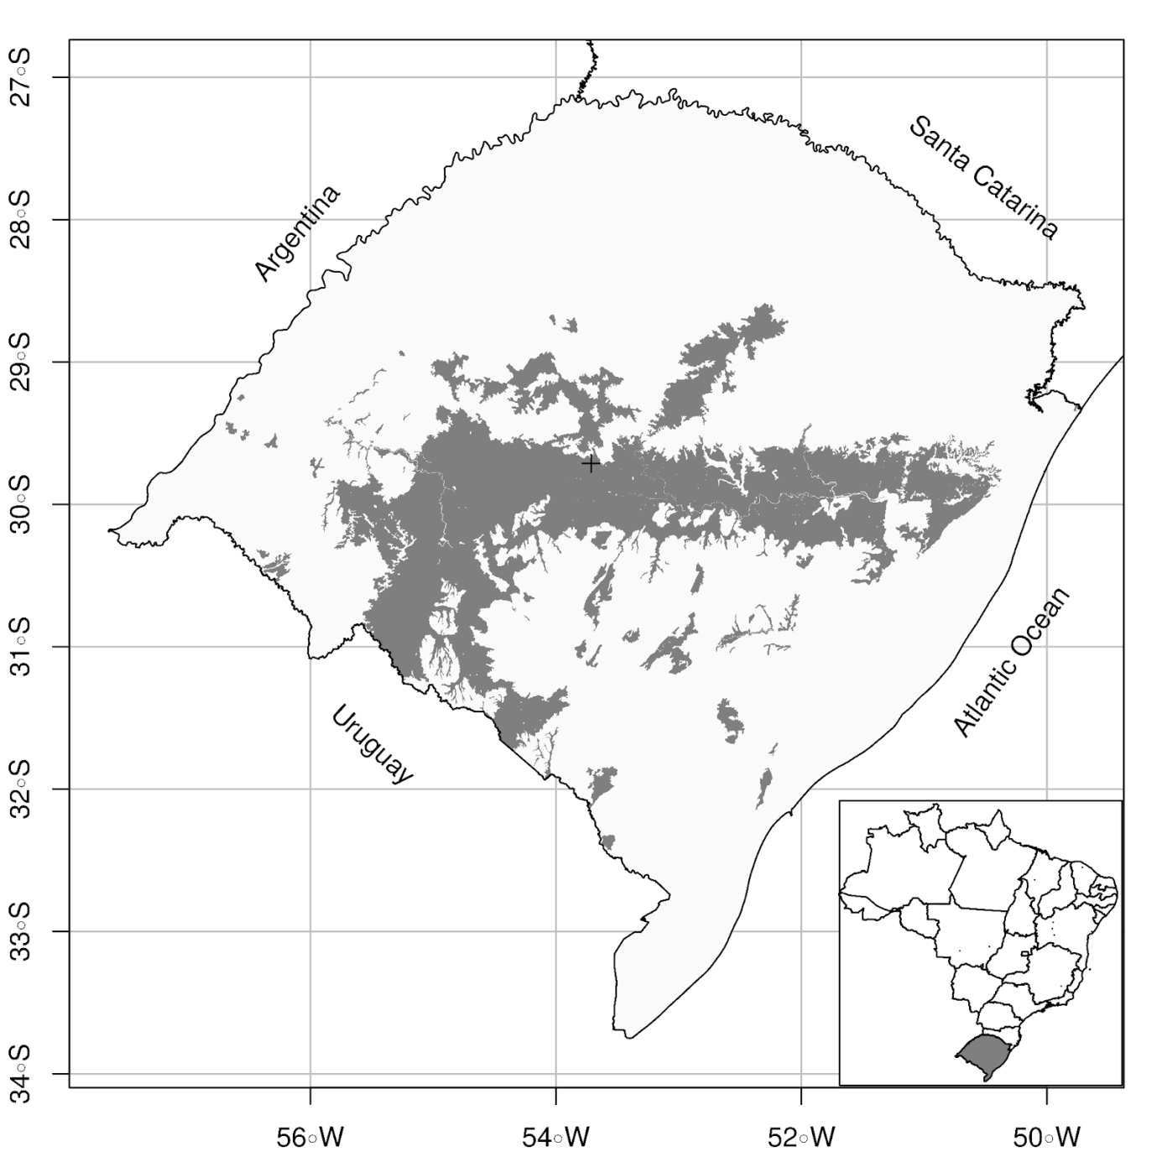

Figure 1: Area of the state of Rio Grande do Sul with a superficial soil layer similar in texture to the soil material used in this study. The cross near the center of the state indicates the location where the soil material was collected.

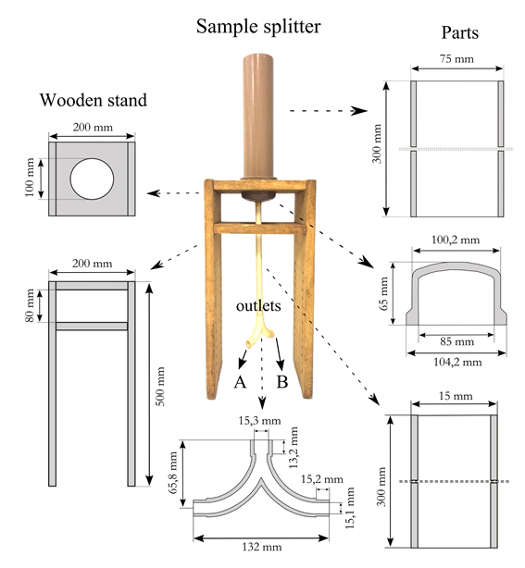

Figure 2: Prototype sample splitter compared to the manual method. The constituent PVC and wooden parts and their dimensions (unscaled) are shown in detail.

# TABLES

# Table 1: Physical properties of the soil profile horizons.

|  |  |  |  |  |  |  |  |  |
| --- | --- | --- | --- | --- | --- | --- | --- | --- |
| Horizon | Bounds | Coarse sand | Fine sand | Clay | Bulk density | Particle density | Macro-porosity | Micro-porosity |
| cm | --------- g kg-1 --------- | | | ------- g cm-3 ------- | | ------ m3 m-3 -------- | |
| A | 0-40 | 140 | 441 | 73 | 1,41 | 2,65 | 0,215 | 0,25 |
| E | 40-60 | 108 | 414 | 70 | 1,68 | 2,63 | 0,133 | 0,23 |
| Bt | 60-90 | 80 | 307 | 262 | 1,65 | 2,69 | 0,060 | 0,33 |
| C | 90-120 | 60 | 298 | 282 | 1,55 | 2,76 | 0,040 | 0,40 |

Table 2: Chemical properties of the soil profile horizons.

|  |  |  |  |  |  |  |  |  |
| --- | --- | --- | --- | --- | --- | --- | --- | --- |
| Horizon | Bounds | pH | Ca2+ | Mg2+ | K+ | H+Al | P2O5 | Organic matter |
| cm | - | ----------------- cmolc kg-1 ---------------- | | | | mg L-1 | g kg-1 |
| A | 0-40 | 4,6 | 2,00 | 0,35 | 0,05 | 2,20 | 1,5 | 12 |
| E | 40-60 | 4,5 | 1,90 | 0,25 | 0,07 | 1,37 | 0,7 | 6 |
| Bt | 60-90 | 4,6 | 2,85 | 0,80 | 0,04 | 2,51 | 0,7 | 4 |
| C | 90-120 | 4,7 | 2,35 | 1,50 | 0,05 | 2,56 | 0,7 | 3 |

|  |  |  |  |
| --- | --- | --- | --- |
| Table 3: Concentration of total solids in five samples obtained using the manual sampling method from three artificial suspensions with a known concentration of total solids of 2, 10 and 50 g L-1. Statistics: SD – standard deviation, CV – coefficient of variation, pME – percentage mean estimation error, t1 – one-sample t-test statistic, p1 – p-value of the t1-test. | | | |
|  | 2 g L-1 | 10 g L-1 | 50 g L-1 |
| 1 | 1,1600 | 4,0600 | 25,5500 |
| 2 | 1,1800 | 6,6800 | 58,6500 |
| 3 | 1,3600 | 4,8100 | 44,7300 |
| 4 | 2,0100 | 4,2600 | 32,3600 |
| 5 | 0,9800 | 4,6200 | 16,9800 |
| Mean (g L-1) | 1,3400 | 4,8900 | 35,6500 |
| SD (g L-1) | 0,4000 | 1,0500 | 16,3800 |
| CV (%) | 29,8200 | 21,3900 | 45,9300 |
| pME (%) | -33,1000 | -51,1400 | -28,6900 |
| t1 | -3,7097 | -10,9415 | -1,9587 |
| p1 | 0,0207 | 0,0004 | 0,1217 |

|  |  |  |  |  |  |  |  |  |
| --- | --- | --- | --- | --- | --- | --- | --- | --- |
| Table 4: Volume of the five samples produced by outlets A and B of the sample splitter for initial volumes of 100, 300, 500 and 1000 mL. Statistics: SD – standard deviation, CV – coefficient of variation, pME – percentage mean estimation error, t1 and t2 – one and two-sample t-test statistic, p1 and p2 – p-value of the t1 and t2-test. | | | | | | | | |
|  | 100 mL A | 100 mL B | 300 mL A | 300 mL B | 500 mL A | 500 mL B | 1000 mL A | 1000 mL B |
| 1 | 48,00 | 50,00 | 155,00 | 145,00 | 245,00 | 254,00 | 507,00 | 484,50 |
| 2 | 44,00 | 54,00 | 144,00 | 156,00 | 261,00 | 239,00 | 457,00 | 534,50 |
| 3 | 47,00 | 51,50 | 153,00 | 146,00 | 248,50 | 251,00 | 492,50 | 498,00 |
| 4 | 45,50 | 53,00 | 150,00 | 150,00 | 256,00 | 244,00 | 512,50 | 477,50 |
| 5 | 42,00 | 57,00 | 146,00 | 154,00 | 249,50 | 250,00 | 525,50 | 464,00 |
| Mean (mL) | 45,30 | 53,10 | 149,60 | 150,20 | 252,00 | 247,60 | 498,90 | 491,70 |
| SD (mL) | 2,39 | 2,66 | 4,62 | 4,82 | 6,41 | 6,02 | 26,24 | 26,89 |
| CV (%) | 5,27 | 5,00 | 3,09 | 3,21 | 2,54 | 2,43 | 5,26 | 5,47 |
| pME (%) | -9,40 | 6,20 | -0,27 | 0,13 | 0,80 | -0,96 | -0,22 | -1,66 |
| t1 | -4,4020 | 2,6110 | -0,1940 | 0,0930 | 0,6970 | -0,8910 | -0,0940 | -0,690 |
| p1 | 0,0117 | 0,0594 | 0,8558 | 0,9305 | 0,5240 | 0,4234 | 0,9298 | 0,528 |
| t2 | -3,4660 | | -0,1420 | | 0,7910 | | 0,3030 | |
| p2 | 0,0257 | | 0,8937 | | 0,4732 | | 0,7770 | |

|  |  |  |  |  |  |  |
| --- | --- | --- | --- | --- | --- | --- |
| Table 5: Concentration of total solids in five samples obtained using the prototype sample splitter from three artificial suspensions with a known concentration of total solids of 2, 10 and 50 g L-1. Statistics: SD – standard deviation, CV – coefficient of variation, pME – percentage mean estimation error, t1 and t2 – one and two-sample t-test statistic, p1 and p2 – p-value of the t1 and t2-test. | | | | | | |
|  | 2 g L-1 A | 2 g L-1 B | 10 g L-1 A | 10 g L-1 B | 50 g L-1 A | 50 g L-1 B |
| 1 | 1,97 | 1,98 | 9,99 | 9,99 | 48,52 | 47,84 |
| 2 | 1,99 | 2,01 | 9,75 | 9,82 | 49,43 | 48,72 |
| 3 | 1,95 | 1,93 | 9,90 | 9,71 | 49,57 | 48,59 |
| 4 | 2,03 | 1,91 | 9,84 | 9,70 | 50,40 | 48,11 |
| 5 | 2,01 | 1,96 | 9,96 | 9,90 | 49,61 | 49,39 |
| Mean (g L-1) | 1,99 | 1,96 | 9,89 | 9,82 | 49,51 | 48,53 |
| SD (g L-1) | 0,03 | 0,04 | 0,10 | 0,12 | 0,67 | 0,60 |
| CV (%) | 1,59 | 2,02 | 0,97 | 1,26 | 1,35 | 1,23 |
| pME (%) | -0,50 | -2,10 | -1,12 | -1,76 | -0,99 | -2,94 |
| t1 | -0,7070 | -2,3700 | -2,6010 | -3,1680 | -1,6500 | -5,4940 |
| p1 | 0,5185 | 0,0768 | 0,0600 | 0,0339 | 0,1742 | 0,0053 |
| t2 | 1,2710 | | 1,3690 | | 2,7850 | |
| p2 | 0,2727 | | 0,2429 | | 0,0496 | |

|  |  |  |  |  |  |  |
| --- | --- | --- | --- | --- | --- | --- |
| Table 6: Sand content in the total solids of five samples obtained using the prototype sample splitter from three artificial suspensions with a known concentration of total solids of 2, 10 and 50 g L-1. Statistics: SD – standard deviation, CV – coefficient of variation, pME – percentage mean estimation error, t1 and t2 – one and two-sample t-test statistic, p1 and p2 – p-value of the t1 and t2-test. | | | | | | |
|  | 2 g kg-1 A | 2 g kg-1 B | 10 g kg-1 A | 10 g kg-1 B | 50 g kg-1 A | 50 g kg-1 B |
| 1 | 342 | 299 | 550 | 515 | 523 | 580 |
| 2 | 367 | 268 | 515 | 575 | 588 | 592 |
| 3 | 320 | 327 | 577 | 534 | 593 | 579 |
| 4 | 316 | 293 | 538 | 574 | 590 | 606 |
| 5 | 294 | 311 | 585 | 525 | 597 | 576 |
| Mean (g kg-1) | 327,57 | 299,68 | 553,35 | 544,53 | 578,18 | 586,60 |
| SD (g kg-1) | 27,68 | 21,99 | 28,65 | 28,10 | 31,11 | 12,35 |
| CV (%) | 8,45 | 7,34 | 5,18 | 5,16 | 5,38 | 2,11 |
| pME (%) | -43,81 | -48,60 | -5,09 | -6,60 | -0,83 | 0,62 |
| t1 | -20,6350 | -28,8150 | -2,3140 | -3,0610 | -0,3470 | 0,6510 |
| p1 | 0,0000 | 0,0000 | 0,0816 | 0,0376 | 0,7464 | 0,5506 |
| t2 | 1,3460 | | 0,3730 | | -0,6030 | |
| p2 | 0,2497 | | 0,7281 | | 0,5791 | |

|  |  |  |  |  |
| --- | --- | --- | --- | --- |
| Table 7: Clay content in the total solids of five samples obtained using the prototype sample splitter from three artificial suspensions with a known concentration of total solids of 10 and 50 g L-1. Statistics: SD – standard deviation, CV – coefficient of variation, pME – percentage mean estimation error, t1 and t2 – one and two-sample t-test statistic, p1 and p2 – p-value of the t1 and t2-test. | | | | |
|  | 10 g kg-1 A | 10 g kg-1 B | 50 g kg-1 A | 50 g kg-1 B |
| 1 | 68 | 78 | 87 | 93 |
| 2 | 72 | 60 | 90 | 94 |
| 3 | 60 | 91 | 91 | 89 |
| 4 | 84 | 60 | 92 | 78 |
| 5 | 83 | 83 | 83 | 85 |
| Mean (g kg-1) | 73,39 | 74,47 | 88,77 | 87,90 |
| SD (g kg-1) | 10,25 | 13,92 | 3,57 | 6,57 |
| CV (%) | 13,96 | 18,69 | 4,02 | 7,47 |
| pME (%) | -17,54 | -16,32 | -0,2600 | -1,2300 |
| t1 | -3,4080 | -2,3330 | -0,1470 | -0,3730 |
| p1 | 0,0271 | 0,0799 | 0,8904 | 0,7279 |
| t2 | -0,1150 | | 0,2460 | |
| p2 | 0,9138 | | 0,8178 | |