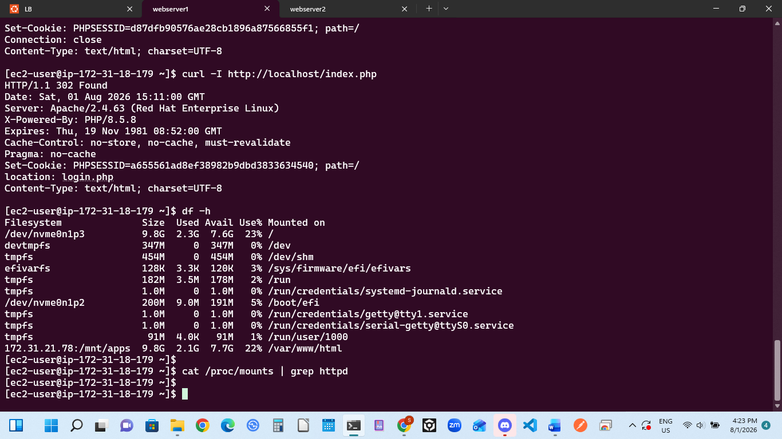

Project 8 Post-Mortem: Load Balancer Alignment & Backend Path Remediation
Incident 1: Load Balancer Daemon Failure (Ubuntu Gateway)
- Problem: The Apache apache2 service on the Ubuntu Load Balancer instance crashed on startup with an exit code error and refused to route traffic. [1]
- Cause: Typographic "smart" or curly quotes (“ and ”) were copied into the VirtualHost configuration file on line 33 (<Proxy “balancer://mycluster”>). The Apache parser could not interpret these non-ASCII characters.
- Solution: Edited /etc/apache2/sites-available/000-default.conf, replaced all smart quotes with standard straight ASCII quotes ("), validated configuration using sudo apachectl configtest, and successfully restarted the service. [1, 2]
Incident 2: Missing Application Deployment Page (RHEL Web Server 1)
- Problem: Navigating to the Load Balancer's public IP served the default Red Hat Enterprise Linux test landing page instead of the StegHub DevOps Tooling Website.
- Cause: An overlapping, duplicate network storage mount structure existed in kernel memory. The central NFS directory /mnt/apps was mounted simultaneously to both /var/www and /var/www/html, which displaced file paths and hid index.php inside a nested subfolder.
- Solution:
  - Executed a lazy unmount (sudo umount -l) on both paths to clear out the zombie kernel locks.
  - Re-mounted the NFS share uniquely to the target directory: sudo mount -t nfs -o nfsvers=4.2 172.31.21.78:/mnt/apps /var/www/html.
  - Restructured directories by migrating all repository files out of the nested folder directly into the root web directory.
Incident 3: Gateway 502 Proxy Error (Upstream Connection Drop)
- Problem: Refreshing the public URL threw a Proxy Error: Error reading from remote server from the Ubuntu frontend gateway.
- Cause: A multi-layered backend processing failure on RHEL Web Server 1:
  - The core php-fpm processor engine was stopped, leaving Apache unable to execute PHP requests.
  - The application files were owned by the root user rather than the apache web server group.
- Solution: Started and enabled the php-fpm daemon, executed a recursive ownership update (sudo chown -R apache:apache /var/www/html/), and temporarily relaxed SELinux boundaries using setenforce 0 to allow clean, uninhibited script execution.
Incident 4: 500 Internal Server Error
- Problem: The browser or local curl requests returned an absolute server execution crash code (HTTP/1.1 500 Internal Server Error).
- Cause: The application's runtime data scripts (index.php / functions.php) attempted to trigger a connection to the dedicated Database instance, which was offline due to AWS usage optimization. [1]
- Solution: Safely initialized the Database instance on the AWS EC2 dashboard, allowing the backend PHP engine to successfully establish its data handshake and render the live admin_tooling.php login dashboard.

