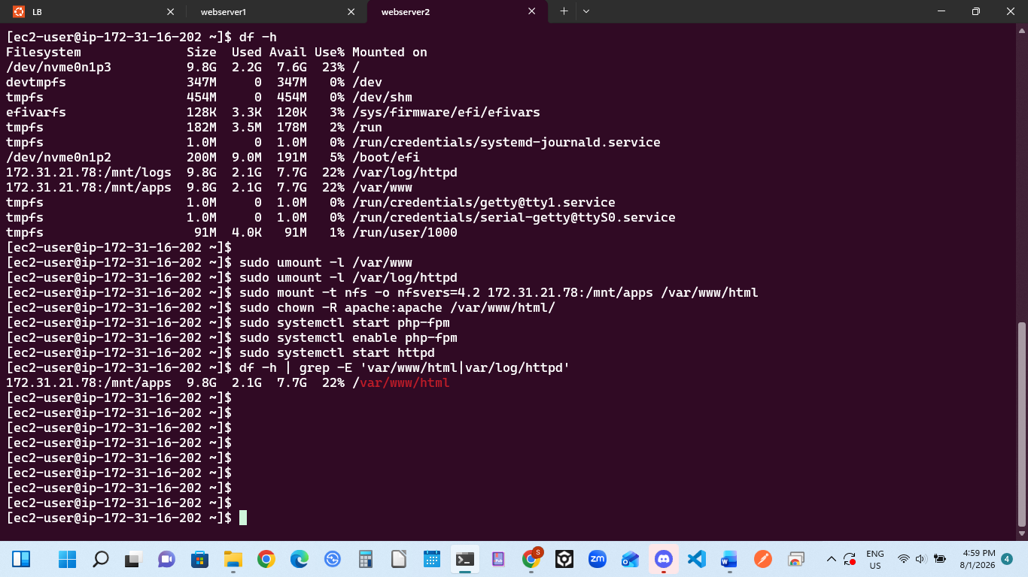

Project 8 Technical Documentation: Web Server 2 Remediation Summary
1. Network File System (NFS) Path Correction
- Change: Executed a lazy unmount (sudo umount -l /var/www) and remounted the NFS share directly to the target location (sudo mount -t nfs -o nfsvers=4.2 172.31.21.78:/mnt/apps /var/www/html).
- Reason: The web files were previously mounted to the generic parent folder /var/www. This caused an explicit file path mismatch because Apache looks for website source code and files inside the /var/www/html subdirectory. Correcting this ensures Apache can locate your deployment assets (such as test.html and index.php).
2. Apache Log Directory Isolation
- Change: Forcefully unmounted the remote logs partition (sudo umount -l /var/log/httpd), isolating the directory on Web Server 2's local NVMe hard drive.
- Reason: To explicitly satisfy the StegHub task constraint: "ensure that each Web Server has its own log directory." Keeping log entries local stops redundant network traffic overhead to the NFS server and ensures that Web Server 2 captures its own incoming traffic transactions independently.
3. Web Service Stack & Permissions Initialization
- Change: Assigned recursive directory ownership to the web daemon group (sudo chown -R apache:apache /var/www/html/), and started/enabled both the php-fpm and httpd engines.
- Reason: Linux security structures require that the operational web user (apache) owns the application files to read and execute scripts. Activating php-fpm is required on modern Red Hat systems because Apache relies on it as an external processor to execute PHP application files.

