BME 4810/6810 Final Project Report

Student: Samuel Schultz

Other team members: Himanshu Thakur

Overview
Optical coherence tomography (OCT) is an imaging technique used to generate a picture of the retina by measuring the amount of dim red light reflected off the retina and optic nerve. Using the OCT-MNIST dataset, a collection of over 109,000 labeled OCT images, our goal is to develop and explore four different machine learning models that accurately diagnose different retinas into one of the four categories: 1) Normal, 2) Choroidal neovascularization, 3) Diabetic Macular Edema, and 4) Drusen.

Methods

Preprocessing, Dimensionality Reduction, or Feature Generation
Several dimensionality reduction strategies were investigated over the course of this study. The objective in each case was to suppress noise in the data and retain only the most informative features, ideally preserving or improving model performance while reducing training time.
The first method considered was average 2x2 pooling. Each 28x28 grayscale image is partitioned into non-overlapping 2x2 blocks, and the four pixel intensities in each block are averaged to produce a single output pixel, yielding a 14x14 image. Applying the procedure twice yields a 7x7 image. Max 2x2 pooling was implemented using the same block structure but taking the maximum of each 2x2 block rather than the mean. The rationale for max pooling was to preserve high-intensity features and produce a higher contrast representation while still reducing the spatial resolution.
Median filtering was investigated as a noise reduction step. For each pixel in the 2D input image, the filter examines a 3x3 neighborhood centered on that pixel and replaces the pixel value with the median of the nine values in that window. This produces a smoother clearer image in which the outliers and noise have been filtered out and replaced with a more homogenous image.
Several feature generation strategies were also evaluated. The simplest involved flattening each image and computing seven summary statistics over its pixel intensities: mean, standard deviation, minimum, maximum, median, first quartile, and third quartile. This method was not expected to perform well and was included primarily as a baseline against which more sophisticated methods could be compared. Principal Component Analysis (PCA) was then applied to the flattened input; PCA identifies the orthogonal directions of greatest variance in the feature space, ranks them by their associated eigenvalues, and discards the components that explain the least variance. Using PCA, the feature space could be reduced from 784 dimensions to as few as 50 while retaining most of the variance. TruncatedSVD was also evaluated as an alternative dimensionality reduction technique. Unlike PCA, TruncatedSVD operates directly on the data matrix without requiring mean-centering, which can be more efficient at the scale considered here. Cumulative explained variance plots were generated for both PCA and TruncatedSVD, and the number of components corresponding to approximately 95% and 90% respectively were selected. The cumulative variance plot for PCA is shown below.
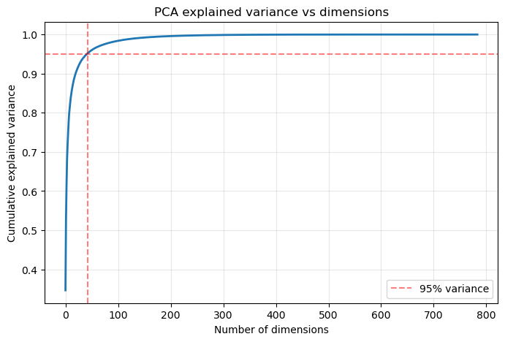
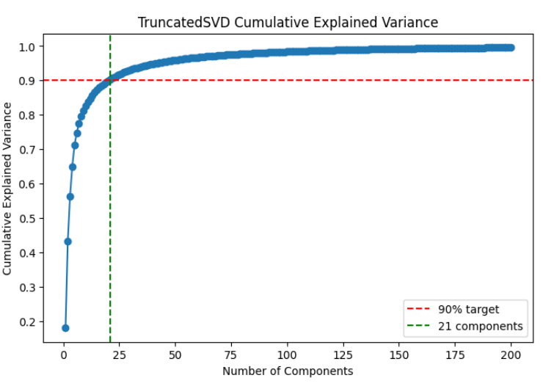

Finally, K-Means clustering was evaluated as a feature reduction method. K-Means initializes a set of cluster centroids at random, assigns each feature (in this case each pixel) to its nearest centroid, and then updates each centroid to the mean of the features assigned to it. This procedure is repeated until the assignments converge. An elbow plot was produced for K-Means, and four clusters were selected as the optimal value. The plot is shown below.
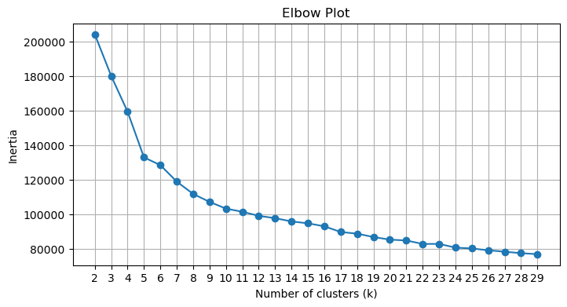
Each preprocessing method was evaluated on three criteria: classification accuracy (equivalent to weighted recall), weighted precision, and training time. LinearSVC was used as a baseline classifier for these comparisons because it provides a reasonably fast and consistent point of reference across preprocessing pipelines. The detailed results are reported in the Results section. Except for K-Means, all of the preprocessing methods evaluated were ultimately incorporated into one or more of the preliminary designs. The results for all preprocessing methods can be seen below:
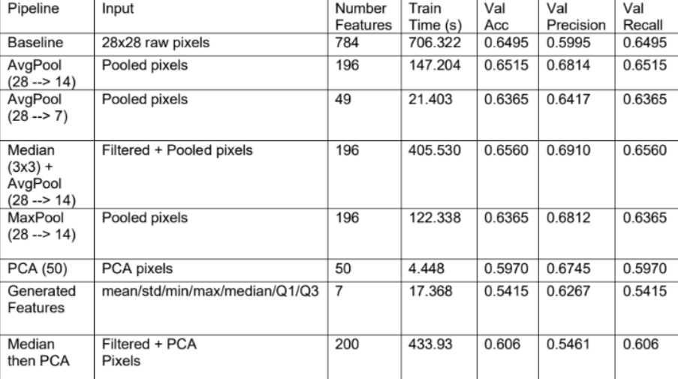

Preliminary Designs
This section discusses each of the preliminary designs developed for this project. Each preliminary design was implemented using either Scikit-Learn or TensorFlow. A stratified subset comprising approximately 10% of the full dataset was used to evaluate the preliminary designs, and the designs were assessed on accuracy, weighted precision, and training time. Confusion matrices were generated to support the evaluation.
The first preliminary design was a preprocessed stacking classifier. The raw inputs were passed through a function transformer implementing the median filter described above, followed by a second function transformer applying average 2x2 pooling to reduce each image to 7x7. This preprocessing combination was selected because it produced the strongest results across the configurations tested in Milestone 1. The preprocessed images were then provided to two base classifiers: a Random Forest with 200 estimators and an SVC with an RBF kernel. The Random Forest was configured to favor deep trees (max_depth set to None, min_samples_leaf set to 1), and each tree was trained on a random 25% of the feature space to encourage diversity among the trees. These two classifiers were chosen because, of the five individual models evaluated (Random Forest, SVM, Stochastic Gradient Descent classifier, AdaBoost, and Gaussian Naive Bayes), the SVM and Random Forest achieved the highest individual accuracies. This result is consistent with the hypothesis that the decision boundary in the original feature space is not linearly separable. The output probabilities from the two base classifiers were combined by a Logistic Regression meta-classifier to produce the final prediction. Logistic Regression was selected as the meta-classifier because of its low risk of overfitting on the small set of generated features, its natural ability to combine the base classifier outputs through a learned linear combination, and its computational efficiency. This first preliminary design achieved an accuracy of 0.725, a precision of 0.723, and a recall of 0.725. The corresponding confusion matrix and ROC curve are shown below. It should be noted that all three scikit learn classifiers strongly ignored the DME class likely due to the lack of class weights.
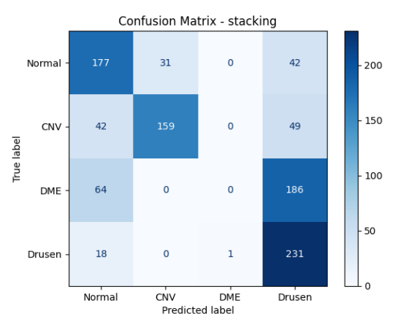
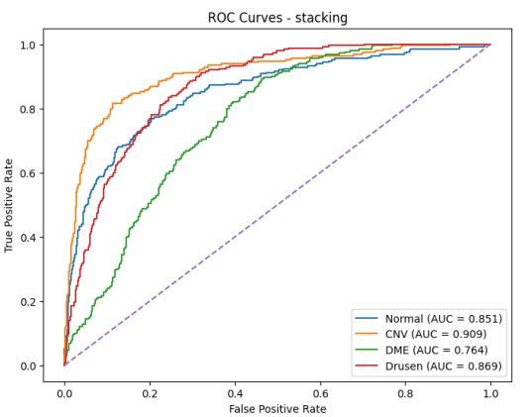
The second preliminary design was a soft voting classifier with minimal preprocessing. Minimal preprocessing was chosen because earlier experiments indicated that the raw input data performed nearly as well as the preprocessed data. After flattening, the images were passed to three classifiers: a Random Forest, an SVC, and an AdaBoost classifier. The Random Forest and SVC were the two strongest individual classifiers from the preliminary evaluation, and AdaBoost was included to introduce greater diversity into the ensemble and to differentiate this design from the stacking classifier above. The probabilistic outputs of the three classifiers were combined using soft voting to produce the final prediction. Soft voting was preferred over hard voting because it weights each classifier’s confidence rather than treating all votes equally, which reduces the influence of underperforming classifiers when the remaining classifiers are confident. As with the stacking design, each component classifier was tuned individually before integration into the ensemble. The voting classifier preliminarily design was tested on the set and achieve an Accuracy of 0.448 and Precision of 0.6789. Confusion Matrix and AUC curves are shown below.
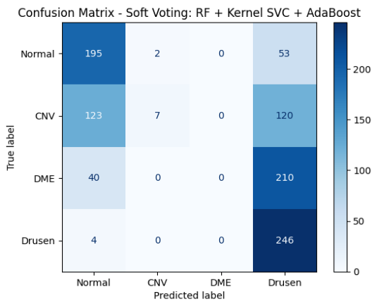
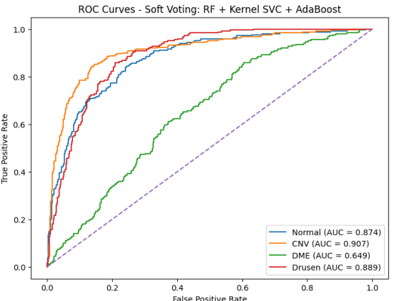
The third preliminary design was a soft voting classifier with explicit dimensionality reduction. After flattening the input data, a MinMaxScaler was applied to normalize features to a consistent range, followed by TruncatedSVD with n_components set to 100. TruncatedSVD was selected for its efficiency advantages. The 100-dimensional outputs were then passed to three classifiers: an SVC with an RBF kernel (C set to 1.0), an SGDClassifier with log loss, and a BaggingClassifier built on DecisionTreeClassifier base estimators (n_estimators set to 50, max_samples set to 0.8). These three classifiers were chosen to maximize variance within the ensemble: The SGD provides a fast linear baseline, the SVC explores non-linear decision boundaries through kernel methods, and the BaggingClassifier explores the advantages of ensemble methods and bags of weak learners. The outputs of the three classifiers were combined through soft voting. As with the previous designs, each component was tuned individually before integration into the ensemble. On the test set the SVD preliminary design scored a 0.32 accuracy and a .5095 precision, disappointing results, the model would essentially flip a coin between Normal and Drusen. The results on the test set can be shown below.
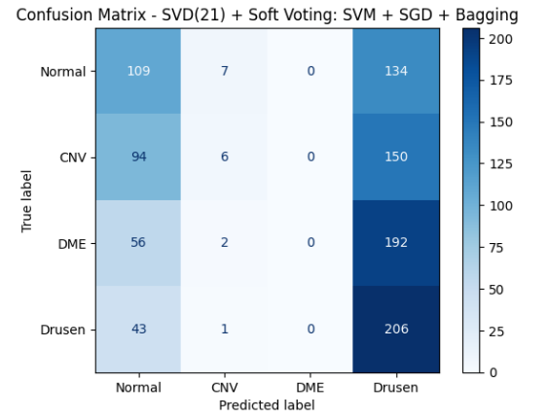
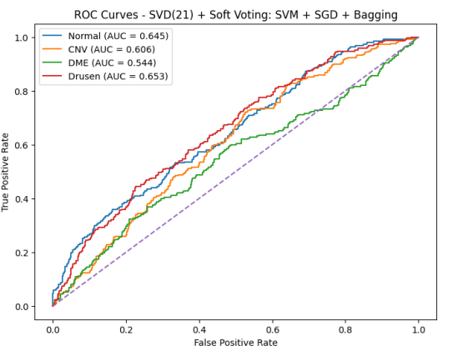
This concludes the designs implemented using Scikit-Learn. The remaining designs use deep learning techniques implemented in TensorFlow.
The fourth preliminary design was a wide and deep neural network. The inputs were flattened and scaled using a MinMaxScaler, after which a FeatureUnion was used to construct two parallel representations of the data: a PCA-reduced version with 133 components, and the full scaled inputs. The choice of 133 components was made to balance the dimensionality of the wide path against the output dimensionality of the deep path while still retaining 99% of the variance. The network consists of two paths. The deep path is composed of two dense layers of 300 units each with ReLU activation. The wide path has no hidden layers or activations and instead provides a direct connection from input to output. The full scaled inputs are passed to the deep path, while the PCA-reduced inputs are passed to the wide path. The outputs of the two paths are concatenated and fed into a softmax layer for classification. The motivation for this architecture is that combining learned non-linear features (from the deep path) with a direct linear projection of the input (from the wide path) can produce a stronger overall classifier than either path alone. The Confusion Matrix and ROC on a subset of the training set for this model can be found below. On validation data the model scored an Accuracy of 0.77 and a Precision of 0.7686. Note the wide and deep network generalized better than the previous models though still struggled on the elusive DME label.
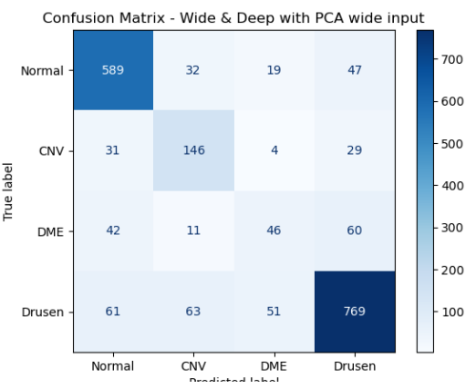
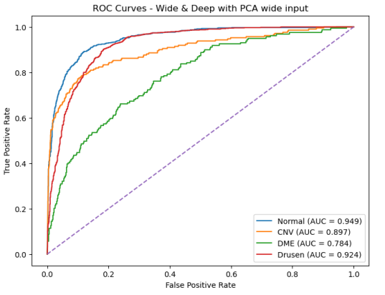
The fifth preliminary design was a standard Convolutional Neural Network (CNN). CNNs are well established as the dominant architecture for image classification tasks because their convolutional and pooling layers are explicitly designed to exploit the spatial structure of image data. For this preliminary design the architecture was kept deliberately simple. After the input layer, the network passes through two convolutional units, each consisting of a Conv2D layer with 64 filters, a kernel size of 3, and ReLU activation, followed by a MaxPooling2D layer with pool size 2. The output is then flattened and passed through a dense layer of 32 units with ReLU activation, and finally through a softmax classification layer. This architecture was intended to serve as a strong but uncomplicated baseline that could be extended in subsequent designs. On validation data the CNN scored an accuracy of 0.7869 and a precision of 0.7606. Our strongest model so far. The confusion matrix and ROC curve can be found below.
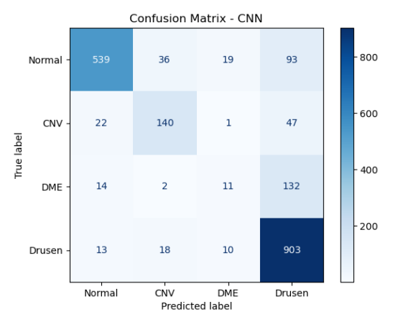
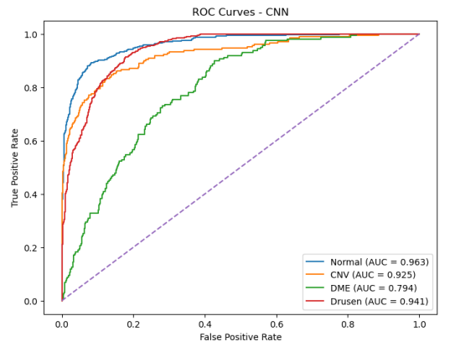
The sixth and final preliminary design was a ResNet-style convolutional network and is the most architecturally complex of the designs evaluated. The motivation for ResNet is as follows. Deeper convolutional networks are in principle desirable because successive layers can capture progressively more abstract patterns: an early layer may learn to detect edges, the next a corner, and so on. In practice, however, very deep networks suffer from the vanishing gradient problem. It has further been observed that adding convolutional layers beyond a certain depth often degrades model performance rather than improving it. In addition to this, when a particular layer is unnecessary, it is surprisingly hard for a standard convolutional network to learn the identity function. ResNet addresses both problems by reformulating the modeling objective. Rather than learning some target function F(x), each block instead learns the residual, defined by H(x) = F(x) + x. This is implemented through the Residual Unit, which consists of a Conv2D layer, a BatchNormalization layer, a ReLU activation, a second Conv2D layer, and a second BatchNormalization layer. The BatchNormalization layers help mitigate the vanishing gradient problem, but most important to the residual unit, is the addition of x into the unit’s final output. If a particular layer is not contributing useful information, the network only needs to drive F(x) toward zero for the unit to behave as an identity mapping, which is a far easier function to learn than an explicit identity. The architecture used here begins with a single Conv2D layer with 32 filters, followed by six residual units organized into three stages of two units each. After every two residual units, the number of filters is doubled and the spatial dimensions are halved by setting the convolutional stride to two. The filter schedule progresses from 32 to 64 to 128. The final spatial reduction is omitted, and the output is instead passed through a GlobalAveragePooling2D layer to prepare data for the softmax classification layer. The final model scored an impeccable 88.99% Accuracy and 89.12% Precision. By far the best of any model. At the steep cost of training time though. The model took 5 minutes on GPU training time; it was only switched to training on a GPU in the first place because it was training for over an hour previously. The results for the Confusion Matrix and ROC Curve can be found below.
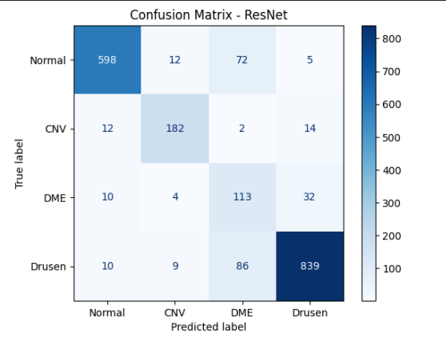
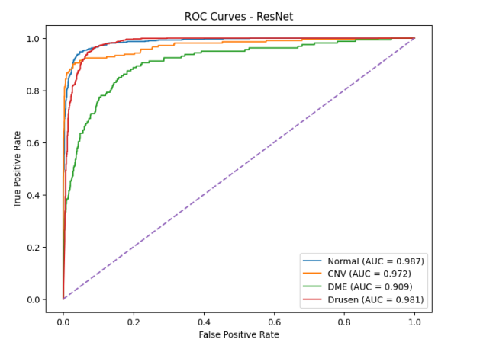
For all our Preliminary Designs DME was the most difficult category to identify by a significant margin. Potentially due to the class Imbalance.

Final Designs and Fine-Tuning
To determine the definitive architecture of each model, a final hyperparameter search was conducted. A stratified subset of 22,000 samples was drawn from the dataset and used for this final tuning. Because of the substantial computational cost of an exhaustive search, the search space for each model was restricted to a small number of high-impact hyperparameters. Accuracy was used as the tuning metric throughout. RandomizedSearchCV was used for the Scikit-Learn classifiers, and Hyperband tuning was used for the TensorFlow classifiers. RandomizedSearchCV was selected over GridSearchCV primarily for its lower computational cost, at the expected cost of some optimization quality. Hyperband was selected on similar grounds but is somewhat more sample-efficient than pure random search because it allocates additional epochs to the most promising configurations. Because the tuning scope was so limited an active effort was made to explore different ideas in the tuning of each preliminary design. While these are final designs, what was taken from each limited tuning scope should be learned. With that information a possible even better model could be developed in the future.
For the stacking preliminary design, three high-impact hyperparameters were selected: the number of components used in the Nystroem approximation, the C value for the SVC, and the C value for the final Logistic Regression estimator. The number of Nystroem components controls the flexibility of the decision boundary learned by the SVC. The C value for the SVC controls the hard-margin versus soft-margin tradeoff, allowing the search to identify the most appropriate margin behavior for this dataset. The C value for the Logistic Regression meta-classifier provides a final regularization control on the combined output. Random Forest Hyperparameters were not included in the search as it was deemed the scope of the search would be too broad for the number of trails being done (only 10 iterations). The search returned 500 components for the Nystroem approximation, a C value of approximately 0.2 for the SVC, and a C value of approximately 8.7 for the final estimator. Together these results indicate that the stacking classifier favors a highly non-linear decision boundary at the base level (high number of rbf components and soft margin classification) combined with relatively weak regularization at the meta-classifier level. Class weights were used during training in accordance with the recommendation provided by Professor Sabato.
The final stacking architecture can therefore be summarized as follows: The inputs are first processed by median filtering and average 2x2 pooling. The preprocessed inputs are then passed in to both a Random Forest, which favors deep trees and uses random feature subsampling, and to an SVC, which projects the input into a high-dimensional space via the Nystroem approximation and classifies using soft-margin classification. The probabilistic outputs of the two base classifiers are combined by a Logistic Regression meta-classifier with relatively weak regularization. The best cross-validation accuracy obtained during tuning was 0.7059.
For the voting classifier, the search space consisted of: number of estimators in the Random Forest (100 to 400), maximum number of features per tree (0.2, 0.25, 0.33, or ‘sqrt’), minimum samples per leaf (1 to 8), and maximum depth (None, 20, or 40); and for the AdaBoost classifier, number of estimators (100 to 400) and learning rate (0.5 to 2.0). The search space was designed to focus primarily on the tree-based components of the ensemble. This is because we dropped RandomForests from the tuning scope of the previous design. Varying the number of estimators allows the search to determine how much model capacity is required, while varying maximum number of features and maximum depth controls the diversity and complexity of the individual trees. The Random Forest results tended toward the extremes of nearly every dimension, favoring the shallowest trees with the largest number of estimators and the smallest feature subsamples per tree. The AdaBoost search explored the tradeoff between the number of weak learners and the boosting learning rate. Sample weights were used during training. The AdaBoost search settled on a learning rate of 0.6 and 230 estimators.
The final voting classifier architecture can therefore be summarized as follows. The raw flattened inputs are passed to three classifiers operating in parallel: a Random Forest of shallow, decorrelated trees; a standard AdaBoost classifier built on decision stumps; and an SVC using the Nystroem approximation for the RBF kernel. The probabilistic outputs of the three classifiers are combined through soft voting. The best cross-validation accuracy obtained during tuning was 0.6955.
The tuning of the SVD-based soft voting classifier focused primarily on the SGDClassifier and the SVC, and unlike the previous two preliminary designs the preprocessing parameters were also included in the search. The number of TruncatedSVD components was searched over the range 75 to 200, which corresponds to approximately 95% to 99.9% of the explained variance. For the SGDClassifier, the search examined the regularization penalty (L2 versus elasticnet) in conjunction with the regularization strength alpha (1e-5 to 1e-2). For the SVC, the search examined the C parameter alongside the RBF kernel coefficient gamma (‘scale’ versus ‘auto’). Searching over different SVC hyperparameters than in the stacking design helped diversify the experiments and reduce the risk of converging on the same configuration. The search settled on moderate regularization for the SGDClassifier (alpha equal to 0.0002 with elasticnet penalty) and a comparatively hard-margin configuration for the SVC (C equal to 7, gamma set to ‘auto’). The selected number of TruncatedSVD components was 100, indicating a preference for a smaller proportion of the explained variance than the upper end of the range. The best cross-validation accuracy obtained during tuning was 0.6506.

As less of the architectural decisions were decided for the TensorFlow models’ greater emphasis was placed on it for the titration of TensorFlow Models.
For the wide and deep network, Hyperband tuning was used to search the space defined in build_tuned_wide_deep. The search covered the PCA variance threshold (0.90, 0.95, 0.99, or 0.999), activation (ReLU or ELU), the number of deep dense layers (1 to 3), the number of units per deep layer (128 to 512 in steps of 64), the inclusion of batch normalization, the dropout rate (0.0 to 0.3), and the learning rate (log-uniform from 1e-4 to 1e-2 with cosine decay and a two-epoch warmup). The search converged on the following configuration: a PCA threshold of 0.90, ReLU activation, two deep dense layers with matching unit counts, no batch normalization, a dropout rate of 0.1, and a learning rate of 0.002. The selection of the lowest available PCA threshold was somewhat unexpected, as higher thresholds preserve more variance. A possible explanation is that due to the deep path already receiving the full inputs the full amount of variance is not needed for the Wide Path. The lack of meaningful dropout and batch normalization was also surprising. I believe this implies that regularization is not a meaningfully impactful contribution to the Wide & Deep Network Architecture. The best validation accuracy obtained during tuning was 0.737.
The final wide and deep architecture can therefore be summarized as follows. Scaled inputs are projected through PCA to retain 90% of the variance, and the resulting components are passed to the wide path. The full normalized input is passed to a deep path consisting of two dense layers with ReLU activation and a dropout rate of 0.1. The two paths are concatenated and passed through a softmax layer over the four output classes.
For the CNN, the same Hyperband strategy was applied to build_tuned_cnn. The search space covered activation (ReLU, ELU, or LeakyReLU), the number of convolutional blocks (2 or 3), kernel size (3 or 5), the inclusion of batch normalization, the dropout rate (0.0 to 0.3), the number of dense layers preceding the output (0 or 1), the number of filters per convolutional block chosen from {32, 64, 128}, the number of dense units chosen from {32, 64, 128}, and the same learning rate range and cosine decay schedule used for the wide and deep network. A convolutional block here consists of a Conv2D layer, an optional batch normalization layer, a MaxPooling2D layer, and an optional dropout layer. Filter counts were searched independently per block rather than constrained to a fixed doubling pattern, in order to allow non-monotonic filter schedules to be selected if they performed better.
The search converged on the following configuration: three convolutional blocks with ReLU activation, batch normalization enabled, no dropout, a learning rate of 0.003, a filter schedule of 64, 128, and 128, and a single dense layer of 64 units preceding the softmax. The doubling-then-flat filter progression is consistent with the small spatial size of the inputs; by the third convolutional block the spatial map is sufficiently reduced that additional filters provide diminishing returns. The selection of batch normalization without dropout is consistent with the wide and deep result, in which heavy regularization was likewise not required. The best validation accuracy obtained during tuning was 0.822.
The final CNN architecture can therefore be summarized as follows. The 28x28x1 inputs are passed through three convolutional blocks (each consisting of a Conv2D layer with ReLU activation, a batch normalization layer, and a MaxPooling2D layer with pool size 2) using 64, 128, and 128 filters respectively. The output is flattened and passed through a dense layer of 64 units with ReLU activation, followed by a softmax layer over the four output classes. The model was trained using the Adam optimizer with a base learning rate of 0.003 under a cosine decay schedule.
“A typical ResNet (e.g., ResNet-18 or ResNet-50) starts with an initial convolution and pooling, followed by multiple stages of residual blocks; at each stage, the number of filters may increase and spatial resolution may decrease (via strided convolutions), and finally the network ends with a global average pooling and a fully connected layer for classification.” was the used definition of a Resnet Architecture taken from This Digital Ocean Article
The concept of a “Residual Stage” was taken to heart and used to frame the search space. For each candidate architecture, the search varied the number of residual stages (2 or 3), the number of residual units per stage (1 or 2), the activation function (ReLU, ELU, or LeakyReLU), the base number of filters (32 or 64) which doubled at each successive stage, the dropout rate applied at the end of each stage (0.0, 0.1, or 0.2), and the learning rate (log-uniform from 1e-4 to 1e-2 with the same cosine decay schedule used for the other deep models). The search additionally selected whether to include a single dense layer (of 64 to 256 units in steps of 64) before the softmax output. Two architectural decisions were held fixed throughout the search: the residual-stage organization itself, and the doubling of filters between stages (which is standard for ResNet architectures). The search returned the best validation accuracy of 0.902 with the following configuration: ReLU activation, three residual stages, two residual units per stage, base filter count of 64, learning rate of 0.0008, and a dense head of 64 units. Notably, the search selected the deepest architecture available within the search space, including the optional dense head. This suggests that the OCT classification task benefits from a substantially richer learned representation than the other final designs were able to provide. It is also worth noting that the full Hyperband tuning procedure for the ResNet required over four hours of compute, which is a substantial drawback that is discussed further in the Conclusions section.

The final ResNet architecture can therefore be summarized as follows. The 28x28x1 inputs are passed through an initial Conv2D layer (64 filters, kernel size 3, stride 1), followed by a batch normalization layer and a ReLU activation. The output is then passed through three residual stages of two residual units each. The first stage uses 64 filters, the second uses 128, and the third uses 256, with the first residual unit of each stage after the first applying a stride of 2 to halve the spatial dimensions. The output of the final residual stage is reduced by a global average pooling layer to a fixed-length vector, passed through a dense layer of 64 units with ReLU activation, and finally through a softmax layer over the four output classes. The model was trained using the Adam optimizer with a base learning rate of 0.0008 under a cosine decay schedule.

Results
Finally, we move into the results of each Model. Each model trained on the entire test set then evaluated on the entire test set as a final gauge of how production ready it is. Every model was judged off of Accuracy, Weighted Precision, Weighted F1 Score and Training time. In addition, confusion matrices and ROC curves were generated for every model.
Stacking Classifier:
The stacking classifier achieved an accuracy of .59, A weighted precision of .65, and a weighted F1 score of .52 and took 3087 seconds to train or around 50 minutes. Confusion Matrices and ROC curves can be observed below. The model does quite well on the Drusen case but terrible on the DME case almost always misclassifying it even with sample weights
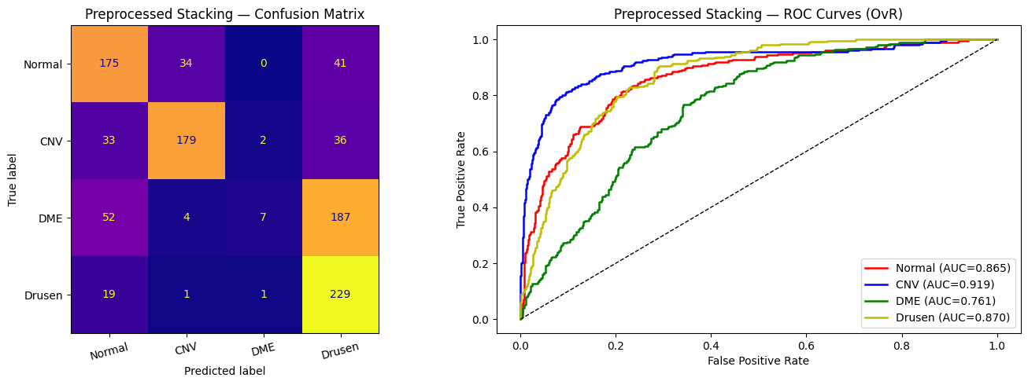
Voting Classifier:
The tuned voting classifier is timing out. (2+ hours and it hasn’t finished training) This is enough to rule it out as a viable model in my mind. For interim results we will use the preliminary design results from earlier. To restate: The voting classifier preliminarily design was tested on the set and achieve an Accuracy of 0.448 and Precision of 0.6789.


SVD:
Similarly, the SVD soft voting classifier timed out. Something about the tuning or some interaction seems to be making these classifiers run for far longer than they are supposed to. To restate: The preliminary design scored a 0.32 accuracy and a .5095 precision. Awful results.

Wide & Deep:
The Wide & Deep final model achieved an accuracy of 0.659, A weighted precision of 0.651, and a F1 score of 0.65 while taking 133.5 seconds to train. Confusion Matrix and ROC curve can be observed below. It does around equally well on Normal, CNV, and Drusen but struggles on DME. Compared to other models it appears a lot less confident in its decisions.
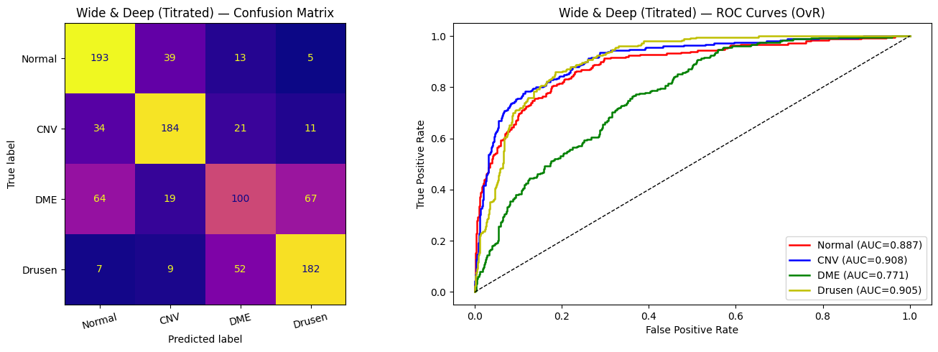

CNN:
The CNN scored an Accuracy of 0.5950, A weighted Precision of 0.6193 and a Weighted F1 of 0.5548. With a train time of 196.7s. This is an extremely surprising result. To the point that it makes me doubt my code. These number
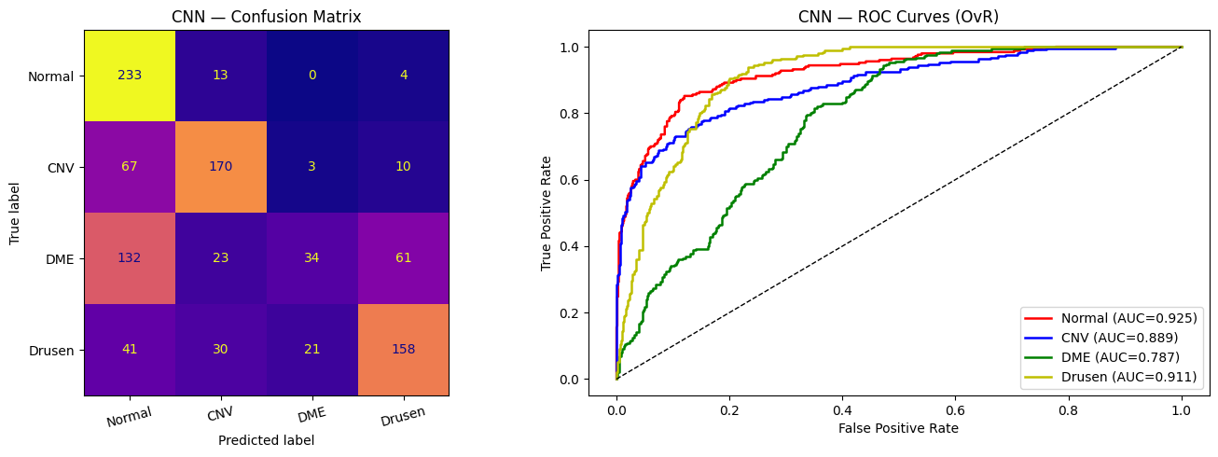

Resnet:
Resnet Got an Accuracy of 0.715, A Weighted Precision of 0.8086, a Weighted F1 score of 0.6868, and had a Training time of 748.9s (Colab GPU). Once again this is less than I would have expected for this model. Is it possible my prepare_dataset() function was broken?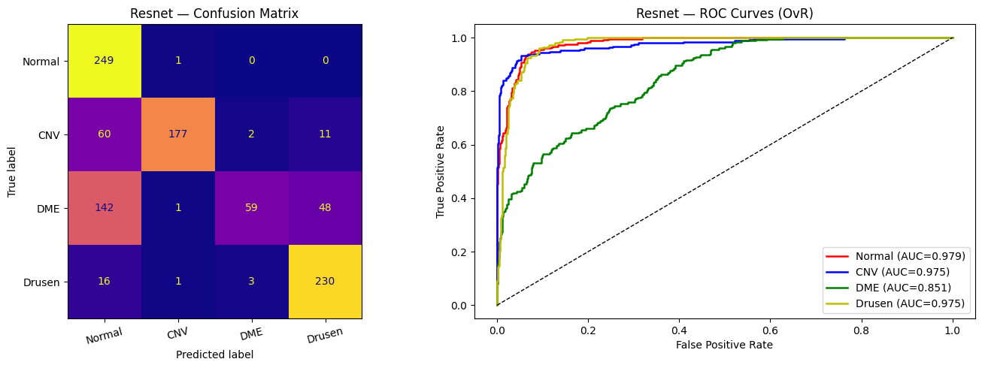

Final Interpretations:
Overall, the results of all the models give us some critical insights into the dataset. Looking at the confusion matrix Drusen, CNV, and Normal are often lumped into one group and Drusen is placed into its own group. DME is unanimously the hardest class to predict. Some research on DME shows that it’s due to a fluid buildup. This could be the reason every classifier is having such a hard time detecting it unlike Drusen which is a much more noticeable bump. Or perhaps it was the class imbalance in combination with the standard evaluation metric of “accuracy”. Perhaps using weighted accuracy would’ve yielded much better results and generalized across classes better. While the results prove a little confounding, even with these bizarre results resnet architecture still appears as the clear winner if you have the architecture to support it, having the highest accuracy, weighted precision, and f1 score.

Closing Remarks
This final milestone made me feel a lot for Icarus. I tried to do too much with loaded of a final schedule. In truth if I skipped a second round of model titration entirely, I would have come out with a lot less headaches, a lot more hours of sleep within the past 72 hours, and likely an overall stronger paper. However, I think very important things can still be gleamed from my experience. What I want to be the key takeaway from my paper is the lesser talked about variable of TIME. I made the mistake of discounting time in this project, I tried to do too much with too little of it and this reflects in model design choices. Resnet while an excellent architecture requires substantial time and effort to get going in the first place.
In an actual production environment this is often more than anything the deciding factor. No one cares about how well a model works “in theory” if it takes too much time deploy it in practice. Models like SVC with an rbf kernel while in isolation performing strongly, similarly bottleneck so hard on large training data that both voting classifiers couldn’t finish within time. It is because of this I would recommend the Wide & Deep network depending on deployment environment. It was faster to train, faster to tune, and less of a headache to implement (though figuring out how to tune it did prove a challenge).

Conclusions
In conclusion, If you have the environment and time, Resnet is the obvious choice, its results speak for themselves. I believe we have not only thought this paper managed to propose multiple different strong classifiers that suit the problem assignment based off your needs. If you need strong performance, the Resnet Architecture provides that in spades. If you need something to ship quickly Wide & Deep or even the Stacking Classifier achieve acceptable results given training time. Some information can only be truly gleamed through adversity. This paper is proof of that, without the struggles of development the perspective of time would have never been such as strong consideration when recommending models.

Contributions
Himanshu was an excellent partner in this class contributing greatly to the development of several preprocessing techniques such as Median Filtering and Truncated SVD. He was the primary architect behind the designs of both the TrucatedSVD classifier and the Convolutional Neural Network and was a massive help in the preparation and creation of the slides in the presentation. More than that we collaborated and communicated constantly throughout the course and our shared insights were an essential part of our successes in this project.

Self-Reflection
To drop the formality for a moment, this was my favorite course I’ve had at Uconn thus far. For as stressful as I found this final report, and for as scared as I am as my tuned resnet is still training as I’m typing this. I truly from the bottom of my heart found this course so much fun and felt I learned so much from it. If I could give any critiques, I wish Neural Networks were maybe introduced earlier in the course? I think they’re such a hard topic and especially Recurrent and Convolutional Networks I still don’t feel fully confident that I have an amazing conceptual understanding of them. The course pace is so fast as is that introducing Neural Networks Earlier may hurt more than help. Finally, one more note: in the course objectives it touches on regression problems; those felt underrepresented in comparison to Classification Problems. Perhaps one more activity focused on more regression tasks would be better nice? This course was very challenging to me, more challenging than any other course I’ve taken at Uconn. Because of this it forced me to develop skills that I had neglected throughout my 3 years here at Uconn, like for example, actually reading the textbook. But I think in the end the difficulty is a good thing. This is a difficult and complex subject, to discount the difficulty is to discount the experience. And this class made me want to try my best to rise to the occasion, and I hope through the report and the compiled files, I have done that in some regard. Thank you Professor Sabato and Amir for all your help and patience throughout the semester. I feel like I’ve developed passion and a skill through my time in your course.

Appendix (Please take the time to look through these the took a long time)
Milestone_Tensorflow Tuning
Milestone_Hyperparam_Search
Models.py
Presentation Slides (figures fetched from here)

