Non-crop features influence the abundance and timing of beneficial arthropod abundance

Samuel Robinson

Jess Vickruck

Lincoln Best

Diane Edwards

Paul Galpern

Ground-dwelling arthropods are important generalist predators in agro-ecosystems, and can use non-crop features as overwintering habitats. However, it is unclear which types of landscape features constitute useful non-crop habitat, and what spatial scale of habitat is required. Additionally, the same landscape feature may act as a sink or a source of arthropods at different times of the year, but this is rarely considered. We modeled the activity density of four highly-abundant species of Canadian prairie arthropods, and used functional regression to simultaneously consider both their habitat preferences and the timing of sources and sinks. We found that canola crops (*Brassica napus* L.) acted as early-season sources, and that grasses and wetlands acted as late-season sinks of arthropods. Farmers should consider the temporal dimension of non-crop habitats, in order to preservea mosaic of grasslands, wetlands and other non-crop features capable of providing reservoirs habitats for beneficial arthropods at different times of the season.

Arthropods are one of the most influential groups of animals in agricultural systems. Pest arthropods can cause large reductions in crop yield (Oerke 2005), which can result in downstream economic effects, food insecurity, and malnutrition. On the other hand, spillover of beneficial arthropods from adjacent non-crop patches can deliver increased crop yields by providing ecosystem services such as extra pollination or pest suppression (Losey & Vaughan 2006; Klein *et al.* 2007; Garibaldi *et al.* 2013). Seasonal “pulses” of food resources from crop fields act as a bottom-up driver of their associated arthropod communities, meaning that agricultural land can act as a source of nutrients and individuals for adjacent non-crop land (Diekötter *et al.* 2010; Galpern *et al.* 2017). These important fluxes of mobile arthropods, both to crops and away from them, are key for managing both crop yield and biodiversity in agroecosystems. Finding “win-win” practices is of particular importance to land managers and conservationists; that is, practices that result in better conservation outcomes while maintaining or improving crop yields. Finally, agricultural land occupies 15 million km (~36%) of land globally (Ramankutty *et al.* 2018), suggesting that there remains great potential to achieve conservation outcomes by adjusting agricultural practices.

Uncultivated semi-natural land (SNL) can act as important habitat for beneficial arthropods (Duelli & Obrist 2003), which may spill over into adjacent cropland. Therefore, landscape management is a strategy to increase beneficial arthropod abundance in crops (Landis *et al.* 2000; Albrecht *et al.* 2010; Martin *et al.* 2020; but see Tscharntke *et al.* 2016; Karp *et al.* 2018). For example, wild bee abundance in agricultural landscapes is largely driven by flower and nest availability (Roulston & Goodell 2011), and the effect of SNL on bee abundance and diversity is generally positive. Predatory arthropods such as beetles or spiders can be limited by water, food, and egg-laying sites (Lövei & Sunderland 1996; Purtauf *et al.* 2005; Gardiner *et al.* 2010), but the effect of SNL on their abundance and diversity is less consistent (Macfadyen & Muller 2013; Shackelford *et al.* 2013) as some taxa may use SNL as a travel corridor or overwintering site, but are not completely dependent on it for reproduction. Some taxa are not dependent on SNL at all, and thrive in cultivated landscapes, while others exclusively inhabit SNL and do not venture beyond the edge of cultivated fields. For example, carabid beetles are thought to reproduce in field margins, while the adults feed in fields (Desender & Alderweireldt 1988). This depends on the life history of the organisms in question, such as the seasonal timing of emergence, feeding, and reproduction, as well as their traits such as dispersal capability. Non-adjacent cropland can also influence arthropod abundance if the organisms are long-distance dispersers (Öberg *et al.* 2008). In this way, the spillover of beneficial arthropods into crops depends not only on the amount of adjacent SNL, but the specific habitat type, the time of the year, and the spatial scale at which an organism gathers resources.

Despite what is known about the spatial and temporal aspects of beneficial arthropod spillover, these are rarely considered together. First, some habitat types may act as sources of arthropods during some times of the year, but as sinks during other times, meaning that the timing of spillover may not align with key periods in crop development. Arthropods can migrate from managed crops back into adjacent SNL at the end of the season (Desender & Alderweireldt 1988; Tscharntke *et al.* 2005), but this is seldom considered. Second, the spatial “grain” of the landscape that is relevant to an organism depends on their traits and life history (Ahrenfeldt *et al.* 2015). For instance, bumblebee abundance can be controlled by both local- and landscape-scale SNL abundance (Westphal *et al.* 2006), but this is poorly studied for other groups of beneficial organisms (but see Sander *et al.* 2006). Finally, the feeding and life-history characteristics of many predatory ground beetles and spiders is often poorly-documented, especially in North America. This makes it difficult to make generalizations of which habitat types harbour beneficial arthropods, making it even more difficult to provide accurate information to farmers about land management practices.

In this study, we used pitfall traps to determine how landscape composition affects the seasonal activity density of arthropods across a large Canadian prairie agroecosystem. We considered the following hypotheses: 1. Untilled semi-natural land (SNL) provides egg-laying and feeding areas for predatory arthropods, meaning that SNL should act as a source of arthropods during the early part of the season, and a sink during the later part of the season. 2. Crops act as sources of food (pest insects) for predatory arthropods during the growing season. This should result in agricultural land becoming a sink for predators in the early part of the season as they migrate into the crop, and a source at the end of the season as they migrate out of the crop. 3. Crops may act as a temporary feeding site for predators. Therefore, crops may act as a local sink for arthropods, but will also be negatively associated at larger (landscape-level) scales. Using a large pitfall trapping dataset, we relate seasonal changes in arthropod abundance to landscape composition at multiple spatial scales.

Methods

We used a set of 198 pitfall traps installed in road margins (minimum of 5 m away from the road edge, 85 traps) and in-field locations (113) across southern Alberta, Canada in 2017 (Figure [fig:siteMap]). Traps were placed starting on May 16, and collections ended on August 28 with collection occurring continuously and traps emptied every 14 days on average (SD: 3) to provide “X” unique temporal estimates per site throughout the season. Traps were deployed for a total of 11614 trapping days. The sites spanned a west-to-east gradient of four natural subregions, including foothills parkland, foothills fescue, mixedgrass, and dry mixedgrass (Natural Regions Committee 2006). In-field traps were placed in canola crops (68), wetlands (16), grassy field margins (11), and remnant prairie grasslands (18). Traps in canola were installed at 25, 75, and 200 m along a transect heading away from the nearest non-crop feature, while the trap at 0 m was installed in the non-crop feature itself. We used 582 mL Solo® cups buried up to the rim and partially filled with ethylene glycol, with 2 cm wire mesh mounted over the rim to prevent vertebrates from falling into the traps. Specimens were identified to species using appropriate taxonomic literature.

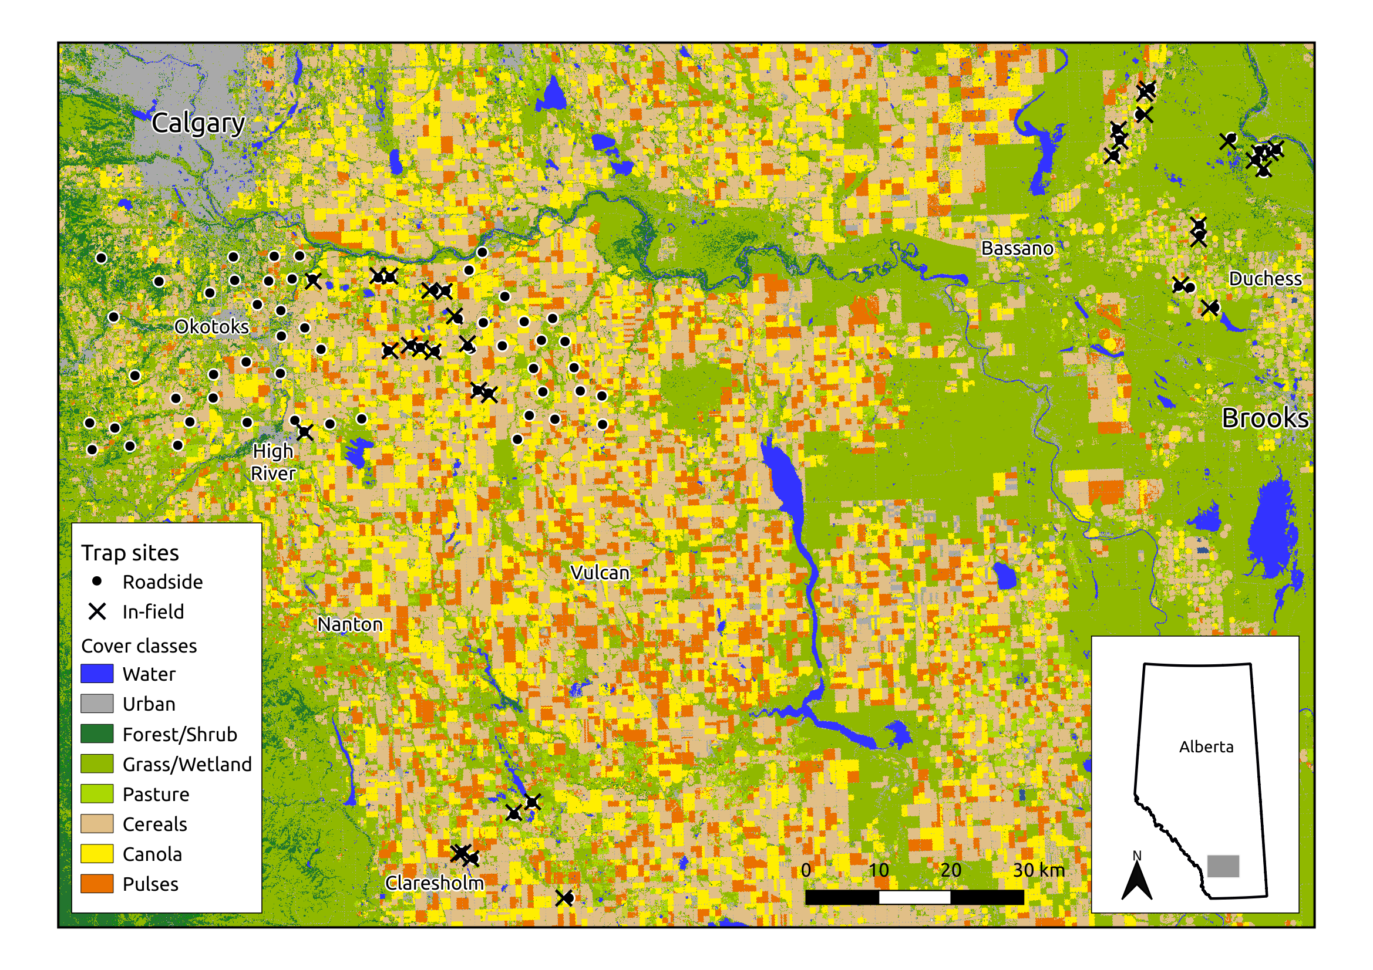

[fig:siteMap]Location of pitfall traps during 2017, and classified cover f. Inset map shows study location within Alberta. Roadside traps were installed in road margins, while in-field traps were installed directly in canola fields or in adjacent wetland or grassy field corners.

We used four highly-abundant species of predatory arthropods found in the pitfall traps, as common species are often more important for ecosystem service provision than rare species (Winfree *et al.* 2015). *Pterostichus melanarius* is an introduced predatory ground beetle (Coleoptera: Carabidae) that is a wide-ranging generalist (Cárcamo & Spence 1994; Larsen *et al.* 2003; Busch 2016). It is commonly found in untilled grasslands (Purtauf *et al.* 2005) and may use grassy field margins as larval habitat (Desender & Alderweireldt 1988). *Pardosa distincta* and *Pardosa moesta* are wolf spiders (Araneae: Lycosidae) that are common across the Canadian prairies and are often found in ungrazed pastures (Cárcamo *et al.* 2014). *P. distincta* is also commonly found in disturbed environments (Collins *et al.* 1996; Wade & Roughley 2010), while *P. moesta* appear to prefer less frequent disturbances (Kowal & Cartar 2011). All *Pardosa* use an active wandering predation strategy (Young & Edwards 1990), and may use road margins and wooded areas as habitat (Buddle 2000; Drapela *et al.* 2011). Finally, *Phallangium opilio* is a widely-distributed generalist harvestman (Opiliones: Phalangiidae), whose habitat preferences are poorly understood. They are commonly found in human-altered landscapes (Muster & Meyer 2014; Van de Poel 2015) and are generally nocturnal hunters and scavengers (Halaj & Cady 2000; Allard & Yeargan 2005b, a).

Increased counts of organisms in pitfall traps can represent higher activity levels (same number of organisms but moving more quickly) or higher abundances (more organisms present in the vicinity of the trap). This means that it is impossible to disentangle arthropod activity from density using single traps (Lang 2000; Zhao *et al.* 2013), meaning that counts in the traps represent the “activity-density” of a given organism. However, activity density is generally positively related to ecosystem services, at least in carabids (Trichard *et al.* 2014; Boetzl *et al.* 2018; González *et al.* 2020), making it acceptable for our study. To characterize landscape composition surrounding the traps, we used publicly available classified landscape data (30 m resolution; Agriculture and Agri-Food Canada 2018). AAFC cropland landscape classifications from 2017 were very accurate for cultivated fields (~90%), but were less accurate for non-crop areas (~70%). We combined functionally similar landscape categories (cereals: *Triticum aestivum* and *Hordeum vulgare*, pulses: *Pisum sativum* and *Lens culinaris*, forest: coniferous and broadleaf). At each site, we extracted the proportion of each cover class within 30m annuli (rings), with the inner radius of each annulus ranging from 30 to 1470m in increments of 30m (total of 49 annuli, 1.5 km maximum). The ten most-common cover classes surrounding our sites represented 98% of the total land cover in our study region: grassland, cereal, canola, pasture, pulses, wetland, urban, shrubland, flax, and forest (Figure [fig:landscapeComp]); flax was removed, as only a single site had nearby flax cover.

Functional regression (Ramsay & Silverman 2004; Yen *et al.* 2014) was used to incorporate landscape information at different distances, allowing assessment of both local and regional landscape composition (Galpern & Gavin 2020). Scalar-on-function regression is a special type of linear regression model (), where the columns of the model matrix contain some continuous predictor of the scalar , and the values of the coefficients () are modeled as a smooth function of the predictors. In our case, the proportion of landscape cover () within each annulus surrounding the trap is a function of distance away from the trap, meaning that the coefficients are a smoothed function of distance (), and represent the additive effect of a given type of landscape cover at distances away from the trap (i.e. ). This allows for the possibility that the size of the landscape “grain” relevant to a given organism may change over the course of its life stages (Addicott *et al.* 1987; Lima & Zollner 1996; Gardiner *et al.* 2010). It also allows for the possibility that certain land cover types may be locally beneficial, but detremental at wider scales, indicating that the cover type may not constitute a completely usable habitat.

Scalar-on-function regression of activity density was fit using generalized additive models (*mgcv* version 1.8.33; Wood 2017). Count data of arthropods were modeled using a negative binomial distribution with a log-link function and a single dispersion parameter (). To account for different lengths of trap exposure, log-days since trap placement were used as a fixed effect with their slope held at 1 (“offset” variable). We included day of year as a 1-dimensional smooth, and easting and northing (km east and north of the trap extent centre point) as a 2-dimensional smooth, in order to account for underlying spatial and temporal autocorrelation in the data. The deviance residuals from each model were visually inspected for normality and equal variance (Hilbe 2011; Wood 2017).

For each landscape cover class, we used three scalar-on-function terms. First, we used the proportion cover in the annuli surrounding each trap location (spatial effect of cover class). Second, we used the average landcover in all annuli across days of the year (temporal effect of cover class). Finally, we used a tensor-product interaction of landscape cover and day of year (spatio-temporal interaction of cover class). We used 10 basis dimensions for the spatial and temporal landscape smoothers, and 16 basis dimensions for the spatio-temporal interaction. This was deemed adequate, as the effective degrees of freedom for all smoothing terms were far below the number of basis dimensions, indicating that no additional basis dimensions were needed (see Tables [tab:PteMelSmooth], [tab:ParDisSmooth], [tab:ParMoeSmooth], [tab:OpilioSmooth]). To remove unimportant terms from the model, we used thin-plate regression splines with shrinkage, a continuous analog to stepwise model selection where weaker terms are completely removed from the model rather than reduced to a line (Marra & Wood 2011). Finally, we calculated the R for each group of terms (Nakagawa *et al.* 2013, 2017).

Preliminary model fits revealed that some of the landscape terms in our model were strongly concurved with each other, so we removed them from the model or combined them. Concurvity is a nonlinear analogue of multicollinearity which can bias estimates of standard errors (Buja *et al.* 1989). There is no agreed-upon threshold of “unacceptable” concurvity, but 0.5 is commonly used (Dominici 2002; Ramsay *et al.* 2003). Forest and shrubland were combined into a single “woodland" category, and grassland and wetland were combined into a single “grassland” category, as they were strongly positively correlated at all distances, indicating similar feature classes. Cereal was removed from the model, as it was negatively correlated with canola cover at distances less than 200m and was positively correlated at distances over 500m, reflecting the most common crop rotations (canola wheat barley) and the commonly-used 800 m block structure of farmland in our study region (quarter-sections). This resulted in a reduced set of landscape terms, none of which were strongly concurved with each other (Figure [fig:concurvity])

Functional regression plots of landscape composition reveal which cover classes are acting as sources or sinks of organisms, and at what spatial scale. Positive responses to nearby landscape cover classes indicate that the cover class acts as a net source (i.e. arthropods spill over *from* it). **Paul, do we need a separate box/figure explaining how to interpret these plots, or should we just include references?** However, negative responses to nearby landscape cover classes can indicate one of two things: 1) It may indicate that the cover class acts as a sink (i.e. organisms spill over *into* it) or 2) it may indicate that the cover class acts as a source, but it is unoccupied (i.e.no organisms available to spill over). We consider 1) to be the more likely scenario, as it is unlikely that any one cover class is *completely* unoccupied. For example, a cover class with low-quality habitat could act as an ecological trap (Galpern *et al.* 2017) if it acts as a sink but never as a source. Alternatively, a cover class could act as a sink by providing high-quality habitat at certain times of the year (e.g. egg laying/feeding), but act as a source at other times (e.g. during emergence).

RESULTS

Grassland, cereal, and canola were the three most-abundant landcover classes surrounding our traps, accounting for 77% of land cover (Figure [fig:landscapeComp]). Several landscape “fingerprints" were evident in the landscape annuli, with cereal cover increasing with distance away, along with a corresponding decrease in canola cover (resulting in strong concurvity). Grassland cover was largely constant with distance, although a cluster of sites had uniformly high or low cover of grassland with distance. The pitfall traps caught a total of 18968 *Pterostichus melanarius*, 5397 *Pardosa distincta*, 2350 *Pardosa moesta*, and 34090 *Phalangium opilio* (mean trapping rates per day: 1.58, 0.49, 0.22, 2.92, SDs: 5.69, 1.08, 1.09, 5.48, respectively).

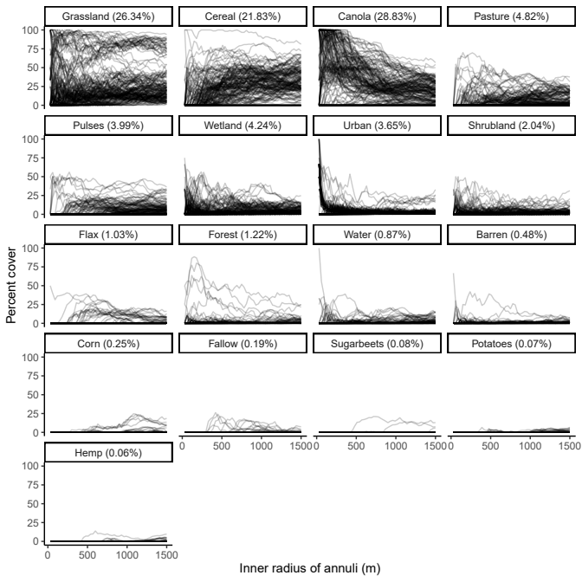

[fig:landscapeComp]Landscape composition in annuli surrounding each trap location. Sites are represented by individual lines. Mean cover for each class is listed in each sub-figure heading.

*P. melanarius* activity density was strongly influenced by trap location and landscape composition (Tables [tab:PteMelLinear], [tab:PteMelSmooth]). Canola crops had a marginally higher activity density of *P. melanarius* than other trap locations (Figure [fig:PteMelLandscape]a). Grassland cover was the most important land cover type in explaining in activity density (: 0.104, Table [tab:rSquared]), and nearby grassland had a neutral effect early in the summer but a negative effect later in the summer (Figure [fig:PteMelLandscape]b), suggesting that *P. melanarius* may move into grasslands later in the year. Nearby canola had a positive effect in the early summer, but far-away canola (>800 m) had a negative effect, indicating that areas with widespread canola coverage had lower *P. melanarius* activity density than those with only local canola cover. Pulses acted as a late-season source, indicating that *P. melanarius* may migrate out of the crop after (or during) harvest. Finally, *P. melanarius* activity density had a strong temporal and spatial component (both p<0.001), indicating that phenology and local geographic factors were strong drivers of ground beetle activity density (Figure [fig:PteMelSpatiotemporal]). The landscape composition and trap location explained 22% of the variance in activity density, while the spatial and temporal smoothers accounted for 41% (Table [tab:rSquared]).

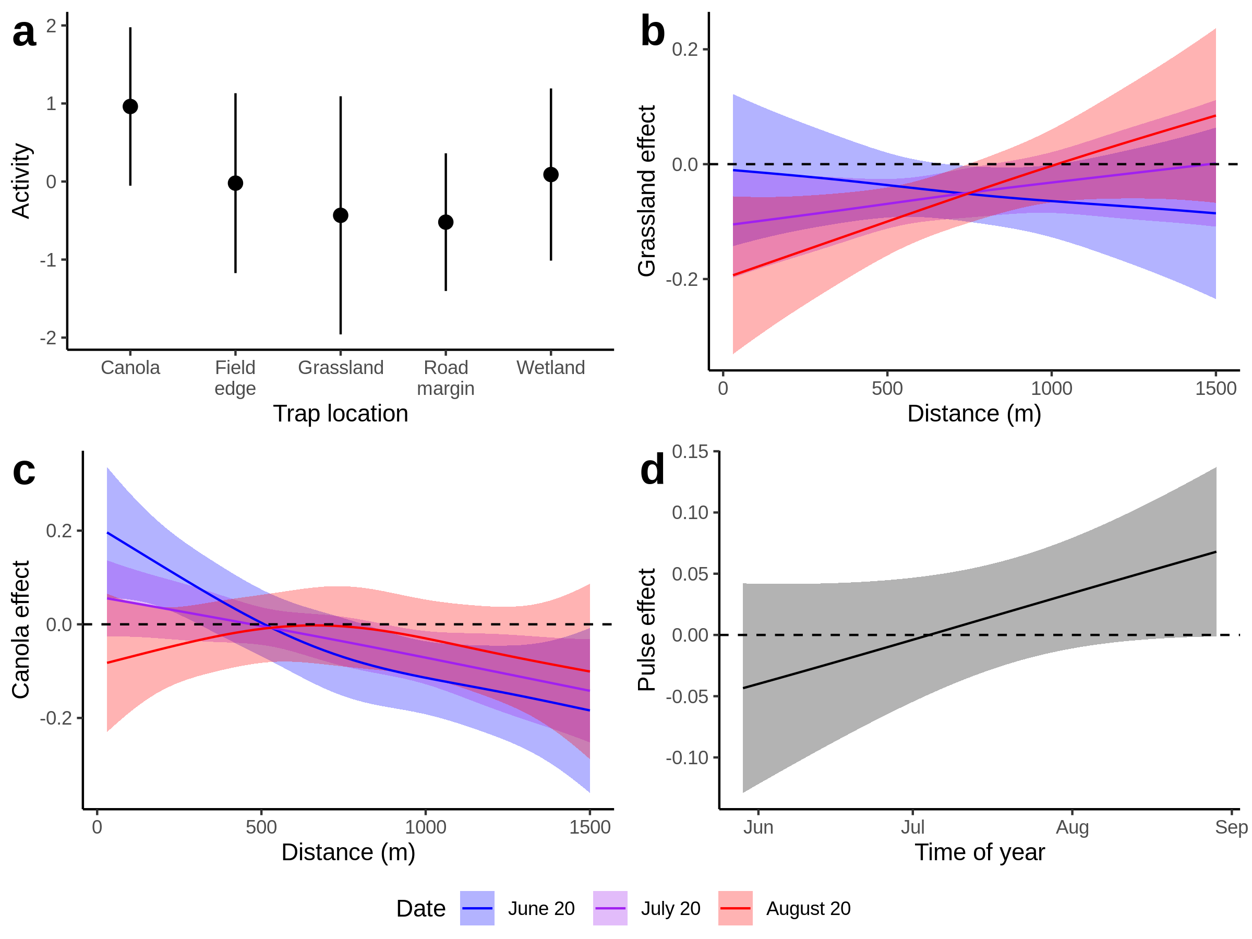

[fig:PteMelLandscape]Landscape influence on Pterostichus melanarius activity density. Lines and dots represent means, and bars and shaded regions represent 95% confidence intervals (1.96 x SE). Coloured regions represent early-, mid-, and late-season effects (red, green, blue)

Activity density of *P. distincta* and *P. moesta* was influenced by trap location and landscape composition (Tables [tab:ParDisLinear], [tab:ParDisSmooth]), but landscape composition had relatively weak effects on both species (: 0.0446, 0.0963). Unlike *P. melanarius*, both *Pardosa* species had far lower activity density in canola than any other cover type (Figures [fig:ParDisLandscape]a, [fig:ParMoeLandscape]a). Nearby canola appeared to act as a source of *P. moesta* and a weak source of *P. distincta*, as activity density was positively related to the local proportion of canola early in the season, but negatively related later in the season (Figures [fig:ParDisLandscape]b, [fig:ParMoeLandscape]c, p=0.077, <0.001). Urban land cover had a similar effect on *P. moesta*, acting as an early source and a late sink (Figure [fig:ParMoeLandscape]f). Trees and shrubs (Woodland) acted as a sink for *P. distincta* later in the season, and as a weak source early on in the season for *P. moesta* (Figures [fig:ParDisLandscape]d, [fig:ParMoeLandscape]d). Grasslands had a local negative effect on *P. moesta*, but a positive landscape-level effect, indicating that while these cover types act as a sink, the general amount of grassland in the area had a positive effect on *P. moesta* abundance. *P. distincta* was similarly affected by pulses: landscape-level abundance of pulses had a positive effect, but the local effect was neutral. Finally, activity density of both *Pardosa* species had a very strong temporal and spatial component, although the temporal component was dominant for *P. distincta*, whereas the spatial component was dominant for *P. moesta* (Figures [fig:ParDisSpatiotemporal] and [fig:ParMoeSpatiotemporal] ; both p<0.001). The landscape composition and trap location explained 34% and 48% of variance in activity density, while the spatial and temporal smoothers accounted for 16% and 12%, for *P. distincta* and *P. moesta* respectively.

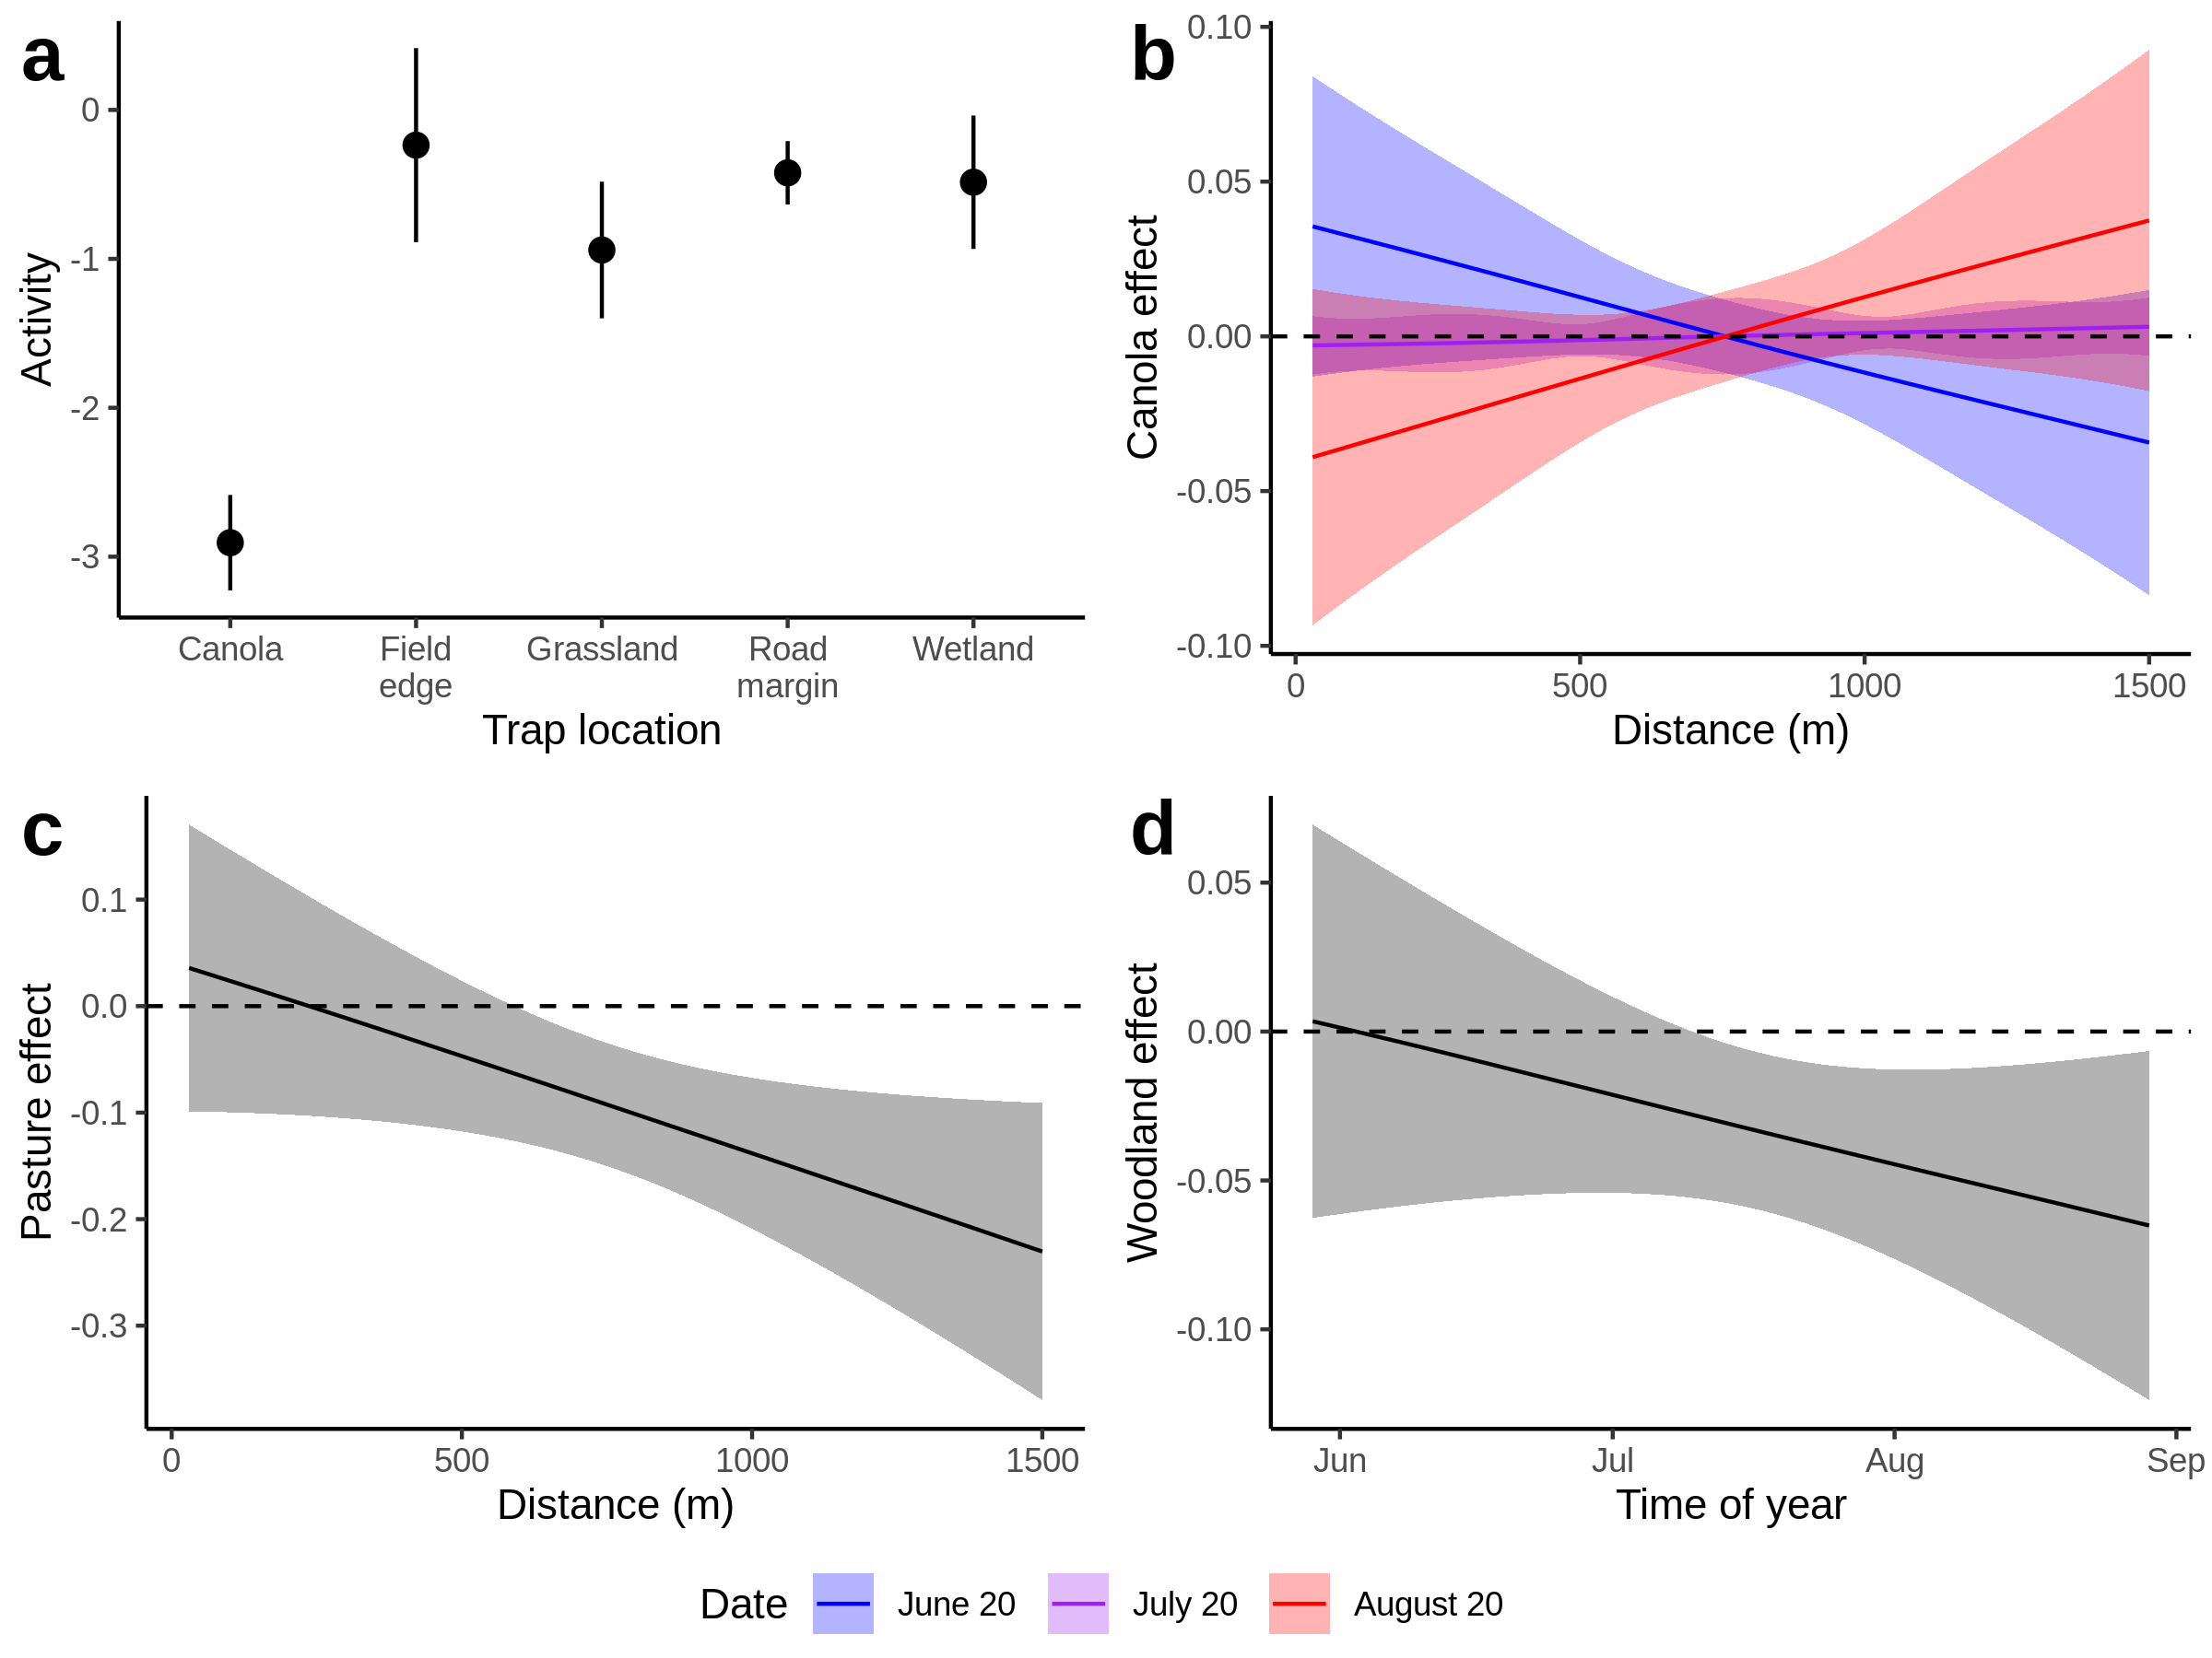

[fig:ParDisLandscape]Landscape influence on Pardosa distincta activity density. Lines and dots represent means, and bars and shaded regions represent 95% confidence intervals (1.96 x SE). Coloured regions represent early-, mid-, and late-season effects (red, green, blue)

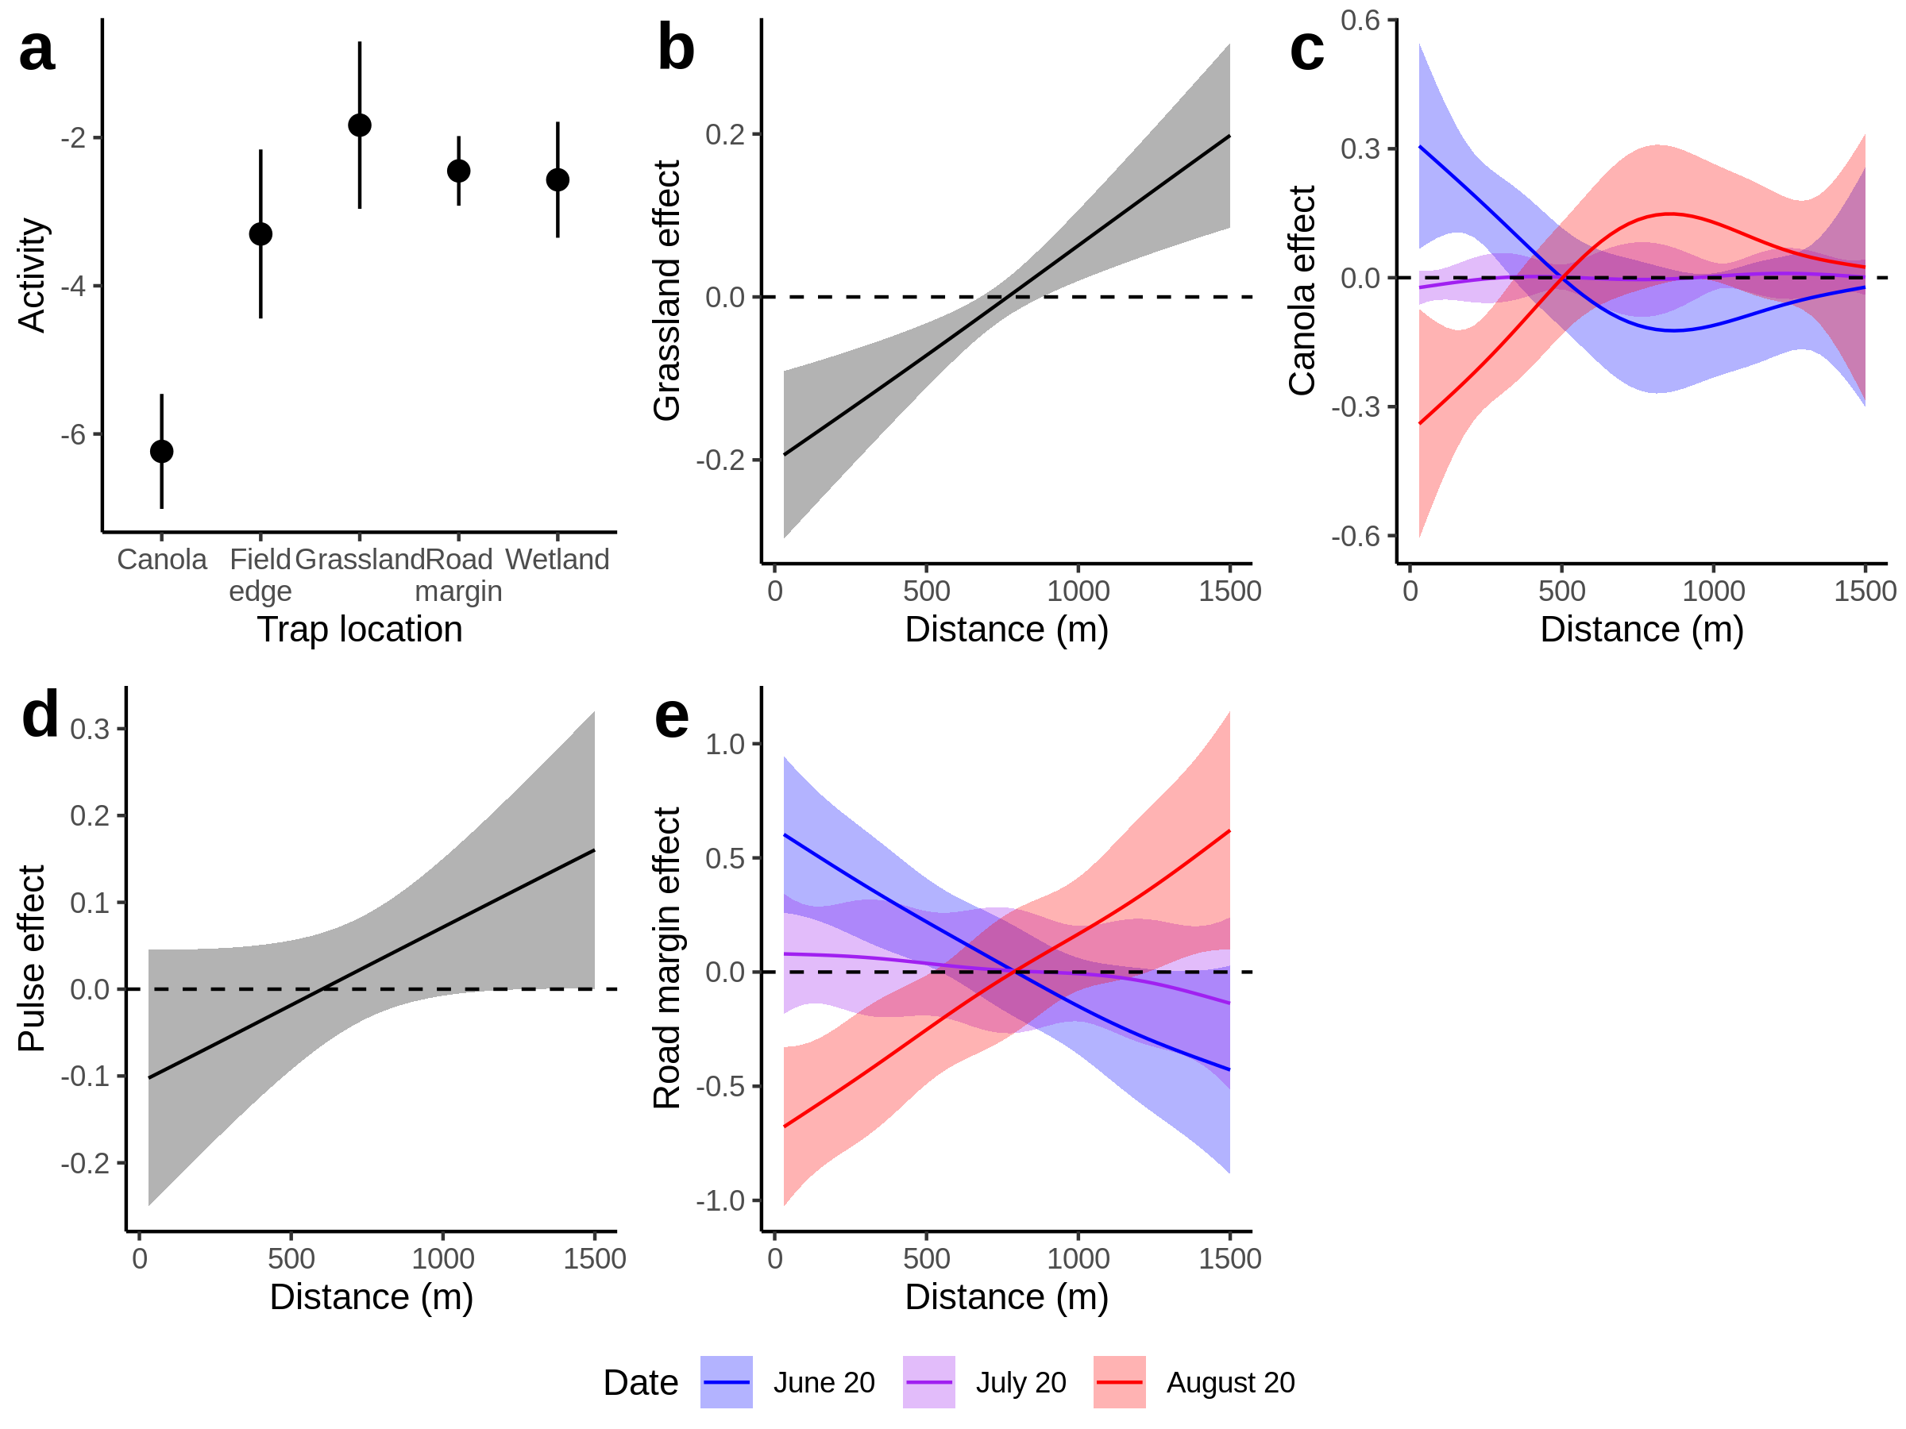

[fig:ParMoeLandscape]Landscape influence on Pardosa moesta activity density. Lines and dots represent means, and bars and shaded regions represent 95% confidence intervals (1.96 x SE). Coloured regions represent early-, mid-, and late-season effects (red, green, blue)

*Phalangium opilio* activity density was strongly influenced by trap location, with pivot corners and wetlands having the highest activity density (Figure [fig:OpilioLandscape]a). Landscape composition explained 0.1052% of variance in *P. opilio* activity density. Nearby grassland (p=) and woodland (p=) both had negative effects on *P. opilio* activity density, but only early in the season (Figures [fig:OpilioLandscape]b,c). Compare this to *P. melanarius*, which is also influenced by grassland and woodland, but where the effect was negative *late* in the season. The temporal and spatial components, as in the other two species, were both very strong (both p<0.001). The landscape composition and trap location explained 13% of variance in activity density, while the spatial and temporal smoothers accounted for 52%.

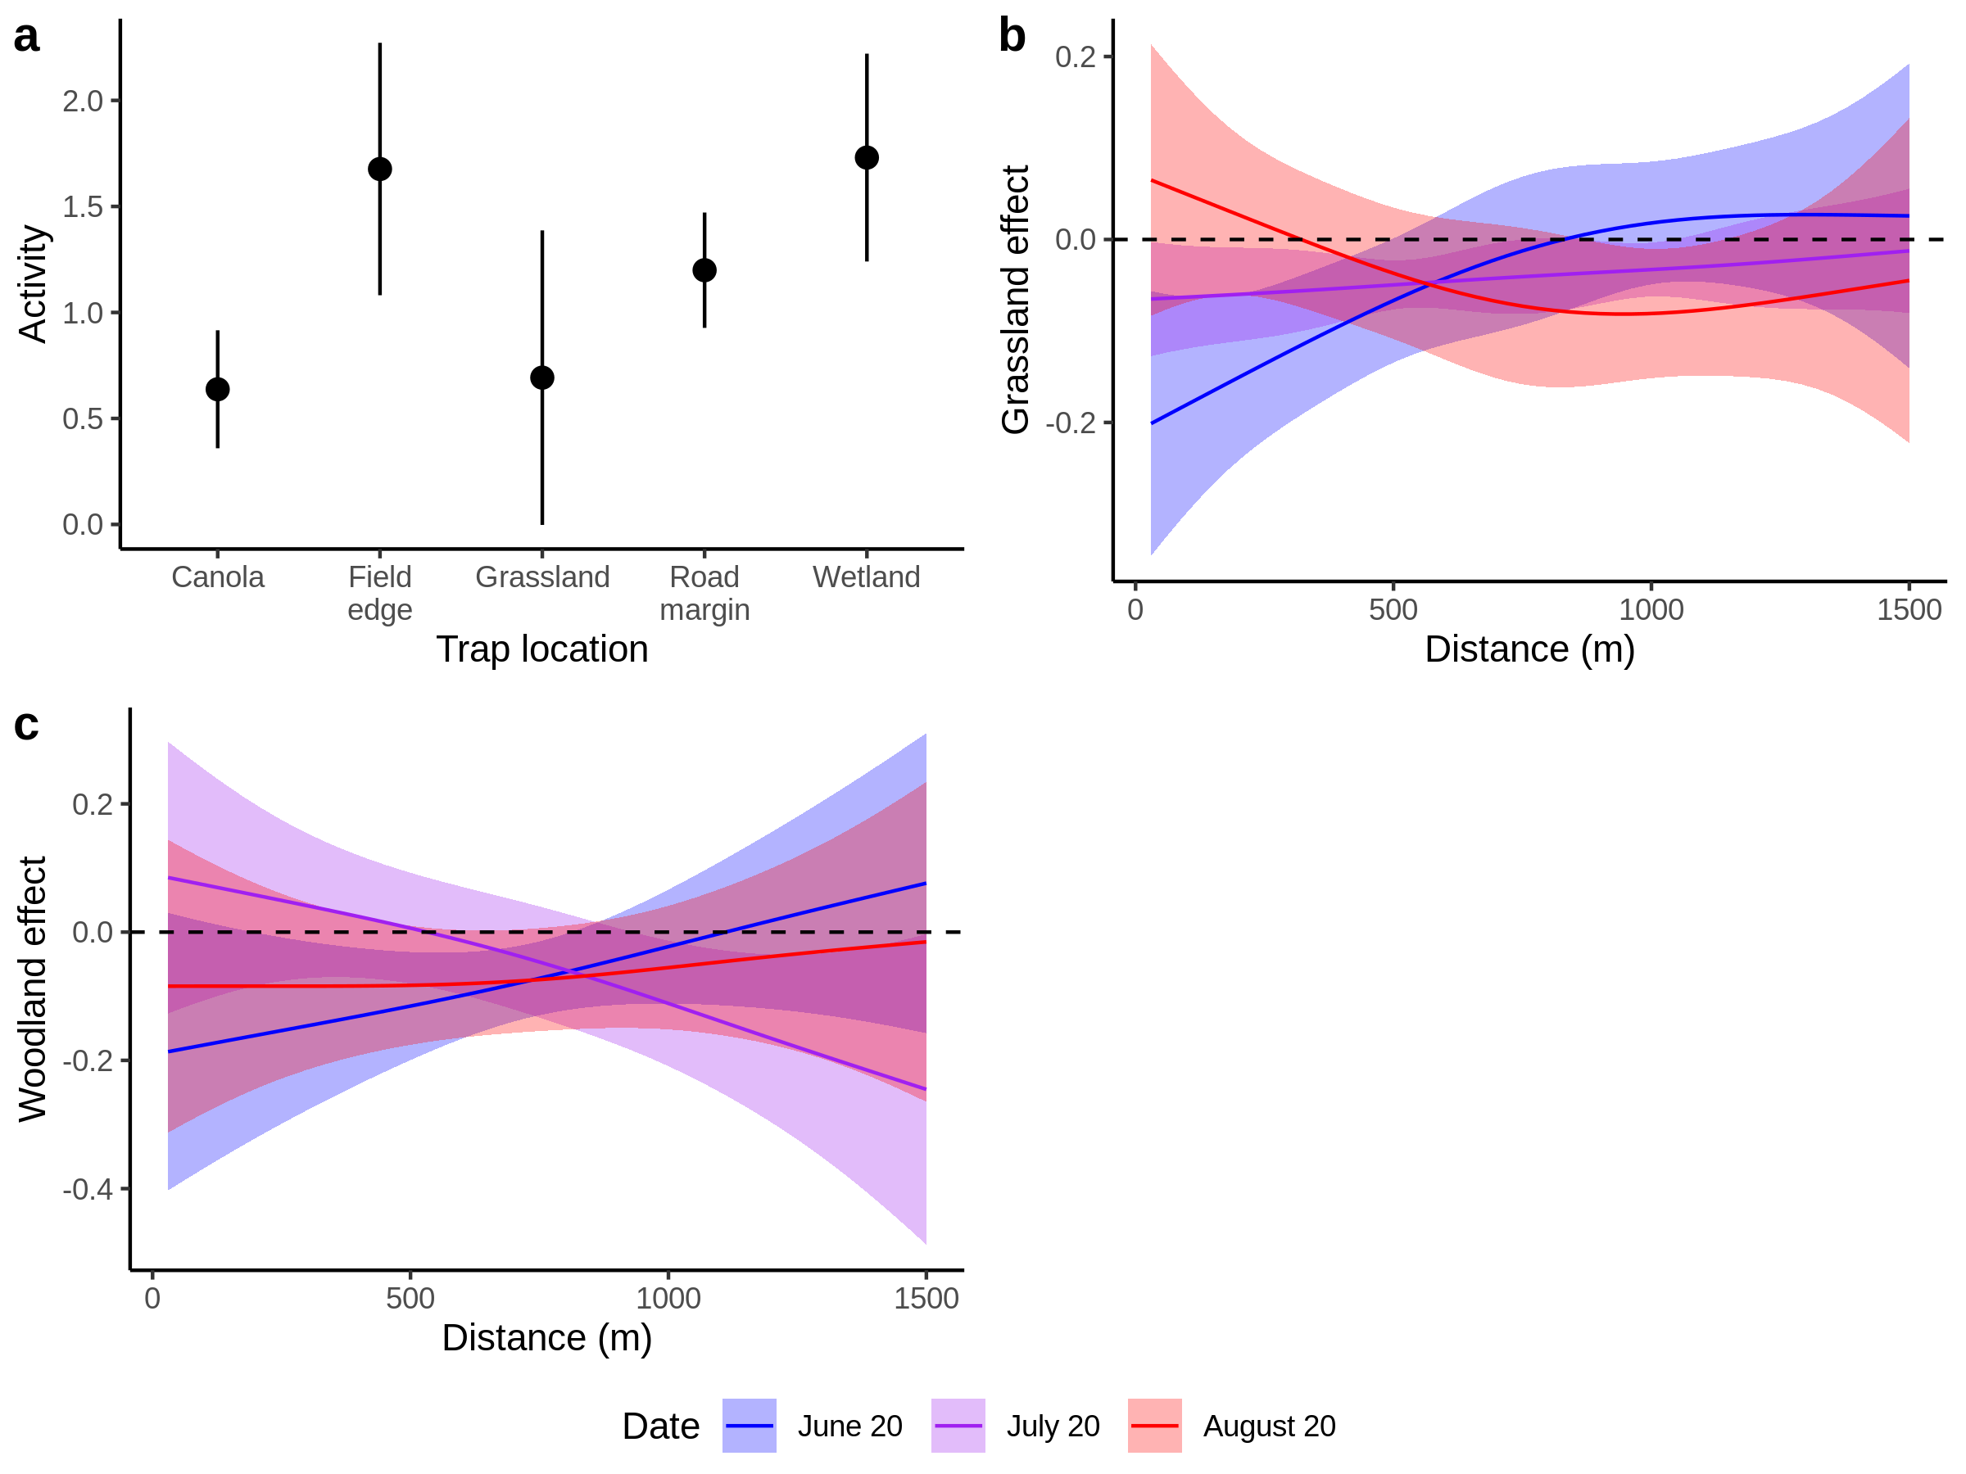

[fig:OpilioLandscape]Landscape influence on Phalangium opilio activity density. Lines and dots represent means, and bars and shaded regions represent 95% confidence regions. Dashed line on panels b-f represents zero effect. Coloured regions represent early-, mid-, and late-season effects (red, green, blue)

[tab:rSquared]R for model components, representing the proportion of total variance attributable to each term.

|  |  |  |  |  |
| --- | --- | --- | --- | --- |
| Term | $\emph{Pterostichus melanarius}$ | $\emph{Pardosa distincta}$ | $\emph{Pardosa moesta}$ | $\emph{Phalangium opilio}$ |
| Trap Location | 0.080 | 0.294 | 0.379 | 0.026 |
| Day of Year | 0.040 | 0.160 | 0.000 | 0.436 |
| Spatial Location | 0.373 | 0.000 | 0.125 | 0.085 |
| Grass/Wetland | 0.104 | 0.000 | 0.017 | 0.086 |
| Canola | 0.030 | 0.002 | 0.037 | 0.000 |
| Pasture | 0.000 | 0.032 | 0.002 | 0.000 |
| Trees/Shrubs | 0.000 | 0.009 | 0.001 | 0.017 |
| Pulses | 0.005 | 0.000 | 0.004 | 0.001 |
| Road margins | 0.000 | 0.001 | 0.034 | 0.002 |
| Residual | 0.369 | 0.502 | 0.400 | 0.348 |

The activity density of *Pterostichus melanarius* and *Phalangium opilio* responded strongly to landscape composition, but the response of *Pardosa distincta* and *Pardosa moesta* was weaker. We found some support for our predictions of SNL (grass and wetland, woodlands, and road margins) acting as a late-season sinks for beneficial arthropods. In particular, grass and wetland acted as a sink for *P. melanarius*, woodlands acted as a sink for *P. distincta*, and road margins acted as a sink for *P. moesta*. While there was limited evidence of SNL acting as early-season sources, some acted as landscape-level sources (grassland and road margins on *P. moesta*), indicating earlier or wider-scale dispersal. Canola and pasture acted as landscape-level sinks for *P. melanarius* and *P. distincta*, respectively, meaning that these cover types likely represent only partial habitat for these arthropods. There was also a strong temporal component to most of the landscape effects, meaning that it is important to consider how sinks and sources may change over the season. Finally, the influence of landscape composition tended to be limited to a radius of about 500m, indicating that large-scale *and* local land cover can be important to beneficial arthropod abundance. These results highlight the seasonal importance of non-crop marginal lands for predatory arthropod abundance.

The predatory ground beetle *Pterostichus melanarius* responded to landscape composition, primarily to canola, pulses, and grass and wetland cover. Grassland and wetland cover acted as a late-season sink, suggesting that *P. melanarius* may migrate into it at the end of the summer. Other studies have found similar results, suggesting that untilled land is important off-field habitat for carabids (Desender & Alderweireldt 1988; Fournier & Loreau 2002; but see Hatten *et al.* 2007). In particular, Purtauf *et al.* (2005) found that carabid density increased with proportion of nearby grasslands, so our finding of grassland as late-season sink may represent *P. melanarius* moving to overwintering habitat at the end of the season. However, *P. melanarius* is also found in a wide variety of habitats, and tends to prefer agricultural fields (Larsen *et al.* 2003). Our models also suggest this, as they showed that canola and pulse crops acted as early- and mid-season sources of *P. melanarius*. Early in the season, canola crops acted as local source but a landscape-level sink, which may indicate that they provide only temporary feeding habitat. The effect of pulse crops on carabid abundance is not well-studied, but our results suggest that pulses may represent a potential food resource for *P. melanarius*, albeit a weak one (Table [tab:rSquared]). Carabids are predators of pea-leaf weevils (*Sitona lineatus*) on other Fabaceae (Hamon *et al.* 1990), and *P. melanarius* can prey upon other carabids that are predators of *S. lineatus*, such as *Bembidion quadrimaculatum* (Vankosky *et al.* 2011), so this effect may be direct or indirect. We did not consider the influence of previous years’ crops, although carabids tend to be more abundant in areas of high crop rotation (Bertrand *et al.* 2016; Busch 2016).

The wolf spiders *Pardosa distincta* and *Pardosa moesta* both responded to landscape composition, but in slightly different ways. Canola acted as an early-season source for both species, indicating that *Pardosa* and *P. melanarius* may both use canola as foraging grounds. The responses to other landscape cover classes, however, was different between each species of spider. The only other landscape classes that influenced *P. distincta* were pasture and woodland. Pasture had a negative effect at the landscape scale, and woodland acted as a late season sink, suggesting that *Pardosa* use woody shrubs and trees for overwintering or winter foraging (Aitchison 1984). *Pardosa* are found in areas close to disturbed roadside strips (Drapela *et al.* 2008, 2011; Kowal & Cartar 2011), but *P. distincta* appears to be less sensitive to disturbances than *P. moesta* (Collins *et al.* 1996; Wade & Roughley 2010). Moring & Stewart (1994) showed that *P. distincta* were more active in grassy habitats, which we found partial evidence of, as *P. distincta* tended to have higher activity density in trap locations with higher grass cover (Figure [fig:ParDisLandscape]a). For *P. moesta*, we found that road margins clearly acted as an early source and a late sink (similar to Drapela *et al.* 2008). Grassland and wetland, as well as pulses, also acted as a local sink but a landscape-level source, suggesting that they draw *P. moesta* away from trapping locations but enhance their landscape-level abundance. Lycosids employ a wandering-active predation strategy (Young & Edwards 1990), meaning that nearby landscape composition may be more influential to *Pardosa* than large-scale composition (Öberg *et al.* 2007, 2008). While trapping location explained a large proportion of variance for both species (0.29 and 0.38), several landscape features were also important at large spatial scales, including grass and wetland, pasture, pulses, and road margins. This suggests that *Pardosa* dispersal distances may be further than previously thought, either through ballooning as juveniles (Richter 1970; Greenstone 1982) or through other long-distance travel.

*Phalangium opilio* activity density responded to grass and wetland cover, as well as trees and shrubs, but the trap location and landscape explained only 13% of the variance. Other studies have found that *P. opilio* is mostly found in human-altered landscapes with a large proportion of farming (Muster & Meyer 2014; Van de Poel 2015). Since most of our study area was in or near farmed land, the lack of variation is understandable, but there were a few notable landscape-level patterns that emerged. *P. opilio* activity density was higher in grassy pivot corners and wetlands, but grasslands and wetlands acted as a local sink of *P. opilio* until late in the season. These indicate that while grass and wetlands could act as a reservoir, spillover into other land cover types may be limited, as *P. opilio* avoids heavily grazed areas, possibly due to low humidity (Šajna *et al.* 2011). *P. opilio* is also found in large numbers at the edges of forests, and may migrate from forests into farmlands (Van de Poel 2015). We found the opposite pattern: forests act as a weak sink for *P. opilio*, at least early in the year. Unlike the other arthropods, most of the variation in activity density for *P. opilio* was explained by day of year (R = 0.44), indicating strong seasonal emergence cues.

Many other studies have considered the overall effect of SNL on ecosystem service provision, but we have highlighted the different spatial and temporal aspects of ecosystem service provision. We have shown how a relatively straightforward statistical technique can be used to consider multiple spatial scales of landscape composition, providing richer inference about the processes acting on beneficial arthropods. Different types of SNL act as sinks or sources at different times of year, but our results reveal the changes in sinks and sources within an agricultural landscape. These patterns imply movement of organisms between landscape features, but since we did not directly measure this, future studies should directly examine arthropod movement, with the goal of integrating landscape ecology and behavioural processes into a single model (Lima & Zollner 1996). This would also allow direct inference about landscape categories that were combined in our dataset, allowing us to consider different landscape categories independently. Finally, future work should explicitly link landscape structure, arthropod abundance, and ecosystem services (Gagic *et al.* 2017).

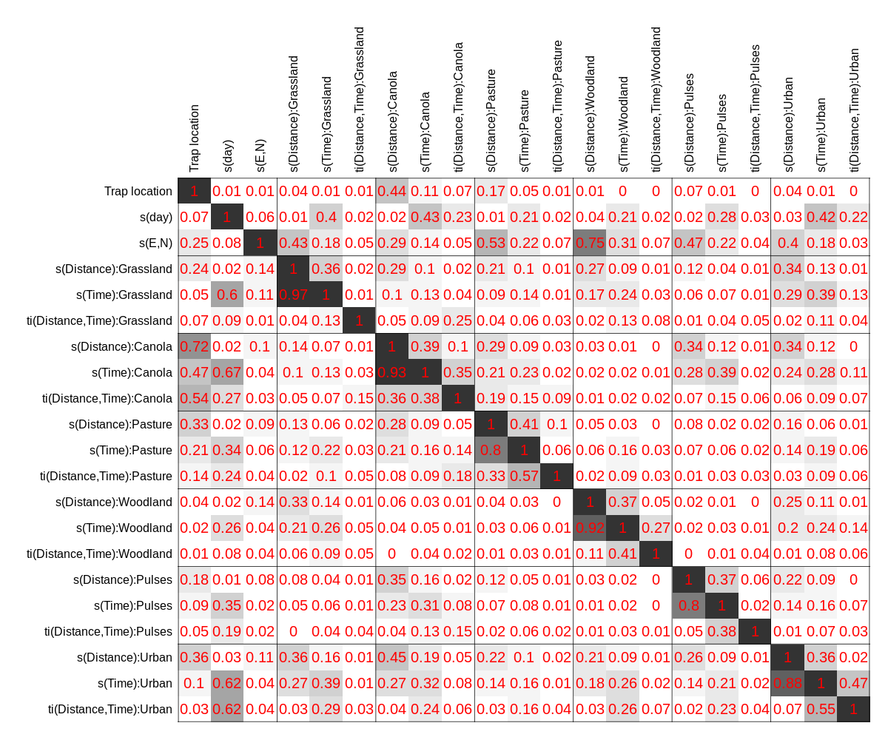

[fig:concurvity]Concurvity estimates for reduced cover classes used in models

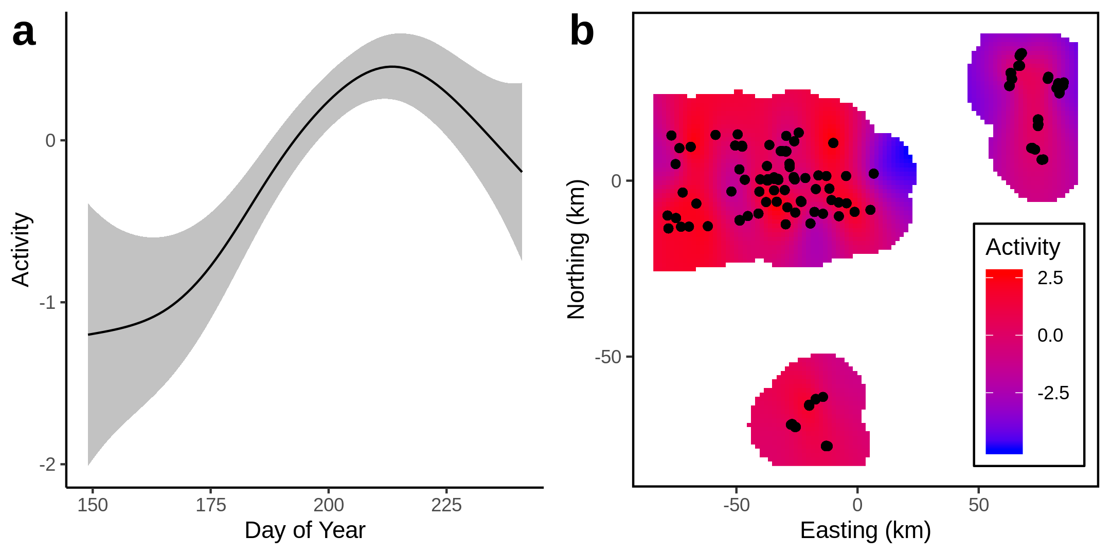

[fig:PteMelSpatiotemporal]Temporal and spatial components of Pterostichus melanarius activity density

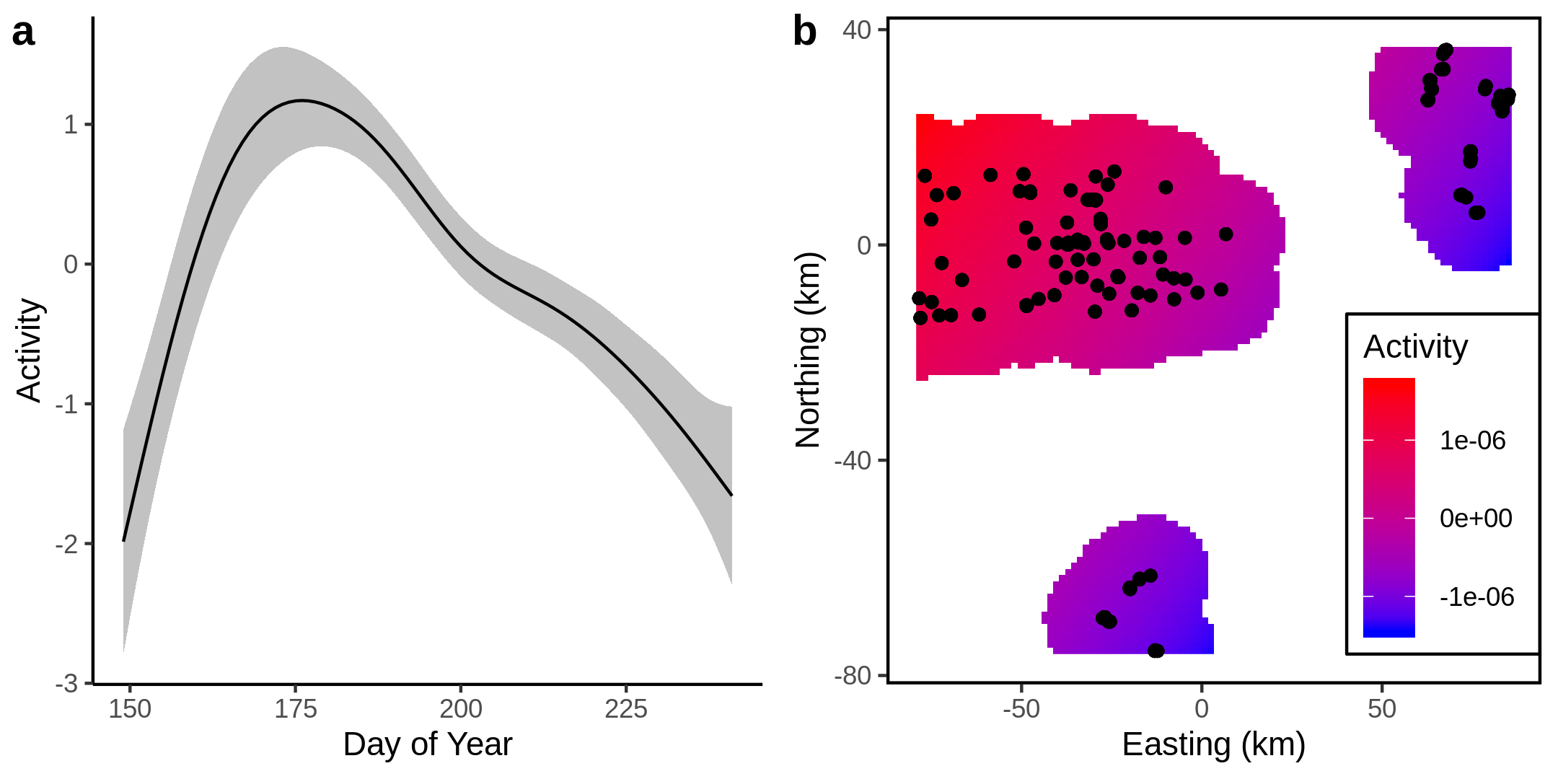

[fig:ParDisSpatiotemporal]Temporal and spatial components of Pardosa distincta activity density

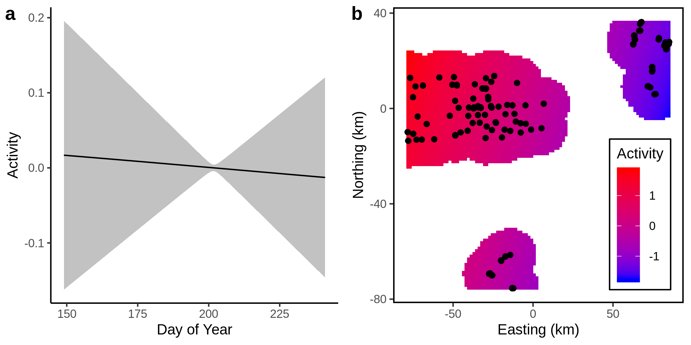

[fig:ParMoeSpatiotemporal]Temporal and spatial components of Pardosa moesta activity density

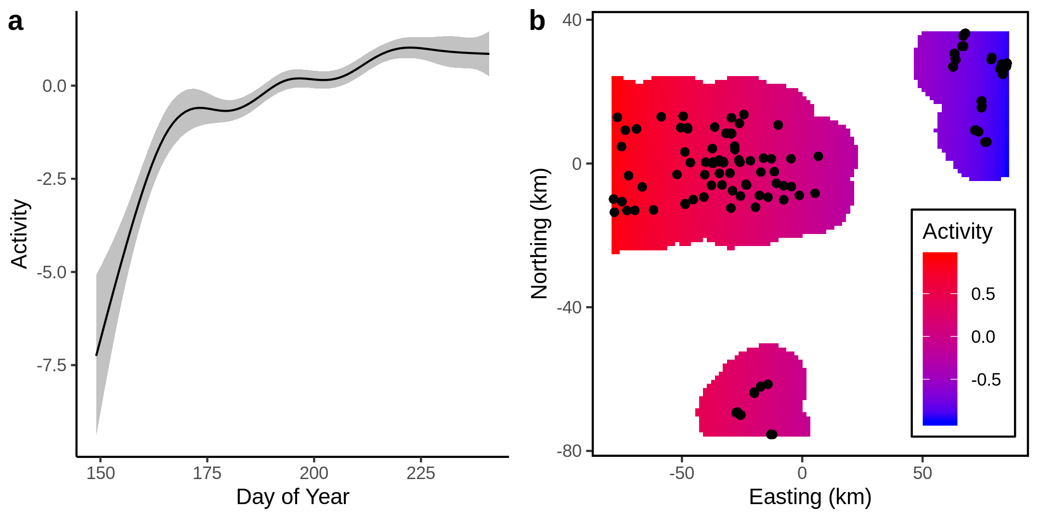

[fig:OpilioSpatiotemporal]Temporal and spatial components of Phalangium opilio activity density

[tab:PteMelLinear]Trap location effects for Pterostichus melanarius

|  |  |  |  |  |
| --- | --- | --- | --- | --- |
| Trap location |  | S.E. | Z | p |
| Canola | 0.96 | 0.52 | 1.86 | 0.063 |
| Road margin | -0.52 | 0.45 | -1.16 | 0.247 |
| Grassland | -0.43 | 0.78 | -0.56 | 0.578 |
| Field edge | -0.02 | 0.59 | -0.04 | 0.972 |
| Wetland | 0.09 | 0.56 | 0.16 | 0.874 |

[tab:PteMelSmooth]Smooth terms for Pterostichus melanarius. s indicates a thin-plate spline, ti indicates a tensor-product interaction. All terms except for day and (E,N) are functional regression fits.

|  |  |  |  |
| --- | --- | --- | --- |
| Smoothing term | E.d.f. |  | p |
| s(Day) | 3.48 | 31.11 | **<0.001** |
| s(E,N) | 39.47 | 309.8 | **<0.001** |
| s(Distance):Grassland | 1.51 | 11.24 | **<0.001** |
| s(Day):Grassland | <0.01 | <0.01 | 0.769 |
| ti(Distance,Day):Grassland | 0.93 | 3.87 | **0.026** |
| s(Distance):Canola | 1.71 | 7.36 | **0.004** |
| s(Day):Canola | <0.01 | <0.01 | 0.824 |
| ti(Distance,Day):Canola | 1.64 | 8.86 | **0.002** |
| s(Distance):Pasture | <0.01 | <0.01 | 0.979 |
| s(Day):Pasture | 0.67 | 0.92 | 0.23 |
| ti(Distance,Day):Pasture | <0.01 | <0.01 | 0.907 |
| s(Distance):Woodland | <0.01 | <0.01 | 0.439 |
| s(Day):Woodland | <0.01 | <0.01 | 0.939 |
| ti(Distance,Day):Woodland | <0.01 | <0.01 | 0.983 |
| s(Distance):Pulses | <0.01 | <0.01 | 0.498 |
| s(Day):Pulses | 1.27 | 3.96 | **0.033** |
| ti(Distance,Day):Pulses | 1.4 | 2.24 | 0.16 |
| s(Distance):Urban | <0.01 | <0.01 | 0.277 |
| s(Day):Urban | <0.01 | <0.01 | 0.582 |
| ti(Distance,Day):Urban | <0.01 | <0.01 | 0.591 |

[tab:ParDisLinear]Trap location effects for Pardosa distincta

|  |  |  |  |  |
| --- | --- | --- | --- | --- |
| Trap location |  | S.E. | Z | p |
| Canola | -2.91 | 0.16 | -17.77 | **<0.001** |
| Road margin | -0.42 | 0.11 | -3.88 | **<0.001** |
| Grassland | -0.94 | 0.23 | -4.02 | **<0.001** |
| Field edge | -0.24 | 0.33 | -0.71 | 0.477 |
| Wetland | -0.49 | 0.23 | -2.12 | **0.034** |

[tab:ParDisSmooth]Smooth terms for Pardosa distincta. s indicates a thin-plate spline, ti indicates a tensor-product interaction. All terms except for day and (E,N) are functional regression fits.

|  |  |  |  |
| --- | --- | --- | --- |
| Smoothing term | E.d.f. |  | p |
| s(Day) | 5.59 | 120.42 | **<0.001** |
| s(E,N) | <0.01 | <0.01 | 0.958 |
| s(Distance):Grassland | <0.01 | <0.01 | 0.966 |
| s(Day):Grassland | <0.01 | <0.01 | 0.94 |
| ti(Distance,Day):Grassland | <0.01 | <0.01 | 0.616 |
| s(Distance):Canola | <0.01 | <0.01 | 0.927 |
| s(Day):Canola | <0.01 | <0.01 | 0.645 |
| ti(Distance,Day):Canola | 0.75 | 2.18 | 0.077 |
| s(Distance):Pasture | 1.76 | 14.9 | **<0.001** |
| s(Day):Pasture | 0.46 | 0.66 | 0.202 |
| ti(Distance,Day):Pasture | <0.01 | <0.01 | 0.799 |
| s(Distance):Woodland | 0.01 | 0.01 | 0.098 |
| s(Day):Woodland | 1.61 | 7.74 | **0.005** |
| ti(Distance,Day):Woodland | 0.56 | 0.98 | 0.153 |
| s(Distance):Pulses | <0.01 | <0.01 | 0.693 |
| s(Day):Pulses | <0.01 | <0.01 | 0.921 |
| ti(Distance,Day):Pulses | <0.01 | <0.01 | 0.43 |
| s(Distance):Urban | <0.01 | <0.01 | 0.725 |
| s(Day):Urban | 0.7 | 1.03 | 0.224 |
| ti(Distance,Day):Urban | <0.01 | <0.01 | 0.919 |

[tab:ParMoeLinear]Trap location effects for Pardosa moesta.

|  |  |  |  |  |
| --- | --- | --- | --- | --- |
| Trap location |  | S.E. | Z | p |
| Canola | -6.24 | 0.40 | -15.76 | **<0.001** |
| Road margin | -2.45 | 0.24 | -10.22 | **<0.001** |
| Grassland | -1.83 | 0.58 | -3.18 | **0.001** |
| Field edge | -3.30 | 0.58 | -5.67 | **<0.001** |
| Wetland | -2.57 | 0.40 | -6.44 | **<0.001** |

[tab:ParMoeSmooth]Smooth terms for Pardosa moesta. s indicates a thin-plate spline, ti indicates a tensor-product interaction. All terms except for day and (E,N) are functional regression fits.

|  |  |  |  |
| --- | --- | --- | --- |
| Smoothing term | E.d.f. |  | p |
| s(Day) | 0.05 | 0.04 | 0.349 |
| s(E,N) | 1.96 | 50.7 | **<0.001** |
| s(Distance):Grassland | 1.87 | 14.39 | **<0.001** |
| s(Day):Grassland | <0.01 | <0.01 | 0.944 |
| ti(Distance,Day):Grassland | <0.01 | <0.01 | 0.976 |
| s(Distance):Canola | <0.01 | <0.01 | 0.341 |
| s(Day):Canola | <0.01 | <0.01 | 0.627 |
| ti(Distance,Day):Canola | 2.22 | 21.63 | **<0.001** |
| s(Distance):Pasture | <0.01 | <0.01 | 0.936 |
| s(Day):Pasture | <0.01 | <0.01 | 0.835 |
| ti(Distance,Day):Pasture | 1.6 | 2.96 | 0.109 |
| s(Distance):Woodland | <0.01 | <0.01 | 0.646 |
| s(Day):Woodland | 0.95 | 2.23 | 0.085 |
| ti(Distance,Day):Woodland | <0.01 | <0.01 | 0.414 |
| s(Distance):Pulses | 1.48 | 3.94 | **0.039** |
| s(Day):Pulses | 0.4 | 0.5 | 0.221 |
| ti(Distance,Day):Pulses | <0.01 | <0.01 | 0.984 |
| s(Distance):Urban | <0.01 | <0.01 | 0.846 |
| s(Day):Urban | 0.63 | 0.8 | 0.252 |
| ti(Distance,Day):Urban | 3.15 | 20.23 | **<0.001** |

[tab:OpilioLinear]Trap location effects for Phalangium opilio

|  |  |  |  |  |
| --- | --- | --- | --- | --- |
| Trap location |  | S.E. | Z | p |
| Canola | 0.64 | 0.14 | 4.49 | **<0.001** |
| Road margin | 1.20 | 0.14 | 8.64 | **<0.001** |
| Grassland | 0.69 | 0.35 | 1.95 | 0.051 |
| Field edge | 1.68 | 0.30 | 5.52 | **<0.001** |
| Wetland | 1.73 | 0.25 | 6.92 | **<0.001** |

[tab:OpilioSmooth]Smooth terms for Phalangium opilio. s indicates a thin-plate spline, ti indicates a tensor-product interaction. All terms except for day and (E,N) are functional regression fits.

|  |  |  |  |
| --- | --- | --- | --- |
| Smoothing term | E.d.f. |  | p |
| s(Day) | 7.2 | 141.89 | **<0.001** |
| s(E,N) | 1.95 | 59.8 | **<0.001** |
| s(Distance):Grassland | 1.69 | 50.17 | **<0.001** |
| s(Day):Grassland | <0.01 | <0.01 | 0.685 |
| ti(Distance,Day):Grassland | 1.39 | 5.79 | **0.013** |
| s(Distance):Canola | <0.01 | <0.01 | 0.466 |
| s(Day):Canola | <0.01 | <0.01 | 0.882 |
| ti(Distance,Day):Canola | <0.01 | <0.01 | 0.675 |
| s(Distance):Pasture | 0.36 | 0.42 | 0.291 |
| s(Day):Pasture | <0.01 | <0.01 | 0.436 |
| ti(Distance,Day):Pasture | <0.01 | <0.01 | 0.585 |
| s(Distance):Woodland | 1.44 | 14.8 | **<0.001** |
| s(Day):Woodland | <0.01 | <0.01 | 0.601 |
| ti(Distance,Day):Woodland | 1.81 | 4.06 | 0.073 |
| s(Distance):Pulses | <0.01 | <0.01 | 0.716 |
| s(Day):Pulses | <0.01 | <0.01 | 0.713 |
| ti(Distance,Day):Pulses | 1.23 | 1.88 | 0.187 |
| s(Distance):Urban | 0.79 | 1.94 | 0.088 |
| s(Day):Urban | <0.01 | <0.01 | 0.419 |
| ti(Distance,Day):Urban | 0.36 | 0.53 | 0.224 |

Addicott, J.F., Aho, J.M., Antolin, M.F., Padilla, D.K., Richardson, J.S. & Soluk, D.A. (1987). Ecological neighborhoods: Scaling environmental patterns. *Oikos*, 49, 340–346.

Agriculture and Agri-Food Canada. (2018). *Annual Crop Inventory*. Available at: <https://open.canada.ca/data/en/dataset/ba2645d5-4458-414d-b196-6303ac06c1c9>. Last accessed.

Ahrenfeldt, E., Klatt, B., Arildsen, J., Trandem, N., Andersson, G. & Tscharntke, T. *et al.* (2015). Pollinator communities in strawberry crops - variation at multiple spatial scales. *Bulletin of Entomological Research*, 105, 497–506.

Aitchison, C.W. (1984). Low temperature feeding by winter-active spiders. *The Journal of Arachnology*, 12, 297–305.

Albrecht, M., Schmid, B., Obrist, M.K., Schüpbach, B., Kleijn, D. & Duelli, P. (2010). Effects of ecological compensation meadows on arthropod diversity in adjacent intensively managed grassland. *Biological Conservation*, 143, 642–649.

Allard, C.M. & Yeargan, K.V. (2005a). Diel activity patterns and microspatial distribution of the harvestman *Phalangium opilio* (Opiliones, Phalangiidae) in soybeans. *Journal of Arachnology*, 33, 745–752.

Allard, C.M. & Yeargan, K.V. (2005b). Effect of diet on development and reproduction of the harvestman *Phalangium opilio* (Opiliones: Phalangiidae). *Environmental Entomology*, 34, 6–13.

Bertrand, C., Burel, F. & Baudry, J. (2016). Spatial and temporal heterogeneity of the crop mosaic influences carabid beetles in agricultural landscapes. *Landscape Ecology*, 31, 451–466.

Boetzl, F.A., Krimmer, E., Krauss, J. & Steffan-Dewenter, I. (2018). Agri-environmental schemes promote ground-dwelling predators in adjacent oilseed rape fields: Diversity, species traits and distance-decay functions. *Journal of Applied Ecology*, 56, 10–20.

Buddle, C.M. (2000). Life history of *Pardosa moesta* and *Pardosa mackenziana* (Araneae, Lycosidae) in central Alberta, Canada. *The Journal of Arachnology*, 28, 319–328.

Buja, A., Hastie, T. & Tibshirani, R. (1989). Linear smoothers and additive models. *The Annals of Statistics*, 17, 453–510.

Busch, A.K. (2016). Life history of *Pterostichus melanarius* (Coleoptera: Carabidae) and its importance for biological control in field crops. Master’s thesis. Pennsylvania State University.

Cárcamo, H.A. & Spence, J.R. (1994). Crop type effects on the activity and distribution of ground beetles (Coleoptera: Carabidae). *Environmental Entomology*, 23, 684–692.

Cárcamo, H., Pinzón, J., Leech, R. & Spence, J. (2014). Spiders (Arachnida: Araneae) of the Canadian Prairies. . In: *Arthropods of Canadian Grasslands (Volume 3): Biodiversity and Systematics Part 1* (Eds. Cárcamo, H. & Giberson, D.). Biological Survey of Canada, pp. 75–137.

Collins, J.A., Jennings, D.T. & Forsythe, H.Y. (1996). Effects of cultural practices on the spider (Araneae) fauna of lowbush blueberry fields in Washington county, Maine. *The Journal of Arachnology*, 24, 43–57.

Desender, K. & Alderweireldt, M. (1988). Population dynamics of adult and larval carabid beetles in a maize field and its boundary. *Journal of Applied Entomology*, 106, 13–19.

Diekötter, T., Kadoya, T., Peter, F., Wolters, V. & Jauker, F. (2010). Oilseed rape crops distort plant-pollinator interactions. *Journal of Applied Ecology*, 47, 209–214.

Dominici, F. (2002). On the use of generalized additive models in time-series studies of air pollution and health. *American Journal of Epidemiology*, 156, 193–203.

Drapela, T., Frank, T., Heer, X., Moser, D. & Zaller, J.G. (2011). Landscape structure affects activity density, body size and fecundity of *Pardosa* wolf spiders (Araneae: Lycosidae) in winter oilseed rape. *European Journal of Entomology*, 108, 609–614.

Drapela, T., Moser, D., Zaller, J.G. & Frank, T. (2008). Spider assemblages in winter oilseed rape affected by landscape and site factors. *Ecography*, 31, 254–262.

Duelli, P. & Obrist, M.K. (2003). Regional biodiversity in an agricultural landscape: The contribution of seminatural habitat islands. *Basic and Applied Ecology*, 4, 129–138.

Fournier, E. & Loreau, M. (2002). Foraging activity of the carabid beetle *Pterostichus melanarius* Ill. in field margin habitats. *Agriculture, Ecosystems & Environment*, 89, 253–259.

Gagic, V., Kleijn, D., Báldi, A., Boros, G., Jørgensen, H.B. & Elek, Z. *et al.* (2017). Combined effects of agrochemicals and ecosystem services on crop yield across Europe. *Ecology Letters*, 20, 1427–1436.

Galpern, P. & Gavin, M.P. (2020). Assessing the potential to increase landscape complexity in Canadian prairie croplands: A multi-scale analysis of land use pattern. *Frontiers in Environmental Science*, 8.

Galpern, P., Johnson, S.A., Retzlaff, J.L., Chang, D. & Swann, J. (2017). Reduced abundance and earlier collection of bumble bee workers under intensive cultivation of a mass-flowering prairie crop. *Ecology and Evolution*, 7, 2414–2422.

Gardiner, M., Landis, D., Gratton, C., Schmidt, N., O’Neal, M. & Mueller, E. *et al.* (2010). Landscape composition influences the activity density of Carabidae and Arachnida in soybean fields. *Biological Control*, 55, 11–19.

Garibaldi, L.A., Steffan-Dewenter, I., Winfree, R., Aizen, M.A., Bommarco, R. & Cunningham, S.A. *et al.* (2013). Wild pollinators enhance fruit set of crops regardless of honey bee abundance. *Science*, 339, 1608–1611.

González, E., Seidl, M., Kadlec, T., Ferrante, M. & Knapp, M. (2020). Distribution of ecosystem services within oilseed rape fields: Effects of field defects on pest and weed seed predation rates. *Agriculture, Ecosystems & Environment*, 295, 106894.

Greenstone, M.H. (1982). Ballooning frequency and habitat predictability in two wolf spider species (Lycosidae: Pardosa). *The Florida Entomologist*, 65, 83–89.

Halaj, J. & Cady, A.B. (2000). Diet composition and significance of earthworms as food of harvestmen (Arachnida: Opiliones). *The American Midland Naturalist*, 143, 487–491.

Hamon, N., Bardner, R., Allen-Williams, L. & Lee, J. (1990). Carabid populations in field beans and their effect on the population dynamics of *Sitona lineatus* (L.). *Annals of Applied Biology*, 117, 51–62.

Hatten, T.D., Bosque-Pérez, N.A., Labonte, J.R., Guy, S.O. & Eigenbrode, S.D. (2007). Effects of tillage on the activity density and biological diversity of carabid beetles in spring and winter crops. *Environmental Entomology*, 36, 356–368.

Hilbe, J.M. (2011). *Negative binomial regression*. Cambridge University Press.

Karp, D.S., Chaplin-Kramer, R., Meehan, T.D., Martin, E.A., DeClerck, F. & Grab, H. *et al.* (2018). Crop pests and predators exhibit inconsistent responses to surrounding landscape composition. *Proceedings of the National Academy of Sciences*, 115, E7863–E7870.

Klein, A.-M., Vaissière, B.E., Cane, J.H., Steffan-Dewenter, I., Cunningham, S.A. & Kremen, C. *et al.* (2007). Importance of pollinators in changing landscapes for world crops. *Proceedings of the Royal Society B: Biological Sciences*, 274, 303–313.

Kowal, V.A. & Cartar, R.V. (2011). Edge effects of three anthropogenic disturbances on spider communities in Alberta’s boreal forest. *Journal of Insect Conservation*, 16, 613–627.

Landis, D.A., Wratten, S.D. & Gurr, G.M. (2000). Habitat management to conserve natural enemies of arthropod pests in agriculture. *Annual Review of Entomology*, 45, 175–201.

Lang, A. (2000). The pitfalls of pitfalls: A comparison of pitfall trap catches and absolute density estimates of epigeal invertebrate predators in arable land. *Journal of Pest Science*, 73, 99–1006.

Larsen, K.J., Work, T.T. & Purrington, F.F. (2003). Habitat use patterns by ground beetles (Coleoptera: Carabidae) of northeastern Iowa. *Pedobiologia*, 47, 288–299.

Lima, S.L. & Zollner, P.A. (1996). Towards a behavioral ecology of ecological landscapes. *Trends in Ecology & Evolution*, 11, 131–135.

Losey, J.E. & Vaughan, M. (2006). The economic value of ecological services provided by insects. *BioScience*, 56, 311.

Lövei, G.L. & Sunderland, K.D. (1996). Ecology and behavior of ground beetles (Coleoptera: Carabidae). *Annual Review of Entomology*, 41, 231–256.

Macfadyen, S. & Muller, W. (2013). Edges in agricultural landscapes: Species interactions and movement of natural enemies. *PLoS ONE*, 8, e59659.

Marra, G. & Wood, S.N. (2011). Practical variable selection for generalized additive models. *Computational Statistics & Data Analysis*, 55, 2372–2387.

Martin, A.E., Collins, S.J., Crowe, S., Girard, J., Naujokaitis-Lewis, I. & Smith, A.C. *et al.* (2020). Effects of farmland heterogeneity on biodiversity are similar to or even larger than the effects of farming practices. *Agriculture, Ecosystems & Environment*, 288, 106698.

Moring, J.B. & Stewart, K.W. (1994). Habitat partitioning by the wolf spider (Araneae, Lycosidae) guild in streamside and riparian vegetation zones of the Conejos River, Colorado. *The Journal of Arachnology*, 22, 205–217.

Muster, C. & Meyer, M. (2014). *Ferrantia*. Travaux scientifiques du musée national d’histoire naturelle de luxembourg. Musée national d’histoire naturelle, Luxembourg.

Nakagawa, S., Johnson, P.C.D. & Schielzeth, H. (2017). The coefficient of determination R^2 and intra-class correlation coefficient from generalized linear mixed-effects models revisited and expanded. *Journal of The Royal Society Interface*, 14, 20170213.

Nakagawa, S., Schielzeth, H. & O’Hara, R.B. (2013). A general and simple method for obtaining R from generalized linear mixed-effects models. *Methods in Ecology and Evolution*, 4, 133–142.

Natural Regions Committee. (2006). *Natural regions and subregions of Alberta*. Government of Alberta, Edmonton.

Oerke, E. (2005). Crop losses to pests. *The Journal of Agricultural Science*, 144, 31–43.

Öberg, S., Ekbom, B. & Bommarco, R. (2007). Influence of habitat type and surrounding landscape on spider diversity in Swedish agroecosystems. *Agriculture, Ecosystems & Environment*, 122, 211–219.

Öberg, S., Mayr, S. & Dauber, J. (2008). Landscape effects on recolonisation patterns of spiders in arable fields. *Agriculture, Ecosystems & Environment*, 123, 211–218.

Purtauf, T., Roschewitz, I., Dauber, J., Thies, C., Tscharntke, T. & Wolters, V. (2005). Landscape context of organic and conventional farms: Influences on carabid beetle diversity. *Agriculture, Ecosystems & Environment*, 108, 165–174.

Ramankutty, N., Mehrabi, Z., Waha, K., Jarvis, L., Kremen, C. & Herrero, M. *et al.* (2018). Trends in global agricultural land use: Implications for environmental health and food security. *Annual Review of Plant Biology*, 69, 789–815.

Ramsay, J.O. & Silverman, B.W. (2004). *Functional data analysis*. Springer series in statistics. 2nd edn. Springer.

Ramsay, T.O., Burnett, R.T. & Krewski, D. (2003). The effect of concurvity in generalized additive models linking mortality to ambient particulate matter. *Epidemiology*, 14, 18–23.

Richter, C.J.J. (1970). Aerial dispersal in relation to habitat in eight wolf spider species (Pardosa, Araneae, Lycosidae). *Oecologia*, 5, 200–214.

Roulston, T.H. & Goodell, K. (2011). The role of resources and risks in regulating wild bee populations. *Annual Review of Entomology*, 56, 293–312.

Sander, A.-C., Purtauf, T., Wolters, V. & Dauber, J. (2006). Landscape genetics of the widespread ground-beetle *Carabus auratus* in an agricultural region. *Basic and Applied Ecology*, 7, 555–564.

Shackelford, G., Steward, P.R., Benton, T.G., Kunin, W.E., Potts, S.G. & Biesmeijer, J.C. *et al.* (2013). Comparison of pollinators and natural enemies: A meta-analysis of landscape and local effects on abundance and richness in crops. *Biological Reviews*, 88, 1002–1021.

Šajna, N., Kušar, P., Novak, L.S. & Novak, T. (2011). Benefits of low-intensity grazing: Co-occurance of umbelliferous plant (*Hladnikia pastinacifolia* RCHB.) and opilionid species (*Phalangium opilio* L.) in dry, calcareous grassland. *Polish Journal of Ecology*, 59, 777–786.

Trichard, A., Ricci, B., Ducourtieux, C. & Petit, S. (2014). The spatio-temporal distribution of weed seed predation differs between conservation agriculture and conventional tillage. *Agriculture, Ecosystems & Environment*, 188, 40–47.

Tscharntke, T., Karp, D.S., Chaplin-Kramer, R., Batáry, P., DeClerck, F. & Gratton, C. *et al.* (2016). When natural habitat fails to enhance biological pest control – five hypotheses. *Biological Conservation*, 204, 449–458.

Tscharntke, T., Rand, T.A. & Bianchi, F.J.J.A. (2005). The landscape context of trophic interactions: Insect spillover across the crop–noncrop interface. *Annales Zoologici Fennici*, 42, 421–432.

Van de Poel, S. (2015). Harvestman communities in small forest patches in European agricultural landscapes. Master’s thesis. University of Antwerp.

Vankosky, M.A., Cárcamo, H.A. & Dosdall, L.M. (2011). Identification of potential natural enemies of the pea leaf weevil, *Sitona lineatus* L. in western Canada. *Journal of Applied Entomology*, 135, 293–301.

Wade, D.J. & Roughley, R.E. (2010). Arthropods of Canadian grasslands (Volume 1): Ecology and interactions in grassland habitats. In: (eds. Shorthouse, J.D. & Floate, K.D.). Biological Survey of Canada, pp. 237–249.

Westphal, C., Steffan-Dewenter, I. & Tscharntke, T. (2006). Bumblebees experience landscapes at different spatial scales: Possible implications for coexistence. *Oecologia*, 149, 289–300.

Winfree, R., W. Fox, J., Williams, N.M., Reilly, J.R. & Cariveau, D.P. (2015). Abundance of common species, not species richness, drives delivery of a real-world ecosystem service. *Ecology Letters*, 18, 626–635.

Wood, S.N. (2017). *Generalized additive models: An introduction with R*. CRC press.

Yen, J.D.L., Thomson, J.R., Paganin, D.M., Keith, J.M. & Mac Nally, R. (2014). Function regression in ecology and evolution: FREE. *Methods in Ecology and Evolution*, 6, 17–26.

Young, O.P. & Edwards, G.B. (1990). Spiders in United States field crops and their potential effect on crop pests. *The Journal of Arachnology*, 18, 1–27.

Zhao, Z.-H., Shi, P.-J., Hui, C., Ouyang, F., Ge, F. & Li, B.-L. (2013). Solving the pitfalls of pitfall trapping: A two-circle method for density estimation of ground-dwelling arthropods. *Methods in Ecology and Evolution*, 4, 865–871.