Case-study report
Prediction of Dynamic Stall on a Pitching NACA 0012 Section
A case study at a tunnel condition and at a rotor-blade-station condition

UNISTALL, a Leishman-Beddoes dynamic-stall load model with tabulated separation (Python package unistall)
Leishman-Beddoes indicial method with a tabulated separation point

Akosa Samuel Onyejekwe (independent)
7 October 2026

1 Summary
This report gives the unsteady lift, drag and pitching moment on a NACA 0012 section in a steady stream with prescribed sinusoidal pitch, as predicted by UNISTALL, a Leishman-Beddoes dynamic-stall load model with tabulated separation (Python package unistall). The load model is the Leishman-Beddoes indicial method with a tabulated separation point. It is run at two conditions.
- Case A: tunnel condition (Mach 0.30, reduced frequency 0.1000, incidence 10° ± 10°): lift reaches 1.80 [-3.3 % mean, 5.3 % standard deviation] at an incidence of 18.1° [-0.3° mean, 0.8° standard deviation], the moment about the quarter chord falls to -0.29 [+0.02 mean, 0.05 standard deviation], drag reaches 0.56 [-0.05 mean, 0.08 standard deviation], and the onset criterion of the vortex is passed at 14.4° (no measured counterpart; the incidence of moment stall is in error by -0.6° mean, 0.7° standard deviation).
- Case B: rotor-blade-station condition (Mach 0.28, reduced frequency 0.0747, incidence 12° ± 8°): lift reaches 1.75 [-3.3 % mean, 5.3 % standard deviation] at an incidence of 17.0° [-0.3° mean, 0.8° standard deviation], the moment about the quarter chord falls to -0.24 [+0.02 mean, 0.05 standard deviation], drag reaches 0.44 [-0.05 mean, 0.08 standard deviation], and the onset criterion of the vortex is passed at 13.8° (no measured counterpart; the incidence of moment stall is in error by -0.6° mean, 0.7° standard deviation).
The figure in brackets after each load is the error of the model in that quantity on the 45 held-out loops, model minus measured, as mean and standard deviation (05_solution/held_out_error_bands.csv); the loads are rounded to match.
How well the load model agrees with measurement is established separately, on 45 held-out oscillating-aerofoil loops of the NASA TM-84245 experiment [1], none of which is used in a fit. Of the targets set for the model, the targets met are 12 of 17 on the model against measurement or theory, 8 of 8 on the numerical method, 8 of 9 on the software, and 6 are not met.
- Targets not met. The loop error in lift is 0.107 against a target of at most 0.100; the loop error in moment is 0.196 against at most 0.150; the sign of cycle damping is correct on a fraction 0.60 of the loops against a target of at least 0.80.
- Cycle damping. The model does not predict cycle damping through stall. It cannot locate a stall-flutter boundary and is not offered for that purpose. The damping figures of the two cases are reported as model output only.
- The flow fields are a reconstruction, not a flow solution. Potential-flow reconstruction drawn round the predicted lift, not a flow solution: incompressible, with a linearised (Karman-Tsien) correction of the pressure that holds only where the local flow is subcritical, and quasi-steady (no shed wake, no pitch-rate boundary condition, no unsteady pressure term, vortex not force-free); no boundary layer, no separated shear layer. A transpiration through the suction surface, of either sign, stands for the separated region, which is not drawn: no reversed flow and no wake appear. The vortex is a marker of the model's vortex clock and does not reproduce a suction footprint. Compared with no measurement; no load depends on it. Its surface pressure is given the lift only and does not return the model's moment or drag.
- Case A is set beside a calibration loop, which is not an independent test.
- Case B is not a rotor calculation. It is an aerofoil at a rotor-blade-station condition in a steady stream with prescribed pitch.
- The unsteady-moment factor of the model is an empirical correction of this model, not a property of the flow.
- Range. The results are for Mach 0.22 to 0.30, reduced frequency up to 0.20 and peak incidence up to 25° on the NACA 0012 section. Nothing is claimed outside it.

2 The problem
On a helicopter in fast forward flight the retreating blade is pitched up through stall once per revolution, at low dynamic pressure. A vortex forms near the leading edge, travels over the upper surface and is shed. While it is over the chord the lift exceeds its static maximum; as it leaves, the lift collapses and a large nose-down pitching moment follows [2, 3]. That cycle limits the thrust and speed of the rotor and drives vibration and control loads.
A design calculation needs the unsteady lift, drag and moment of the blade section many times over, so a load model that costs a small fraction of a flow solution is wanted. The Leishman-Beddoes method [4] is such a model: a set of first-order lags, marched in time, that stand for the delay of the pressure, of the boundary layer and of the vortex. This report applies one implementation of it and states how far its predictions agree with measurement.

3 What is solved
The unsteady loads on a NACA 0012 section in a steady stream, pitching sinusoidally about the quarter chord, by the load model in unistall/dsmodel.py. The motion and the reduced frequency are
 | 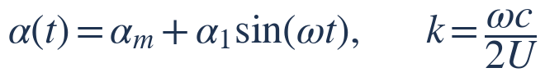 | (1)
with U the stream speed and c the chord. Table 1 gives the conditions. Both lie inside the range over which the model has been compared with measurement: Mach 0.22 to 0.30, reduced frequency up to 0.20 and peak incidence up to 25° on the NACA 0012 section.
Table 1. The cases (03_model_setup/flow_conditions.csv, 03_model_setup/kinematics.csv, 03_model_setup/solver_config.json).
Quantity | Case A: tunnel condition | Case B: rotor-blade-station condition
Purpose | tunnel condition of NASA TM-84245, frame 9302 | an aerofoil at a rotor-blade-station condition (steady stream, prescribed pitch); not a rotor calculation
Mach number | 0.30 | 0.28
Chord, m | 0.610 | 0.527
Stream speed, m/s | 102.09 | 95.28
Reynolds number on chord in sea-level standard air (not the tunnel value of the frame, nor a flight value; the load model does not use it) | 4.3 × 10⁶ | 3.4 × 10⁶
Reduced frequency k | 0.1000 | 0.0747
Mean incidence, deg | 10.0 | 12.0
Pitch amplitude, deg | 10.0 | 8.0
Pitch frequency, Hz | 5.327 | 4.300
Period, s | 0.1877 | 0.2326
Steps per cycle | 3240 | 4320
Cycles marched | 5 | 4

Case A is a condition of the NASA TM-84245 experiment, so its loops can be set beside a measured loop (frame 9302). That frame is one of the calibration loops, so the comparison in Case A is an illustration and not an independent test; the independent test is the held-out set of Section 6.
Case B is not a rotor calculation. Its chord and its once-per-revolution pitch frequency are those of the UH-60A main rotor (4 blades, radius 26.83 ft, chord 20.76 in, 258 rpm; Bousman, NASA/TP-2003-212265 (UH-60A main rotor)). The station at 0.75 of the radius turns at 165.7 m/s. Case B takes the Mach number 0.28 for it, which the station sees at azimuth 270° (the retreating side) at a forward speed of 70.4 m/s (137 kt, advance ratio 0.32); the pitch frequency is the rotor speed, 4.30 Hz, and the reduced frequency 0.0747 follows from it, the chord and the stream speed (03_model_setup/station_condition.csv). Round the azimuth the Mach number at that station runs from 0.28 to 0.69: Case B holds the lowest value steady. Its incidence history is assumed and comes from no trim calculation. The real blade uses the SC1095 and SC1094 R8 sections with a swept tip, not a NACA 0012. There is no time-varying velocity, sweep, inflow, trim or blade motion, and no rotor measurement is compared with.

The section is drawn in Figure 1. Its coordinates come from the NACA four-digit thickness form with the closed trailing edge (a gap of 0.0 % of the chord): the greatest thickness is 0.1200 of the chord at 0.299 of the chord from the leading edge, and the leading-edge radius is 0.0159 of the chord (01_geometry/section_geometry_summary.csv). The same outline is used by the grid, by the panels of the flow-field reconstruction and by the drawings.
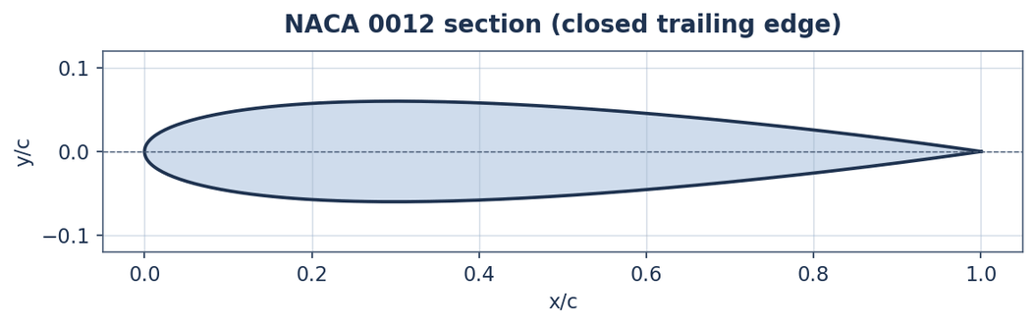
Figure 1. The NACA 0012 section (01_geometry).
The case study is kept in numbered folders. Table 2 says what each holds and what standing it has.
Table 2. The parts of the case study and their standing (00_overview/case_definition.md).
Folder | Contents | Status
01_geometry | the section's coordinates and thickness | the NACA four-digit thickness form with a closed trailing edge; the same outline in the grid, the panels and the drawings
02_mesh | a structured O-grid round the section | an illustration: the load model has no spatial mesh and does not read it; no equation of the flow is solved on it; the reconstructed field is evaluated at its nodes for one picture
03_model_setup | flow conditions, kinematics, air properties, solver configuration, static inputs | derived by script; the constants are the calibrated ones
04_solver | the driver for the two cases | the solver itself is the unistall package: a set of ordinary differential equations marched in time
05_solution | time histories, surface pressures, reconstructed fields, metrics, convergence | loads are the model's prediction; fields and surface pressures are a reconstruction (below), not a solution of the flow equations
06_postprocessing | load loops, maps of the reconstructed field | drawn from 05_solution; the field maps show the reconstruction
07_report | the case-study report, a plots album and a data dossier | built from the files above
08_engineering_drawings | four illustrative sheets | every dimension from one table with its source; not for manufacture

4 The model
The load model is a chain of first-order lags marched in time. Attached-flow loads come from indicial functions; a lagged normal force decides where the flow separates; a lagged separation point reduces the circulatory load through the Kirchhoff relation; and a vortex, started when a critical normal force is passed, adds lift and nose-down moment while it travels over the chord. The equations are those of Leishman and Beddoes [4] in the form given by Damiani and Hayman [5]. Every equation and constant the code evaluates is listed, with the places where the implementation departs from that source, in docs/formulation.md; the principal ones follow. A subscript n marks the value at step n.

4.1 Attached flow
Time is counted in semichords of travel, and compressibility enters through the Prandtl-Glauert factor:
 | 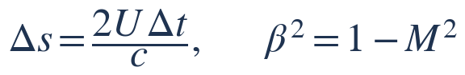 | (2)
The pitch rate is made dimensionless with the chord and the stream speed, and the incidence is taken at the three-quarter chord, where x_{p} is the pitch axis as a fraction of the chord:
 | 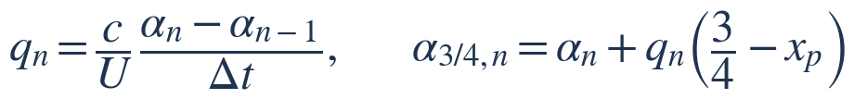 | (3)
The circulatory lift lags the incidence. The lag is carried by a pair of deficiency functions, each advanced by an exact exponential recurrence over the step:
(4)
They give the effective incidence and the circulatory normal force:
(5)
The impulsive (non-circulatory) force, the pressure wave of a sudden change of incidence, decays with its own time constant T_{α}. With K_{α} the rate of change of incidence, a second recurrence of the same form gives it, and a like term C_{N}^{nc,q} follows from the pitch rate. The sum is the normal force the section would carry with the flow attached:
 | 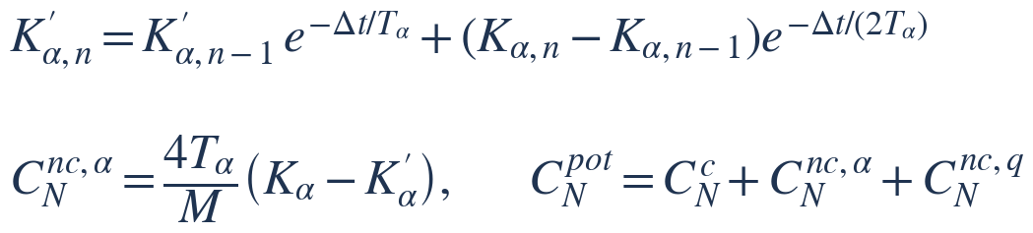 | (6)
The indicial constants are those of compressible flow. Below Mach 0.20 the attached-flow loads are blended with incompressible loads marched by the same recurrences, with a weight w that falls from one at Mach 0.20 to zero at Mach 0.10; at the Mach numbers of this study w is one and the equations above are unchanged. In attached flow the model is checked against Theodorsen's solution [6] (Section 6).

4.2 Separated flow: the pressure lag, the boundary-layer lag and the Kirchhoff relation
The leading-edge pressure does not follow the normal force at once. A first-order lag with time constant T_{p} gives a delayed normal force C'_{N}:
(7)
The delayed force is turned into an equivalent incidence, at which the static position of the separation point f (the fraction of the chord over which the flow is attached) is read:
 | 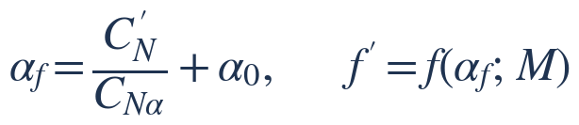 | (8)
Here the model departs from the usual form. The Leishman-Beddoes method fits f with a exponential law; this model reads f from a table made from the static measurements themselves, by inverting the Kirchhoff relation at each measured incidence, with f kept between 0.02 and one:
 | 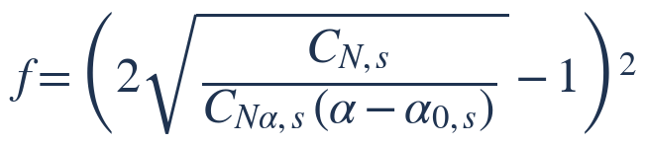 | (9)
The boundary layer in turn does not follow the pressure at once. A further lag with time constant T_{f} gives the dynamic separation point f''. The multiplier σ₁ changes the time constant with the state of the flow (separating or reattaching, with or without a vortex over the chord), by fixed rules taken from the source and not fitted:
 | 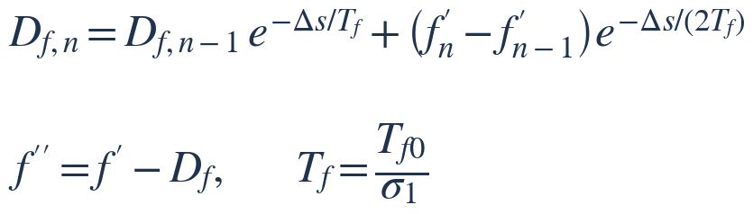 | (10)
The Kirchhoff relation then reduces the circulatory normal force for the separated flow:
 | 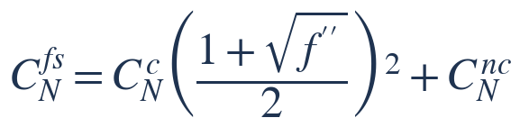 | (11)

4.3 The vortex lift
The vortex starts when the delayed normal force first exceeds the normal force at static stall, C_{N1}. From then a clock τ_{v} counts the semichords travelled. While the vortex is over the chord (τ_{v} up to T_{VL}) it is fed by the difference between the attached and the separated circulatory force, and its lift decays with time constant T_{V}:
 | 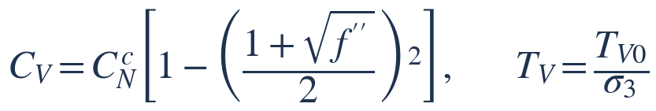 | (12)
 | 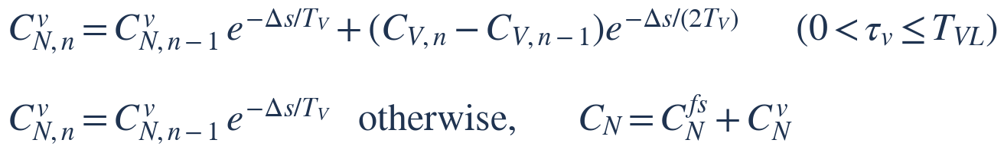 | (13)
Once the vortex has passed the trailing edge the feed stops and its lift only decays. The multiplier σ₃ again follows fixed rules.

4.4 The chord force, lift and drag
The chord force is the leading-edge suction, reduced by separation and by the recovery factor η:
 | 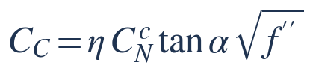 | (14)
The normal and chord forces are resolved into lift and drag, with the drag at zero lift C_{D0} added:
(15)

4.5 The moment
The vortex lift acts at a point that moves aft as the vortex travels:
(16)
The moment about the quarter chord is the static moment read at a lagged incidence, the unsteady moment terms of attached flow, and the moment of the vortex lift:
 | 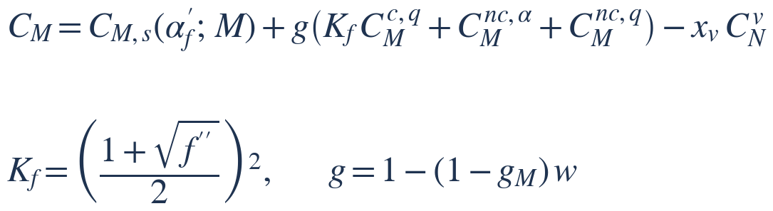 | (17)
The factor g_{M} is empirical. Below static stall the model gives a wider moment loop than is measured. g_{M} = 0.728 is the one number that minimises the moment loop error on the three calibration loops whose peak incidence is below static stall (results/attached_moment_factor.json). Part of the excess comes from reading the static moment at the lagged incidence and not from the unsteady terms, so the factor corrects the model as a whole below stall; the file gives both parts for each loop. Taken alone, the loops with a closed moment loop would choose 0.60 and 0.71. It rests on few loops at one Mach number and is not a property of the flow.

4.6 The step rule
The model has no spatial mesh: its only discretisation is the time step. Because the lags are measured in semichords of travel, the step is set in semichords and not as a fraction of the cycle. The number of steps per cycle is the smallest that satisfies
 | 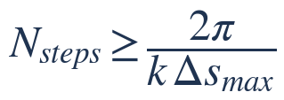 | (18)
with Δs_{max} = 0.02, and is never fewer than 720. Enough cycles are marched for 200 semichords of travel to precede the reported cycle, between 3 and 8 cycles in all (03_model_setup/solver_config.json). Section 7 gives the resolution of the cases and what the convergence studies show.

4.7 Constants
Table 3 lists the constants that are fitted or empirical, with their literature values. The five stall constants are fitted on 20 calibration loops by least squares; the cost, the sum over those loops of the squared loop errors in lift, moment and drag, falls from 2.143 at the literature values to 1.906 (results/calibrated_constants.json). Table 4 lists the constants that are fixed.
Table 3. Fitted and empirical constants; the time constants are in semichords (results/tables.md, Table 3).
Constant | Literature value | Value used | Status | Range over the starts of the fit
pressure lag T_{p} | 1.700 | 1.652 | fitted; the two refined starts differ by 0.835 | 1.25 to 2.03
boundary-layer lag T_{f} | 3.000 | 6.278 | fitted; the two refined starts differ by 2.533 | 4.61 to 7.36
vortex decay T_{v} | 6.000 | 6.318 | fitted; the two refined starts differ by 5.902 | 2.65 to 9.30
vortex travel time T_{vl} | 7.000 | 8.392 | fitted; the two refined starts differ by 5.928 | 6.84 to 12.99
chord-force recovery η | 0.950 | 0.907 | fitted; the two refined starts differ by 0.002 | 0.91 to 0.91
unsteady-moment factor g_{M} | 1.000 | 0.728 | empirical, from loops below static stall

Table 4. Fixed constants (docs/formulation.md, section 5; [DH19] is Damiani and Hayman). Equation numbers in this table are those of that file, not of this report; names in brackets are those of the code.
Constant | Value | Source
A₁, A₂ | 0.30, 0.70 | Leishman & Beddoes, as given in [DH19]
b₁, b₂ | 0.14, 0.53 | as above
A₃, A₄ | 1.5, -0.5 | Leishman & Beddoes impulsive moment
b₃, b₄ | 0.25, 0.1 | as above
A₅, b₅ | 1.0, 0.5 | Leishman & Beddoes ([DH19] prints b₅ = 5)
factor 0.75 in (13) of formulation.md | 0.75 | [DH19] Eq. (1.10)
x_{cp,v} (xcp_v) | 0.20 | [DH19] Eq. (1.57)
St_{sh} (St_sh) | 0.19 | Strouhal number of repeated shedding, [DH19] Eq. (1.54)
c_{m} (cm_lag) | 0.10 | [DH19] Eq. (1.43)
C_{D0} (CD0) | 0.0072 | NASA TM-84245 Vol. 1 Table 8
F_{MIN} | 0.02 | floor on the separation point
chord-force offset (cc_offset) | 0 | 0 gives (43) of formulation.md; 0.2 gives Gonzalez's form sqrt f'' - 0.2, [DH19] Eq. (1.40), kept as an option and not used
blend limits in (18a) of formulation.md | 0.10, 0.20 | below the lowest Mach number of the static data
onset-level factor (cn1_factor) | 1 | multiplies C_{N1} in (34) of formulation.md; 1 is the static value (results/onset_level_check.csv)
cmq_kirchhoff | 1 | 1 applies K_{f} to the circulatory pitch-rate moment in (49) of formulation.md; 0 does not
sigma_rules | 1 | 1 uses (41) of formulation.md and (42) of formulation.md; 0 sets both multipliers to 1 (T_{V} halved once the vortex has left the chord)
cc_floor | 1 | 1 holds the leading-edge suction C_{N}^c tan(α) in (43) of formulation.md at zero where the formula would make it negative (the lagged circulatory force and the incidence of opposite sign near zero lift); 0 leaves it as the formula gives it
cc_geometric | 1 | 1 uses α in (43) of formulation.md; 0 uses α_{e} + α₀ as [DH19]
drop in C_{M} that marks moment stall, (53g) of formulation.md | 0.05 | unistall/metrics.py

5 Static inputs
The model takes from static measurement the lift-curve slope, the zero-lift incidence, the normal force at static stall C_{N1}, the separation point f and the static moment, each as a function of Mach number. They are tabulated at two Mach stations, 0.215 and 0.302, from quasi-steady sweeps of the same experiment and from the static figures of the NASA report [1, 7], and interpolated between the stations (Table 5).
Table 5. Static inputs at the Mach stations (results/static_by_mach_naca0012.csv).
Mach | Lift-curve slope, per deg | Zero-lift incidence, deg | Maximum static lift coefficient | Static-stall incidence, deg | Normal force at static stall | Source sweep
0.215 | 0.118 | -0.01 | 1.644 | 16.2 | 1.598 | frame_13308
0.302 | 0.117 | 0.24 | 1.364 | 13.6 | 1.336 | frame_12102

Table 6. Static inputs interpolated to the Mach numbers of the cases (03_model_setup/solver_config.json).
Quantity | Case A: tunnel condition | Case B: rotor-blade-station condition
Lift-curve slope, per rad | 6.705 | 6.718
Zero-lift incidence, deg | 0.23 | 0.18
Static normal force at zero incidence | -0.027 | -0.021
Static-stall incidence, deg | 13.66 | 14.26
Normal force at onset | 1.342 | 1.402

The static inputs carry the offset of the measured sweeps. The section is symmetric, yet the static inputs give it a zero-lift incidence of +0.23° in Case A and +0.18° in Case B, and a static normal force at zero incidence of -0.027 and -0.021. The offset is that of the measured static sweeps (a flow angle of the tunnel or an offset of the balance), not a property of the section; the model keeps it so that it reads the static data as measured. The incidence uncertainty the experiment states is not held in the data files of this repository, so the offset is not set against it here.
The static inputs of Case B are a straight-line blend of two Mach stations, and no static measurement at its Mach number supports the blend. Run with the inputs of the station at Mach 0.215 and of the station at Mach 0.302 in turn, Case B gives a peak lift of 1.91 and 1.70 (reported 1.75), a minimum moment of -0.29 and -0.24 (reported -0.24) and an onset incidence of 15.3° and 13.3° (reported 13.8°). The spread between the stations is 0.20 in peak lift, 0.054 in minimum moment, 0.10 in peak drag and 2.0° in onset incidence (05_solution/static_station_spread.csv); the results of Case B are uncertain within it.

Past static stall the measurements are not single-valued: they show a more separated and a less separated state. The model follows the attached curve up to static stall and the more separated state beyond it. That choice was made on the calibration loops, where it gives a cost of 2.14 against 3.33 for the less separated state (results/static_curve_choice.csv). Figure 2 shows the static normal force, separation point and moment at the Mach numbers of the cases, and Figure 3 the same inputs at the Mach stations with the measurements they come from.
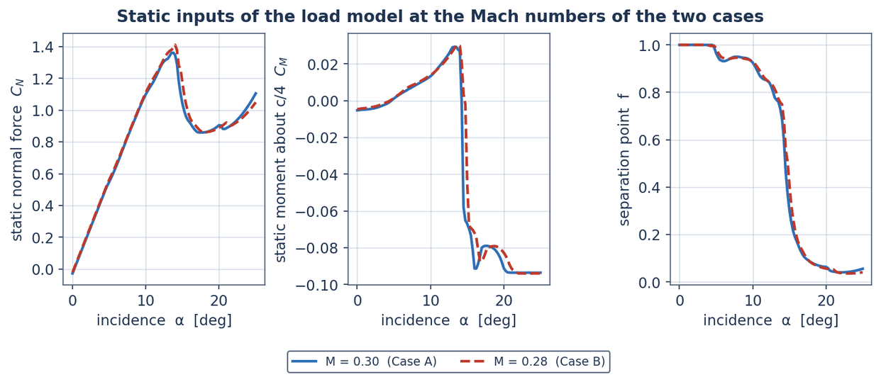
Figure 2. Static inputs of the load model at the Mach numbers of the cases (06_postprocessing).
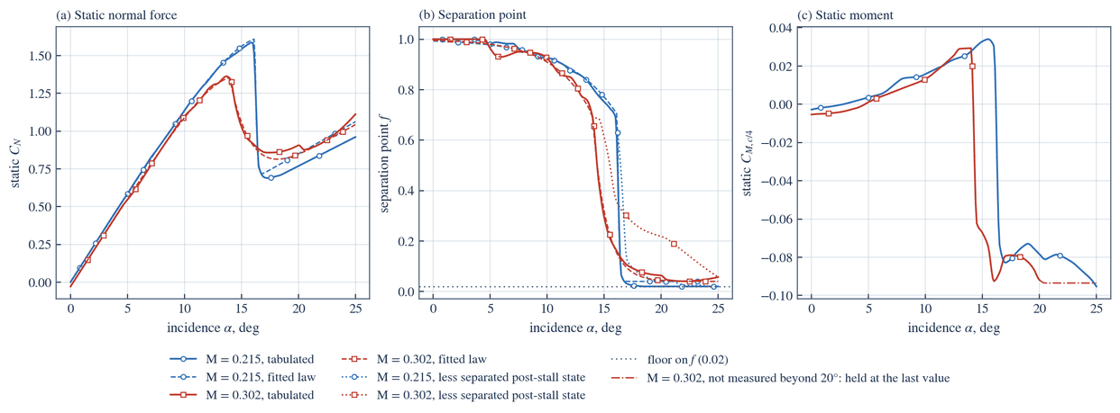
Figure 3. Static normal force, separation point and moment at the Mach stations (results/figures).

6 Calibration and the comparison with measurement

6.1 The measured loops and the fit
All measured loops are from the NASA TM-84245 experiment on oscillating aerofoils [1]. Table 7 lists how they are divided. The loops outside the Mach range of the static data are scored but support no claim.
Table 7. Measured loops used (results/tables.md, Table 1).
Set | Inside the static Mach range | Loops | Mach | Reduced frequency | Mean incidence, deg | Amplitude, deg
calibration | no | 4 | 0.04 to 0.18 | 0.099 to 0.248 | 10 to 15 | 10 to 10
calibration | yes | 20 | 0.29 to 0.30 | 0.010 to 0.201 | 4 to 15 | 5 to 10
held out | no | 15 | 0.04 to 0.18 | 0.010 to 0.284 | 8 to 15 | 5 to 10
held out | yes | 45 | 0.22 to 0.30 | 0.010 to 0.202 | 3 to 15 | 5 to 10

The stall constants are fitted on the 20 calibration loops inside the static Mach range, by bounded least squares from 8 starting points, each refined at the resolution the results are reported at. The fit lowers the cost by 11 % from the literature constants, and the starts refined at full resolution reach costs of from 1.906 to 2.013 (results/calibrated_constants.json). Figure 4 shows the cost of every start, the sensitivity of the cost to each constant, the cross-validation inside the calibration set and a section of the cost surface.
As a check on the onset criterion, the level of normal force at which the vortex starts was multiplied by factors from 0.92 to 1.08; the calibration cost is lowest, 1.906, at a factor of 1.00 (results/onset_level_check.csv).
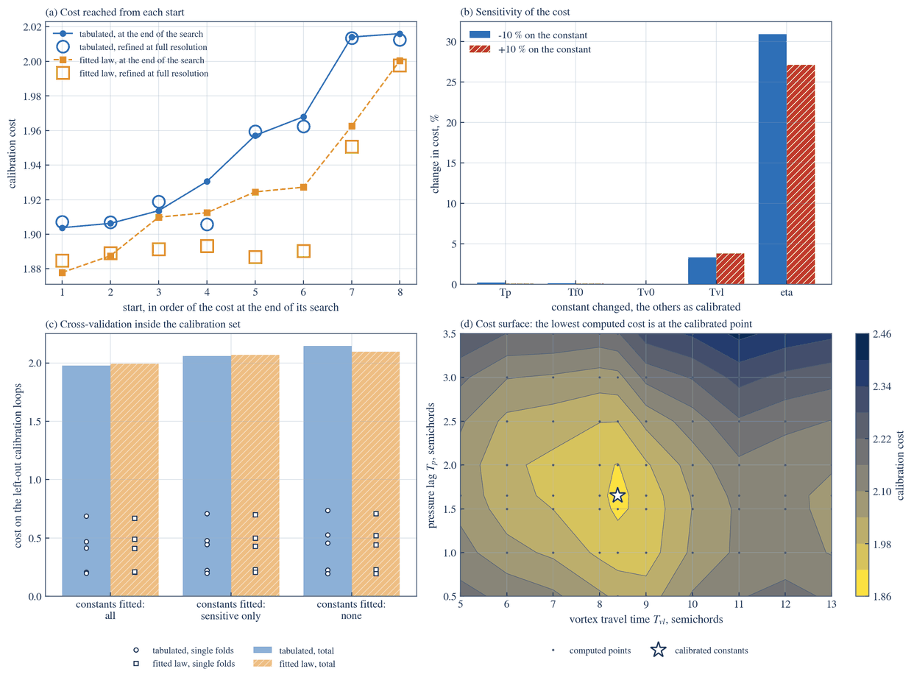
Figure 4. The calibration: cost of every start, sensitivity, cross-validation and cost surface (results/figures).

6.2 Accuracy on the held-out loops
The model is scored on 45 held-out NACA 0012 loops, each run at its own measured conditions. A loop error is the root-mean-square difference between the predicted and the measured loop, divided by the measured range of the quantity over the loop. Table 8 gives the six measures with the targets set for them.
Table 8. Accuracy on the held-out loops against the targets (results/validation_targets.csv).
Measure | Measured on the held-out loops | Target | Result
Loop error, lift | 0.107 | at most 0.100 | not met
Loop error, moment | 0.196 | at most 0.150 | not met
Loop error, drag | 0.153 | at most 0.200 | met
Incidence of maximum lift | 0.57° | at most 0.72° | met
Incidence of moment stall | 0.62° | at most 1.00° | met
Fraction of loops with the sign of cycle damping correct | 0.60 | at least 0.80 | not met

The lift and moment loop-error targets and the damping-sign target are not met. The drag loop-error target and the targets on the incidence of maximum lift and of moment stall are met.

The error a perfect model would show from the stated measurement uncertainty alone is 0.028 in lift, 0.059 in moment and 0.059 in drag (results/uncertainty_summary.csv); the errors of the model are several times that. Over every target set for the model, including those on attached flow, structure, code and numerics, the targets met are 12 of 17 on the model against measurement or theory, 8 of 8 on the numerical method, 8 of 9 on the software, and 6 are not met (results/targets_scoreboard.csv); Table 9 lists those.
Table 9. Targets not met (results/targets_scoreboard.csv; names as in the file, with spaces for underscores).
Group | Kind of target | Target | Kind | Target value | Measured | Met
attached flow | physical | no stall frame nRMS CM max | at most | 0.1 | 0.1235 | no
held out validation | physical | mean nRMS CL max | at most | 0.1 | 0.1067 | no
held out validation | physical | mean nRMS CM max | at most | 0.15 | 0.1959 | no
held out validation | physical | damping sign agreement min | at least | 0.8 | 0.6 | no
code quality | software | unused parameters max | at most | 0 | 1 | no
equivalence of separation laws | physical | margin CL | at most | 0.01 | 0.01402 | no

Figure 5 sets the held-out errors beside their intervals, the measurement floor and the targets, and Figure 6 shows measured and predicted loops for some of the held-out loops.
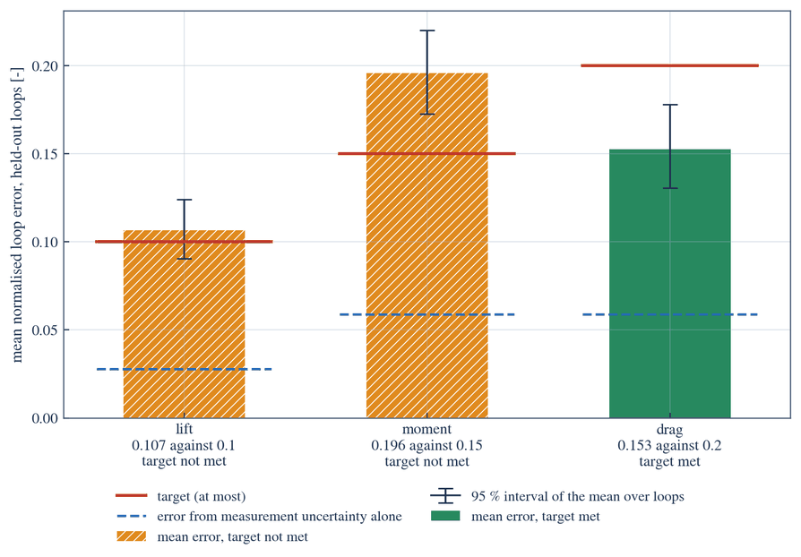
Figure 5. Held-out errors with their confidence intervals, the measurement floor and the targets (results/figures).
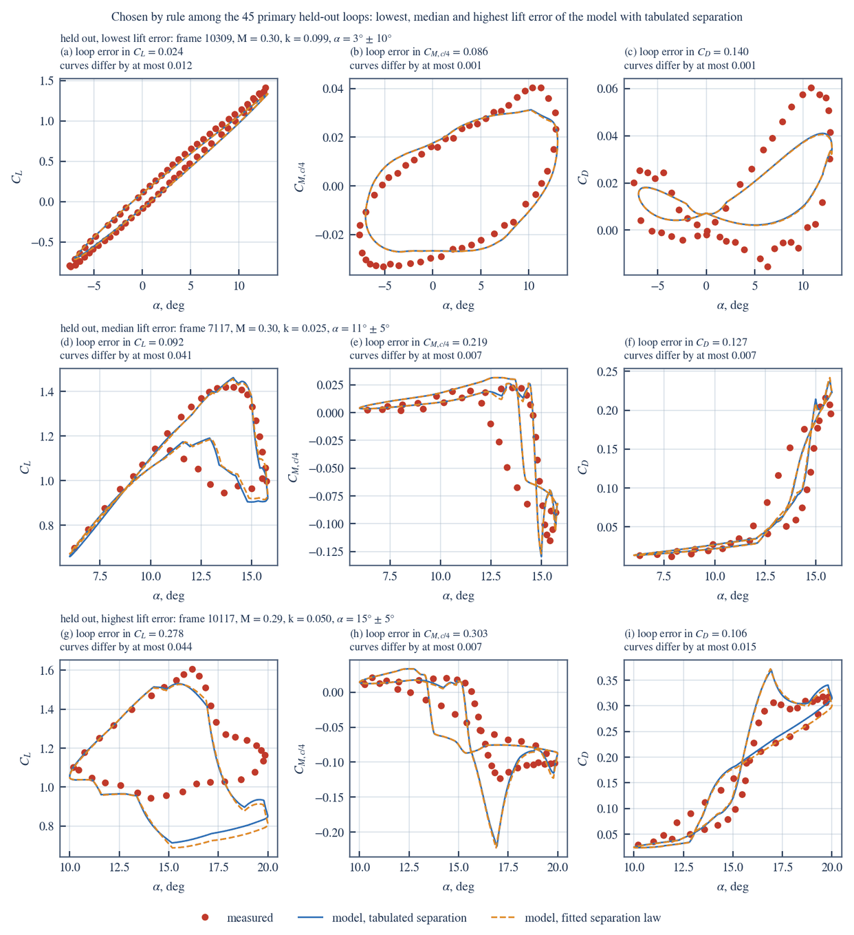
Figure 6. Measured and predicted lift, moment and drag loops for held-out loops, with both separation laws (results/figures).
Figure 7 sets measured and predicted loops side by side for loops chosen by a fixed rule from results/validation_table.csv: the held-out loops with the lowest, the median and the highest loop error in lift, and the calibration loop that Case A is set beside. The folder 06_postprocessing/validation holds that figure, the static comparison, a row for every scored loop and the targets with their verdicts; they are the same numbers as those of results/, set out beside the case study, not a second assessment.
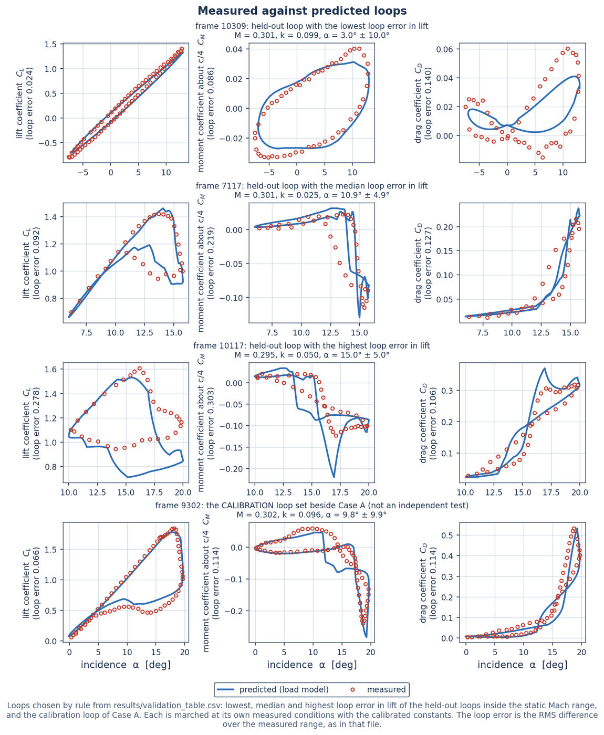
Figure 7. Measured against predicted loops of lift, moment and drag for loops chosen by rule; the last row is a calibration loop (06_postprocessing/validation).
Table 10 groups the same loops by how far the peak incidence goes beyond static stall.
Table 10. Held-out accuracy by stall depth (results/validation_by_stall_depth.csv).
Group | Loops | Loop error, lift | Loop error, moment | Loop error, drag | Damping sign correct, fraction | Mean size of measured damping
attached or marginal (peak less than 2 deg beyond static stall) | 19 | 0.0927 | 0.2407 | 0.209 | 0.4737 | 0.0983
light stall (2 to 6 deg beyond) | 7 | 0.1306 | 0.1553 | 0.1517 | 0.4286 | 0.0563
deep stall (6 deg or more beyond) | 19 | 0.112 | 0.166 | 0.0964 | 0.7895 | 0.1246

In attached incompressible flow the model is compared with Theodorsen's solution [6]: over the reduced frequencies tested the largest error is 1.86 % in lift amplitude, 0.62° in lift phase, 0.01 % in moment amplitude and 0.06° in moment phase (results/tables.md, Table 9).

6.3 Tabulated against fitted separation law
The one departure of this model from the usual method is the tabulated separation point. To see what it changes, a reference model with the usual fitted exponential law is run on the same held-out loops. With the same dynamic constants in both models, over three sets of constants, the two score alike against measurement: mean loop errors differ by at most 0.0017 and the incidence of stall by at most 0.02°, and the 95 % interval of every loop-error difference lies inside the equivalence margin recorded beforehand in data/targets.json (one tenth of each accuracy target). Of the 18 paired comparisons, 5 favour the fitted law and 2 the tabulated one at the 95 % level (results/comparison_same_constants.csv).
The loads themselves are compared directly, as the RMS difference between the two predictions over the cycle divided by the measured range and averaged over the loops; the largest over the sets of constants is: lift 0.0116 (upper 95 % limit 0.0140, margin 0.010, worst loop 0.047); moment 0.0074 (upper 95 % limit 0.0114, margin 0.015, worst loop 0.081); drag 0.0096 (upper 95 % limit 0.0116, margin 0.020, worst loop 0.038) (results/equivalence.csv).
On this data set the tabulated and the fitted separation laws are equally accurate, and the loads they predict are close but not identical. At the recorded margin the loads are not shown to be equivalent in lift. The tabulated law is not shown to be more accurate than the fitted one.

Calibrated separately by the same procedure, the two models differ at the 95 % level in: loop error in drag 0.153 against 0.151; peak-lift error 4.53 % against 4.35 % (tabulated model first; the fitted-law model is the better in each). With identical constants those differences shrink to the size given above, so they come from the values each calibration gave the constants and not from the separation law (results/comparison.csv). Figure 8 shows the paired differences.
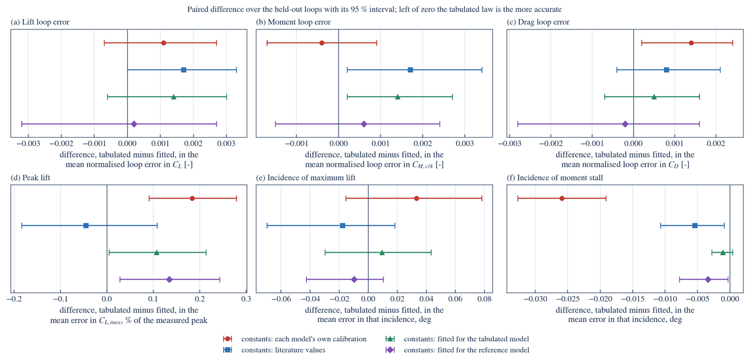
Figure 8. Tabulated against fitted separation law: paired differences on the held-out loops (results/figures).

6.4 Cycle damping
The cycle damping is the work the moment does on the pitching section over a cycle, made dimensionless with the pitch amplitude α₁; a negative value means the air feeds the motion:
 | 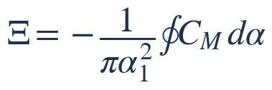 | (19)
On the 45 held-out loops with a closed measured moment loop the sign of the damping is predicted correctly on a fraction 0.60; a prediction of positive damping everywhere would score 0.67. The correlation between predicted and measured damping is 0.33 and the root-mean-square error 0.120. 15 loops measure negative damping; the model predicts negative damping on 0 of them, and on 3 loops whose measured damping is positive. On the 19 loops in deep stall the sign is correct on a fraction 0.79 (results/validation_damping.csv; Figure 9).
The model does not predict cycle damping through stall. It cannot locate a stall-flutter boundary and is not offered for that purpose. Where this report gives a damping figure for a case, it is model output and not a statement about stall flutter.

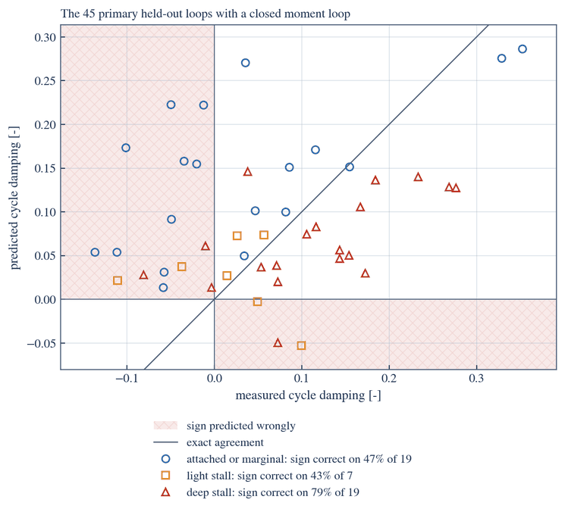
Figure 9. Predicted against measured cycle damping on the held-out loops (results/figures).

7 Numerical resolution
There is no spatial mesh. The model is a set of first-order lags marched in time, so the only discretisation is the time step. The linear lags use exact exponential recurrences and the march has no stability limit; but the switching of the time-constant multipliers, the vortex leaving the chord and repeated shedding are resolved only to the nearest step, so the error of the march is set by those events and need not fall smoothly with the step.
Case A is marched with 3240 steps per cycle, a step of 0.0194 semichords, for 5 cycles; Case B is marched with 4320 steps per cycle, a step of 0.0195 semichords, for 4 cycles (03_model_setup/solver_config.json). The last cycle is the one reported. The step the load model marches is checked against the configured one when this report is built.
On the 20 calibration loops, a march with 4 times as many steps changes the loop error of any loop by at most 0.0008, and one with 4 more cycles changes it by at most 0; the target for both is 0.002 (results/convergence_summary.csv; Figure 10).
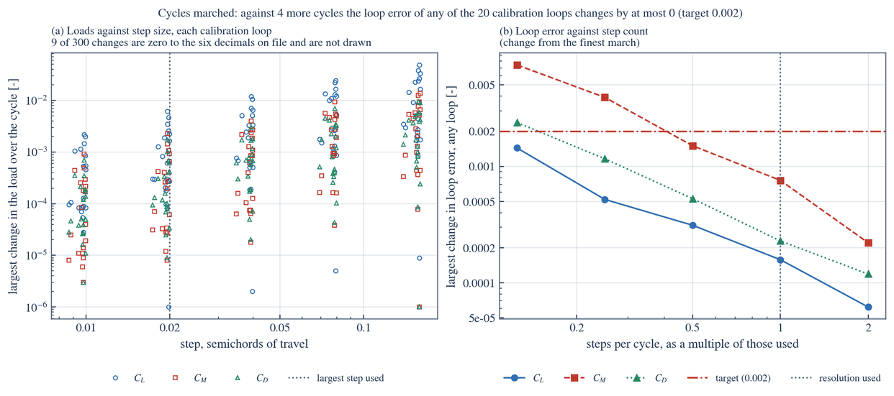
Figure 10. Loads and loop errors of the calibration loops against step size and cycles marched (results/figures).
For Case A the reported march differs from one with 12960 steps per cycle by 0.004 % in peak lift, 0.016 % in minimum moment and 0.012 % in peak drag. For Case B the reported march differs from one with 17280 steps per cycle by 0.002 % in peak lift, 0.007 % in minimum moment and 0.007 % in peak drag. Table 11 gives the refinement of the step for the cases and Figure 11 shows it.
Table 11. Refinement of the time step (05_solution/convergence/timestep_refinement.csv).
Case | Steps per cycle | Step, semichords | Peak lift | Minimum moment | Peak drag | Peak lift, % from finest | Minimum moment, % from finest | Peak drag, % from finest | Reported march
Case A | 405 | 0.1551 | 1.796 | -0.2888 | 0.5544 | 0.05767 | 0.2588 | 0.1707 | no
Case A | 810 | 0.07757 | 1.796 | -0.2895 | 0.5554 | 0.02954 | 0.02768 | 0.00369 | no
Case A | 1620 | 0.03879 | 1.795 | -0.2894 | 0.5552 | 0.0132 | 0.04638 | 0.0289 | no
Case A | 3240 | 0.01939 | 1.795 | -0.2896 | 0.5554 | 0.004248 | 0.01565 | 0.01249 | yes
Case A | 6480 | 0.009696 | 1.795 | -0.2896 | 0.5554 | 0.00329 | 0.004552 | 0.004954 | no
Case A | 12960 | 0.004848 | 1.795 | -0.2896 | 0.5554 | 0 | 0 | 0 | no
Case B | 540 | 0.1557 | 1.746 | -0.233 | 0.4297 | 0.02481 | 1.642 | 1.469 | no
Case B | 1080 | 0.07786 | 1.746 | -0.2352 | 0.4334 | 0.01248 | 0.6755 | 0.6118 | no
Case B | 2160 | 0.03893 | 1.745 | -0.2363 | 0.4352 | 0.003727 | 0.2098 | 0.1941 | no
Case B | 4320 | 0.01947 | 1.745 | -0.2369 | 0.4361 | 0.001995 | 0.006849 | 0.007056 | yes
Case B | 8640 | 0.009733 | 1.745 | -0.2368 | 0.4361 | 0.001149 | 0.0003026 | 0.001485 | no
Case B | 17280 | 0.004867 | 1.745 | -0.2368 | 0.4361 | 0 | 0 | 0 | no

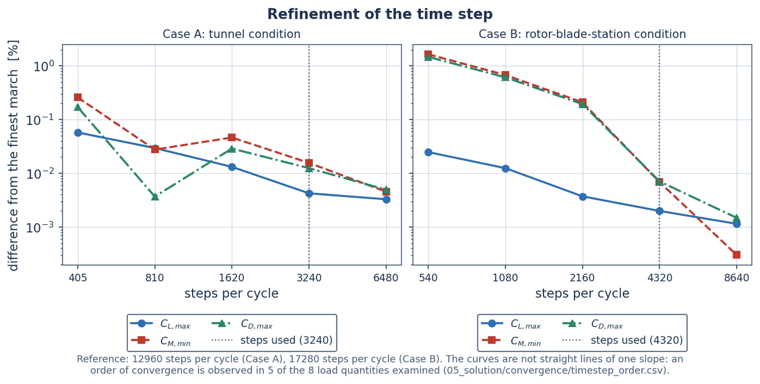
Figure 11. Refinement of the time step for the cases: difference from the finest march (06_postprocessing).
An order of convergence was looked for in the three finest marches of each case (the reported number of steps, twice it and four times it). It is observed in five of the eight quantities examined, where it lies between 0.6 and 1.9; in the others (minimum moment of Case B, peak lift of Case A, peak lift of Case B) the three marches do not change monotonically and no order is observed. Where an order is observed the reported value is set against the Richardson estimate; elsewhere the range of the three marches is taken. The largest discretisation uncertainty of a reported value found in this way is 0.02 % (peak drag, Case A; 05_solution/convergence/timestep_order.csv). Table 12 gives the figures.
Table 12. Observed order of convergence, Richardson estimate and discretisation uncertainty of the reported loads, from the three finest marches (05_solution/convergence/timestep_order.csv).
Case | Quantity | Value at the reported steps | Change on doubling the steps | Change on doubling them again | Observed order | Richardson estimate less the reported value | Discretisation uncertainty | Uncertainty, % of reported
Case A | Peak lift | 1.795 | -1.7 × 10⁻⁵ | -5.9 × 10⁻⁵ | none observed | not formed | 7.6 × 10⁻⁵ | 0.004
Case A | Minimum moment | -0.2896 | 3.2 × 10⁻⁵ | 1.3 × 10⁻⁵ | 1.29 | 5.4 × 10⁻⁵ | 5.4 × 10⁻⁵ | 0.019
Case A | Peak drag | 0.5554 | -4.2 × 10⁻⁵ | -2.8 × 10⁻⁵ | 0.60 | -0.00012 | 0.00012 | 0.022
Case A | Onset incidence, deg | 14.43 | 0.00017 | 8.5 × 10⁻⁵ | 1.04 | 0.00034 | 0.00034 | 0.002
Case B | Peak lift | 1.745 | -1.5 × 10⁻⁵ | -2 × 10⁻⁵ | none observed | not formed | 3.5 × 10⁻⁵ | 0.002
Case B | Minimum moment | -0.2369 | 1.6 × 10⁻⁵ | 7.2 × 10⁻⁷ | none observed | not formed | 1.6 × 10⁻⁵ | 0.007
Case B | Peak drag | 0.4361 | -2.4 × 10⁻⁵ | -6.5 × 10⁻⁶ | 1.91 | -3.3 × 10⁻⁵ | 3.3 × 10⁻⁵ | 0.008
Case B | Onset incidence, deg | 13.85 | 1.1 × 10⁻⁵ | 3.7 × 10⁻⁶ | 1.52 | 1.6 × 10⁻⁵ | 1.6 × 10⁻⁵ | 0.000

The reported cycle repeats to this extent: for Case A the largest change of any load over the cycle, from the reported cycle to the last of 8 marched, is 0; for Case B the largest change of any load over the cycle, from the reported cycle to the last of 8 marched, is 5 × 10⁻¹⁰. That figure, and not the change of one particular cycle, is the floor of repeatability of the loop: at a turning point of the motion the sign of the pitch rate decides a branch of the model, and rounding can place it on either side of zero, so a change of this size can reappear after the loop has settled. Figure 12 shows the cycle-to-cycle change.
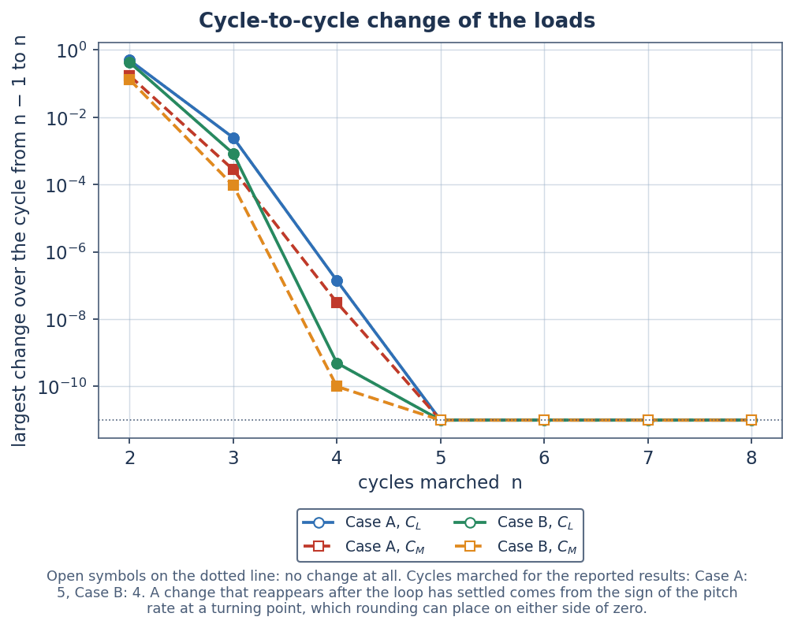
Figure 12. Cycle-to-cycle change of the loads against the number of cycles marched (06_postprocessing).

8 The state-space form
The same model is also written as 14 first-order differential equations (unistall/statespace.py), integrated by the classical fourth-order Runge-Kutta method with the step of Eq. (18). With s the travel in semichords, each lag is written on the quantity it delays. The circulatory lags of the incidence and of the pitch rate become
 | 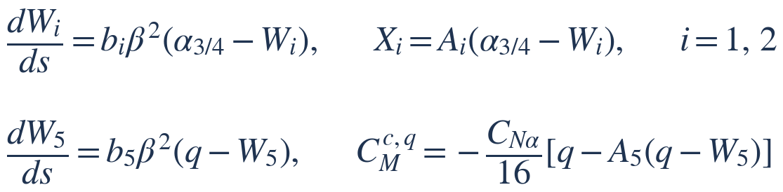 | (20)
the impulsive terms of the normal force and of the moment become
 | 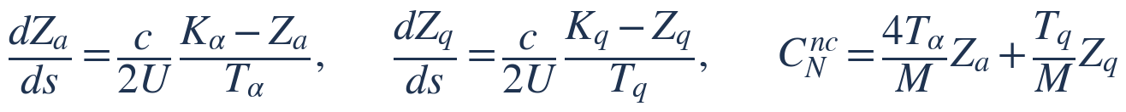 | (21)
 | 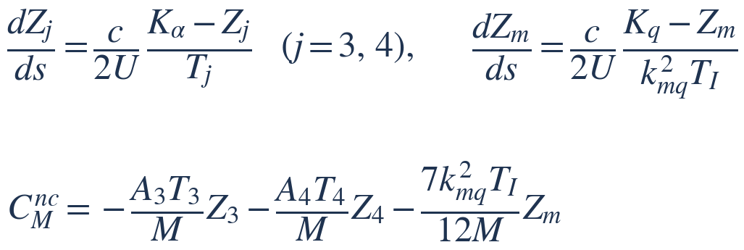 | (22)
and the pressure lag, the boundary-layer lag, the lag of the incidence at which the static moment is read, and the vortex lift become
 | 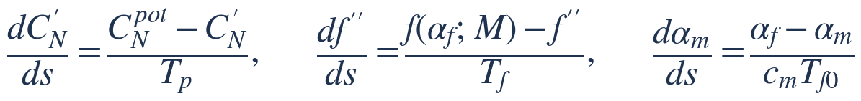 | (23)
(24)
Each recurrence of Section 4 is the exact solution of the matching equation over a step with a linearly varying input, so the two forms are the same model. The multipliers on the time constants are evaluated at the start of each step and held over it, and the vortex clock is advanced at the end of the step; across a switch the two forms therefore differ by an amount that depends on the step.
On the 24 calibration loops the largest difference between the two forms in any loop error is 0.0004 (target 0.002; mean 0.0001), and in cycle damping 0.0003. At any instant the largest difference is 0.5 % of the range in lift, 2.0 % in moment and 3.6 % in drag; those largest differences sit where the model switches a time constant. The state-space march costs 4.9 times the CPU time of the indicial one (results/statespace_summary.csv; Figure 13).
The state-space form covers the whole Mach range of the indicial one, including the low-Mach blend: 4 of those loops are below Mach 0.20, down to Mach 0.04, where further states carry the incompressible circulatory lift. No dynamic-stall claim is made for those loops; they test only that the two forms agree.
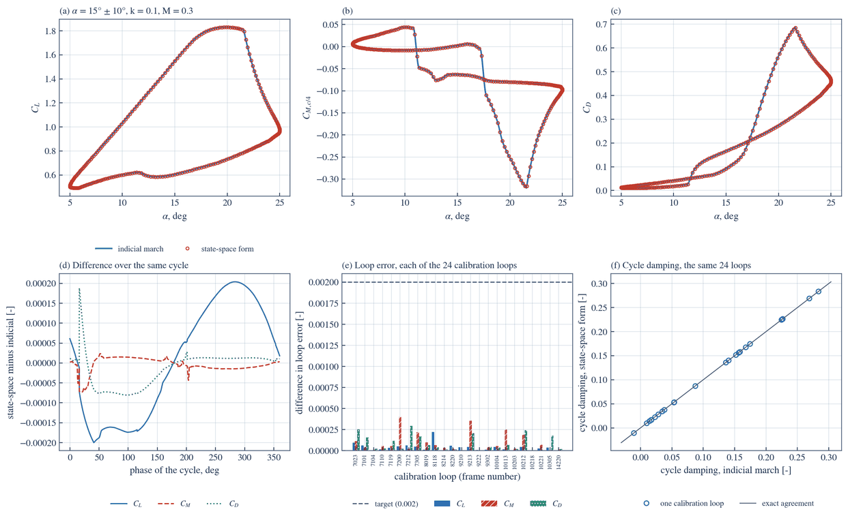
Figure 13. The state-space form against the indicial march (results/figures).
Coupled to a section free in torsion (unistall/structural.py), the pitch angle and its rate join the state vector and the whole is integrated as one system. In 6 of 6 conditions it gives the same sign of growth or decay of the free motion as the step-by-step coupling of the indicial march; the motion grows in 1 of them (results/structural_checks.csv; Table 13). This shows that the two forms of the model agree. It is not a prediction of stall flutter: the growth or decay follows from the cycle damping of the model, which is not predicted through stall.
Table 13. A section free in torsion: logarithmic growth of the motion per cycle from the two forms of the model; model output only (results/structural_checks.csv).
Mean incidence, deg | Amplitude, deg | k | Mach | Cycle damping of the model | Growth per cycle, indicial march | Growth per cycle, state-space form | Same sign
5 | 5 | 0.1 | 0.3 | 0.1575 | -0.00833 | -0.00833 | yes
9 | 5 | 0.1 | 0.3 | 0.1741 | -0.00896 | -0.00897 | yes
11 | 5 | 0.1 | 0.3 | 0.048 | -0.00268 | -0.00274 | yes
12 | 5 | 0.05 | 0.3 | 0.0284 | -0.00139 | -0.00146 | yes
15 | 5 | 0.1 | 0.29 | -0.0506 | 0.00159 | 0.00155 | yes
10 | 8 | 0.15 | 0.25 | 0.0532 | -0.00384 | -0.00394 | yes

9 Results: Case A: tunnel condition
Case A is the NACA 0012 section at Mach 0.30, reduced frequency 0.1000, incidence 10° ± 10°, on a chord of 0.610 m.
Lift rises above its static maximum and reaches 1.80 [-3.3 % mean, 5.3 % standard deviation] at an incidence of 18.1° [-0.3° mean, 0.8° standard deviation]. The onset criterion of the vortex is passed at 14.4°, and the vortex normal force reaches 0.51 at 19.6°. The moment about the quarter chord falls to -0.29 [+0.02 mean, 0.05 standard deviation] at 19.6° and the drag reaches 0.56 [-0.05 mean, 0.08 standard deviation] at 19.6°; the lowest drag over the cycle is 0.004. The figure in brackets after each load is the error of the model in that quantity on the 45 held-out loops, model minus measured, as mean and standard deviation (05_solution/held_out_error_bands.csv); the loads are rounded to match. The vortex clock runs two times in the cycle, which is the number of sheddings the load model counts (2). The cycle damping the model gives is 0.09; as Section 6 shows, the model does not predict cycle damping through stall, so that figure is model output and says nothing about stall flutter. Table 14 lists the scalar results.
Table 14. Scalar results of Case A (05_solution/metrics_A_validation.csv), with the held-out error of the model where the quantity is scored against measurement (05_solution/held_out_error_bands.csv).
Quantity | Case A | Held-out error of the model in this quantity (model minus measured)
Peak lift coefficient | 1.80 | -3.3 % mean, 5.3 % standard deviation
Incidence at peak lift, deg | 18.1 | -0.3° mean, 0.8° standard deviation
Minimum moment coefficient about the quarter chord | -0.29 | +0.02 mean, 0.05 standard deviation
Incidence at minimum moment, deg | 19.6 | no measured counterpart scored
Peak drag coefficient | 0.56 | -0.05 mean, 0.08 standard deviation
Incidence at peak drag, deg | 19.6 | no measured counterpart scored
Lowest drag coefficient | 0.004 | no measured counterpart scored
Incidence at which the onset criterion is passed, deg | 14.4 | no measured counterpart scored
Vortex sheddings per cycle, as the load model counts them | 2 | no measured counterpart scored
Runs of the vortex clock in the cycle (the ramps of the states figure) | 2 | no measured counterpart scored
Greatest vortex normal force | 0.51 | no measured counterpart scored
Incidence at greatest vortex normal force, deg | 19.6 | no measured counterpart scored
Cycle damping (model output only) | 0.089 | no measured counterpart scored

The loops are drawn with the measured points of frame 9302 of NASA TM-84245. The curve is the model at the nominal condition of the case; the points were measured at Mach 0.302, reduced frequency 0.096, incidence 9.8° ± 9.9° (06_postprocessing/overlay_record.csv); both sets of conditions are printed in the legend of each loop. That frame is a calibration loop, so agreement with it is not an independent test. In the accuracy study the frame is run at its own measured conditions (Mach 0.302, reduced frequency 0.096, incidence 9.8° ± 9.9°). There its loop errors are 0.066 in lift, 0.114 in moment and 0.114 in drag; the predicted peak lift is 1.778 against a measured 1.844, and the predicted minimum moment -0.282 against -0.239 (results/validation_table.csv).
Figure 14 shows the loads through the reported cycle, Figure 15 to Figure 17 the loops of lift, moment and drag against incidence, and Figure 18 the states of the model: the static and the lagged separation point, the vortex normal force, the lagged normal force as a fraction of its onset level and the vortex clock as a fraction of the travel time over the chord.
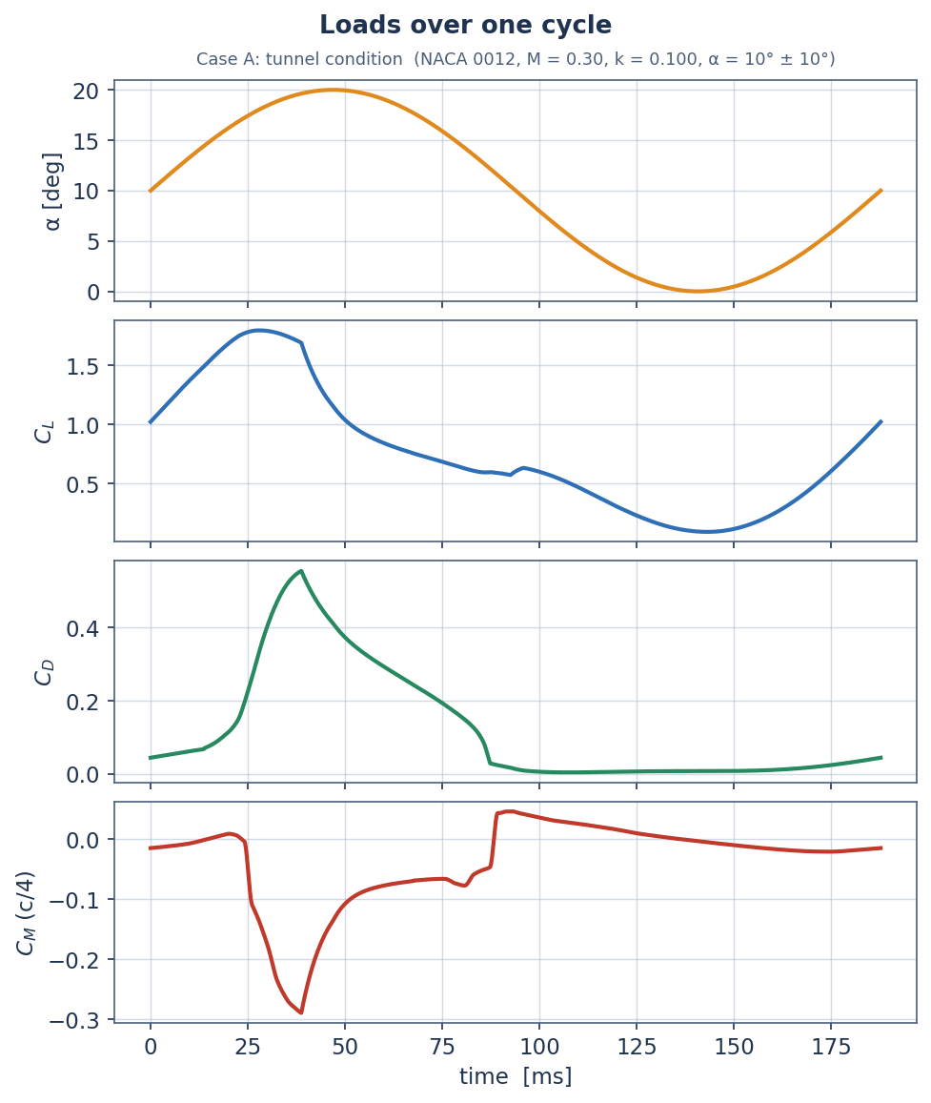
Figure 14. Case A: lift, drag and moment through the reported cycle.
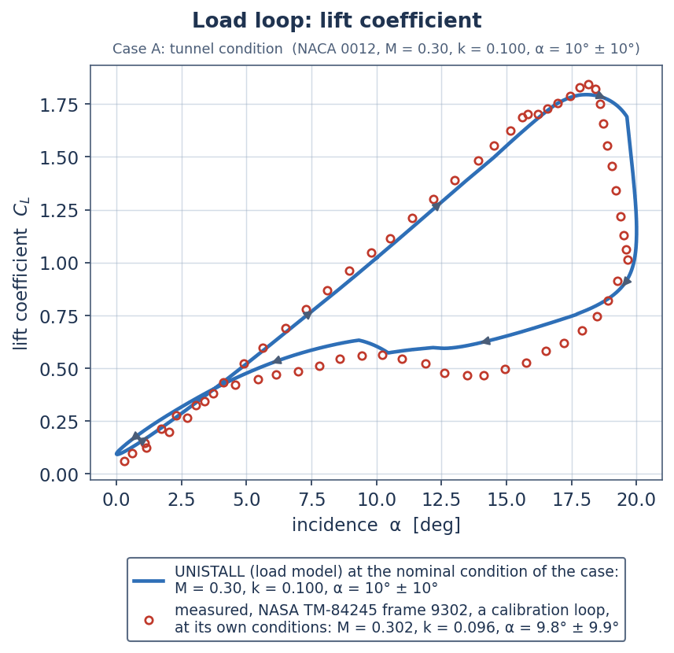
Figure 15. Case A: loop of lift against incidence.
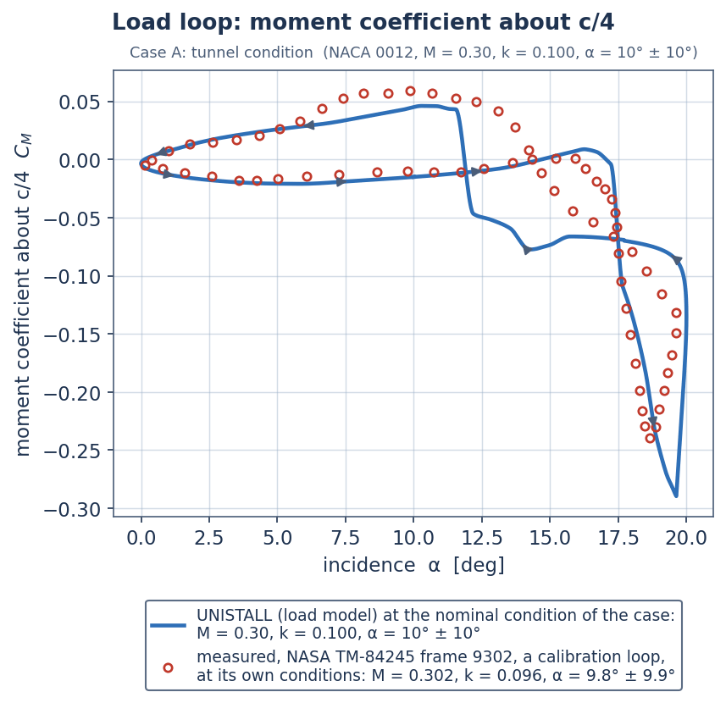
Figure 16. Case A: loop of moment about the quarter chord against incidence.
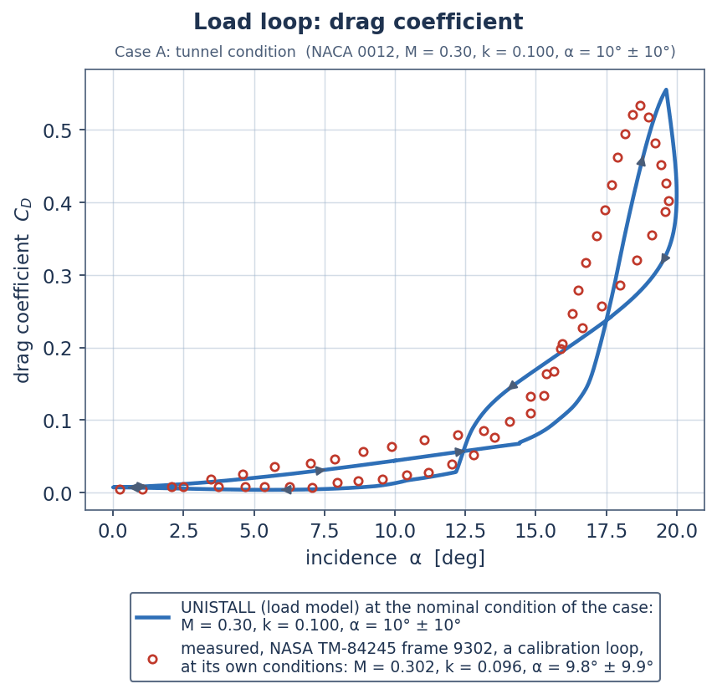
Figure 17. Case A: loop of drag against incidence.
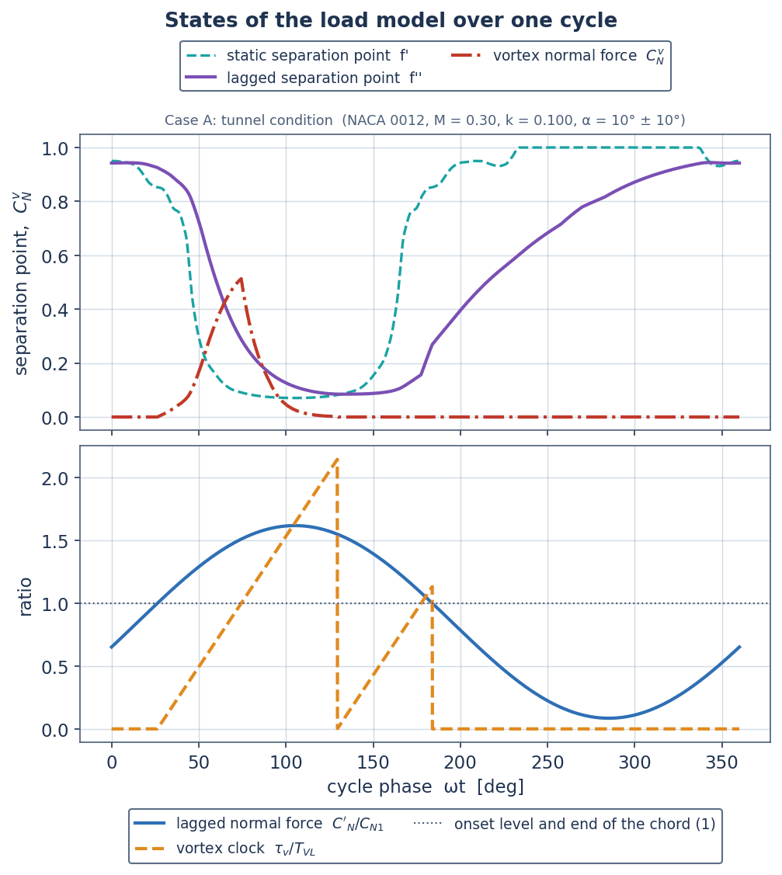
Figure 18. Case A: states of the load model through the reported cycle.

10 Results: Case B: rotor-blade-station condition
Case B is the NACA 0012 section at Mach 0.28, reduced frequency 0.0747, incidence 12° ± 8°, on a chord of 0.527 m.
Case B is not a rotor calculation. It is an aerofoil at a rotor-blade-station condition in a steady stream with prescribed pitch, at the lowest Mach number the station sees round the azimuth and with an assumed incidence history (Section 3). Its static inputs are a blend of two Mach stations, and its results are uncertain within the spread given in Section 5. Nothing here stands for a rotor in flight.

Lift rises above its static maximum and reaches 1.75 [-3.3 % mean, 5.3 % standard deviation] at an incidence of 17.0° [-0.3° mean, 0.8° standard deviation]. The onset criterion of the vortex is passed at 13.8°, and the vortex normal force reaches 0.39 at 18.1°. The moment about the quarter chord falls to -0.24 [+0.02 mean, 0.05 standard deviation] at 18.1° and the drag reaches 0.44 [-0.05 mean, 0.08 standard deviation] at 18.1°; the lowest drag over the cycle is 0.009. The figure in brackets after each load is the error of the model in that quantity on the 45 held-out loops, model minus measured, as mean and standard deviation (05_solution/held_out_error_bands.csv); the loads are rounded to match. The vortex clock runs three times in the cycle, which is the number of sheddings the load model counts (3). The cycle damping the model gives is 0.06; as Section 6 shows, the model does not predict cycle damping through stall, so that figure is model output and says nothing about stall flutter. Table 15 lists the scalar results.
Table 15. Scalar results of Case B (05_solution/metrics_B_application.csv), with the held-out error of the model where the quantity is scored against measurement (05_solution/held_out_error_bands.csv).
Quantity | Case B | Held-out error of the model in this quantity (model minus measured)
Peak lift coefficient | 1.75 | -3.3 % mean, 5.3 % standard deviation
Incidence at peak lift, deg | 17.0 | -0.3° mean, 0.8° standard deviation
Minimum moment coefficient about the quarter chord | -0.24 | +0.02 mean, 0.05 standard deviation
Incidence at minimum moment, deg | 18.1 | no measured counterpart scored
Peak drag coefficient | 0.44 | -0.05 mean, 0.08 standard deviation
Incidence at peak drag, deg | 18.1 | no measured counterpart scored
Lowest drag coefficient | 0.009 | no measured counterpart scored
Incidence at which the onset criterion is passed, deg | 13.8 | no measured counterpart scored
Vortex sheddings per cycle, as the load model counts them | 3 | no measured counterpart scored
Runs of the vortex clock in the cycle (the ramps of the states figure) | 3 | no measured counterpart scored
Greatest vortex normal force | 0.39 | no measured counterpart scored
Incidence at greatest vortex normal force, deg | 18.1 | no measured counterpart scored
Cycle damping (model output only) | 0.065 | no measured counterpart scored

No measurement is compared with in this case.
Figure 19 shows the loads through the reported cycle, Figure 20 to Figure 22 the loops of lift, moment and drag against incidence, and Figure 23 the states of the model: the static and the lagged separation point, the vortex normal force, the lagged normal force as a fraction of its onset level and the vortex clock as a fraction of the travel time over the chord.
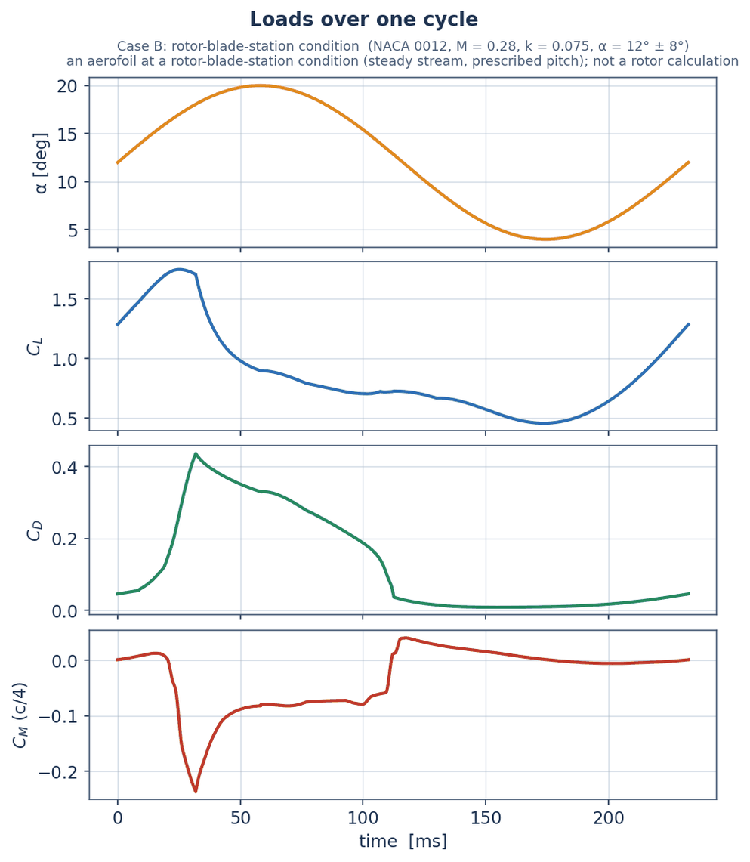
Figure 19. Case B: lift, drag and moment through the reported cycle.
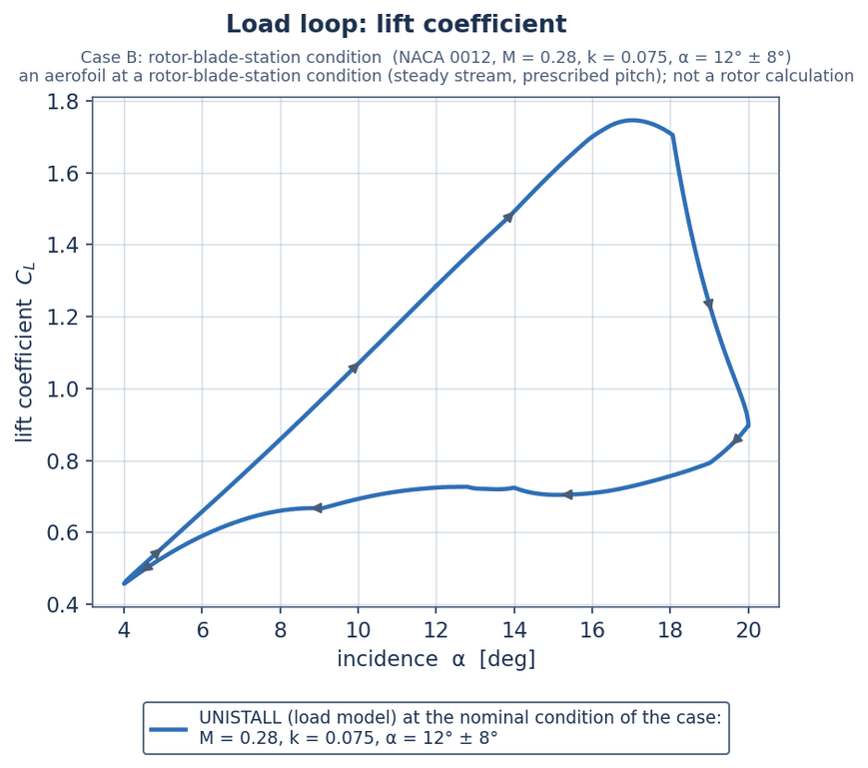
Figure 20. Case B: loop of lift against incidence.
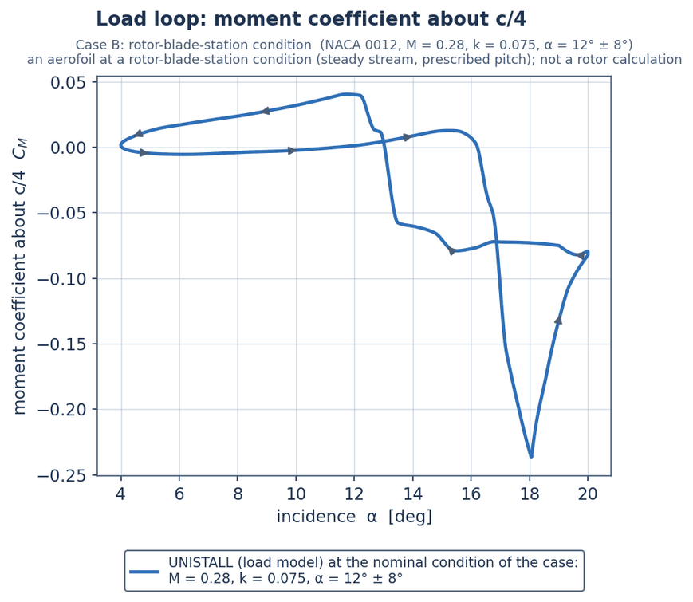
Figure 21. Case B: loop of moment about the quarter chord against incidence.
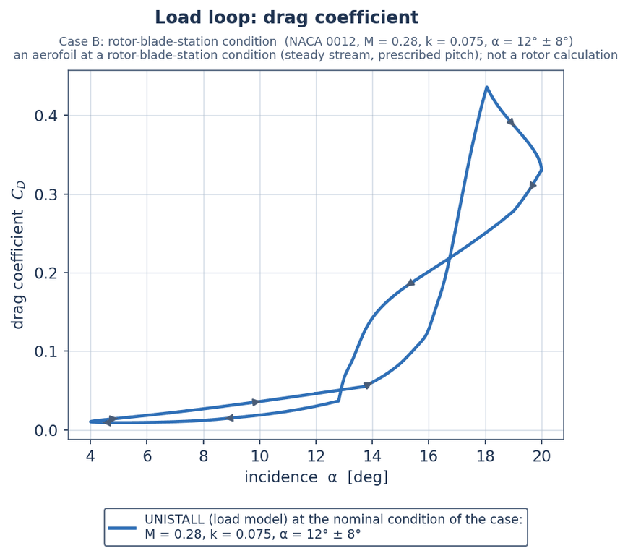
Figure 22. Case B: loop of drag against incidence.
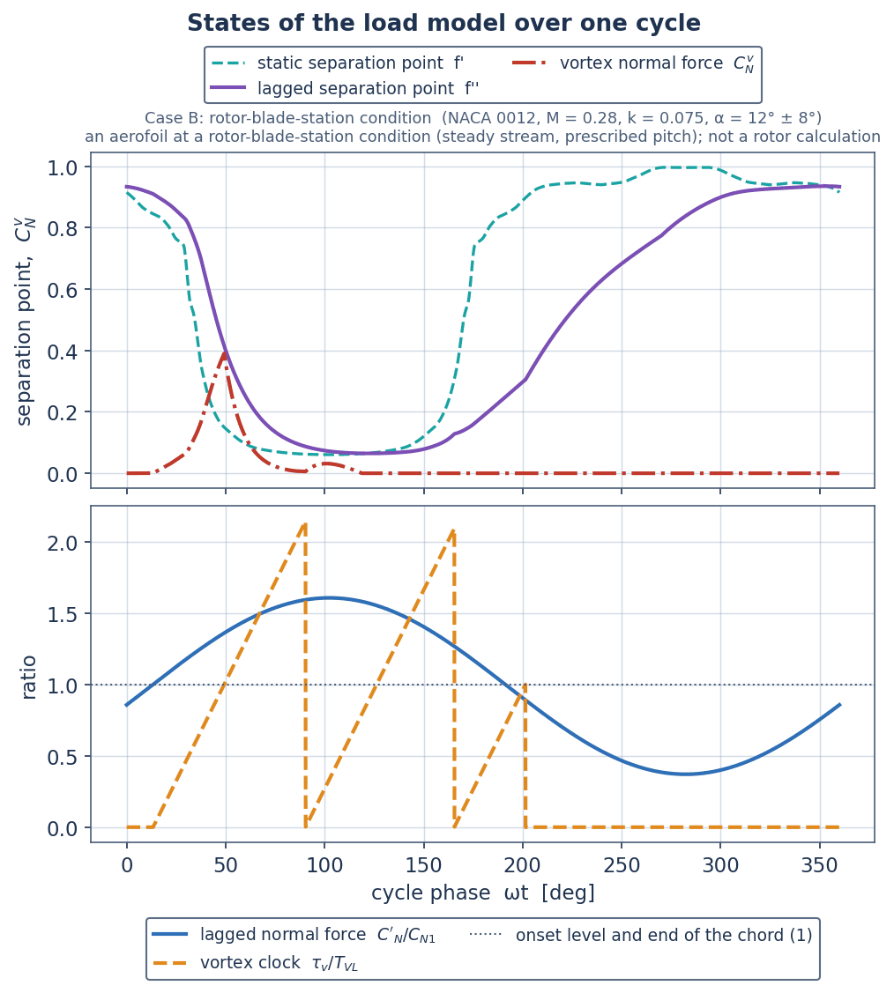
Figure 23. Case B: states of the load model through the reported cycle.

11 The reconstructed flow field
The flow fields are a reconstruction, not a flow solution. Potential-flow reconstruction drawn round the predicted lift, not a flow solution: incompressible, with a linearised (Karman-Tsien) correction of the pressure that holds only where the local flow is subcritical, and quasi-steady (no shed wake, no pitch-rate boundary condition, no unsteady pressure term, vortex not force-free); no boundary layer, no separated shear layer. A transpiration through the suction surface, of either sign, stands for the separated region, which is not drawn: no reversed flow and no wake appear. The vortex is a marker of the model's vortex clock and does not reproduce a suction footprint. Compared with no measurement; no load depends on it. It is given the lift only: its surface pressure does not return the model's moment or drag.

The reconstruction (unistall/flowfield.py) is built from these parts (03_model_setup/solver_config.json).
- The section and its lift. The closed section is 320 straight panels, each carrying a source of constant strength and a vortex sheet of one uniform strength that carries the circulation of the predicted lift. The velocity of every panel comes from the closed-form integrals of the constant-strength panel, the same in the wall condition, on the surface and in the field.
- A transpiration for the separated region. The predicted lift is not, in general, the lift at which potential flow leaves the trailing edge smoothly; in stall it is far below it. Flow is therefore passed through the suction-surface panels aft of the separation point of the load model, rising smoothly from nothing there to its full strength at the trailing edge. Its strength is the single number that makes the pressure the same at the two control points next to the trailing edge (the Kutta condition) while the circulation stays that of the predicted lift. It takes either sign: an outflow where the predicted lift is below the Kutta value and an inflow, a suction into the wall, where it is above it. Where the flow of the model is attached the transpiration is confined to the last 0.05 of the suction surface.
- The vortex marker. A single Lamb-Oseen vortex marks the vortex clock of the load model. It carries the circulation of the predicted vortex normal force and moves along a straight path that puts it over the trailing edge when the clock says the vortex leaves the chord, and downstream of it afterwards. Its path and its core radius (0.05 of the chord) are assumed.
- A linearised correction for compressibility. The incompressible pressure coefficient is corrected by the Kármán-Tsien rule at the stream Mach number of the case, and the sheet is given the fraction of the circulation of the lift at which the corrected surface pressure returns the lift given; the fraction is solved at each instant, starting from the Prandtl-Glauert factor. From the corrected pressure the local Mach number, the static temperature and the recovery temperature follow by the isentropic relations with the stagnation state of the stream; the recovery factor is 0.896 (Pr^(1/3), the usual value for a turbulent boundary layer on a flat plate, with Pr = 0.72 for air). This is a correction applied to an incompressible reconstruction, not a compressible solution, and it holds only where the local flow is subcritical. Where the corrected pressure coefficient is below the critical value, -6.95 in Case A and -8.06 in Case B, the local Mach number it gives is above one and the values are not physical: that region is hatched in every figure and its size is given at each instant. The corrected value is not allowed below 0.95 of the vacuum value.
The incompressible velocity, the pressure coefficient (corrected and incompressible), the local Mach number, the static and recovery temperatures, the vorticity and the flag of the region beyond the critical pressure are stored on a rectangular grid of 180 by 140 points over x/c from -1.0 to 2.0 and y/c from -1.2 to 1.2, at four instants of the cycle.

11.1 Limits of the reconstruction
- It is potential flow round the predicted lift. There is no boundary layer and no separated shear layer.
- It is quasi-steady. Each instant is a steady flow at that instant's incidence and lift, with steady Bernoulli pressure: no shed wake; no pitch-rate boundary condition; no unsteady pressure term; vortex not force-free. The circulation the sheet carries is that of the lift; with the vortex marker present the total circulation round section and marker is larger, and the two are tabulated side by side below.
- The compressibility correction is linearised and holds only for subcritical flow. At peak lift the lowest incompressible surface pressure coefficient is -15.4 in Case A and -13.8 in Case B; corrected, the pressure is below the critical value over a fraction 0.032 and 0.023 of the surface at the leading edge, and over 0.0009 c² and 0.0006 c² of the field. Inside that region the pressure, the local Mach number and the temperatures are not physical: no shock and no supersonic region is represented. The region is hatched in the figures and its size tabulated per instant; some of the surface is in it over a fraction 0.37 of the cycle in Case A and 0.37 in Case B.
- The temperatures are isentropic estimates. They follow from the corrected pressure with a uniform total temperature; there is no heat conduction. The recovery temperature is that of an adiabatic wall under a turbulent boundary layer, which the reconstruction does not have; in a field map it is only what such a wall would take at the local state.
- The transpiration is an equivalent one, and it is not always an outflow. It is chosen to satisfy the Kutta condition, and its shape is chosen for illustration. Over the cycle it reaches -0.059 U at the trailing edge at its lowest and an inflow over a fraction 0.20 of the cycle in Case A, and +0.032 U at the trailing edge at its lowest and an inflow over a fraction 0.00 of the cycle in Case B. It is not a model of the flow inside a separated region.
- The separated region is not drawn. The transpiration produces no reversed flow, no shear layer and no wake, so the maps at the instants of deep stall look like attached flow. They are not pictures of a stalled flow; each map marks the separation point of the load model on the section.
- The vortex is a marker of the vortex clock, not a model of the dynamic-stall vortex. A clockwise vortex above the surface slows the surface flow beneath it and so raises the pressure there, where a dynamic-stall vortex leaves a suction footprint: in Case A the marker is over the chord at three of the stored instants and raises the surface pressure coefficient beneath it at two of them (change from -0.14 to +0.56); in Case B the marker is over the chord at three of the stored instants and raises the surface pressure coefficient beneath it at two of them (change from -0.11 to +0.36). Its path and core radius are assumed.
- The surface pressure does not integrate exactly to the lift it was given, and does not return the model's moment or drag (next paragraphs).
- The vorticity maps show the singularities, not a vorticity field. The vorticity of the reconstruction is zero everywhere except in the core of the vortex marker; the bound sheet lies on the surface itself. No boundary-layer or wake vorticity is in them, and no sign information about a real flow should be read from them.
- Not compared with measurement. No measured pressure or velocity is set beside any of it.
Closure of the lift. The model's lift is the lift of a compressible flow, so the pressure compared with it is the corrected one. With the whole circulation of the lift on the sheet, the incompressible surface pressure returns the lift at peak lift within -1.00 % in Case A and -0.67 % in Case B (panels alone, a solid wall and no vortex: -0.73 % and -0.66 %); correcting that pressure would raise the lift above the one given. With the circulation reduced by the Prandtl-Glauert factor (0.954 and 0.960), the corrected pressure returns the lift within +6.10 % and +7.52 %: the Kármán-Tsien rule raises a strong suction by more than that factor. The reconstruction that is stored therefore solves the fraction of the circulation at each instant so that the corrected pressure returns the lift given: at peak lift the fraction is 0.893 and 0.889 (over the cycle from 0.881 to 0.963 and from 0.884 to 0.967), and what is left of the difference is the tolerance of that solution (1.1 × 10⁻⁵ % and 2.6 × 10⁻⁶ %). The lift closes because it is made to; the corrected pressure inside the region beyond the critical value, which is not physical, is part of the integral. The reconstructed surface pressures are therefore a picture and not a second source of the loads.
The reconstruction is given the lift and nothing else. Its surface pressure does not return the model's moment or drag. At peak lift the pitching moment about the quarter chord found from the surface pressure differs from the model's by +0.277 in Case A and +0.244 in Case B, and the two have the same sign at only 2 and 3 of the 6 stored instants: through stall the model's moment is nose down and that of the reconstruction is not. The pressure drag of the surface pressure differs from the model's drag by -0.466 and -0.415 at peak lift and by up to 0.682 and 0.594 over the stored instants. A potential flow with a transpiration carries neither the aft loading of a separated flow nor its drag. No pressure, moment or drag should be read from these fields.
Dependence on the number of panels. The six stored instants of each case were solved again with a quarter, a half and twice the 320 panels used. Table 16 gives the largest change of each quoted quantity over the six instants when the panels are doubled, with the tolerance set for it: 8 of the 8 entries change by less than their tolerance on doubling from 320 panels. The lowest pressure coefficient is the value at a control point of an incompressible solution with a sharp suction peak; it is quoted to the figures this table supports and no further.
Table 16. Largest change of the quoted quantities of the reconstruction over the six instants when the number of panels is doubled (05_solution/convergence/panel_convergence_summary.csv).
Case | Quantity | Change measured as | Half to the panels used | Panels used to twice as many | Tolerance | Within tolerance on doubling
Case A | Lowest incompressible surface pressure coefficient | percent of the value | 0.941 | 0.367 | 1 | yes
Case A | Transpiration at the trailing edge, over U | absolute | 0.00144 | 0.000991 | 0.005 | yes
Case A | Lift difference of the incompressible surface pressure | percentage points | 0.373 | 0.19 | 0.5 | yes
Case A | Part of the surface beyond the critical pressure | absolute | 0.00254 | 0.00109 | 0.005 | yes
Case B | Lowest incompressible surface pressure coefficient | percent of the value | 1.15 | 0.342 | 1 | yes
Case B | Transpiration at the trailing edge, over U | absolute | 0.001 | 0.000774 | 0.005 | yes
Case B | Lift difference of the incompressible surface pressure | percentage points | 0.324 | 0.166 | 0.5 | yes
Case B | Part of the surface beyond the critical pressure | absolute | 0.00175 | 0.0014 | 0.005 | yes

11.2 Figures and pictures of the reconstruction
Table 17 gives the scalar figures of the reconstruction, Table 18 the quantities that are assumed and not results, and Table 19 to Table 24 the transpiration, the circulations, the corrected pressure with the size of the region beyond the critical value, the local state and the closure at each stored instant.
Figure 24 to Figure 39 show the reconstruction; every one of them is subject to the limits above. In every figure the pressure coefficient is shown with suction upwards, and each figure of a corrected quantity prints the part of the surface and of the field beyond the critical pressure at its instant.
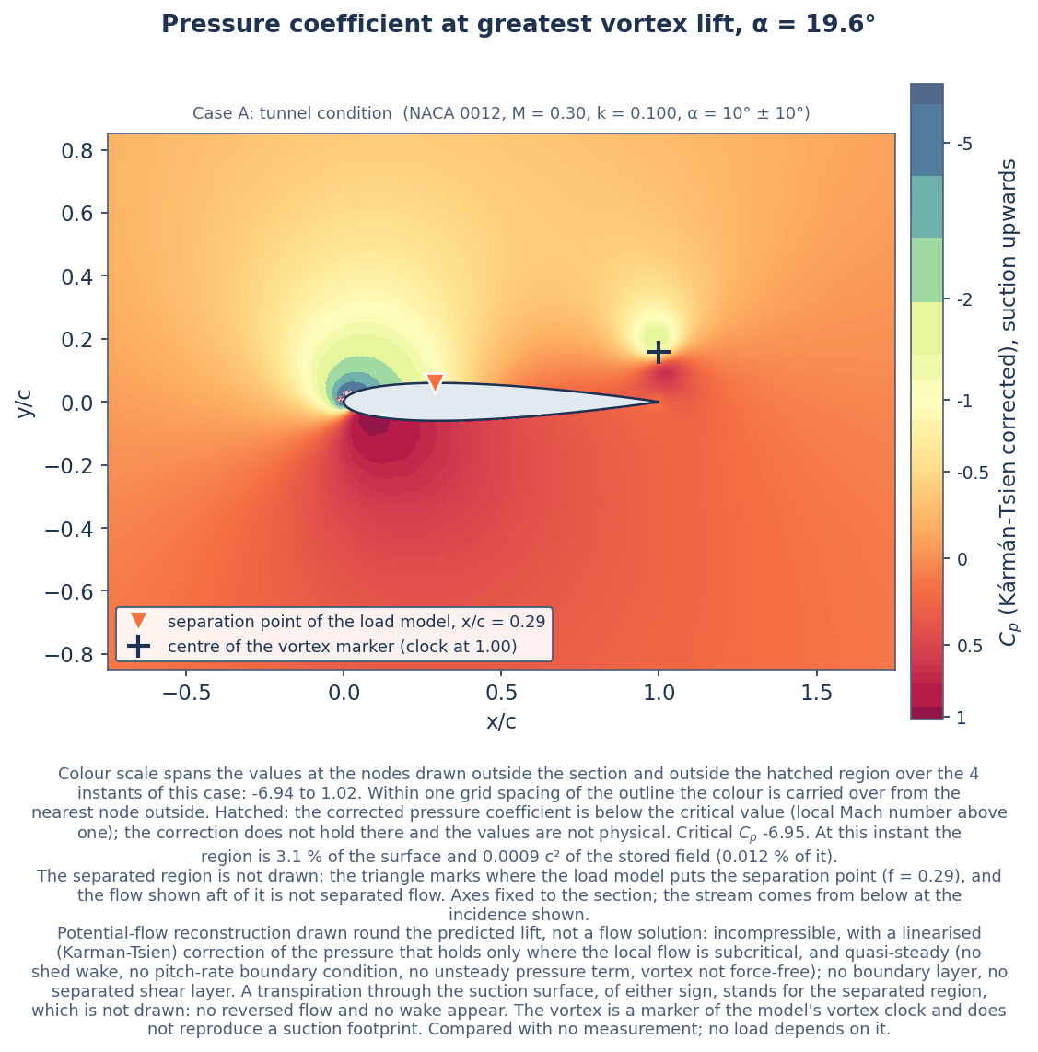
Figure 24. Case A, instant of greatest vortex normal force: corrected pressure coefficient. Hatched: the corrected pressure coefficient is below the critical value (local Mach number above one); the correction does not hold there and the values are not physical. The separated region is not drawn; the triangle marks the separation point of the load model. Potential-flow reconstruction drawn round the predicted lift, not a flow solution: incompressible, with a linearised (Karman-Tsien) correction of the pressure that holds only where the local flow is subcritical, and quasi-steady (no shed wake, no pitch-rate boundary condition, no unsteady pressure term, vortex not force-free); no boundary layer, no separated shear layer. A transpiration through the suction surface, of either sign, stands for the separated region, which is not drawn: no reversed flow and no wake appear. The vortex is a marker of the model's vortex clock and does not reproduce a suction footprint. Compared with no measurement; no load depends on it.
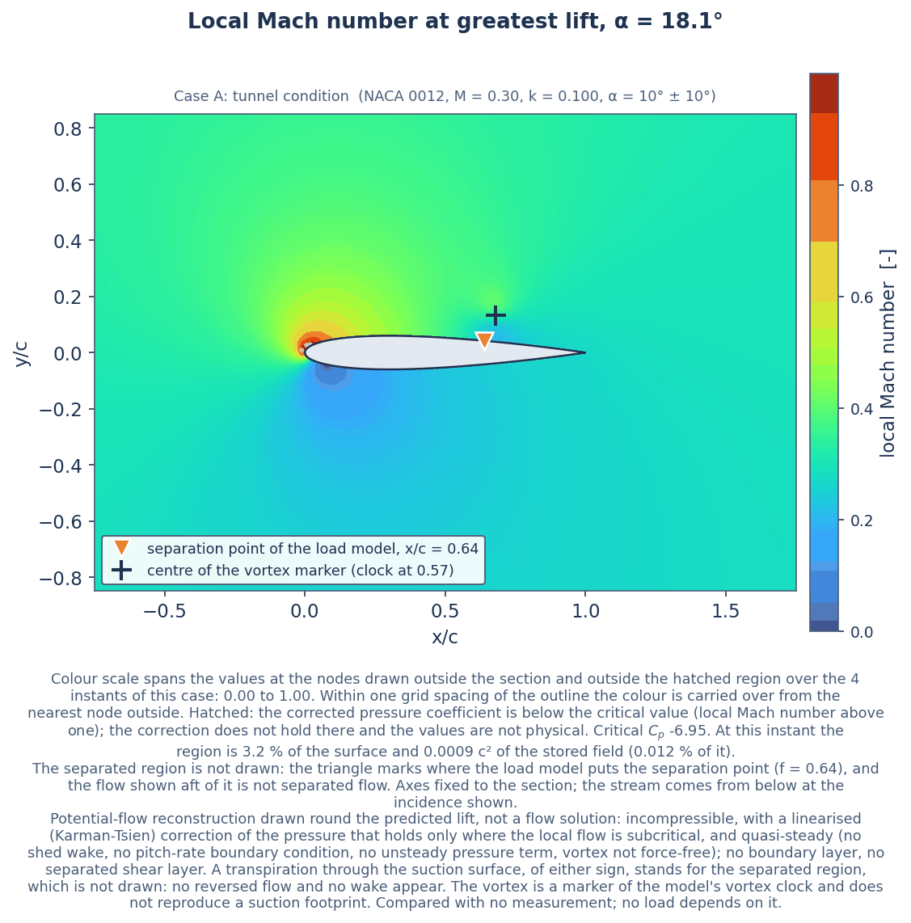
Figure 25. Case A, instant of greatest lift: local Mach number from the corrected pressure. Hatched: the corrected pressure coefficient is below the critical value (local Mach number above one); the correction does not hold there and the values are not physical. The separated region is not drawn; the triangle marks the separation point of the load model. Potential-flow reconstruction drawn round the predicted lift, not a flow solution: incompressible, with a linearised (Karman-Tsien) correction of the pressure that holds only where the local flow is subcritical, and quasi-steady (no shed wake, no pitch-rate boundary condition, no unsteady pressure term, vortex not force-free); no boundary layer, no separated shear layer. A transpiration through the suction surface, of either sign, stands for the separated region, which is not drawn: no reversed flow and no wake appear. The vortex is a marker of the model's vortex clock and does not reproduce a suction footprint. Compared with no measurement; no load depends on it.
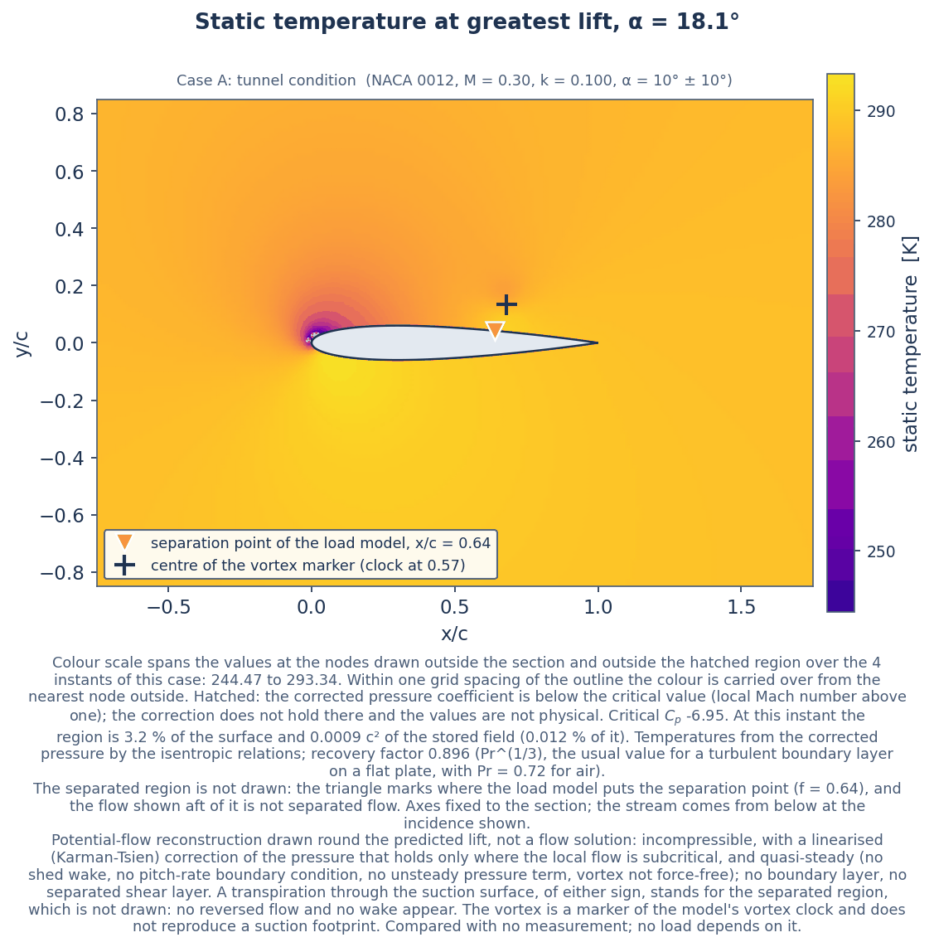
Figure 26. Case A, instant of greatest lift: static temperature, an isentropic estimate from the corrected pressure. Hatched: the corrected pressure coefficient is below the critical value (local Mach number above one); the correction does not hold there and the values are not physical. Potential-flow reconstruction drawn round the predicted lift, not a flow solution: incompressible, with a linearised (Karman-Tsien) correction of the pressure that holds only where the local flow is subcritical, and quasi-steady (no shed wake, no pitch-rate boundary condition, no unsteady pressure term, vortex not force-free); no boundary layer, no separated shear layer. A transpiration through the suction surface, of either sign, stands for the separated region, which is not drawn: no reversed flow and no wake appear. The vortex is a marker of the model's vortex clock and does not reproduce a suction footprint. Compared with no measurement; no load depends on it.
Table 17. Scalar figures of the reconstruction (05_solution/metrics_A_validation.csv, 05_solution/metrics_B_application.csv).
Quantity | Case A | Case B
Critical pressure coefficient at the stream Mach number | -6.95 | -8.06
Pressure coefficient of a vacuum at the stream Mach number | -15.87 | -18.22
Total temperature of the stream, K | 293.34 | 292.67
Recovery factor | 0.896 | 0.896
Lowest incompressible surface pressure coefficient over the stored instants | -16.0 | -14.7
Lowest corrected surface pressure coefficient over the stored instants (held at the vacuum-side bound) | -15.1 | -17.3
Largest part of the surface beyond the critical pressure over the stored instants, fraction | 0.032 | 0.023
The same over the whole cycle | 0.033 | 0.025
Fraction of the cycle with any of the surface beyond the critical pressure | 0.37 | 0.37
Largest area of the field beyond the critical pressure, over c² | 0.0009 | 0.0006
The same as a fraction of the stored field | 0.00012 | 0.00008
Lift from the stored (corrected) surface pressure at peak lift, difference from the lift given, % | 1.1 × 10⁻⁵ | 2.6 × 10⁻⁶
Fraction of the circulation of the lift the sheet carries for that, at peak lift | 0.893 | 0.889
Prandtl-Glauert factor the fraction starts from | 0.954 | 0.960
Lift difference of the corrected pressure with the circulation fixed at the Prandtl-Glauert factor, at peak lift, % | +6.10 | +7.52
Lift difference of the incompressible pressure with the whole circulation, at peak lift, % | -1.00 | -0.67
The same with the panels alone (solid wall, no vortex), % | -0.73 | -0.66
Largest lift difference of the incompressible pressure over the stored instants, % | 3.45 | 3.55
Smallest fraction of the circulation over the cycle | 0.881 | 0.884
Largest fraction of the circulation over the cycle | 0.963 | 0.967
Pitching moment of the surface pressure less the model's, at peak lift | +0.277 | +0.244
Pressure drag of the surface pressure less the model's drag, at peak lift | -0.466 | -0.415
Largest moment difference over the stored instants | 0.415 | 0.363
Largest drag difference over the stored instants | 0.682 | 0.594
Stored instants at which the two moments have the same sign | 2 | 3
Stored instants | 6 | 6
Largest difference of pressure coefficient across the trailing edge over the stored instants | 1.1 × 10⁻⁸ | 6.5 × 10⁻⁹
Greatest transpiration speed at the trailing edge over the cycle, over U (outflow) | 0.597 | 0.583
Least transpiration speed over the cycle, over U (negative: inflow) | -0.059 | +0.032
Fraction of the cycle with inflow | 0.205 | 0.000
Greatest flux through the suction surface over the cycle, over U c | 0.259 | 0.268
Circulation of the vortex marker at its greatest, over U c | 0.257 | 0.195
Vorticity at the centre of the vortex marker at its greatest, times c / U | 32.7 | 24.8
Incompressible pressure coefficient at the centre of the vortex marker | -0.99 | -0.56

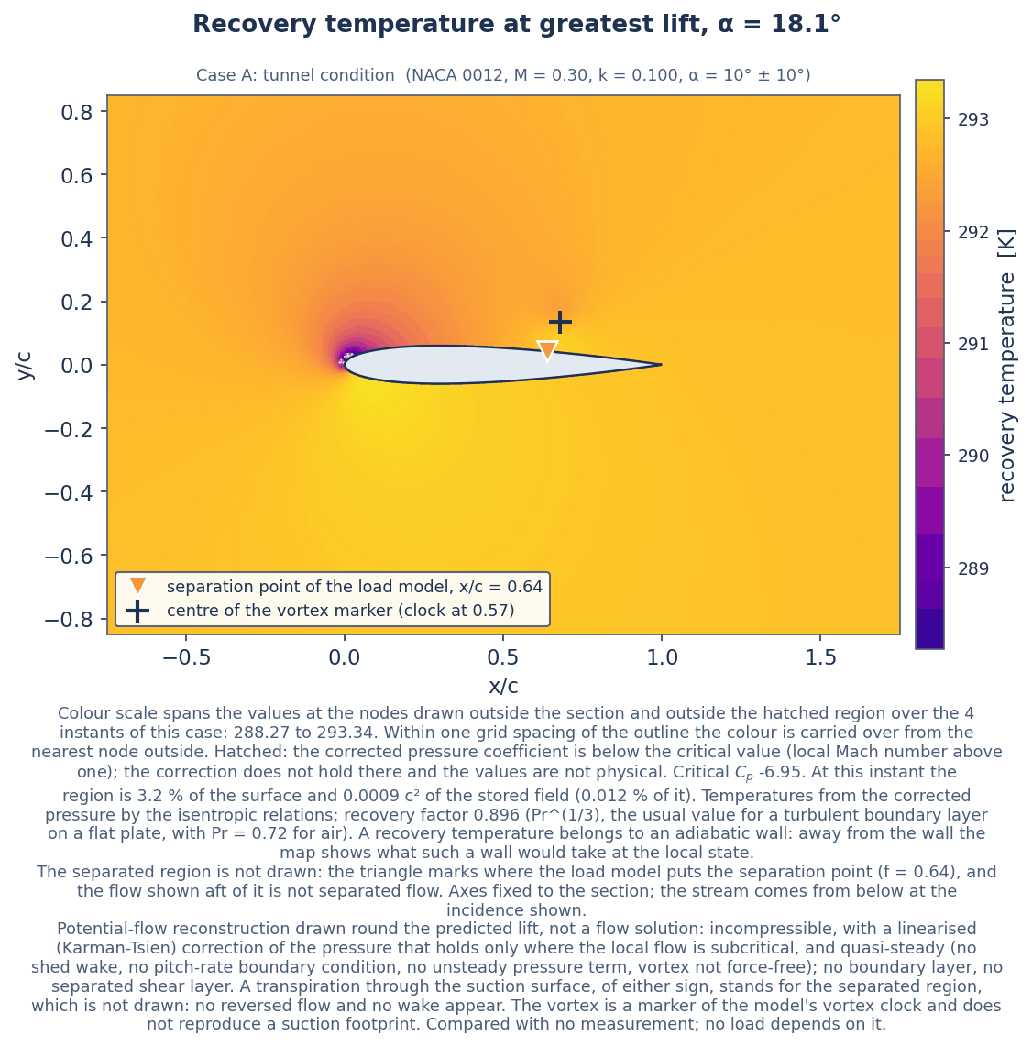
Figure 27. Case A, instant of greatest lift: recovery temperature. It belongs to an adiabatic wall under a turbulent boundary layer, which the reconstruction does not have; away from the wall the map shows what such a wall would take at the local state. Hatched: the corrected pressure coefficient is below the critical value (local Mach number above one); the correction does not hold there and the values are not physical. Potential-flow reconstruction drawn round the predicted lift, not a flow solution: incompressible, with a linearised (Karman-Tsien) correction of the pressure that holds only where the local flow is subcritical, and quasi-steady (no shed wake, no pitch-rate boundary condition, no unsteady pressure term, vortex not force-free); no boundary layer, no separated shear layer. A transpiration through the suction surface, of either sign, stands for the separated region, which is not drawn: no reversed flow and no wake appear. The vortex is a marker of the model's vortex clock and does not reproduce a suction footprint. Compared with no measurement; no load depends on it.
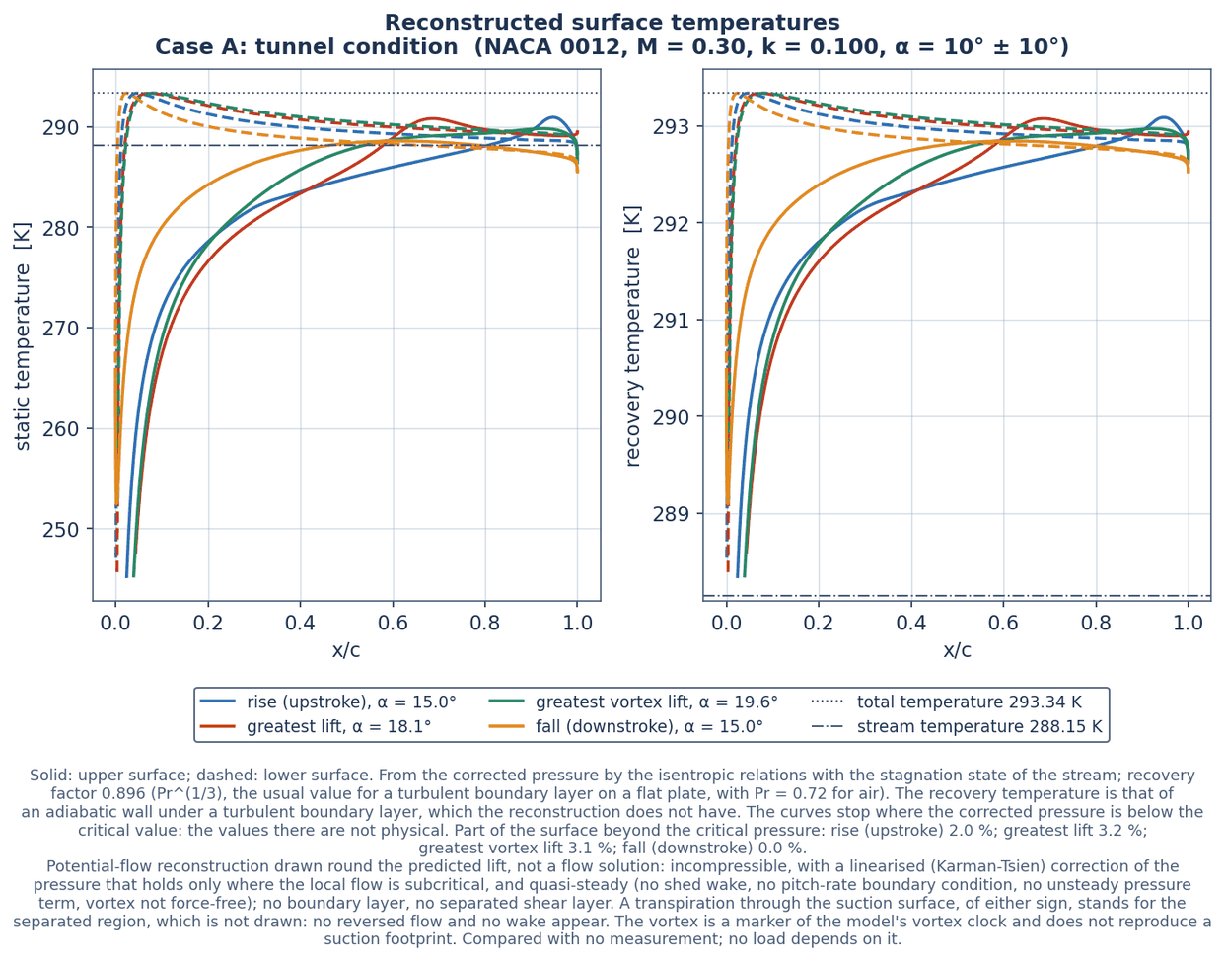
Figure 28. Case A: static and recovery temperature along the surface; the curves stop where the corrected pressure is below the critical value. Potential-flow reconstruction drawn round the predicted lift, not a flow solution: incompressible, with a linearised (Karman-Tsien) correction of the pressure that holds only where the local flow is subcritical, and quasi-steady (no shed wake, no pitch-rate boundary condition, no unsteady pressure term, vortex not force-free); no boundary layer, no separated shear layer. A transpiration through the suction surface, of either sign, stands for the separated region, which is not drawn: no reversed flow and no wake appear. The vortex is a marker of the model's vortex clock and does not reproduce a suction footprint. Compared with no measurement; no load depends on it.
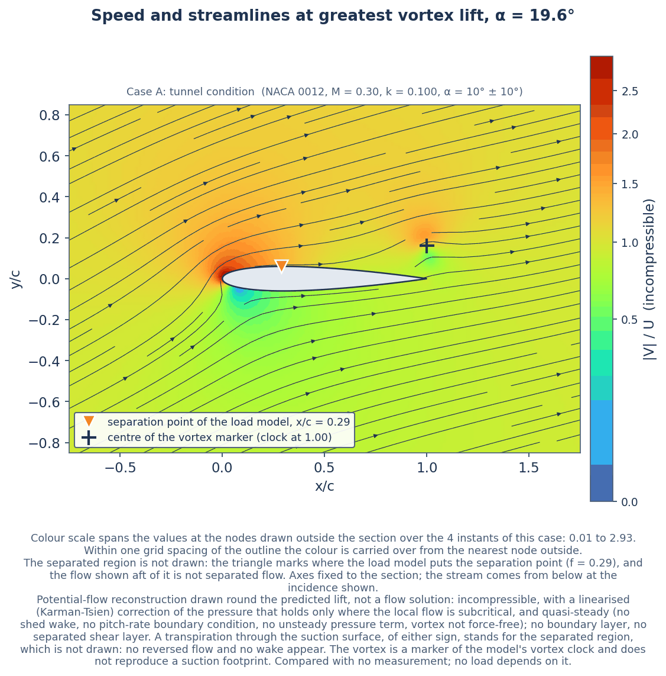
Figure 29. Case A, instant of greatest vortex normal force: speed of the incompressible solution and streamlines. The separated region is not drawn; the triangle marks the separation point of the load model. Potential-flow reconstruction drawn round the predicted lift, not a flow solution: incompressible, with a linearised (Karman-Tsien) correction of the pressure that holds only where the local flow is subcritical, and quasi-steady (no shed wake, no pitch-rate boundary condition, no unsteady pressure term, vortex not force-free); no boundary layer, no separated shear layer. A transpiration through the suction surface, of either sign, stands for the separated region, which is not drawn: no reversed flow and no wake appear. The vortex is a marker of the model's vortex clock and does not reproduce a suction footprint. Compared with no measurement; no load depends on it.
Table 18. Quantities of the vortex marker that follow from constants chosen for illustration: settings, not results, and the same in the two cases at the same clock (05_solution/metrics_A_validation.csv, 05_solution/metrics_B_application.csv).
Assumed quantity | Case A | Case B
Vortex marker position x/c at its greatest (assumed path) | 1.00 | 1.00
Vortex marker position y/c at its greatest (assumed path) | 0.16 | 0.16
Core radius of the vortex marker, over c (assumed) | 0.05 | 0.05

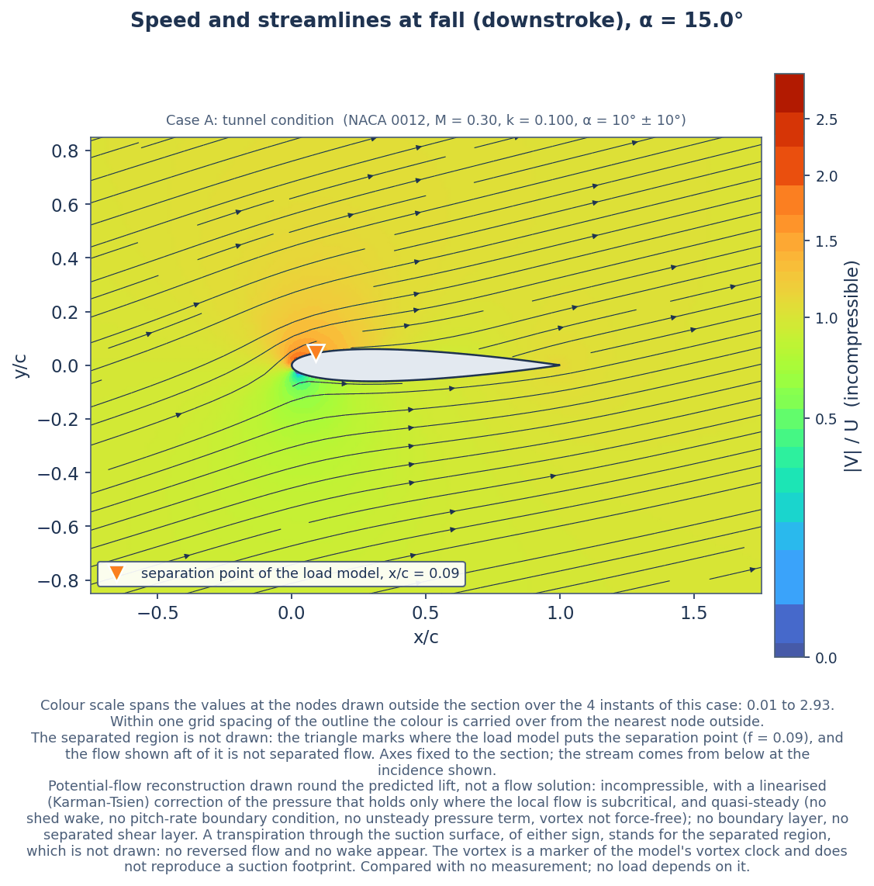
Figure 30. Case A, downstroke, deep in stall by the load model: speed and streamlines. The flow drawn looks attached because the separated region is not represented. The separated region is not drawn; the triangle marks the separation point of the load model. Potential-flow reconstruction drawn round the predicted lift, not a flow solution: incompressible, with a linearised (Karman-Tsien) correction of the pressure that holds only where the local flow is subcritical, and quasi-steady (no shed wake, no pitch-rate boundary condition, no unsteady pressure term, vortex not force-free); no boundary layer, no separated shear layer. A transpiration through the suction surface, of either sign, stands for the separated region, which is not drawn: no reversed flow and no wake appear. The vortex is a marker of the model's vortex clock and does not reproduce a suction footprint. Compared with no measurement; no load depends on it.
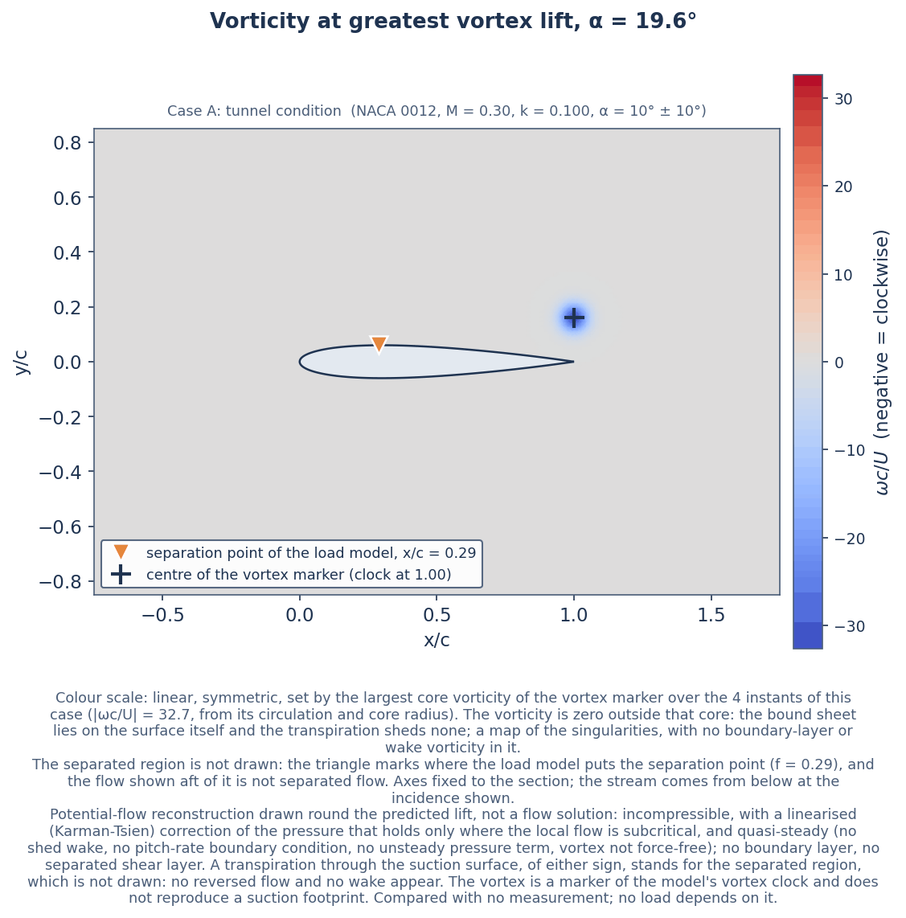
Figure 31. Case A, instant of greatest vortex normal force: vorticity. A picture of the singularities with no physical sign information: it is zero outside the core of the vortex marker, and no boundary-layer or wake vorticity is in it. Potential-flow reconstruction drawn round the predicted lift, not a flow solution: incompressible, with a linearised (Karman-Tsien) correction of the pressure that holds only where the local flow is subcritical, and quasi-steady (no shed wake, no pitch-rate boundary condition, no unsteady pressure term, vortex not force-free); no boundary layer, no separated shear layer. A transpiration through the suction surface, of either sign, stands for the separated region, which is not drawn: no reversed flow and no wake appear. The vortex is a marker of the model's vortex clock and does not reproduce a suction footprint. Compared with no measurement; no load depends on it.
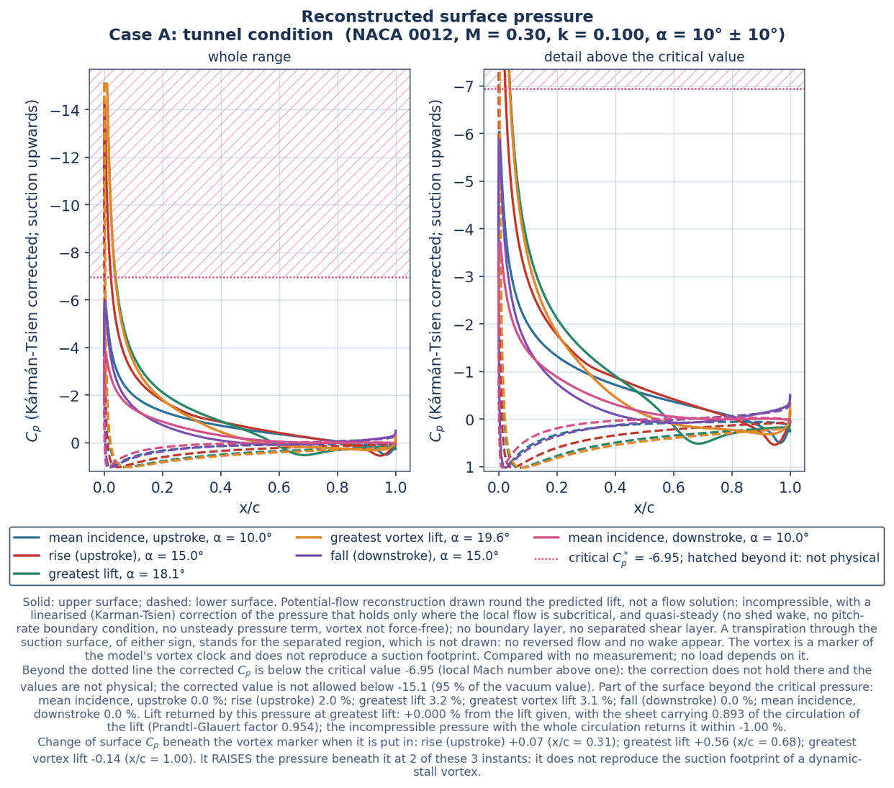
Figure 32. Case A: reconstructed surface pressure at instants of the cycle, with the band beyond the critical value hatched. The note under the figure gives the part of the surface in that band, the closure of the lift and the change of pressure beneath the vortex marker at each instant with its sign. Potential-flow reconstruction drawn round the predicted lift, not a flow solution: incompressible, with a linearised (Karman-Tsien) correction of the pressure that holds only where the local flow is subcritical, and quasi-steady (no shed wake, no pitch-rate boundary condition, no unsteady pressure term, vortex not force-free); no boundary layer, no separated shear layer. A transpiration through the suction surface, of either sign, stands for the separated region, which is not drawn: no reversed flow and no wake appear. The vortex is a marker of the model's vortex clock and does not reproduce a suction footprint. Compared with no measurement; no load depends on it.
Table 19. Case A: the reconstruction instant by instant, the transpiration and the circulations (05_solution/reconstruction_A_validation.csv). Total circulation is that of the sheet plus that of the vortex marker. A blank in the last column means the marker is not over the chord at that instant.
Instant | Incidence, deg | Separation point, x/c | Transpiration at the edge, over U | Flux through the surface, over U c | Circulation of the sheet, over U c | Total circulation, over U c | Change of Cp beneath the vortex
mean up | 10 | 0.942 | 0.335 | 0.00975 | 0.471 | 0.471
rise | 15 | 0.913 | 0.421 | 0.0185 | 0.692 | 0.698 | 0.0724
peak | 18.1 | 0.639 | 0.211 | 0.0383 | 0.801 | 0.922 | 0.558
dsv | 19.6 | 0.288 | 0.544 | 0.195 | 0.759 | 1.02 | -0.137
fall | 15 | 0.0875 | 0.445 | 0.204 | 0.305 | 0.305
mean down | 10 | 0.203 | 0.247 | 0.0989 | 0.29 | 0.29

Table 20. Case A: the reconstruction instant by instant, the corrected pressure, the region beyond the critical pressure and the local state (05_solution/reconstruction_A_validation.csv). The field is stored at four of the six instants; the others are blank in the field columns.
Instant | Lowest surface Cp, incompressible | Lowest surface Cp, corrected | Surface beyond critical, fraction | Field beyond critical, over c² | Field beyond critical, fraction | Highest surface Mach number outside that region | Lowest surface static temperature outside it, K | Highest surface recovery temperature, K
mean up | -5.06 | -6.04 | 0 |  |  | 0.915 | 251 | 293
rise | -10.3 | -14.4 | 0.0196 | 0 | 0 | 0.991 | 245 | 293
peak | -15.4 | -15.1 | 0.0321 | 0.000868 | 0.00012 | 0.985 | 246 | 293
dsv | -16 | -15.1 | 0.0309 | 0.000868 | 0.00012 | 0.99 | 245 | 293
fall | -4.94 | -5.88 | 0 | 0 | 0 | 0.9 | 252 | 293
mean down | -3.28 | -3.73 | 0 |  |  | 0.704 | 267 | 293

Table 21. Case A: the reconstruction instant by instant, the loads its surface pressure returns beside the model's (05_solution/reconstruction_A_validation.csv).
Instant | Fraction of the circulation carried | Lift difference, corrected pressure, % | The same at the Prandtl-Glauert factor, % | Lift difference, incompressible, % | Lift difference, panels alone, % | Moment, model | Moment, surface pressure | Drag, model | Pressure drag, surface pressure
mean up | 0.923 | -3.31 × 10⁻⁷ | 3.35 | -0.495 | -0.764 | -0.0151 | 0.0508 | 0.0439 | -0.0189
rise | 0.892 | 2.95 × 10⁻⁸ | 7.11 | -0.728 | -0.662 | 0.00187 | 0.0828 | 0.079 | -0.0722
peak | 0.893 | 1.06 × 10⁻⁵ | 6.1 | -0.996 | -0.73 | -0.139 | 0.138 | 0.338 | -0.128
dsv | 0.898 | 2.81 × 10⁻⁵ | 5.13 | -1.58 | -1.09 | -0.29 | 0.125 | 0.555 | -0.127
fall | 0.936 | 4.32 × 10⁻⁸ | 1.73 | -2.6 | -4.24 | -0.0735 | 0.0863 | 0.169 | -0.00342
mean down | 0.962 | -2.03 × 10⁻⁶ | -0.793 | -3.45 | -2.92 | 0.045 | 0.0632 | 0.0129 | -0.00421

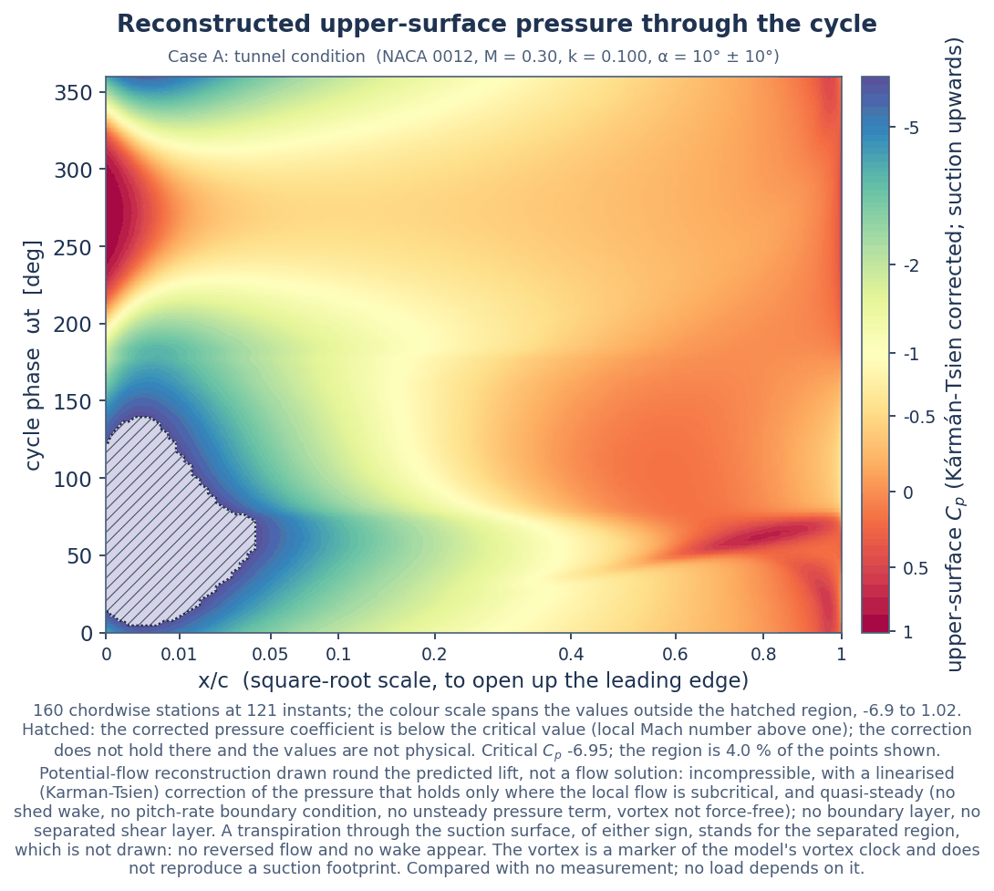
Figure 33. Case A: reconstructed upper-surface pressure over the chord and the cycle. Hatched: the corrected pressure coefficient is below the critical value (local Mach number above one); the correction does not hold there and the values are not physical. Potential-flow reconstruction drawn round the predicted lift, not a flow solution: incompressible, with a linearised (Karman-Tsien) correction of the pressure that holds only where the local flow is subcritical, and quasi-steady (no shed wake, no pitch-rate boundary condition, no unsteady pressure term, vortex not force-free); no boundary layer, no separated shear layer. A transpiration through the suction surface, of either sign, stands for the separated region, which is not drawn: no reversed flow and no wake appear. The vortex is a marker of the model's vortex clock and does not reproduce a suction footprint. Compared with no measurement; no load depends on it.
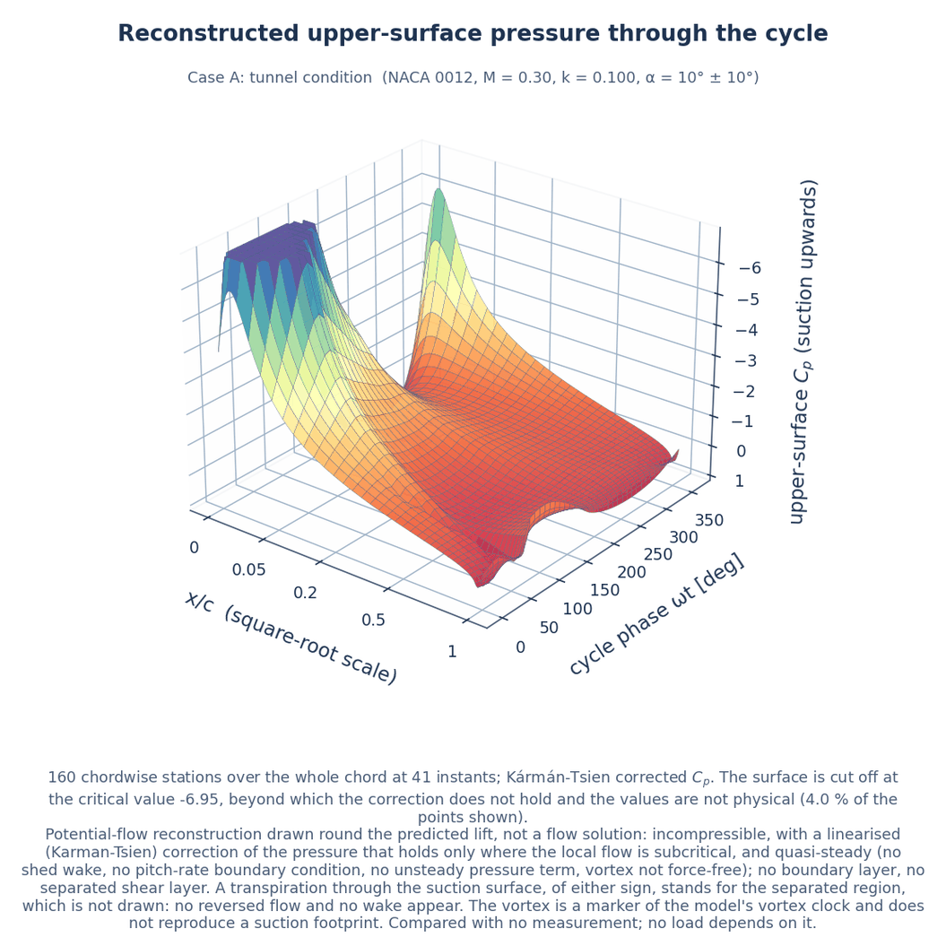
Figure 34. Case A: the same as a surface, suction upwards, cut off at the critical value. Potential-flow reconstruction drawn round the predicted lift, not a flow solution: incompressible, with a linearised (Karman-Tsien) correction of the pressure that holds only where the local flow is subcritical, and quasi-steady (no shed wake, no pitch-rate boundary condition, no unsteady pressure term, vortex not force-free); no boundary layer, no separated shear layer. A transpiration through the suction surface, of either sign, stands for the separated region, which is not drawn: no reversed flow and no wake appear. The vortex is a marker of the model's vortex clock and does not reproduce a suction footprint. Compared with no measurement; no load depends on it.
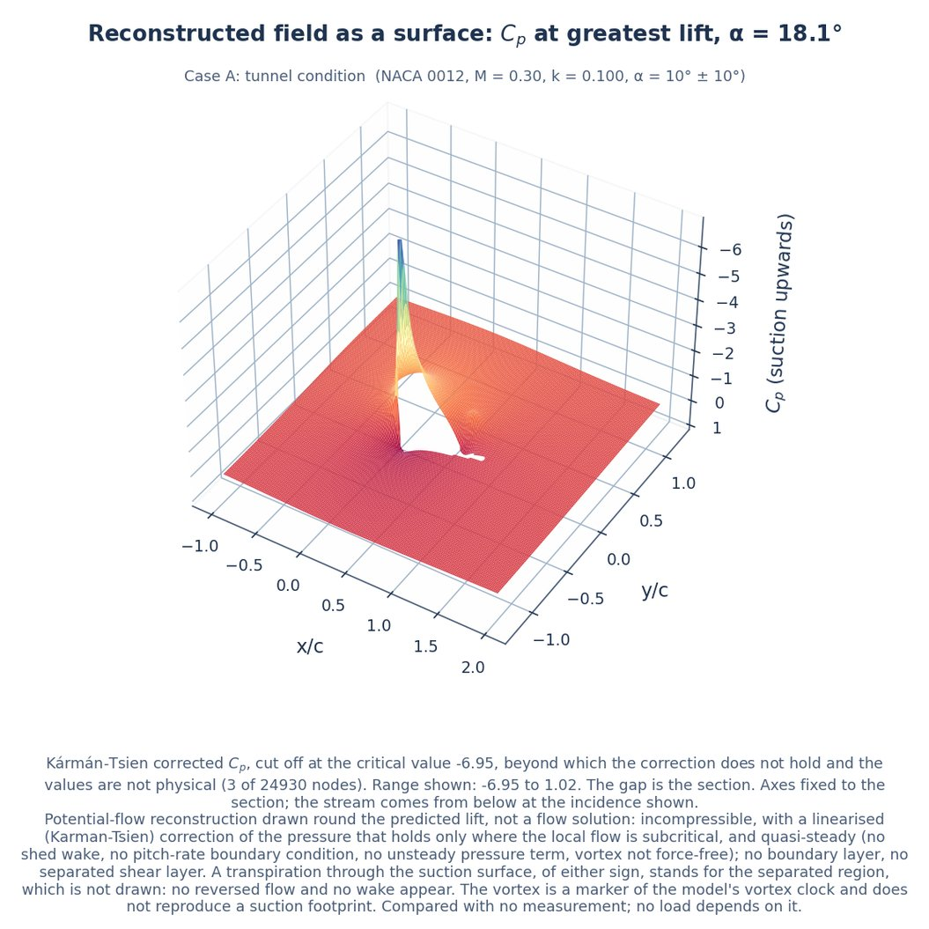
Figure 35. Case A, instant of greatest lift: the corrected pressure field as a surface, suction upwards, cut off at the critical value. Potential-flow reconstruction drawn round the predicted lift, not a flow solution: incompressible, with a linearised (Karman-Tsien) correction of the pressure that holds only where the local flow is subcritical, and quasi-steady (no shed wake, no pitch-rate boundary condition, no unsteady pressure term, vortex not force-free); no boundary layer, no separated shear layer. A transpiration through the suction surface, of either sign, stands for the separated region, which is not drawn: no reversed flow and no wake appear. The vortex is a marker of the model's vortex clock and does not reproduce a suction footprint. Compared with no measurement; no load depends on it.
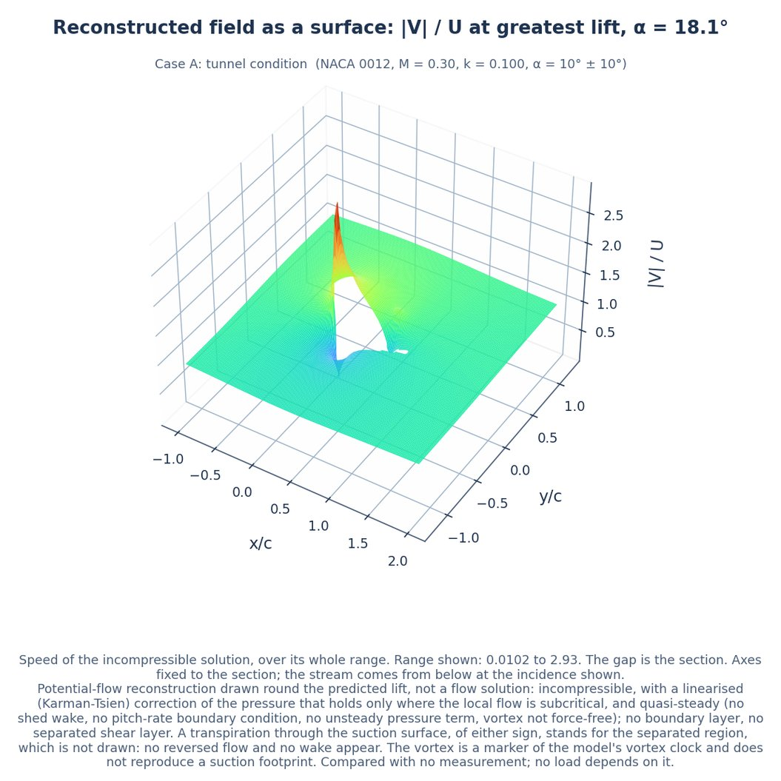
Figure 36. Case A, instant of greatest lift: the speed of the incompressible solution as a surface. Potential-flow reconstruction drawn round the predicted lift, not a flow solution: incompressible, with a linearised (Karman-Tsien) correction of the pressure that holds only where the local flow is subcritical, and quasi-steady (no shed wake, no pitch-rate boundary condition, no unsteady pressure term, vortex not force-free); no boundary layer, no separated shear layer. A transpiration through the suction surface, of either sign, stands for the separated region, which is not drawn: no reversed flow and no wake appear. The vortex is a marker of the model's vortex clock and does not reproduce a suction footprint. Compared with no measurement; no load depends on it.
Table 22. Case B: the reconstruction instant by instant, the transpiration and the circulations (05_solution/reconstruction_B_application.csv). Total circulation is that of the sheet plus that of the vortex marker. A blank in the last column means the marker is not over the chord at that instant.
Instant | Incidence, deg | Separation point, x/c | Transpiration at the edge, over U | Flux through the surface, over U c | Circulation of the sheet, over U c | Total circulation, over U c | Change of Cp beneath the vortex
mean up | 12 | 0.934 | 0.305 | 0.0102 | 0.594 | 0.594
rise | 16 | 0.825 | 0.25 | 0.0221 | 0.766 | 0.799 | 0.249
peak | 17 | 0.663 | 0.224 | 0.0381 | 0.776 | 0.874 | 0.359
dsv | 18.1 | 0.415 | 0.453 | 0.133 | 0.761 | 0.956 | -0.109
fall | 16 | 0.0786 | 0.464 | 0.215 | 0.335 | 0.335
mean down | 12 | 0.186 | 0.29 | 0.119 | 0.35 | 0.35

Table 23. Case B: the reconstruction instant by instant, the corrected pressure, the region beyond the critical pressure and the local state (05_solution/reconstruction_B_application.csv). The field is stored at four of the six instants; the others are blank in the field columns.
Instant | Lowest surface Cp, incompressible | Lowest surface Cp, corrected | Surface beyond critical, fraction | Field beyond critical, over c² | Field beyond critical, fraction | Highest surface Mach number outside that region | Lowest surface static temperature outside it, K | Highest surface recovery temperature, K
mean up | -7.25 | -8.9 | 0.00517 |  |  | 0.998 | 244 | 293
rise | -12.3 | -17.2 | 0.0203 | 0 | 0 | 0.969 | 246 | 293
peak | -13.8 | -17.3 | 0.0229 | 0.000579 | 8.02 × 10⁻⁵ | 0.98 | 246 | 293
dsv | -14.7 | -17.3 | 0.0229 | 0.000579 | 8.02 × 10⁻⁵ | 0.995 | 244 | 293
fall | -5.62 | -6.63 | 0 | 0 | 0 | 0.883 | 253 | 293
mean down | -4.44 | -5.1 | 0 |  |  | 0.76 | 262 | 293

Table 24. Case B: the reconstruction instant by instant, the loads its surface pressure returns beside the model's (05_solution/reconstruction_B_application.csv).
Instant | Fraction of the circulation carried | Lift difference, corrected pressure, % | The same at the Prandtl-Glauert factor, % | Lift difference, incompressible, % | Lift difference, panels alone, % | Moment, model | Moment, surface pressure | Drag, model | Pressure drag, surface pressure
mean up | 0.924 | 1.5 × 10⁻⁸ | 3.92 | -0.482 | -0.596 | 0.00122 | 0.0485 | 0.0462 | -0.0294
rise | 0.901 | -5.16 × 10⁻⁷ | 6.67 | -1.09 | -0.574 | 0.00711 | 0.0857 | 0.128 | -0.105
peak | 0.889 | 2.56 × 10⁻⁶ | 7.52 | -0.668 | -0.66 | -0.116 | 0.128 | 0.269 | -0.146
dsv | 0.893 | -1.85 × 10⁻⁶ | 6.68 | -1.4 | -0.874 | -0.237 | 0.126 | 0.436 | -0.157
fall | 0.945 | 2.99 × 10⁻⁸ | 1.41 | -2.69 | -3.96 | -0.0774 | 0.0856 | 0.201 | -0.00221
mean down | 0.966 | 1.46 × 10⁻⁶ | -0.653 | -3.55 | -2.79 | 0.0401 | 0.0702 | 0.0301 | -0.00595

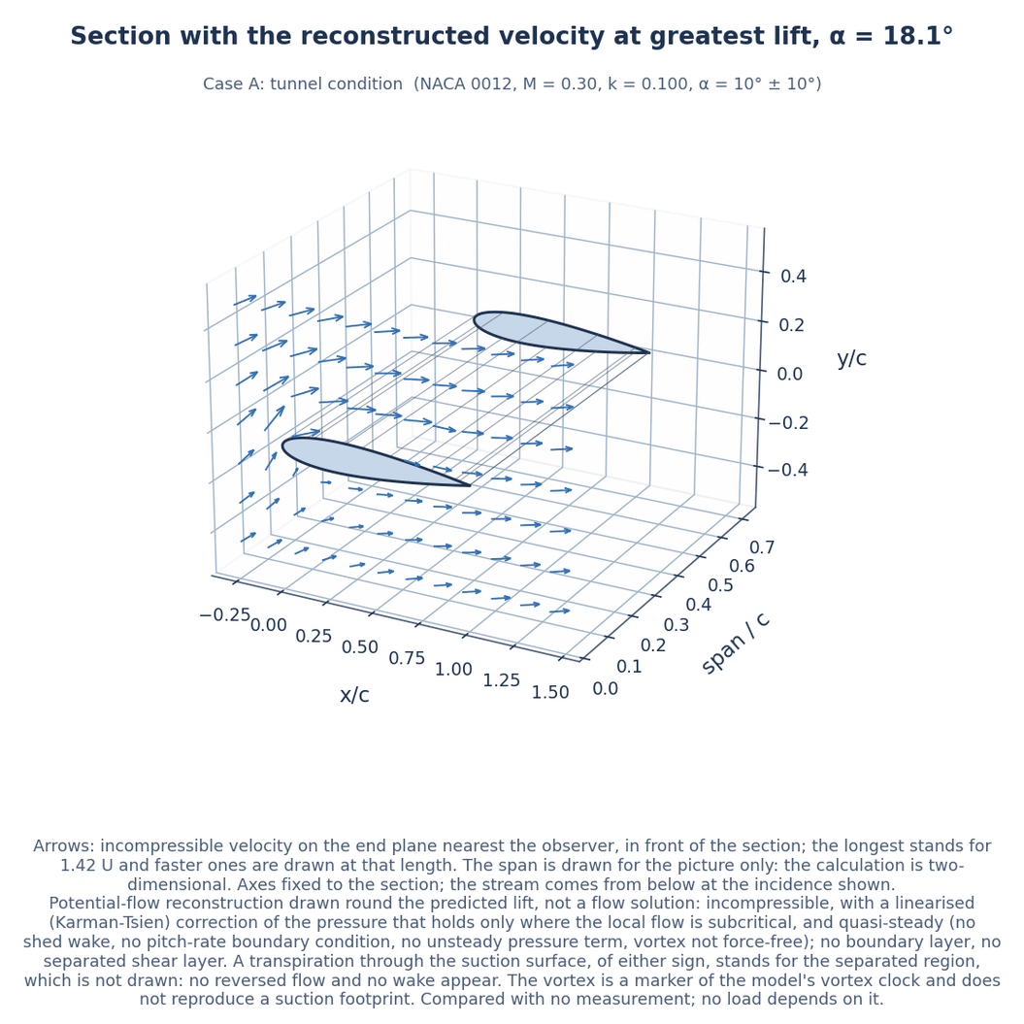
Figure 37. Case A, instant of greatest lift: the section drawn with span, with the reconstructed velocity on its near end plane. The span is for the picture only; the calculation is two-dimensional. Potential-flow reconstruction drawn round the predicted lift, not a flow solution: incompressible, with a linearised (Karman-Tsien) correction of the pressure that holds only where the local flow is subcritical, and quasi-steady (no shed wake, no pitch-rate boundary condition, no unsteady pressure term, vortex not force-free); no boundary layer, no separated shear layer. A transpiration through the suction surface, of either sign, stands for the separated region, which is not drawn: no reversed flow and no wake appear. The vortex is a marker of the model's vortex clock and does not reproduce a suction footprint. Compared with no measurement; no load depends on it.
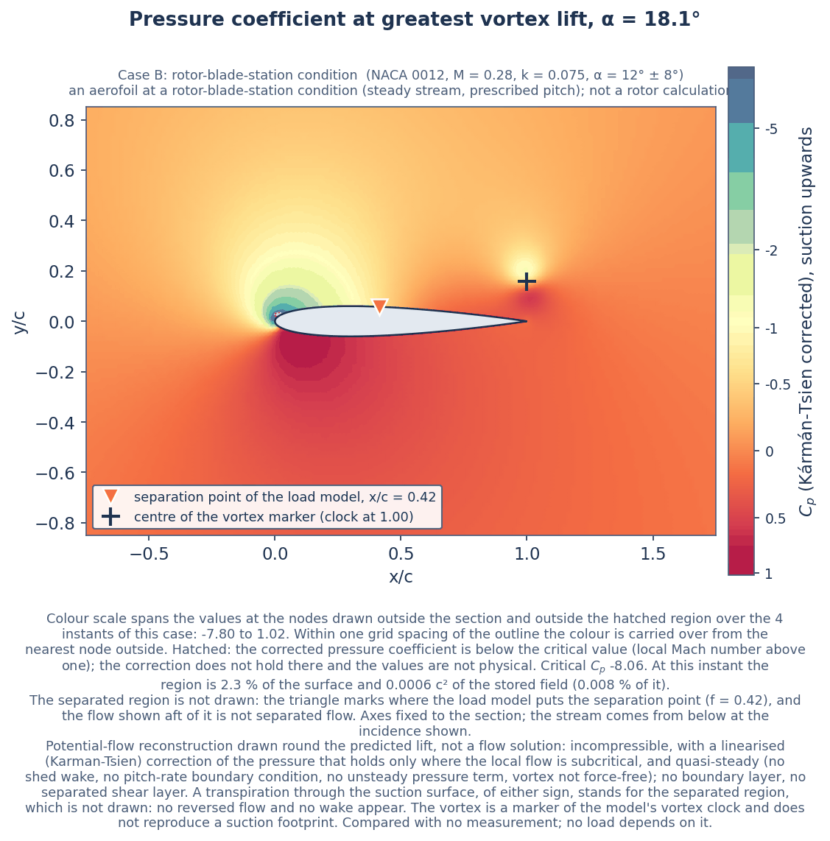
Figure 38. Case B, instant of greatest vortex normal force: corrected pressure coefficient. Hatched: the corrected pressure coefficient is below the critical value (local Mach number above one); the correction does not hold there and the values are not physical. The separated region is not drawn; the triangle marks the separation point of the load model. Potential-flow reconstruction drawn round the predicted lift, not a flow solution: incompressible, with a linearised (Karman-Tsien) correction of the pressure that holds only where the local flow is subcritical, and quasi-steady (no shed wake, no pitch-rate boundary condition, no unsteady pressure term, vortex not force-free); no boundary layer, no separated shear layer. A transpiration through the suction surface, of either sign, stands for the separated region, which is not drawn: no reversed flow and no wake appear. The vortex is a marker of the model's vortex clock and does not reproduce a suction footprint. Compared with no measurement; no load depends on it.
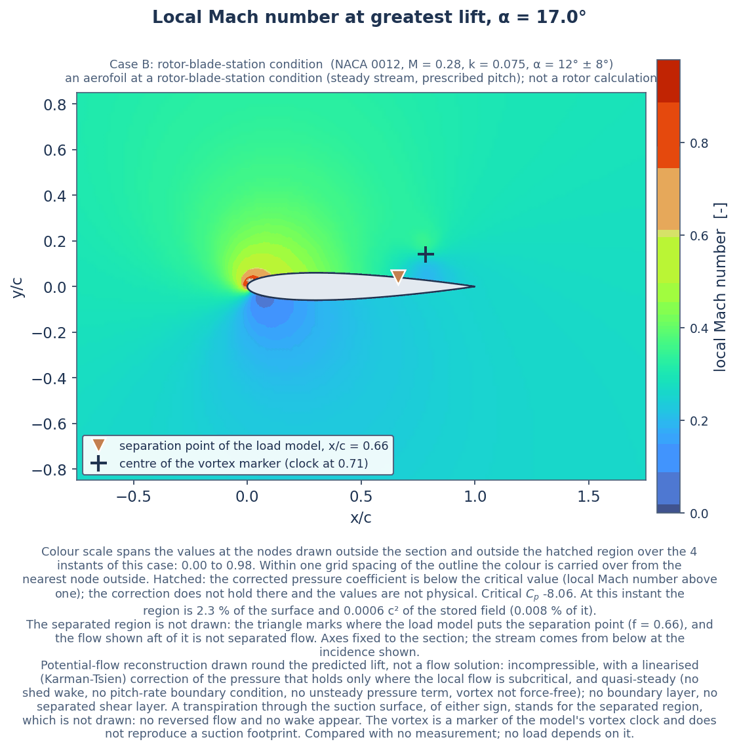
Figure 39. Case B, instant of greatest lift: local Mach number from the corrected pressure. Hatched: the corrected pressure coefficient is below the critical value (local Mach number above one); the correction does not hold there and the values are not physical. The separated region is not drawn; the triangle marks the separation point of the load model. Potential-flow reconstruction drawn round the predicted lift, not a flow solution: incompressible, with a linearised (Karman-Tsien) correction of the pressure that holds only where the local flow is subcritical, and quasi-steady (no shed wake, no pitch-rate boundary condition, no unsteady pressure term, vortex not force-free); no boundary layer, no separated shear layer. A transpiration through the suction surface, of either sign, stands for the separated region, which is not drawn: no reversed flow and no wake appear. The vortex is a marker of the model's vortex clock and does not reproduce a suction footprint. Compared with no measurement; no load depends on it.

12 The grid
The folder 02_mesh holds a structured O-grid round the section: 193 nodes round the section by 81 outwards, 15360 cells, a far boundary at 20 chords, a first layer 0.001 of the chord high and a growth ratio of 1.100. Its status, as the file states it, is: "not a CFD mesh that has been run; not read by the load model" (02_mesh/mesh_quality_metrics.csv).
What the grid is for. The load model has no spatial mesh and does not read this grid; no load in this report depends on it. No equation of the flow is solved on it, and its wall spacing is not sized for a boundary layer. Its one use is as a set of points at which the reconstructed flow field is evaluated for one picture. The folders of this case study follow the layout of a flow-solver case, but the calculation is a set of ordinary differential equations marched in time; in a paper on the load model the grid and the field reconstruction would be left out.

The largest equiangle skewness is 0.908, in the cells at the sharp trailing edge; without those cells it is 0.491. The smallest orthogonality angle is 8.3°, or 45.8° without the trailing-edge cells, and the number of inverted cells is 0.
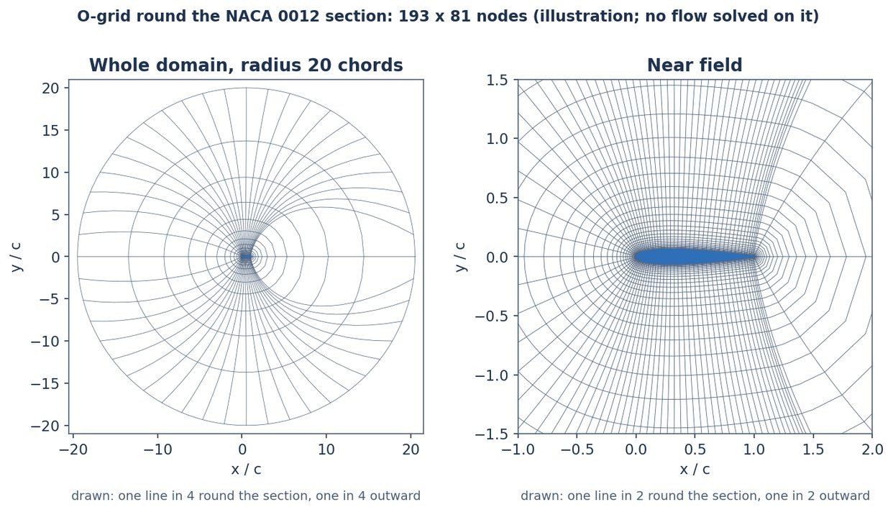
Figure 40. The O-grid round the section (02_mesh). An illustration: no equation of the flow is solved on it, and the load model does not read it.
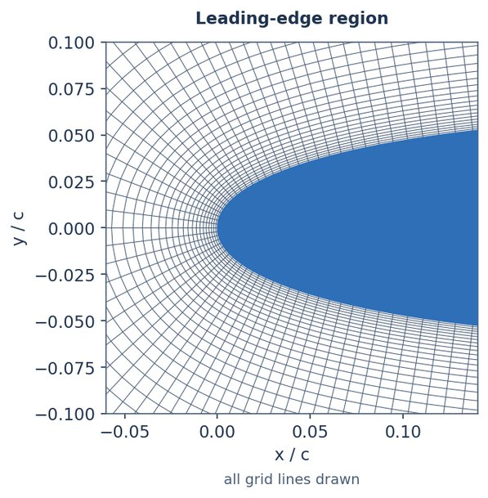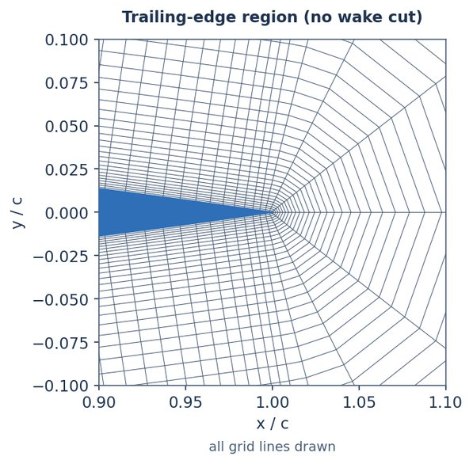
Figure 41. The grid at the leading edge (left) and at the trailing edge (right) (02_mesh).
The script 02_mesh/field_on_mesh.py evaluates the reconstructed field at the 15633 nodes of the O-grid, for each case at the instant of peak lift read from the stored time history, and writes it to 05_solution (field_<case>_peak_on_mesh.csv.gz). The 193 nodes of the wall line take the values on the surface itself; the 579 nodes nearer the wall than the distance within which the field shows the junctions of the panels carry no value; the rest take the field. Figure 42 shows the pressure coefficient for Case A. It is the same reconstruction as in Section 11, with the same limits: the grid supplies the points and nothing else. The maps of Section 11 are drawn from the reconstruction evaluated on its own rectangular grid of 180 by 140 points (03_model_setup/solver_config.json).
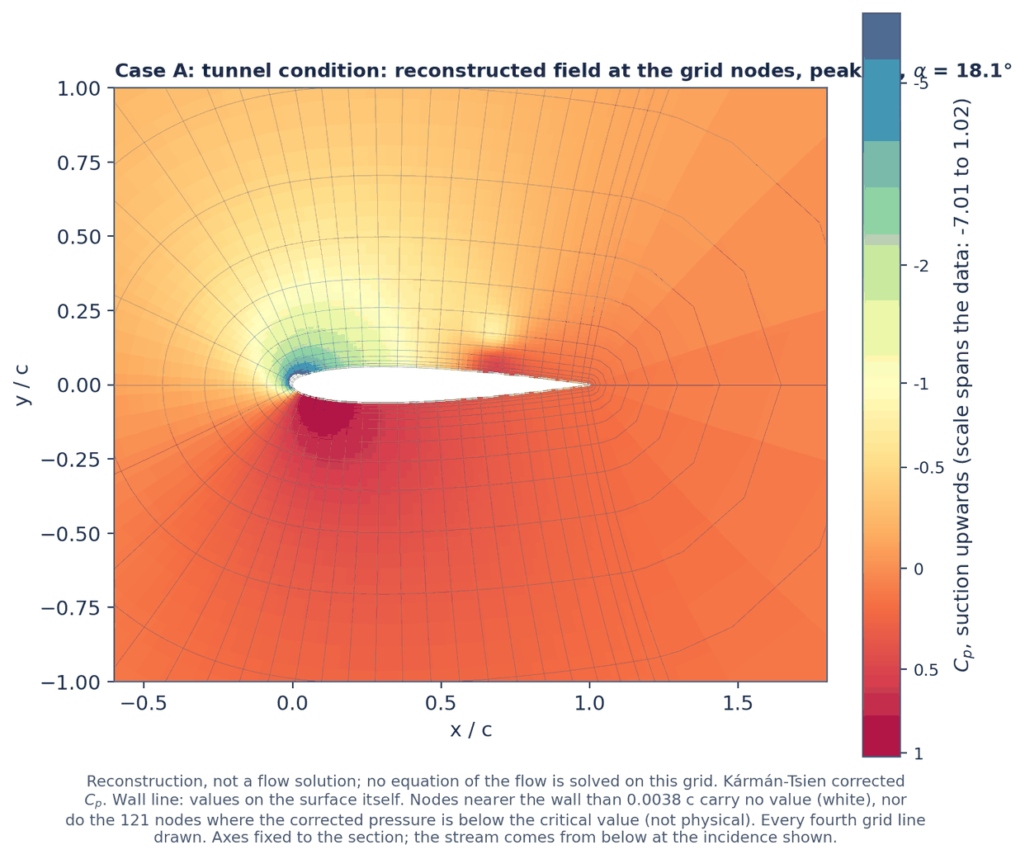
Figure 42. Case A: pressure coefficient of the reconstructed field at the nodes of the O-grid, at the instant of peak lift. Potential-flow reconstruction drawn round the predicted lift, not a flow solution: incompressible, with a linearised (Karman-Tsien) correction of the pressure that holds only where the local flow is subcritical, and quasi-steady (no shed wake, no pitch-rate boundary condition, no unsteady pressure term, vortex not force-free); no boundary layer, no separated shear layer. A transpiration through the suction surface, of either sign, stands for the separated region, which is not drawn: no reversed flow and no wake appear. The vortex is a marker of the model's vortex clock and does not reproduce a suction footprint. Compared with no measurement; no load depends on it.

13 The response over mean incidence and reduced frequency
The load model is run at 42 conditions: mean incidence from 6 to 16° and reduced frequency from 0.04 to 0.16, at the Mach number (0.28) and pitch amplitude (8°) of Case B. As in Case B, this is a section in a steady stream with prescribed pitch, not a rotor calculation. The highest peak incidence is 24°, inside the 25° reached by the measured loops the model was compared with.
Over these conditions the peak lift runs from 1.42 to 1.84, the minimum moment from -0.33 to -0.01 and the onset incidence from 12.9 to 15.0°. The cycle damping the model gives runs from 0.023 to 0.229 and is negative at 0 of the conditions. That is not evidence that the damping is positive there: on the 45 held-out loops with a closed measured moment loop the model gets the sign of the damping right on a fraction 0.60, where a prediction of positive damping everywhere would score 0.67, and 15 of those loops measure negative damping (results/validation_damping.csv). The damping surface is model output: it does not locate a stall-flutter boundary, and the sign of the damping in it is not evidence of what a measurement would show. It is kept here only with that figure beside it, which is also printed on the plot, and it would be left out of a paper. Figure 43 shows the surfaces and Table 25 and Table 26 the values (05_solution/response_surface.csv).
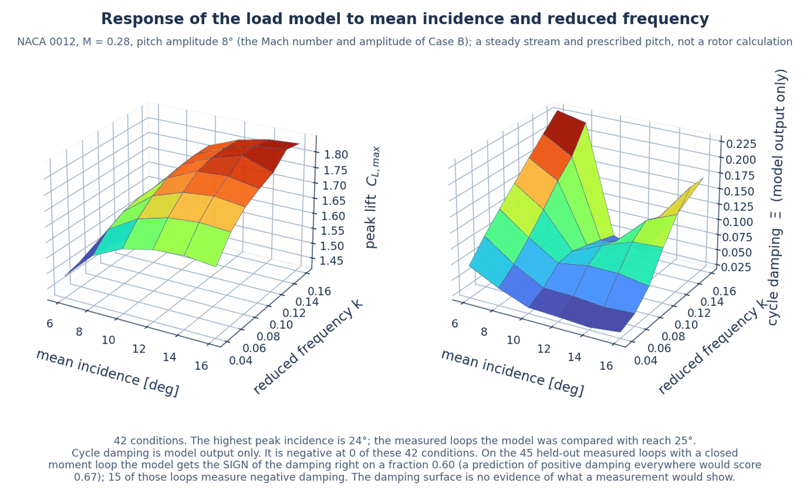
Figure 43. Peak lift and cycle damping given by the load model over mean incidence and reduced frequency. The damping is model output only: on the 45 held-out loops with a closed measured moment loop the model gets the sign of the damping right on a fraction 0.60, where a prediction of positive damping everywhere would score 0.67, and 15 of those loops measure negative damping (results/validation_damping.csv).
Table 25. Peak lift coefficient over mean incidence and reduced frequency (05_solution/response_surface.csv).
Mean incidence, deg | k = 0.04 | k = 0.06 | k = 0.08 | k = 0.10 | k = 0.12 | k = 0.14 | k = 0.16
6 | 1.485 | 1.499 | 1.495 | 1.481 | 1.462 | 1.441 | 1.423
8 | 1.577 | 1.627 | 1.651 | 1.662 | 1.663 | 1.656 | 1.646
10 | 1.622 | 1.683 | 1.724 | 1.750 | 1.762 | 1.766 | 1.766
12 | 1.643 | 1.710 | 1.756 | 1.792 | 1.805 | 1.807 | 1.804
14 | 1.649 | 1.717 | 1.767 | 1.797 | 1.833 | 1.833 | 1.825
16 | 1.638 | 1.711 | 1.755 | 1.779 | 1.800 | 1.842 | 1.832

Table 26. Cycle damping given by the model over mean incidence and reduced frequency; model output only, with the sign agreement on the held-out loops given in the text above (05_solution/response_surface.csv).
Mean incidence, deg | k = 0.04 | k = 0.06 | k = 0.08 | k = 0.10 | k = 0.12 | k = 0.14 | k = 0.16
6 | 0.070 | 0.101 | 0.128 | 0.154 | 0.180 | 0.205 | 0.229
8 | 0.046 | 0.067 | 0.093 | 0.123 | 0.153 | 0.178 | 0.219
10 | 0.028 | 0.041 | 0.064 | 0.066 | 0.059 | 0.051 | 0.042
12 | 0.026 | 0.041 | 0.072 | 0.087 | 0.077 | 0.054 | 0.025
14 | 0.023 | 0.036 | 0.072 | 0.105 | 0.122 | 0.112 | 0.089
16 | 0.028 | 0.039 | 0.063 | 0.107 | 0.143 | 0.171 | 0.170

14 Drawings
The folder 08_engineering_drawings holds four sheets. They are illustrative: they show the section of Case A, and for Case B the rotor whose blade station gives the condition, so that a reader can see where the dimensions come from. They are not for manufacture, and the helicopter outline in them is a generic sketch drawn from one set of body coordinates on both sheets that show it. Every dimension on them is taken from the one table reproduced as Table 27, with its source. Each sheet states its scale, or that it has none, in its title block. Section A-A of sheet 3 is drawn as seen looking the way its cutting-plane arrows point (outboard), with the leading edge on the left (08_engineering_drawings/sheet_record.csv).
Sheets 1 and 2 show a helicopter, and this study contains no rotor calculation. They are kept in the repository only to show where the chord, the radius and the rotor speed of Case B come from. In a paper they would be left out, with sheet 4 and the station sketch of sheet 3 kept.

Table 27. The dimensions of the drawings (08_engineering_drawings/dimensions.csv).
Dimension | Value | Unit | Source
Case A section | NACA 0012 | - | NASA TM-84245
Case A chord of the tunnel model | 0.61 | m | NASA TM-84245
Case A maximum thickness, percent of chord | 12 | % of chord | NACA 0012 designation
Case A maximum thickness | 0.0732 | m | derived: 12 % of the Case A chord
Case A station of maximum thickness, fraction of chord | 0.2995 | chord | four-digit thickness form (01_geometry)
Case A pitch axis from the leading edge, fraction of chord | 0.25 | chord | NASA TM-84245
Case B rotor radius | 8.18 | m | Bousman, NASA/TP-2003-212265 (UH-60A main rotor)
Case B rotor radius, in feet | 26.83 | ft | Bousman, NASA/TP-2003-212265 (UH-60A main rotor)
Case B blade chord | 0.527 | m | Bousman, NASA/TP-2003-212265 (UH-60A main rotor)
Case B blade chord, in inches | 20.76 | in | Bousman, NASA/TP-2003-212265 (UH-60A main rotor)
Case B number of blades | 4 | - | Bousman, NASA/TP-2003-212265 (UH-60A main rotor)
Case B rotor speed | 258 | rpm | Bousman, NASA/TP-2003-212265 (UH-60A main rotor)
Case B analysis station, fraction of rotor radius | 0.75 | R | case definition of this study
Root end of the blade as drawn, fraction of rotor radius | 0.13 | R | Bousman, NASA/TP-2003-212265 (Table 3: root cutout 42.00 in of 322.00 in)

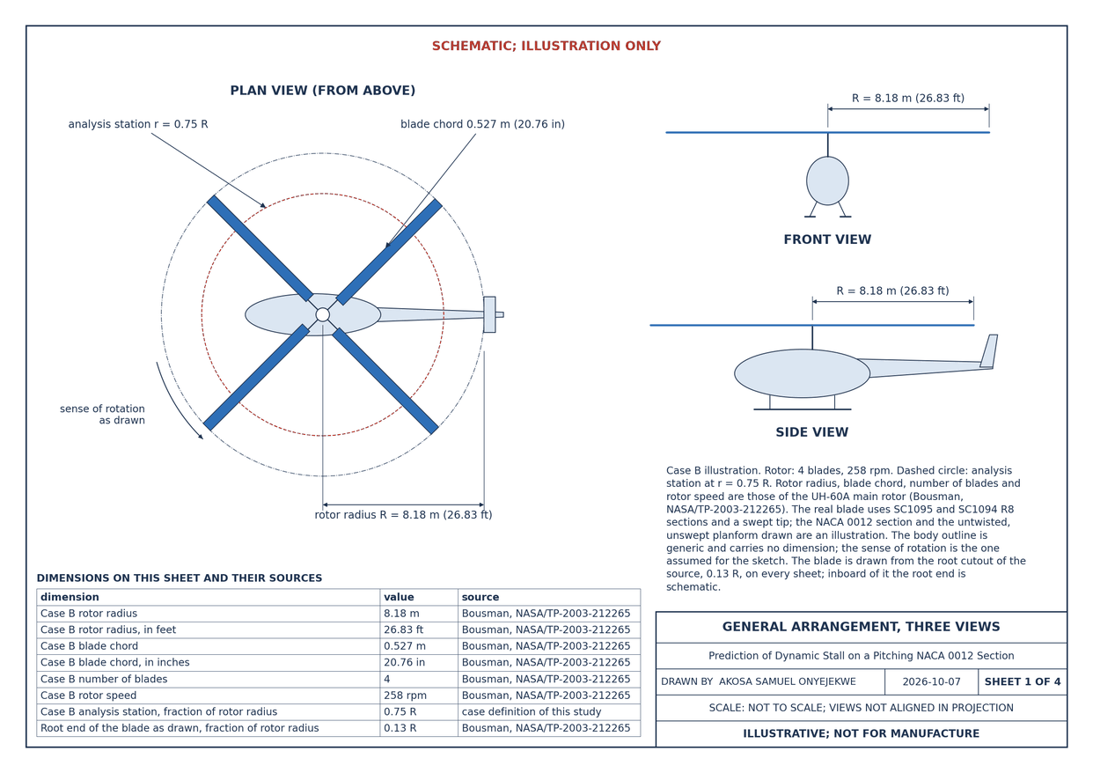
Figure 44. Drawing sheet 1: general arrangement three views. Scale as the sheet states it: NOT TO SCALE; VIEWS NOT ALIGNED IN PROJECTION. Shown reduced from the sheet format. Illustrative; not for manufacture.
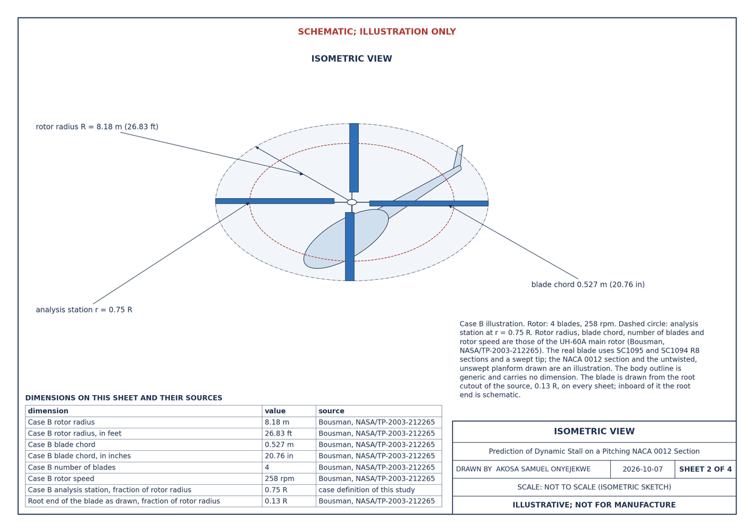
Figure 45. Drawing sheet 2: isometric. Scale as the sheet states it: NOT TO SCALE (ISOMETRIC SKETCH). Shown reduced from the sheet format. Illustrative; not for manufacture.
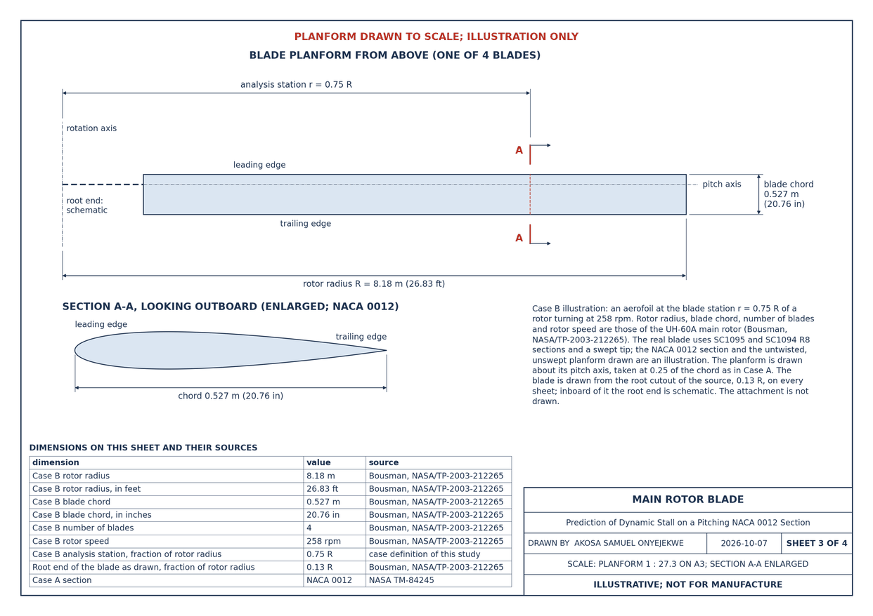
Figure 46. Drawing sheet 3: main rotor blade. Scale as the sheet states it: PLANFORM 1 : 27.3 ON A3; SECTION A-A ENLARGED. Shown reduced from the sheet format. Illustrative; not for manufacture.
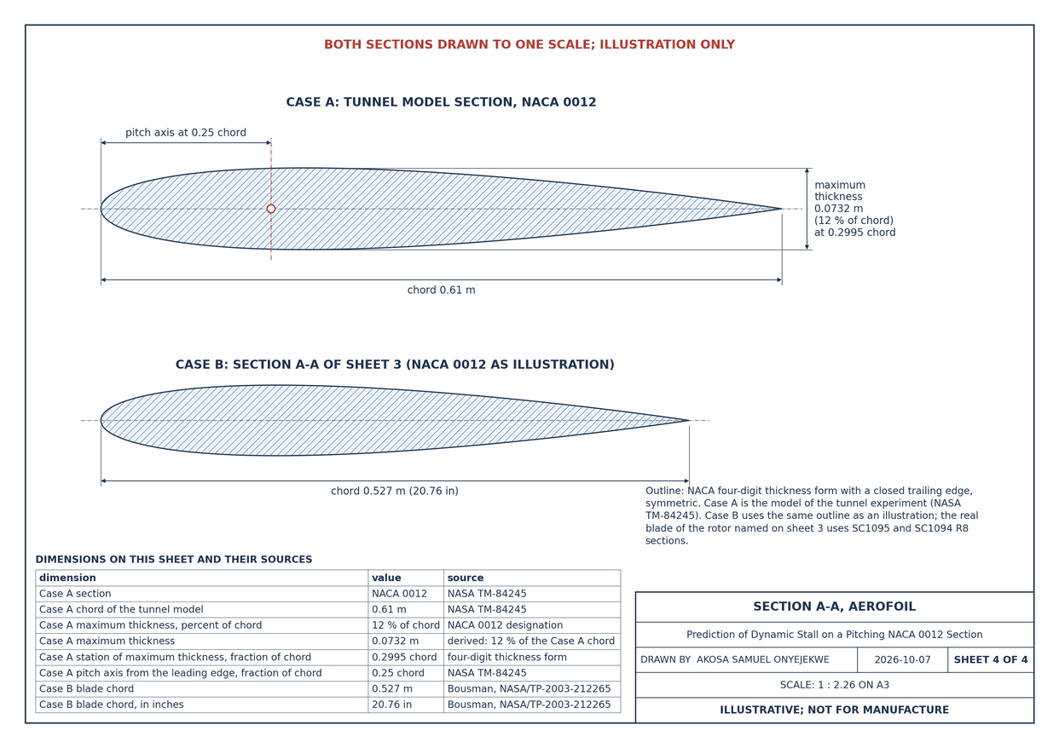
Figure 47. Drawing sheet 4: section A-A airfoil. Scale as the sheet states it: 1 : 2.26 ON A3. Shown reduced from the sheet format. Illustrative; not for manufacture.

15 Limits of the study
- Accuracy. On the held-out loops the loop error in lift is 0.107 against a target of at most 0.100, the loop error in moment 0.196 against a target of at most 0.150, and the fraction of loops with the sign of cycle damping correct 0.60 against a target of at least 0.80. Those targets are not met.
- Cycle damping. The model does not predict cycle damping through stall and cannot locate a stall-flutter boundary.
- The unsteady-moment factor is an empirical correction of this model, taken from few loops at one Mach number. It is not a property of the flow.
- The separation law. On this data set the tabulated separation point gives the same accuracy as the usual fitted law; it is not shown to be better.
- Range. The results are for Mach 0.22 to 0.30, reduced frequency up to 0.20 and peak incidence up to 25° on the NACA 0012 section. Most of the measured loops are near the upper end of that Mach range. Nothing is claimed outside it, and nothing is claimed for another section.
- Case A is set beside a calibration loop, which is not an independent test.
- Case B is an aerofoil at a rotor-blade-station condition in a steady stream with prescribed pitch, held at the lowest Mach number the station sees round the azimuth, with an assumed incidence history. It is not a rotor calculation and no rotor measurement is compared with.
- The results of the cases carry the error of the model. The figure in brackets after each load is the error of the model in that quantity on the 45 held-out loops, model minus measured, as mean and standard deviation (05_solution/held_out_error_bands.csv); the loads are rounded to match. The results of Case B are further uncertain within the spread between the two Mach stations of the static inputs (Section 5).
- The flow fields are a reconstruction, not a flow solution. Potential-flow reconstruction drawn round the predicted lift, not a flow solution: incompressible, with a linearised (Karman-Tsien) correction of the pressure that holds only where the local flow is subcritical, and quasi-steady (no shed wake, no pitch-rate boundary condition, no unsteady pressure term, vortex not force-free); no boundary layer, no separated shear layer. A transpiration through the suction surface, of either sign, stands for the separated region, which is not drawn: no reversed flow and no wake appear. The vortex is a marker of the model's vortex clock and does not reproduce a suction footprint. Compared with no measurement; no load depends on it. Its surface pressure does not return the model's moment or drag. Section 11 gives its limits one by one and how far the surface pressure is from returning the lift it was given.
- The grid is not read by the load model, and no equation of the flow is solved on it.
- The drawings are illustrative; sheets 1 and 2 show a helicopter although the study contains no rotor calculation.
- The state-space form agrees with the indicial march to the figures of Section 8; where the model switches a time constant the two forms differ by an amount that depends on the step. The growth or decay it gives for a section free in torsion is model output, with the same standing as the cycle damping.

16 References
[1] McCroskey, W. J. and McAlister, K. W. and Carr, L. W. and Pucci, S. L. (1982). An experimental study of dynamic stall on advanced airfoil sections. Volume 1: Summary of the experiment. National Aeronautics and Space Administration, USAAVRADCOM-TR-82-A-8-Vol-1; A-8924; NAS 1.15:84245-Vol-1. https://ntrs.nasa.gov/citations/19820024438
[2] McCroskey, W J (1982). Unsteady Airfoils. Annual Review of Fluid Mechanics 14(1), 285-311. doi:10.1146/annurev.fl.14.010182.001441
[3] Carr, Lawrence W. (1988). Progress in analysis and prediction of dynamic stall. Journal of Aircraft 25(1), 6-17. doi:10.2514/3.45534
[4] Leishman, J. G. and Beddoes, T. S. (1989). A Semi‐Empirical Model for Dynamic Stall. Journal of the American Helicopter Society 34(3), 3-17. doi:10.4050/jahs.34.3.3
[5] Damiani, Rick R. and Hayman, Gregory (2019). The Unsteady Aerodynamics Module for FAST 8. National Renewable Energy Laboratory, NREL/TP-5000-66347. doi:10.2172/1576488
[6] Theodorsen, Theodore (1935). General Theory of Aerodynamic Instability and the Mechanism of Flutter. National Advisory Committee for Aeronautics, NACA-TR-496. https://ntrs.nasa.gov/citations/19800006788
[7] McAlister, K. W. and Pucci, S. L. and McCroskey, W. J. and Carr, L. W. (1982). An experimental study of dynamic stall on advanced airfoil section. Volume 2: Pressure and force data. National Aeronautics and Space Administration, USAAVRADCOM-TR-82-A-8-VOL-2; NASA-TM-84245-VOL-2; NAS 1.15:84245-VOL-2. https://ntrs.nasa.gov/citations/19830003778
The rotor dimensions of Case B are those the dimension table attributes to "Bousman, NASA/TP-2003-212265 (UH-60A main rotor)" (08_engineering_drawings/dimensions.csv). That report is not an entry of docs/references.bib, and the four parameters taken from it (radius, chord, number of blades, rotor speed) have not been checked against its pages in this repository.

