Simulation Output Curves — Graphical Representation of the Generated CSV Data
Perth SWRO — Cockburn Sound submerged-diffuser brine-discharge simulation · run folder: /3 · calibration: validated (2.3% error vs WA EPA target dilution 45 at 50 m)
This note plots every CSV file produced by the simulation run in the /3 folder. Three datasets were generated — the plume centreline curve, the water-column vertical profile, and the metrics time series — and each is represented graphically below with a short interpretation. All values are read directly from the CSV files (curve_centerline.csv, curve_vertical_profile.csv, metrics_timeseries.csv).

1. Plume centreline curve (curve_centerline.csv)
This file traces the plume along its axis: for each along-axis distance it records the excess salinity above ambient, the dilution, and the depth of the plume core. Negative distances are up-current of the diffuser (source at 0 m).
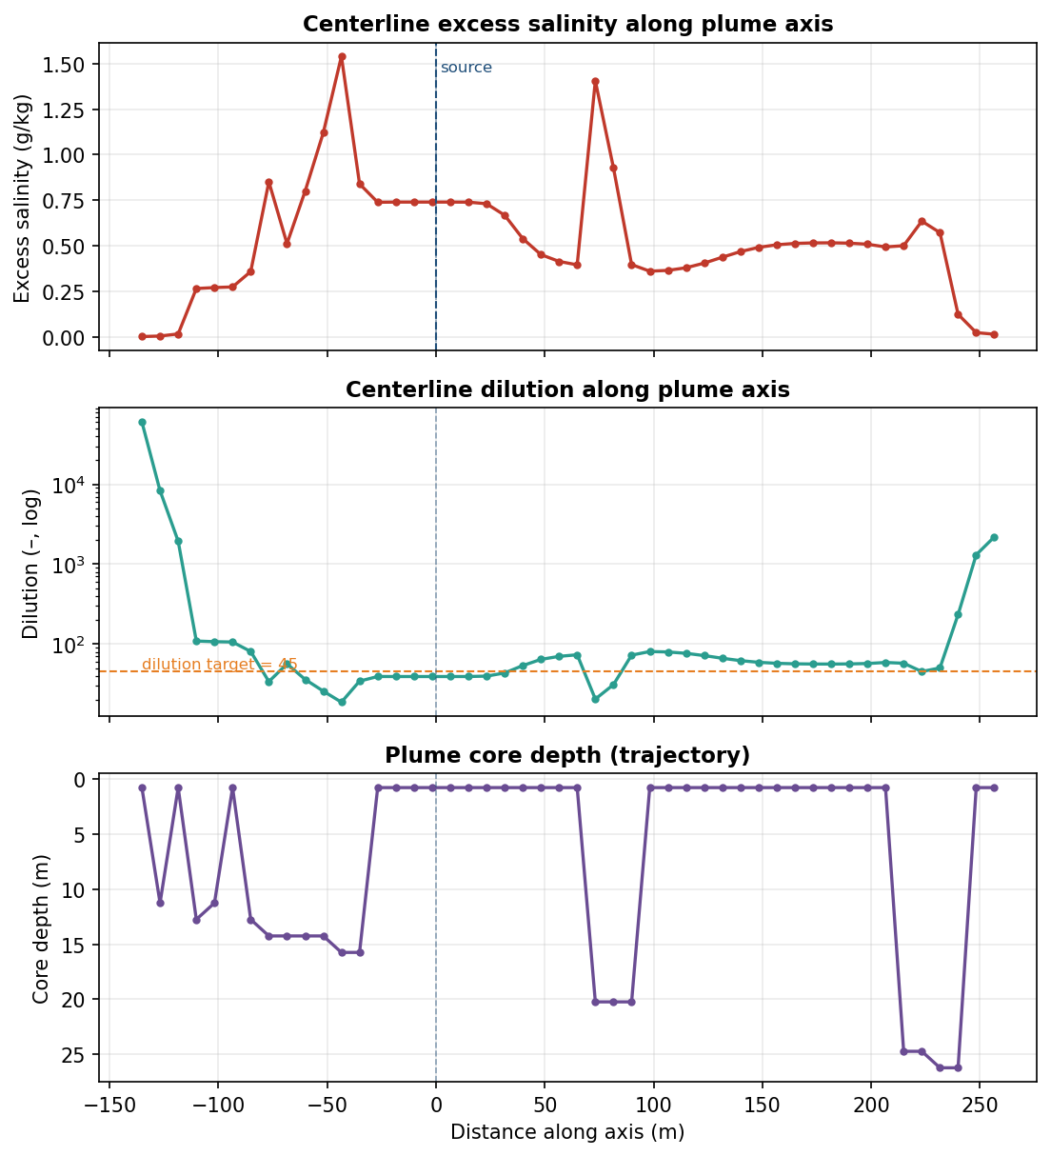
Figure 1. Centreline excess salinity (top), dilution on a log scale with the 45× regulatory target (middle), and plume-core depth/trajectory (bottom) vs distance along the axis.
Reading it: excess salinity peaks near the source and decays with distance as the brine is entrained and diluted; dilution rises by orders of magnitude away from the source (from ~19 near-field to ~6.0×10⁴ far-field), crossing the 45× target well within the regulated distance; the core-depth panel shows the dense brine plume sinking toward the seabed before spreading.

2. Vertical profile (curve_vertical_profile.csv)
This file samples the water column at the monitoring location, giving excess salinity, absolute salinity, temperature and density as a function of depth (depth increases downward).
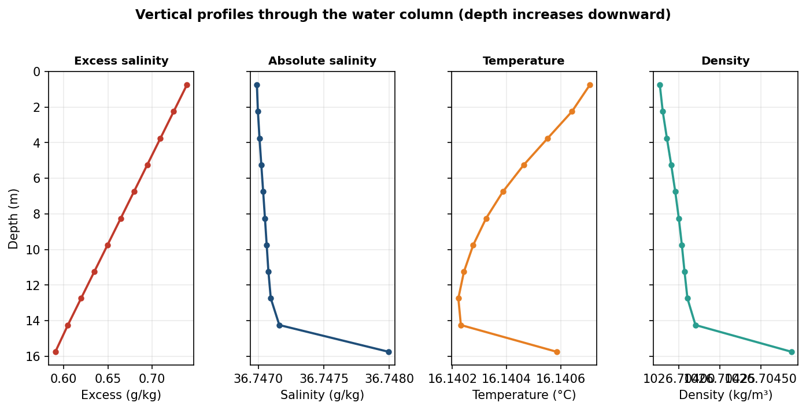
Figure 2. Vertical profiles of excess salinity, absolute salinity, temperature and density through the water column.
Reading it: the excess-salinity profile shows the densest, most saline water concentrated near the bed (excess ≈ 0.74 g/kg at 0.75 m, falling to ≈ 0.59 g/kg near the surface) — the expected signature of a negatively buoyant brine plume. Absolute salinity, temperature and density vary only slightly over depth at this station (near-uniform background), so the environmental impact is driven by the excess-salinity gradient rather than the absolute field.

3. Metrics time series (metrics_timeseries.csv)
This file records the evolution of the key plume metrics through the 600-second simulation: peak salinity and excess, minimum dilution, plume reach and depth, seabed footprint, and the solver's maximum divergence (a numerical-stability diagnostic).
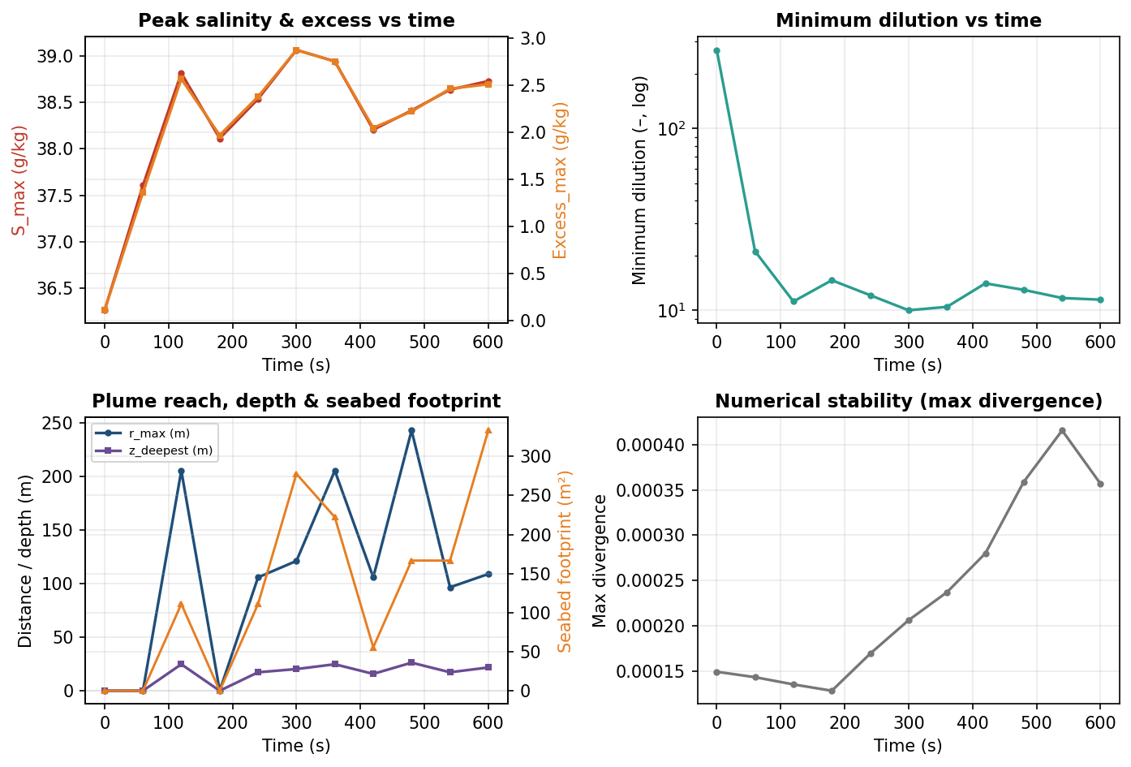
Figure 3. Time evolution of peak salinity/excess (top-left), minimum dilution (top-right), plume reach/depth and seabed footprint (bottom-left), and numerical divergence (bottom-right).
Reading it: peak salinity and excess rise quickly as the plume establishes, then settle around S_max ≈ 38.7 g/kg and excess ≈ 2.5 g/kg; the minimum dilution falls from a transient high toward its steady ~11× near-field value; the plume reach (r_max), deepest penetration and seabed footprint grow as the brine reaches and spreads along the bed; and the max-divergence panel stays at ~10⁻⁴ throughout, confirming the solver remained stable (no blow-up).

4. Key end-state values
For reference, the headline metrics at the end of the run (from metrics_summary.json):
Metric | Value
Peak salinity S_max | 38.73 g/kg
Peak excess salinity | 2.51 g/kg
Minimum dilution | 11.5 ×
Max plume reach r_max | 109.1 m
Deepest penetration | 21.8 m
Seabed footprint | 333 m²
Affected volume | 500 m³
Near-field return dilution | 64.2 ×
Densimetric Froude no. Fr_d | 38.8

All three CSV datasets are therefore consistent: a negatively buoyant brine plume that sinks to the bed, dilutes rapidly past the 45× regulatory target, and reaches a stable steady state within the 600-second simulation — produced by a numerically stable solver.

