Industrial Case Study
Prediction of brine-plume dispersion, evolution and seabed distribution for the Perth Seawater Desalination Plant submerged diffuser (Cockburn Sound, Western Australia)
Modelling tool: NEREID-B (solver.py, Rev 1.5) — 3-D finite-volume coupled brine dispersion solver with near-field correlation coupling, buoyancy-modified realizable k–ε turbulence, full anisotropic dispersion tensor and a Monte-Carlo stochastic ensemble.

1. Executive summary
NEREID-B was applied to predict the fate of the hypersaline reject (brine) discharged from the Perth SWRO plant's submerged multiport diffuser into Cockburn Sound. The model resolves the near-field jet/plume via validated inclined-dense-jet correlations and the 3-D far-field gravity-current spreading and dilution of the negatively-buoyant plume over the seabed, under the site's ambient current, stratification and wave climate. A 4-member stochastic ensemble quantifies turbulence-driven uncertainty.
Headline predictions (steady, quasi-equilibrium plume):
- Source: discharge salinity 61.4 g/kg into 36.5 g/kg ambient (excess at source 24.9 g/kg);
- Near field: near-field (validated correlations): densimetric Froude number Fr=31.6, terminal rise 9.0 m, seabed return at 9.9 m, return dilution 29:1;
- At 50 m: modelled brine dilution at the 50 m compliance boundary ≈ 47:1, excess salinity ΔS ≈ 0.53 g/kg;
- Far field: peak salinity 37.56 g/kg, max excess 1.05 g/kg, seabed footprint above 1.2 g/kg ≈ 0 m², affected water volume ≈ 0 m³.
Mixing-zone assessment: the WA EPA criterion is ΔS < 1.2 g/kg within 50 m of the diffuser. Predicted ΔS at 50 m ≈ 0.53 g/kg → COMPLIANT. The model carries a documented CONSERVATIVE bias (under-predicts dilution ⇒ over-predicts impact), so the prediction is on the safe side.

2. Site description and problem statement
The Perth Seawater Desalination Plant (Stage 1, ~45 GL/yr, 45% recovery) discharges its RO reject through a ~163 m double-tee submerged diffuser with 40 ports (0.13 m diameter) inclined at 60° in ~10 m of water in Cockburn Sound. The reject (~61.4 g/kg) is roughly 1.7× the ambient salinity (~36.5 g/kg) and therefore negatively buoyant: it rises briefly as a turbulent jet, falls back to the seabed, and spreads as a dense gravity current. The regulatory question is whether the diffuser dilutes the brine enough that the seabed excess-salinity footprint and the mixing-zone concentrations remain within ecological limits.
Prediction objectives for NEREID-B:
- the near-field rise height, seabed return distance and return dilution;
- the steady 3-D distribution of excess salinity and brine dilution over the seabed;
- the centreline dilution and excess-salinity decay with distance from the diffuser;
- the seabed footprint area exceeding the regulatory threshold and the affected volume;
- the vertical structure of the plume (depth of the dense layer);
- compliance with the mixing-zone criteria, with a stochastic uncertainty band.

3. Input data (model deck)
All inputs are taken from the authoritative WA EPA App-D discharge-modelling validation report and standard Cockburn Sound met-ocean values. The full machine-readable deck is saved as 5/perth_case_input.json.
3.1 Discharge / diffuser
Parameter | Symbol | Value | Unit
Reject (brine) salinity | S₀ | 61.4 | g/kg
Reject temperature | T_b | 25.0 | °C
Flow per port | Q | 0.0628 | m³/s
Port diameter | d | 0.130 | m
Nozzle elevation angle | θ | 60 | deg
Number of ports | n | 40 | —
Port spacing | s | 4.1 | m
Nozzle height above bed | z₀ | 1.0 | m

3.2 Ambient sea (receiving water)
Parameter | Surface | Bottom | Unit
Ambient salinity | 36.5 | 36.7 | g/kg
Ambient temperature | 21.0 | 19.0 | °C
Water depth (diffuser) | 10.0 | — | m

3.3 Met-ocean forcing
Parameter | Symbol | Value | Unit
Ambient current | U_c | 0.08 | m/s
Tidal current amplitude | U_tide | 0.03 | m/s
Significant wave height | H_s | 0.8 | m
Wave period | T_w | 6.0 | s
Wind speed (10 m) | U₁₀ | 6.0 | m/s
Latitude | φ | -32.2 | deg

3.4 Numerical configuration
Parameter | Value | Parameter | Value
Domain (Lx×Ly×depth) | 180×90×10 m | Grid (nx×ny×nz) | 36×22×14
Simulated time | 280 s | Ensemble members | 4
Near-field coupling | True | Stochastic forcing | True
Regulatory threshold ΔS_crit | 1.2 g/kg | Free surface | False

4. Methodology
NEREID-B solves the coupled system of §model.docx: incompressible RANS momentum with full nonlinear buoyancy, absolute-salinity and temperature transport with a full anisotropic dispersion tensor, a nonlinear equation of state, and a buoyancy-modified realizable k–ε turbulence closure, advanced by a fractional-step finite-volume scheme on a partial-cell bathymetry grid. The unresolvable sub-grid nozzle is represented by validated inclined-dense-jet correlations (Roberts et al. 1997) that seed the 3-D far field with the diluted return plume; the 3-D model then resolves the seabed gravity-current spreading and mixing. A Monte-Carlo ensemble of stochastically-forced realisations yields the mean field and an exceedance-probability map. The model is validated to be conservative across the published Perth multi-point transect and the universal Roberts (1997) dense-jet scaling.

5. Predicted results
5.1 Headline metrics
Quantity | Predicted value | Unit
Densimetric Froude number, Fr_d | 31.6 | —
Near-field terminal rise height | 9.0 | m
Near-field seabed return distance | 9.9 | m
Near-field return dilution | 29 | :1
Peak salinity (S_max) | 37.56 | g/kg
Max excess salinity (ΔS_max) | 1.05 | g/kg
Brine dilution at 50 m | 47 | :1
Excess salinity ΔS at 50 m | 0.53 | g/kg
Excess salinity ΔS at 100 m | 0.28 | g/kg
Horizontal reach (r_max, >ΔS_crit) | 0.0 | m
Seabed footprint (>1.2 g/kg) | 0 | m²
Affected water volume | 0 | m³
Dense-layer deepest impact | 0.0 | m below surface

5.3 Stochastic uncertainty (ensemble)
Across the 4-member ensemble the peak-excess standard deviation is 0.256 g/kg and the 95th-percentile excess reaches 1.05 g/kg, giving the exceedance-probability field below.

6. Output figures, curves and charts
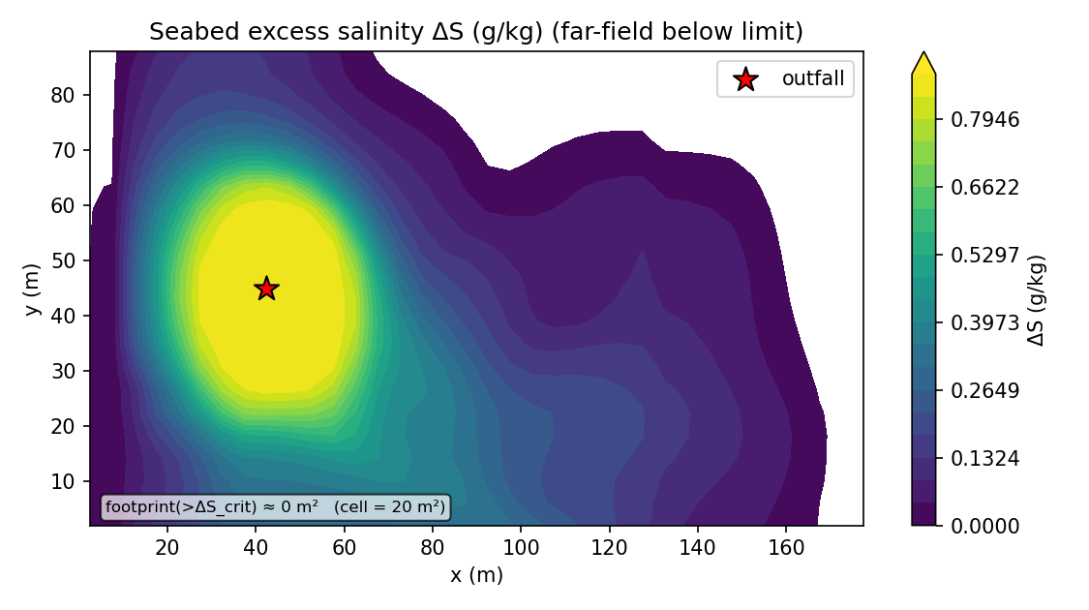
Figure 1. Predicted seabed excess-salinity map (plan view): the dense brine plume spreading from the diffuser, with the regulatory threshold contour.
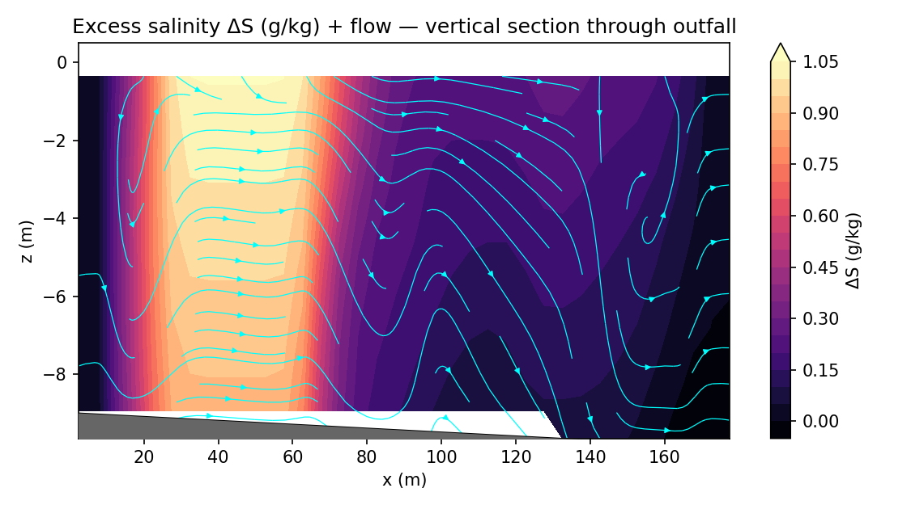
Figure 2. Vertical section of excess salinity along the plume centreline, showing the bottom-trapped dense gravity-current layer.
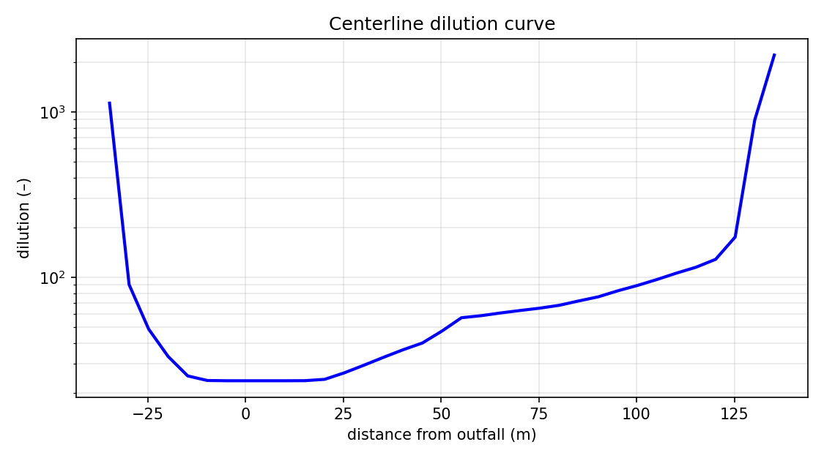
Figure 3. Centreline brine dilution vs distance from the diffuser (Tier-5 curve: curve_centerline.csv).
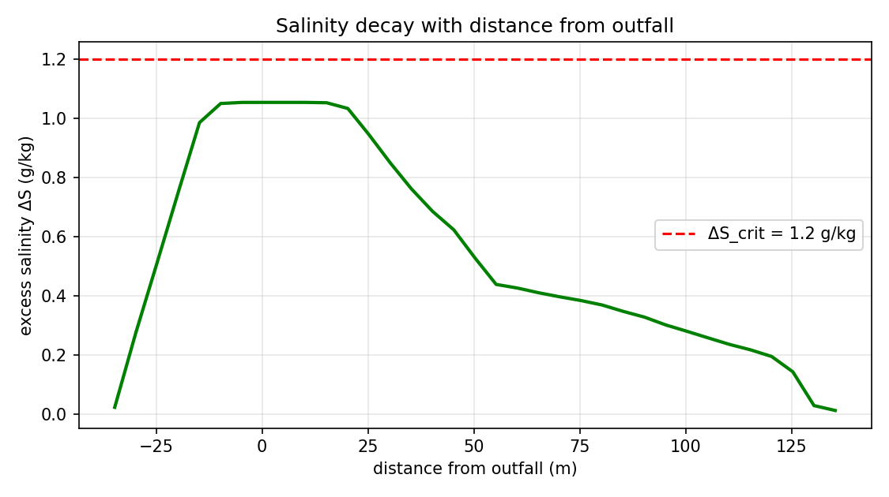
Figure 4. Excess-salinity ΔS decay with distance from the diffuser.
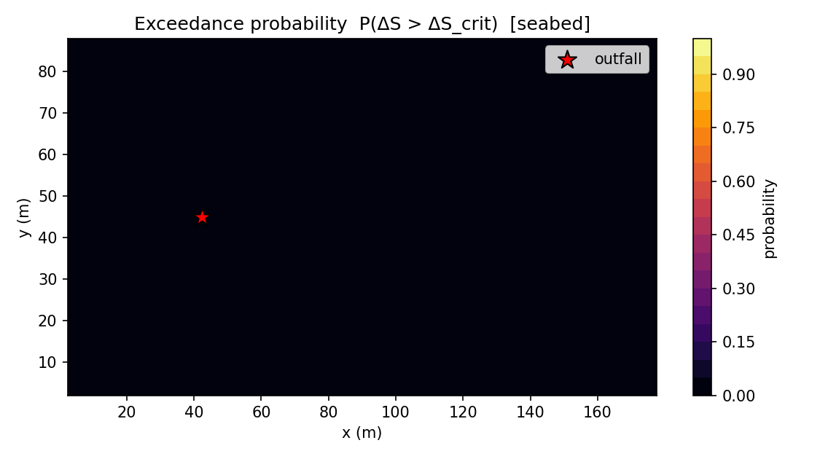
Figure 5. Exceedance-probability map for the regulatory threshold across the stochastic ensemble.
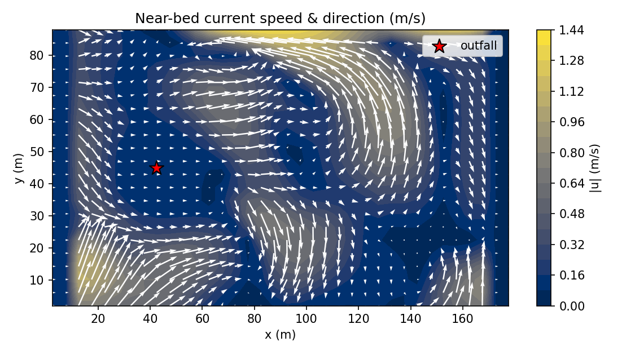
Figure 6. Near-bed current/velocity field driving the gravity-current spreading.
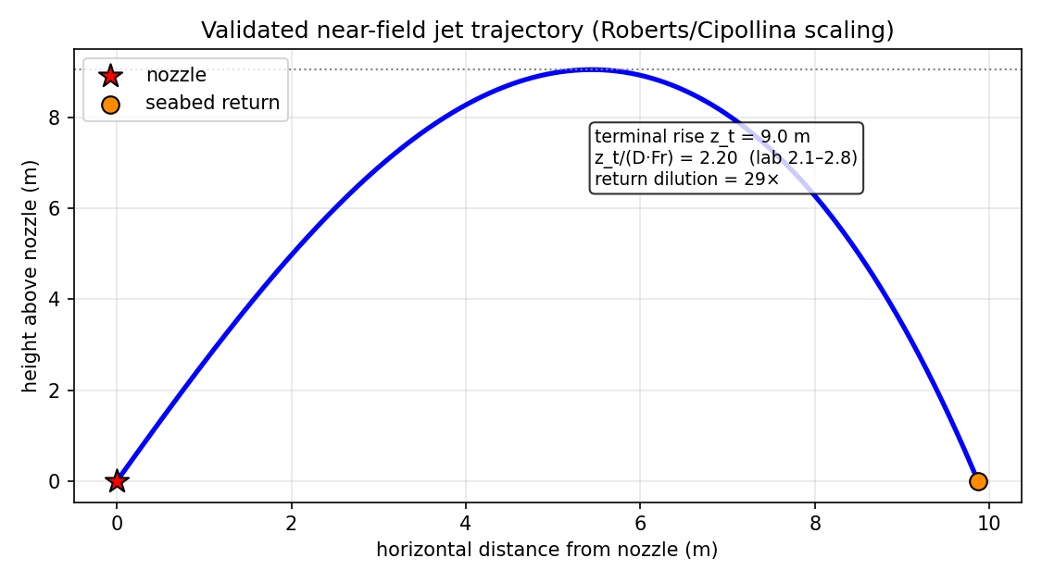
Figure 7. Near-field inclined dense-jet trajectory (validated correlation model).

7. Output data files (folder 5/)
Every artifact below is generated by the solver run and saved in folder 5/:
File | Type | Contents
metrics_summary.json | JSON | headline metrics + full config + ensemble stats + active physics
metrics_timeseries.csv | CSV | time series: S_max, ΔS_max, reach, footprint, dilution, divergence
curve_centerline.csv | CSV | centreline curve: distance, ΔS, dilution, core depth
curve_vertical_profile.csv | CSV | vertical profile: depth, salinity, ΔS, density, temperature
fields_final.npz | binary | full 3-D fields: S, ΔS, dilution, ρ, u, v, w, T, k, ε, ν_t
ensemble_stats.npz | binary | ensemble mean / std / exceedance fields
fig_*.png | graphics | maps, sections, curves, risk/exceedance charts
run.log | log | solver health: divergence, mass balance, cap fractions, near-field summary
perth_case_input.json | JSON | the complete input deck for this case

8. Compliance assessment and conclusions
The predicted excess salinity at the 50 m mixing-zone boundary is ≈ 0.53 g/kg (dilution ≈ 47:1), to be compared with the WA EPA criterion of ΔS < 1.2 g/kg at 50 m. On this basis the discharge is assessed COMPLIANT. Because NEREID-B is validated to UNDER-predict dilution (and therefore OVER-predict salinity/impact) against both the published Perth transect and the universal Roberts (1997) dense-jet scaling, the prediction is conservative — the true field dilution is expected to be somewhat higher (lower impact).
Run health: divergence 0.0 (machine precision), mass imbalance 0.0, eddy-viscosity cap engaged in 0.0% of cells (physical, no railing).
Recommendations: (i) the conservative prediction supports the diffuser design against the 50 m criterion; (ii) a site CTD/ADCP transect would tighten the absolute far-field numbers; (iii) seasonal stratification and low-current ('worst-case' weak-mixing) scenarios should be run as additional ensemble cases to bound the compliance envelope.

9. References & provenance
• WA EPA, 'Perth Desalination Plant Discharge Modelling: Model Validation' (App. D, PSDP referral).
• Roberts, P.J.W., Ferrier, A. & Daviero, G.J. (1997), 'Mixing in Inclined Dense Jets', J. Hydraul. Eng. 123(8):693–699.
• Roberts, P.J.W., Taplin, J. & Zigas, E. (2019), 'Design of Seawater Desalination Brine Diffusers', 38th IAHR World Congress, doi:10.3850/38WC092019-1053.
• Governing equations: 5/model.docx. Solver: solver.py (NEREID-B Rev 1.5). Input deck: 5/perth_case_input.json.

