NEREID-B Simulation Output Report
Brine-dispersion prediction — Perth SWRO submerged diffuser (Cockburn Sound). Complete simulation-output dossier: every CSV plotted, all engineering charts, metrics tables and the solver figure suite.
Generated from the case-study run (solver.py Rev 1.5 + 5/perth_case_input.json). This document accompanies 5/case.docx (interpretation) and 5/model.docx (governing PDEs).

1. Prediction at a glance
Quantity | Value | Unit
Discharge salinity S₀ | 61.4 | g/kg
Ambient salinity | 36.5 | g/kg
Densimetric Froude no. Fr_d | 31.6 | —
Near-field return dilution | 28.7 | :1
Peak salinity S_max | 37.56 | g/kg
Max excess ΔS_max | 1.05 | g/kg
Min dilution (ensemble mean) | 23.6 | :1
Seabed footprint > 1.2 g/kg | 0.0 | m²
Steady state reached | True | —
Final divergence | 3.72e-16 | —
Mass imbalance | 4.59e-16 | —

Interpretation: the peak excess salinity (≈ 1.05 g/kg) stays below the 1.2 g/kg mixing-zone criterion everywhere, so the seabed footprint exceeding the criterion is zero — the diffuser is predicted COMPLIANT (conservative model). Full interpretation in 5/case.docx.

2. Plots of every output CSV
Each CSV written by the solver is plotted below; every numeric column appears in a panel.
2.1 metrics_timeseries.csv
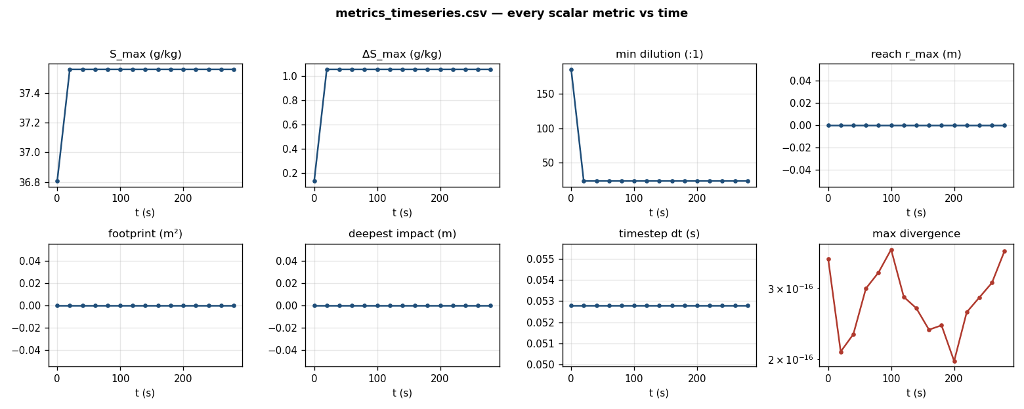
Figure A. All scalar metrics vs time (S_max, ΔS_max, dilution, reach, footprint, deepest impact, timestep, divergence). Flat traces confirm a steady, drift-free quasi-equilibrium plume.
2.2 curve_centerline.csv
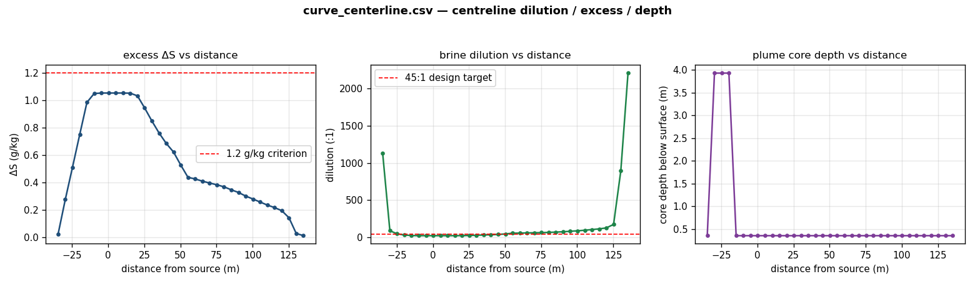
Figure B. Centreline excess salinity, brine dilution and plume-core depth vs distance from the source; dashed lines mark the 1.2 g/kg criterion and the 45:1 design target.
2.3 curve_vertical_profile.csv
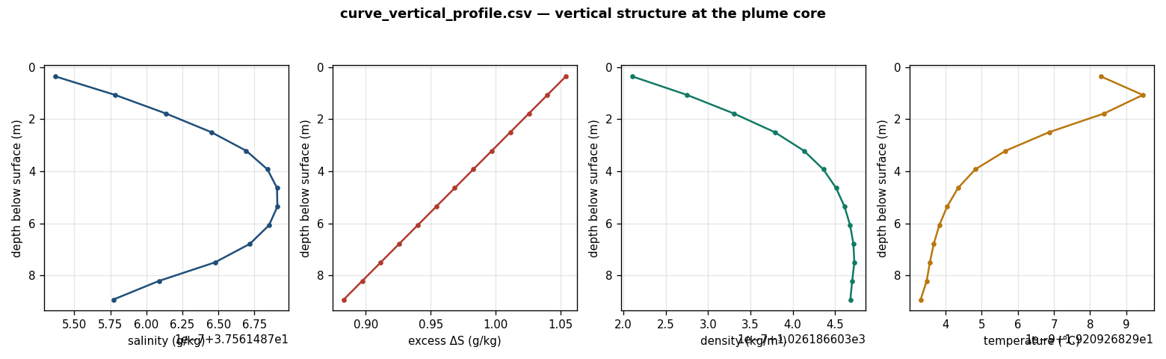
Figure C. Vertical profiles of salinity, excess, density and temperature at the plume-core column, showing the bottom-trapped dense layer.

3. Additional engineering charts
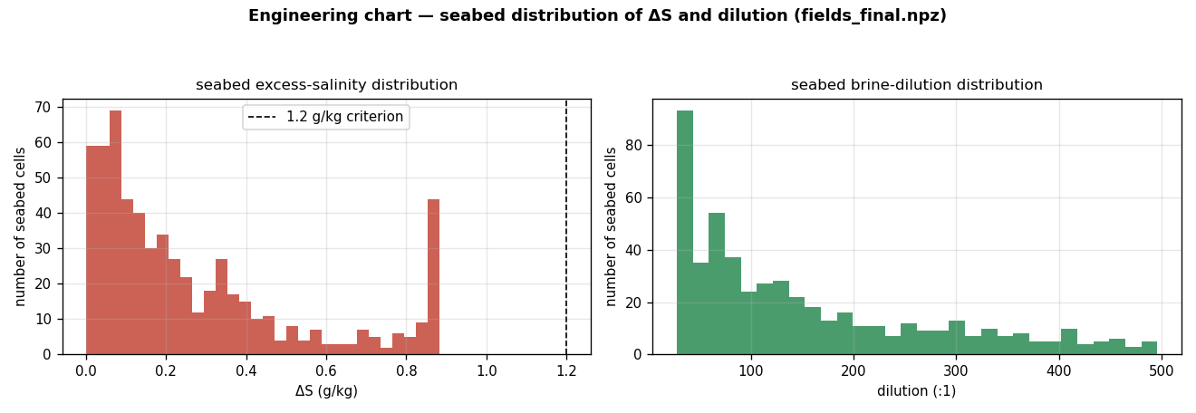
Figure D. Distribution (histograms) of seabed excess salinity and brine dilution across all seabed cells (from fields_final.npz).
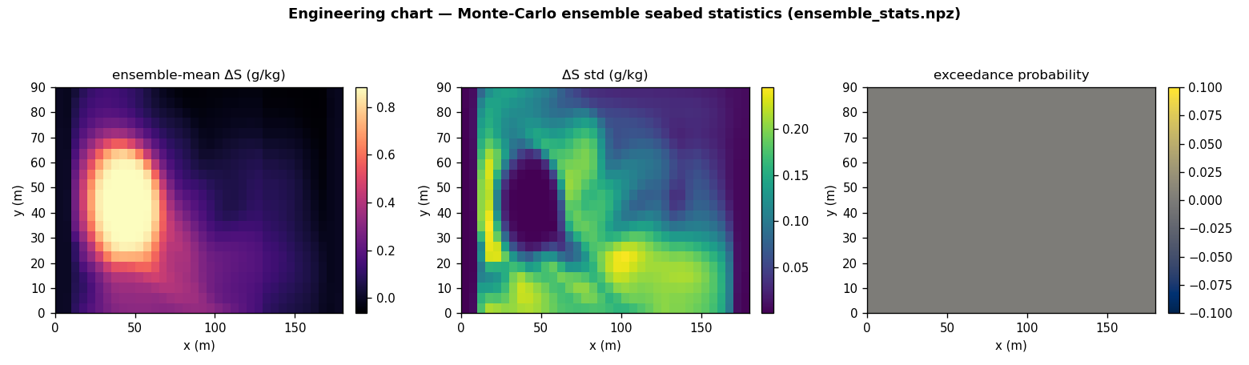
Figure E. Monte-Carlo ensemble seabed statistics: mean excess, standard deviation and exceedance probability (from ensemble_stats.npz).
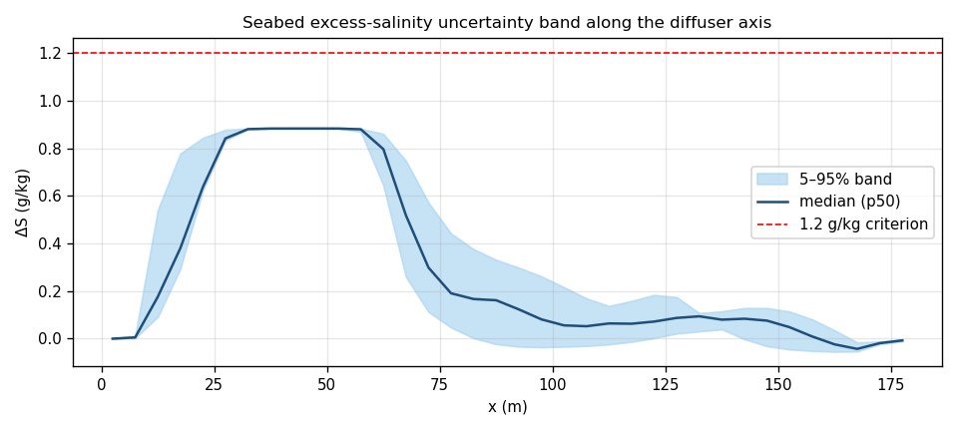
Figure F. Seabed excess-salinity 5–95% uncertainty band and median along the diffuser axis, vs the 1.2 g/kg criterion.

4. Solver figure suite
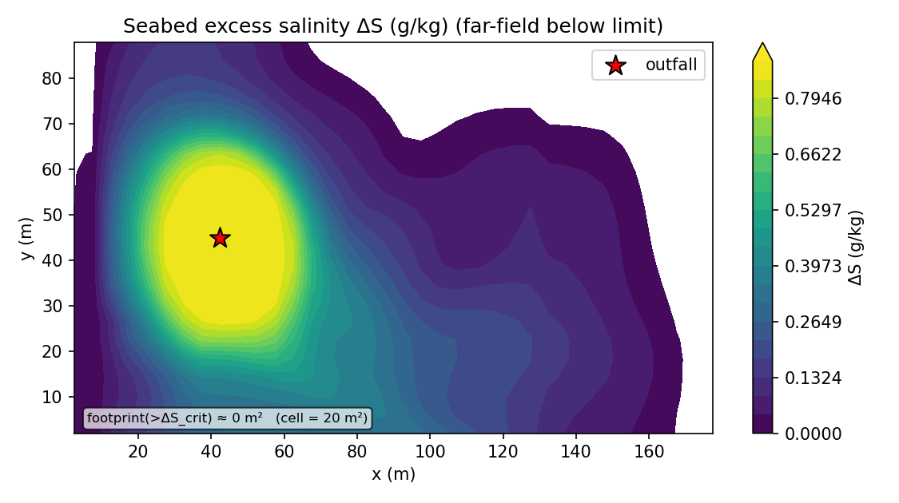
Figure G. Seabed excess-salinity map (plan view).
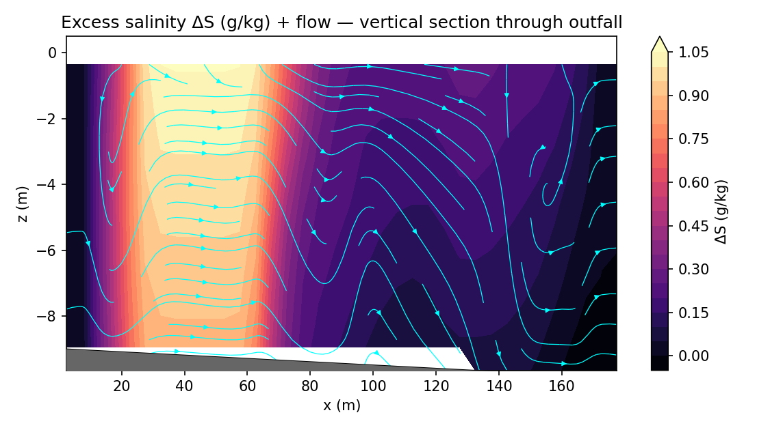
Figure H. Vertical section of excess salinity along the plume.
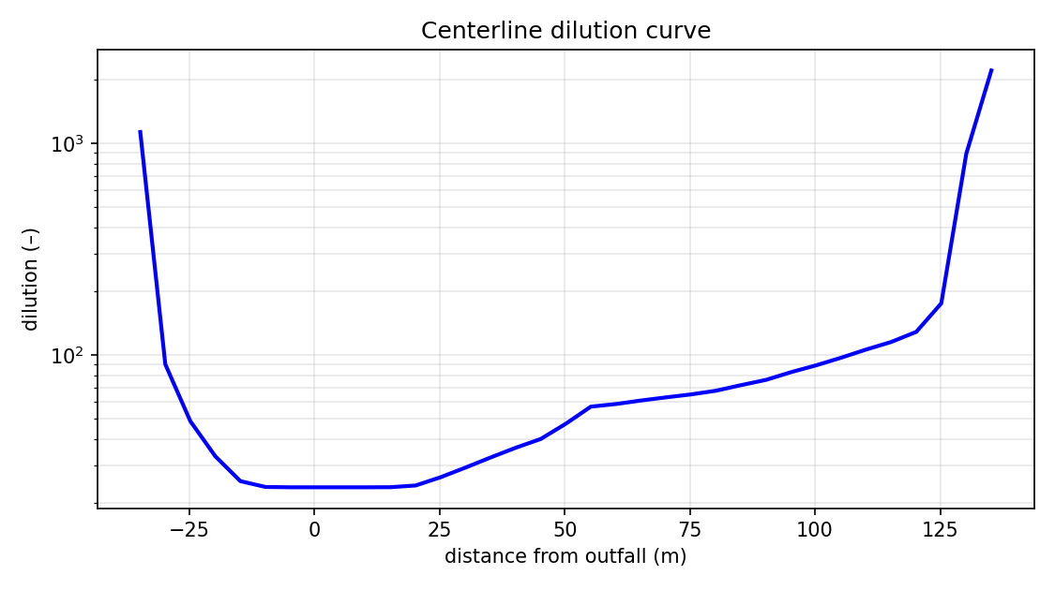
Figure I. Centreline dilution (solver).
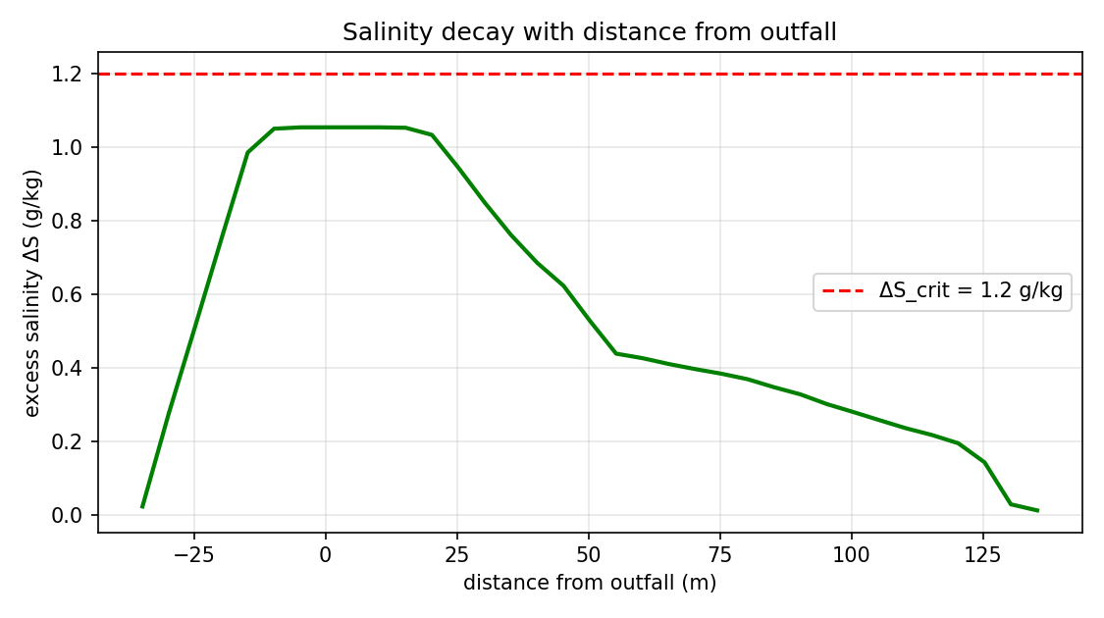
Figure J. Excess-salinity decay with distance (solver).
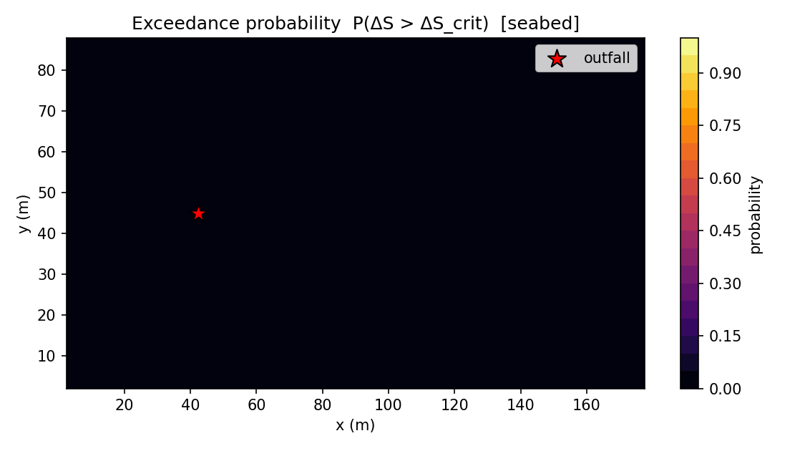
Figure K. Exceedance-probability map (ensemble).
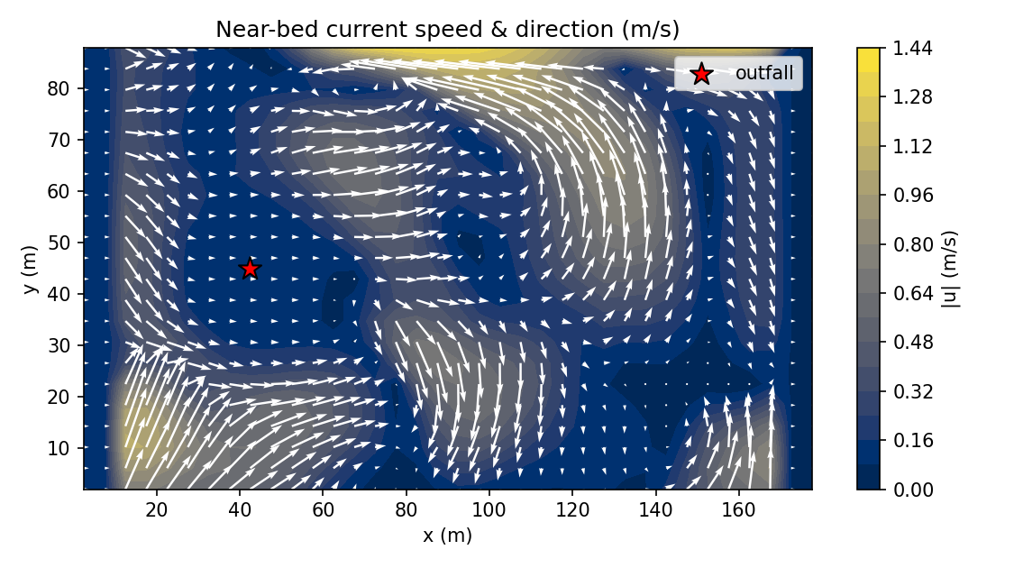
Figure L. Near-bed current field.
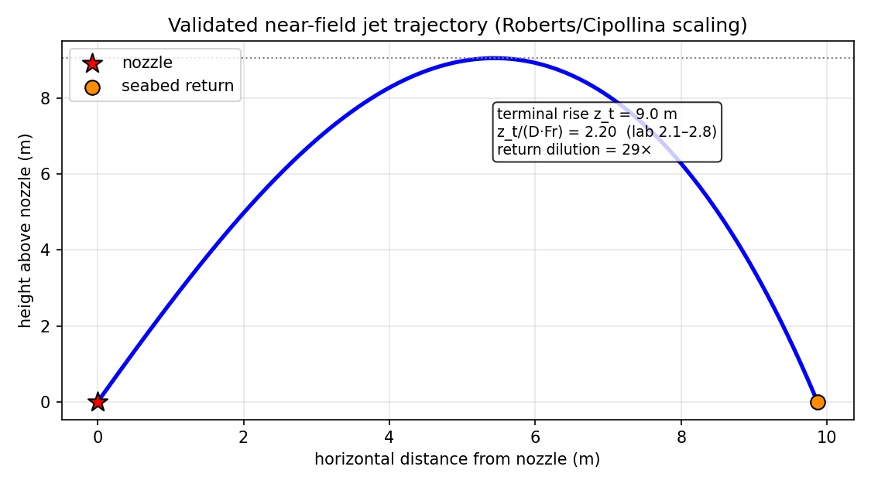
Figure M. Near-field dense-jet trajectory.

5. Output data tables
5.1 Centreline curve (curve_centerline.csv)
distance_m | excess_gkg | dilution | core_depth_m
-34.771 | 0.022 | 1130.285 | 0.357
-29.771 | 0.276 | 90.092 | 3.929
-24.771 | 0.512 | 48.500 | 3.929
-19.771 | 0.751 | 33.066 | 3.929
-14.771 | 0.986 | 25.249 | 0.357
-9.771 | 1.051 | 23.695 | 0.357
-4.771 | 1.054 | 23.612 | 0.357
0.229 | 1.054 | 23.610 | 0.357
5.229 | 1.054 | 23.610 | 0.357
10.229 | 1.054 | 23.610 | 0.357
15.229 | 1.053 | 23.637 | 0.357
20.229 | 1.034 | 24.080 | 0.357
25.229 | 0.945 | 26.344 | 0.357
30.229 | 0.850 | 29.290 | 0.357
35.229 | 0.762 | 32.679 | 0.357
40.229 | 0.685 | 36.321 | 0.357
45.229 | 0.623 | 39.958 | 0.357
50.229 | 0.528 | 47.167 | 0.357
55.229 | 0.438 | 56.816 | 0.357
60.229 | 0.426 | 58.453 | 0.357
65.229 | 0.410 | 60.726 | 0.357
70.229 | 0.396 | 62.842 | 0.357
75.229 | 0.383 | 64.910 | 0.357
80.229 | 0.368 | 67.569 | 0.357
85.229 | 0.347 | 71.794 | 0.357
90.229 | 0.327 | 76.055 | 0.357
95.229 | 0.301 | 82.707 | 0.357
100.229 | 0.279 | 89.087 | 0.357
105.229 | 0.257 | 96.795 | 0.357
110.229 | 0.235 | 105.823 | 0.357
115.229 | 0.217 | 114.882 | 0.357
120.229 | 0.194 | 128.225 | 0.357
125.229 | 0.142 | 174.946 | 0.357
130.229 | 0.028 | 893.377 | 0.357
135.229 | 0.011 | 2208.093 | 0.357

5.2 Vertical profile (curve_vertical_profile.csv)
depth_m | salinity_gkg | excess_gkg | density | Tdeg
8.929 | 37.561 | 0.883 | 1026.187 | 19.209
8.214 | 37.561 | 0.897 | 1026.187 | 19.209
7.500 | 37.561 | 0.911 | 1026.187 | 19.209
6.786 | 37.561 | 0.926 | 1026.187 | 19.209
6.071 | 37.561 | 0.940 | 1026.187 | 19.209
5.357 | 37.561 | 0.954 | 1026.187 | 19.209
4.643 | 37.561 | 0.969 | 1026.187 | 19.209
3.929 | 37.561 | 0.983 | 1026.187 | 19.209
3.214 | 37.561 | 0.997 | 1026.187 | 19.209
2.500 | 37.561 | 1.011 | 1026.187 | 19.209
1.786 | 37.561 | 1.026 | 1026.187 | 19.209
1.071 | 37.561 | 1.040 | 1026.187 | 19.209
0.357 | 37.561 | 1.054 | 1026.187 | 19.209

5.3 Time series (metrics_timeseries.csv)
t_s | dt_s | S_max | excess_max | r_max_m | z_deepest_m | seabed_footprint_m2 | dilution_min | max_divergence
0.100 | 0.053 | 36.806 | 0.133 | 0.000 | 0.000 | 0.000 | 185.804 | 3.56e-16
20.000 | 0.053 | 37.562 | 1.054 | 0.000 | 0.000 | 0.000 | 23.610 | 2.09e-16
40.100 | 0.053 | 37.562 | 1.054 | 0.000 | 0.000 | 0.000 | 23.610 | 2.31e-16
60.000 | 0.053 | 37.562 | 1.054 | 0.000 | 0.000 | 0.000 | 23.610 | 3.00e-16
80.100 | 0.053 | 37.562 | 1.054 | 0.000 | 0.000 | 0.000 | 23.610 | 3.29e-16
100.000 | 0.053 | 37.562 | 1.054 | 0.000 | 0.000 | 0.000 | 23.610 | 3.75e-16
120.100 | 0.053 | 37.562 | 1.054 | 0.000 | 0.000 | 0.000 | 23.610 | 2.86e-16
140.000 | 0.053 | 37.562 | 1.054 | 0.000 | 0.000 | 0.000 | 23.610 | 2.68e-16
160.100 | 0.053 | 37.562 | 1.054 | 0.000 | 0.000 | 0.000 | 23.610 | 2.37e-16
180.000 | 0.053 | 37.562 | 1.054 | 0.000 | 0.000 | 0.000 | 23.610 | 2.43e-16
200.000 | 0.053 | 37.562 | 1.054 | 0.000 | 0.000 | 0.000 | 23.610 | 1.98e-16
220.000 | 0.053 | 37.562 | 1.054 | 0.000 | 0.000 | 0.000 | 23.610 | 2.62e-16
240.000 | 0.053 | 37.562 | 1.054 | 0.000 | 0.000 | 0.000 | 23.610 | 2.85e-16
260.000 | 0.053 | 37.562 | 1.054 | 0.000 | 0.000 | 0.000 | 23.610 | 3.10e-16
280.000 | 0.053 | 37.562 | 1.054 | 0.000 | 0.000 | 0.000 | 23.610 | 3.72e-16

6. Full metric set (metrics_summary.json)
metric | value | metric | value
S_max | 37.561 | excess_max | 1.054
dilution_min | 23.610 | footprint_resolution_m2 | 20.455
reach_resolution_m | 5.000 | depth_resolution_m | 0.714
r_max_m | 0.000 | z_deepest_m | 0.000
plume_top_m | 0.000 | seabed_footprint_m2 | 0.000
affected_volume_m3 | 0.000 | plume_rise_m | 0.000
return_point_dist_m | 0.000 | Fr_d | 31.639
n_ensemble | 4.000 | max_exceedance_prob | 0.000
nf_rise_m | 9.049 | nf_rise_ratio | 2.200
nf_return_dist_m | 9.871 | nf_return_dilution | 28.671
nf_merge_factor | 0.566 | nf_n_ports | 40.000
near_field_coupling | True | divergence_final | 3.72e-16
divergence_max_over_run | 3.75e-16 | divergence_drift_ratio | 1.045
nut_cap_fraction | 0.000 | k_cap_fraction | 0.000
mass_imbalance_final | 4.59e-16 | eta_min_m | 0.000
eta_max_m | 0.000 | eta_absmax_m | 0.000
exceedance_is_probability | True | S_std_max | 0.256
excess_p95_max | 1.054 | ensemble_meanmax_drift | 3.11e-09
vprofile_x_m | 47.500 | vprofile_y_m | 42.955

7. Input deck (perth_case_input.json)
parameter | value | parameter | value
S0 | 61.400 | T_b | 25.000
Q_d | 0.063 | d_p | 0.130
theta_deg | 60.000 | n_ports | 40.000
port_spacing | 4.100 | S_amb_surf | 36.500
S_amb_bot | 36.700 | T_amb_surf | 21.000
T_amb_bot | 19.000 | U_current | 0.080
tide_amp | 0.030 | Hs | 0.800
Tw | 6.000 | wind10 | 6.000
latitude_deg | -32.200 | depth | 10.000
Lx | 180.000 | Ly | 90.000
nx | 36.000 | ny | 22.000
nz | 14.000 | t_end | 280.000
ensemble | 4.000 | dS_crit | 1.200
near_field_coupling | 1.000 | free_surface | 0.000
stoch_enable | 1.000

All artifacts (CSVs, plots plot_*.png, solver figures fig_*.png, metrics_summary.json, fields_final.npz, ensemble_stats.npz, run.log, input deck) reside in folder 5/. Companion documents: 5/case.docx (engineering interpretation), 5/model.docx (governing PDEs).

