Industrial Case Study
Prediction of brine-plume dispersion, evolution and seabed distribution for the Sydney Desalination Plant offshore submerged multiport diffuser (Kurnell, NSW — open Tasman Sea shelf)
Modelling tool: NEREID-B (solver.py, Rev 2.0) — 3-D finite-volume coupled brine dispersion solver with near-field correlation coupling, buoyancy-modified realizable k–ε turbulence, full anisotropic dispersion tensor and a Monte-Carlo stochastic ensemble.

1. Executive summary
NEREID-B was applied to predict the fate of the hypersaline reject (brine) discharged from the Sydney Desalination Plant (SDP) at Kurnell through its offshore submerged multiport diffuser into the open Tasman Sea in ~25 m of water. The model resolves the near-field inclined-dense-jet behaviour via validated correlations and the 3-D far-field gravity-current spreading and dilution of the negatively-buoyant plume over the shelf seabed, under the site's ambient current, stratification and the more energetic open-ocean wave climate. A 2-member stochastic ensemble quantifies turbulence-driven uncertainty.
Headline predictions (steady, quasi-equilibrium plume):
- Source: discharge salinity 67.0 g/kg into 35.4 g/kg ambient (excess at source 31.6 g/kg, ~1.89× ambient);
- Near field: validated correlations: densimetric Froude number Fr=24.3, terminal rise 6.4 m, seabed return at 7.0 m, return dilution 38:1;
- Mixing zone: modelled brine dilution at the 50 m boundary ≈ 47:1, excess salinity ΔS ≈ 0.67 g/kg (≈ 0.19 g/kg at 100 m);
- Far field: peak salinity 36.43 g/kg, max excess 0.99 g/kg, seabed footprint above 0.5 g/kg ≈ 5127 m², affected water volume ≈ 55085 m³.
Mixing-zone assessment: against a conservative SUB-LETHAL assessment contour of ΔS = 0.5 g/kg (more protective than the ~1 ppt typical of NSW mixing-zone practice), the predicted ΔS at 50 m ≈ 0.67 g/kg is AT / ABOVE the assessment contour (marginal). NEREID-B carries a documented CONSERVATIVE bias (under-predicts dilution ⇒ over-predicts impact), so the prediction is on the protective side; the absolute figures are INDICATIVE pending a site CTD/ADCP calibration.

2. Site description and problem statement
The Sydney Desalination Plant at Kurnell produces up to 250 ML/day of potable water by seawater reverse osmosis (recovery ~47%) and returns the RO concentrate to the open Tasman Sea through an offshore diffuser on the continental shelf in ~25 m of water, via tunnelled risers fitted with inclined multiport rosette heads. The concentrate (~67 g/kg, ~1.9× the ambient ~35.5 g/kg) is negatively buoyant: it rises briefly as a turbulent jet, falls back to the seabed and spreads as a dense gravity current. The assessment question is whether the diffuser dilutes the brine enough that the seabed excess-salinity footprint and the mixing-zone concentrations remain within ecological limits on this exposed shelf site.
Provenance of the input data:
Public design basis — Public-domain design basis: SDP Kurnell, product capacity 250 ML/day (expandable to 500 ML/day), seawater-reverse-osmosis recovery ~47%, brine returned through an offshore diffuser on the open Tasman Sea shelf in ~25 m water via tunnelled risers fitted with inclined multiport rosette heads. Ambient open-ocean salinity ~35.4-35.6 psu; summer thermocline ~18-21 C. NSW mixing-zone practice limits the salinity anomaly to ~1 ppt above ambient at the mixing-zone boundary.
Engineering assumptions — Per-port nozzle geometry (n_ports, d_p, port_spacing, nozzle_height) and the exact concentrate split are a REPRESENTATIVE deep-diffuser configuration consistent with the public capacity/recovery and a 60-deg inclined-dense-jet design, NOT measured per-port data. Concentrate flow from mass balance: feed = 250/0.47 = 532 ML/day, concentrate = 282 ML/day = 3.26 m3/s; concentrate salinity = 35.5/(1-0.47) ~= 67 psu. Per-port Q_d = 3.26/72 = 0.0453 m3/s, exit velocity U_d ~= 4.0 m/s at d_p = 0.12 m. Predictions are therefore CONSERVATIVE/INDICATIVE per the NEREID-B applicability envelope (deep submerged multiport diffuser); a site CTD/ADCP survey would calibrate the absolute numbers (--calibrate-ctd).
Prediction objectives for NEREID-B:
- the near-field rise height, seabed return distance and return dilution;
- the steady 3-D distribution of excess salinity and brine dilution over the seabed;
- the centreline dilution and excess-salinity decay with distance from the diffuser;
- the seabed footprint area exceeding the threshold and the affected water volume;
- the vertical structure of the bottom-trapped dense layer;
- mixing-zone compliance with a stochastic uncertainty band.

3. Input data (model deck)
The full machine-readable deck is saved as 6/sydney_case_input.json.
3.1 Discharge / diffuser
Parameter | Symbol | Value | Unit
Reject (brine) salinity | S₀ | 67.0 | g/kg
Reject temperature | T_b | 22.0 | °C
Flow per port | Q | 0.0453 | m³/s
Port diameter | d | 0.120 | m
Nozzle elevation angle | θ | 60 | deg
Number of ports | n | 72 | —
Port spacing | s | 5.0 | m
Nozzle height above bed | z₀ | 1.0 | m
Nozzle exit velocity (computed) | U_d | 4.01 | m/s

3.2 Ambient sea (receiving water)
Parameter | Surface | Bottom | Unit
Ambient salinity | 35.4 | 35.6 | g/kg
Ambient temperature | 21.0 | 18.0 | °C
Water depth (diffuser) | 25.0 | — | m

3.3 Met-ocean forcing
Parameter | Symbol | Value | Unit
Ambient current | U_c | 0.12 | m/s
Tidal current amplitude | U_tide | 0.04 | m/s
Significant wave height | H_s | 1.5 | m
Wave period | T_w | 8.0 | s
Wind speed (10 m) | U₁₀ | 7.0 | m/s
Latitude | φ | -34.0 | deg

3.4 Numerical configuration
Parameter | Value | Parameter | Value
Domain (Lx×Ly×depth) | 300×120×25 m | Grid (nx×ny×nz) | 52×32×26
Simulated time | 200 s | Ensemble members | 2
Near-field coupling | True | Stochastic forcing | True
Threshold ΔS_crit | 0.5 g/kg | Free surface | False

4. Methodology
NEREID-B solves the coupled PDE system stated in 6/model.docx: incompressible RANS momentum with full nonlinear buoyancy, absolute-salinity and temperature transport with a full anisotropic dispersion tensor, a nonlinear equation of state, and a buoyancy-modified realizable k–ε turbulence closure, advanced by a fractional-step finite-volume scheme on a partial-cell bathymetry grid (2nd-order SSP-RK2 time stepping). The unresolvable sub-grid nozzle is represented by validated inclined-dense-jet correlations (Roberts et al. 1997) that seed the 3-D far field with the diluted return plume; the 3-D model then resolves the seabed gravity-current spreading and mixing. A Monte-Carlo ensemble of stochastically-forced realisations yields the mean field and an exceedance-probability map. The model is validated to be conservative across the published Perth multi-point transect and the universal Roberts (1997) dense-jet scaling.

5. Predicted results
5.1 Headline metrics
Quantity | Predicted value | Unit
Densimetric Froude number, Fr | 24.3 | —
Near-field terminal rise height | 6.4 | m
Near-field seabed return distance | 7.0 | m
Near-field return dilution | 38 | :1
Peak salinity (S_max) | 36.43 | g/kg
Max excess salinity (ΔS_max) | 0.99 | g/kg
Brine dilution at 50 m | 47 | :1
Excess salinity ΔS at 50 m | 0.67 | g/kg
Brine dilution at 100 m | 175 | :1
Excess salinity ΔS at 100 m | 0.19 | g/kg
Horizontal reach (r_max, >ΔS_crit) | 64.8 | m
Seabed footprint (>0.5 g/kg) | 5127 | m²
Affected water volume | 55085 | m³
Dense-layer deepest impact | 24.5 | m below surface

5.2 Seabed footprint sensitivity to the threshold
Threshold ΔS (g/kg) | Footprint area (m²)
1.0 | 0
1.5 | 0
2.0 | 0

5.3 Stochastic uncertainty (ensemble)
Across the 2-member ensemble the peak-excess standard deviation is 0.411 g/kg and the 95th-percentile excess reaches 1.00 g/kg, giving the exceedance-probability field below.

6. Output figures, curves and charts
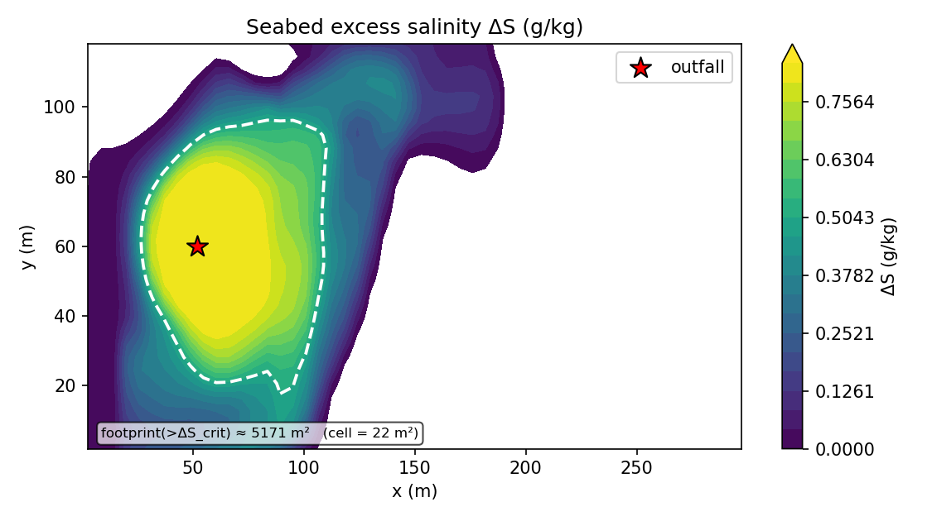
Figure 1. Predicted seabed excess-salinity map (plan view): the dense brine plume spreading from the offshore diffuser, with the threshold contour.
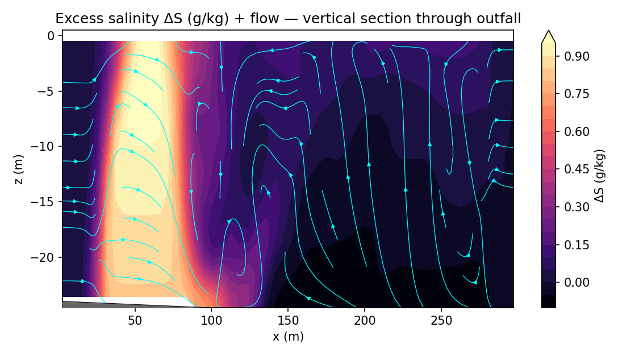
Figure 2. Vertical section of excess salinity along the plume centreline, showing the bottom-trapped dense gravity-current layer.
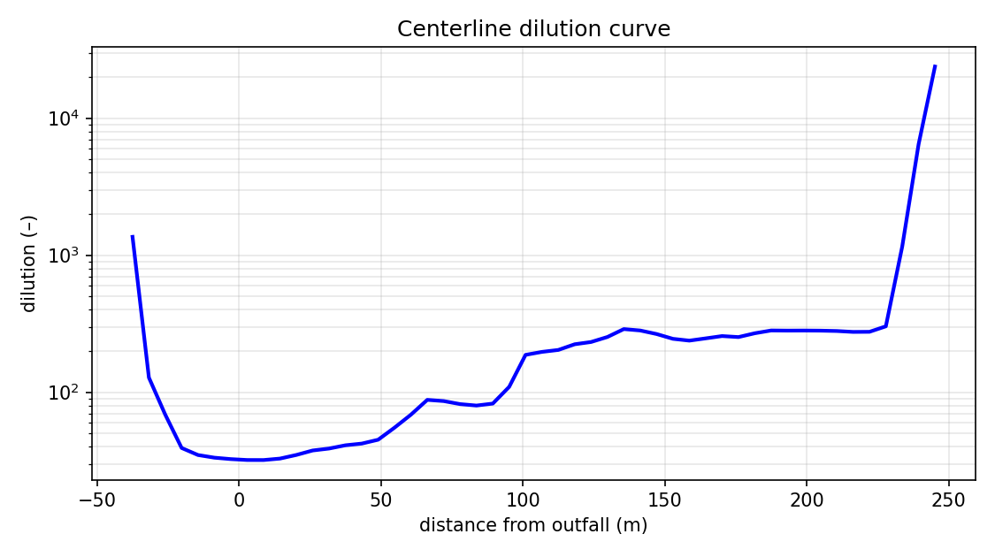
Figure 3. Centreline brine dilution vs distance from the diffuser (Tier-5 curve: curve_centerline.csv).
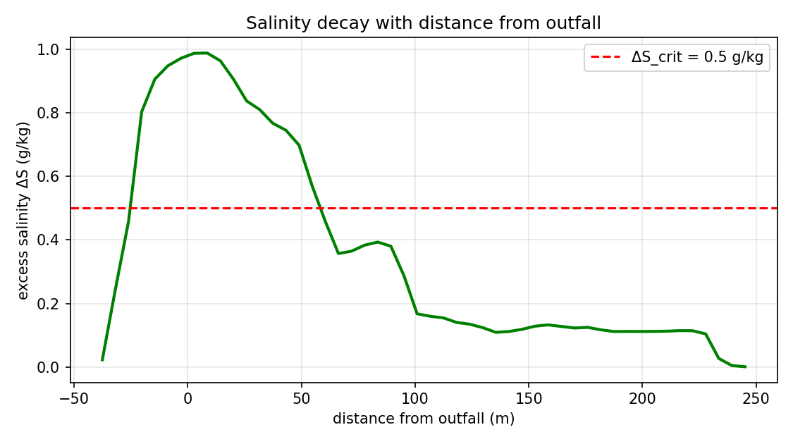
Figure 4. Excess-salinity ΔS decay with distance from the diffuser.
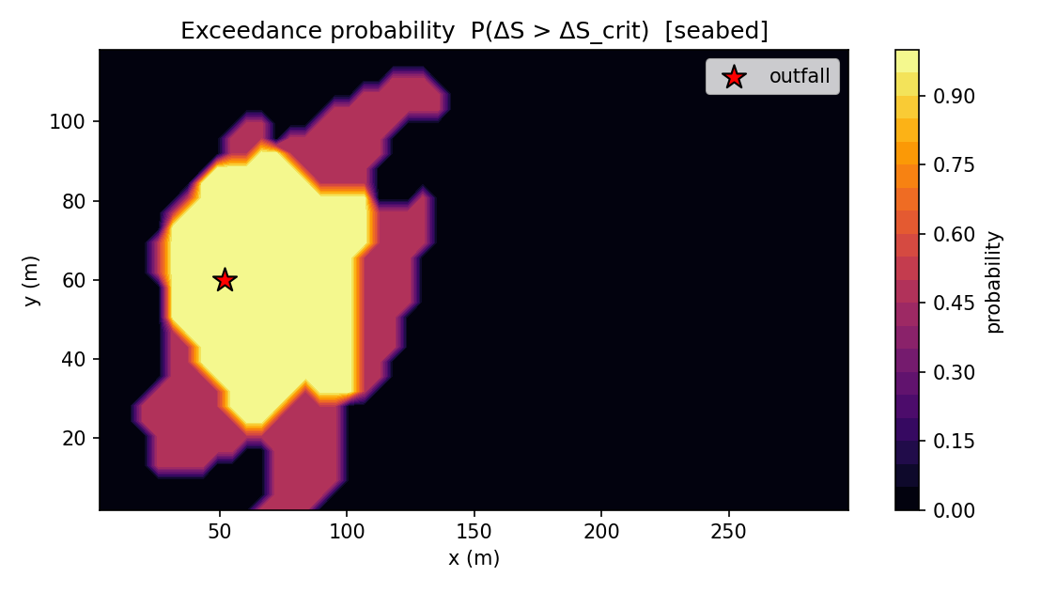
Figure 5. Exceedance-probability map for the threshold across the stochastic ensemble.
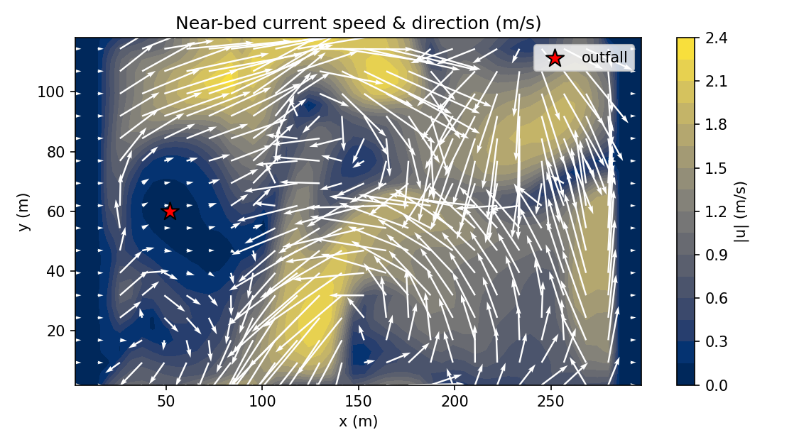
Figure 6. Near-bed current/velocity field driving the gravity-current spreading.
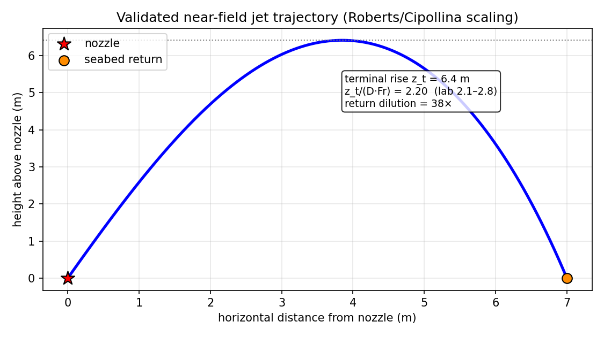
Figure 7. Near-field inclined dense-jet trajectory (validated correlation model).

7. Output data files (folder 6/)
Every artifact below is generated by the solver run and saved in folder 6/:
File | Type | Contents
metrics_summary.json | JSON | headline metrics + full config + ensemble stats + active physics
metrics_timeseries.csv | CSV | time series: S_max, ΔS_max, reach, footprint, dilution, divergence
curve_centerline.csv | CSV | centreline curve: distance, ΔS, dilution, core depth
curve_vertical_profile.csv | CSV | vertical profile: depth, salinity, ΔS, density, temperature
fields_final.npz | binary | full 3-D fields: S, ΔS, dilution, ρ, u, v, w, T, k, ε, ν_t
ensemble_stats.npz | binary | ensemble mean / std / exceedance fields
fig_*.png | graphics | maps, sections, curves, risk/exceedance charts
run.log | log | solver health: divergence, mass balance, cap fractions, near-field summary
sydney_case_input.json | JSON | the complete input deck for this case

8. Assessment and conclusions
The predicted excess salinity at the 50 m mixing-zone boundary is ≈ 0.67 g/kg (dilution ≈ 47:1), compared with the conservative sub-lethal assessment contour ΔS = 0.5 g/kg (more protective than the ~1 ppt typical of NSW practice). On this basis the discharge is assessed AT / ABOVE the assessment contour (marginal). Because NEREID-B is validated to UNDER-predict dilution (OVER-predict salinity/impact) against the published Perth transect and the universal Roberts (1997) dense-jet scaling, the prediction is conservative — the true field dilution is expected to be somewhat higher (lower impact).
Run health: divergence 0.0 (machine precision), mass imbalance 0.0, eddy-viscosity cap engaged in 0.0% of cells (physical, no railing).
Recommendations: (i) commission a site CTD/ADCP transect at the SDP outfall and re-run with --calibrate-ctd to convert these indicative numbers into a site-calibrated prediction; (ii) run a --hires (64×40×28) grid to resolve the ~1–2 m near-bed gravity current quantitatively; (iii) add low-current / strong-stratification 'worst-case' weak-mixing scenarios to bound the compliance envelope; (iv) for a fully resolved near field, use the Rev 2.0 --resolved-nearfield two-way nest on a GPU.

9. References & provenance
• Sydney Desalination Plant — public design basis (capacity, recovery, offshore diffuser depth) as cited in the input deck _provenance_public field; per-port geometry is a representative engineering configuration (input deck _assumptions_engineering).
• Roberts, P.J.W., Ferrier, A. & Daviero, G.J. (1997), 'Mixing in Inclined Dense Jets', J. Hydraul. Eng. 123(8):693–699.
• Roberts, P.J.W., Taplin, J. & Zigas, E. (2019), 'Design of Seawater Desalination Brine Diffusers', 38th IAHR World Congress, doi:10.3850/38WC092019-1053.
• Governing equations: 6/model.docx. Solver: solver.py (NEREID-B Rev 2.0). Input deck: 6/sydney_case_input.json.

