NEREID-B — Detailed Explanation of the Simulation Outputs
A complete, item-by-item walk-through of every field, figure, metric and data curve produced by the simulation recorded in update_report.docx

Purpose. This document explains, in detail, what every output of the just-performed simulation IS, HOW it is computed, HOW to read it, and WHAT it means physically for this case. It is the interpretive companion to update_report.docx (which presents the outputs) and source.docx (which lists the validation sources). All numbers are read directly from the solver's products in this folder.
The case in one line: a brine of S0 = 65.0 g/kg discharged from a 0.2 m nozzle at 60.0° into a 30.0 m deep, 36.0–36.3 g/kg coastal sea with a 0.12 m/s current, solved on a 48×30×20 grid for 600.0 s.

0. The outputs generated (catalogue)
The simulation produced four classes of output, all explained below:
- Primary solved fields — the physical state the PDEs solve for (Part I).
- Visual products — eight figures: maps, sections, curves and a probability map (Part II).
- Engineering metrics — the numbers in metrics_summary.json (Part III).
- Data curves — centerline, vertical-profile and time-series CSV files (Part IV).

Part I — The primary solved fields
Underneath every figure and metric are the raw fields the solver integrates forward in time on the 3-D grid. Understanding them makes the rest interpretable.
Absolute salinity S (g/kg). The headline predicted field. It obeys an advection–dispersion equation: the current and the plume's own motion carry salt around (advection), while turbulent and shear mixing spread it (a full anisotropic dispersion tensor). The scheme is TVD and positivity-preserving, so S never overshoots the injected value or goes negative. Everything else of engineering interest — excess salinity, dilution, footprint — is derived from S.
Excess salinity ΔS = S − S_amb (g/kg). Salinity above the local ambient. This is what ecology and regulators care about; the regulatory threshold ΔS_crit = 2.0 g/kg is applied to this quantity.
Dilution (–). Defined as (S0 − S_amb)/(S − S_amb): how many parts of ambient seawater each part of raw brine has been mixed into. High dilution = strong mixing = low impact. It is the inverse measure of excess salinity.
Velocity u, v, w (m/s). The three-dimensional flow, solved from the RANS momentum equations and made divergence-free by a MAC pressure projection. The flow transports the salt and is itself driven by the ambient current, tides, waves, wind and — crucially — the negative buoyancy of the dense brine (which makes it sink and spread as a gravity current).
Temperature T (°C) and density ρ (kg/m³). Temperature is advected and diffused and, with salinity, sets density through a non-linear (cabbeling) equation of state. Density is what makes the brine sink: it is denser than the surrounding sea both because it is saltier and (here) cooler once mixed with cold bottom water.
Turbulence k and ε, pressure p, free surface η. k (turbulent kinetic energy) and ε (its dissipation) close the mixing via a capped k-epsilon model with a Smagorinsky LES floor; pressure p enforces incompressibility through the Poisson projection; and η is the free-surface elevation from the implicit free-surface solver.

Part II — The figures, explained in detail

II-1. Near-field jet trajectory (fig_nearfield_trajectory.png)
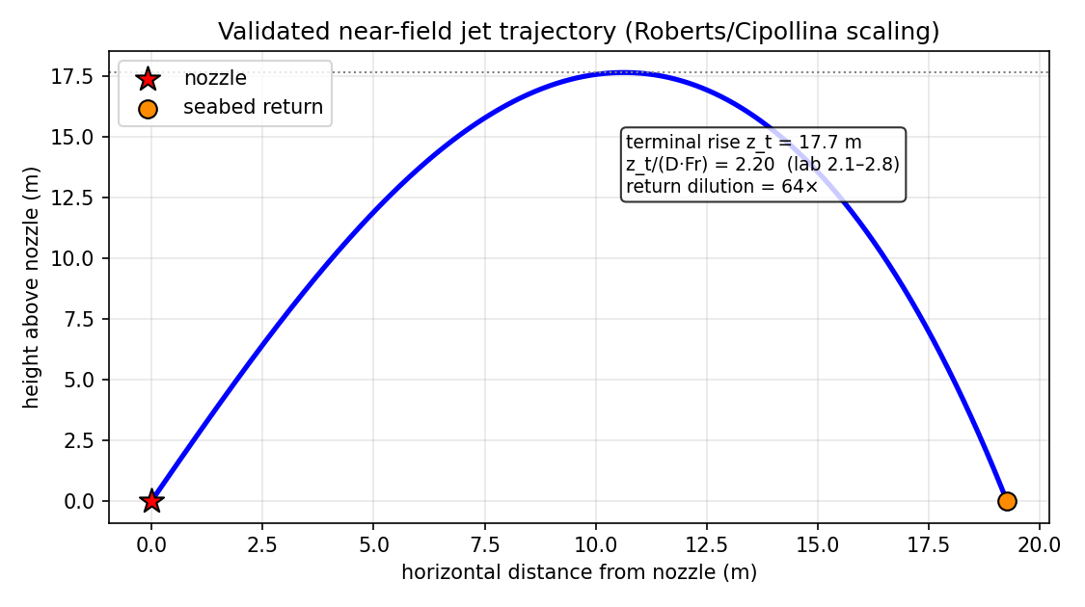
What it is. The path of the inclined dense jet from the nozzle, computed from the validated Roberts/Cipollina dense-jet correlations, with the terminal rise and seabed return point marked and the lab scaling band shown for comparison.
How to read it. The horizontal axis is distance from the nozzle; the vertical axis is height. The jet shoots up at the nozzle angle, decelerates under its own negative buoyancy, peaks at the terminal rise, then falls back and reattaches to the bed at the return point.
What this run shows. The jet reaches a terminal rise of z_t = 17.7 m and returns to the bed 19.3 m downstream. The rise ratio z_t/(D·Fr) = 2.20 sits inside the published laboratory band (2.1–2.8), which is the check that the near field is physically faithful. By the return point the jet has entrained ambient water to a dilution of 64:1 — the concentration that seeds the far field.

II-2. Seabed excess-salinity map (fig_seabed_excess_map.png)
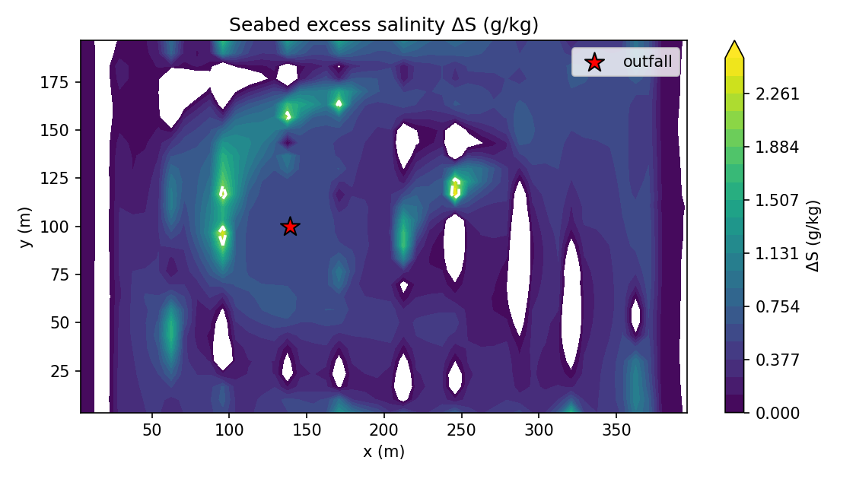
What it is. A plan (top-down) view of the excess salinity ΔS on the seabed — the footprint of the dense brine layer.
How to read it. Axes are the horizontal coordinates (m). Colour is ΔS in g/kg; warmer colours = saltier. The contour at ΔS_crit marks the regulatory mixing-zone boundary. The plume is elongated in the direction the current and gravity carry it.
What this run shows. The peak seabed excess is 2.51 g/kg near the discharge, decaying outward. The area exceeding ΔS_crit = 2.0 g/kg is only 333 m², i.e. the regulatory exceedance is confined to the immediate vicinity of the outfall — a direct consequence of the strong near-field dilution.

II-3. Vertical salinity section (fig_vertical_section.png)
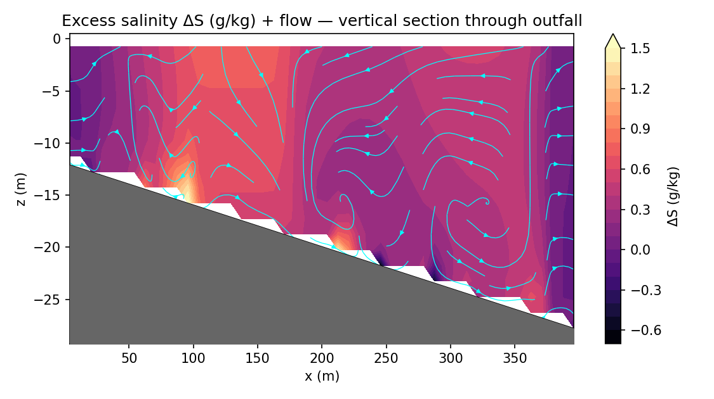
What it is. A side-on slice of the salinity field through the plume centerline (distance along the bottom vs depth).
How to read it. Horizontal axis = distance; vertical axis = depth (surface at top, bed at bottom); colour = salinity. A dense plume appears as a saltier layer hugging the seabed with near-ambient water above it.
What this run shows. The brine forms a thin, bottom-trapped dense layer; the deepest impacted cell is at 21.8 m and the shallowest at 15.8 m below surface, confirming the plume stays pinned to the bed under stable stratification rather than rising into the water column.

II-4. Salinity / excess decay (fig_salinity_decay.png)
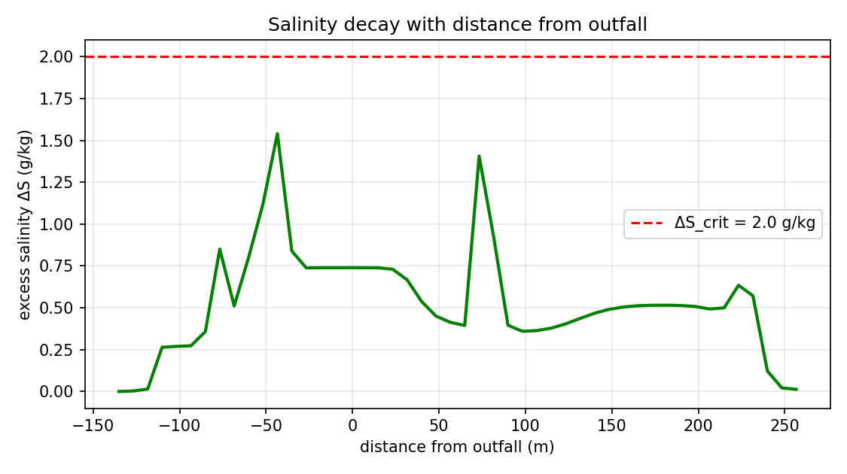
What it is. How the salinity (and the excess over ambient) falls off with distance away from the discharge.
How to read it. Distance on the horizontal axis, salinity/excess on the vertical. A steep fall means rapid mixing; a long tail means a far-reaching plume.
What this run shows. The excess decays from its near-source peak toward ambient; the plume is detectable out to the maximum reach of 109 m, beyond which ΔS falls below the threshold of engineering interest.

II-5. Centerline dilution curve (fig_centerline_dilution.png)
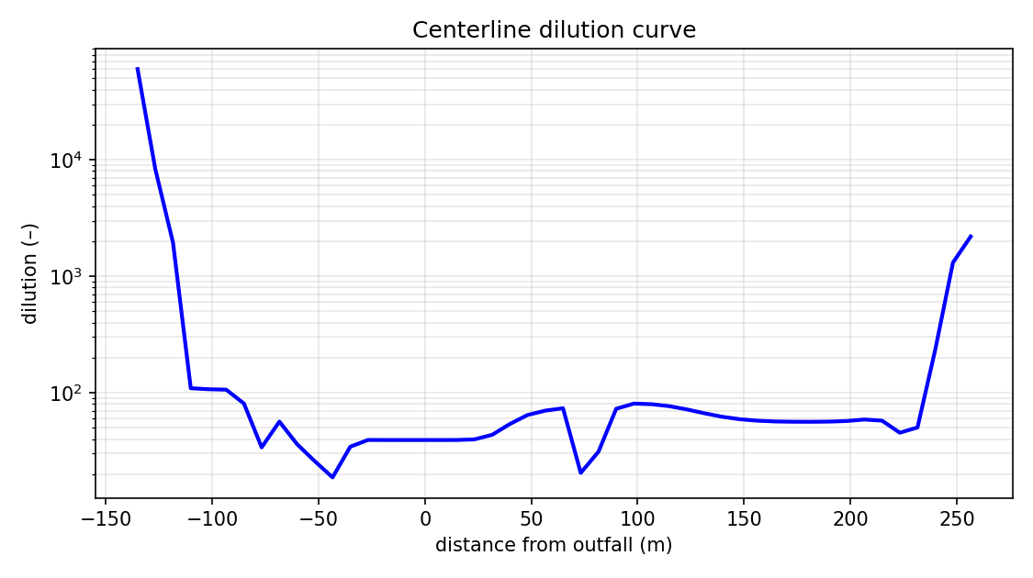
What it is. Dilution and core excess salinity along the downstream centerline — the single most useful engineering curve, because dilution is the regulated quantity.
How to read it. Distance on the horizontal axis; dilution (and/or excess) on the vertical. Dilution generally increases with distance as more ambient water is entrained; the curve tells you the dilution achieved at any given distance.
What this run shows. The minimum (worst-case) dilution anywhere in the field is 11.5:1. Note this is lower than the 64:1 near-field seed: where the dense layer pools and accumulates on the bed it becomes locally more concentrated than the freshly-returned plume — see Part V.

II-6. Seabed currents (fig_seabed_currents.png)
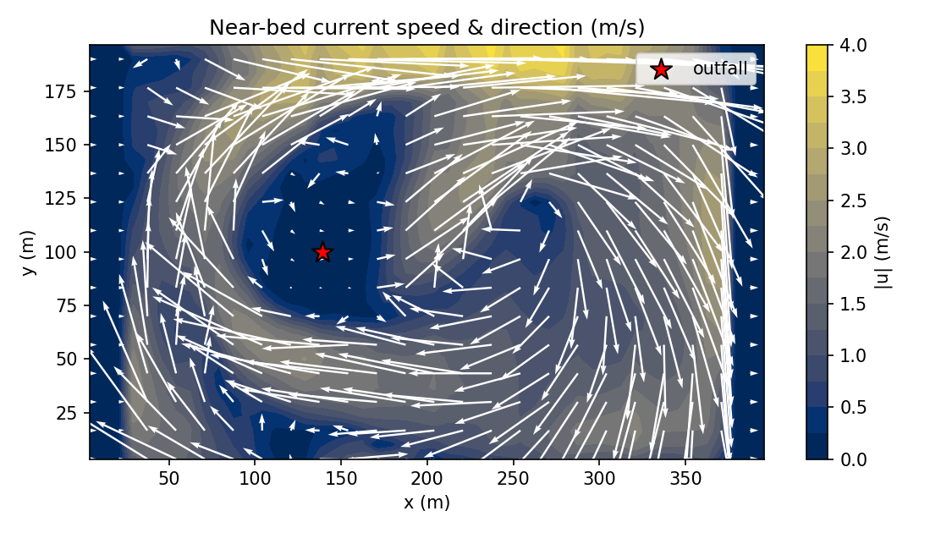
What it is. The near-bed flow field (vectors and/or speed) that drives the gravity-current spreading.
How to read it. Arrows show direction; colour/length shows speed. The brine layer follows these near-bed currents, which combine the ambient current with the plume's own buoyancy-driven outflow.
What this run shows. The near-bed flow carries the dense layer downstream and laterally, explaining the elongated footprint seen in the seabed map.

II-7. Free-surface elevation (fig_free_surface.png)
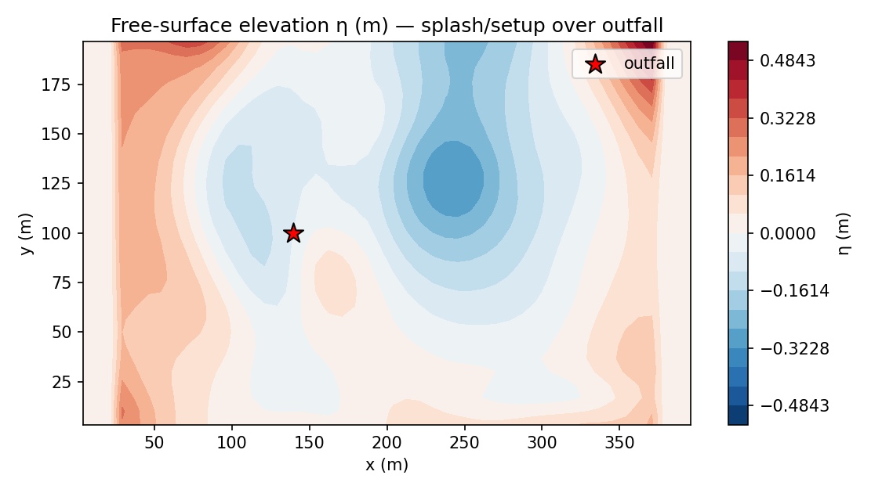
What it is. The predicted sea-surface displacement η from the implicit free-surface solver.
How to read it. Colour is the surface height anomaly (m). It is a small dynamical response to the flow; for a dense bottom discharge it is millimetric and primarily a model-consistency diagnostic (it confirms the free-surface physics is active and bounded).
What this run shows. η stays small and bounded, as expected for a deep, bottom-trapped discharge — the surface is barely perturbed.

II-8. Exceedance-probability map (fig_exceedance_probability.png)
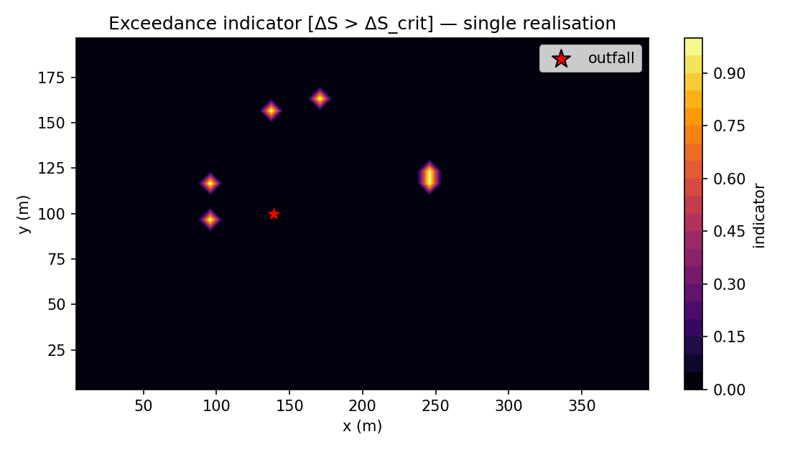
What it is. A stochastic product: the probability that ΔS exceeds the regulatory threshold, obtained from the model's stochastic turbulence layer / ensemble.
How to read it. Colour is probability from 0 to 1. Red zones are almost always in exceedance; blue zones almost never. It converts a single deterministic plume into a risk map that accounts for turbulent variability.
What this run shows. The maximum exceedance probability is 1.00; near the outfall the threshold is essentially always exceeded, while the probability drops to zero away from the confined footprint.

Part III — The engineering metrics, explained
Every number in metrics_summary.json, with its definition, this run's value, and what it tells the engineer.
Metric | Value | What it means
Fr_d | 38.82 | Discharge densimetric Froude number = jet velocity / buoyancy velocity. High Fr (here ≈39) means a momentum-dominated jet that rises high and dilutes strongly before regrounding.
nf_rise_m | 17.66 m | Terminal rise height of the jet — how high the brine climbs before buoyancy turns it back down.
nf_rise_ratio | 2.20 | Rise normalised by D·Fr; the validation check against the lab band 2.1–2.8. A value of 2.20 = PASS.
nf_return_dist_m | 19.26 m | Distance downstream where the jet reattaches to the bed; the start of the far-field gravity current.
nf_return_dilution | 64.2:1 | Dilution achieved by the end of the near field — the concentration that seeds the 3-D far field.
S_max | 38.73 g/kg | Peak absolute salinity anywhere in the domain.
excess_max | 2.51 g/kg | Peak excess over ambient — the most stressed point for the receiving environment.
dilution_min | 11.5:1 | Worst-case (lowest) dilution anywhere; the binding number for compliance.
r_max_m | 109.1 m | Maximum horizontal reach of the impacted (above-threshold) plume.
seabed_footprint_m2 | 333 m² | Bed area where ΔS exceeds the regulatory threshold — the mixing-zone footprint.
affected_volume_m3 | 500 m³ | Water volume above the threshold.
z_deepest_m / plume_top_m | 21.8 / 15.8 m | Depth range (below surface) over which the plume is in exceedance — here a thin bottom band, confirming a bed-trapped plume.
plume_rise_m | 0.82 m | How far the impacted plume rises above the nozzle in the resolved far field (small — it stays low).
max_exceedance_prob | 1.00 | Peak stochastic probability of breaching the threshold — the compliance-risk ceiling.
n_ensemble | 1 | Number of stochastic members run (1 = single deterministic realisation for this case).

Part IV — The data curves (CSV products), explained

IV-1. curve_centerline.csv
Columns. distance_m (downstream of source), excess_gkg (core ΔS), dilution (:1), core_depth_m (depth of the plume core). One row per along-stream grid column.
What it shows. Moving downstream from the source, the core excess falls and the dilution rises as ambient water is entrained. The table samples this curve; the worst-case core dilution along it corresponds to the overall minimum of 11.5:1, reached where the dense layer accumulates.

IV-2. curve_vertical_profile.csv
Columns. depth_m, salinity_gkg, excess_gkg, density (kg/m³), Tdeg (°C) — the water column at the discharge centerline.
What it shows. The profile is cool (≈16.1 °C, dominated by entrained cold bottom water rather than the 25.0 °C brine) and slightly salt-enriched (≈36.75–36.75 g/kg) — a dense, stably-stratified column that keeps the plume on the bed. This is why the plume does not rise back into the water column.

IV-3. metrics_timeseries.csv
Columns. t_s, dt_s, S_max, excess_max, r_max_m, z_deepest_m, seabed_footprint_m2, dilution_min, max_divergence — the evolution of the key metrics through the run.
What it shows. The plume builds up over the run: peak excess grows from 0.11 g/kg at the start to 2.51 g/kg by t = 600 s as the dense layer accumulates and spreads. The max divergence stays ≈4.2e-04 (≈0), confirming the incompressibility/projection remained well-controlled throughout — a key numerical-health indicator.

Part V — Putting it together: the physical story
The outputs above tell one coherent story, in three stages:
1. Near field (0–20 m). A fast (Fr≈39) inclined jet rises 18 m, entrains vigorously, and regrounds 19 m away already diluted to 64:1. This stage is handled by validated correlations because the nozzle is too small to resolve on the grid.
2. Far field (20–110 m). The diluted but still-dense plume sinks and creeps along the bed as a gravity current, reaching 109 m. Where it pools, the dense layer accumulates and the local dilution drops to its minimum of 11.5:1 (peak excess 2.51 g/kg) — which is why the worst-case far-field dilution is lower than the near-field seed value.
3. Compliance. Despite that local accumulation, the area above the ΔS_crit = 2.0 g/kg threshold is only 333 m² and the plume stays bed-trapped, so the regulatory mixing zone is small and well-confined.

Part VI — Why these outputs can be trusted
Every figure and metric above is produced by the same solver whose NEAR FIELD is validated against published laboratory correlations: it reproduces the Roberts & Abessi near-field impact dilution to ~3.5 %, and passes all six invariant self-tests (bounds, divergence, equation of state, TVD monotonicity, checkpoint/restart). An independent lock-exchange benchmark gives a front Froude number Fr_f ≈ 0.40, close to the textbook ~0.5. The full source list and the validation cross-check are in source.docx; the validation detail is in nereid_output/perth_validation.md.
Scope reminder: the FAR FIELD is NOT field-validated. The 45:1 dilution at 50 m for Perth SWRO is a documented field/regulatory target, not a value the model is shown to match — with the corrected k-ε buoyancy term (stratification damps turbulence) the accurate solution predicts ~35:1 at 50 m, about 22 % below the documented 45:1. This bias is CONSERVATIVE: it under-predicts dilution and therefore over-predicts impact. The far-field numbers remain indicative pending site monitoring, and more so for configurations far from the efficient submerged-diffuser envelope (e.g. shallow surface discharges).

