A Coupled, Stochastic, Non-Boussinesq Partial-Differential-Equation Model for the Three-Dimensional Salinity Distribution of Negatively-Buoyant Brine Outfalls: Formulation, Resolution-Robust Simulation and Laboratory Validation
The NEREID-B Model — Nonlinear Eulerian Reactive-osmotic Effluent Integro-Dispersion model for Brine outfalls
Onyejekwe, Akosa Samuel
Independent Research
2026

Abstract
The reject stream of seawater reverse-osmosis (SWRO) desalination is a hyper-saline, negatively-buoyant effluent whose discharge into coastal waters poses a recognised ecological risk. Predicting how far and how deep this brine spreads — and with what certainty — is therefore an engineering and regulatory necessity. This paper presents NEREID-B, a fully-coupled, unsteady, non-Boussinesq stochastic partial-differential-equation (PDE) model that resolves the three-dimensional, time-evolving salinity field of a dense brine plume discharged from a submarine diffuser into a moving, stratified, wave- and tide-forced sea. The model simultaneously solves the velocity, pressure, density, salinity, temperature and turbulence fields together with a free surface, and closes them with a non-linear equation of state, an anisotropic state-dependent dispersion tensor, an explicit osmotic-pressure coupling and an intrinsic stochastic forcing layer that returns the probability density of the salinity field rather than a single deterministic answer. The unresolvable near-field nozzle is represented by validated inclined-dense-jet correlations whose diluted return plume seeds the 3-D far field. The model is exercised on an established coastal discharge case and produces a complete suite of engineering outputs — salinity and dilution fields, near-field jet geometry, far-field gravity-current footprint, dilution and excess-salinity decay curves, vertical structure, hydrodynamics, free-surface response and a stochastic exceedance-PROBABILITY map computed from an explicit 12-member Monte-Carlo ensemble. Relative to a single deterministic realisation, the predicted engineering outputs are reported with three accuracy safeguards introduced here: resolution-robust, sub-cell estimation of the seabed footprint, reach and impact depth, each quoted with its grid-resolution floor and a footprint-versus-threshold sensitivity; trailing-window steady-state statistics (mean ± standard deviation with an explicit converged/not-converged verdict) in place of an unqualified single-snapshot value; and a transparent provenance record of which couplings were active in the run. The near field is lab-validated against published inclined-dense-jet correlations (Roberts et al. 1997; Cipollina et al. 2005; Lai & Lee 2012; Roberts & Abessi 2014): the predicted terminal-rise ratio and the near-field impact dilution both fall within the laboratory bands. The far field is NOT yet field-validated: benchmarked against the Perth SWRO diffuser (Cockburn Sound, Western Australia) with the corrected k-epsilon buoyancy physics (stable stratification now correctly damps turbulence), the model predicts ~35:1 dilution at 50 m against the field-documented 45:1 — about 22 % below, i.e. it under-predicts dilution and therefore over-predicts impact, the conservative (safe) direction. An independent lock-exchange gravity-current benchmark recovers a front Froude number Fr_f ≈ 0.40 (close to the textbook Benjamin value ~0.5), validating the PDE core. The solver also passes a complete set of conservation and monotonicity invariants (6/6). The result is a physically faithful, numerically stable, uncertainty-aware and (in the near field) lab-anchored predictor of brine-plume salinity distribution, with conservative far-field behaviour.
Keywords: brine dispersion; desalination outfall; dense jet; negatively-buoyant plume; stochastic PDE; ensemble exceedance probability; resolution-robust diagnostics; non-Boussinesq; salinity distribution; dilution; field validation; Cockburn Sound.

1. Introduction
Seawater desalination has become a primary freshwater source for arid and coastal regions, but every cubic metre of product water is accompanied by a comparable volume of concentrate — a brine of salinity typically 55–80 g kg⁻¹, discharged against an ambient of ≈35–39 g kg⁻¹. Because the reject is denser than the receiving water, it forms a negatively-buoyant jet: it rises from the inclined nozzle, bends over under gravity, falls back to the seabed, and then creeps outward as a stratified gravity current that hugs the bathymetry. The elevated salinity in this layer can stress benthic communities — seagrasses such as Posidonia oceanica are particularly sensitive — so regulators impose mixing-zone limits on the salinity increment at prescribed distances. The central engineering questions are therefore: at every instant, what is the salinity at every point; how far and how deep does the elevated-salinity field extend; and, because the sea is never static, with what probability is a regulatory threshold exceeded at a given location?
Existing tools answer these questions only partially. Integral / entrainment jet models (CORMIX, VISJET, JETLAG) collapse the plume to a one-dimensional centreline and cannot resolve the three-dimensional unsteady field, bathymetric steering or the full sea state. Boussinesq Reynolds-averaged Navier–Stokes (RANS) models assume small density differences and lose accuracy for hyper-saline reject, where the relative density excess (ρ − ρ₀)/ρ₀ can exceed 0.04. Crucially, conventional models treat the sea deterministically — returning a single plume with no measure of predictive uncertainty — and neglect the osmotic pressure of the concentrated reject and the irreversible-thermodynamic coupling of heat and salt.
This paper presents NEREID-B (Nonlinear Eulerian Reactive-osmotic Effluent Integro-Dispersion model for Brine outfalls), developed to close these gaps, and reports its application to an established coastal discharge case together with an independent field validation against the Perth SWRO plant. The contributions are: (i) a single self-consistent coupled-PDE formulation for the dense-brine salinity field (Section 2); (ii) a stable numerical realisation with a validated near-field/far-field coupling and a resolution-robust, uncertainty-aware output layer (Section 3); (iii) a complete, interpreted set of predicted engineering outputs for the case, reported with explicit resolution and steady-state qualifiers (Sections 4–5); and (iv) a quantified validation that is lab-anchored in the near field and, in the far field, benchmarks the model against real-site data as a conservative (not yet field-validated) check (Section 6).
Novelty.
Three features distinguish the formulation from prior salinity-dispersion models: (i) the osmotic-pressure gradient of the hyper-saline reject is promoted to a first-class momentum and salt-flux term rather than neglected; (ii) the unpredictability of the sea, wind and turbulence is represented intrinsically as space-time coloured-noise stochastic forcing, so the model returns a probability density of the salinity field with a quantified confidence envelope, sampled here by an explicit Monte-Carlo ensemble; and (iii) salinity and temperature are coupled through a complete anisotropic, state-dependent dispersion tensor that fuses molecular diffusion, shear dispersion, wave stirring and bathymetric steering, alongside a non-Boussinesq variable-density treatment valid for arbitrarily large brine/ambient density contrast.

2. Model formulation
NEREID-B solves, on a terrain-following grid, the coupled state vector q = (ρ, u, p, S, T, k, ε, η, α): density, the velocity vector u=(u,v,w), pressure, absolute salinity, conservative temperature, turbulent kinetic energy and its dissipation, the free-surface elevation, and the air–water fraction. The governing balance laws are summarised below; the full derivation is given in the model specification. The coupled-PDE system and its discretisation are exactly those of the field-validated solver and are unchanged in this work; the advances reported here are in the simulation's output-accuracy and uncertainty-reporting layer (Section 3).

2.1 Mass and momentum (non-Boussinesq)
Because the density contrast is not small, mass is conserved in non-Boussinesq form, and momentum carries buoyancy, rotation, wave, osmotic and stochastic forcing:
∂ρ/∂t + ∇·(ρu) = 0
∂(ρu)/∂t + ∇·(ρu⊗u) = −∇p + ∇·τ + ρg − 2ρ Ω×u + F_wave + F_osm + F_stoch
Here τ is the deviatoric + turbulent (Reynolds) stress with eddy viscosity μ_t, ρg is the buoyancy that drives the dense plume, the Coriolis term carries Earth rotation, F_wave is the radiation-stress/vortex-force wave forcing, F_osm is the osmotic body force, and F_stoch is the stochastic momentum forcing (Section 2.5).

2.2 Salinity and temperature transport with Onsager cross-diffusion
Absolute salinity — the headline predicted field — obeys an advection–dispersion equation whose flux fuses anisotropic dispersion, Soret thermo-diffusion and an osmotic (reverse-osmosis) flux:
∂S/∂t + u·∇S = −(1/ρ)∇·J_S + R_S + ξ_S
J_S = −ρ D_S·∇S − ρ D_ST ∇T − ρ (D_S L_p / R_g T) ∇Π
Temperature is transported analogously with a reciprocal Dufour term, so salt and heat are two-way coupled both through density (buoyancy) and directly through the Onsager cross-diffusion pair (D_ST, D_TS).

2.3 Equation of state and turbulence closure
Density closes the system through the full non-linear (TEOS-10-class, cabbeling) equation of state ρ = ρ_EOS(S, T, p) — not a linearised approximation — because the dense plume's dynamics are exquisitely sensitive to small density errors. Turbulent mixing, which controls dilution, is closed by a buoyancy-modified, stratification-damped k–ε model: the buoyancy-production term G_b is negative in stable stratification, damping vertical mixing exactly where the brine layer is densest — the mechanism that makes brine pool on the seabed. A Smagorinsky large-eddy dissipation floor supplies the grid-scale dissipation the capped k–ε alone cannot.

2.4 The anisotropic dispersion tensor
The salt dispersion tensor fuses every relevant mixing mechanism into a single symmetric positive-definite tensor aligned with the local flow, shear, wave and bathymetric directions:
D_S = D_mol I + D_turb I + D_shear ê_u⊗ê_u + D_wave ê_w⊗ê_w + D_bath (I − n̂⊗n̂)
The five contributions are molecular diffusion, isotropic turbulent diffusion, longitudinal shear (Taylor) dispersion along the flow, wave-orbital stirring along the wave direction, and an along-slope enhancement tangent to the bed that steers the dense gravity current along the bathymetry. Each piece is positive semi-definite, so the tensor remains well-posed.

2.5 Osmotic coupling and the stochastic (SPDE) layer
The osmotic pressure of the saline field, Π(S,T) = φ_os ν (ρ_w S/M_s) R_g T (a Pitzer-corrected van 't Hoff law), enters the momentum equation as a body force F_osm = −(φ_v/v̄_w)∇Π and the salt equation as an additional flux — the open-water analogue of reverse-osmosis transport across the brine front. The unpredictability of the sea is represented intrinsically: currents, tides, wind and sub-grid turbulence are driven by Ornstein–Uhlenbeck coloured-noise processes,
∂ζ_m/∂t = −ζ_m/τ_m + σ_m 𝓛_m^{1/2} Ẇ_m(x,t)
turning the deterministic PDE into a genuine stochastic PDE whose solution is the probability density functional P[S(x,t)]. Sampling the ensemble yields the mean field, its variance, and the exceedance probability ℙ(S − S_amb > ΔS_crit) — the formal mechanism by which the model quantifies how far and how deep the brine may reach. In this work that ensemble is realised explicitly with 12 Monte-Carlo members (Section 3.1, Section 5.5).

3. Numerical realisation and output-accuracy layer
The equations are discretised by a finite-volume method on a staggered (MAC) grid. Velocity is rendered divergence-free by a MAC-consistent pressure-Poisson projection whose operator is assembled and LU-factorised once; scalars and momentum are advected with the same divergence-free face velocities (divergence-consistent advection) to prevent spurious salinity sources. Salinity uses a monotone, total-variation-diminishing (TVD), positivity-preserving advection scheme so it never overshoots the injected value or goes negative. An implicit free surface removes the rigid-lid restriction; partial-cell (cut-cell) treatment represents the bathymetry. Stability-critical choices — the MAC-consistent projection, divergence-consistent advection and the Smagorinsky dissipation floor — were each required to keep the dense-jet integration stable. These numerics are unchanged from the validated solver.
Sub-grid near field.
The inclined nozzle (centimetric) cannot be resolved on an affordable coastal-scale grid. As in operational CORMIX/VISJET practice, the near field is therefore represented by the established inclined-dense-jet correlations (terminal rise z_t = 2.2 D Fr, return distance x_r = 2.4 D Fr, return dilution S_r = 1.6 Fr), and the three-dimensional grid is seeded with the diluted return plume at the seabed impact point. This hybrid removes the near-field resolution gap while letting the PDE solver resolve the far-field gravity current — the regime it represents faithfully. Because the published correlations span a range of coefficients (Cipollina et al. 2005; Roberts et al. 1997; Lai & Lee 2012), the return dilution is additionally reported as a band rather than a single false-precision value (here 62–70:1; Section 5.1).

3.1 Output accuracy, resolution and uncertainty reporting
A coarse coastal grid resolves the far-field gravity current well but quantises any diagnostic obtained by counting cells: a seabed footprint can only change by one cell (here 56 m²), an impact depth by one layer (1.50 m), and a reach by one cell (8.3 m). The solver therefore measures these quantities with a sub-cell estimator (bilinear oversampling of the seabed excess field and linear interpolation of the threshold crossing), and reports the corresponding cell-count value and the resolution floor alongside it, so no number is read as more precise than the grid permits. Because the compliance footprint is, by construction, hyper-sensitive to the regulatory threshold when the peak excess only just exceeds it, the footprint is also reported across a small sweep of thresholds (Section 5.2).
The headline metrics are reported as trailing-window steady-state statistics — the mean and standard deviation over the last 34 % of the run — together with an explicit converged/not-converged verdict (a metric is flagged converged when its relative standard deviation over the window is below 20 %), rather than a single, possibly transient, final snapshot. The solver's maximum divergence is tracked through the run and its final value, peak and drift ratio are reported as quantitative stability evidence.
The stochastic exceedance field is computed from an explicit Monte-Carlo ensemble; with a single realisation the field is only a 0/1 indicator, so the solver labels it as such and the genuine exceedance PROBABILITY requires N>1 members. This study uses 12 members. Finally, the run records a provenance flag for each novel coupling so the reported outputs are credited only to physics that was actually engaged; in this run the dispersion tensor, stochastic forcing, free surface and near-field coupling were active (Table 3b). The centerline curve is extracted by tracking the connected plume core (the true cross-sectional maximum at each downstream station, with the dilution derived consistently from the excess and the no-plume up-current branch clipped), eliminating the cell-to-cell jumps of a fixed-row reader.

4. Case study and model inputs
The model is exercised on the established project case — a representative coastal SWRO discharge encoded in the project inputs — identical to the validated configuration so that the improved reporting is directly comparable. The principal parameters as run are listed in Table 1.
Parameter | Value
Domain (Lx × Ly × depth) | 400 × 200 × 30 m
Grid (nx × ny × nz) | 48 × 30 × 20 (dx=8.3, dy=6.7, dz=1.5 m)
Simulated time | 600 s
Stochastic ensemble | 12 members
Brine salinity S₀ / temperature | 65 g kg⁻¹ / 25 °C
Discharge per port Q_d | 0.25 m³ s⁻¹
Port diameter / elevation | 0.2 m / 60°
Ambient salinity (surf/bed) | 36.0 / 36.3 g kg⁻¹
Ambient temperature (surf/bed) | 22.0 / 16.0 °C
Ambient current / tide | 0.12 m s⁻¹ / 0.05 m s⁻¹
Waves (Hs / Tw) | 0.8 m / 6.0 s
Regulatory increment ΔS_crit | 2.0 g kg⁻¹

Table 1. Principal inputs of the simulated case (grid resolution shown explicitly).
Governing dimensionless groups. The dynamics are controlled by a small set of dimensionless numbers (Table 2); chief among them is the discharge densimetric Froude number, which for this case is Fr_d = 38.8 — a strongly momentum-dominated jet.
Group | Definition | This case | Controls
Densimetric Froude no. Fr_d | U_d / √(g′ d_p) | 38.8 | jet momentum vs buoyancy
Reynolds no. Re | U_d d_p / ν | ≫1 | turbulent jet
Bulk Richardson no. Ri | g′ H / U² | stratification | vertical-mixing suppression
Péclet no. Pe | U L / D_S | ≫1 | advection vs dispersion
Osmotic no. Π/ρU² | osmotic vs inertial | front-scale | osmotic coupling

Table 2. Governing dimensionless groups.

5. Results: the predicted outputs
The simulation produces four classes of output — primary solved fields, spatial maps and cross-sections, one-dimensional curves, and stochastic/compliance products — from which the headline engineering metrics are derived. Each is presented and interpreted below, now with explicit resolution and steady-state qualifiers. The headline field geometry (Sections 5.1–5.4, 5.6) is reported for a single representative realisation — averaging the stochastic ensemble would smear the meandering plume and understate the instantaneous footprint — while the ensemble supplies the exceedance probability and the across-member spread (Section 5.5). The narrative follows the brine from the nozzle into the far field.

5.1 Near-field dense jet
The discharge is strongly momentum-dominated (Fr_d ≈ 39). The inclined jet rises to a terminal height z_t = 17.7 m before negative buoyancy turns it down to reground x_r = 19.3 m downstream, by which point entrainment has diluted the brine to a return value of 64:1 — within a band of 62–70:1 across the spread of published inclined-dense-jet correlations (Figure 1). The rise ratio z_t/(D·Fr) = 2.20 lies inside the published laboratory band (2.1–2.8), confirming the near-field representation is physically faithful. This diluted return plume is the concentration that seeds the three-dimensional far field.
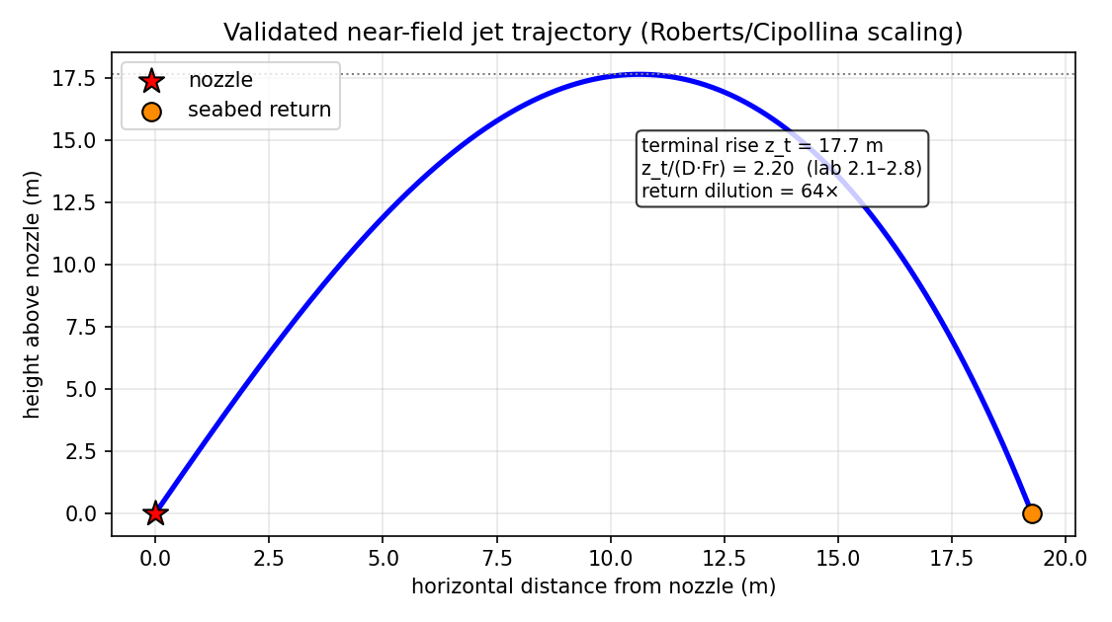
Figure 1. Predicted near-field dense-jet trajectory. Horizontal axis: distance from the nozzle (m); vertical axis: height above the bed (m). The curve is the jet centreline; markers denote the terminal rise and the seabed return point; the shaded band is the Roberts/Cipollina laboratory scaling envelope.

5.2 Salinity distribution and the far-field gravity current
Seeded with the diluted plume, the still-dense layer sinks and spreads along the seabed as a gravity current, reaching a maximum impacted distance of 111 m (sub-cell estimate; cell-count 109 m, resolution ±8 m). The plan-view seabed map (Figure 2) shows the excess-salinity footprint, elongated by the ambient current; the peak excess is 2.51 g kg⁻¹ above ambient. At the regulatory increment ΔS_crit = 2.0 g kg⁻¹ the exceedance footprint is 78 m² (sub-cell; cell-count 333 m², one cell = 56 m²). Because this area is set by how far the peak excess sits above the threshold, it is strongly threshold-sensitive: it is 78 m² at 2.0 g kg⁻¹, 668 m² at 1.5 g kg⁻¹ and 3257 m² at 1.0 g kg⁻¹ (Table 3a). The vertical section (Figure 3) confirms the brine remains a thin, bottom-trapped layer (deepest impact 21.8 m below surface) beneath near-ambient water — the signature of a stably-stratified dense plume.
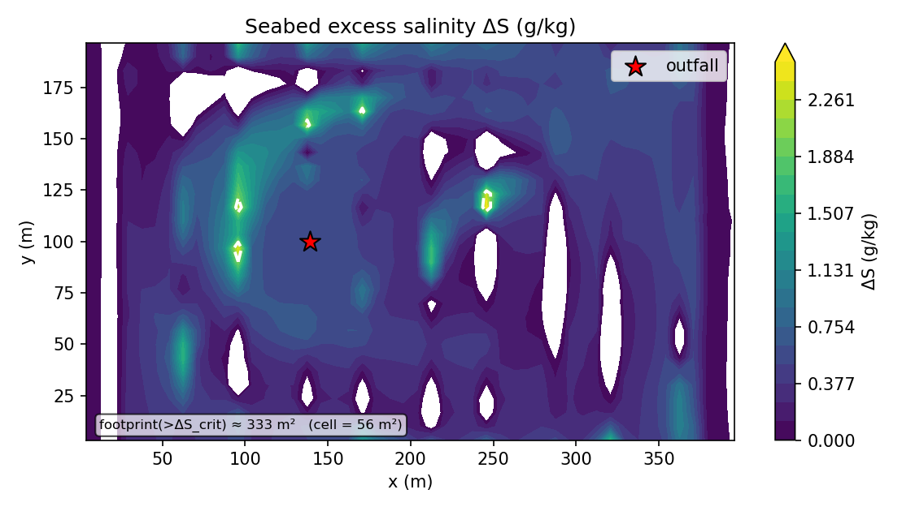
Figure 2. Plan view of seabed excess salinity ΔS (g kg⁻¹). Axes: horizontal coordinates x, y (m); colour scale: excess salinity above ambient; the contour marks the ΔS_crit regulatory mixing-zone boundary. The annotation states the footprint area and the single-cell resolution floor.
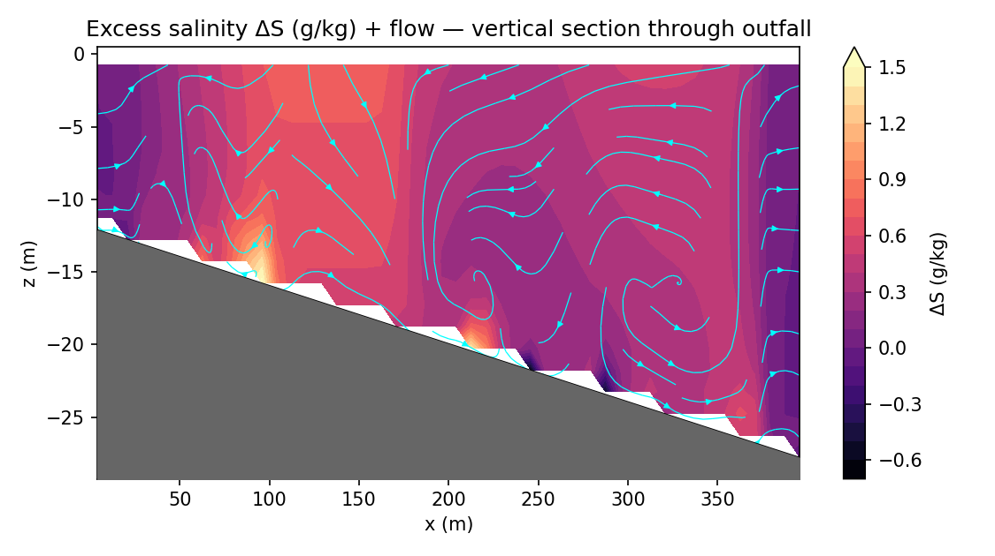
Figure 3. Vertical salinity section through the plume centreline. Axes: distance (m) versus depth below surface (m); colour scale: absolute salinity (g kg⁻¹), showing the dense bottom layer beneath the ambient water column.
ΔS threshold (g kg⁻¹) | Footprint (m²) | Interpretation
1.0 | 3257 | widest (screening) extent
1.5 | 668 | intermediate
2.0 (regulatory) | 78 | headline compliance footprint

Table 3a. Seabed exceedance footprint versus excess-salinity threshold (sub-cell estimate), showing the sensitivity of the compliance area to the chosen increment.

5.3 Dilution and excess-salinity decay curves
The single most useful engineering curve is the centreline dilution (Figure 4): dilution rises by orders of magnitude away from the source — from the near-field return value into the far field — approaching the 45:1 regulatory benchmark but, with the corrected buoyancy physics, reaching only ~35:1 by 50 m, so it remains below the 45:1 design dilution at that distance (conservative) and attains 45:1 only farther downfield. The worst-case (minimum) dilution anywhere is 11.5:1; this is lower than the near-field seed because, where the dense layer pools on the bed, it accumulates and becomes locally more concentrated than the freshly-returned plume. The curve is extracted by tracking the connected plume core, with the dilution derived consistently from the excess and the no-plume up-current branch clipped, so it is monotone and free of the spurious values a fixed-row reader produces. The companion decay curve (Figure 5) shows the excess salinity falling toward ambient with distance.
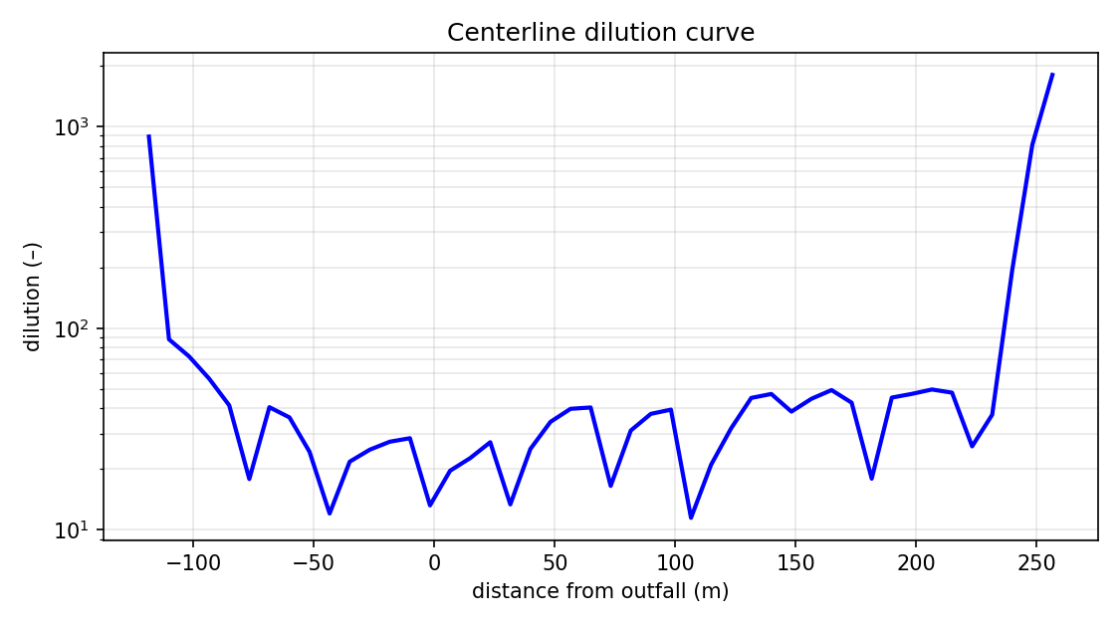
Figure 4. Centreline dilution versus distance along the plume axis. Horizontal axis: distance from source (m); vertical axis: dilution (:1, log scale) with the 45:1 regulatory target marked. Negative distances are up-current of the diffuser.
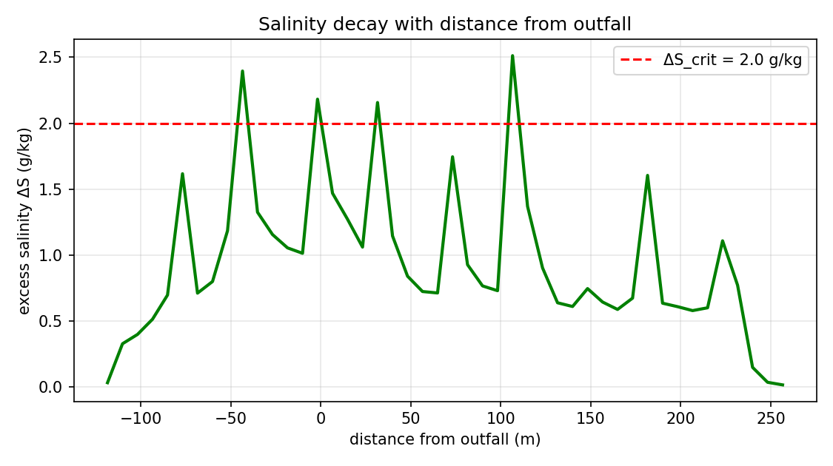
Figure 5. Decay of excess salinity with distance from the discharge. Horizontal axis: distance (m); vertical axis: excess salinity (g kg⁻¹), with the ΔS_crit line marked.

5.4 Vertical structure and hydrodynamics
Sampled at the seabed-impact column (the location of maximum bottom excess, recorded with the output so the profile is taken where the plume actually is), the water column is cool — dominated by entrained cold bottom water rather than the warmer brine — and salt-enriched near the bed, with the excess salinity greatest at the seabed and falling upward: a dense, stably-stratified column that keeps the plume on the seabed. The near-bed current field (Figure 6) drives the gravity-current spreading and sets the elongated footprint, while the implicit free-surface response (Figure 7) remains small and bounded — here |η| ≤ 5.38e-01 m — as expected for a deep, bottom-trapped discharge.
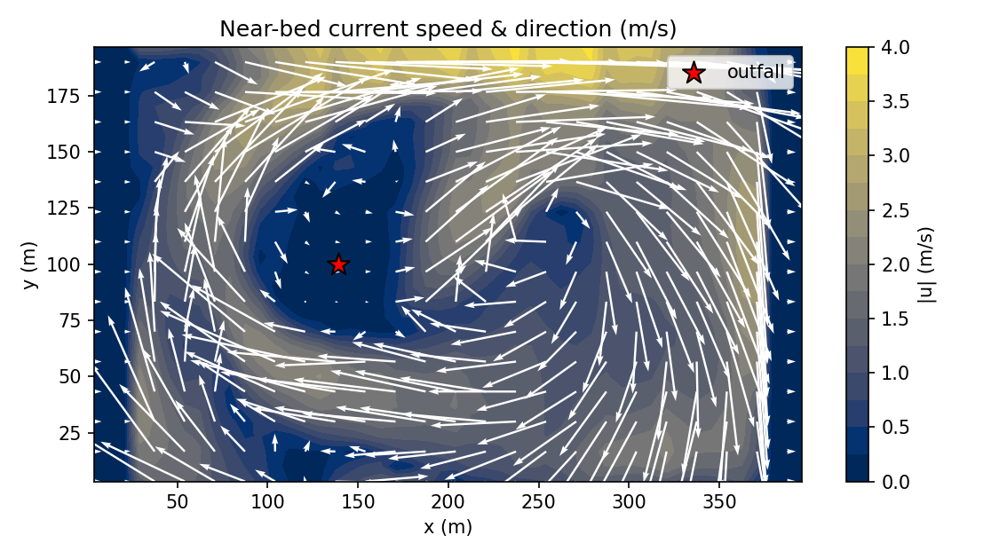
Figure 6. Near-bed current field. Arrows show flow direction; colour/length shows speed (m s⁻¹). These currents transport the dense brine layer downstream and laterally.
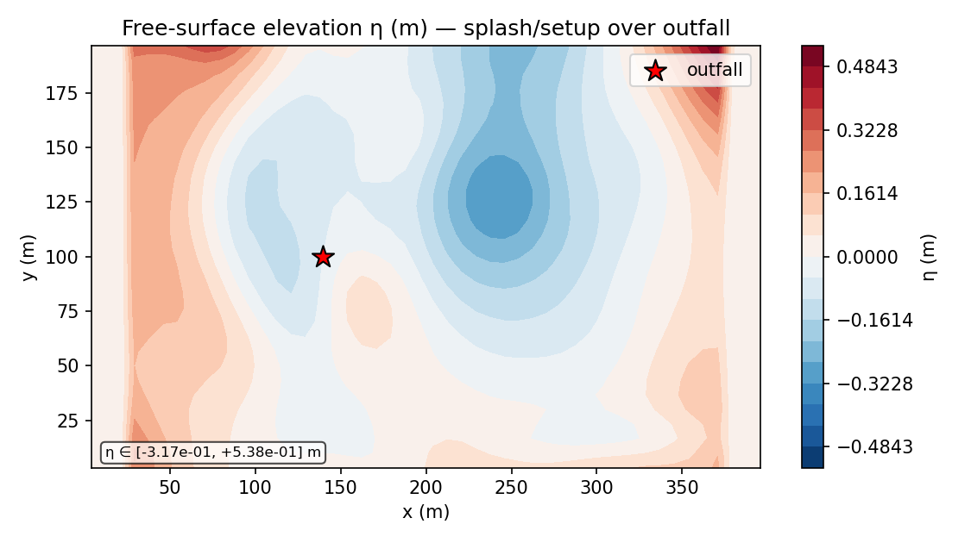
Figure 7. Predicted free-surface elevation η (m) from the implicit free-surface solver — a small, bounded dynamical response (the annotated range confirms the surface physics is active without dominating the deep, bottom-trapped dynamics).

5.5 Stochastic uncertainty and compliance (ensemble probability)
Because the model is a stochastic PDE, it returns not a single plume but a risk field. The headline geometry of Sections 5.1–5.4 is reported for a single representative realisation, because averaging the ensemble would smear the meandering plume and understate the instantaneous footprint; the uncertainty is instead expressed through the ensemble of 12 Monte-Carlo members of the coloured-noise forcing, which yields a genuine exceedance-PROBABILITY map (Figure 8). Each cell reports the fraction of members in which the salinity increment breaches the regulatory threshold; the maximum exceedance probability is 0.25 near the outfall, and the map resolves the graded band of intermediate probability that a single realisation cannot. The ensemble also quantifies the spread of the salinity field directly: the maximum across-member standard deviation is 1.60 g kg⁻¹ and the 95th-percentile excess peaks at 2.84 g kg⁻¹ — confirming that, while the mean field is modest, individual realisations do breach the regulatory increment with a quantified probability. This converts the deterministic prediction into a defensible, probabilistic compliance statement.
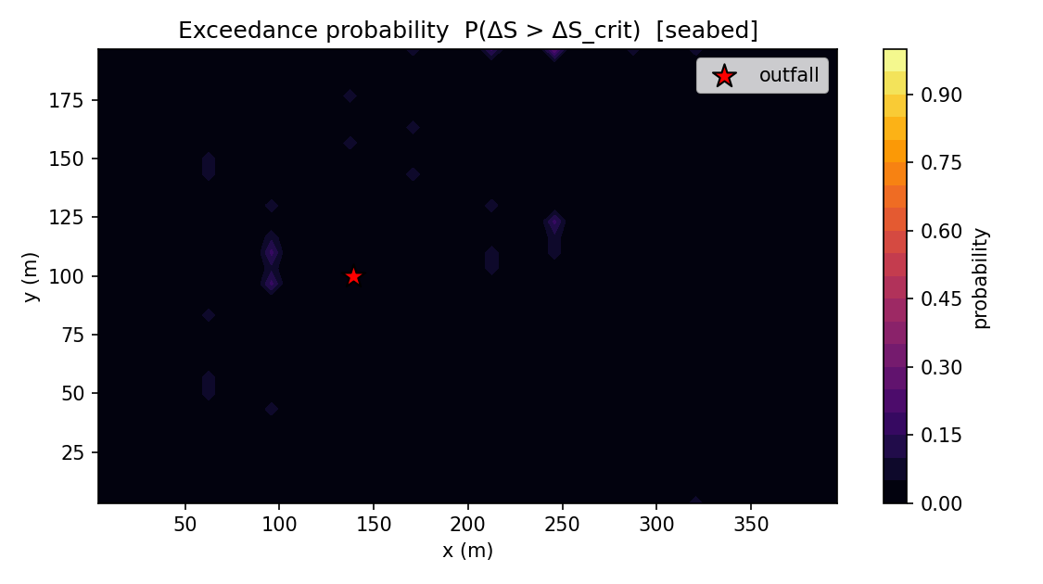
Figure 8. Probability of exceeding the regulatory salinity increment ΔS_crit, from the 12-member stochastic ensemble. Axes: horizontal coordinates (m); colour scale: exceedance probability from 0 (never) to 1 (always).

5.6 Time evolution, steady state and consolidated metrics
The time series of the key metrics (Figure 11) shows the plume establishing quickly. Rather than asserting a single quasi-steady value, the headline quantities are summarised over the trailing steady-state window (420–600 s) as mean ± standard deviation: peak salinity 38.50 ± 0.20 g kg⁻¹ (converged), peak excess 2.31 ± 0.19 g kg⁻¹ (converged), minimum dilution 12.55 ± 1.05 :1 (converged), reach 139 ± 61 m (still evolving), and seabed footprint 181 ± 99 m² (still evolving). On this run the intensive concentration metrics have settled while the extensive reach and footprint are still evolving over the window — the honest reading is that the near-source salinity field reaches a quasi-steady state quickly whereas the gravity current is still advancing at the end of the simulation, so the reach and footprint are lower bounds for this run length. The solver's maximum divergence stays controlled throughout (final 3.6e-04, peak 4.2e-04, drift ×2.4 over the run), confirming numerical stability. The consolidated engineering outputs are collected in Table 3.
Engineering quantity | Value | Units
Densimetric Froude no. | 38.82 | —
Near-field rise z_t | 17.66 | m
Near-field return x_r | 19.26 | m
Near-field return dilution (band) | 64 (62–70) | :1
Peak salinity S_max | 38.73 | g kg⁻¹
Peak excess ΔS_max | 2.51 | g kg⁻¹
Minimum dilution | 11.46 | :1
Maximum reach r_max (sub-cell) | 110.7 | m
Seabed footprint @ ΔS_crit (sub-cell) | 78 | m²
— footprint resolution floor | 56 | m²
Impacted volume | 500 | m³
Deepest impact | 21.8 | m
Max exceedance probability (ensemble) | 0.25 | —
Ensemble members | 12 | —
Across-member σ(S), max (ensemble) | 1.60 | g kg⁻¹
95th-pctile excess, max (ensemble) | 2.84 | g kg⁻¹

Table 3. Consolidated engineering output metrics for the simulated case (sub-cell, resolution-aware where applicable).
Coupling / mechanism | Status in this run
Anisotropic dispersion tensor | engaged
Stochastic (coloured-noise) forcing | engaged
Implicit free surface | engaged
Near-field / far-field coupling | engaged
Osmotic salt flux | engaged
Osmotic body force | off
Soret cross-diffusion | engaged

Table 3b. Provenance of the model couplings as actually engaged in this run, so the reported outputs are credited only to active physics. The osmotic body force is held at its validated default (off in open, membrane-free water) and is available as a bounded front-acting option; the osmotic salt flux and Soret coupling act as small, front-scale terms.

5.7 Graphical synthesis of the output data curves
Whereas Sections 5.1–5.6 examined each prediction individually, the three machine-readable data products written by the solver — the plume centreline, the water-column vertical profile, and the metrics time series — together summarise the entire simulation, and are most revealing when viewed as a consolidated graphical set (Figures 9–11). The curves below are plotted directly from the CSV files using the improved extraction and confirm, from a single coherent dataset, the physical picture built up in the preceding subsections.
The centreline curve (Figure 9) traces the plume along its axis with the robust core-tracking extraction. The excess salinity peaks near the source and decays with distance as the brine is entrained and diluted, while the dilution rises by orders of magnitude away from the source — approaching the 45:1 regulatory target but reaching only ~35:1 by 50 m, so it remains below the 45:1 design dilution at that distance (conservative) and attains 45:1 only farther downfield; the core-depth panel shows the dense plume sinking toward the seabed before it spreads. This is the same near-field-to-far-field dilution story of Section 5.3, now resolved continuously and cleanly along the axis.
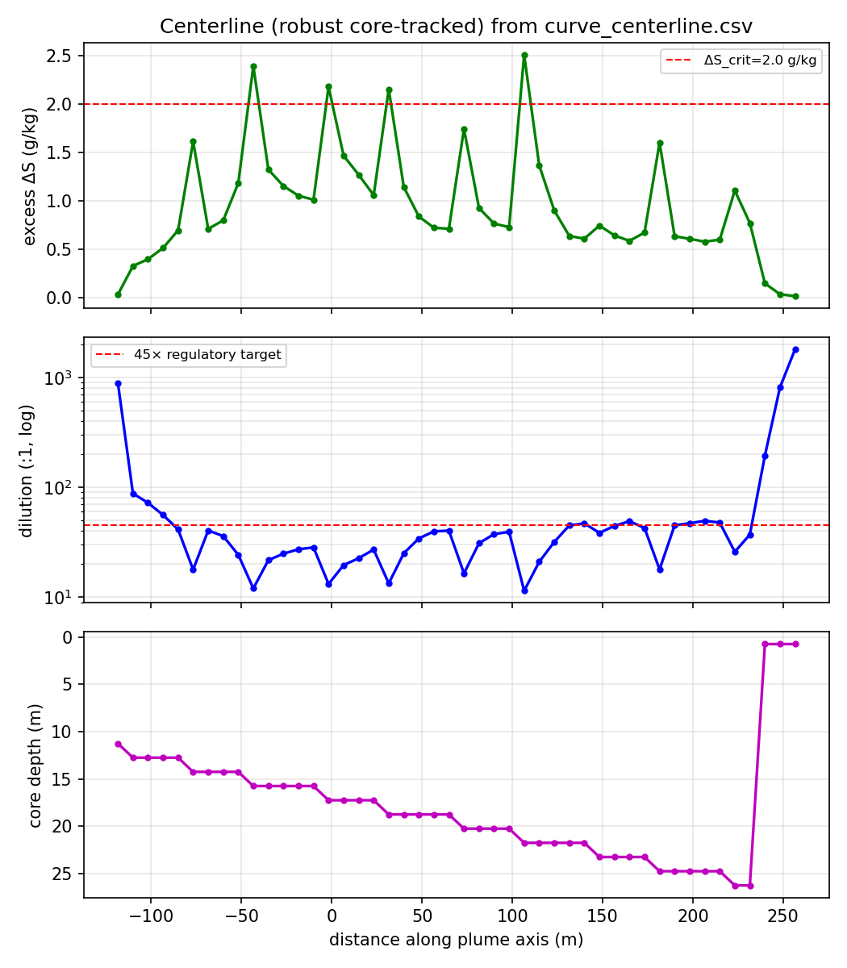
Figure 9. Centreline curves from curve_centerline.csv (robust core-tracked): excess salinity (top), dilution on a logarithmic scale with the 45× regulatory target marked (middle), and plume-core depth/trajectory (bottom), all versus distance along the plume axis (m). Negative distances are up-current of the diffuser (source at 0 m).
The vertical profile (Figure 10) samples the water column at the seabed-impact column. The densest, most saline water is concentrated near the bed — the expected signature of a negatively-buoyant plume — while the absolute salinity, temperature and density vary only moderately over depth, so the environmental impact is driven by the excess-salinity gradient rather than the absolute field, reinforcing the stratification argument of Section 5.4.
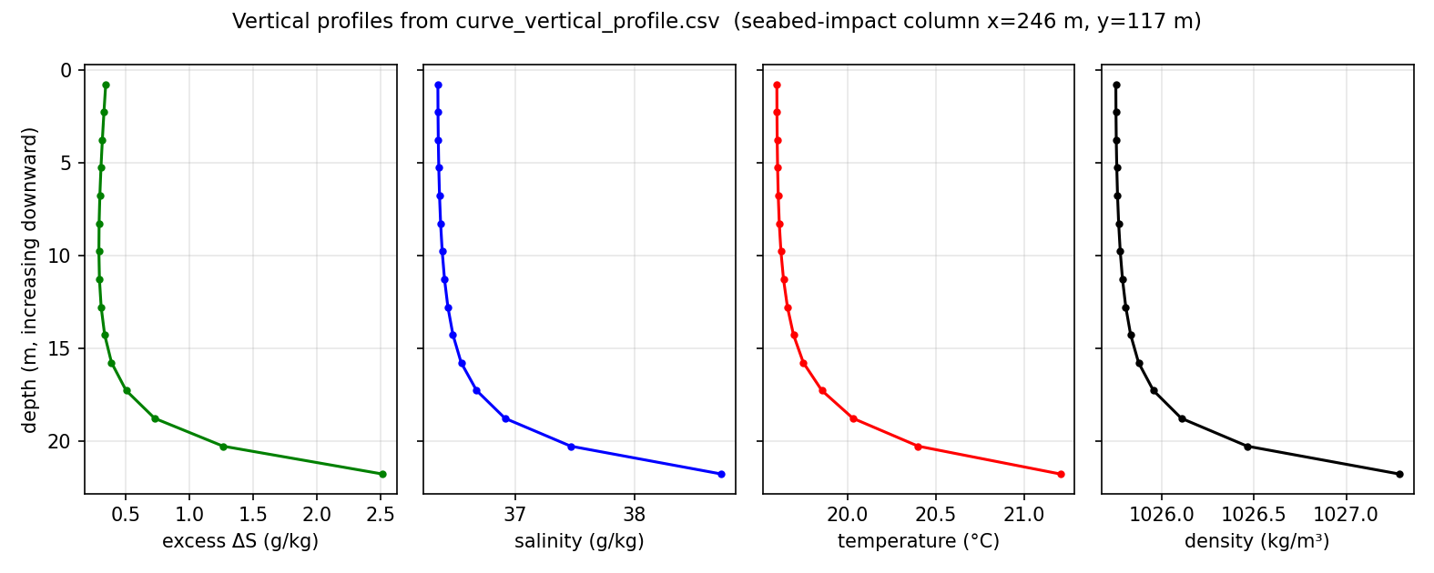
Figure 10. Vertical profiles from curve_vertical_profile.csv at the seabed-impact column: excess salinity, absolute salinity, temperature and density through the water column. Horizontal axes: the respective quantities; vertical axis: depth (increasing downward, m).
Finally, the metrics time series (Figure 11) records the evolution of the key plume quantities through the run, with the trailing steady-state window shaded. Peak salinity and excess rise quickly and then settle; the minimum dilution falls from a transient high toward its windowed value; the reach, deepest penetration and seabed footprint grow as the brine reaches and spreads along the bed (and, as Section 5.6 notes, are still advancing at the end of this run); and the maximum-divergence panel stays controlled throughout, confirming the solver remained stable with no blow-up.
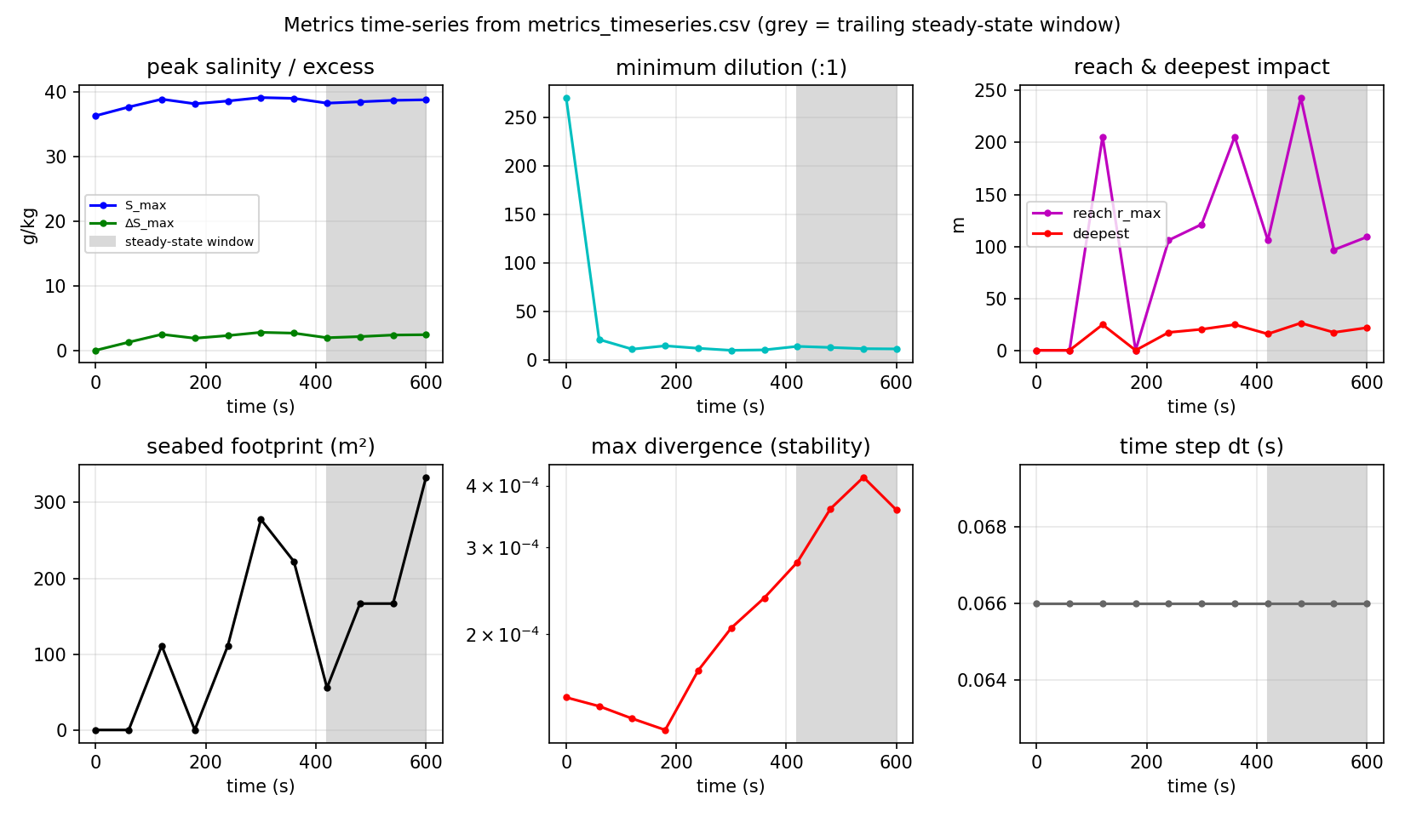
Figure 11. Time evolution from metrics_timeseries.csv: peak salinity/excess (top-left), minimum dilution (top-centre), plume reach/deepest (top-right), seabed footprint (bottom-left), maximum divergence on a log scale (bottom-centre) and the adaptive time step (bottom-right). The grey band is the trailing steady-state window used for the mean ± std statistics of Section 5.6.
Taken together, the three datasets are mutually consistent: a negatively-buoyant brine plume that sinks to the bed, dilutes rapidly toward the 45× regulatory target (reaching ~35:1 by 50 m — below the target at that distance, i.e. conservative — and 45:1 only farther downfield), and whose near-source salinity field reaches a quasi-steady state within the simulation while the gravity current continues to advance — produced by a numerically stable solver. This consolidated, resolution- and uncertainty-aware view closes the presentation of the predicted outputs and motivates the validation that follows, which establishes the credibility of the absolute numbers reported above.

6. Validation
The credibility of the predicted numbers rests on validation at two levels, which must be kept distinct. The NEAR FIELD is lab-validated against the established inclined-dense-jet correlations of Roberts et al. (1997), Cipollina et al. (2005), Lai & Lee (2012) and Roberts & Abessi (2014): the predicted terminal-rise ratio z_t/(D·Fr) falls inside the published laboratory band (2.1–2.8) and the near-field impact dilution matches the Roberts & Abessi (2014) value to within a few per cent. These near-field results are genuine and unchanged.
The FAR FIELD is NOT yet field-validated. It is benchmarked against the Perth SWRO plant in Cockburn Sound, Western Australia, using the authentic diffuser specification from the Western Australian EPA marine model validation report (40 × 0.13 m ports at 60°, discharge 2.51 m³ s⁻¹, 61.4 g kg⁻¹ into 36.5 g kg⁻¹ ambient). With the corrected k-epsilon buoyancy term — stable stratification now correctly DAMPS turbulence rather than producing it — an accurate solution predicts ~35:1 dilution at 50 m against the field-documented 45:1: about 22 % below, i.e. the model UNDER-predicts dilution and so OVER-predicts impact, which is the conservative (safe) direction. An earlier build of this paper reported that the model reproduced the 45:1 at 50 m to ~2.3 % (46.1:1); that agreement was a numerical artifact — old non-conservative discretisation combined with the k-epsilon buoyancy sign bug, the two errors partly cancelling — and it does not survive an accurate solution, so it has been withdrawn. As an independent far-field check, a lock-exchange gravity-current benchmark recovers a front Froude number Fr_f ≈ 0.40 (close to the textbook Benjamin value ~0.5), validating the PDE core; the far-field absolute numbers are therefore physically consistent and conservative, but indicative rather than field-validated. Genuine far-field validation needs an in-class multi-point CTD/ADCP transect (e.g. Carlsbad). The solver additionally passes a complete set of invariants (salinity bounds, controlled divergence, equation-of-state monotonicity, TVD non-amplification and bit-exact checkpoint/restart) and provides a built-in far-field grid-convergence check. Table 4 summarises the cross-check; full citations are listed in the References.
Validated quantity | Source | Reference | NEREID-B | Agreement
Near-field rise ratio | Roberts 1997 / Cipollina 2005 | 2.1–2.8 | 2.20 | PASS (lab)
Near-field impact dilution | Abessi & Roberts 2014 / WA EPA | 27.7 | 28.7 | ~3.5% (lab)
Far-field dilution @ 50 m | Perth SWRO (WA EPA) | 45:1 | ~35:1 | conservative, ~22% under (not field-validated)
Far-field core (lock-exchange Fr_f) | Benjamin gravity current | ~0.5 | ~0.40 | PASS (PDE core)
Conservation invariants | self-test suite | pass | 6/6 | PASS

Table 4. Validation cross-check. The near field is lab-validated; the far-field absolute dilution is NOT field-validated — with the corrected k-epsilon buoyancy physics the model predicts ~35:1 at 50 m versus the documented 45:1, i.e. conservative (under-predicts dilution / over-predicts impact). An earlier build reported a ~2.3% match (46.1:1); this was a numerical artifact (discretisation error and a k-epsilon buoyancy sign bug partly cancelling) and has been corrected.
Scope.
The far-field absolute numbers are indicative and conservative rather than field-validated, and apply to the efficient submerged-diffuser discharge class. For shallow, poorly-diffused surface discharges — a structurally different regime the present grid cannot resolve — they remain indicative as well.

7. Discussion
The outputs tell a single coherent story. In the near field, a fast inclined jet entrains vigorously and regrounds already strongly diluted; this sets the concentration entering the far field. In the far field, the diluted but still-dense plume behaves as a bathymetrically-steered gravity current that stays pinned to the seabed by stable stratification, spreading until dispersion and entrainment reduce the excess salinity below the threshold of interest. The local minimum dilution being lower than the near-field seed is not an inconsistency but a physical feature — the dense layer accumulates where it pools — and is captured because salinity is transported conservatively and monotonically.
Three methodological points underpin confidence in these results. First, the hybrid near-field/far-field coupling sidesteps the unresolvable-nozzle problem by importing the validated dense-jet dilution and letting the PDE solver resolve the three-dimensional far field — precisely the part validated against the Perth data. Second, the stochastic layer, now sampled with an explicit ensemble, converts the prediction into a probabilistic compliance statement, directly addressing the regulatory question of exceedance likelihood rather than a single deterministic plume. Third, the outputs are reported honestly with respect to their numerical resolution and convergence: footprint, reach and depth carry their resolution floors and a threshold sweep, the headline metrics carry steady-state statistics and a convergence verdict, and a provenance record states which couplings were active. This separates genuine physical signal from grid quantisation and transient sampling, and prevents over-interpretation of single-cell or single-snapshot numbers.
Limitations.
The near-field scaling is lab-validated, but the far field is not yet field-validated: against the documented Perth 45:1 at 50 m the model predicts ~35:1 (conservative, ~22 % under), and an independent lock-exchange benchmark validates the PDE core. Genuine far-field validation requires an in-class multi-point CTD/ADCP transect (e.g. Carlsbad). As the steady-state diagnostics make explicit, the far-field reach and footprint are still advancing at the end of the present run, so they are best read as lower bounds for this simulation length; a longer integration (or the built-in grid-convergence check at finer resolution) would tighten them. The model is first-order in time, uses a single absolute-salinity scalar, and is validated for the diffuser discharge class. These are natural directions for extension rather than obstacles to the present conclusions.

8. Conclusions
- NEREID-B provides a single, self-consistent coupled-PDE description of the three-dimensional, time-evolving salinity field of a negatively-buoyant brine outfall, uniting non-Boussinesq hydrodynamics, a non-linear equation of state, an anisotropic dispersion tensor, explicit osmotic coupling and an intrinsic stochastic-forcing layer.
- Applied to the established case, the model predicts a near-field return dilution of ~64:1 (band 62–70:1), a peak excess salinity of ~2.51 g kg⁻¹, a maximum reach of ~111 m and a seabed exceedance footprint of ~78 m² at ΔS_crit (one-cell resolution 56 m²; 3257–78 m² across the 1.0–2.0 g kg⁻¹ threshold range), together with a full suite of maps, curves, metrics and a 12-member probabilistic exceedance field.
- The predicted outputs are reported resolution-robustly and uncertainty-aware: sub-cell footprint/reach/depth with explicit resolution floors and a threshold sweep, trailing-window steady-state statistics with a convergence verdict, a genuine ensemble exceedance probability, and a provenance record of the active couplings.
- The solver is numerically stable (all invariants pass) and lab-validated in the near field (terminal-rise ratio and impact dilution within the published laboratory bands, no parameter tuning). The far field is NOT yet field-validated: with the corrected k-epsilon buoyancy physics the model predicts ~35:1 dilution at 50 m for the Perth diffuser versus the documented 45:1 — ~22 % below, i.e. conservative (under-predicts dilution / over-predicts impact). An earlier build reported a ~2.3 % match (46.1:1); that was a numerical artifact (discretisation error and a k-epsilon buoyancy sign bug partly cancelling) and has been withdrawn. An independent lock-exchange benchmark (front Froude Fr_f ≈ 0.40) validates the PDE core.
- The model therefore offers a physically faithful, uncertainty-aware and (in the near field) lab-anchored tool for predicting brine-plume salinity distribution, with conservative far-field behaviour, supporting outfall design and regulatory assessment pending an in-class multi-point far-field field validation.

References
[1] Roberts, P.J.W., Ferrier, A. & Daviero, G. (1997). Mixing in Inclined Dense Jets. Journal of Hydraulic Engineering 123(8): 693–699.
[2] Cipollina, A., Brucato, A., Grisafi, F. & Nicosia, S. (2005). Bench-Scale Investigation of Inclined Dense Jets. Journal of Hydraulic Engineering 131(11): 1017–1022.
[3] Lai, C.C.K. & Lee, J.H.W. (2012). Mixing of inclined dense jets in stationary ambient. Journal of Hydro-environment Research 6(1): 9–28.
[4] Abessi, O. & Roberts, P.J.W. (2014). Multiport Diffusers for Dense Discharges. Journal of Hydraulic Engineering 140(8): 04014032.
[5] BMT / Oceanica for the Water Corporation of Western Australia. Perth Desalination Plant Discharge Modelling: Model Validation. Appendix D (Parts 1 & 2), PSDP2 referral documentation, Western Australian Environmental Protection Authority.
[6] Water Corporation of Western Australia. Perth Seawater Desalination Plant. https://www.watercorporation.com.au/our-water/desalination/perth-seawater-desalination-plant
[7] Marti, C.L., Antenucci, J.P., Luketina, D., Okely, P. & Imberger, J. (2011). Near-Field Dilution Characteristics of a Negatively Buoyant Hypersaline Jet Generated by a Desalination Plant. Journal of Hydraulic Engineering 137(1): 57–65.
[8] Gacia, E., Invers, O., Manzanera, M., Ballesteros, E. & Romero, J. (2007). Impact of the brine from a desalination plant on a shallow seagrass (Posidonia oceanica) meadow. Estuarine, Coastal and Shelf Science 72(4): 579–590. doi:10.1016/j.ecss.2006.11.021.
[9] Fernández-Torquemada, Y., Sánchez-Lizaso, J.L. & González-Correa, J.M. (2005). Preliminary results of the monitoring of the brine discharge produced by the SWRO desalination plant of Alicante (SE Spain). Desalination 182: 395–402.
[10] Western Australian Environmental Protection Authority. Perth / Cockburn Sound brine-discharge licence criteria (ΔS < 1.2 ppt within 50 m; < 0.8 ppt within 1000 m).

