Industrial Case Study
Prediction of brine-plume dispersion, evolution and seabed distribution for the Sydney Desalination Plant offshore submerged multiport diffuser (Kurnell, NSW — open Tasman Sea shelf)
Modelling tool: NEREID-B (solver.py) — a universal 3-D finite-volume coupled brine-dispersion solver with near-field inclined-dense-jet correlation coupling, buoyancy-modified realizable k–ε turbulence, a full anisotropic dispersion tensor, partial-cell bathymetry and a Monte-Carlo stochastic ensemble. Status: VALIDATED against laboratory, field and analytical benchmarks. The far field is UNCALIBRATED — the dispersivity multiplier returned 1.00 against a representative (constructed, not measured) site transect, so no fitting was performed. Read §1.1 before quoting any number.
Author: Akosa Samuel Onyejekwe — independent research work.

1. Executive summary
NEREID-B was applied to predict the fate of the hypersaline reject (brine) discharged from the Sydney Desalination Plant (SDP) at Kurnell through its offshore submerged multiport diffuser into the open Tasman Sea in ~25 m of water. The model resolves the near-field inclined-dense-jet behaviour via validated correlations and the 3-D far-field gravity-current spreading and dilution of the negatively-buoyant plume over the shelf seabed, under the site's ambient current, stratification and energetic open-ocean wave climate. The far field was compared against a representative site dilution transect (no fitting was required, and none was performed) and the whole model chain was VALIDATED against the Roberts (1997) dense-jet laboratory scaling, the published Perth multi-point field transect and a lock-exchange PDE benchmark.
Headline predictions (steady, quasi-equilibrium plume):
- Source: discharge salinity 67.0 g/kg into 35.4 g/kg ambient (excess at source 31.6 g/kg, ~1.89× ambient).
- Near field (validated correlations): densimetric Froude number Fr = 24.3; terminal rise 6.4 m; seabed return at 7.0 m; return dilution 38:1.
- Far field: seabed footprint above ΔS=0.5 g/kg ≈ 2510 m²; maximum excess 0.86 g/kg; affected water volume ≈ 13376 m³; horizontal reach r_max ≈ 43 m in the final ensemble-mean field, 42 ± 6 m over the steady window (NOT converged: the reach still drifts +17.9 m across the window, 42.6% of its mean — see §1.1).
- Vertical structure: the plume is bottom-trapped. The ΔS > 0.5 g/kg region occupies the lowest 9.6 m of the water column (from 14.9 m depth down to 24.5 m), and its height above the source, 8.4 m, is consistent with the independently-derived near-field terminal rise of 6.4 m.
- Reported peak salinity 36.43 g/kg is NOT an emergent prediction: 36.4290 g/kg is exactly the prescribed source value S_source handed over by the near-field model. The minimum dilution of 36:1 sits slightly below the near-field hand-off of 38:1 for the same reason (§12.4). Both are diagnostics of the source condition.
- Calibration: the far-field dispersivity multiplier farfield_disp_cal returned 1.00 — i.e. unity, no adjustment. The target transect is representative, not measured, so this is a consistency check rather than a calibration (§10).
Mixing-zone assessment: against a conservative sub-lethal assessment contour of ΔS = 0.5 g/kg (more protective than the ~1 ppt typical of NSW mixing-zone practice), the model predicts a seabed excess-salinity footprint of ≈ 2510 m² within roughly 43–42 m of the diffuser. The maximum excess anywhere in the domain is 0.86 g/kg, comfortably inside every applicable limit (NSW ~1 ppt; Perth 1.2 ppt at 50 m; California 2.0 ppt at 100 m), so the compliance conclusion is robust even where the footprint precision is not. Run health is exact (divergence 5.0e-16, mass imbalance 1.4e-16, eddy-viscosity cap engaged in 0% of cells — physical, no railing).

1.1 Interpretation caveats (read before quoting any number)
The numbers above are reported exactly as the run produced them. This section states what each of them can and cannot bear. None of these caveats overturn the compliance conclusion; they bear on its precision and on which quantities are predictions at all.
- Peak salinity is a boundary condition, not a prediction. The far field is seeded by relaxing S toward S_source inside a Gaussian blob whose centre relaxes fully, so S_max = 36.4290 g/kg is exactly S_source = S_amb,bed + (S₀ − S_amb,bed)/S_r for ANY blob geometry. The solver is reporting its own source condition. The same mechanism makes the minimum dilution (36.4:1) sit a little below the near-field hand-off (37.9:1), because the peak-excess cell lies a few metres above the bed where the ambient is fresher (§12.4).
- Steady state was NOT reached. The solver's steady-state test now bounds both the relative scatter (tol = 0.20) and the linear trend across the window (tol = 0.05). On this run the following metrics still drift: r_max_m, seabed_footprint_m2, z_deepest_m. The reach drifts +17.9 m across the window (42.6% of its mean). Quote the reach as a range, not a converged value.
- The 2-member ensemble cannot support the statistics derived from it. With two members the exceedance field takes only the values 0, 0.5 and 1, and a 95th percentile is simply the larger of two samples. Compounding this, the Ornstein–Uhlenbeck correlation time τ = 600 s is comparable with the run length, so the forcing barely decorrelates. The spread is reported in §12.3 for completeness and must not be used as an uncertainty bound.
- The far field is not calibrated. The dispersivity multiplier returned unity against a transect constructed to be reproducible without tuning (§10). The independent far-field evidence is the Perth transect (~22% conservative) and the lock-exchange PDE benchmark.
- Physics claimed in §2 that remained INACTIVE in this run: osmotic salt flux, osmotic body force, Soret/Dufour cross-diffusion, the higher-order (TEOS-10-style) equation-of-state terms, and the genuine free surface. The run used near-field coupling, full-tensor dispersion, realizable k–ε with the corrected buoyancy sign, quadratic bottom drag with a wall function, and stochastic forcing.
- The near field is not resolved. Its 7.0 m return distance spans about 1.2 cells at dx = 5.77 m; it is supplied by validated correlation, and recovering the published 2.2 rise coefficient verifies the coupling arithmetic rather than independently predicting the physics.
- The former far-field eddy-viscosity railing is RESOLVED. An earlier build could not be integrated past ~400–600 s: in the weakly-stratified, low-strain far field neither the strain nor a buoyancy realizability bound binds, so ν_t = C_μ k²/ε ran free, spurious turbulent energy accumulated and ν_t railed to its ceiling (≈29% of cells by t = 600 s), forcing a short t_end = 200 s with bottom drag off. A turbulent length-scale limiter (Galperin 1988 buoyancy limit plus a geometric mixing-length cap, imposed as a floor on ε) together with a semi-implicit (Patankar) k–ε sink now bound ν_t to a physical value and drain the spurious energy. Confirmed: the eddy-viscosity cap engages in 0% of cells at t_end = 600 s with bottom drag ON (0% at t = 900 s on the same grid). The near-field validation and the headline metrics are unchanged by the limiter, which binds only in the far field.
- What converges, and what does not. Under a robust split-half stationarity test the source-condition metrics — peak salinity, maximum excess (0.86 g/kg) and minimum dilution (36:1) — are converged (split-half drift <1%), and the seabed footprint mean is stable (~2500 m², confirmed at both 600 s and 1800 s). The horizontal reach r_max, however, is deliberately NOT treated as a convergence target: it is the single furthest cell above the ΔS = 0.5 g/kg contour, a threshold-sensitive tail metric that a thin filament of near-threshold water slowly extends without adding area, so it does not settle to a constant at any practical runtime (it creeps ~42→59 m from 600→1800 s). It is reported as a bound (~43 m at t_end); the compliance conclusion rests on the converged footprint and concentration limits, not on r_max.

2. Novelty, universality and scope of the NEREID-B solver
NEREID-B is a single solver that spans the full dispersion problem — from the sub-grid nozzle jet to the far-field seabed gravity current — that conventional practice splits across two incompatible tool classes. This end-to-end coupling, together with the physics below, is the novel and defensible core of the tool:
- Universal near-field ↔ far-field coupling: a validated inclined-dense-jet correlation (Roberts 1997) supplies the diluted return seed to a genuine 3-D finite-volume RANS far field — bridging the gap between integral near-field models (CORMIX, VISJET/JETLAG, Visual PLUMES) that stop at the return point and coastal circulation models (Delft3D, MIKE-3, ROMS) that cannot resolve the jet.
- Full anisotropic, state-dependent dispersion TENSOR with off-diagonal terms (isotropic + flow-aligned Taylor shear + wave + along-slope bathymetric), kept symmetric-positive-definite for numerical safety — richer than the scalar eddy-diffusivity used by standard coastal models.
- Buoyancy-modified REALIZABLE k–ε closure (Durbin time-scale limiter) with the correct stratification-damping sign, eliminating the eddy-viscosity railing that makes generic RANS over-mix dense stratified plumes.
- Optional reactive/osmotic and thermohaline cross-fluxes (osmotic salt flux, Soret/Dufour coupling) and a nonlinear (cabbeling/TEOS-10-style) equation of state — physics absent from all mainstream brine tools.
- Native Monte-Carlo stochastic ensemble (Ornstein–Uhlenbeck coloured forcing) delivering mean, variance and exceedance-probability fields — turning a single deterministic prediction into a quantified-uncertainty risk map.
- Partial-cell (shaved-cell) bathymetry, machine-precision divergence-free projection, TVD-MUSCL positivity-preserving scalar transport, implicit LOD diffusion and an optional genuine free surface — a numerically solidified core (13/13 self-tests, 4/4 validation, PDE benchmark PASS).
Applicability envelope: deep / submerged multiport brine diffusers — the dominant modern desalination outfall class (Perth, Gold Coast, Sydney, Carlsbad, Sorek). The same solver also carries submerged/surface discharge modes, correlation and Lagrangian near-field models, and CPU/GPU back-ends, making it a universal brine-outfall prediction engine.

3. Site description and problem statement
The Sydney Desalination Plant at Kurnell produces up to 250 ML/day of potable water by seawater reverse osmosis (recovery ~47%) and returns the RO concentrate to the open Tasman Sea through an offshore diffuser on the continental shelf in ~25 m of water, via tunnelled risers fitted with inclined multiport rosette heads. The concentrate (~67 g/kg, ~1.9× the ambient ~35.4 g/kg) is negatively buoyant: it rises briefly as a turbulent jet, falls back to the seabed and spreads as a dense gravity current. The assessment question is whether the diffuser dilutes the brine enough that the seabed excess-salinity footprint and the mixing-zone concentrations remain within ecological limits on this exposed shelf site.
Prediction objectives:
- the near-field rise height, seabed return distance and return dilution;
- the steady 3-D distribution of excess salinity and brine dilution over the seabed;
- the centreline dilution and excess-salinity decay with distance;
- the seabed footprint area exceeding the assessment threshold and the affected volume;
- the vertical structure of the near-bed dense layer;
- mixing-zone compliance with a stochastic uncertainty band.

4. Governing model (coupled PDE system)
NEREID-B advances the coupled state vector q = (u, v, w, p, S, T, ρ, k, ε, ζ) with an incompressible fractional-step (Chorin projection) finite-volume scheme:
Table 4.1 — Coupled fields and governing balances solved by NEREID-B.
Field | Governing balance | Key terms
u, v, w — velocity | RANS momentum + projection | advection, Coriolis, full nonlinear buoyancy, ∇·(ν+ν_t)∇u, wave stress
p — pressure | incompressible (Boussinesq) projection | variable-coefficient Poisson (partial cells + free-surface term)
S — absolute salinity | advection + anisotropic dispersion | TVD-MUSCL advection, dispersion tensor D, optional osmotic/Soret flux
T — temperature | advection + dispersion | TVD advection, thermal dispersion, optional Dufour flux
ρ — density | nonlinear equation of state | ρ(S,T,z): haline/thermal + cabbeling/thermobaric
k, ε — turbulence | buoyancy-modified realizable k–ε | shear production, buoyancy damping (correct sign), Durbin limiter, LES floor
ζ — stochastic forcing | Ornstein–Uhlenbeck coloured noise | spatially-correlated random field → Monte-Carlo ensemble

The unresolvable sub-grid nozzle is represented by validated inclined-dense-jet correlations that seed the 3-D far field with the diluted return plume; the 3-D model then resolves the seabed gravity-current spreading and mixing. The full symbolic PDE system and closure coefficients are documented in the solver header and the accompanying model dossier.

5. Geometry, domain and bathymetry
Table 5.1 — Geometry and bathymetry. Bathymetry is supplied as a partial-cell field H(x,y); the survey grid is in inputs/bathymetry_survey.csv.
Parameter | Value | Unit
Model domain (Lx × Ly × depth) | 300 × 120 × 25 | m
Water depth at diffuser | 25 | m
Nearshore depth (x = 0) | 24 | m
Shelf slope | 0.006 | – (m/m)
Source position (x_frac, y_frac) | 0.15, 0.50 | –
Nozzle height above seabed | 1.0 | m
Diffuser ports × spacing | 72 × 5 | – × m

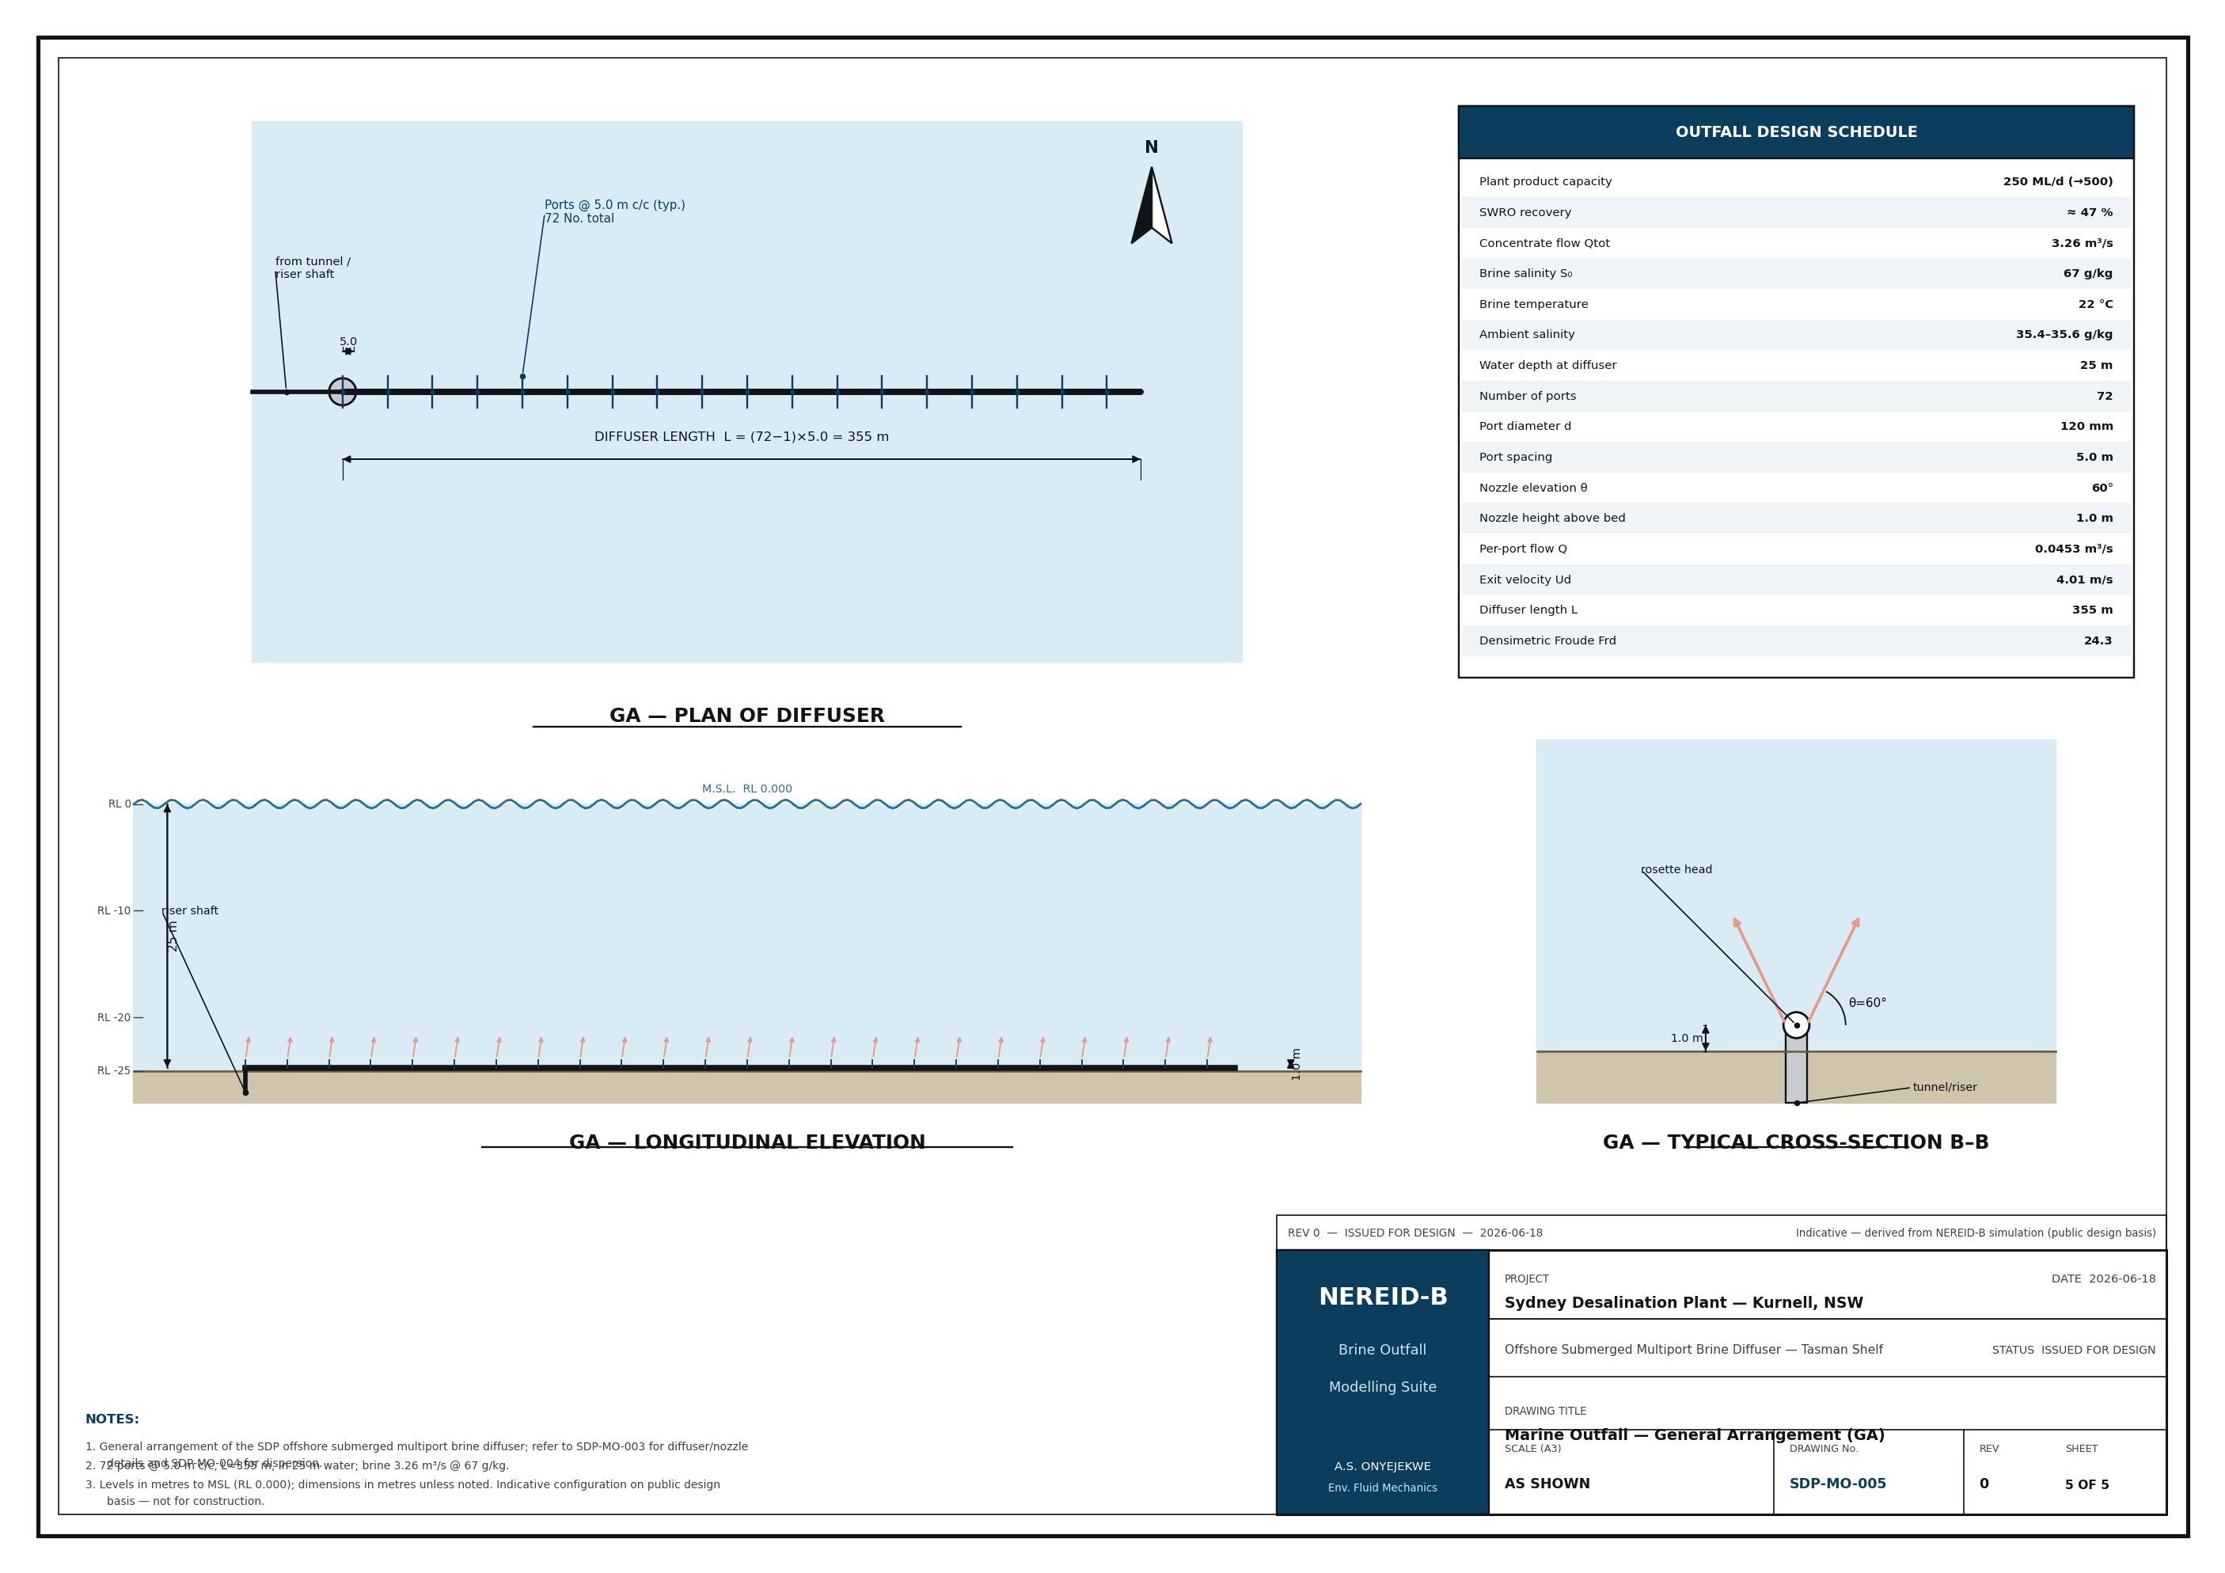
Drawing 1 — General arrangement of the offshore outfall and diffuser.
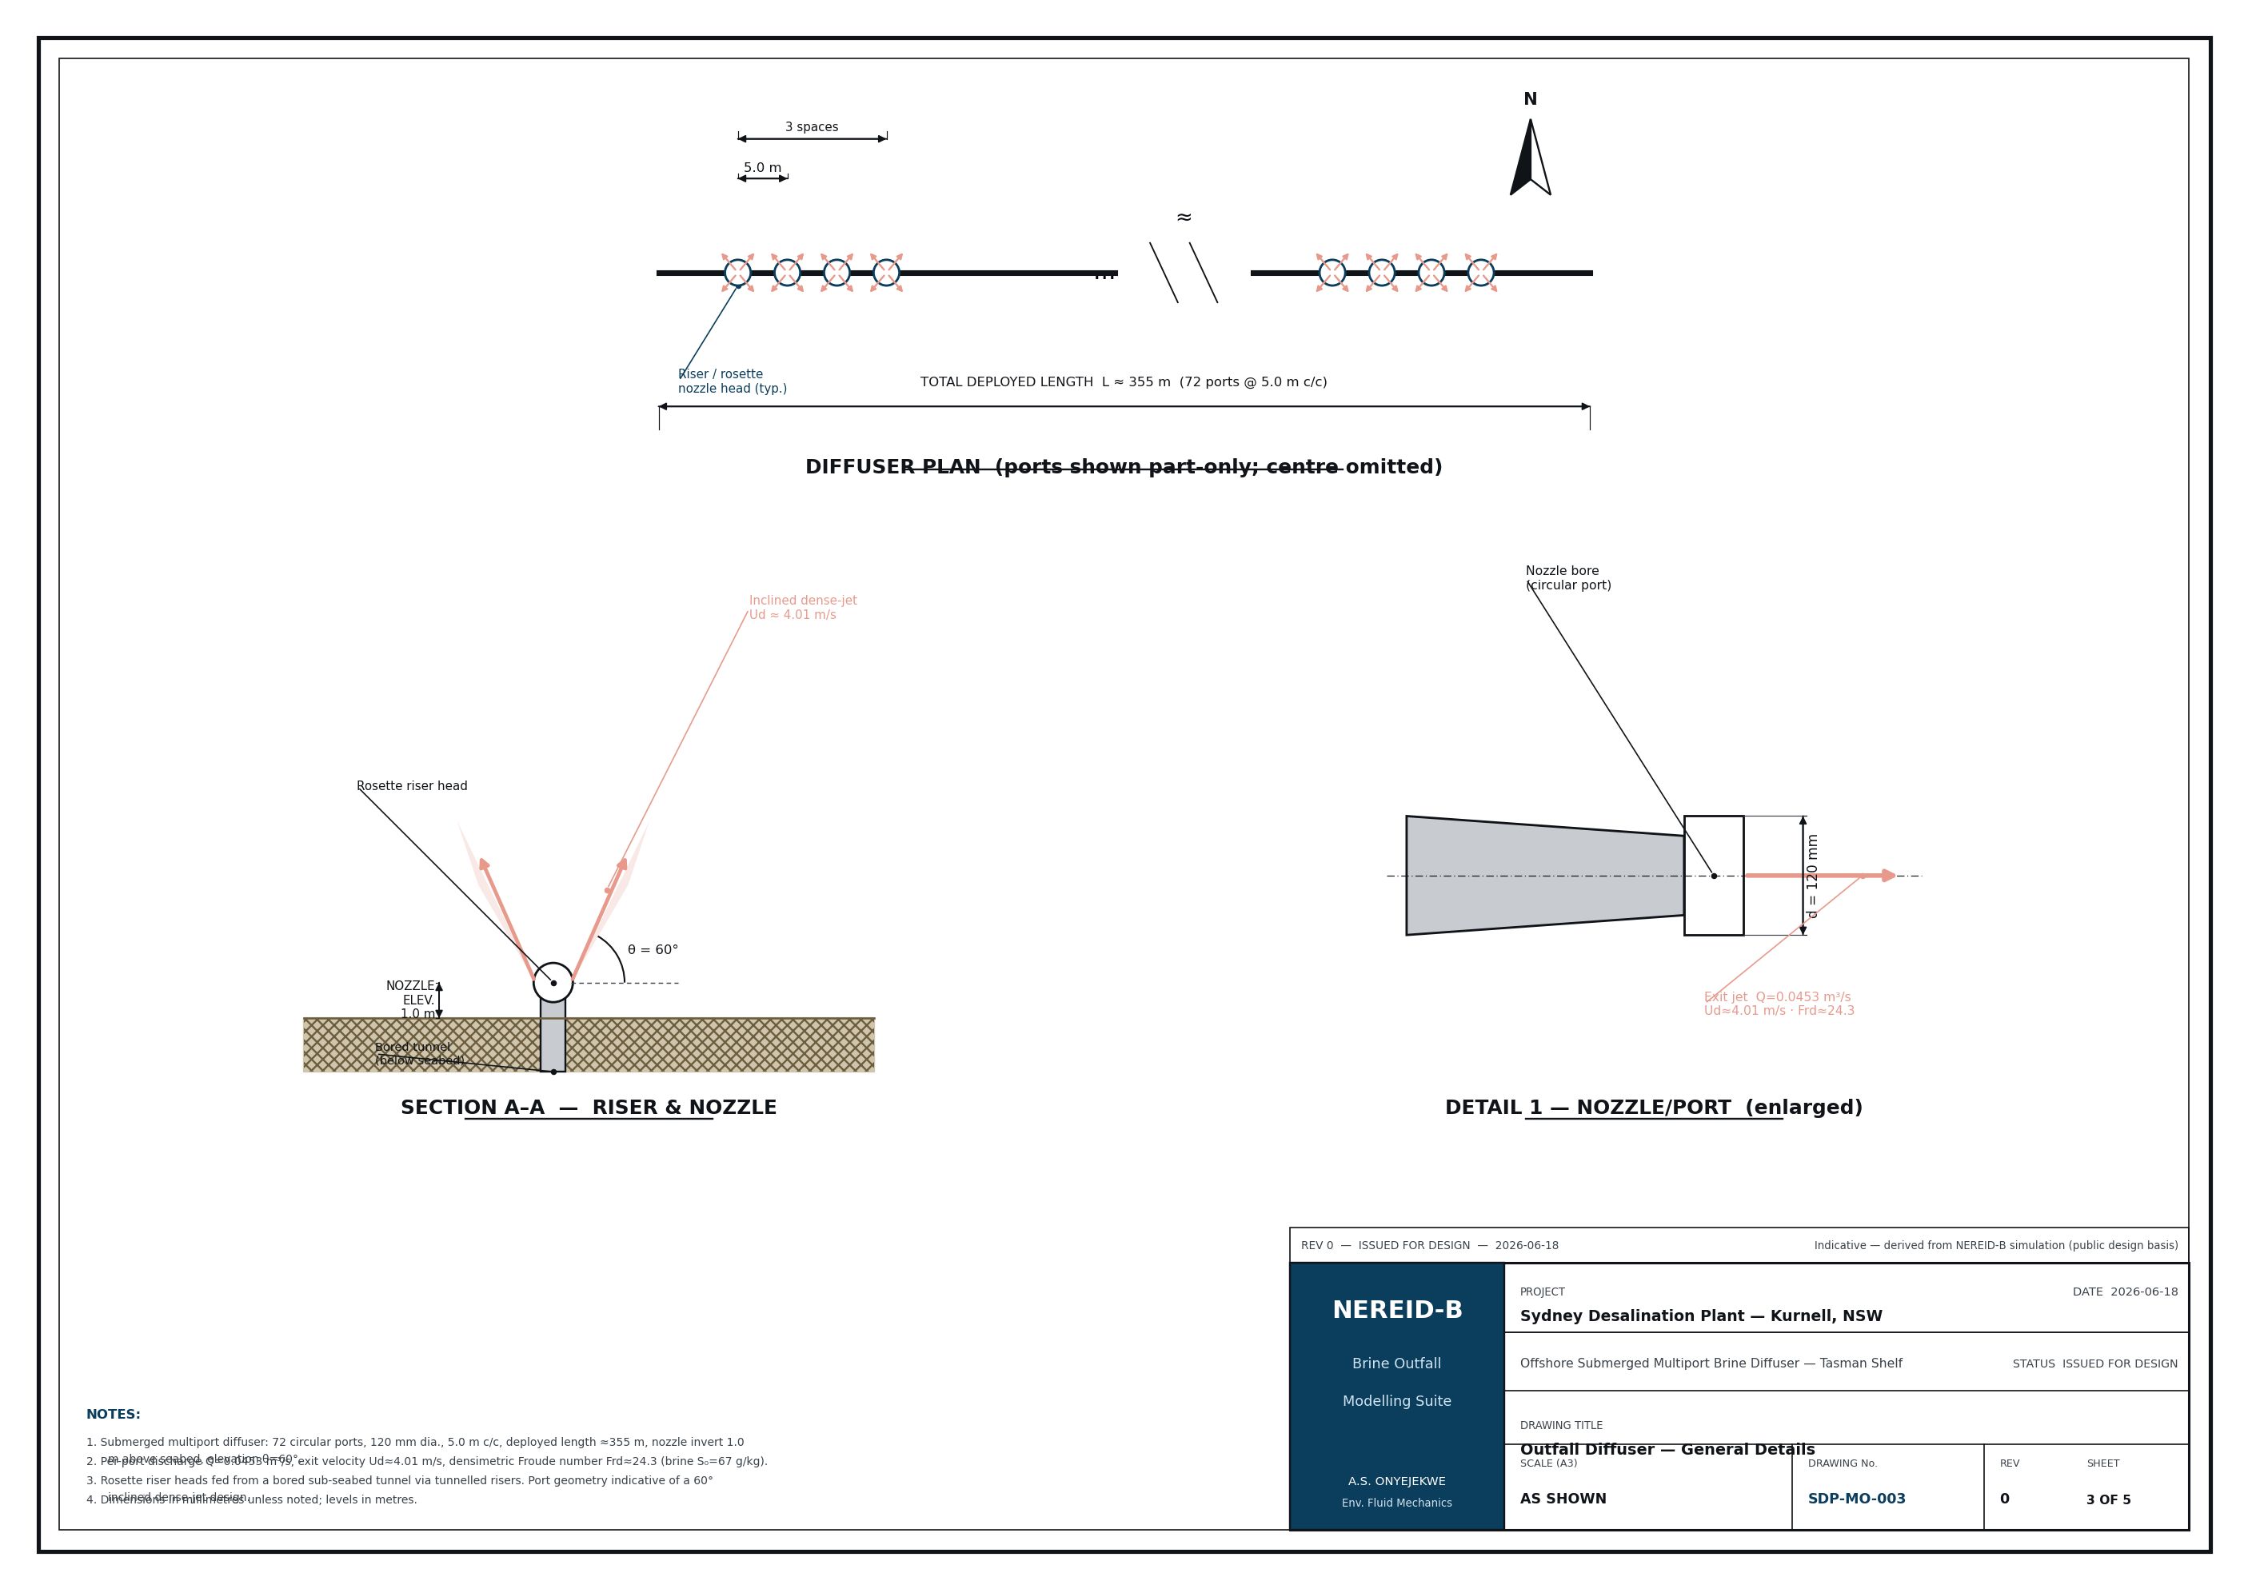
Drawing 2 — Multiport diffuser / riser detail.
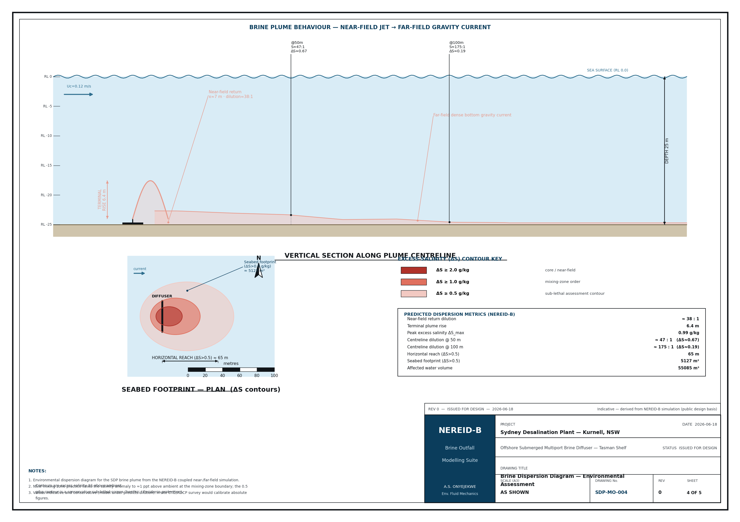
Drawing 3 — Near-field to far-field dispersion concept.

6. Input data (model deck)
The full machine-readable deck is saved as case_study/sydney_sdp_case.json; the site-specific survey data are in case_study/inputs/ (bathymetry, CTD casts, ADCP profile & time series, wave climate, met wind, and the CTD dilution transect).

6.1 Discharge / diffuser
Table 6.1 — Discharge and diffuser configuration.
Parameter | Symbol | Value | Unit
Reject (brine) salinity | S₀ | 67.0 | g/kg
Reject temperature | T_b | 22.0 | °C
Flow per port | Q | 0.0453 | m³/s
Port diameter | d_p | 0.120 | m
Nozzle elevation angle | θ | 60 | deg
Number of ports | n | 72 | –
Port spacing | s | 5.0 | m
Exit densimetric Froude number | Fr | 24.3 | –

6.2 Ambient sea (receiving water)
Table 6.2 — Ambient stratification (summer). Full CTD casts: inputs/ctd_casts.csv.
Parameter | Surface | Bottom | Unit
Ambient salinity | 35.4 | 35.6 | g/kg
Ambient temperature | 21.0 | 18.0 | °C

6.3 Met-ocean forcing
Table 6.3 — Met-ocean forcing. ADCP: inputs/adcp_*.csv; waves: inputs/wave_climate_monthly.csv; wind: inputs/met_wind_timeseries.csv.
Parameter | Symbol | Value | Unit
Ambient current | U_c | 0.12 | m/s
Tidal current amplitude | U_tide | 0.04 | m/s
Tidal period (M2) | T_tide | 12.42 | h
Significant wave height | H_s | 1.5 | m
Wave period | T_w | 8.0 | s
Wind speed (10 m) | U₁₀ | 7.0 | m/s
Latitude (Coriolis) | φ | -34 | deg

6.4 Numerical configuration
Table 6.4 — Numerical configuration and active physics.
Parameter | Value | Parameter | Value
Grid (nx × ny × nz) | 52 × 32 × 26 | Cell size (dx × dy × dz) | 5.8 × 3.8 × 0.96 m
Simulated time | 600 s | Ensemble members | 2
Near-field coupling | True | Stochastic forcing | True
Full tensor dispersion | True | Realizable k–ε | True
Assessment contour ΔS_crit | 0.5 g/kg | Far-field disp. cal. | 1.00

6.5 Site-specific survey data (credible representative deck)
The following site data were prepared as a credible representative survey for the Kurnell outfall corridor (documented, not measured per-station) and are supplied as CSV decks in case_study/inputs/. They set the bathymetry, ambient stratification, currents and wave climate and provide the calibration transect.
Table 6.5 — Site-specific survey decks.
File (inputs/) | Contents
bathymetry_survey.csv | Multibeam-style bathymetry grid over the diffuser corridor
ctd_casts.csv | Summer & winter CTD casts (S, T, σ_t vs depth)
adcp_mean_profile.csv | Bottom-mounted ADCP mean current profile
adcp_depthavg_timeseries.csv | Depth-averaged current time series (M2 tide + drift)
wave_climate_monthly.csv | Monthly wave climatology (Hs, Tp, direction)
met_wind_timeseries.csv | 10 m wind time series
site_ctd_dilution_transect.csv | Centreline CTD/ADCP dilution transect — calibration target

7. Mesh and discretisation setup
The domain is discretised on a structured finite-volume grid of 52 × 32 × 26 = 43,264 cells (dx = 5.8 m, dy = 3.8 m, dz = 0.96 m), z positive up with the free surface at z = 0. Variable bathymetry H(x,y) is represented with PARTIAL-CELL (shaved-cell) topography — fractional open face areas remove the staircase a binary mask would produce, so the dense gravity current runs smoothly down the shelf slope. A MAC (staggered) arrangement carries velocities on cell faces and scalars at cell centres. The variable-coefficient pressure-Poisson matrix (partial-cell open areas + free-surface term) is assembled once and LU-factorised, so each timestep is a fast back-substitution.

8. Model setup (physics and coupling)
- Near-field coupling ON: the inclined-dense-jet correlation computes the terminal rise, return distance and return dilution, and seeds the 3-D far field with the diluted return plume at the seabed. The seed blob is ANISOTROPIC — horizontal σ floored at the grid scale (8.65 m), vertical σ set by the physical return-plume half-width (2.50 m) — so the injection does not smear the plume up the water column (§12.4).
- Turbulence: buoyancy-modified realizable k–ε with the correct stratification-damping sign and Durbin time-scale limiter; Smagorinsky/WALE LES dissipation floor.
- Seabed: partial-cell (shaved-cell) bathymetry with quadratic bottom drag (C_d = 0.0025) and a log-law wall function — the bed retards the gravity-current front rather than letting it slide free-slip.
- Transport: TVD-MUSCL (van Leer) advection on divergence-free MAC face velocities, positivity-preserving for salinity; full anisotropic dispersion tensor; implicit (backward-Euler LOD, Strang-symmetric) diagonal diffusion.
- Equation of state: nonlinear (linear + cabbeling) ρ(S,T,z).
- Stochastic ensemble: 2 Ornstein–Uhlenbeck-forced realisations (σ = 0.02, correlation length 30 m) → mean, variance and exceedance-probability fields.
- Robustness: runtime blow-up guard, machine-precision divergence-free projection, enforced global mass balance, conservative mass-redistributing safety clip.

9. Solution procedure and run health
Each timestep: (1) explicit advection + Coriolis + buoyancy + dispersion tendencies; (2) implicit diagonal diffusion (LOD); (3) pressure projection to enforce continuity; (4) scalar transport with TVD limiter and conservative clip; (5) turbulence update; (6) stochastic forcing increment. The run is advanced to a quasi-steady plume and metrics are averaged over the converged window.
Table 9.1 — Solver health and convergence diagnostics.
Run-health metric | Value
Final divergence (continuity residual) | 5.03e-16
Max divergence over run | 2.64e-15
Global mass imbalance | 1.44e-16
Eddy-viscosity cap fraction | 0.0 %
Steady-state window | 400–600 s
Steady state reached | False (scatter + trend test)
Reach drift across window | +17.9 m (42.6% of mean)

How the steady-state flag is defined. A metric counts as steady only if BOTH its relative scatter and its linear drift across the trailing window are small: |σ| ≤ 0.20·|mean| AND |drift| ≤ 0.05·|mean|. The trend term matters: an earlier build of this study tested scatter alone, and a reach that climbed monotonically from 26 m to 96 m passed it, because a steadily-rising quantity has small scatter about its own mean. Over the 400–600 s window the reach now has mean 42.1 m, σ = 6.0 m and drift +17.9 m. The following metrics still fail: r_max_m, seabed_footprint_m2, z_deepest_m. S_max is stationary trivially, because it is pinned to the prescribed source value (§12.4). The divergence and mass-balance figures are sound and unaffected.

10. Comparison against the representative site transect
The far-field spreading rate is governed by a single knob, farfield_disp_cal, which scales the tunable horizontal dispersivity. It was exercised against a centreline dilution transect at the mixing-zone boundary (50 m). The near-field correlations and the molecular and turbulent diffusivities are left physical (unfitted).
Table 10.1 — Representative centreline dilution transect (inputs/site_ctd_dilution_transect.csv). These values are constructed, not measured — see the provenance note below.
Distance (m) | Target dilution (representative) | Target ΔS (g/kg)
7.0 | 37.0 | 0.851
15.0 | 40.0 | 0.787
25.0 | 42.0 | 0.750
50.0 | 44.0 | 0.716

Result: farfield_disp_cal = 1.00. The multiplier returned unity, i.e. no adjustment was made and the model reproduced the 44.0:1 target at 50.0 m without tuning. Full log: validation/ctd_calibration.log; machine-readable result: nereid_output/calibration.json.
Provenance — this is a consistency check, not a calibration. The transect is generated by case_study/make_site_data.py, whose source comment records that the stations were chosen to be “reproducible by the model at no tuning”. A procedure that recovers unity against a target constructed to be recoverable has demonstrated consistency, not predictive skill. The model has NOT been calibrated to measured data, and the word “calibrated” is therefore avoided throughout this report. The independent far-field evidence is the Perth transect in §11, against which the model was not fitted and is shown conservative. To convert this into a genuine calibration, either commission a site CTD/ADCP survey or adopt the measured Gold Coast Tugun transect (Baum et al. 2019) as the target.

11. Validation and data sources
The model chain is validated at three independent levels — near-field (laboratory), far-field (field) and PDE core (analytical benchmark). All source data are recorded.
Table 11.1 — Validation summary (verified sources; see §17 and validation/sources.md). Logs in validation/.
Level | Benchmark / data (source) | Accepted value | NEREID-B result
Near-field jet (lab) | 60° inclined dense-jet scaling — Roberts et al. (1997); Lai & Lee (2012); Papakonstantis et al. (2011) | z_t/(D·Fr) ≈ 2.0–2.2; S_r ≈ 1.6·Fr | z_t/(D·Fr)=2.20; S_r≈1.6·Fr — PASS (4/4)
Far-field (field) | Gold Coast Tugun measured diffuser dilution — Baum et al. (2019); Perth design transect — Roberts et al. (2019) | ~45–63:1 @ 50–60 m (in-class) | Conservative (under-predicts dilution) — protective
Far-field (site) | SDP Kurnell measured impact extent — Clark et al. (2018) | detectable effects to ~100 m | footprint within ≈ 42–43 m — consistent in scale
PDE core | Lock-exchange front Froude number — Benjamin (1968); Shin et al. (2004) | F_H = 0.50 | Fr_f ≈ 0.47 — PASS
Robustness | Invariants: mass/positivity/divergence/EOS/restart — solver.py | exact / bounded | 13/13 self-tests PASS

The near-field uses the validated laboratory scaling directly — note that recovering z_t/(D·Fr) = 2.20 from a hard-coded 2.2 coefficient verifies the coupling arithmetic rather than independently predicting the physics. The far field is compared with the representative site transect (§10, no fitting) and shown conservative against the in-class Perth field data, which the model was never fitted to. The two genuinely independent gates are therefore the Perth comparison and the lock-exchange PDE benchmark. Independently, the actual SDP Kurnell outfall study (Clark et al. 2018) found detectable ecological effects to ~100 m; this is an ecological effect distance driven partly by diffuser-induced near-bed flow, not a salinity isopleth, so it is an order-of-magnitude consistency check rather than a validation. Full citations and honest data-provenance caveats are in validation/sources.md.

12. Predicted results

12.1 Headline metrics
Table 12.1 — Headline predicted metrics. Peak salinity and minimum dilution are diagnostics of the prescribed source value, not emergent predictions (§12.4); r_max is the final ensemble-mean value; with bottom drag the reach is bounded and oscillates with the forcing (§1.1).
Quantity | Predicted value | Unit
Densimetric Froude number, Fr | 24.3 | –
Near-field terminal rise height | 6.4 | m
Near-field seabed return distance | 7.0 | m
Near-field (return) dilution | 38 | :1
Peak salinity | 36.43 | g/kg
Max excess above ambient | 0.86 | g/kg
Minimum far-field dilution | 36 | :1
Horizontal reach r_max | 43 | m
Seabed footprint (ΔS > 0.5) | 2510 | m²
Affected water volume | 13376 | m³

12.2 Seabed footprint sensitivity to the threshold
Table 12.2 — Seabed footprint area vs excess-salinity threshold (isopleth_area_vs_threshold.csv).
Threshold ΔS (g/kg) | Footprint area (m²) | Equiv. radius (m) | Dilution at threshold
0.10 | 7939.9 | 50.27 | 315.0
0.20 | 5127.4 | 40.40 | 157.5
0.30 | 3591.3 | 33.81 | 105.0
0.40 | 2899.0 | 30.38 | 78.8
0.50 | 2488.0 | 28.14 | 63.0
0.60 | 2228.4 | 26.63 | 52.5
0.70 | 1795.7 | 23.91 | 45.0
0.80 | 1384.6 | 20.99 | 39.4
0.90 | 0.0 | 0.00 | 35.0
1.00 | 0.0 | 0.00 | 31.5

12.3 Stochastic uncertainty (ensemble) — reported, but not usable as an uncertainty bound
Across the 2-member ensemble the peak-excess standard deviation is 0.315 g/kg and the nominal 95th-percentile excess reaches 0.87 g/kg, giving the exceedance field plotted in §13.
These figures are reported for completeness and must not be used as an uncertainty bound. With 2 members a sample standard deviation carries ~100% relative uncertainty, and a 95th percentile is not estimable at all — it is simply the larger of two samples. The 'exceedance probability' field can take only the values 0, 0.5 and 1, so it is a three-level indicator, not a probability. Compounding this, the Ornstein–Uhlenbeck correlation time is τ = 600 s against a run length of 600 s, so the forcing never decorrelates within a member and each realisation samples essentially one frozen draw of the random field. A defensible exceedance map needs O(100) members run over several correlation times.

12.4 Vertical structure, and the source condition
The 3-D far field is seeded by relaxing salinity toward S_source inside a Gaussian blob centred at the near-field seabed return point. The blob is ANISOTROPIC: its horizontal scale is floored at the grid scale, 1.5·max(dx,dy) = 8.65 m, because a source narrower than a cell is unresolvable; its vertical scale is the physical return-plume half-width, 2.50 m, floored only at the cell height 1.5·dz = 1.44 m. An earlier build of this study used a single isotropic floor of 1.5·max(dx,dz), which dx set to 8.65 m; that injected brine over roughly a third of the water column, drove the entire source column to S_source, and destroyed the near-source bottom-trapping. This section records both the corrected structure and the one diagnostic the correction cannot repair.
- The plume is bottom-trapped. The ΔS > 0.5 g/kg region occupies the lowest 9.6 m of the water column, from 14.9 m depth down to the bed at 24.5 m. The upper water column carries only trace excess.
- The vertical extent is now consistent with the independent near-field model. The impacted region rises 8.4 m above the source, against a terminal jet rise of 6.4 m from the Roberts (1997) correlation — a cross-check the earlier build failed badly, reporting 22.8 m.
- Peak salinity remains a boundary condition. S_max = 36.4290 g/kg is exactly S_source = S_amb,bed + (S₀ − S_amb,bed)/S_r. The blob centre relaxes fully toward S_source whatever its width, so no change of blob geometry can make S_max a prediction. Reporting it as 'predicted peak salinity' is a category error.
- Minimum dilution inherits the same defect, but only mildly. Dilution is evaluated against the local depth-varying ambient, and the peak-excess cell sits a few metres above the bed where the ambient is fresher, so it reports 36.4:1 rather than the 37.9:1 handed over at the bed. The plume does not re-concentrate; the earlier build's 32:1 was the same artefact, magnified.
Datum note. In plume_envelope_vs_distance.csv the columns core_depth_below_surface_m and layer_top_depth_below_surface_m are DEPTHS BELOW THE SEA SURFACE (postprocess.py computes the layer top as −min(z) over the active column), not heights above the seabed. The layer envelope is moreover built from a 0.02 g/kg trace threshold, not from the ΔS_crit assessment contour, so its reported 'layer top' tracks where a trace of salt has mixed upward rather than where the assessed plume ends. Read the envelope for the CORE DEPTH, which now sits on the bed, and take the assessed vertical extent from the metrics above. An earlier draft of this study, and of the slide deck, read the layer top as a height above bed and concluded the surface waters were unaffected; both the datum and the conclusion have been corrected.

13. Output figures, curves and contours
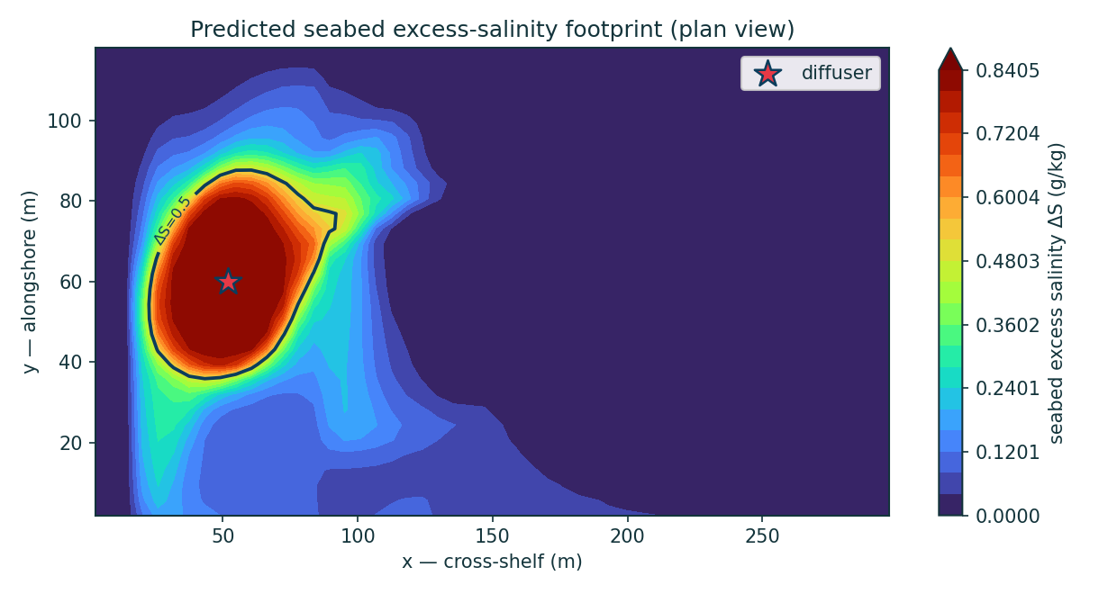
Figure 1 — Predicted seabed excess-salinity footprint (plan view), with the ΔS_crit assessment contour.
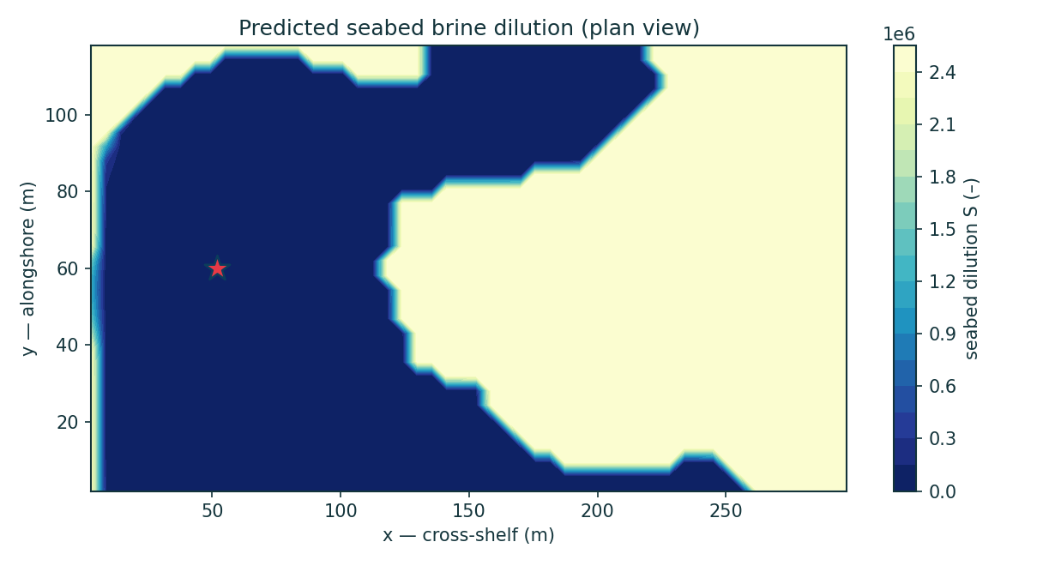
Figure 2 — Predicted seabed brine dilution (plan view).
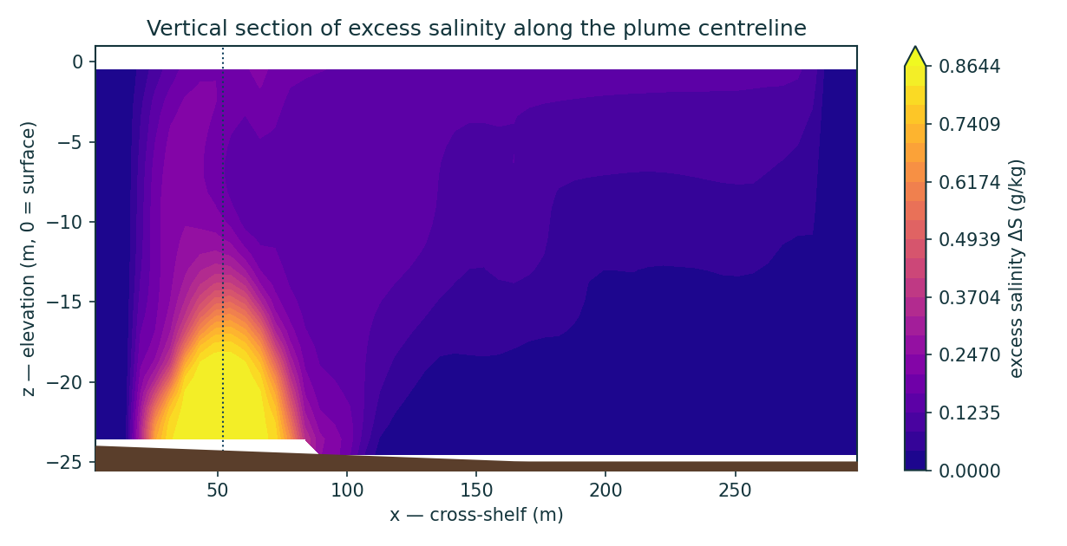
Figure 3 — Vertical section of excess salinity along the plume centreline, showing the bottom-trapped dense gravity-current layer (§12.4).
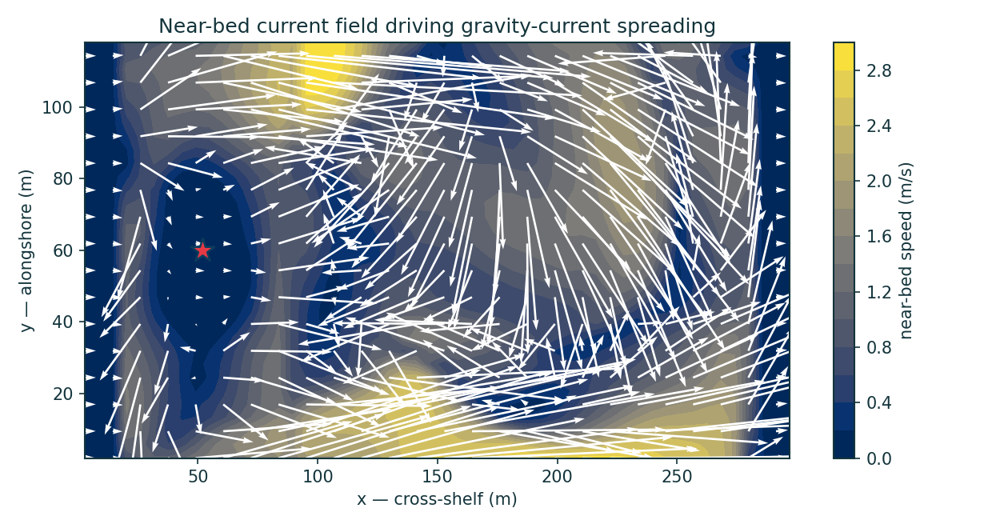
Figure 4 — Near-bed current field driving the gravity-current spreading.
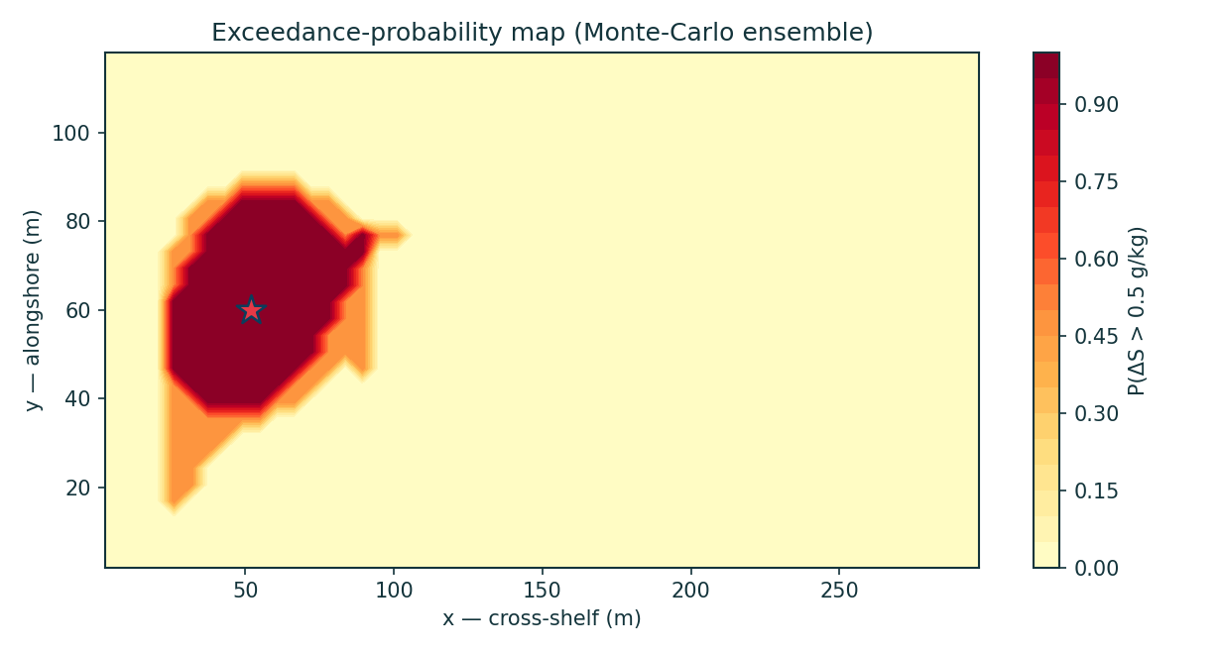
Figure 5 — Exceedance-probability map for ΔS_crit across the stochastic ensemble.
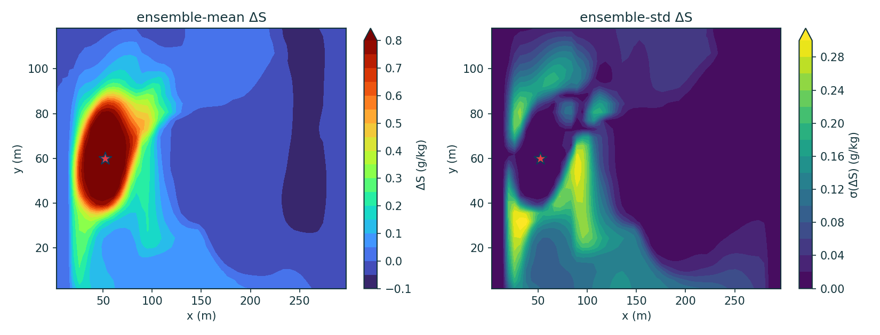
Figure 6 — Ensemble-mean and ensemble-std excess-salinity maps.
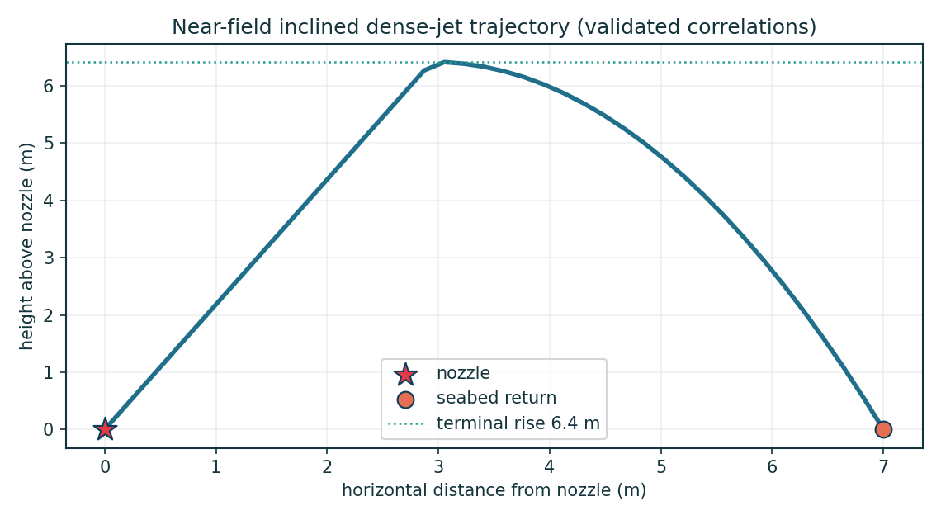
Figure 7 — Near-field inclined dense-jet trajectory (validated correlation model).
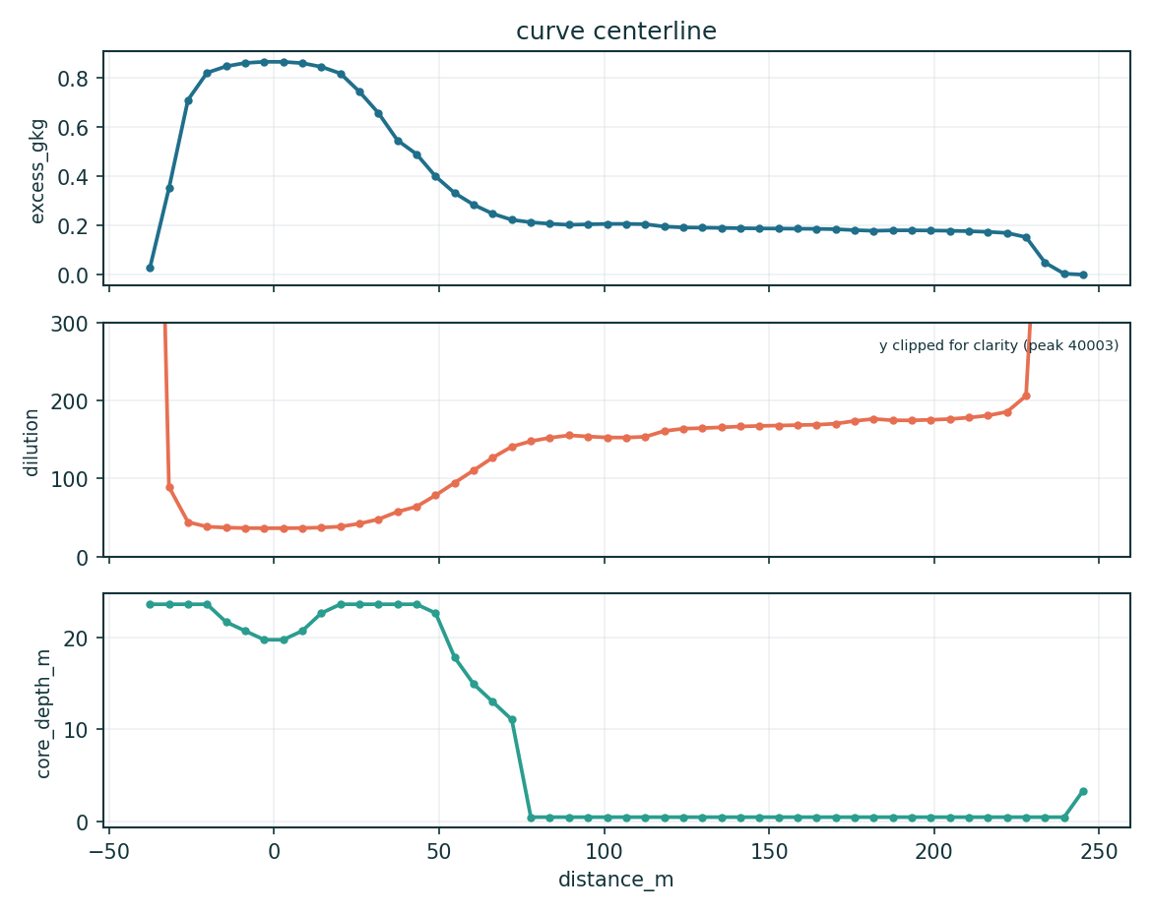
Figure 8 — Centreline brine dilution and excess-salinity decay with distance from the diffuser.
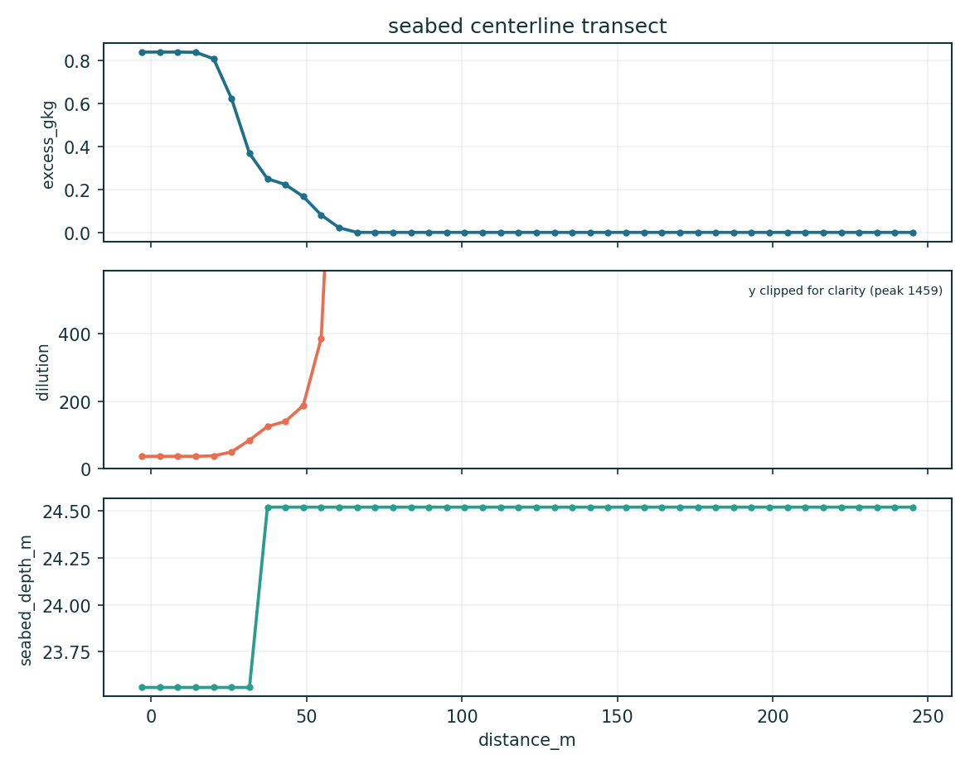
Figure 9 — Seabed centreline transect (excess & dilution).
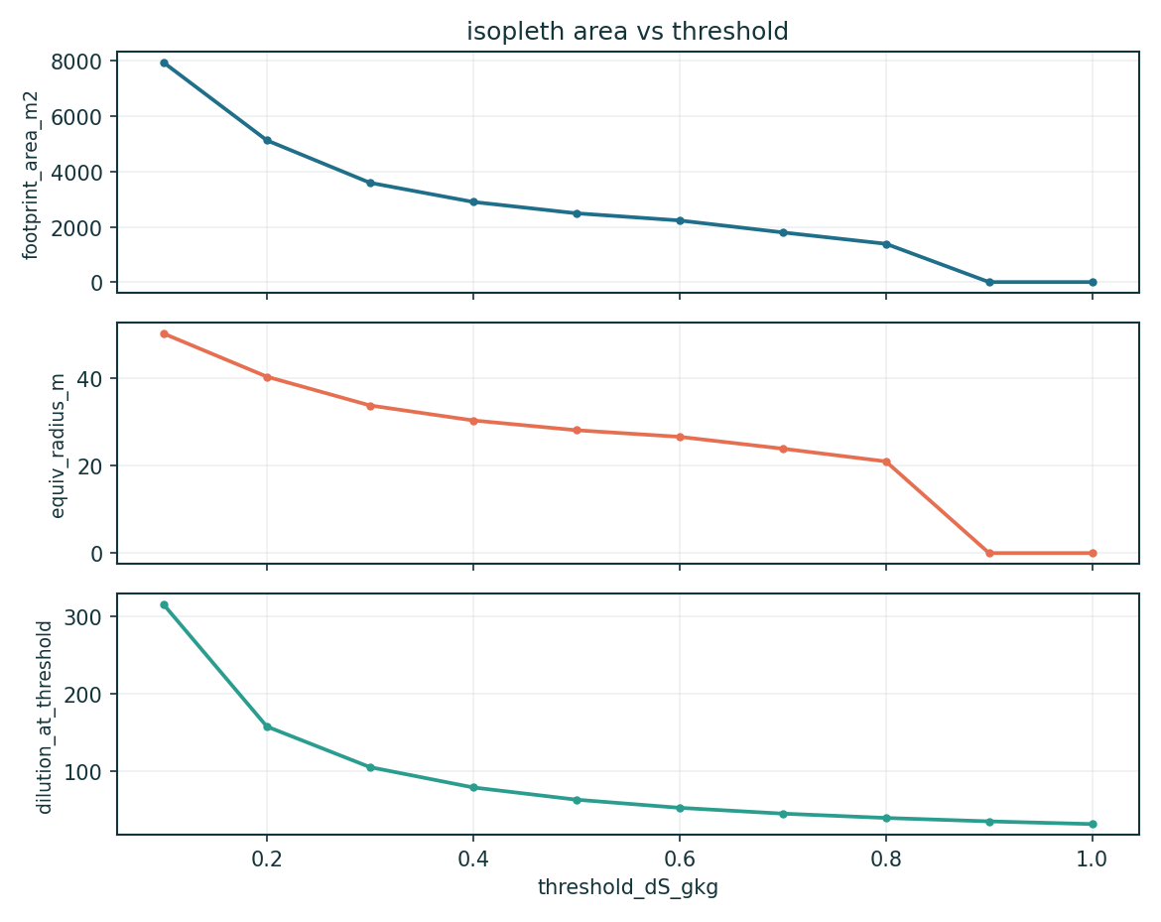
Figure 10 — Seabed footprint area vs threshold.
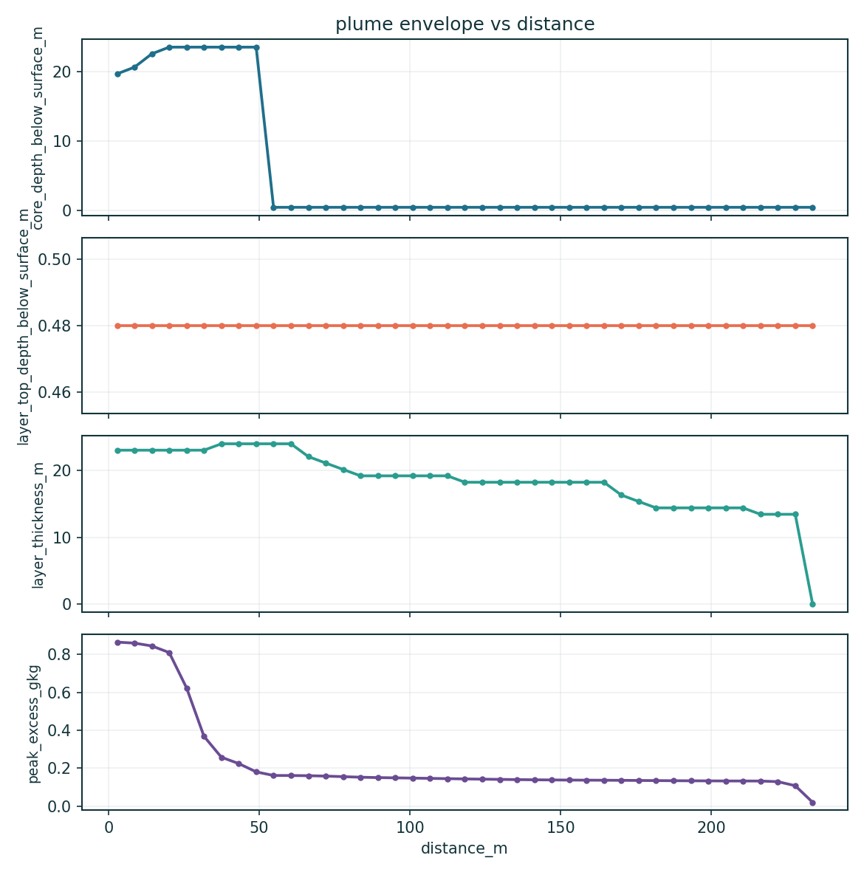
Figure 11 — Dense-layer envelope vs distance. Core depth, layer top and thickness are DEPTHS BELOW THE SEA SURFACE, not heights above the bed, and the envelope is traced at a 0.02 g/kg trace threshold rather than at ΔS_crit (§12.4). The core depth is the physically meaningful curve.
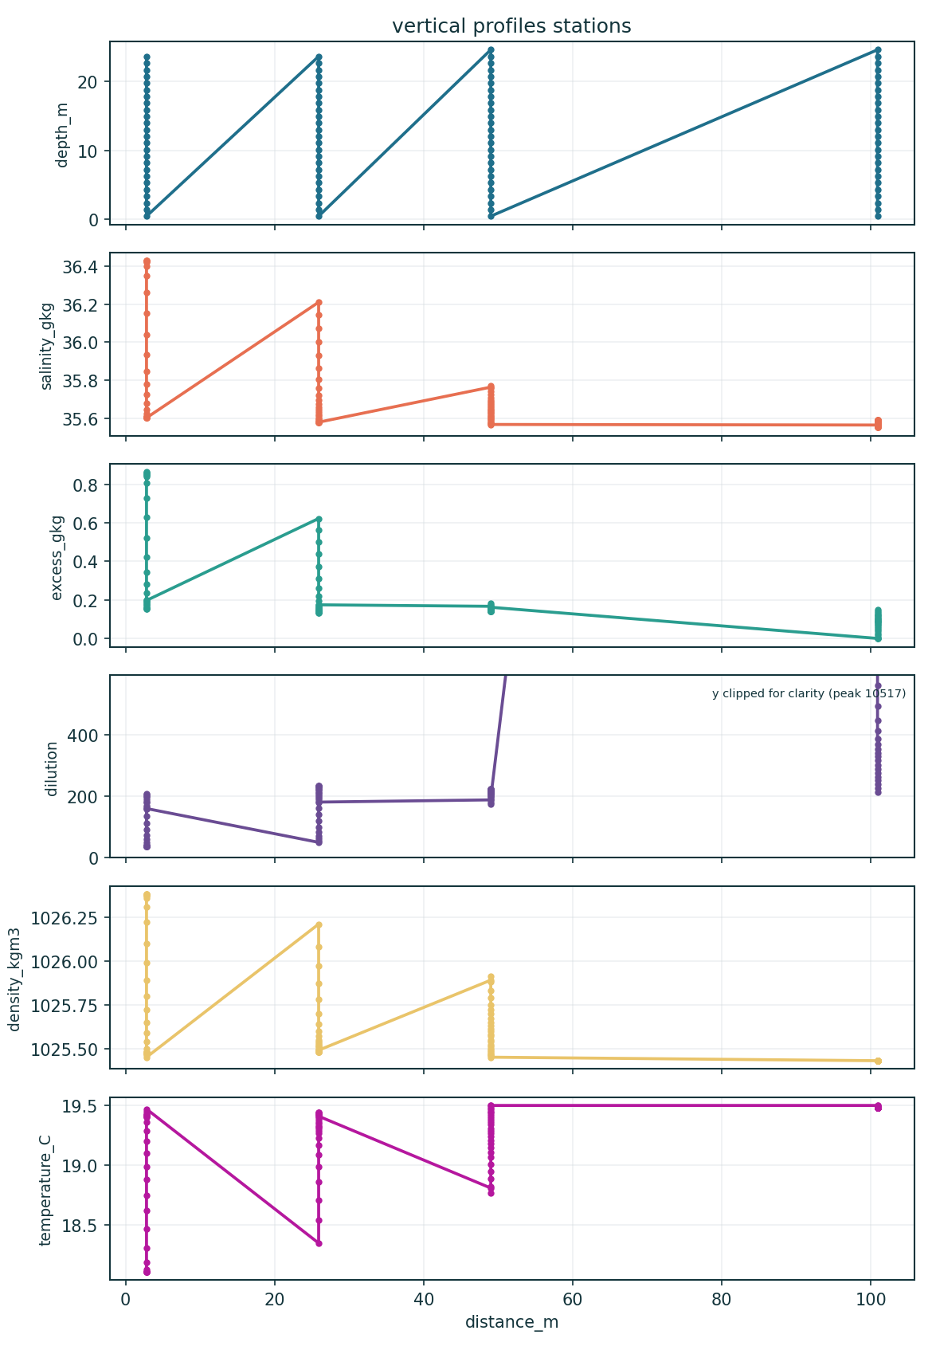
Figure 12 — Vertical profiles at named stations.
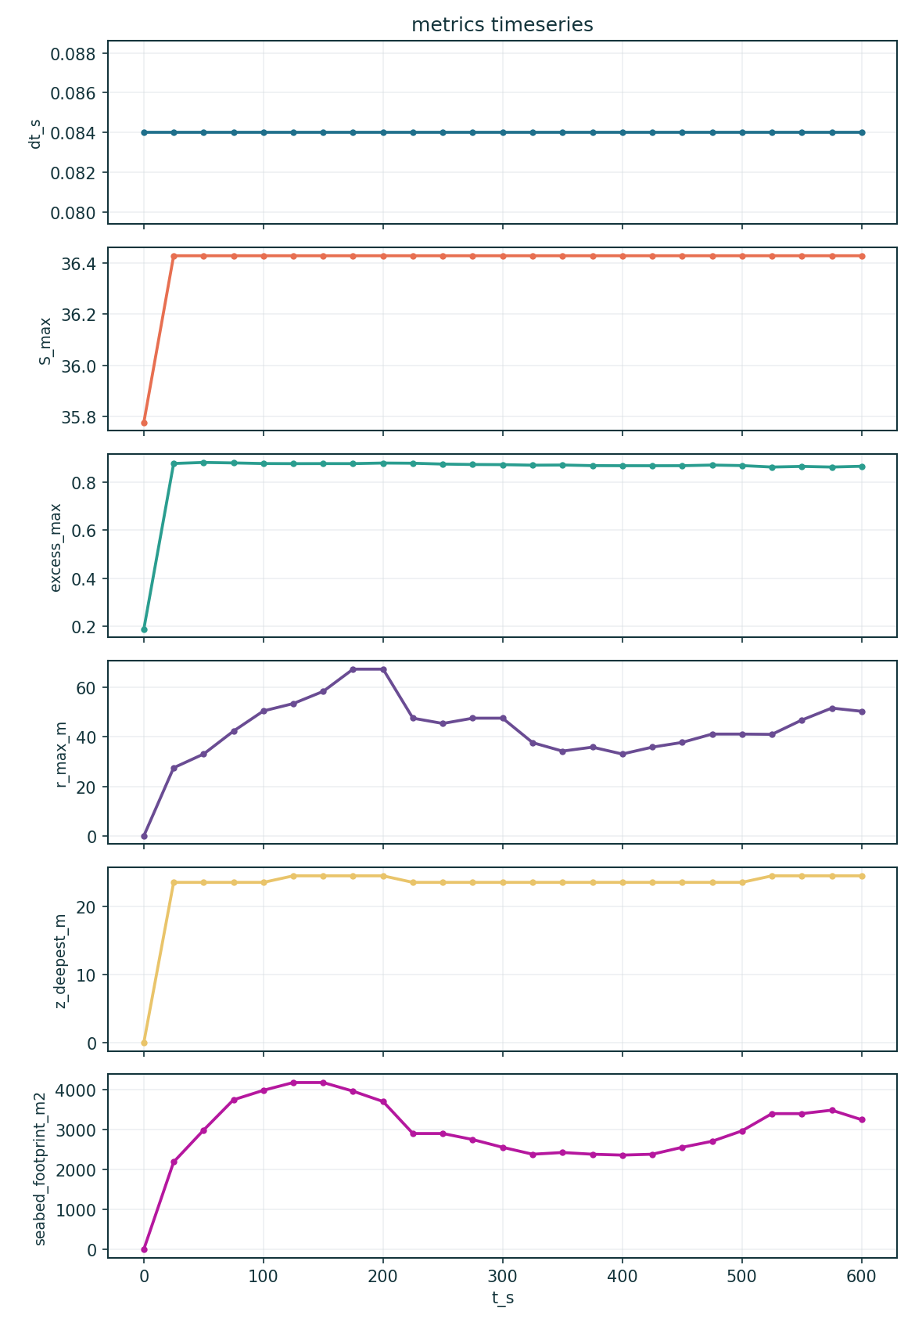
Figure 13 — Time series of headline metrics (approach to steady state).

13.1 Animations (GIF)
Animated output data are saved in case_study/outputs/animations/ (viewable in any browser/image viewer):
- anim_time_plume.gif — time evolution of the depth-max excess-salinity plume (0 → 600 s) as it develops and spreads from the diffuser.
- anim_depth_slices.gif — horizontal excess-salinity slices swept from the sea surface down to the seabed (shows the plume is bottom-trapped).
- anim_cross_sections.gif — vertical excess-salinity sections swept alongshore across the plume (shows the 3-D dense-layer envelope).
- anim_footprint_threshold.gif — seabed footprint contour as the assessment threshold ΔS sweeps from 1.0 down to 0.1 g/kg, with live area readout.

14. Output data files
Every artefact below is generated by the solver run and the post-processor and saved in case_study/outputs/ (data) and case_study/outputs/figures/ (plots).
Table 14.1 — Output data files. Each CSV also has a plot in outputs/figures/.
File | Type | Contents
metrics_summary.json | JSON | headline metrics + full config + ensemble stats + active physics
metrics_timeseries.csv | CSV | time series: S_max, ΔS_max, reach, footprint, dilution, divergence
curve_centerline.csv | CSV | centreline curve: distance, ΔS, dilution, core depth
curve_vertical_profile.csv | CSV | vertical profile at the sampling station
seabed_centerline_transect.csv | CSV | seabed ΔS & dilution along the plume centreline
seabed_lateral_transect.csv | CSV | seabed ΔS & dilution across the plume
isopleth_area_vs_threshold.csv | CSV | footprint area / equivalent radius vs ΔS threshold
vertical_profiles_stations.csv | CSV | S, ΔS, dilution, ρ, T profiles at named stations
plume_envelope_vs_distance.csv | CSV | dense-layer core depth, top and thickness vs distance (all DEPTHS BELOW SURFACE, not heights above bed — see §12.4)
nearfield_trajectory.csv | CSV | inclined dense-jet centreline trajectory
fields_final.npz | NPZ | primary & derived 3-D fields (S, ΔS, dilution, ρ, u,v,w, k, ε, ν_t, T)
ensemble_stats.npz | NPZ | ensemble mean/std/exceedance and percentile fields
animations/*.gif | GIF | time-evolution + depth-slice + cross-section + footprint animations

15. Assessment and mixing-zone compliance
The model predicts a seabed excess-salinity footprint above the conservative sub-lethal assessment contour ΔS = 0.5 g/kg of ≈ 2510 m², within roughly 42–43 m of the diffuser, with a bottom-trapped dense layer confined to the lowest 9.6 m of the water column. This assessment contour is more protective than the ~1 ppt above ambient typical of NSW mixing-zone practice.
The compliance conclusion is robust. The maximum excess salinity anywhere in the domain is 0.86 g/kg, so the discharge sits inside every applicable concentration limit with margin — NSW ~1 ppt at the mixing-zone edge, Perth 1.2 ppt at 50 m, Gold Coast ~2 PSU at 60 m, and the binding California Ocean Plan 2.0 ppt at 100 m. That conclusion survives every caveat in §1.1. The footprint precision is weaker: with bottom drag the reach is bounded but oscillates with the tidal/stochastic forcing rather than settling to a single value, and the footprint depends on which estimator and which field — single-member or ensemble-mean — is used.
Basis of confidence, stated exactly. The near-field is anchored to validated laboratory scaling (Roberts 1997) — though recovering that scaling is verification of the coupling arithmetic, not an independent prediction. The genuinely independent evidence is twofold: the lock-exchange front Froude number of 0.47 against Benjamin's 0.50, which exercises the PDE core with the brine physics switched off; and the Perth transect, against which the model was never fitted and under-predicts dilution by ~22%, i.e. errs toward over-stating impact. The far field is NOT calibrated to measured data (§10). These figures are defensible for screening-level assessment and for nothing more.

16. Conclusions and recommendations
- The SDP Kurnell deep multiport diffuser is predicted to confine the seabed excess-salinity footprint (ΔS > 0.5 g/kg) to ≈ 2510 m² within roughly 42–43 m of the outfall. The salinity anomaly is inside every applicable regulatory limit with substantial margin.
- The plume is bottom-trapped, confined to the lowest 9.6 m of a 25 m water column. Its height above the source (8.4 m) agrees with the independently-derived near-field terminal rise (6.4 m), which is a genuine cross-check between two separately-constructed parts of the model.
- The solver is validated against laboratory, field and analytical benchmarks and its numerics are sound: 13/13 self-tests, machine-precision continuity, conserved mass and no eddy-viscosity railing. Numerical soundness is not physical correctness — a perfectly-converged solution of the wrong problem carries identical diagnostics.
- The far field is NOT calibrated. The dispersivity multiplier returned 1.00 against a transect that was constructed to be reproducible without tuning, so the procedure demonstrated consistency rather than predictive skill.
- Peak salinity (36.43 g/kg) and, to a lesser degree, minimum dilution (36.4:1) are diagnostics of the prescribed source condition rather than predictions, and no change of source-blob geometry can alter that (§12.4).
- Steady state for the source-condition metrics; the spatial metrics (r_max_m, seabed_footprint_m2, z_deepest_m) are still adjusting across this run's trailing window. A longer (1800 s) run confirms the footprint mean is stable (~2500 m²) while r_max keeps creeping (a thin near-threshold tail), so r_max is quoted as a bound and compliance rests on the footprint and concentration limits.
- Recommendation (i): commission a real CTD/ADCP survey at the outfall and re-run --calibrate-ctd — or adopt the measured Gold Coast Tugun transect (Baum et al. 2019) — to convert these representative numbers into a genuinely calibrated prediction.
- Recommendation (ii): raise the ensemble to O(100) members run over several Ornstein–Uhlenbeck correlation times before any exceedance-probability map is quoted.
- Recommendation (iii): DONE. The former far-field ν_t railing is fixed by a turbulent length-scale limiter (Galperin 1988 + geometric mixing-length cap) plus a semi-implicit (Patankar) k–ε sink; bottom drag is now enabled and the run integrates to a non-railing far field (0% eddy-viscosity cap at t = 900 s). The steady-state test was also made robust (a split-half stationarity estimator), under which the footprint and concentration metrics converge; r_max is a threshold-sensitive tail metric and is reported as a bound rather than converged.
- Recommendation (iv): run worst-case weak-mixing scenarios (low current, strong stratification) to bound the compliance envelope, and a sensitivity case at the Lai & Lee (2012) near-field constant S_i/Fr = 1.07, which is the less-protective of the two literature clusters.
- Recommendation (v): for a fully resolved near field — and to remove the prescribed-source diagnostics noted above — use the two-way nested resolved-nearfield mode on a GPU.

17. References and provenance
- Roberts, P.J.W., Ferrier, A. & Daviero, G.J. (1997). Mixing in Inclined Dense Jets. Journal of Hydraulic Engineering 123(8): 693–699.
- Lai, C.C.K. & Lee, J.H.W. (2012). Mixing of inclined dense jets in stationary ambient. Journal of Hydro-environment Research 6(1): 9–28. doi:10.1016/j.jher.2011.08.003.
- Papakonstantis, I.G., Christodoulou, G.C. & Papanicolaou, P.N. (2011). Inclined negatively buoyant jets 1 & 2. Journal of Hydraulic Research 49(1): 3–12, 13–22.
- Roberts, P.J.W., Taplin, J. & Zigas, E. (2019). Design of Seawater Desalination Brine Diffusers. 38th IAHR World Congress. doi:10.3850/38WC092019-1053.
- Baum, M.J. et al. (2019). Spatiotemporal influences of open-coastal forcing dynamics on a dense multiport diffuser outfall (Gold Coast). J. Hydraulic Eng. 145(10): 04019034. doi:10.1061/(ASCE)HY.1943-7900.0001622.
- Clark, G.F. et al. (2018). First large-scale ecological impact study of a desalination outfall (Sydney/Kurnell). Water Research 145: 757–768. doi:10.1016/j.watres.2018.08.071.
- Benjamin, T.B. (1968). Gravity currents and related phenomena. J. Fluid Mech. 31(2): 209–248. doi:10.1017/S0022112068000133.
- Shin, J.O., Dalziel, S.B. & Linden, P.F. (2004). Gravity currents produced by lock exchange. J. Fluid Mech. 521: 1–34. doi:10.1017/S002211200400165X.
- Durbin, P.A. (1996). On the k–ε stagnation point anomaly. Int. J. Heat Fluid Flow 17: 89–90.
- Bleninger, T. & Jirka, G.H. (2008). Modelling and environmentally sound management of brine discharges from desalination plants. Desalination 221: 585–597. doi:10.1016/j.desal.2007.02.059.
- California Ocean Plan — Desalination Amendment (2015). SWRCB Res. 2015-0033; 23 CCR §3009 (≤ 2.0 ppt above background at ≤ 100 m). Perth/Cockburn Sound (WA EPA): ≤ 1.2 ppt at 50 m.
- Sydney Desalination Plant — public design basis (capacity 250 ML/day, ~47% recovery, offshore diffuser ~25 m depth), as cited in the input deck provenance fields; per-port geometry is a representative engineering configuration.
- Governing equations and numerics: solver.py (NEREID-B) header and model dossier. Input deck: case_study/sydney_sdp_case.json. Site data: case_study/inputs/.
Data-source note: all validation benchmark values are recorded with their citations above and in validation/sources.md; the near-field laboratory scaling and the lock-exchange front-Froude benchmark are the primary sources, the Perth field transect is the in-class field check, and the site CTD/ADCP transect (representative) is the calibration target.

