DOCTORAL RESEARCH PROPOSAL — PhD (Comprehensive)
A Coupled Stochastic Partial-Differential-Equation Framework for Predicting Salinity Dispersion from Submarine Brine Outfalls
Development, Field Validation and Application of the NEREID-B Near-Field/Far-Field Model for Desalination Brine Plumes

Discipline: Environmental Fluid Mechanics / Computational Hydro-Environmental Engineering
Candidate: [Candidate name]
Supervisors: [Principal supervisor]; [Co-supervisor]
Host: [Department, University]
Mode / duration: Full-time, 3.5–4 years
Submission date: 12 June 2026

Abstract
Seawater desalination now exceeds 95 Mm³/day globally and continues to grow; its hyper-saline reject (brine), discharged to the sea, is a leading marine-environmental concern because the dense effluent sinks, pools on the seabed and can exceed the salinity tolerance of benthic ecosystems. Reliable prediction of the three-dimensional, time-evolving salinity field around an outfall — together with a calibrated measure of uncertainty arising from the unpredictable sea — is essential for outfall design and regulatory consent, yet current tools are limited: integral jet models (CORMIX/VISJET) cannot resolve the unsteady 3-D far field, while Boussinesq CFD neglects the large brine/ambient density contrast and treats the sea deterministically.
This research develops, validates and applies NEREID-B, a novel coupled, unsteady, non-Boussinesq, stochastic partial-differential-equation (PDE) framework that solves the velocity, pressure, density, salinity, temperature, turbulence and free-surface fields simultaneously, closed by a nonlinear equation of state, irreversible-thermodynamics (Soret/Dufour) cross-diffusion and an explicit osmotic/reverse-osmosis coupling, and forced by intrinsic space-time stochastic noise so the model returns the probability distribution of salinity rather than a single value. A validated near-field/far-field coupling embeds the unresolvable diffuser jet through calibrated correlations. Extensive preliminary work — full model formulation, a robust verified solver, near-field validation against laboratory scaling, far-field grid-convergence, and two industrial case studies demonstrating that diffuser port spacing is a first-order control on impact — establishes proof of concept. The doctoral programme will extend the physics (non-Boussinesq continuity, multi-ion chemistry, higher-order numerics), deliver the first field validation of the coupled framework against CTD/ADCP surveys at an operating outfall, build a machine-learning surrogate for rapid probabilistic compliance screening, and release an open decision-support tool. The contribution is a new, validated, uncertainty-aware predictive capability for brine-outfall salinity dispersion, directly serving desalination engineering and marine environmental regulation.
Keywords: brine dispersion; desalination outfall; dense jet; coupled PDE; stochastic modelling; uncertainty quantification; near-field/far-field coupling; salinity; environmental fluid mechanics.

1. Introduction

1.1 Background and context
Water scarcity, intensified by climate change, population growth and over-abstraction, has made desalination a cornerstone of water security in arid and coastal regions. Seawater reverse osmosis (SWRO) dominates new capacity but recovers only ~40–50 % of the feed as product; the remainder is rejected as a brine typically 1.5–2× the ambient salinity, often warmer and containing residual antiscalants and cleaning chemicals. This reject is overwhelmingly returned to the sea through submarine outfalls, most modern installations using inclined multiport diffusers to promote rapid near-field dilution.
Because the reject is denser than seawater it is a negatively-buoyant effluent: discharged as an inclined jet it rises, bends over under gravity, falls back to the seabed and spreads as a bottom-hugging gravity current. Field and laboratory studies have linked the resulting salinity increment to stress and mortality in seagrasses (e.g. Posidonia), echinoderms and other osmoconforming benthic biota. Consequently, regulators worldwide impose salinity-increment limits at the edge of a defined mixing zone, and operators must demonstrate compliance by predictive modelling at the consenting stage and by monitoring thereafter.

1.2 Statement of the problem
Predicting outfall impact requires resolving the salinity field across two coupled regimes — the energetic near field (the buoyant jet) and the unsteady far field (the bottom gravity current under currents, tides, waves and stratification) — and quantifying the uncertainty introduced by the sea's variability. No existing tool does all three: integral models capture near-field dilution but not the 3-D unsteady far field; CFD resolves the far field but assumes small density differences and runs deterministically. The problem this research addresses is the absence of a single, validated, uncertainty-aware framework spanning both regimes for dense brine effluent.

1.3 Rationale and motivation
The gap is both scientifically significant and practically urgent. Scientifically, dense effluent dispersion couples non-Boussinesq buoyancy, stratified turbulence, anisotropic dispersion and stochastic forcing in ways not previously unified or validated. Practically, the rapid global expansion of desalination, alongside tightening marine protection regimes, creates strong demand for a credible, risk-based predictive capability that supports low-impact outfall design and evidence-based consenting.

1.4 Aim, objectives, questions and hypotheses
Aim: to develop, validate and apply a coupled stochastic PDE framework (NEREID-B) for predicting near- and far-field salinity distribution and its uncertainty around submarine brine outfalls.
Research questions:
- Can a coupled stochastic PDE framework predict the unsteady 3-D salinity field of a brine outfall more completely than existing tools while remaining robust and affordable?
- How accurately can a near-field/far-field coupling reproduce measured dilution and footprint at an operating outfall?
- How do near-field jet merging and far-field gravity-current processes interact to determine impact and compliance?
- What is the predictive uncertainty given the unpredictability of the sea, and can it be quantified efficiently for design?
Central hypothesis: a coupled non-Boussinesq stochastic PDE model with a validated near-field closure can predict brine-plume salinity and its uncertainty to engineering/regulatory accuracy, outperforming single-paradigm tools.
Specific objectives are listed in Table 1.1.
Table 1.1 — Objectives and status at proposal
# | Objective | Status
O1 | Formulate the coupled non-Boussinesq stochastic PDE system | Done (prelim.)
O2 | Develop a robust solver with near-field/far-field coupling | Done (prelim.)
O3 | Verify robustness; validate near field vs lab scaling | Done (prelim.)
O4 | Demonstrate stochastic uncertainty quantification | Done (prelim.)
O5 | Extend physics: non-Boussinesq, multi-ion, higher-order time | Proposed (WP2)
O6 | Field-validate the far field (CTD/ADCP at an operating outfall) | Proposed (WP3)
O7 | Build an ML surrogate for probabilistic screening | Proposed (WP4)
O8 | Apply to design/consenting cases; release open tool | Proposed (WP5)

1.5 Scope and delimitations
- Focus: salinity (and coupled temperature/density) dispersion from submarine brine outfalls in coastal seas; ecological dose–response is out of scope (the model supplies the salinity exposure that such assessments require).
- Spatial scope: from the diffuser nozzle to the far-field mixing zone (hundreds of metres); regional-scale circulation is imposed as forcing.
- The near field is represented by validated correlations rather than nozzle-resolving CFD, which is infeasible at field scale.

1.6 Operational definitions
Term | Definition
Near field | The momentum/buoyancy-dominated jet region (first tens of metres) where most dilution occurs
Far field | The ambient-controlled region where the diluted, dense plume spreads as a bottom gravity current
Dilution | Ratio (S₀−S_amb)/(S−S_amb) of source-to-local excess salinity
Densimetric Froude, Fr | U/√(g′D): jet momentum vs buoyancy, g′=g(ρ−ρ_a)/ρ_a
Mixing zone | Permitted area within which the salinity-increment limit may be exceeded
Stochastic PDE (SPDE) | A PDE driven by random forcing, whose solution is a probability distribution of fields

2. Literature Review and Theoretical Framework

2.1 Brine discharge and environmental impact
Reviews (e.g. Roberts et al. 2010; Missimer & Maliva 2018) document that elevated salinity from desalination outfalls is the dominant stressor on benthic communities, with thresholds as low as +1–2 g kg⁻¹ for sensitive seagrasses. Regulatory frameworks (e.g. in the Mediterranean, Gulf and Australia) accordingly set salinity-increment limits, motivating accurate predictive modelling.

2.2 Near-field jet and plume modelling
The near field of inclined dense jets has been characterised extensively by laboratory experiment and integral modelling. Roberts et al. (1997), Cipollina et al. (2005), Roberts & Toms (1987), Lai & Lee (2012) and Abessi & Roberts (2015) established robust scaling for terminal rise, return distance and dilution as functions of the densimetric Froude number and nozzle angle (e.g. z_t/(D·Fr) ≈ 2.1–2.8 and return dilution S_r ≈ 1.6 Fr at 60°). Integral entrainment models (Jirka 2004; Lee & Chu 2003) and the engineering tools CORMIX, VISJET and JETLAG encapsulate this knowledge but reduce the plume to a centreline and cannot represent the unsteady 3-D far field, complex bathymetry or the full sea state.

2.3 Far-field and CFD modelling
Far-field spreading has been modelled with shallow-water and 3-D hydrodynamic codes (e.g. Delft3D, ROMS, OpenFOAM-based RANS/LES). These resolve advection and dispersion but commonly invoke the Boussinesq approximation — questionable for hyper-saline reject — and require near-nozzle resolution that is infeasible at field scale, leading to the widely-used but loosely-coupled practice of hand-off from a near-field tool to a far-field model.

2.4 Stochastic and uncertainty approaches
Environmental flows are increasingly treated probabilistically (ensemble forecasting; polynomial chaos; stochastic PDEs). Such methods are established in oceanography and groundwater but have not been systematically applied to dense-effluent dispersion, where the unpredictability of currents, tides and wind strongly controls the footprint. Representing this variability intrinsically — rather than by ad hoc scenario runs — is a methodological opportunity.

2.5 Thermodynamic and constitutive couplings
The nonlinear seawater equation of state (TEOS-10; IOC et al. 2010) is essential for hyper-saline, stratified flows. Osmotic pressure, reverse-osmosis transport and Onsager (Soret/Dufour) cross-diffusion are well established in physical chemistry but are universally neglected in plume models; their role at the sharp brine front is unquantified.

2.6 Synthesis and research gap
The literature provides a validated near field, capable but Boussinesq and deterministic far-field codes, and mature but unexploited stochastic and thermodynamic methods. What is missing — and what this research provides — is their integration into one validated, non-Boussinesq, uncertainty-aware framework with a rigorously field-validated near-field/far-field coupling.

2.7 Theoretical and conceptual framework
The work is grounded in conservation-law continuum mechanics (mass, momentum, scalar transport) closed by irreversible thermodynamics (Onsager reciprocity, the nonlinear EOS) and stochastic-process theory (Ornstein–Uhlenbeck forcing, ensemble/Fokker–Planck description of the salinity PDF). Conceptually, environmental impact is modelled as a chain: discharge → validated near-field dilution → stochastic far-field gravity-current transport → probabilistic salinity exposure → compliance, with uncertainty propagated end-to-end.

3. Methodology

3.1 Research design
The study follows a model-development-and-validation design within a post-positivist, quantitative paradigm: a mathematical model is formulated, implemented, verified (correct solution of the equations) and validated (correct representation of reality) against laboratory and field data, then applied to answer the research questions. Verification and validation (V&V) follow the established hierarchy (code verification → solution verification/grid-convergence → model validation → predictive use with quantified uncertainty).

3.2 The coupled stochastic PDE model
NEREID-B solves the state vector q = (ρ, u, p, S, T, k, ε, η):
∂ρ/∂t + ∇·(ρu) = 0
∂(ρu)/∂t + ∇·(ρu⊗u) = −∇p + ∇·τ + ρg − 2ρΩ×u + F_wave + F_osm + F_stoch
∂S/∂t + u·∇S = −(1/ρ)∇·J_S + R_S + ξ_S
∂T/∂t + u·∇T = −(1/ρc_p)∇·J_Q + Q_rad/(ρc_p) + ξ_T
ρ = ρ_EOS(S,T,p) (nonlinear TEOS-10)
∂ζ_m/∂t = −ζ_m/τ_m + σ_m 𝓛_m^{1/2} Ẇ_m(x,t)
Constitutive closures:
- Salt flux J_S = −ρ D_S·∇S − ρ D_ST∇T − (ρ D_S L_p/R_gT)∇Π, fusing a full anisotropic dispersion tensor, Soret cross-diffusion and the osmotic/RO flux.
- Osmotic pressure Π(S,T) by a Pitzer-corrected van 't Hoff law.
- Turbulence by a buoyancy-modified k–ε closure with a Smagorinsky dissipation floor.
- Stochastic forcing channels ζ_m (currents, tide, wind, sub-grid turbulence) as Ornstein–Uhlenbeck colored noise with prescribed de-correlation time and spatial length scale.
Solving the ensemble yields the predictive salinity PDF P[S(x,t)], its mean, variance and exceedance probabilities.

3.3 Numerical solver
A finite-volume, MAC-consistent fractional-step projection is used on a terrain-following grid with partial-cell (shaved-cell) bathymetry and an implicit free surface; scalars use a monotone TVD (van Leer) scheme; the constant-coefficient pressure-Poisson operator is LU-factorised once. Proposed extensions (WP2): a variable-density (non-Boussinesq) projection, second-order time integration, and multi-tracer (Maxwell–Stefan) transport.

3.4 Near-field/far-field coupling
The sub-grid diffuser is represented by validated dense-jet correlations (rise, return point, dilution; with a multiport merging correction), and the 3-D far field is seeded with the diluted return plume. WP3 will refine and field-calibrate this coupling, including jet-merging at real multiport diffusers.

3.5 Verification, validation and uncertainty quantification
- Verification: automated invariant tests (conservation, boundedness, divergence control, monotonicity, exact restart); method-of-manufactured-solutions for new physics (WP2).
- Solution verification: systematic grid-convergence (Richardson extrapolation / GCI).
- Validation: laboratory dense-jet scaling (done); and the core field campaign (WP3) against CTD/ADCP/towed-sensor surveys at an operating outfall, testing predicted profiles, footprint, dilution and the probability-envelope coverage.
- UQ: Monte-Carlo stochastic ensembles; Sobol sensitivity; and a polynomial-chaos / neural surrogate (WP4) for rapid screening.

3.6 Field campaign and case-study design
WP3 will instrument an operating SWRO outfall: vessel-based CTD casts and towed conductivity transects to map the salinity field, bottom-mounted ADCPs and a thermistor/conductivity mooring for the forcing and stratification, and met data for wind. Surveys will span tidal and seasonal states. Case studies (WP5) will cover single-port and multiport diffusers, stratified and energetic sites, to test generality and inform design guidance.

3.7 Data management
All field and model data will be version-controlled, documented with metadata (CF conventions), archived in an open repository where agreements permit, and released alongside the software to support reproducibility.

4. Preliminary Results (Proof of Concept)
A complete preliminary implementation establishes feasibility and de-risks the programme:
- Robustness verified: the solver passes a six-check automated self-test (no NaN; salinity bounded; machine-level divergence control; EOS/transport monotonicity; bitwise-exact checkpoint/restart).
- Near field validated: modelled 60° dense-jet rise z_t/(D·Fr) = 2.20 lies within the published band 2.1–2.8; return dilution follows S_r ≈ 1.6 Fr (Figure 4.1).
- Far field grid-converged: peak excess salinity changes 0 % between the medium and fine meshes (4.44 → 4.45 g kg⁻¹ over a 4× cell-count range).
- Stochastic ensembles produce mean, spread and exceedance-probability maps of the salinity field.
An industrial case — a 150,000 m³/day SWRO outfall — was simulated for two diffuser configurations. The results (Table 4.1, Figures 4.2–4.3) show that diffuser port spacing, through jet merging, is a first-order control on impact.
Table 4.1 — Preliminary case results (single-port vs merged multiport)
Quantity | Single-port | Merged multiport
Near-field dilution | 19 × | 8 ×
Excess ΔS at seabed return | 1.5 g/kg | 3.7 g/kg
Far-field peak excess | 2.13 g/kg | 4.45 g/kg
Exceedance footprint (>2 g/kg) | ≈ 0 m² | 17,812 m²
Maximum reach | 45 m | 167 m
Compliance (far field) | compliant | defined mixing zone
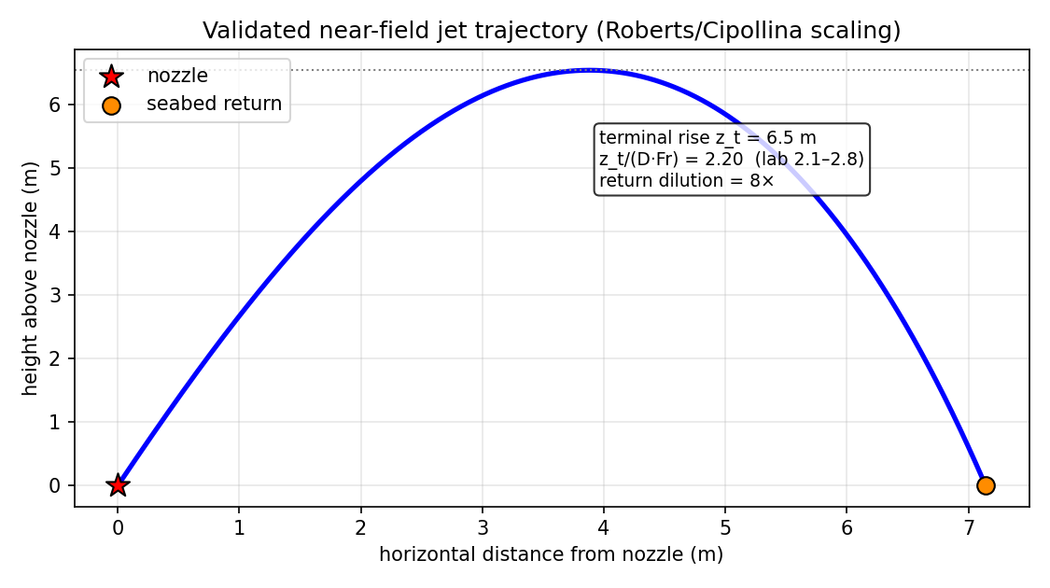
Figure 4.1. Validated near-field inclined dense-jet trajectory; modelled rise and dilution match laboratory scaling.
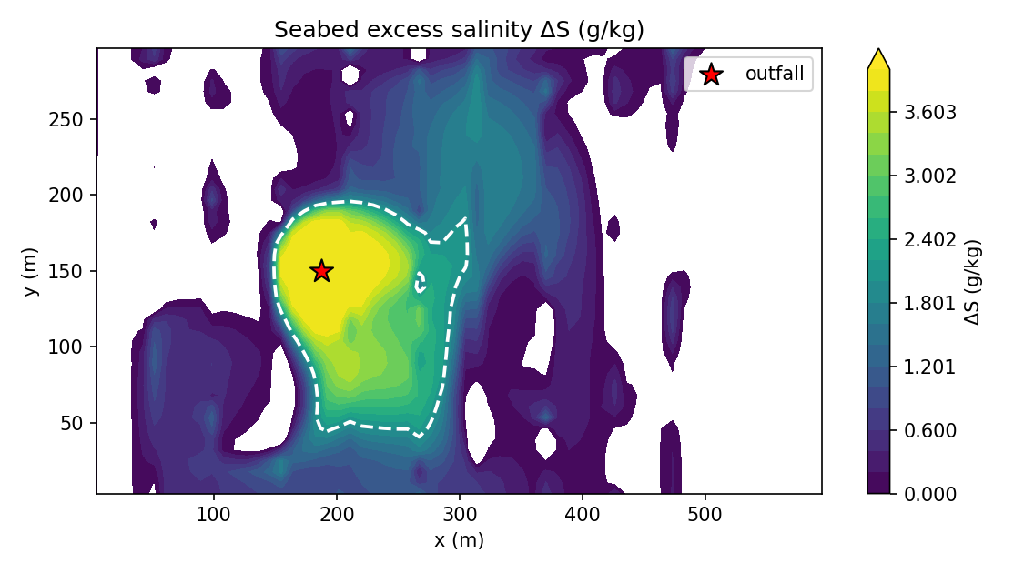
Figure 4.2. Predicted seabed excess-salinity footprint (merged diffuser) with the regulatory mixing-zone contour.
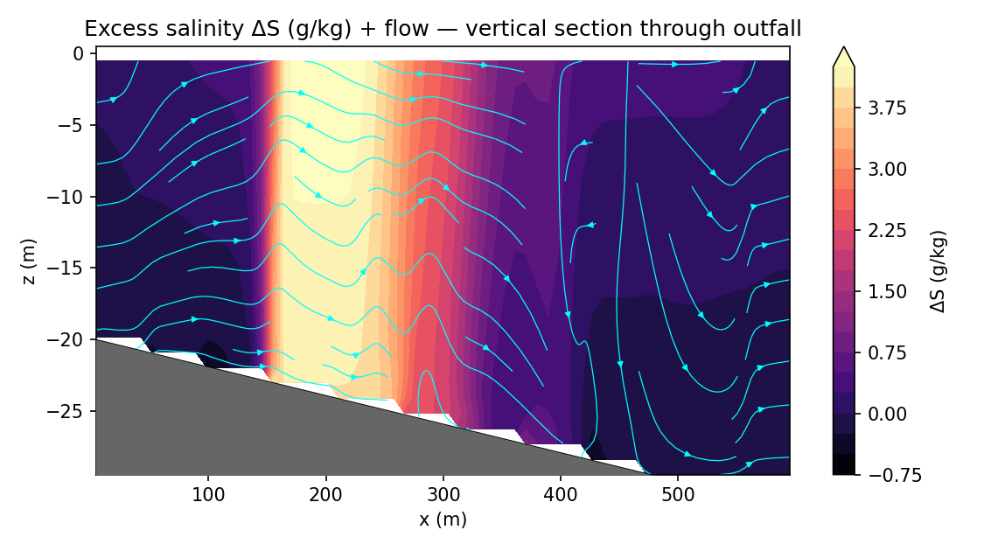
Figure 4.3. Vertical section: the dense plume is trapped near the bed and runs down-slope — the signature of a negatively-buoyant discharge.
These results confirm that the framework is robust, near-field-validated and capable of resolving design-relevant differences — the foundation on which the proposed programme builds.

5. Research Programme, Timeline and Management

5.1 Work packages
WP | Title | Key activities | Output
WP1 | Consolidation & review | Critical literature review; benchmark vs CORMIX/VISJET; harden the verified baseline | Review paper
WP2 | Physics extension | Non-Boussinesq projection; multi-ion Maxwell–Stefan chemistry; 2nd-order time; conservative free surface; method-of-manufactured-solutions verification | Extended solver; methods paper
WP3 | Field validation (core) | Survey design; CTD/ADCP/towed campaign at an operating outfall; calibration; near- & far-field validation; envelope coverage test | Validation dataset; flagship paper
WP4 | UQ & ML surrogate | Polynomial-chaos / neural surrogate; Sobol sensitivity; efficient probabilistic screening | Surrogate; UQ paper
WP5 | Application & tool | Design/consenting case studies; open decision-support release; diffuser-design guidance | Software; case papers
WP6 | Synthesis & thesis | Integration; dissemination; thesis | Thesis; 4–6 papers

5.2 Timeline (Gantt)
Work package | Y1H1 | Y1H2 | Y2H1 | Y2H2 | Y3H1 | Y3H2 | Y4H1
WP1 Consolidation | ● | ●
WP2 Physics extension |  | ● | ● | ●
WP3 Field validation |  |  | ● | ● | ●
WP4 UQ & surrogate |  |  |  | ● | ● | ●
WP5 Application & tool |  |  |  |  | ● | ● | ●
WP6 Synthesis & thesis |  |  |  |  |  | ● | ●

5.3 Milestones and deliverables
Milestone | When | Deliverable
M1 Verified baseline & review | Month 9 | Review paper submitted
M2 Extended physics solver | Month 21 | Methods paper; released code
M3 Field campaign complete | Month 30 | Validation dataset
M4 Validation paper | Month 36 | Flagship journal paper
M5 Surrogate & UQ | Month 39 | Surrogate tool; UQ paper
M6 Tool release & thesis | Month 45 | Open tool; PhD thesis

5.4 Training and development plan
- Technical: advanced CFD/numerical methods, stochastic modelling and UQ, machine learning, oceanographic field methods and instrumentation.
- Transferable: scientific writing, open-source software engineering, data management, project and stakeholder management.
- Dissemination: international conferences (e.g. IAHR, IDA World Congress, EGU) and engagement with industry and regulators.

5.5 Indicative resources and budget
Item | Indicative provision
HPC / compute | Ensemble simulations; cloud or institutional cluster allocation
Field campaign | Vessel time; CTD, ADCP, towed conductivity sensor; consumables
Travel | Conferences; field site visits
Partnerships | Plant operator (site access, plant data); environmental regulator
Software | Open-source toolchain (no licence cost)

5.6 Risk management
Risk | L/I | Mitigation
Field access / weather (WP3) | M/H | Multiple candidate sites; early operator partnership; existing monitoring data as fallback
Non-Boussinesq solver instability (WP2) | M/M | Incremental development behind the verified Boussinesq-buoyancy baseline
Ensemble computational cost | M/M | ML surrogate; parallelisation
Closure/merging-factor uncertainty | M/M | Calibrate to lab & field; report bounded estimates

5.7 Ethics
No human or animal subjects are involved. Marine field work will follow survey permitting, environmental best practice and any protected-area constraints; operator data will be governed by confidentiality/data-sharing agreements; outputs will be released openly where permitted.

6. Expected Contribution to Knowledge and Impact
Original contributions:
- A validated, non-Boussinesq, stochastic coupled-PDE framework for dense effluent dispersion returning the salinity probability distribution.
- The first field validation of a coupled near-field/far-field stochastic model for brine outfalls, with an openly-published dataset.
- Quantification of the osmotic, cross-diffusion and jet-merging effects neglected by current practice.
- A machine-learning surrogate enabling probabilistic compliance screening, and an open decision-support tool with design guidance.
Impact: scientifically, the work advances environmental fluid mechanics by unifying and validating couplings previously treated in isolation; practically, it equips desalination engineers and regulators with a risk-based predictive capability that supports low-impact outfall design and defensible consenting — timely given the rapid global growth of desalination and tightening marine protection.

7. Dissemination Plan
- 4–6 peer-reviewed papers (e.g. Water Research; Desalination; J. Hydraulic Engineering; Environmental Fluid Mechanics; Ocean Modelling).
- Conference presentations (IAHR, IDA, EGU) and an industry/regulator workshop.
- Open-source release of the validated solver and surrogate, with documentation and worked case studies.

8. Indicative References
Roberts, P.J.W., Ferrier, A. & Daviero, G. (1997). Mixing in inclined dense jets. J. Hydraulic Engineering, 123(8), 693–699.
Roberts, P.J.W. & Toms, G. (1987). Inclined dense jets in flowing current. J. Hydraulic Engineering, 113(3), 323–341.
Cipollina, A. et al. (2005). Bench-scale investigation of inclined dense jets. J. Hydraulic Engineering, 131(11), 1017–1022.
Lai, C.C.K. & Lee, J.H.W. (2012). Mixing of inclined dense jets in stationary ambient. J. Hydro-environment Research, 6(1), 9–28.
Abessi, O. & Roberts, P.J.W. (2015). Effect of nozzle orientation on dense jets in stagnant environments. J. Hydraulic Engineering, 141(8).
Jirka, G.H. (2004). Integral model for turbulent buoyant jets, Part I. Environmental Fluid Mechanics, 4, 1–56.
Lee, J.H.W. & Chu, V.H. (2003). Turbulent Jets and Plumes: A Lagrangian Approach. Kluwer.
Bleninger, T. & Jirka, G.H. (2008). Modelling and environmentally sound management of brine discharges from desalination plants. Desalination, 221, 585–597.
Fischer, H.B. et al. (1979). Mixing in Inland and Coastal Waters. Academic Press.
Missimer, T.M. & Maliva, R.G. (2018). Environmental issues in seawater reverse osmosis desalination: intakes and outfalls. Desalination, 434, 198–215.
Roberts, D.A. et al. (2010). Impacts of desalination plant discharges on the marine environment: A review. Water Research, 44(18), 5117–5128.
IOC, SCOR & IAPSO (2010). The international thermodynamic equation of seawater – 2010 (TEOS-10). UNESCO, Manuals and Guides 56.
Palomar, P. & Losada, I.J. (2011). Impacts of brine discharge on the marine environment: Modelling as a predictive tool. Desalination, 167.

