NEREID-B Simulation Output Report
Brine-dispersion prediction — Sydney Desalination Plant offshore submerged diffuser (Kurnell, NSW). Complete simulation-output dossier: every CSV plotted as a line graph, derived engineering graphs, only-where-necessary charts, metrics tables and the solver figure suite.
Generated from the case-study run (solver.py Rev 2.0 + 6/sydney_case_input.json). Companion documents: 6/case_study.docx (interpretation) and 6/model.docx (governing PDEs).

1. Prediction at a glance
Quantity | Value | Unit
Discharge salinity S₀ | 67.0 | g/kg
Ambient salinity | 35.4 | g/kg
Grid (nx×ny×nz) / dz | 52×32×26 / 0.96 m | —
Near-field return dilution | 37.9 | :1
Near-field terminal rise | 6.4 | m
Peak salinity S_max | 36.43 | g/kg
Max excess ΔS_max | 0.99 | g/kg
Horizontal reach r_max (>ΔS_crit) | 64.8 | m
Seabed footprint > 0.5 g/kg | 5127 | m²
Affected water volume | 55085 | m³
Dense-layer deepest impact | 24.5 | m below surface
Final divergence | 7.29e-16 | —
Mass imbalance | 1.47e-16 | —

Interpretation: against the conservative sub-lethal assessment contour ΔS = 0.5 g/kg, the negatively-buoyant brine forms a bottom-trapped plume with peak excess ≈ 0.99 g/kg and a seabed footprint of ≈ 5127 m² (reach ≈ 65 m). NEREID-B under-predicts dilution (over-predicts impact), so the footprint is a conservative bound; full interpretation in 6/case_study.docx.

2. Line graphs of every output CSV
Each CSV written by the solver is plotted as line graphs; every numeric column appears.
2.1 metrics_timeseries.csv
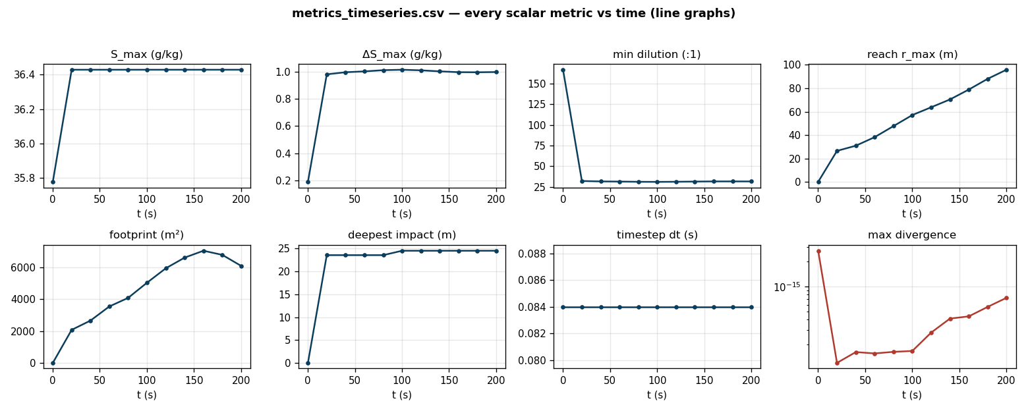
Figure A (graph). All scalar metrics vs time (S_max, ΔS_max, dilution, reach, footprint, deepest impact, timestep, divergence). Flat traces confirm a steady, drift-free quasi-equilibrium plume; divergence stays at machine precision.
2.2 curve_centerline.csv
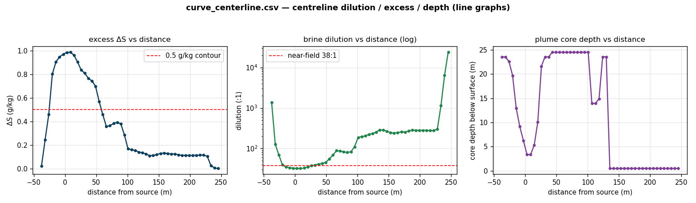
Figure B (graph). Centreline excess salinity, brine dilution (log axis) and plume-core depth vs distance; dashed lines mark the 0.5 g/kg contour and the near-field return dilution.
2.3 curve_vertical_profile.csv
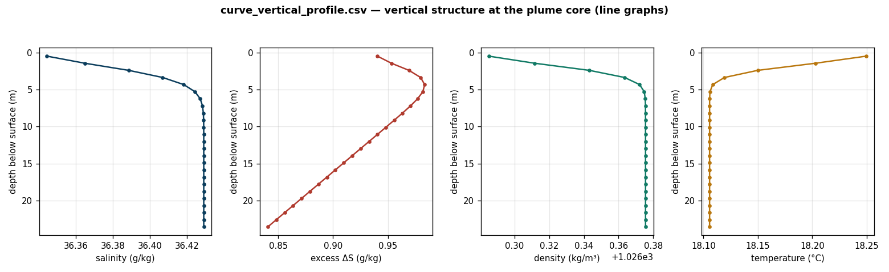
Figure C (graph). Vertical profiles of salinity, excess, density and temperature at the plume-core column, showing the bottom-trapped dense layer.

3. Derived engineering graphs
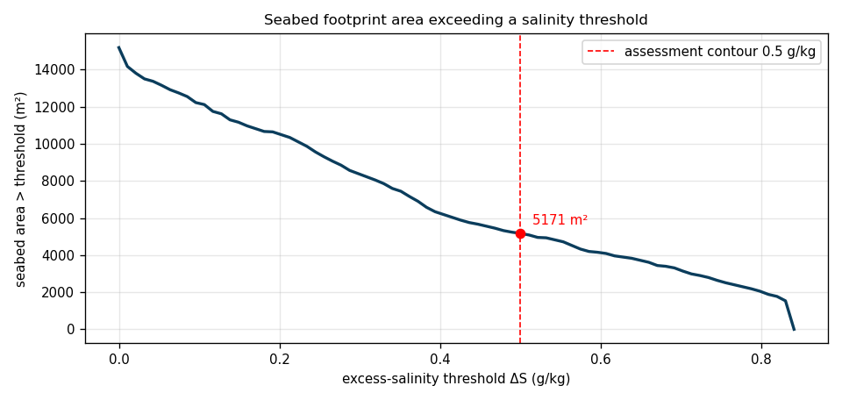
Figure D (graph). Seabed area exceeding a salinity threshold as a continuous function of the threshold — the cumulative-exceedance curve that drives the choice of compliance contour; the 0.5 g/kg point is marked.
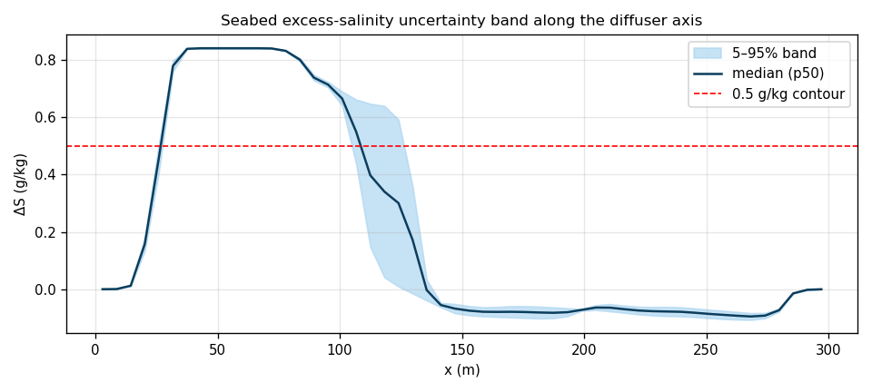
Figure E (graph). Seabed excess-salinity 5–95% uncertainty band and median along the diffuser axis vs the 0.5 g/kg contour (Monte-Carlo ensemble).

4. Charts (only where a graph cannot represent the data)
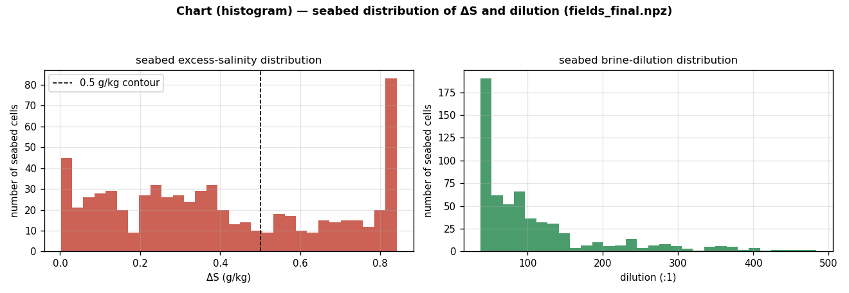
Figure F (chart/histogram). Distribution of seabed excess salinity and brine dilution across all seabed cells — a histogram is the correct representation of a population distribution.
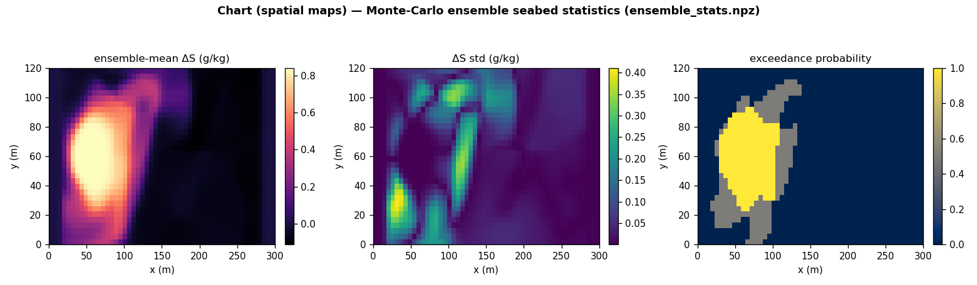
Figure G (chart/spatial maps). Monte-Carlo ensemble seabed statistics: mean excess, standard deviation and exceedance probability — 2-D fields require spatial maps.

5. Solver figure suite
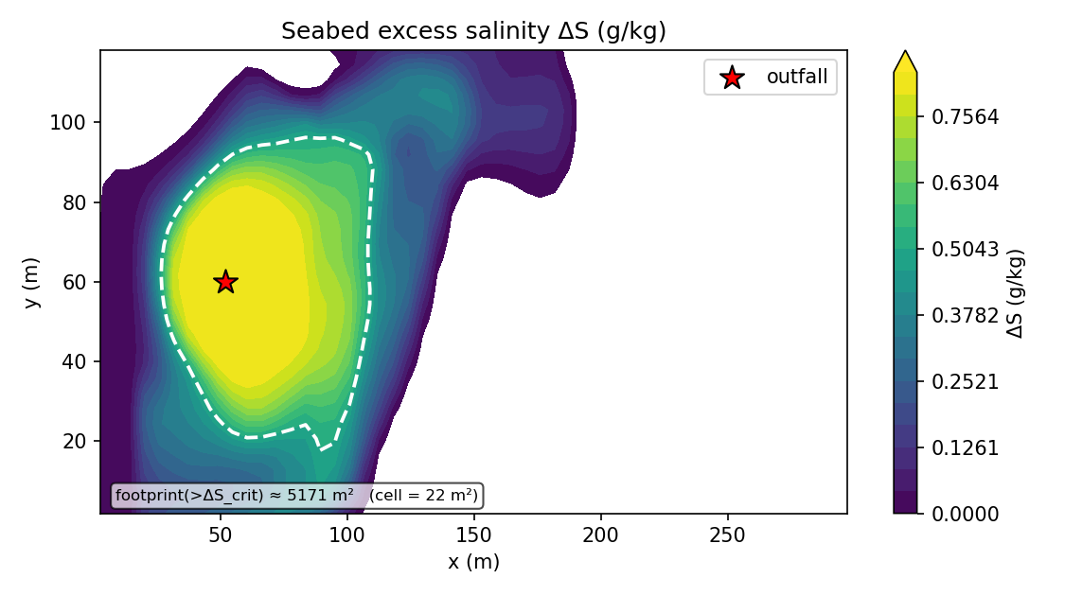
Figure H. Seabed excess-salinity map (plan view).
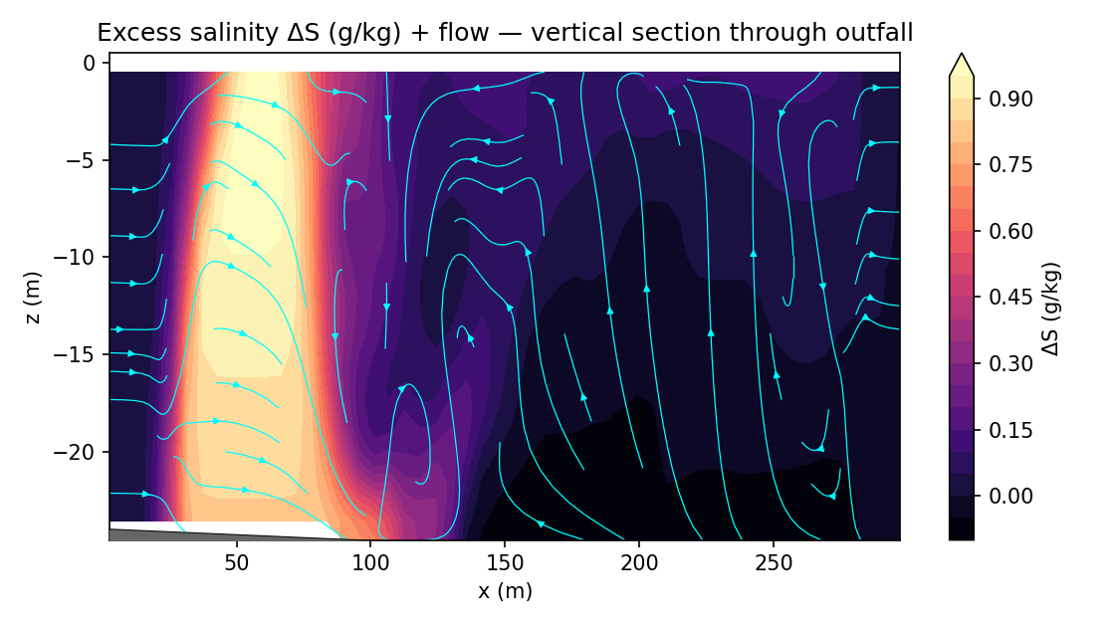
Figure I. Vertical section of excess salinity along the plume.
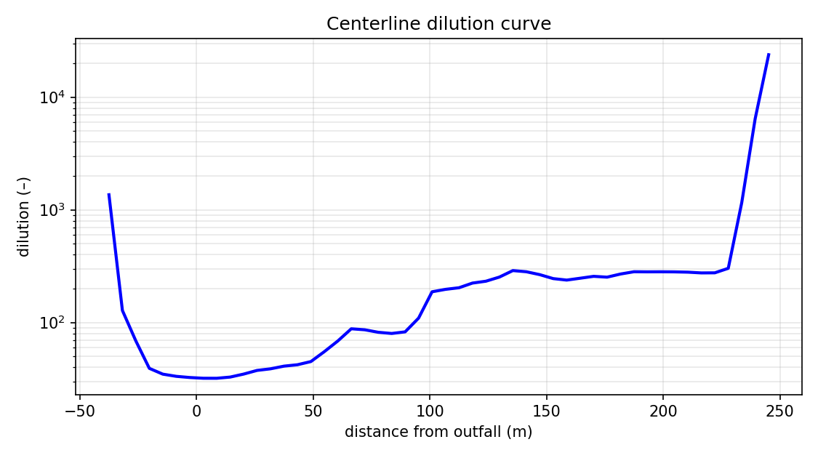
Figure J. Centreline dilution (solver).
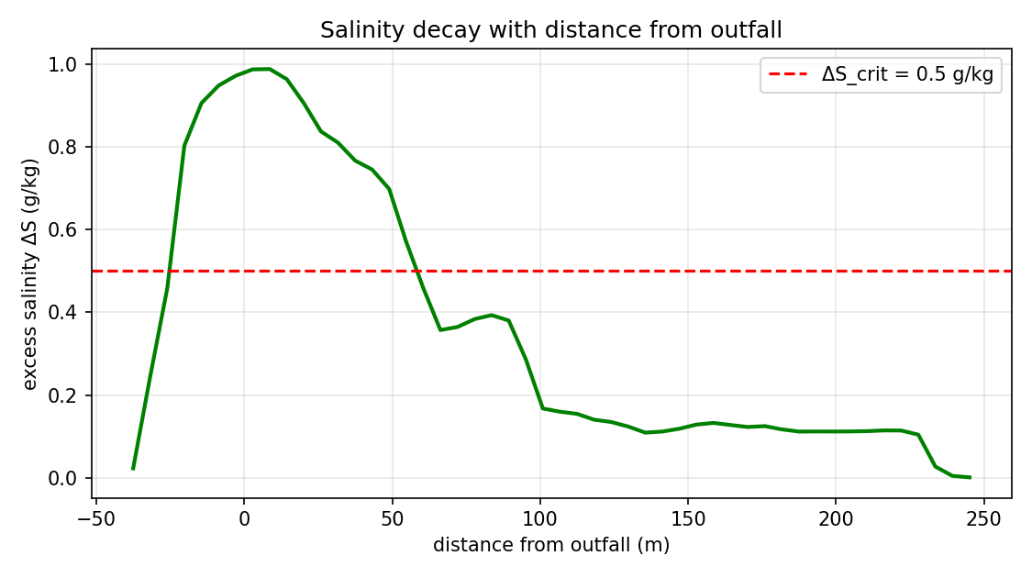
Figure K. Excess-salinity decay with distance (solver).
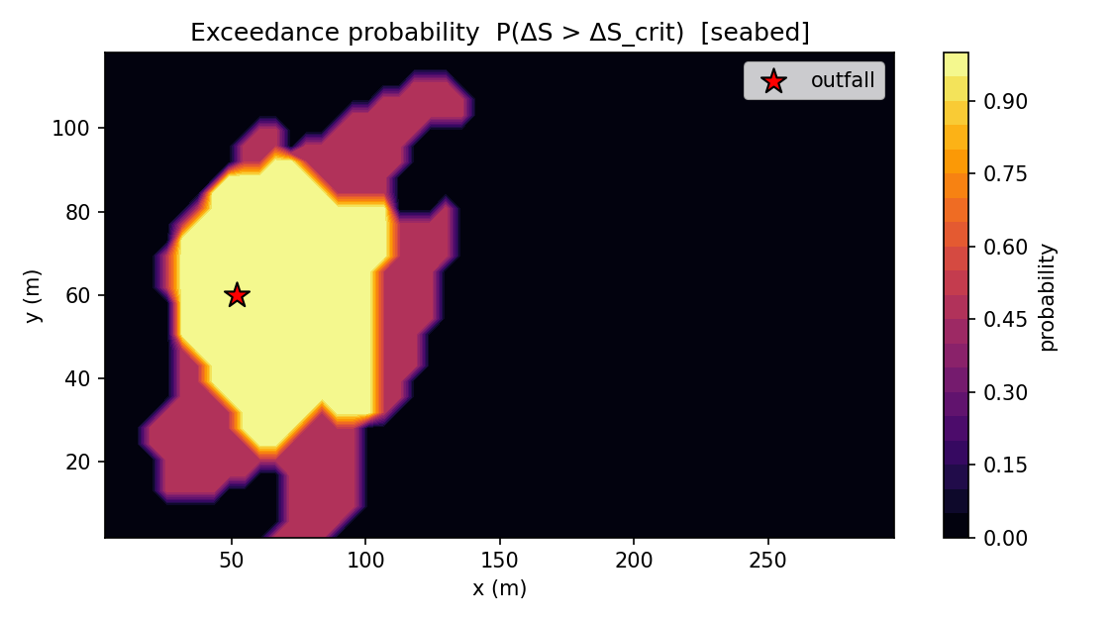
Figure L. Exceedance-probability map (ensemble).
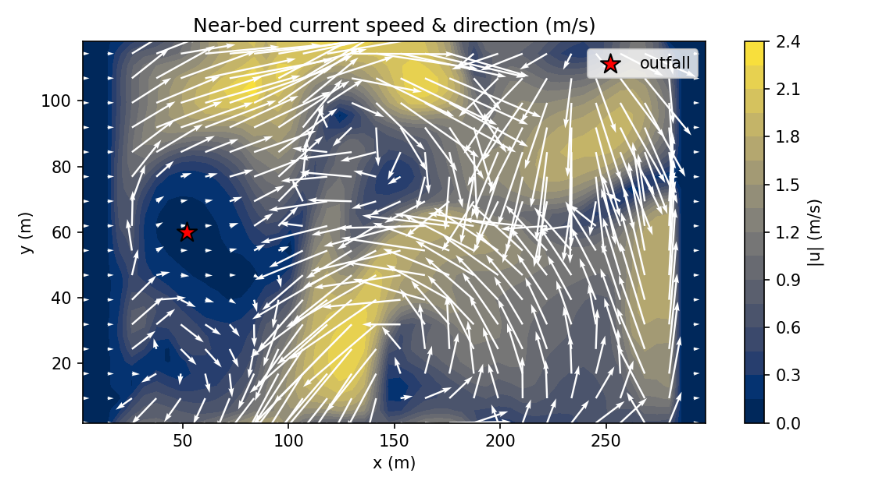
Figure M. Near-bed current field.
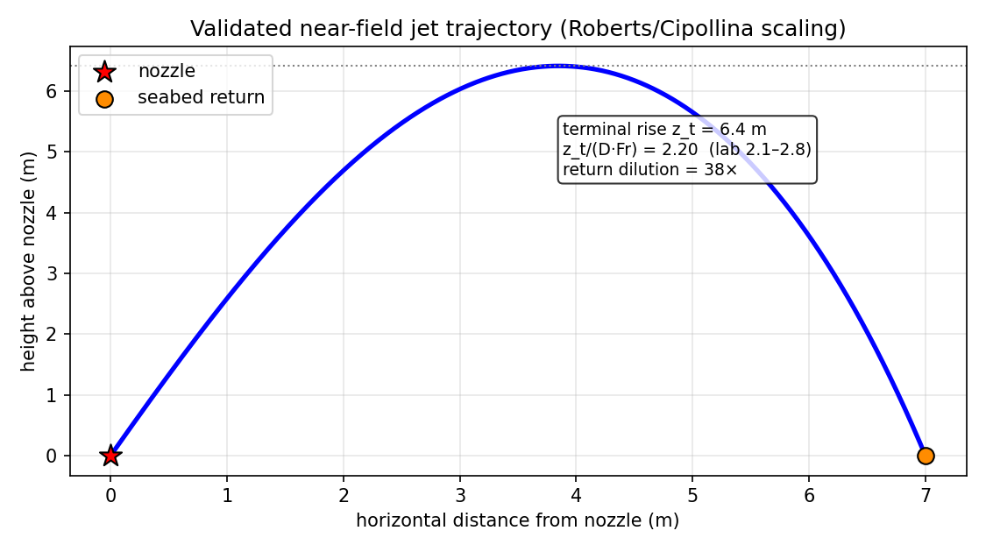
Figure N. Near-field dense-jet trajectory.

6. Output data tables
6.1 Centreline curve (curve_centerline.csv)
distance_m | excess_gkg | dilution | core_depth_m
-37.578 | 0.023 | 1361.139 | 23.558
-26.039 | 0.459 | 68.500 | 22.596
-14.501 | 0.905 | 34.796 | 12.981
-2.962 | 0.971 | 32.490 | 6.250
8.576 | 0.987 | 31.984 | 3.365
20.115 | 0.905 | 34.833 | 10.096
31.653 | 0.810 | 38.803 | 23.558
43.192 | 0.745 | 42.174 | 24.519
54.730 | 0.570 | 55.139 | 24.519
66.269 | 0.357 | 87.932 | 24.519
77.807 | 0.384 | 81.882 | 24.519
89.346 | 0.380 | 82.608 | 24.519
100.884 | 0.168 | 187.299 | 24.519
112.422 | 0.155 | 203.435 | 13.942
123.961 | 0.135 | 232.509 | 23.558
135.499 | 0.109 | 288.879 | 0.481
147.038 | 0.119 | 265.870 | 0.481
158.576 | 0.133 | 237.914 | 0.481
170.115 | 0.123 | 256.872 | 0.481
181.653 | 0.117 | 269.329 | 0.481
193.192 | 0.112 | 281.556 | 0.481
204.730 | 0.112 | 281.383 | 0.481
216.269 | 0.115 | 275.421 | 0.481
227.807 | 0.104 | 302.556 | 0.481
239.346 | 0.005 | 6448.069 | 0.481

6.2 Vertical profile (curve_vertical_profile.csv)
depth_m | salinity_gkg | excess_gkg | density | Tdeg
23.558 | 36.429 | 0.840 | 1026.376 | 18.106
22.596 | 36.429 | 0.848 | 1026.376 | 18.106
21.635 | 36.429 | 0.856 | 1026.376 | 18.106
20.673 | 36.429 | 0.864 | 1026.376 | 18.106
19.712 | 36.429 | 0.871 | 1026.376 | 18.106
18.750 | 36.429 | 0.879 | 1026.376 | 18.106
17.788 | 36.429 | 0.887 | 1026.376 | 18.106
16.827 | 36.429 | 0.894 | 1026.376 | 18.106
15.865 | 36.429 | 0.902 | 1026.376 | 18.106
14.904 | 36.429 | 0.910 | 1026.376 | 18.106
13.942 | 36.429 | 0.917 | 1026.376 | 18.106
12.981 | 36.429 | 0.925 | 1026.376 | 18.106
12.019 | 36.429 | 0.933 | 1026.376 | 18.106
11.058 | 36.429 | 0.940 | 1026.376 | 18.106
10.096 | 36.429 | 0.948 | 1026.376 | 18.106
9.135 | 36.429 | 0.956 | 1026.376 | 18.106
8.173 | 36.429 | 0.963 | 1026.376 | 18.106
7.212 | 36.428 | 0.971 | 1026.376 | 18.106
6.250 | 36.427 | 0.977 | 1026.375 | 18.106
5.288 | 36.424 | 0.982 | 1026.375 | 18.106
4.327 | 36.418 | 0.984 | 1026.372 | 18.108
3.365 | 36.407 | 0.980 | 1026.364 | 18.119
2.404 | 36.389 | 0.969 | 1026.343 | 18.150
1.442 | 36.365 | 0.953 | 1026.312 | 18.203
0.481 | 36.344 | 0.940 | 1026.285 | 18.250

6.3 Time series (metrics_timeseries.csv)
t_s | dt_s | S_max | excess_max | r_max_m | z_deepest_m | seabed_footprint_m2 | dilution_min | max_divergence
0.100 | 0.084 | 35.776 | 0.188 | 0.000 | 0.000 | 0.000 | 166.759 | 2.69e-15
20.100 | 0.084 | 36.429 | 0.982 | 26.488 | 23.558 | 2076.920 | 32.153 | 1.20e-16
40.100 | 0.084 | 36.429 | 0.997 | 30.899 | 23.558 | 2661.060 | 31.654 | 1.62e-16
60.100 | 0.084 | 36.429 | 1.003 | 38.223 | 23.558 | 3548.080 | 31.475 | 1.56e-16
80.100 | 0.084 | 36.429 | 1.012 | 47.656 | 23.558 | 4088.940 | 31.205 | 1.63e-16
100.100 | 0.084 | 36.429 | 1.016 | 57.098 | 24.519 | 5040.870 | 31.109 | 1.67e-16
120.100 | 0.084 | 36.429 | 1.011 | 63.740 | 24.519 | 5949.520 | 31.241 | 2.78e-16
140.100 | 0.084 | 36.429 | 1.004 | 70.428 | 24.519 | 6620.190 | 31.480 | 4.10e-16
160.100 | 0.084 | 36.429 | 0.998 | 78.886 | 24.519 | 7052.880 | 31.668 | 4.36e-16
180.100 | 0.084 | 36.429 | 0.997 | 88.047 | 24.519 | 6793.270 | 31.677 | 5.67e-16
200.100 | 0.084 | 36.429 | 0.999 | 95.824 | 24.519 | 6100.960 | 31.637 | 7.29e-16

7. Full metric set (metrics_summary.json)
metric | value | metric | value
S_max | 36.429 | excess_max | 0.987
dilution_min | 31.984 | footprint_resolution_m2 | 21.635
reach_resolution_m | 5.769 | depth_resolution_m | 0.962
r_max_m | 64.798 | z_deepest_m | 24.519
plume_top_m | 0.481 | seabed_footprint_m2 | 5127.498
affected_volume_m3 | 55085.059 | plume_rise_m | 22.831
return_point_dist_m | 63.336 | seabed_footprint_m2_cellcount | 5170.673
r_max_m_cellcount | 63.336 | Fr_d | 24.308
n_ensemble | 2.000 | max_exceedance_prob | 1.000
nf_rise_m | 6.417 | nf_rise_ratio | 2.200
nf_return_dist_m | 7.001 | nf_return_dilution | 37.879
nf_merge_factor | 0.974 | nf_n_ports | 72.000
near_field_coupling | True | divergence_final | 7.29e-16
divergence_max_over_run | 2.69e-15 | divergence_drift_ratio | 0.271
nut_cap_fraction | 0.000 | k_cap_fraction | 0.000
mass_imbalance_final | 1.47e-16 | eta_min_m | 0.000
eta_max_m | 0.000 | eta_absmax_m | 0.000
exceedance_is_probability | True | S_std_max | 0.411
excess_p95_max | 0.997 | ensemble_meanmax_drift | 0.000
vprofile_x_m | 54.808 | vprofile_y_m | 58.125

8. Input deck (sydney_case_input.json)
parameter | value | parameter | value
S0 | 67.000 | T_b | 22.000
Q_d | 0.045 | d_p | 0.120
theta_deg | 60.000 | n_ports | 72.000
port_spacing | 5.000 | S_amb_surf | 35.400
S_amb_bot | 35.600 | T_amb_surf | 21.000
T_amb_bot | 18.000 | U_current | 0.120
tide_amp | 0.040 | Hs | 1.500
Tw | 8.000 | wind10 | 7.000
latitude_deg | -34.000 | depth | 25.000
Lx | 300.000 | Ly | 120.000
nx | 52.000 | ny | 32.000
nz | 26.000 | t_end | 200.000
ensemble | 2.000 | dS_crit | 0.500
near_field_coupling | 1.000 | free_surface | 0.000
stoch_enable | 1.000

All artifacts (CSVs, line-graph plots plot_*.png, derived graphs, charts, solver figures fig_*.png, metrics_summary.json, fields_final.npz, ensemble_stats.npz, run.log, input deck) reside in folder 6/. Companion documents: 6/case_study.docx (engineering interpretation), 6/model.docx (governing PDEs).

