MARINE OUTFALL DRAWING SET
Sydney Desalination Plant (Kurnell, NSW) — Offshore Submerged Multiport Brine Diffuser
Tasman-Shelf Outfall · Derived from the NEREID-B Coupled Stochastic-PDE Brine-Dispersion Simulation
A.S. Onyejekwe — Environmental Fluid Mechanics & Computational Modelling
Issued for Design · Rev 0 · 2026-06-18

Drawing Register
Drawing No. | Title | Scale (A3)
SDP-MO-001 | Marine Outfall — General Layout (schematic long-section) | NTS
SDP-MO-002 | Outfall Pipeline Layout — plan & longitudinal profile | As shown
SDP-MO-003 | Outfall Diffuser — general details (plan, section, nozzle) | As shown
SDP-MO-004 | Brine Dispersion Diagram — environmental assessment | As shown
SDP-MO-005 | Marine Outfall — General Arrangement (GA) | As shown

Design Basis & Notes
- Source: dimensions and predicted dispersion metrics are taken from the project report (6/report.docx) and the NEREID-B simulation outputs (6/metrics_summary.json, 6/sydney_case_input.json) for the Sydney Desalination Plant offshore diffuser.
- Discharge: SWRO product 250 ML/d (expandable to 500 ML/d), recovery ≈47%; concentrate ≈3.26 m³/s at S₀=67 g/kg and 22 °C into a 35.4–35.6 g/kg ambient.
- Diffuser: 72 circular ports of 120 mm diameter at 5.0 m centres (deployed length ≈355 m), nozzle invert 1.0 m above seabed at 60° elevation, per-port flow 0.0453 m³/s, exit velocity ≈4.01 m/s, densimetric Froude number ≈24.3, in 25 m water.
- Predicted performance: near-field return dilution ≈38:1, terminal rise 6.4 m, peak excess ΔS_max 0.99 g/kg, horizontal reach (ΔS>0.5 g/kg) ≈65 m, seabed footprint ≈5127 m², affected volume ≈55085 m³.
- Status: the per-port nozzle geometry is a representative deep-diffuser configuration consistent with the public design basis (60° inclined dense jet); figures are indicative and conservative. NOT FOR CONSTRUCTION — a site CTD/ADCP survey is required to calibrate absolute values.
- Convention: levels in metres relative to Mean Sea Level (RL 0.000); dimensions in metres unless noted otherwise; drawings sized for ISO A3.
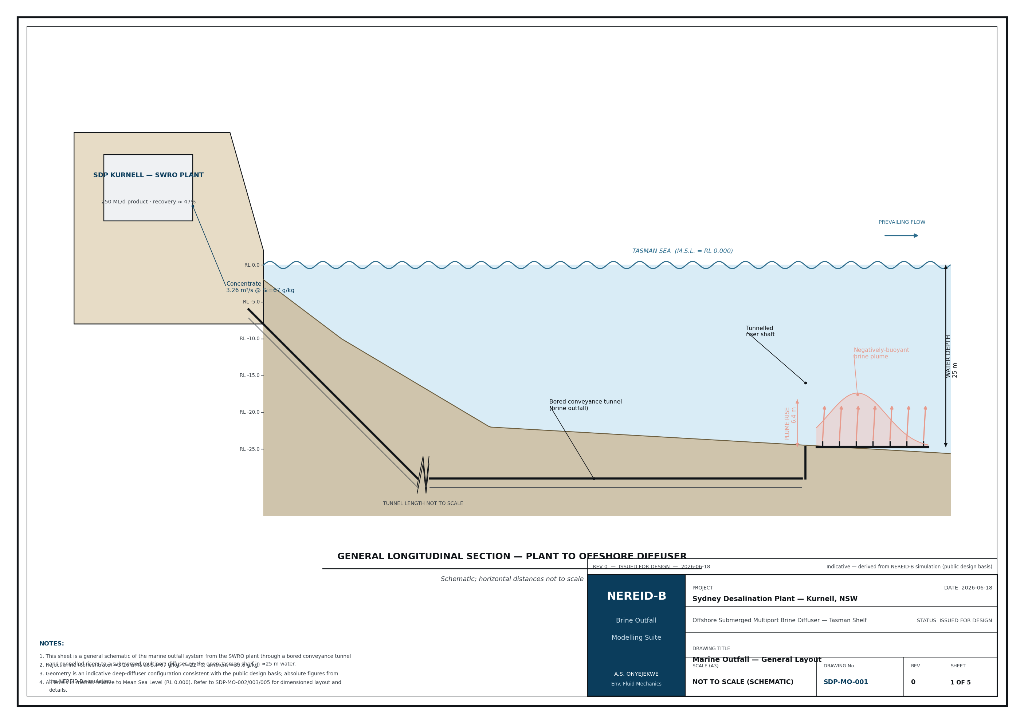
Drawing SDP-MO-001 — Marine Outfall General Layout.
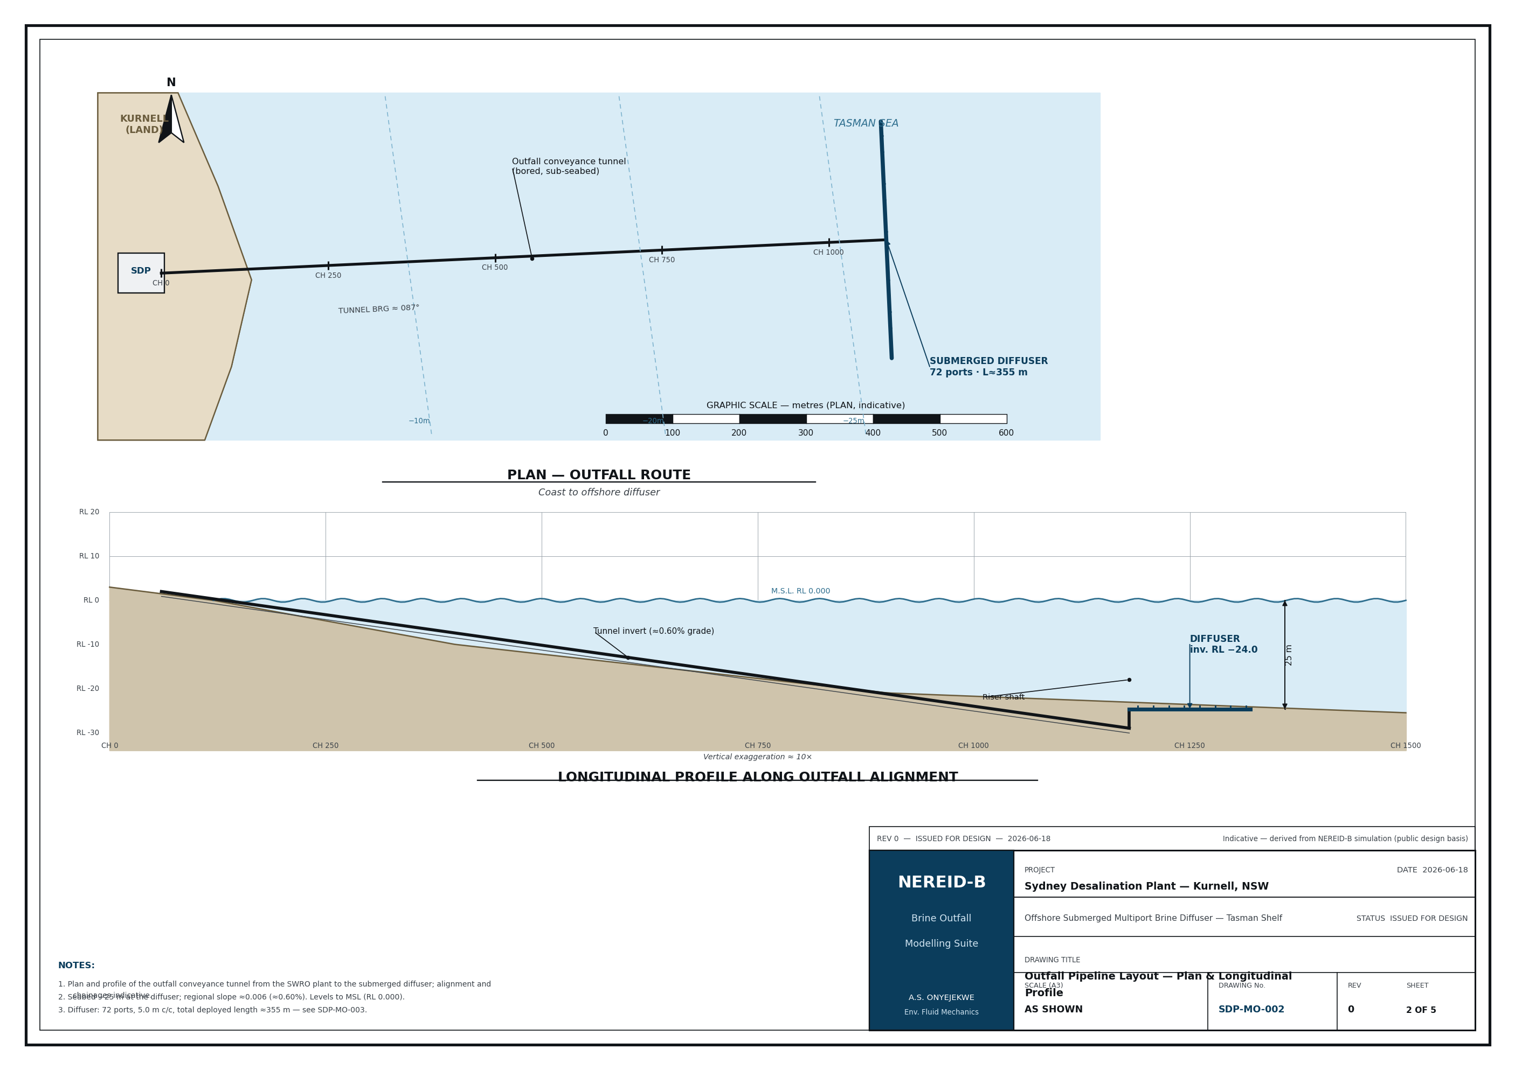
Drawing SDP-MO-002 — Outfall Pipeline Layout (plan and longitudinal profile).
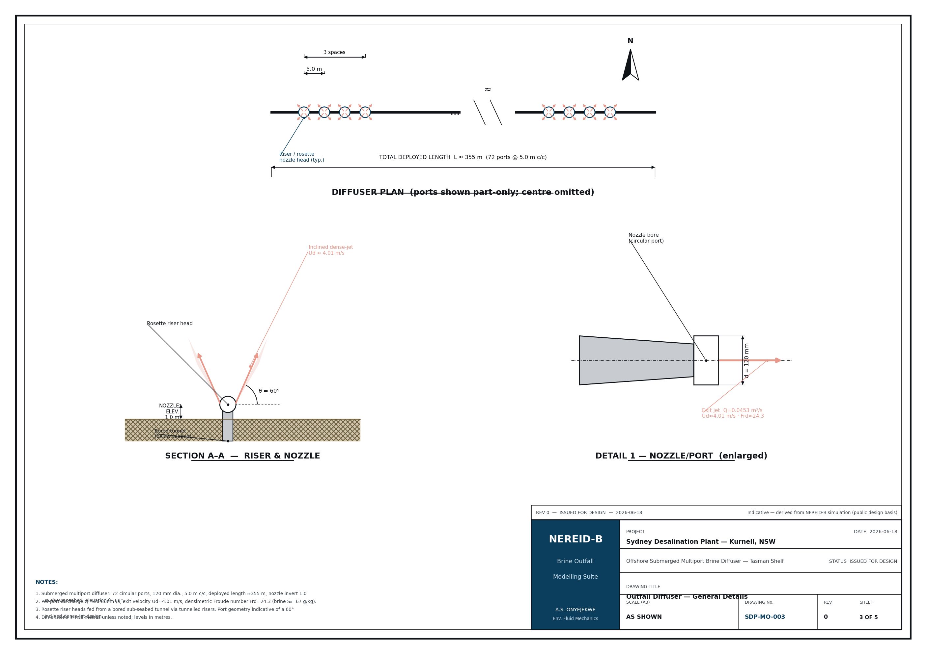
Drawing SDP-MO-003 — Outfall Diffuser General Details.
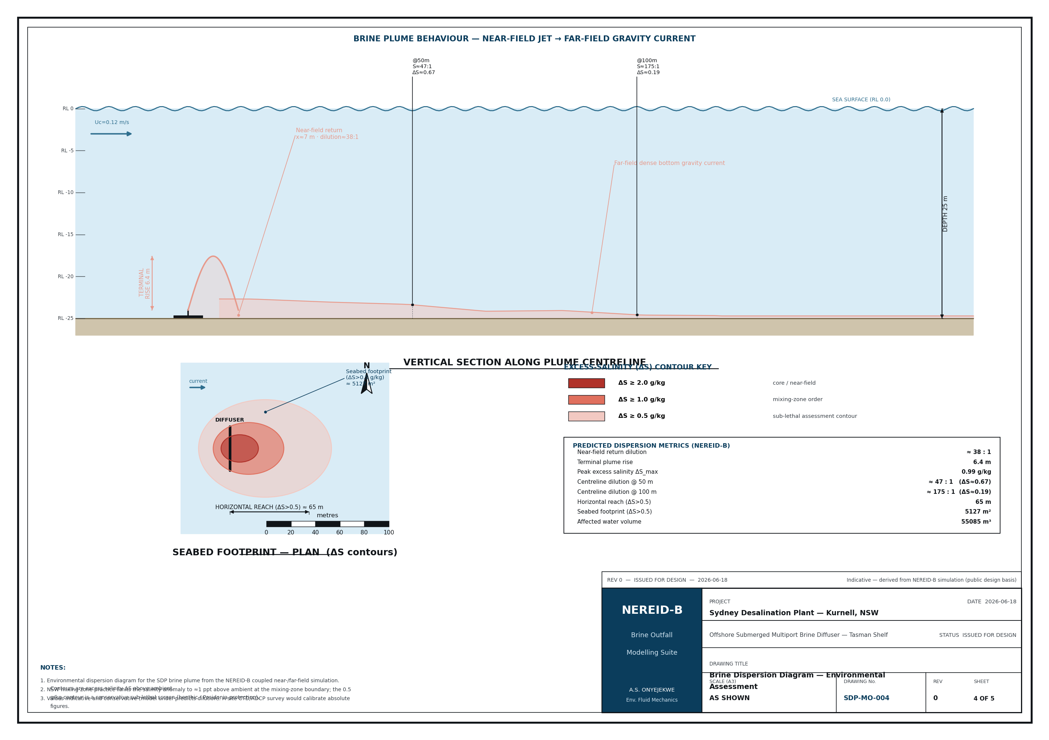
Drawing SDP-MO-004 — Brine Dispersion Diagram (environmental assessment).
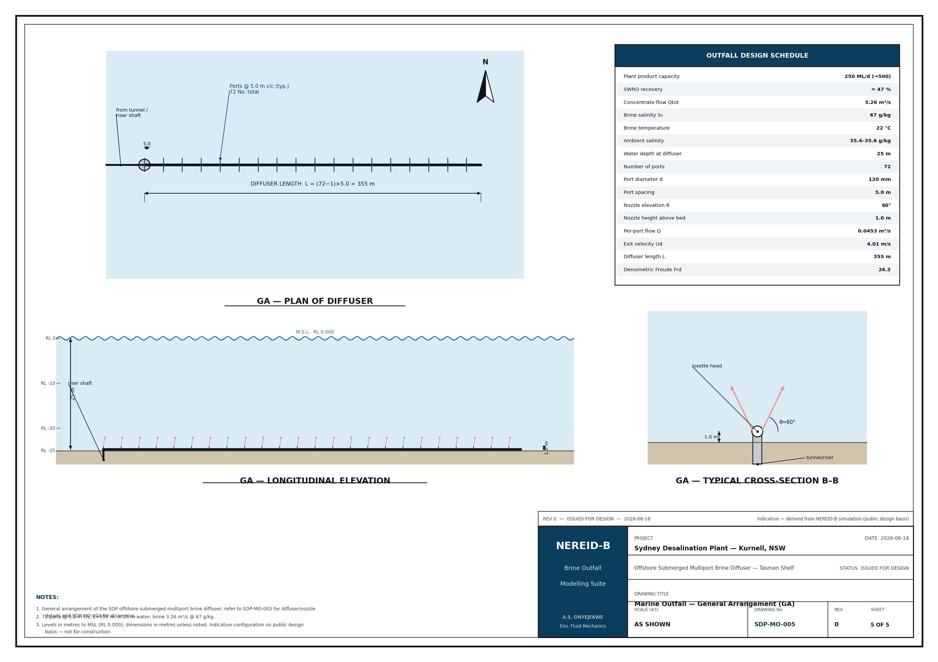
Drawing SDP-MO-005 — Marine Outfall General Arrangement.

