Snapchat Prototype Project Presentation (SNAPCLONE)

App Overview
My app is a prototype of Snapchat, SnapClone. It allows users to send temporary photos/videos (snaps), view stories that disappear after 24 hours, chat with friends, and add/manage contacts.

Snapchat
Launched in 2011, Snapchat revolutionized social media by introducing ephemerality (content that disappears).
Unlike Facebook or Instagram, which were designed to be permanent “galleries,” Snapchat was designed to mimic real-life conversation where what you say or show is temporary.
Cloning Snapchat is a great project because it requires handling:
Media Handling. Real-time Interaction.
.Automated Expiration: Logic that deletes data (Stories) after exactly 24 hours.

Core Features
- User Authentication (Sign up / Login)
- Send Snaps (image upload + view once)
- Stories (24-hour posts)
- Chat system (basic messages)
- Friend system (add/remove users)

Database Schema

1. Users Table
- user_id (PK)
- username
- email
- password
- created_at

2. Friends Table
- friendship_id (PK)
- requester_id
- receiver_id
- status
- created_at

3. Snaps Table
- snap_id (PK)
- sender_id (FK → Users.user_id)
- receiver_id (FK → Users.user_id)
- media_url
- is_viewed
- sent_at

4. Stories Table
- story_id (PK)
- user_id (FK → Users.user_id)
- media_url
- created_at
- expires_at

5. Messages Table
- messages_id (PK)
- sender_id (FK → Users.user_id)
- receiver_id (FK → Users.user_id)
- content
- created_at

Schema Relationships
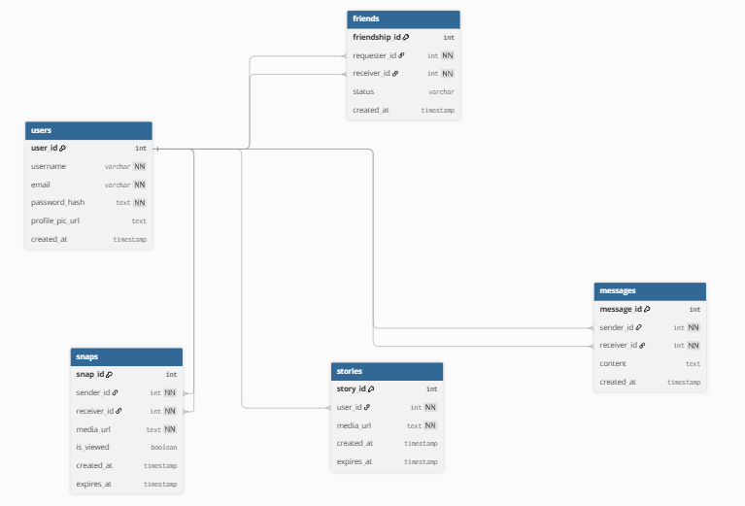

Tech Stack
Frontend - (HTML, CSS, Javascript)
Backend - (Node.js, Express)
Database - (PostgreSql)

9. Conclusion
This prototype demonstrates the core idea of Snapchat with proper database design and system structure.

