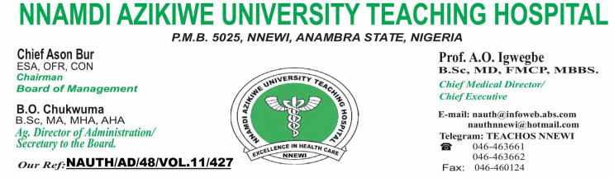

***Your Ref: ________________________*  Date: 08/07/2021 .**

\**TO WHOM IT MAY CONCERN**

# **MEDICAL CERTIFICATE OF FITNESS**

# **RE: EJIRE STELLA NJUJIMA/FEMALE/27 YEARS**

**The above named patient of our hospital has been properly examined.**

**She is not known to be suffering from any chronic illness.**

**Investigation findings are as follows:**

**Hepatitis -Negative**

**HIV 1&11 screening -Negative**

**Cerebrospinal menigitis -Nil**

**Malaria parasite -Negative**

**Blood group -O+Ve**

**Genotype -AS**

**Eye -Myopia**

**PCV -42.7%**

**Hearing -Clear**

**Chest x-ray -Normal study**

**Urinalysis -Normal**

**I hereby certify the above patient to be medically fit for NYSC.**

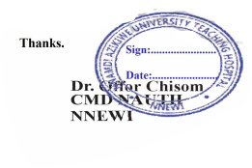

**Thanks**