DOCUMENTATION

INTRODUCTION

This project was implemented within the study of the subject **“Advanced programming methods”** which focuses on the analysis of the **Java** programming language.

I chose project number **A.20** which requires the implementation of the **“Towers of Hanoi”** game using **Java** (and other additional tools).

1. MOTIVATION

I chose this project because I already implement this game in **C++,** using the **SFML** library, and I wanted to make a more complex, clean version that would highlight my progress as a programmer.

Here is a video of the old project: [Towers of Hanoi - with C++ and SFML](https://www.youtube.com/watch?v=ZXsqru5iJmU). This project does not implement the logging system using a database and focuses strictly on the game, it is much more simplistic.

The new project uses animations, execution threads and also implements the logging system. In addition, the automatic mode in which the computer solves the game is also implemented.

1. THE THEMATIC CONTEXT OF THE PROBLEM

As I said, this project was implemented within the study of the subject **“Advanced Programming Methods”.** The project was assigned to students, to show their gained knowledge related to the Java programming language. It was mandatory to use a database and connect it to the graphical interface, and my project also required the use of execution threads for windows and animations.

PROBLEM DESCRIPTION

1. THE TASK

My project requirement is as follows:

Write a Java application that visualizes the Towers of Hanoi problem in a suggestive way.

The application should run in two modes: manual mode – in which the user moves the discs on the rods; and in automatic mode – where the computer solves the problem.

* Put the algorithm in automatic mode in a thread so as not to block the interface.
* Provide for manual/automatic mode a counter that measures the time required to the user to resolve the issue.
* Implement the possibility of abandonment.
* Allow specifying the number of disks.
* Insist on the graphic representation, to be as suggestive as possible. Set the working speed in the automatic mode appropriate to human perception. Let every movement made be easily noticeable. Show the disc moved and the path taken during the movement. Use motion animation with execution threads.

1. “TOWERS OF HANOI” GAME

But what is the game “Towers of Hanoi” actually about?

The Tower of Hanoi (also called The problem of Benares Temple or Tower of Brahma or Lucas' Tower and sometimes pluralized as Towers, or simply pyramid puzzle) is a mathematical game or puzzle consisting of three rods and a number of disks of various diameters, which can slide onto any rod. The puzzle begins with the disks stacked on one rod in order of decreasing size, the smallest at the top, thus approximating a conical shape. The objective of the puzzle is to move the entire stack to the last rod, obeying the following rules:

* Only one disk may be moved at a time.
* Each move consists of taking the upper disk from one of the stacks and placing it on top of another stack or on an empty rod.
* No disk may be placed on top of a disk that is smaller than it.

With **3** disks, the puzzle can be solved in **7** moves. The minimal number of moves required to solve a Tower of Hanoi puzzle is , where **n** is the number of disks.

The puzzle can be played with any number of disks, although many toy versions have around 7 to 9 of them. The minimal number of moves required to solve a Tower of Hanoi puzzle is , where **n** is the number of disks.

With **3** disks, the puzzle can be solved in moves.

MY SOLUTION

1. THE MAIN CONCEPTS

The application consists of a graphic interface and a database that are connected.

I chose to develope the game in the **Intellij IDE** using **JavaFX** and **Maven**. The code used for the ghrafic interface respects the [**MVC**](https://en.wikipedia.org/wiki/Model–view–controller) design pattern. Every stage consists of a **JavaFX** class, controller class and a **.fxml** file where the design is done. In some cases I also used **CSS** for styling.

The application has a menu window on which the user selects what he wants to do by clicking one of the following buttons:

* **Play** – play the game (manual game)
* **Tutorial** – see computer’s solution (automatic game)
* **Options** (change game information)
* **Statistics** – see statistics about the best performers
* **Settings** – change account settings
* **Quit** – close the application

The application has a basic sign up/login system implemented in a class dedicated for this task. All the data is managed using a relational database called: **towers-of-Hanoi**.

The application is connected to my database which was constructed in **MySQL** using the **Java JDBC API** and the **MySQL Connector/J** driver.

All coding operations were done under the „supervision” of a version control system: **git**. My open source repository can be found on my **GitHub** profile: [towers-of-Hanoi](https://github.com/samuelburaga/towers-of-Hanoi).

1. TOOLS USED











THE PROJECT

1. THE APPLICATION

I have a video demo that presents the whole application posted on YouTube (Unlisted mode): This link is also found in the **README.md** file from my GitHub repository.

1. THE ARCHITECTURE
2. THE GRAPHICAL INTERFACE

JavaFX applications are designed to respect the **MVC** architecture.

1. THE DATABASE

The database respects the **3FN** conditions.

What is 3FN? Third normal form (3NF) is a database schema design approach for relational databases which uses normalizing principles to reduce the duplication of data, avoid data anomalies, ensure referential integrity, and simplify data management. It was defined in 1971 by Edgar F. Codd, an English computer scientist who invented the relational model for database management.

A database relation (e.g. a database table) is said to meet third normal form standards if all the attributes (e.g. database columns) are functionally dependent on solely the primary key. Codd defined this as a relation in second normal form where all non-prime attributes depend only on the candidate keys and do not have a transitive dependency on another key.

My database has 2 tables that meet the requirements:

* They both have a primary key
* The table columns are functionally dependent on solely the primary key.

1. STRUCTURE

The local git repository looks like this:

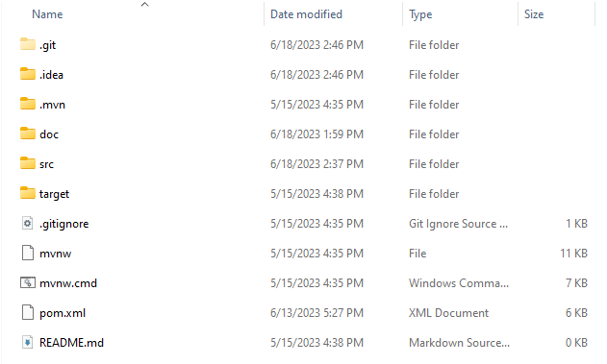

* **.git** directory contains all information required for version control
* **.idea** directory contains a set of configuration files (**.xml**) for the project.
* **.mvn** is a directory where you can put some **Maven** configuration files
* **doc** directory contains the documentation of the project in **.docx** and **.pdf** format
* **src** directory is the most complex and is the root directory for both application code. The application source code goes into **src/main/java**. Any resource files (e.g. property files) needed by the application goes into the **src/main/resources** directories. Apart from the .fxml files, I only have one **.css** file, one image for the background and one **.wav** file for the background music. I also added at the root level of the directory a subfolder called database where I have the files used to create the database and some query files (**.sql**).
* **target** directory contains all the final products that are the result of Maven building the project. The target directory also contain any temporary and intermediate files needed by Maven when building the application.
* **.gitignore** file specifies intentionally untracked files that Git should ignore.
* **mvnw** **file & mvn.cmd** files are known as maven wrappers. These files let users run maven builds without installing a maven distribution in your machine. These files allow the users to have a fully encapsulated build system.
* **pom.xml** is the Maven POM file (Project Object Model). It is an XML file that contains information about the project and configuration details used by Maven to build the project.
* **README.md** file is a Markdown file that describes the git repository. GitHub and Gitiles renders it when you browse the repository**.**

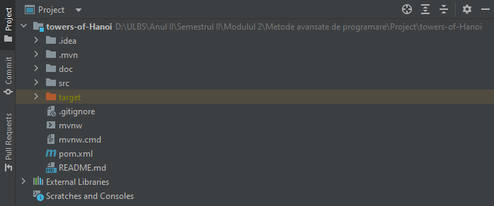This structure can also be seen in Intellij:

1. DATA MANAGEMENT

All the necessary data is stored in the **“towers-of-Hanoi”** database which contains **2** tables: **“users”** and **“statistics”**. The generating script for this 2 tables was also generated by an **entity relationship diagram** created in **MySQL** workbench using forward engineering. All the files used can be found in the “src/database” directory.

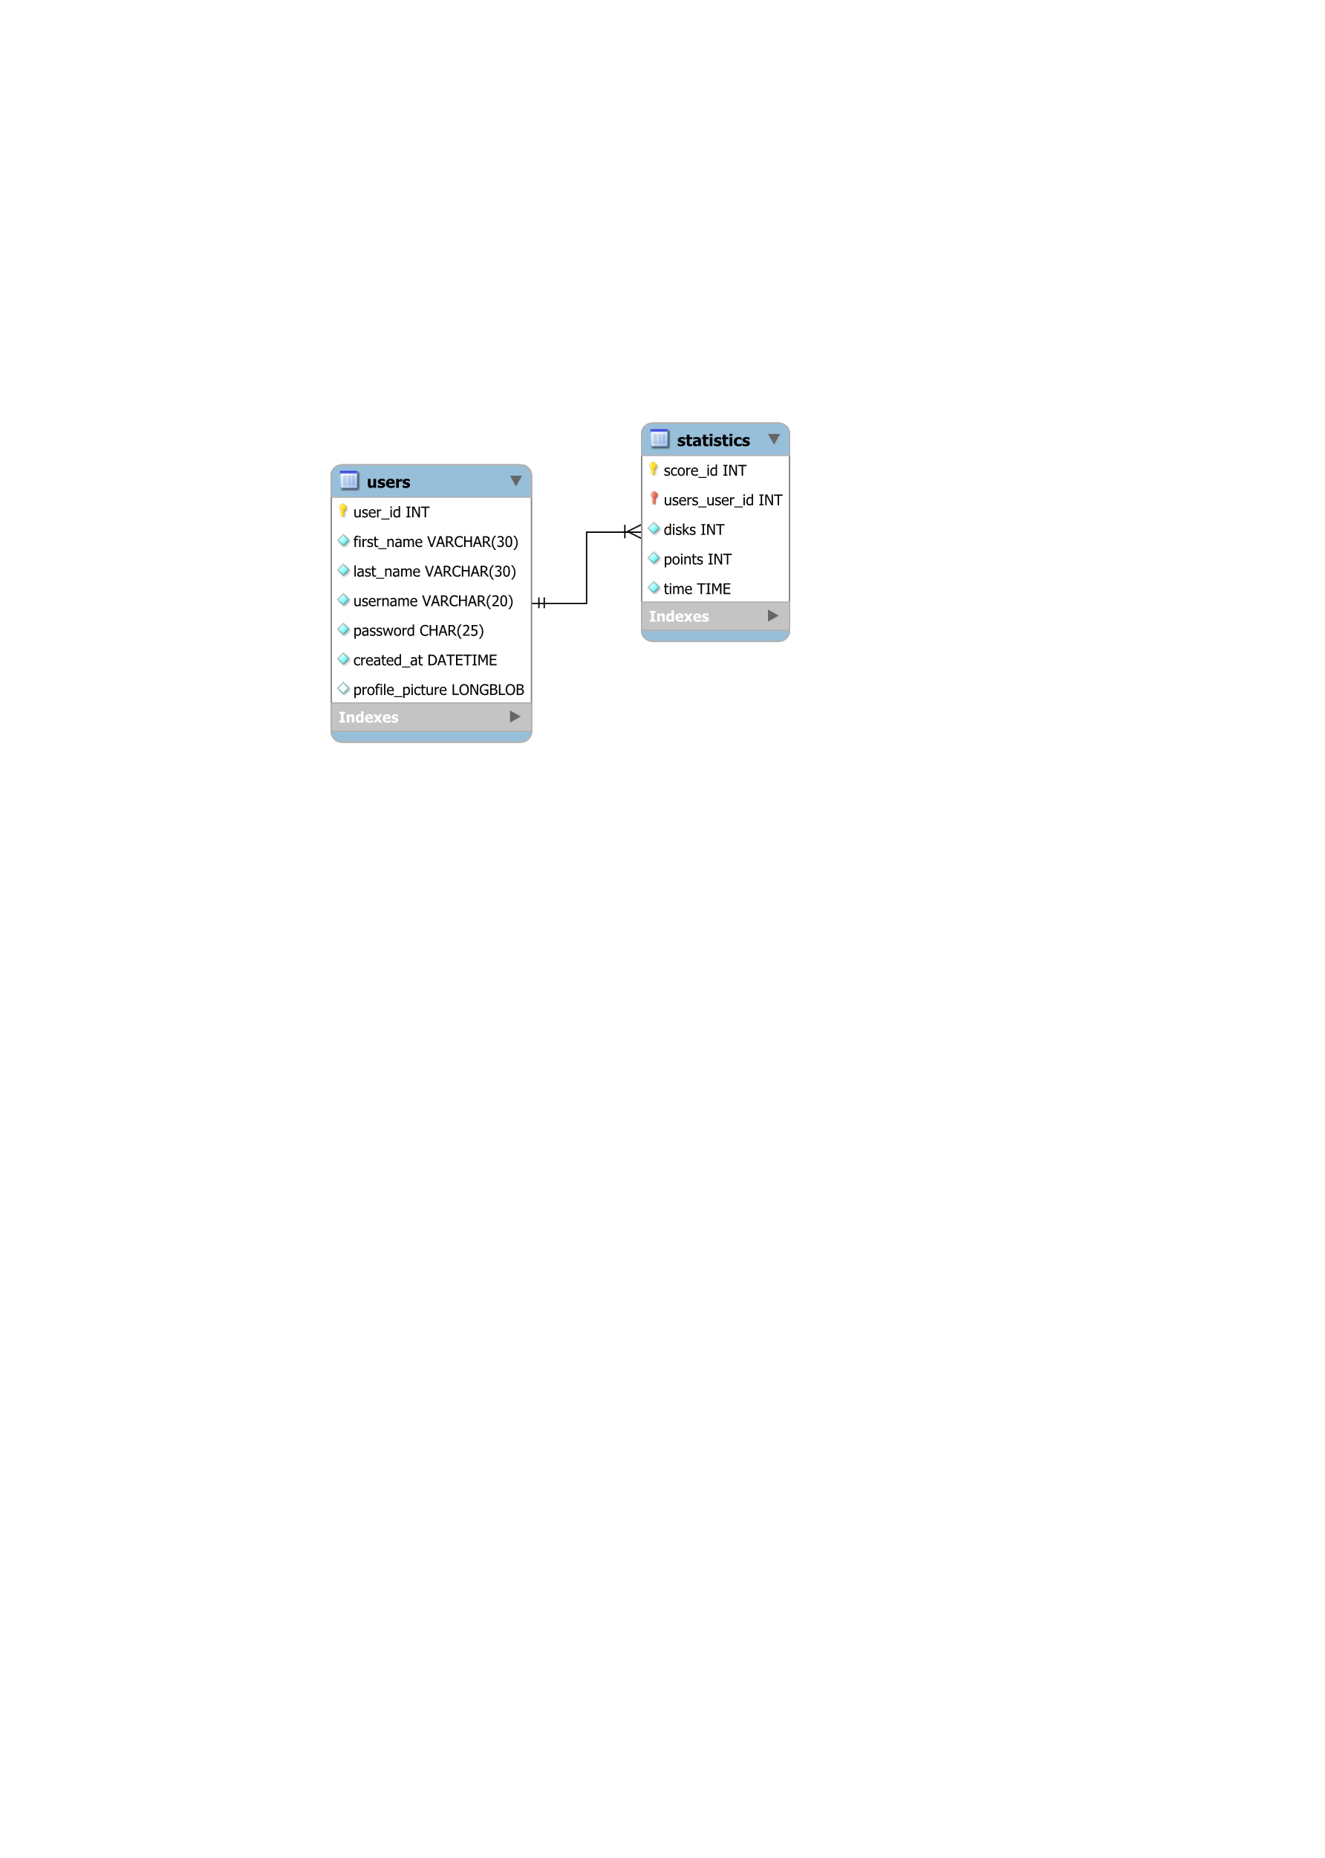Here is the ERD:

The tables are connected by a one-to-many relationship. The **“users”** table contains the primary key and the **“statistics”** table contains the foreign key.

And here is the generating script:

*-- MySQL Workbench Forward Engineering*

SET @OLD_UNIQUE_CHECKS=@@UNIQUE_CHECKS, UNIQUE_CHECKS=0;

SET @OLD_FOREIGN_KEY_CHECKS=@@FOREIGN_KEY_CHECKS, FOREIGN_KEY_CHECKS=0;

SET @OLD_SQL_MODE=@@SQL_MODE, SQL_MODE='ONLY_FULL_GROUP_BY,STRICT_TRANS_TABLES,NO_ZERO_IN_DATE,NO_ZERO_DATE,ERROR_FOR_DIVISION_BY_ZERO,NO_ENGINE_SUBSTITUTION';

*-- -----------------------------------------------------*

*-- Schema towers-of-Hanoi*

*-- -----------------------------------------------------*

*-- This database contains tables used to store user data and other information related to the classic game "Towers of Hanoi" made by myself using JavaFX. The database will be connected to Java using the MySQL Connector/J driver.*

*-- -----------------------------------------------------*

*-- Schema towers-of-Hanoi*

*--*

*-- This database contains tables used to store user data and other information related to the classic game "Towers of Hanoi" made by myself using JavaFX. The database will be connected to Java using the MySQL Connector/J driver.*

*-- -----------------------------------------------------*

CREATE SCHEMA IF NOT EXISTS `towers-of-Hanoi` DEFAULT CHARACTER SET utf8 COLLATE utf8_bin ;

USE `towers-of-Hanoi` ;

*-- -----------------------------------------------------*

*-- Table `towers-of-Hanoi`.`users`*

*-- -----------------------------------------------------*

CREATE TABLE IF NOT EXISTS `towers-of-Hanoi`.`users` (

  `user_id` INT UNSIGNED NOT NULL AUTO_INCREMENT,

  `first_name` VARCHAR(30) NOT NULL,

  `last_name` VARCHAR(30) NOT NULL,

  `username` VARCHAR(20) NOT NULL,

  `password` CHAR(25) NOT NULL,

  `created_at` DATETIME NOT NULL COMMENT 'This table contains the basic columns used for the login process. The table could be updated so that the password is salted and hashed to assure security.',

  `profile_picture` LONGBLOB NULL,

  PRIMARY KEY (`user_id`),

  UNIQUE INDEX `user_id_UNIQUE` (`user_id` ASC) VISIBLE,

  UNIQUE INDEX `username_UNIQUE` (`username` ASC) VISIBLE,

  UNIQUE INDEX `password_UNIQUE` (`password` ASC) VISIBLE)

ENGINE = InnoDB;

*-- -----------------------------------------------------*

*-- Table `towers-of-Hanoi`.`statistics`*

*-- -----------------------------------------------------*

CREATE TABLE IF NOT EXISTS `towers-of-Hanoi`.`statistics` (

  `score_id` INT UNSIGNED NOT NULL AUTO_INCREMENT,

  `users_user_id` INT UNSIGNED NOT NULL,

  `disks` INT UNSIGNED NOT NULL COMMENT 'This table is used to store the user\'s game statistics.',

  `points` INT UNSIGNED NOT NULL,

  `time` TIME NOT NULL,

  PRIMARY KEY (`score_id`, `users_user_id`),

  UNIQUE INDEX `score_id_UNIQUE` (`score_id` ASC) VISIBLE,

  INDEX `fk_statistics_users_idx` (`users_user_id` ASC) VISIBLE,

  CONSTRAINT `fk_statistics_users`

    FOREIGN KEY (`users_user_id`)

    REFERENCES `towers-of-Hanoi`.`users` (`user_id`)

    ON DELETE NO ACTION

    ON UPDATE NO ACTION)

ENGINE = InnoDB;

SET SQL_MODE=@OLD_SQL_MODE;

SET FOREIGN_KEY_CHECKS=@OLD_FOREIGN_KEY_CHECKS;

SET UNIQUE_CHECKS=@OLD_UNIQUE_CHECKS;

The application is connected to my database which was constructed in **MySQL** using the **Java JDBC API** and the **MySQL Connector/J** driver.

1. DATA REPRESENTATION

CONCLUSIONS