**Student ID:** 610726

**Full Names:** SAMUEL BWAMBALE

Web Application Programming

(CS472)

(April 2020)

Instructor: O. Kalu

Final Exam

1. The exam duration is 2 hours.
2. The exam is an online, computer-based exam; so you may use a computer for both the Part 1 (theory) and Part 2 (coding) tasks.
3. **This exam paper document is a copyrighted material and so it must not be copied or reproduced or transferred or shared or distributed**.
4. You are expected to use an IDE or any Code Editor tool of your choice to implement your solutions for the questions in the Part 2 (Web Application Coding).
5. During the exam, if you have any question, please **send it to me through a Chat** in the Microsoft Teams app.
6. Upon completion, put your entire Exam (including the projects/folders with your **source code** and this document with your typed-in answers) into a single zip file named **FinalExam.zip**, and submit to Sakai, under the Assignment titled, “Final Exam”.
7. **NOTE**: ***If you fail to submit your exam to Sakai because it has past the Submission due time, and you then email it instead, then be aware that your maximum possible score will be 83%,and only if your work scores up to that level.***

--------------------------------------------------------------------------------------------------------------------

Make sure to include the screenshots of your results, where it is required.

--------------------------------------------------------------------------------------------------------------------

(CS472 –WAP)

(April 2020)

Final Exam (40 points)

**Part I – Theory (True/False, Short answers, Multiple-choice questions):** (16 points)

**Note:** *For these questions, please follow the instructions given for each individual question and do type or mark all your answers right here in this document.*

1. (6 points) Answer the following questions with True or False. For each answer, give a rationale (i.e. If True state how, if False state why. No rationale, earns you just half of the points if your True/False answer is correct, and zero point if your True/False answer is incorrect).
   1. (2 point) HTTP is stateless; Hence Web Applications need additional mechanisms and techniques for Maintaining State.

True or False? **(Note: You must mention an example in your rationale)**

TRUE

Rationale:

Basically, every request to the server is treated as a new request. Take an example of an online shopping application. To maintain state, the server should be able to associate every request with a particular user. This can be achieved scoping particular request or session to a single user.

* 1. (2 points) During execution of a web application that uses Java Servlet technology, a new instance of the Servlet class in created by the container, for every HttpRequest received.

True or False?

FASLE

Rationale:

The instance of Servlet class is created once and each time the server receives a request for a servlet, the server starts a new thread and calls service. The service() method checks the HTTP request type (GET, POST, PUT, DELETE, etc.) and calls doGet, doPost, doPut, doDelete, etc. methods as appropriate.

* 1. (2 points) In Java web application programming, the statements,

*RequestDispatcher reqDispatcher = request.getRequestDispatcher(“stuRegForm.jsp”);*

*reqDispatcher.forward(request, response);*

causes the web browser to resend a new HttpRequest to the web page named, stuRegForm.jsp.

True or False?

TRUE

Rationale:

When the servlet passes (“forward”) the request processing to a browser, the browser issues another HTTP request to a specified URL

1. (8 points) Give short answers (and citing examples where required) to the following questions.
   1. (2 points) What is the difference between a Web Server and a Web Container? Give an example for each.

Web Server provides HTTP Request and HTTP response. It handles request from client only through HTTP protocol. It contains Web Container. Web Application mostly deployed on web Server

Web Container maintains the life cycle for Servlet Object. Calls the service method for that servlet object. pass the HttpServletRequest and HttpServletResponse Object

Web Server: Apache Tomcat

Web Container: WildFly

* 1. (2 points) Given in the table below, is the data for Employees to be stored in an HRM web system.

|  |  |  |  |  |  |  |  |  |
| --- | --- | --- | --- | --- | --- | --- | --- | --- |
| **Employees** | | | | | | | | |
| EmpId | SSN | FullName | PhoneNo | DateOfBirth | DateOfEmployment | Level | Salary | Email |
| 1 | 123-45-67 | Usain Bolt |  | 1996-12-3 | 2014-1-4 | 16 | $15,005.95 |  |
| 2 | 123-45-68 | Anna-Marie Rodriguez | (641) 451-0001 | 2000-5-21 | 2014-11-9 | 13 | $4,562.00 | [amrod@gmail.mx](mailto:amrod@gmail.mx) |
| 3 | 123-45-69 | Victor Luiz Garcia |  | 1998-11-7 | 2013-11-7 | 12 | $17,750.05 |  |

Express and write-out, in the space below, the Employees data in JSON format.

Const Employees = {

EmpId: 1

SSN: "123-45-67"

FullName: "Usain Bolt"

PhoneNo: null

DateOfBirth: "1996-12-3"

DateOFEmployment: "2014-1-4"

Level: 16

Salary: 15005.95

Email: null

},

{

EmpId: 2

SSN: "123-45-68"

FullName: "Anna-Marie Rodriguez"

PhoneNo: "(641) 451-0001"

DateOfBirth: "2000-5-21"

DateOFEmployment: "2014-11-9"

Level: 13

Salary: 4562.00

Email: "amrod@gmail.mx"

},

{

EmpId: 3

SSN: "123-45-69"

FullName: "Victor Luiz Garcia"

PhoneNo: null

DateOfBirth: "1998-11-7"

DateOFEmployment: "2013-11-7"

Level: 12

Salary: 17750.05

Email: null}

* 1. (1 point) How is a Java Server Page related to Servlet? A JSP is served by a servlet when a client requests for a web page.
  2. (3 points) Name and briefly explain 3 mechanisms for maintaining state in Web applications.

1. Application Scope: Global info available to any other users or servlets in this application

2. Session Scope: Conversational state info across a series of sequential requests from a particular user

3. Request Scope: Short term computed results to pass from one servlet to another

1. (2 points) The following questions involve multiple choices; choose the correct option(s) by marking with green highlight/background.
   1. (1 point) For a JSP custom tag whose Tag Library Descriptor (TLD) specifies the following:

<tag>

**<name>showCardBox</name>**

**<tag-class>edu.miu.test.cardBoxTag</tag-class>**

**<body-content>*scriptless*</body-content>**

</tag>

Which is a correct usage of the tag on a JSP page?

**Option A**.

<cbx:showCardBox><%= request.getAttribute(“msgBox”) %></cbx:showCardBox>

**Option B**.

<cbx:showCardBox>${msgBox}</cbx:showCardBox>

**Option C**.

<cbx:showCardBox><% request.getAttribute(“msgBox”) %></cbx:showCardBox>

* 1. (1 point) Consider the following Java Servlet code fragment:

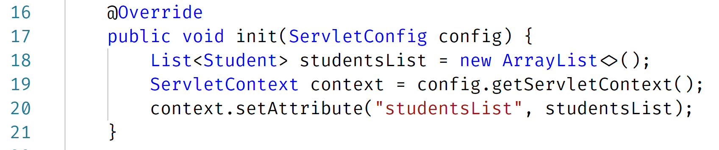

When the code is executed, the attribute named, ‘studentsList’, will be available on which scope?

A. Session scope

B. Request scope

C. Application scope

D. Page scope

**Part II – Web Application Coding Skills:** (24 points)

**Note:** *For the tasks in this question, where applicable, you are expected to take screenshot(s) of your web UI(s), save into a .png or .jpg image file, placed inside a folder named, screenshots and include these in the FinalExam.zip file, you submit or copy and paste your screenshots to the bottom of the associated question(s) right here in this document.*

1. (24 points) The figure marked as Figure x displayed below, is of a Student Registration web form. The content of the drop-down list data field (labeled, Next Course to take) is shown in Figure y, further below.

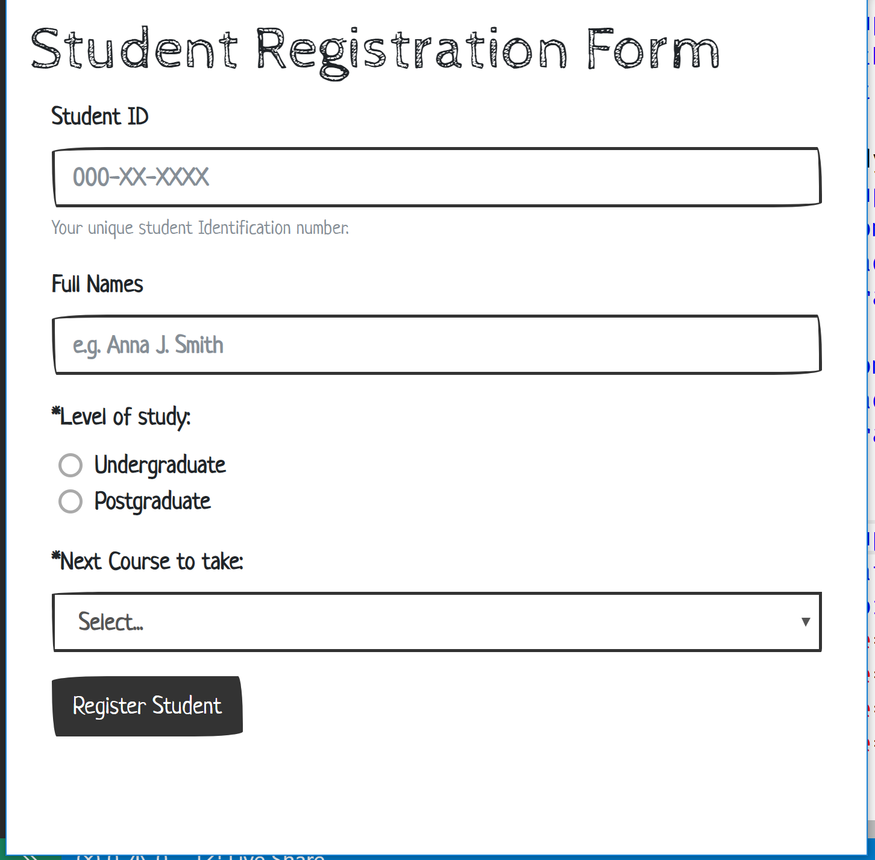

Figure x

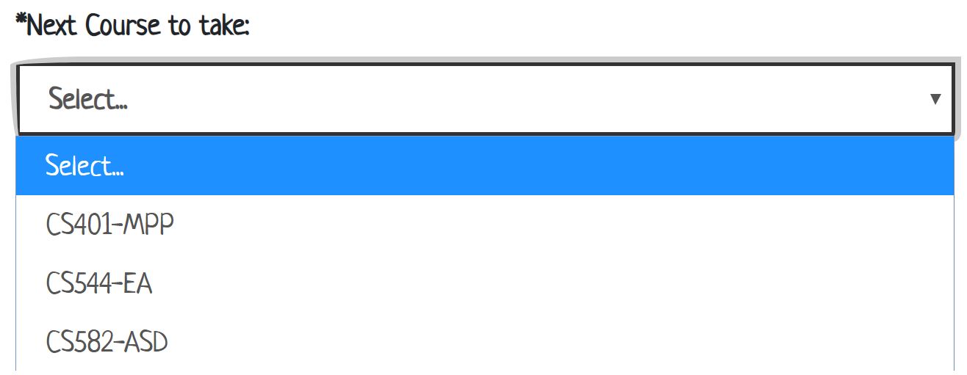

Figure y

Now, build a Web Application that presents a user (e.g. the Registrar) with the above web form and provides the following features and functionalities:

1. Using HTML5 (and optionally, CSS), code the appropriate markup for the form, as shown in Figures x and y above. Note: Your UI does not necessarily have to be exactly the same as the sample shown, but it should have all the necessary form data input fields, labels etc.
2. Student ID, Full Name, Level of study and Next Course are all required data needed and mandatory for registering a Student into the system.
3. Add validation using appropriate regular expression to ensure that any Student ID entered must be in the specified format of, 000-XX-XXXX, as shown on the form UI above. And where X is a numeric digit.
4. Upon entering all the required data in the web form, when the user clicks the “Register Student” button, the form data should be submitted/transmitted to a backend/server-side code implementation which does the following:
   1. Stores all the Registered Student data in memory. Note: You are expected to choose/use an appropriate data structure and implement an appropriate in-memory data storage mechanism.
   2. Prints-out each new Student Registration data to the console on the server.
5. Upon submission of the Student Registration form data, the form data fields should be cleared.
6. The backend/server-side code should be implemented using the Model 2 (MVC) architecture.

//-- The End --//