Supplementary data S4

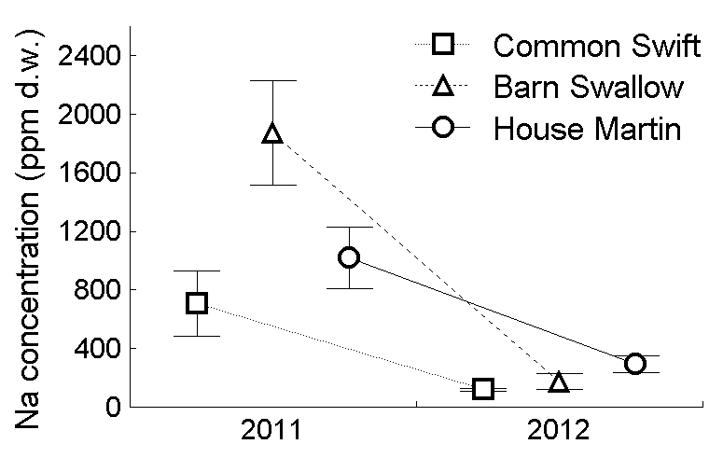 | 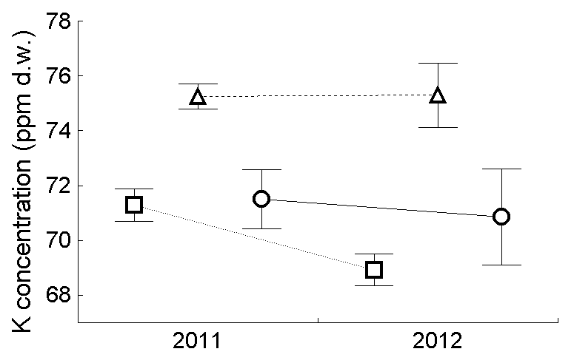 | 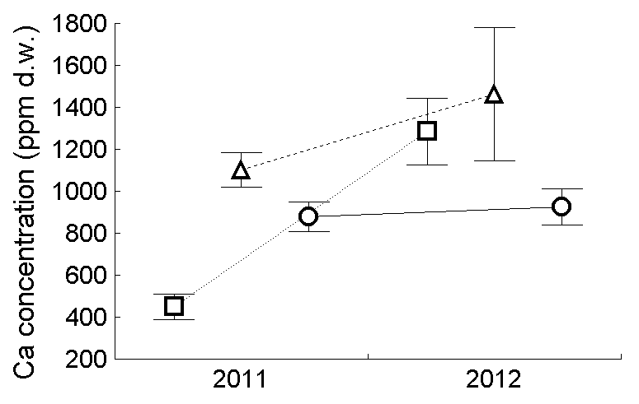
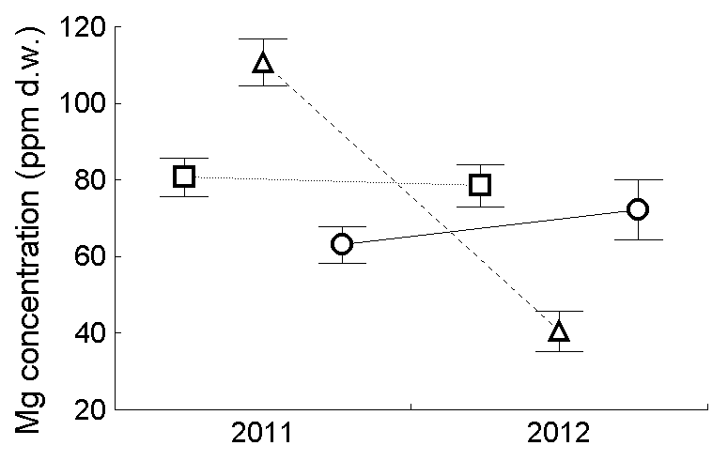 | 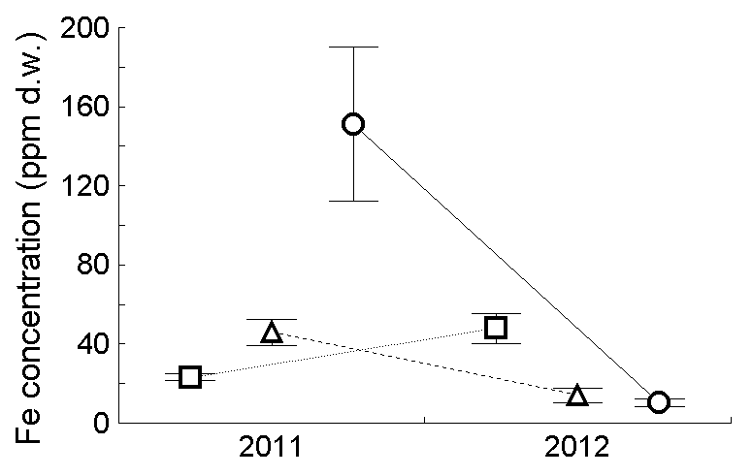 | 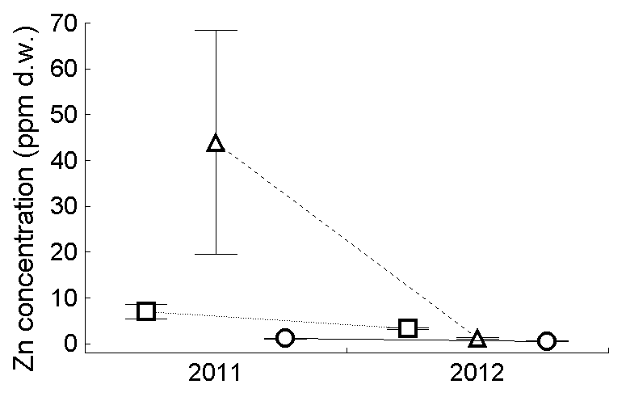
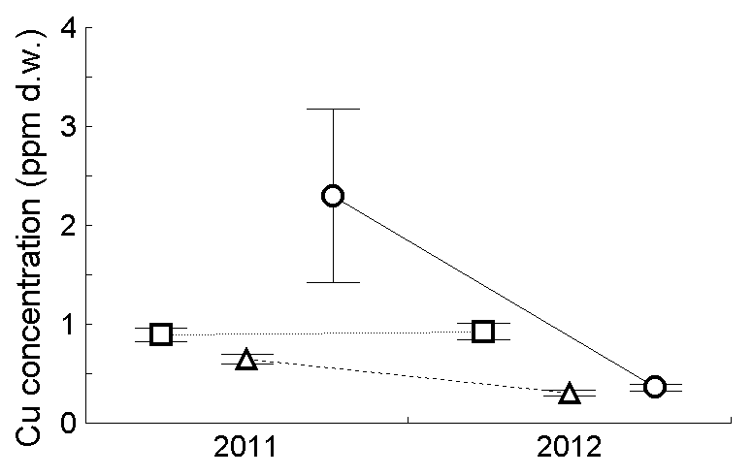 | 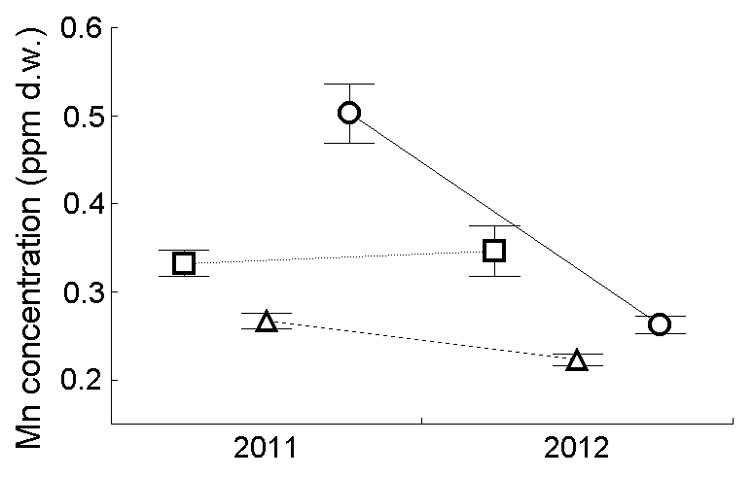 | 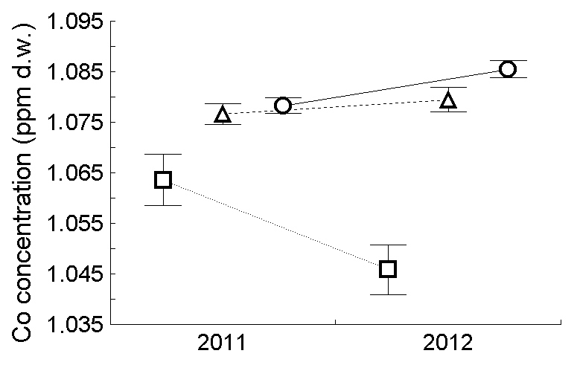
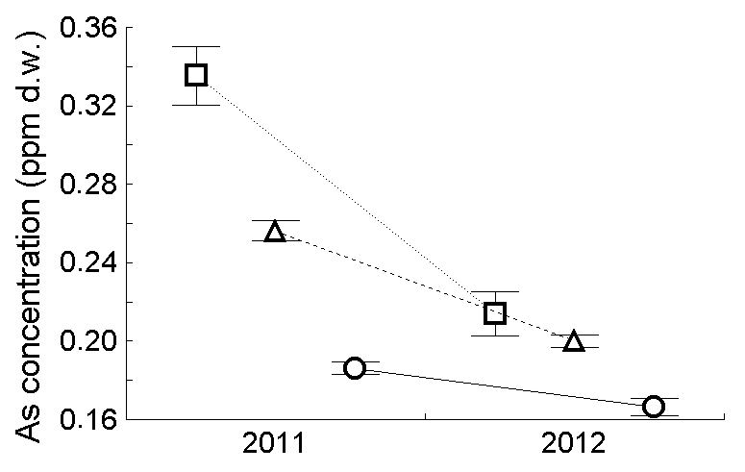 | 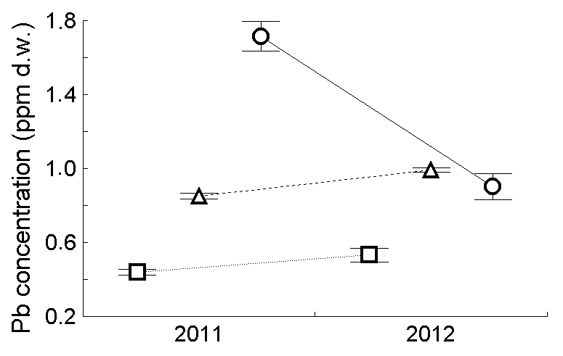 | 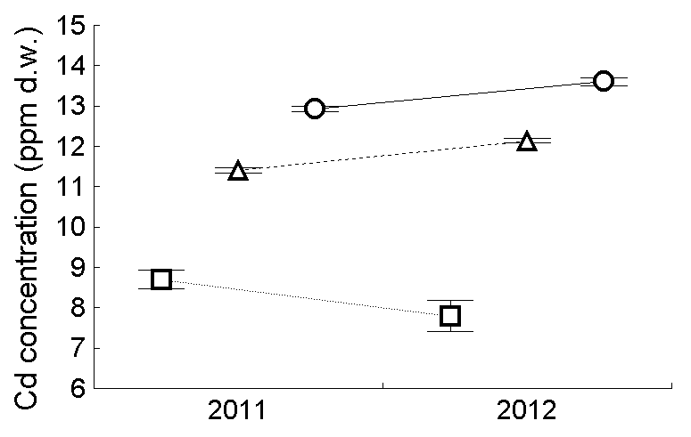

Fig. S1. The comparison of the average (± SE) concentrations of elements in the faeces of nestlings of three species of avian aerial insectivores, Common Swift (□), Barn Swallow (∆) and House Martin (○) in 2011 and 2012.

Table S1. Partial correlation coefficients between the biomasses (mg d.w.) of six functional prey groups and concentrations of 12 essential and non-essential elements in faecal sacs from nestlings of three sympatric avian aerial insectivores; the asterisks denote the significance level: * – P < 0.05, ** – P < 0.01, *** – P < 0.001.

Prey functional group | Element
Prey functional group | Na | K | Ca | Mg | Fe | Zn |  | Cu |  | Mn | Co | As |  | Pb |  | Cd
 | COMMON SWIFT (n = 57)
Mixed | -0.111 | -0.054 | -0.171 | -0.109 | -0.113 | -0.160 |  | -0.248 |  | -0.027 | 0.047 | 0.210 |  | 0.005 |  | 0.108
Crop | -0.020 | -0.165 | -0.020 | 0.104 | 0.265* | 0.103 |  | 0.144 |  | 0.078 | 0.254 | -0.145 |  | 0.197 |  | 0.081
Coprophilous | 0.230 | -0.333* | -0.138 | 0.091 | 0.101 | 0.027 |  | 0.045 |  | 0.160 | 0.080 | -0.111 |  | 0.139 |  | -0.220
Oil-seed rape | 0.119 | 0.086 | -0.016 | 0.178 | 0.232 | 0.266* |  | 0.082 |  | 0.234 | 0.231 | -0.106 |  | -0.048 |  | -0.013
Other pests | -0.177 | 0.204 | 0.033 | 0.039 | -0.141 | -0.022 |  | -0.252 |  | -0.066 | 0.198 | 0.185 |  | 0.080 |  | 0.105
Non-crop | -0.252 | -0.044 | 0.033 | -0.092 | 0.225 | -0.101 |  | -0.046 |  | -0.362** | -0.119 | 0.034 |  | 0.132 |  | 0.019
 | BARN SWALLOW (n = 66)
Mixed | 0.126 | 0.110 | 0.085 | -0.008 | 0.211 | 0.194 |  | 0.108 |  | 0.124 | 0.071 | 0.102 |  | -0.017 |  | 0.117
Crop | -0.303* | -0.174 | -0.180 | -0.177 | -0.253* | -0.124 |  | -0.227 |  | -0.303* | 0.008 | -0.317* |  | 0.352** |  | 0.406**
Coprophilous | -0.072 | -0.124 | 0.117 | 0.067 | 0.067 | 0.092 |  | -0.115 |  | -0.072 | 0.051 | -0.214 |  | 0.374** |  | 0.397**
Oil-seed rape | -0.084 | -0.004 | -0.006 | -0.026 | -0.095 | -0.075 |  | -0.077 |  | -0.084 | 0.125 | 0.119 |  | -0.050 |  | 0.075
Other pests | 0.436*** | 0.098 | -0.068 | 0.300* | 0.277* | 0.196 |  | 0.195 |  | 0.437*** | 0.200 | 0.333** |  | -0.230 |  | -0.289*
Non-crop | 0.112 | 0.111 | 0.017 | 0.203 | 0.038 | 0.111 |  | 0.018 |  | 0.112 | 0.253* | 0.091 |  | -0.160 |  | -0.095
 | HOUSE MARTIN (n = 60)
Mixed | -0.016 | -0.042 | -0.172 | -0.109 | 0.073 | -0.019 |  | 0.107 |  | -0.022 | -0.044 | 0.144 |  | 0.307* |  | -0.182
Crop | 0.058 | 0.072 | 0.238 | 0.133 | -0.009 | -0.033 |  | 0.143 |  | 0.057 | 0.259* | 0.086 |  | -0.014 |  | 0.121
Coprophilous | -0.102 | 0.110 | -0.148 | 0.000 | 0.106 | -0.065 |  | 0.003 |  | -0.097 | 0.141 | -0.183 |  | 0.101 |  | -0.033
Oil-seed rape | -0.220 | 0.078 | -0.177 | -0.042 | -0.111 | 0.135 |  | 0.138 |  | -0.219 | 0.128 | 0.175 |  | 0.199 |  | -0.097
Other pests | 0.053 | -0.035 | -0.014 | 0.298* | 0.104 | 0.252 |  | 0.248 |  | 0.056 | -0.038 | 0.333* |  | 0.108 |  | -0.039
Non-crop | 0.187 | -0.048 | 0.099 | 0.244 | 0.265* | 0.144 |  | 0.468*** |  | 0.190 | 0.016 | 0.105 |  | 0.081 |  | 0.021

