**Intake controls complex relationships within nutrients and mass budgets in a terrestrial consumer during growth**

**Samuel M. Charberet** [1](https://orcid.org/0000-0001-6284-0548), **Jérôme Mathieu** [1](https://orcid.org/0000-0002-9106-6106)**, Annick Maria** [1](https://orcid.org/000-0002-0000-0000)**, David Siaussat** [1](https://orcid.org/0000-0002-6548-0370)**, and Isabelle Gounand** [1](https://orcid.org/0000-0002-0675-3973)

1

Sorbonne Université, CNRS, UPEC, CNRS, IRD, INRAE Institute of Ecology and Environmental Sciences (iEES Paris), Paris, F-75005, France.

efficiency | rate | retention time

Type of article : Letter

Abstract: 148 / 150 words

Main text: 4990 / 5000 words

References : 121

number in main text, (total number including supplementary)

Figures: 3, (14)

Tables: 0, (7)

Boxes: 0

Correspondence: *samuelcharberet@gmail.com*

Charberet *et al.* | September 10, 2024 | 1–36

**In ecosystems, nutrients eaten by consumers are either immobilized in the food chain through assimilation ~~for body growth~~, or recycled to primary producers through waste production and decomposition. The factors that modulate the balance between these two pathways are likely to indirectly influence the nutrient stocks in the ecosystems. In particular, food shortage, which is common in nature, is known/believed to affect assimilation efficiency and can thus results in cascading effects at the ecosystem level by modifying the balance between these two pathways at the individual level. Here, we investigated how food shortage can modify this balance in a herbivorous insect growing under food restriction, and how it affects the chemical composition of wastes. The efficiency of assimilation and the retention time of C, N, P, Na, Mg, S, K and Ca decreased with the degree of food shortage, resulting in a gradual change in waste and body chemical composition. Growth efficiency was constrained by maintenance at one end of the intake spectrum and by low assimilation efficiency at the other, resulting in a humped-shaped relationship between growth rate and growth efficiency. These results highlight that resource availability modulates the interplay between nutrient retention and release at the individual level, which might affect nutrient recycling when upscaled at the ecosystem level.**

# Introduction

Trophic and stoichiometric mechanisms interact through consumer-level processes to shape the structure of ecosystems (Allen and Gillooly, 2009; Cebrian, 1999; Elser and Urabe, 1999; Hessen et al., 2004). At the consumer level, ingested food can follow different pathways: (i) directly rejected as faeces, (ii) excreted as inorganic or organic substances, or (iii) assimilated and then integrated into the food web through consumer body growth. Trophic ecology acknowledged the effect of individual-level processes on the complexity of predator-prey interaction (Arditi and Ginzburg, 2012), and ecological stoichiometry along with the metabolic theory of ecology have done so on nutrient cycling (Allen and Gillooly, 2009). Establishing a mechanistic connection between physiological and ecosystem processes requires an understanding of how consumers distribute their dietary intake between assimilation and excretion (Hessen et al., 2004). In particular, nutrient cycles might be affected by intake rate through impacts on nutrient assimilation efficiencies (Bielik and Kolisek, 2021).

In this regard, the efficiency of two physiological processes are of foremost importance: food assimilation efficiency and nutrient conversion efficiency (or gross growth efficiency). Assimilation efficiency is the fraction of ingested food not being afterwards released as wastes in the environment, whereas growth efficiency is the fraction of consumed food converted into growth, the difference between the two representing the allocation to metabolic needs of maintenance (or reproduction in reproduction periods). Assimilation efficiency is important to nutrient cycles (Montagnes and Fenton, 2012). Indeed, variations in elemental assimilation efficiencies affect body and waste composition. Changes in consumer body stoichiometry have been repeatedly recorded in consumers (Hessen et al., 2013; Persson et al., 2010; Simpson et al., 2002; Wei et al., 2022), and these changes have been shown to affect predator population dynamics by modulating the mismatch between predator food and feeding requirements (Boersma et al., 2008, 2009; Jensen et al., 2011; Malzahn et al., 2010; Schoo et al., 2010). The variation in the chemical composition of wastes can impact soil chemistry and plant communities through micro-organisms interaction (Arenberg and Arai, 2019; Güsewell and Gessner, 2009; Sitters et al., 2014). Gross growth efficiency is central to ecosystem functioning because it determines food chain potential length: higher growth efficiencies allow to transfer more material and energy to upper trophic levels and thus to sustain longer food chains (Post, 2002; Yodzis, 1984). If a high proportion of nutrients is allocated to growth in the consumer biomass, or immobilized for a long time before being excreted, the cycling of nutrients is slowed down (DeMott et al., 2010), but the food chain can be active.

These two efficiencies are usually assumed to be constant and independent of food availability, in particular in predator-prey models (Montagnes and Fenton, 2012), or stoichiometric models (Andersen et al., 2004). However, several studies show that they can considerably vary within individuals for different environmental conditions. Critically, assimilation efficiency is known to vary with food availability in aquatic systems, while affecting ingestion rate (Andersen et al., 2009; Fenton et al., 2010; Mitra and Flynn, 2007; Montagnes and Fenton, 2012; Rinke and Vijverberg, 2005). For instance, several studies revealed that assimilation efficiency in systems made of copepods and algae can increase when the food is less abundant, (Besiktepe and Dam, 2002; Gaudy, 1974; Kiørboe et al., 1985; Landry et al., 1984; Thor and Wendt, 2010). The same trend is observed in other zooplankton (Evjemo et al., 2000; Lukas and Wacker, 2014; Urabe, 1991; Urabe and Watanabe, 1991), though it does not always hold in copepod species (Barthel, 1983; Conover, 1966). These studies suggest that food abundance can control assimilation efficiency by affecting intake rate (Pahlow and Prowe, 2010). Since growth depends on assimilation, this suggests that intake rate could also drive growth efficiency (Almeda et al., 2009; Li and Montagnes, 2015) and in turn determine the "efficiency" of nutrient release to the environment: the proportion of nutrients in the food that are recycled in the ecosystem in a given time.

A mechanistic explanation of the effects of food intake level on assimilation suggested that high intake rates inherently cause ingested material to pass quickly through the gut, leading to "inefficient" digestion and absorption (Flynn, 2009; Mitra and Flynn, 2007), which would result in poor assimilation. In contrast, during food restriction, the slow gut transit increases absorption efficiency and enables the consumer to extract the highest possible amount of energy and nutrients from the food (Jumars, 2000). Increased assimilation efficiency could in turn affect growth efficiency, resulting in a higher growth and retention of nutrients in the body and in turn transferred to the upper trophic level. On the flip side, higher assimilation efficiency results in a smaller fraction of ingested food being returned to the environment through wastes at the time scale of the individual (DeMott et al., 2010). This suggests that intake rate can control the fraction of consumption routed to trophic transfer or nutrient recycling with potential effects on species interactions such as predator-prey (Montagnes and Fenton, 2012), or consumer-plant relationships (Flynn, 2009), in which the focal consumer may be involved. Because periods of low food availability are frequent in ecosystems (Dunham et al., 1989; Karasov, 1986; McCue, 2010; Nagy et al., 1999), this mechanism is likely to play an overlooked role at the ecosystem level.

In the terrestrial realm, the effect of the intake rate in assimilation efficiency is more versatile than in aquatic systems, being reported as negative in isopods, positive or negative in insects and mammals respectively), (Clauss et al. 2014; Cymbaluk et al. 1989; Lawton 1970). The inconclusive nature of these investigations might be due to the limited range of food availability in the studies and the different ways it was reported (food concentration, intake rate, predator-prey ratio) impairing comparability, so that general conclusions are not easily drawn from this ensemble of studies in terrestrial ecosystems.

Il faut une transition ici

So far, data on assimilation efficiency of nutrients are still limited in the literature, which limits our capacity to understand its role in nutrient cycles. It is known from aquatic studies that phosphorus (He and Wang, 2007) and nitrogen (Kiørboe et al., 1985; Landry et al., 1984; Lombard et al., 2009) absorption efficiencies can decrease at higher food concentrations. A critical but unresolved question is whether assimilation efficiency of the different nutrients respond in the same manner or not to environmental conditions, in particular to food availability. A difference in assimilation efficiency among nutrients would result in a modification of the ratio of nutrients in the body of the consumers, in their excretion and in their faeces along food availability, potentially cascading on the speed of nutrient recycling through stoichiometric constraints on the decomposers. This suggests The potential differences in assimilation efficiency among nutrients along environmental conditions is likely to result in non-linear effects of intake level on assimilation efficiency of individual nutrients. Indeed, a specific response of the different nutrients would result in a change of the ratio of the absorbed nutrients along the gradient. The process can be nonlinear as the absorption of nutrients are known to depend on the availability of other nutrients. As the chemical ratio of assimilated food is also known to modulate body growth of both plants and animals, this mechanism may also lead to nonlinear growth efficiency along environmental conditions such as food availability. This scenario is supported by several studies who found that intake reduction indeed altered body composition (Chen et al., 2005; Hirche and Kattner, 1993; Molnar et al., 2006) and waste (Vanni and McIntyre, 2016).

. Moreover, primary producer growth limitation can be triggered by other elements, such as Mg, Ca, K, and S (Baribault et al., 2012; Hopper et al., 2021; Lapenis et al., 2013; Naples and Fisk, 2009; Peñuelas et al., 2019) and C, N, P assimilation is likely not independent from the intake in other nutrients (Couzy et al., 1993; Fairweather-Tait and Hurrell, 1996; Goff, 2018; Kiela and Ghishan, 2016). Proteins (containing N), ATP (containing P), but also ionic gradients (K, Ca, Na, Mg, etc.) are essential to the proper functioning of digestion and absorption (Jeyasingh et al., 2023; Sans et al., 2021).

To better understand the interplay between intake rate, assimilation, growth, and body-waste chemical composition, we experimentally submitted larvae of the moth *Spodoptera littoralis* to various food intake levels. We tested the hypothesis that resource scarcity would increase the assimilation efficiency of eight essential chemical elements (C, N, P, Na, Mg, S, K, Ca), possibly at different extents, which, in turn, would increase growth efficiency. We assessed whether the chemical composition of wastes and organisms would vary under various intake levels due to the unequal assimilation of individual elements. We also opportunistically investigated the relationship between growth efficiency and growth rate in this resource scarcity context. Our results show that intake rate differently affected nutrient assimilation efficiency resulting in changes in stoichiometry of both body and waste, growth efficiency was shown to be a non-monotonic function of both intake rate and growth rate.

0.1 Study system

# Methods

## Study system

We used the polyphagous lepidoptera *Spodoptera littoralis*, a common species in temperate areas*.* Its large size enabled us to measure intake rate and frass output at the individual level. The experiment was performed during the intense growth period of the seventh and last instar, in which body mass can increase by a factor of four, to test the effects of food restriction on growth with a high resolution in a logistically feasible timeframe. Larvae from a laboratory strain were reared at 25*◦*C, 60 - 70% relative humidity, and a 16:8 light/dark cycle (Hinks and Byers, 1976). During the feeding trial, they were provided with a semi-artificial diet whose composition is given in table 1 (76 % water and 43 % C, 4.2 % N and 0.5% P in proportion of dry weight, also see fig. S1). For the purpose of this experimentation, 400 sixth instar larvae were isolated in individual 30 mL circular polypropylene containers. They were provided *ad libitum* food until the completion of the sixth moult (start of the seventh instar). The newly moulted seventh instar larvae, weighing 311 *±* 66 mg (mean *±* standard deviation, see fig. S3), were used for the study.

**Figure 1.** Methods overview. Yellow cubes represent food; masses are given in fresh weight. Pooled samples of frass from 4 caterpillars were used for chemical analyses. Groups of two caterpillars were used for chemical analyses.

## Experimental design

We randomly assigned each of the 400 seventh instar larvae to one of five food provision levels (80 individuals per level): 120, 240, 360, 480 or 900 mg (fresh weight) of food per day per individual. We had beforehand estimated that the maximal individual intake rate was 595 *±* 43 mg/day/individual, meaning that individuals receiving 900 mg per day were fed *ad libitum*, while the other larvae were not. Individuals were placed isolated in separate microcosms during xx days, in ten temporal batches (40 individuals in each batch, 8 by food intake level). We checked that the initial larvae masses were not significantly different among treatments and temporal blocks? (see fig.S2). Larvae were fed for a period of two or three days, depending on the timing of their pre-pupation, which varied due to growth rate differences among the treatments. Body mass measurements, as well as food leftover and frass collections, were carried out daily during this period. The pre-pupation stage, as determined by the sudden and visible water loss, occurred on either the third day of the seventh instar, in which case measures were taken over two days, or later, in which case measures were taken over three days. This way, measurements were not taken when the larvae stopped feeding and growing.

## Experimental workflow

Throughout the experiment, food was prepared at each temporal block and kept in a fridge. Every day, each larva was weighed and provided with the assigned quantity of freshly prepared food. Food subsamples were taken at every food preparation for subsequent chemical analysis (fig. S1). We also collected and weighed frass and food leftovers to determine the actual intake and frass production rates for each larva. Food leftovers and frass were promptly stored at *−*20*◦*C, and later dried for 72 hours at 60*◦*C in an oven to measure their dry mass. On the seventh instar third day, half the larvae were quickly stored at *−*20*◦*C, dried for 72 hours at 60*◦*C in an oven, and prepared for body chemical analyses. The remaining half was left in the rearing chambers until emergence to examine the impact of food scarcity on mortality, emergence success, and adult body masses. Intake variation did not affect emergence success (only two larvae did not emerge; one was fed 120 mg per day, and the other was fed 900 mg per day). Adult body mass increased with larval intake rate (fig. S6).

## Chemical analysis

To obtain the requisite quantities of samples for chemical analysis, it was necessary to pool the samples from several individuals together. Hence, groups of four caterpillars reared over the same temporal block and on the same food provision level were formed. Two individuals were randomly picked for chemical analysis, while the remaining two were left alive until for emergence rate estimation. The frass chemical analysis was performed on a composite sample sourced from all four individuals.

The dried samples of food, larvae, and frass were ground to a fine powder using a mixer mill (Retsch MM 200). To enable appropriate grinding, larvae were enclosed in the grinding jar, and the jar plunged into liquid nitrogen before being ground. The total carbon and total nitrogen content were determined using an elemental analyzer (Flash HT - Delta V Advantage, ThermoFisher) using aromatic polyimide (EMA-P2) as a standard. The contents of P, Na, Mg, S, K, and Ca were analyzed using ICP-MS after undergoing liquid microwave acid digestion (Milestone 1200 Mega, Milestone Inc., USA) in Teflon bombs with a 3:1 mixture of HNO3 and HCl.

0.5 Growth and mass budget

## Growth and mass budget

Food limitation depends on the balance between intake and requirements, the latter largely depending on body mass. To account for this dependency on body mass we used the Mass-Specific Intake Rate (MSIR). This metric, calculated as the ratio of food intake to body mass, serves as an indicator of food limitation. Specifically, the MSIR values decreases with food restriction since it indicates that an individual of the same mass, with hypothetical identical needs, eats less.

## *Ii*

MSIR*i* =

*tibi*

with *Ii* the total mass of food ingested by the individual *i* throughout the seventh instar, in dry weight. *Ii* was computed using fresh weight and food water content estimated for each food preparation. *ti* the number of days spent in the seventh instar before pre-pupation by individual *i*, and *bi* the average body mass during the same period, in dry weight, calculated as:

1 Z *ti bi* =  *Si*(*x*)*dx ti −*1 1

where *Si*(*x*) is a natural cubic spline constructed on the dry bodymass of individual *i* according to time. Dry bodymass was back-calculated using the larva fresh weight and the larvae water content. As there was a small difference of 1.1% between initial and final water content (see fig. S4), we chose to take the average of these two values to back-calculate individual dry bodymass. The approach involving the average value function above takes advantage of the fact that bodymass varies smoothly through time, and is a better estimator of the temporal mean than the arithmetic mean, especially with low *ti*. MSIR has the dimension of a rate T*−*1 (or a mass-specific flow rate MM*−*1T*−*1).

Growth rate (GR*i*) is computed over *ti* as the geometric mean of daily growth rates. Masses are given in dry weight.

1

 *ti* *ti*

GR*i* =Y*gi,j*

*j*=1

with *i* the individual index, *j* the day index, *ti* the number of days spent in the seventh instar by the individual *i*, and *gi,j* the growth rate of the individual *i* on day *j* computed as:

*bj −bj*+1

## *gi,j* =

*bj*

with *bj* the dry body mass on day *j*. GR is, therefore, a dimensionless quantity.

The assimilation efficiency (AE) is the proportion of ingested mass which is subsequently not egested nor excreted, over the seventh instar, given here in % dry weight. If intake and frass production rates are equal, the assimilation efficiency is 0. If intake is greater than frass production, AE is positive; in the opposite case, it is negative.

*Ii −Ei* AE*i* =

## *Ii*

with *Ii* the total dry mass of food consumed by the individual *i*, *Ei* the total dry mass of frass produced by the individual *i* throughout *ti*. AE is a dimensionless quantity.

Growth efficiency (GE) is the proportion of ingested mass resulting in growth (expressed as % dry weight):

∆*bi* GE*i* =

## *Ii*

with ∆*bi* the change in dry body mass over *ti*. GE is a dimensionless quantity.

In the case of a group of caterpillars used for chemical analysis, the corresponding mass-specific intake rate is computed as the mean of individual MSIR.

0.6 Statistical analyses

For each element (C, N, P, Na, Mg, S, K and Ca) we can compute the assimilation efficiency as follows. For the element *x* and group *k* the assimilation efficiency *AExk* is given by:

=1*− EjCxkE*

AE*xk IjCxkI*

with *CxkE* the proportion of element *x* in the frass of the group *k*, *Ek* the combined mass of frass produced by the four larvae of the group *k*, *CxkI* the proportion of element *x* in the food of the group *k*, *Ik* the mass of food consumed by the four larvae of the group *k*.

Retention time (RT) represents the average time an element spends in the body pool in the group of larvae and is computed by dividing the mass of the element in the bodymass by the output rate of the element:

*CL b* RT*xk* = *xk k*

*Exk*

with *CxkL* the proportion (in DW) of element *x* in the larvae of the group *k*, *bk* the average dry body mass of individuals in group *k*, and *Exk* the average mass of element *x* egested by larvae of the group *k* throughout the duration of the seventh instar.

As a whole, we were able to measure body mass, growth rate, growth efficiency, total assimilation efficiency, and body chemical composition at the individual level (n=40 per treatment; n=200 in total), as well as frass chemical composition and elemental assimilation efficiency at the level of groups of four caterpillars (n=10 per treatment; n=50 in total).

### Statistical analyses

Due to non-linearity, we used generalized additive models to describe the relationships between mass-specific intake rate and growth rate, absorption efficiencies (including at the nutrient level), growth efficiency and nutrient retention times. Except for the two models (GE ~MSIR) and (GE ~GR) for which we used adaptive splines, all models operated under thin plate regression splines (Wood, 2003). Model diagnostics suggested the use of different families for conditional distributions of the response variables: Scaled Student’s t distributions were used for GR and GE. We used the gamma distribution and the log link function for retention times, the classic Gaussian family for larvae and frass nutrient content, and beta distribution with logit link function for absorption efficiencies. Models were fitted using the mgcv package in R (Wood, 2017).

Before fitting the models mentioned above, we removed outliers by using a very conservative threshold of

leverage given by:

*p*

*hii <*10 *n*

where *hii* is the leverage value of the observation *i*, *p* the number of parameters, and *n* the number of observations. A much lower threshold of 2*np* is sometimes used. We did not use Cook’s distance because it does not have the same properties in the generalized linear model case as in the linear model case.

For some of the models, we also computed the first derivative as well as the associated simultaneous confidence interval using the gratia package in R (Simpson, 2024). This allows to determine whether the slope of the smooth at any particular predictor value is significantly positive or negative.

We performed contrasts on marginal means and marginal trends to investigate whether the overall elemental AE and RT, as well as the effect of MSIR on elemental AE and RT differed between pairs of elements. For this, we fitted one general GAM with the appropriate family and link function (see above) involving the elementS as a factorial predictor for both AE and RT, and used the marginaleffect package in R (Arel-Bundock et al., Forthcoming).

Rajouter une section data et code availabilty 0.7 Effects of intake on assimilation and growth efficiencies

# Results

**Effects of intake on assimilation and growth efficiencies**

## a b

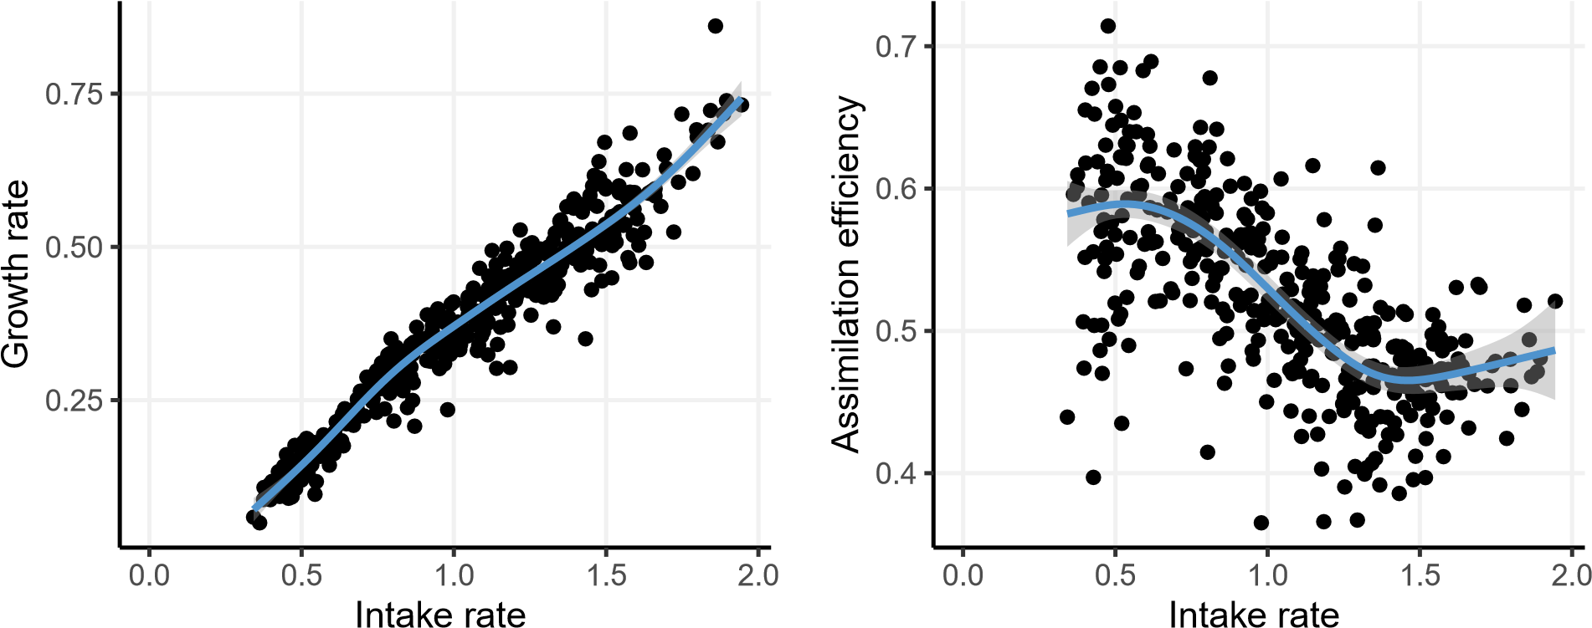

(mgfood mgbody−1 day−1) (mgfood mgbody−1 day−1)

## c d

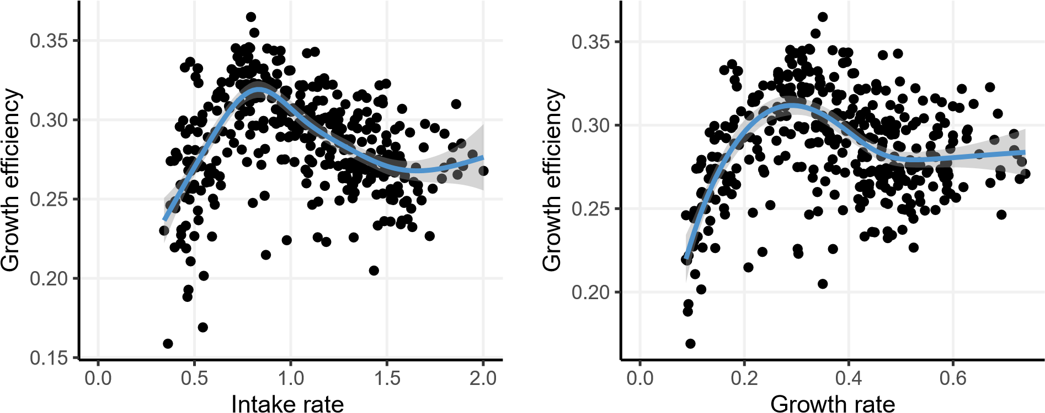

(mgfood mgbody−1 day−1)

**Figure 2.** Relationships between intake, growth and assimilation. One point represents a measurement taken at the level of one individual. The lines represent GAMs, and shaded areas are 95% confidence intervals of the mean. Growth rate, assimilation efficiency, and growth efficiency are dimensionless quantities and are given in dry weight. Growth rate is computed on a day-to-day basis. (b) Assimilation efficiency represents the proportion of ingested food not ending up in excretion or egestion, is non-dimensional and is given in dry weight. (c, d) Growth efficiency represents the proportion of ingested food resulting in growth. The vertical line in panel (c) represents a rate of 1, for which daily intake is equal to body mass. The horizontal line indicates a growth efficiency of 50%, where half of the intake is converted to growth.

There was some individual variation in intake rates within the five food provision treatments, which was both due to food availability and individual body mass. This ended up in a gradient of mass-specific intake rates ranging from 0.35 to 2mg of food daily ingested by mg of body mass. As anticipated, growth rate was positively correlated to intake rate, (fig.2.a, fig.S5.a). Assimilation efficiency decreased non linearly with intake rate and was thus higher for underfed individuals (fig.2.b, S5.b). Intake reduction increased assimilation efficiency up to 30% compared to individuals fed *ad libitum*. On average, underfed individuals had an assimilation efficiency of 60%, whereas well-fed individuals were around an efficiency of 45% (fig.2.b).

The relationship between growth efficiency and intake rate (fig. 2c), as well as the relationship between growth efficiency and growth rate (fig. 2d), were non-monotonic, first increasing, then decreasing. The first derivatives for these models indeed show that the trend is significantly positive before becoming significantly negative (fig.S5.c and .d). The highest growth efficiency (32 %) was observed at an intermediate intake level (0.8 mg *×* day*−*1 *×* mg*−*1) and not the highest one (2 mg day*−*1 mg*−*1). Growth efficiency was lower at both ends of the intake rate span, resulting in a hump-shaped relationship (see fig.2.c). We find a similar hump-shaped relationship between growth rate

0.8 Impact of intake level on element assimilation and retention time

and growth efficiency (fig.2.d, fig.S5.d), meaning that the maximum growth efficiency occurred at an intermediate specific growth rate.

### Impact of intake level on element assimilation and retention time

**a. b.**

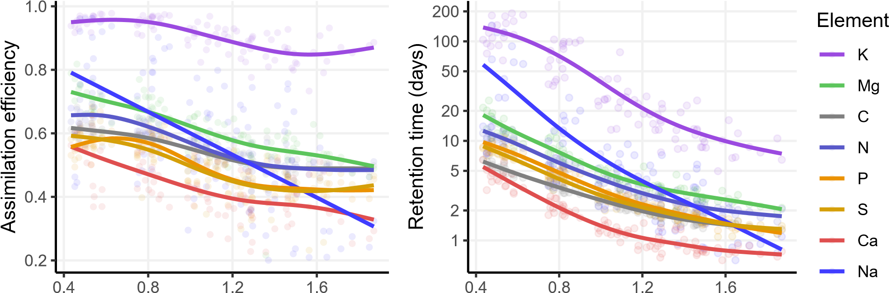

Intake rate (mgfood mg−b1ody day−1)

**Figure 3.** Assimilation efficiencies and retention times for each of the eight elements (C, N, P, Na, Mg, S, K and Ca) according to intake rate (computed at the level of a group of 4 caterpillars). Retention time is the average time an atom of the element spends within the larva before being egested or excreted. Lines show GAMs.

For each of the eight considered elements, the relationship between assimilation efficiency and intake rate was negative (fig. S7 and S8), but the overall assimilation, as well as the strength of the effect of intake varied among elements, as indicated by the different average predictions (table 6) and slopes (table 7). Only a few pairs of elements did not significantly differ in their average assimilation efficiencies, including, interestingly, C and N, as well as P and S, and Na-Mg (table 4). The effect of intake (slope) also differed between some pairs of elements, including most pairs involving Na or K (table 5). Interestingly, the effect of intake on AE did not differ between C, N and P. There was no obvious peak in elemental assimilation efficiencies at intermediate intake rates (fig. 3) as also observed at the total mass budget level (fig. 2b).

Similarly to AE, the retention time of all nutrients strongly decreased with intake rates (figs.3, S10). Irrespective of intake rate, all pairs of average elemental retention times differed (table 6). The retention times were at most doubled for C, multiplied by five for N, and P, and by 50 for Na, as a result of intake rate reduction. The effect of intake varied between most pairs of elements, except C-Ca, N- P, and P-S, indicating that food restriction modulates differently the retention of specific elements into the biomass (table 7)

### Impact of intake level on body and wastes CNP composition

Individuals feeding at high rates (*i.e.*, not food-restricted) were generally richer in carbon and hence comparatively poorer in N, P and other elements than underfed animals (figs. 4 and S11). As a result, body C/N and C/P ratios were higher at high intake rates and lower at low intake rates (fig.4.a and b). However, underfeeding yielded uneven levels of enrichment for different body nutrients, including N and P, which resulted in body N/P ratio increasing with intake rate (see fig.4.c ).

At low intake rates, frass was poorer in nutrients, including N and P (fig.4 and fig.S12). Not all nutrients were equally rarefied in frass as a result of low intake. For instance, frass produced at low intake were of lower N/P ratios than at high intake (fig.4 .f). Of interest is the positive though weak relationship found between body N/P and frass N/P (fig. S14).

0.9 Impact of intake level on body and wastes CNP composition

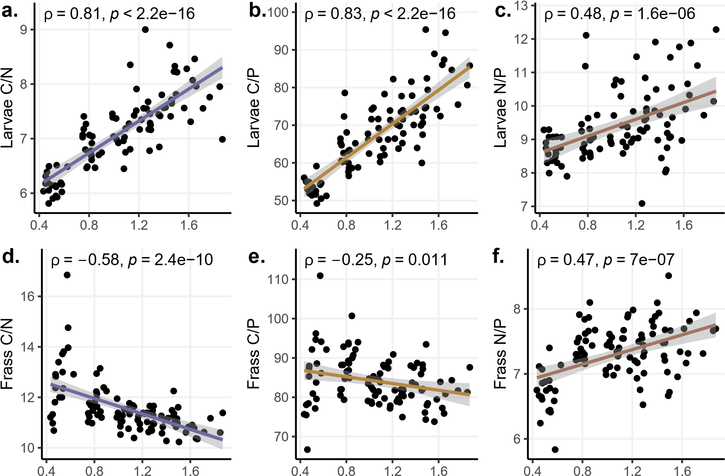

Intake rate (mgfood mg−b1ody day−1)

**Figure 4.** Effect of intake rate on body and frass chemical composition illustrated through the massic ratios between C, N and P. Each point is a measure done with pooled samples of 4 individuals for frass and two for larvae. The lines represent linear models. *ρ* is the Spearman correlation coefficient, and the p-values are those of the associated correlation tests.

0.10 Assimilation efficiency increases with food restriction

# Discussion

Our experiment provides a thorough budget of elemental fluxes and stocks in individuals of a growing herbivorous insect under different levels of food restriction. The results indicate that total food assimilation efficiency was reduced when intake was increased. This caused the growth efficiency to be reduced at the highest intake rates. However, at the lowest intake rates, growth efficiency was also reduced, which can be interpreted as the effect of maintenance processes (respiration). This resulted in a hump-shaped relationship between intake rate and growth efficiency. Because intake and growth rates are highly correlated, we also observed a hump-shaped relationship between growth rate and growth efficiency, meaning that both could not be maximized simultaneously. Elemental assimilation efficiencies differed between elements and were all increased under restriction, mostly to the same degree, resulting in the lengthening of retention times for these elements in the larval pool. Body and waste chemical compositions were also impacted, with larvae being richer in C at high intake rates and richer in N and P at low intake rates. Finally, wastes were generally poorer in nutrients at low intake rate.

## Assimilation efficiency increases with food restriction

The increase of assimilation efficiency at low intake rates is in line with numerous studies from aquatic species (Besiktepe and Dam, 2002; Gaudy, 1974; Kiørboe et al., 1985; Landry et al., 1984; Thor and Wendt, 2010) but also contrasts with other studies both in aquatic and terrestrial species where positive or no correlation were found (Barthel, 1983; Besiktepe and Dam, 2002; Conover, 1966; Lawton, 1970; Rosen et al., 2000). This result is classically interpreted as resulting from longer gut transit times at low intake, passively lengthening digestion and absorption, thereby increasing assimilation efficiency (Flynn, 2009; Jumars, 2000; Mitra and Flynn, 2007). Low intake could also induce plastic responses that would improve assimilation, such as an increase in enzyme or acid secretion, a process involving changes of gene expression (Chatterjee et al., 2014; Darchambeau, 2005; Panserat and Kaushik, 2010; Zinke et al., 2002), but determining to which extent such processes could have been taking place in our experiment would require more precise, organ-specific respiration measurements.

Theoretical approaches have sometimes used the negative relationship between assimilation efficiency and food availability to model predator-prey systems and found that the dynamics can be largely impacted by the response of trophic transfer efficiency to prey density (Burian et al., 2020; Li and Montagnes, 2015; Mitra and Flynn, 2007; Montagnes and Fenton, 2012; Montagnes et al., 2019).

## Growth efficiency peaks at moderate food restriction and growth rate

Our experiment reveals that insects’ growth efficiency can exhibit a unimodal response to variation in intake. Due to the positive correlation between growth rate and intake rate, this shape was also conserved for the relationship between growth efficiency and growth rate. Past studies have found various patterns regarding the relationship between growth efficiency and food provision as algae concentration in aquatic invertebrates: positive (Liu and Ban, 2016; Pandian, 1967; Wang et al., 1998), negative (Bartley et al., 1980; Lukas and Wacker, 2014; Mullin and Brooks, 1970; Paffenhofer, 1976; Straile, 1997), and strikingly, we found two instances of non-monotonic variation (Reeve, 1963; Urabe, 1991; Urabe and Watanabe, 1991). These last results can be interpreted as follows: assuming constant maintenance requirements, as the intake rate decreases when algae availability is lower, a greater proportion of consumed substrate is used for obligatory maintenance, less for growth, hence growth efficiency decreases (Pirt and Hinshelwood, 1965; Wang and Post, 2012). In their 1991 article, Urabe and colleagues appropriately highlighted that: *The K*1 [*n.b.* growth efficiency] *peak shown at an intermediate food concentration is of great interest with respect to production efficiency in aquatic ecosystems, because it suggests that there is an optimal resource concentration at which material or energy transfer efficiencies to a higher trophic level are maximized* (Urabe and Watanabe, 1991). In a recent fitness optimization model, such a relationship was predicted in animals (Burian et al. 2020, fig. 6H). Our study shows that insects, which populations represent large pools of biomass in ecosystems and which are involved into multiple trophic interactions in food webs, could also be subjected to this complex relationship between intake and trophic transfer efficiency. Investigating the interplay between quality and quantity could shed light on whether the observed hump-shaped relationship between growth efficiency and intake persists or transforms under diverse nutritional landscapes as suggested by Burian et al. (2020).

The similarly important relationship between growth rate and growth efficiency at the individual level is much less explored in the ecological literature. Interestingly, our results suggest an intrinsic impossibility of maximizing both growth rate and growth efficiency simultaneously when intake controls this relationship. More generally, and since food availability, ingestion rate and growth rate are often monotonic functions of each other, the GE-GR relationship should also be unimodal. However, the GE-GR relationship can only have one root since whenever GE is 0, GR must also be 0. Such a response to resource availability might have far-reaching consequences on

0.12 Assimilation efficiency response to intake depends on the element

population persistence and community dynamics under a fluctuating environment. For example, during unfavourable seasons or perturbations, buffering stress by improving assimilation and growth efficiency could propagate up the food chain, making each trophic level grow less rapidly but more efficiently (Fenton et al., 2010; Montagnes and Fenton, 2012) which could stabilize food chain length in face of perturbations (Post, 2002).

## Assimilation efficiency response to intake depends on the element

At the nutrient level, organisms better absorb all of the eight tested chemical elements at low intake rates. Under a certain threshold, very low intake rates could theoretically result in a decrease in elemental assimilation efficiency (Burian et al., 2020), owing to limitations in other nutrients, but such peaks were not visible in our data. However, the reduction of intake did not affect the assimilation of the various elements equally. The assimilation of some nutrients was more sensible to food restriction than others, indicated by greater slopes, whereas the maximal assimilation also varied, indicated by the different average predictions (fig. 3). Some minerals exist as free ions and are readily absorbed through channels and pumps in the gut (Rajendran et al., 2018). Our data shows that both K and Na are indeed highly assimilated at low intake rates (fig.3). However, an increase in intake rate drastically reduces the assimilation of Na, and Ca is poorly assimilated at all intake rates (fig.3). This suggests that maximal assimilation of these ions is not required at all intake rates and that adaptive assimilation may play a role in regulating the input of these cations, which are crucial in maintaining chemical osmosis and appropriate signalling (Bradley, 2009; Clapham, 2007; Naikkhwah and O’Donnell, 2012).

By contrast, other elements occur in complex molecular contexts, such as C, N, P and S, which are found in proteins, carbohydrates, nucleic acids, phytates, and secondary metabolites. Some of these compounds are refractory to digestion, (*e.g.* complex carbohydrates, phytates (Huang et al., 2009; Martin, 1983)), and this may hinder the proper assimilation of these elements, as the lesser slopes of these elements suggest. This challenging digestion might explain the lower enhancement of C, P and S assimilation efficiencies at low intake rates. The different slopes among elemental assimilation efficiencies show that relative assimilation efficiencies vary between pairs of elements. This means that food restriction will modify the stoichiometry of assimilation, and subsequently egestion fluxes, therefore affecting the interactions between nutrient cycles.

## Food restriction increases retention times

Higher assimilation efficiencies were accompanied by longer retention times of nutrients in the biomass with food restriction (fig.3). Hence, at low intake, the larvae transiently immobilized nutrients that would have otherwise been voided as frass. In theoretical studies, the return time of nutrients through egestion and excretion has been shown to have a small but positive effect on recycling in nutrient-poor systems (Cherif and Loreau, 2013). Our results suggest that the return rate of nutrients to the soil could therefore be partially controlled by intake rate, and be quicker at high intake rate *i.e.* in a resource-rich environment. This effect could potentially participate in the slow cycling of nutrients typical of nutrient-poor ecosystems (Delgado-Baquerizo et al., 2013). Moreover, many experiments tend to show that moderate food restriction extends lifespan (Partridge et al., 2005; Speakman and Mitchell, 2011), and therefore trigger a slower return of body nutrients, at least at the individual scale. In invertebrates though, the change in retention time should have a limited impact on nutrient fluxes since the lifespan is on the scale of days to months. However, we can expect food restriction to induce longer retention times in larger and long-lived animals.

## Response to food restriction modifies body and waste stoichiometries

The elemental composition of both larvae and their frass was also impacted by intake level. At high intake rates, the body nutrient content was lower apart from C (fig.4.a and b). This is likely due to the accumulation of C-rich lipidic reserves that increased the C content at high intake. Similarly, the N/P ratio of larvae increased with intake rate (fig.4). This result adds to numerous instances of intraspecific variability in consumer stoichiometry (Hessen et al., 2013; Persson et al., 2010; Simpson et al., 2002; Wei et al., 2022). The variation in the carbon-to-nutrient ratio in animals experiencing various intake levels may affect whether energy or nutrients (lipids or proteins, respectively) are limiting for the predator (Elser et al., 2016). Moreover, consumer stoichiometry variation has been shown to propagate up the food chain and impact predator dynamics (Boersma et al., 2008, 2009; Jensen et al., 2011; Malzahn et al., 2010; Schoo et al., 2010). Intake rate, and therefore resource availability could therefore control the amount of stoichiometric mismatch between prey and predators and have non-local effects on the food chain.

On the other hand, animals’ wastes nutrient level also varied with intake (fig.4.c and d, fig.S11). At low intake, wastes were produced in lesser quantity and quality. Lower nutrient content is known to reduce the decomposition rate of wastes (Enríquez et al., 1993; Güsewell and Gessner, 2009; Sitters et al., 2014; Wang et al., 2018; Zechmeister-Boltenstern et al., 2015), slowing down even more the cycling of nutrients at low intake. The

waste N/P ratio decreased at lower intake, suggesting that N was poorly excreted, while P, found mainly in egesta, continued to be egested, potentially due to the poor digestibility of phytates. Moreover, contrarily to expectations under the classic stoichiometric model of homeostatic growth (Sterner et al., 2002), the frass N/P was not negatively correlated to body N/P (fig. S14). Non-homeostasis caused by variation in intake possibly prevented us from seeing such a relationship due to a decoupling of assimilation and body requirements at variable body stoichiometry.

## Note on the growth rate hypothesis

Although our experiment was not designed to test the growth rate hypothesis (GRH) which states fast-growing organisms are high in P (Isanta-Navarro et al., 2022; Sterner and Hessen, 1994), our data allows us to assess the relevance of the theory in the context of a gradient of food availability. Opposite to the GRH, we observed a decrease in body P, P/N or P/C content with growth rate (fig.S13). This indicates that in our experiment, faster-growing animals were poorer in P than slower-growing ones and had a stronger decrease in P than in N content with growth rate (fig.4.c). Many experiments confirming this hypothesis at the intraspecific level forced the differences in growth by manipulating the P contents of food (Elser et al., 2003, 2006; Kyle et al., 2006). Conversely, we show here that under constant food stoichiometry, a lower growth rate during food restriction does not necessarily imply lower body P and body N/P increase. In our experiment, high intake rates allowed the building of a lot of C-rich lipidic reserves, therefore increasing C-nutrient ratios at high growth rates and diluting P content. At low intake, biosynthesis likely focused on building N-rich proteins to maintain functioning. Variation in lipid storage combined with the absence of P limitation ultimately may have masked the predictions expected under the growth rate hypothesis.

# Acknowledgements

The authors wish to thank Anabelle Fuentes and Philippe Couzi for their contribution to rearing, Magloire Mandeng-Yogo and Mélanie Longchamp for their support to chemical analysis.

# Bibliography

Allen, A. P. and Gillooly, J. F. (2009). Towards an integration of ecological stoichiometry and the metabolic theory of ecology to better understand nutrient cycling. *Ecology Letters*, 12(5):369–384. doi: 10.1111/j.1461-0248.2009.01302.x.

Almeda, R., Pedersen, T. M., Jakobsen, H. H., Alcaraz, M., Calbet, A., and Hansen, B. W. (2009). Feeding and growth kinetics of the planktotrophic larvae of the spionid polychaete polydora ciliata (johnston). *Journal of Experimental Marine Biology and Ecology*, 382(1):61–68. doi: https://doi.org/10.1016/j.jembe.2009.09.017.

Andersen, K., Beyer, J., and Lundberg, P. (2009). Trophic and individual efficiencies of size-structured communities. *Proceedings of the Royal Society B: Biological Sciences*, 276(1654):109–114. doi: 10.1098/rspb.2008.0951.

Andersen, T., Elser, J. J., and Hessen, D. O. (2004). Stoichiometry and population dynamics. *Ecology Letters*, 7(9):884–900. doi: 10.1111/j.1461-0248.2004.00646.x.

Arditi, R. and Ginzburg, L. *How Species Interact: Altering the Standard View on Trophic Ecology*. Oxford University Press, (2012). doi: 10.1093/acprof:osobl/9780199913831.001.0001. URL [https://doi.org/10.1093/acprof:osobl/9780199913831. 001.0001](https://doi.org/10.1093/acprof:osobl/9780199913831.001.0001).

Arel-Bundock, V., Greifer, N., and Heiss, A. (Forthcoming). How to interpret statistical models using marginaleffects in R and Python. *Journal of Statistical Software*.

Arenberg, M. R. and Arai, Y. (2019). Uncertainties in soil physicochemical factors controlling phosphorus mineralization and immobilization processes. *Advances in agronomy*, 154:153–200.

Baribault, T. W., Kobe, R. K., and Finley, A. O. (2012). Tropical tree growth is correlated with soil phosphorus, potassium, and calcium, though not for legumes. *Ecological Monographs*, 82(2):189–203.

Barthel, K. G. (1983). Food uptake and growth efficiency of eurytemora affinis (copepoda: Calanoida). *Marine Biology*, 74(3): 269–274. doi: 10.1007/bf00403450.

Bartley, D. M., Carlberg, J. M., Van Olst, J. C., and Ford, R. F. (1980). Growth and conversion efficiency of juvenile american lobsters (homarus americanus) in relation to temperature and feeding level. *Proceedings of the World Mariculture Society*, 11 (1-4):355–368. doi: https://doi.org/10.1111/j.1749-7345.1980.tb00130.x.

Besiktepe, S. and Dam, H. (2002). Coupling of ingestion and defecation as a function of diet in the calanoid copepod acartia tonsa. *Marine Ecology Progress Series*, 229:151–164. doi: 10.3354/meps229151.

Bielik, V. and Kolisek, M. (2021). Bioaccessibility and bioavailability of minerals in relation to a healthy gut microbiome. *International Journal of Molecular Sciences*, 22(13). doi: 10.3390/ijms22136803.

Boersma, M., Aberle, N., Hantzsche, F. M., Schoo, K. L., Wiltshire, K. H., and Malzahn, A. M. (2008). Nutritional limitation travels up the food chain. *International Review of Hydrobiology*, 93(4-5):479–488. doi: https://doi.org/10.1002/iroh.200811066.

Boersma, M., Becker, C., Malzahn, A. M., and Vernooij, S. (2009). Food chain effects of nutrient limitation in primary producers. *Marine and Freshwater Research*, 60(10):983–989. doi: 10.1071/MF08240.

Bradley, T. J. *Animal osmoregulation*. Oxford University Press, (2009).

Brett, J. R., Shelbourn, J. E., and Shoop, C. T. (1969). Growth rate and body composition of fingerling sockeye salmon, oncorhynchus nerka, in relation to temperature and ration size. *Journal of the Fisheries Research Board of Canada*, 26 (9):2363–2394. doi: 10.1139/f69-230.

Burian, A., Nielsen, J. M., and Winder, M. (2020). Food quantityquality interactions and their impact on consumer behavior and trophic transfer. *Ecological Monographs*, 90(1):e01395. doi: https://doi.org/10.1002/ecm.1395.

Cebrian, J. (1999). Patterns in the fate of production in plant communities. *The American Naturalist*, 154(4):449–468. doi: 10.1086/303244. PMID: 10523491.

Chatterjee, D., Katewa, S. D., Qi, Y., Jackson, S. A., Kapahi, P., and Jasper, H. (2014). Control of metabolic adaptation to fasting by dilp6-induced insulin signaling in drosophila oenocytes. *Proceedings of the National Academy of Sciences*, 111(50): 1795917964. doi: 10.1073/pnas.1409241111.

Chen, Y., Ke, C.-H., Zhou, S.-Q., and Li, F.-X. (2005). Effects of food availability on feeding and growth of cultivated juvenile babylonia formosae habei (altena & gittenberger 1981). *Aquaculture Research*, 36(1):94–99. doi: https://doi.org/10.1111/ j.1365-2109.2004.01189.x.

Cherif, M. and Loreau, M. (2013). Plant-herbivore-decomposer stoichiometric mismatches and nutrient cycling in ecosystems.

*Proceedings of the Royal Society B: Biological Sciences*, 280(1754):1–9. doi: 10.1098/rspb.2012.2453.

Clapham, D. E. (2007). Calcium signaling. *Cell*, 131(6):1047–1058. doi: 10.1016/j.cell.2007.11.028.

Clauss, M., Schiele, K., Ortmann, S., Fritz, J., Codron, D., Hummel, J., and Kienzle, E. (2014). The effect of very low food intake on digestive physiology and forage digestibility in horses. *Journal of Animal Physiology and Animal Nutrition*, 98(1):107–118.

doi: https://doi.org/10.1111/jpn.12053.

Conover, R. J. (1966). Factors affecting the assimilation of organic matter by zooplankton and the question of superfluous feeding. *Limnology and Oceanography*, 11(3):346–354. doi: https://doi.org/10.4319/lo.1966.11.3.0346.

Couzy, F., Keen, C., Gershwin, M., and Mareschi, J. (1993). Nutritional implications of the interactions between minerals. *Progress in Food & Nutrition Science*, 17(1):65–87.

Cymbaluk, N. F., Christison, G. I., and Leach, D. H. (1989). Nutrient utilization by limit- and ad libitum-fed growing horses. *Journal of Animal Science*, 67(2):414–425. doi: 10.2527/jas1989.672414x.

Darchambeau, F. (2005). Filtration and digestion responses of an elementally homeostatic consumer to changes in food quality: a predictive model. *Oikos*, 111(2):322–336. doi: https://doi.org/10.1111/j.0030-1299.2005.13497.x.

Delgado-Baquerizo, M., Maestre, F. T., Gallardo, A., Bowker, M. A., Wallenstein, M. D., Quero, J. L., Ochoa, V., Gozalo, B., García-Gómez, M., Soliveres, S., García-Palacios, P., Berdugo, M., Valencia, E., Escolar, C., Arredondo, T., Barraza-Zepeda, C., Bran, D., Carreira, J. A., Chaieb, M., Conceição, A. A., Derak, M., Eldridge, D. J., Escudero, A., Espinosa, C. I.,

Gaitán, J., Gatica, M. G., Gómez-González, S., Guzman, E., Gutiérrez, J. R., Florentino, A., Hepper, E., Hernández, R. M., Huber-Sannwald, E., Jankju, M., Liu, J., Mau, R. L., Miriti, M., Monerris, J., Naseri, K., Noumi, Z., Polo, V., Prina, A., Pucheta, E., Ramírez, E., Ramírez-Collantes, D. A., Romão, R., Tighe, M., Torres, D., Torres-Díaz, C., Ungar, E. D., Val, J., Wamiti, W., Wang, D., and Zaady, E. (2013). Decoupling of soil nutrient cycles as a function of aridity in global drylands. *Nature*, 502 (7473):672–676. doi: 10.1038/nature12670.

DeMott, W. R., McKinney, E. N., and Tessier, A. J. (2010). Ontogeny of digestion in daphnia: implications for the effectiveness of algal defenses. *Ecology*, 91(2):540–548. doi: https://doi.org/10.1890/08-2103.1.

Dunham, A. E., Grant, B. W., and Overall, K. L. (1989). Interfaces between biophysical and physiological ecology and the population ecology of terrestrial vertebrate ectotherms. *Physiological Zoology*, 62(2):335–355. doi: 10.1086/physzool.62.2. 30156174.

Elliott, J. M. (1975). The growth rate of brown trout (salmo trutta l.) fed on reduced rations. *Journal of Animal Ecology*, 44(3): 823–842.

Elser, J. J. and Urabe, J. (1999). The stoichiometry of consumer-driven nutrient recycling: Theory, observations, and consequences. *Ecology*, 80(3):735–751. doi: 10.1890/0012-9658(1999)080[0735:TSOCDN]2.0.CO;2.

Elser, J. J., Acharya, K., Kyle, M., Cotner, J., Makino, W., Markow, T., Watts, T., Hobbie, S., Fagan, W., Schade, J., Hood,

J., and Sterner, R. W. (2003). Growth rate-stoichiometry couplings in diverse biota. *Ecology Letters*, 6(10):936–943. doi:

10.1046/j.1461-0248.2003.00518.x.

Elser, J. J., Watts, T., Bitler, B., and Markow, T. A. (2006). Ontogenetic coupling of growth rate with RNA and P contents in five species of Drosophila. *Functional Ecology*, 20(5):846–856. doi: 10.1111/j.1365-2435.2006.01165.x.

Elser, J. J., Kyle, M., Learned, J., McCrackin, M. L., Peace, A., and Steger, L. (2016). Life on the stoichiometric knife-edge: effects of high and low food c:p ratio on growth, feeding, and respiration in three daphnia species. *Inland Waters*, 6(2):136–146. doi: 10.5268/IW-6.2.908.

Enríquez, S., Duarte, C. M., and Sand-Jensen, K. (1993). Patterns in decomposition rates among photosynthetic organisms: the importance of detritus C:N:P content. *Oecologia*, 94(4):457–471. doi: 10.1007/BF00566960.

Evjemo, J. O., Vadstein, O., and Olsen, Y. (2000). Feeding and assimilation kinetics of artemia franciscana fed isochrysis galbana (clone t. iso). *Marine Biology*, 136(6):1099–1109. doi: 10.1007/s002270000306.

Fairweather-Tait, S. and Hurrell, R. F. (1996). Bioavailability of minerals and trace elements. *Nutrition Research Reviews*, 9(1): 295324. doi: 10.1079/NRR19960016.

Fenton, A., Spencer, M., and Montagnes, D. J. S. (2010). Parameterising variable assimilation efficiency in predatorprey models. *Oikos*, 119(6):1000–1010. doi: https://doi.org/10.1111/j.1600-0706.2009.17875.x.

Flynn, K. J. (2009). Food-density-dependent inefficiency in animals with a gut as a stabilizing mechanism in trophic dynamics. *Proceedings of the Royal Society B: Biological Sciences*, 276(1659):1147–1152. doi: 10.1098/rspb.2008.1575.

Gaudy, R. (1974). Feeding four species of pelagic copepods under experimental conditions. *Marine Biology*, 25(2):125–141. doi: 10.1007/bf00389261.

Goff, J. P. (2018). Invited review: Mineral absorption mechanisms, mineral interactions that affect acidbase and antioxidant status, and diet considerations to improve mineral status. *Journal of Dairy Science*, 101(4):2763–2813. doi: https://doi.org/ 10.3168/jds.2017-13112.

Güsewell, S. and Gessner, M. O. (2009). N : p ratios influence litter decomposition and colonization by fungi and bacteria in microcosms. *Functional Ecology*, 23(1):211–219. doi: https://doi.org/10.1111/j.1365-2435.2008.01478.x.

He, X. and Wang, W.-X. (2007). Kinetics of phosphorus in daphnia at different food concentrations and carbon:phosphorus ratios. *Limnology and Oceanography*, 52(1):395–406. doi: https://doi.org/10.4319/lo.2007.52.1.0395.

Hessen, D. O., Ågren, G. I., Anderson, T. R., Elser, J. J., and de Ruiter, P. C. (2004). Carbon sequestration in ecosystems: The role of stoichiometry. *Ecology*, 85(5):1179–1192.

Hessen, D. O., Elser, J. J., Sterner, R. W., and Urabe, J. (2013). Ecological stoichiometry: An elementary approach using basic principles. *Limnology and Oceanography*, 58(6):2219–2236. doi: 10.4319/lo.2013.58.6.2219.

Hinks, C. F. and Byers, J. R. (1976). Biosystematics of the genus euxoa (lepidoptera: Noctuidae): v. rearing procedures, and life cycles of 36 species. *The Canadian Entomologist*, 108(12):13451357. doi: 10.4039/Ent1081345-12.

Hirche, H.-J. and Kattner, G. (1993). Egg production and lipid content of calanus glacialis in spring: indication of a food-dependent and food-independent reproductive mode. *Marine Biology*, 117(4):615–622. doi: 10.1007/BF00349773.

Hopper, G. W., Dickinson, G. K., and Atkinson, C. L. (2021). Associations among elements in freshwater mussel shells (unionidae) and their relation to morphology and life history. *Freshwater Biology*, 66(10):1980–1991. doi: https://doi.org/10.1111/fwb. 13807.

Huang, H., Shi, P., Wang, Y., Luo, H., Shao, N., Wang, G., Yang, P., and Yao, B. (2009). Diversity of beta-propeller phytase genes in the intestinal contents of grass carp provides insight into the release of major phosphorus from phytate in nature. *Applied and Environmental Microbiology*, 75(6):1508–1516. doi: 10.1128/AEM.02188-08.

Hubbell, S. P., Sikora, A., and Paris, O. H. (1965). Radiotracer, gravimetric and calorimetric studies of ingestion and assimilation rates of an isopod. *Health physics*, 11(12):1485–1501.

Isanta-Navarro, J., Prater, C., Peoples, L. M., Loladze, I., Phan, T., Jeyasingh, P. D., Church, M. J., Kuang, Y., and Elser, J. J. (2022). Revisiting the growth rate hypothesis: Towards a holistic stoichiometric understanding of growth. *Ecology Letters*, 25 (10):2324–2339. doi: https://doi.org/10.1111/ele.14096.

Jensen, K., Mayntz, D., Toft, S., Raubenheimer, D., and Simpson, S. J. (2011). Nutrient regulation in a predator, the wolf spider pardosa prativaga. *Animal Behaviour*, 81(5):993–999. doi: https://doi.org/10.1016/j.anbehav.2011.01.035.

Jeyasingh, P. D., Sherman, R. E., Prater, C., Pulkkinen, K., and Ketola, T. (2023). Adaptation to a limiting element involves mitigation of multiple elemental imbalances. *Journal of The Royal Society Interface*, 20(198):20220472. doi: 10.1098/rsif. 2022.0472.

Jumars, P. A. (2000). Animal guts as ideal chemical reactors: Maximizing absorption rates. *The American Naturalist*, 155(4): 527–543. doi: 10.1086/303333. PMID: 10753079.

Karasov, W. (1986). Energetics, physiology and vertebrate ecology. *Trends in Ecology & Evolution*, 1(4):101–104. doi: https: //doi.org/10.1016/0169-5347(86)90034-0.

Kaspari, M. (2020). The seventh macronutrient: how sodium shortfall ramifies through populations, food webs and ecosystems. *Ecology Letters*, 23(7):1153–1168. doi: https://doi.org/10.1111/ele.13517.

Kiela, P. R. and Ghishan, F. K. (2016). Physiology of intestinal absorption and secretion. *Best Practice & Research Clinical Gastroenterology*, 30(2):145–159. doi: https://doi.org/10.1016/j.bpg.2016.02.007. Diagnosis and Management of Malabsorption.

Kiørboe, T., Møhlenberg, F., and Hamburger, K. (1985). Bioenergetics of the planktonic copepod acartia tonsa: relation between feeding, egg production and respiration, and composition of specific dynamic action. *Marine Ecology-progress Series - MAR ECOL-PROGR SER*, 26:85–97. doi: 10.3354/meps026085.

Kodama, N., Nishimuta, M., and Suzuki, K. (2003). Negative balance of calcium and magnesium under relatively low sodium intake in humans. *Journal of nutritional science and vitaminology*, 49(3):201–209.

Kyle, M., Acharya, K., Weider, L. J., Looper, K., and Elser, J. J. (2006). Coupling of growth rate and body stoichiometry in daphnia: a role for maintenance processes? *Freshwater Biology*, 51(11):2087–2095. doi: https://doi.org/10.1111/j.13652427.2006.01639.x.

Landry, M. R., Hassett, R. P., Fagerness, V., Downs, J., and Lorenzen, C. J. (1984). Effect of food acclimation on assimilation efficiency of calanus pacificus. *Limnology and Oceanography*, 29(2):361–364. doi: https://doi.org/10.4319/lo.1984.29.2. 0361.

Lapenis, A. G., Lawrence, G. B., Heim, A., Zheng, C., and Shortle, W. (2013). Climate warming shifts carbon allocation from stemwood to roots in calcium-depleted spruce forests. *Global Biogeochemical Cycles*, 27(1):101–107. doi: https: //doi.org/10.1029/2011GB004268.

Lawton, J. (1970). Feeding and food energy assimilation in larvae of the damselfly pyrrhosoma nymphula (sulz.)(odonata: Zygoptera). *The Journal of Animal Ecology*, pages 669–689.

Li, J. and Montagnes, D. J. (2015). Restructuring fundamental predator-prey models by recognising prey-dependent conversion efficiency and mortality rates. *Protist*, 166(2):211–223. doi: https://doi.org/10.1016/j.protis.2015.02.003.

Li, X., Wang, H., and Kuang, Y. (2011). Global analysis of a stoichiometric producer-grazer model with Holling type functional responses. *Journal of Mathematical Biology*, 63(5):901–932. doi: 10.1007/s00285-010-0392-2.

Liesegang, A., Hatt, J.-M., and Wanner, M. (2007). Influence of different dietary calcium levels on the digestibility of ca, mg and p in hermann’s tortoises (testudo hermanni). *Journal of Animal Physiology and Animal Nutrition*, 91(11-12):459–464. doi: https://doi.org/10.1111/j.1439-0396.2007.00676.x.

Liu, X. and Ban, S. (2016). Effects of acclimatization on metabolic plasticity of Eodiaptomus japonicus (Copepoda: Calanoida) determined using an optical oxygen meter. *Journal of Plankton Research*, 39(1):111–121. doi: 10.1093/plankt/fbw084.

Lombard, F., Renaud, F., Sainsbury, C., Sciandra, A., and Gorsky, G. (2009). Appendicularian ecophysiology i: Food concentration dependent clearance rate, assimilation efficiency, growth and reproduction of oikopleura dioica. *Journal of Marine Systems*, 78 (4):606–616. doi: https://doi.org/10.1016/j.jmarsys.2009.01.004. Revisiting the Role of Zooplankton in Pelagic Ecosystems. Lukas, M. and Wacker, A. (2014). Daphnia’s dilemma: adjustment of carbon budgets in the face of food and cholesterol limitation. *Journal of Experimental Biology*, 217(7):1079–1086. doi: 10.1242/jeb.094151.

Malzahn, A. M., Hantzsche, F., Schoo, K. L., Boersma, M., and Aberle, N. (2010). Differential effects of nutrient-limited primary production on primary, secondary or tertiary consumers. *Oecologia*, 162(1):35–48. doi: 10.1007/s00442-009-1458-y.

Martin, M. M. (1983). Cellulose digestion in insects. *Comparative Biochemistry and Physiology Part A: Physiology*, 75(3): 313–324. doi: https://doi.org/10.1016/0300-9629(83)90088-9.

McCue, M. D. (2010). Starvation physiology: Reviewing the different strategies animals use to survive a common challenge. *Comparative Biochemistry and Physiology Part A: Molecular & Integrative Physiology*, 156(1):1–18. doi: https://doi.org/10. 1016/j.cbpa.2010.01.002.

Mitra, A. and Flynn, K. J. (2007). Importance of interactions between food quality, quantity, and gut transit time on consumer feeding, growth, and trophic dynamics. *The American Naturalist*, 169(5):632–646. doi: 10.1086/513187. PMID: 17427134.

Molnar, T., Szabo, A., Szabo, G., Szabo, C., and Hancs, C. (2006). Effect of different dietary fat content and fat type on the growth and body composition of intensively reared pikeperch sander lucioperca (l.). *Aquaculture Nutrition*, 12(3):173–182. doi: https://doi.org/10.1111/j.1365-2095.2006.00398.x.

Montagnes, D. J. and Fenton, A. (2012). Prey-abundance affects zooplankton assimilation efficiency and the outcome of biogeochemical models. *Ecological Modelling*, 243:1–7. doi: https://doi.org/10.1016/j.ecolmodel.2012.05.006.

Montagnes, D. J. S., Zhu, X., Gu, L., Sun, Y., Wang, J., Horner, R., and Yang, Z. (2019). False exclusion: A case to embed predator performance in classical population models. *The American Naturalist*, 194(5):654–670. doi: 10.1086/705381. PMID: 31613665.

Mullin, M. M. and Brooks, E. R. (1970). The effect of concentration of food on body weight, cumulative ingestion, and rate of growth of the marine copepod calanus helgolandicus. *Limnology and Oceanography*, 15(5):748–755. doi: https://doi.org/ 10.4319/lo.1970.15.5.0748.

Nagy, K. A., Girard, I. A., and Brown, T. K. (1999). Energetics of free-ranging mammals, reptiles, and birds. *Annual Review of Nutrition*, 19(1):247–277. doi: 10.1146/annurev.nutr.19.1.247. PMID: 10448524.

Naikkhwah, W. and O’Donnell, M. J. (2012). Phenotypic plasticity in response to dietary salt stress: Na+ and k+ transport by the gut ofdrosophila melanogasterlarvae. *Journal of Experimental Biology*, 215(3):461470. doi: 10.1242/jeb.064048.

Naples, B. K. and Fisk, M. C. (2009). Belowground insights into nutrient limitation in northern hardwood forests. *Biogeochemistry*, 97(23):109121. doi: 10.1007/s10533-009-9354-4.

Paffenhofer, G.-A. (1976). Feeding, growth, and food conversion of the marine planktonic copepod calanus helgolandicus. *Limnology and Oceanography*, 21(1):39–50. doi: https://doi.org/10.4319/lo.1976.21.1.0039.

Pahlow, M. and Prowe, A. F. (2010). Model of optimal current feeding in zooplankton. *Marine Ecology Progress Series*, 403: 129–144. doi: 10.3354/meps08466.

Pandian, T. J. (1967). Transformation of food in the fish megalops cyprinoides. *Marine Biology*, 1(2):107–109. doi: 10.1007/ BF00386513.

Panserat, S. and Kaushik, S. J. (2010). Regulation of gene expression by nutritional factors in fish. *Aquaculture Research*, 41(5): 751–762. doi: https://doi.org/10.1111/j.1365-2109.2009.02173.x.

Partridge, L., Piper, M. D., and Mair, W. (2005). Dietary restriction in drosophila. *Mechanisms of Ageing and Development*, 126 (9):938–950. doi: https://doi.org/10.1016/j.mad.2005.03.023. Dietary restriction, longevity and ageing - the current state of our knowledge and ignorance.

Peñuelas, J., Fernández-Martínez, M., Ciais, P., Jou, D., Piao, S., Obersteiner, M., Vicca, S., Janssens, I. A., and Sardans, J. (2019). The bioelements, the elementome, and the biogeochemical niche. *Ecology*, 100(5):e02652. doi: https://doi.org/10. 1002/ecy.2652.

Persson, J., Fink, P., Goto, A., Hood, J. M., Jonas, J., and Kato, S. (2010). To be or not to be what you eat: Regulation of stoichiometric homeostasis among autotrophs and heterotrophs. *Oikos*, 119(5):741–751. doi: 10.1111/j.1600-0706.2009.

18545.x.

Pirt, S. J. and Hinshelwood, C. N. (1965). The maintenance energy of bacteria in growing cultures. *Proceedings of the Royal Society of London. Series B. Biological Sciences*, 163(991):224–231. doi: 10.1098/rspb.1965.0069.

Post, D. M. (2002). The long and short of food-chain length. *Trends in Ecology & Evolution*, 17(6):269–277. doi: https: //doi.org/10.1016/S0169-5347(02)02455-2.

Rajendran, V. M., Schulzke, J.-D., and Seidler, U. E. Chapter 58 - ion channels of the gastrointestinal epithelial cells. In Said, H. M., editor, *Physiology of the Gastrointestinal Tract (Sixth Edition)*, pages 1363–1404. Academic Press, sixth edition edition, (2018). ISBN 978-0-12-809954-4. doi: https://doi.org/10.1016/B978-0-12-809954-4.00058-X. URL [https://www.sciencedirect.com/science/article/pii/B978012809954400058X.](https://www.sciencedirect.com/science/article/pii/B978012809954400058X)

Reeve, M. R. (1963). Growth efficiency in artemia under laboratory conditions. *The Biological Bulletin*, 125(1):133–145. doi: 10.2307/1539296.

Rinke, K. and Vijverberg, J. (2005). A model approach to evaluate the effect of temperature and food concentration on individual life-history and population dynamics of daphnia. *Ecological Modelling*, 186(3):326–344. doi: https://doi.org/10.1016/j. ecolmodel.2005.01.031.

Rosen, D. A., Williams, L., and Trites, A. W. (2000). Effect of ration size and meal frequency on assimilation and digestive efficiency in yearling stellar sea lions, eumetopias jubatus. *Aquatic Mammals*, 26(1):76–82.

Sans, M. D., Crozier, S. J., Vogel, N. L., D’Alecy, L. G., and Williams, J. A. (2021). Dietary protein and amino acid deficiency inhibit pancreatic digestive enzyme mrna translation by multiple mechanisms. *Cellular and Molecular Gastroenterology and Hepatology*, 11(1):99–115. doi: 10.1016/j.jcmgh.2020.07.008.

Schoo, K. L., Aberle, N., Malzahn, A. M., and Boersma, M. (2010). Does the nutrient stoichiometry of primary producers affect the secondary consumer pleurobrachia pileus? *Aquatic Ecology*, 44(1):233–242. doi: 10.1007/s10452-009-9265-4.

Sehested, J., Diernaes, L., Moller, P., and Skadhauge, E. (1996). Transport of sodium across the isolated bovine rumen epithelium: interaction with short-chain fatty acids, chloride and bicarbonate. *Experimental Physiology*, 81(1):79–94. doi:

https://doi.org/10.1113/expphysiol.1996.sp003920.

Simpson, G. L. *gratia: Graceful ggplot-Based Graphics and Other Functions for GAMs Fitted using mgcv*, (2024). URL [https:](https://gavinsimpson.github.io/gratia/)

[//gavinsimpson.github.io/gratia/](https://gavinsimpson.github.io/gratia/). R package version 0.9.2.

Simpson, S. J., Raubenheimer, D., Behmer, S. T., Whitworth, A., and Wright, G. A. (2002). A comparison of nutritional regulation in solitarious- and gregarious-phase nymphs of the desert locust Schistocerca gregaria. *Journal of Experimental Biology*, 205 (1):121–129. doi: 10.1242/jeb.205.1.121.

Sitters, J., Maechler, M.-J., Edwards, P. J., Suter, W., and Olde Venterink, H. (2014). Interactions between cnp stoichiometry and soil macrofauna control dung decomposition of savanna herbivores. *Functional Ecology*, 28(3):776–786. doi: https: //doi.org/10.1111/1365-2435.12213.

Speakman, J. R. and Mitchell, S. E. (2011). Caloric restriction. *Molecular Aspects of Medicine*, 32(3):159–221. doi: https: //doi.org/10.1016/j.mam.2011.07.001. Caloric Restriction.

Sterner, R. W. and Elser, J. J. *Ecological Stoichiometry: The Biology of Elements from Molecules to the Biosphere*. Princeton

University Press, (2002). URL [http://www.jstor.org/stable/j.ctt1jktrp3.](http://www.jstor.org/stable/j.ctt1jktrp3)

Sterner, R. W. and Hessen, D. O. (1994). Algal nutrient limitation and the nutrition of aquatic herbivores. *Annual Review of Ecology and Systematics*, 25(1):1–29. doi: 10.1146/annurev.es.25.110194.000245.

Sterner, R. W., Elser, J. J., and VITOUSEK, P. *Imbalanced Resources and Animal Growth*, pages 179–230. Princeton University

Press, (2002). URL [http://www.jstor.org/stable/j.ctt1jktrp3.11.](http://www.jstor.org/stable/j.ctt1jktrp3.11)

Straile, D. (1997). Gross growth efficiencies of protozoan and metazoan zooplankton and their dependence on food concentration, predator-prey weight ratio, and taxonomic group. *Limnology and Oceanography*, 42(6):1375–1385. doi: https://doi.org/10. 4319/lo.1997.42.6.1375.

Suzuki-Ohno, Y., Kawata, M., and Urabe, J. (2012). Optimal feeding under stoichiometric constraints: A model of compensatory feeding with functional response. *Oikos*, 121(4):569–578. doi: 10.1111/j.1600-0706.2011.19320.x.

Thor, P. and Wendt, I. (2010). Functional response of carbon absorption efficiency in the pelagic calanoid copepod acartia tonsa. *Limnology and Oceanography*, 55(4):1779–1789. doi: https://doi.org/10.4319/lo.2010.55.4.1779.

Urabe, J. (1991). Effect of food concentration on the carbon balance of bosmina longirostris (crustacea: Cladocera). *Freshwater Biology*, 26(1):57–68. doi: https://doi.org/10.1111/j.1365-2427.1991.tb00508.x.

Urabe, J. and Watanabe, Y. (1991). Effect of food concentration on the assimilation and production efficiencies of daphnia galeata

g.o. sars (crustacea: Cladocera). *Functional Ecology*, 5(5):635–641.

Vanni, M. J. and McIntyre, P. B. (2016). Predicting nutrient excretion of aquatic animals with metabolic ecology and ecological stoichiometry: A global synthesis. *Ecology*, 97(12):3460–3471. doi: 10.1002/ecy.1582.

Wang, G. and Post, W. M. (2012). A theoretical reassessment of microbial maintenance and implications for microbial ecology modeling. *FEMS Microbiology Ecology*, 81(3):610–617. doi: https://doi.org/10.1111/j.1574-6941.2012.01389.x.

Wang, H., Lu, Z., and Raghavan, A. (2018). Weak dynamical threshold for the “strict homeostasis” assumption in ecological stoichiometry. *Ecological Modelling*, 384(April):233–240. doi: 10.1016/j.ecolmodel.2018.06.027.

Wang, N., Hayward, R. S., and Noltie, D. B. (1998). Variation in food consumption, growth, and growth efficiency among juvenile hybrid sunfish held individually. *Aquaculture*, 167(1):43–52. doi: https://doi.org/10.1016/S0044-8486(98)00299-3.

Wei, H., Liang, Y., Luo, Q., Gu, D., Mu, X., and Hu, Y. (2022). Environmental-related variation of stoichiometric traits in body and organs of non-native sailfin catfishes pterygoplichthys spp. *Ecology and Evolution*, 12(11):e9483. doi: https://doi.org/10. 1002/ece3.9483. e9483 ECE-2022-06-00886.R3.

Wellard, G. and Hume, I. (1981). Digestion and digesta passage in the brushtail possum, trichosurus vulpecula (kerr). *Australian Journal of Zoology*, 29(2):157–166. doi: 10.1071/ZO9810157.

Wood, S. *Generalized Additive Models: An Introduction with R*. Chapman and Hall/CRC, 2 edition, (2017).

Wood, S. N. (2003). Thin Plate Regression Splines. *Journal of the Royal Statistical Society Series B: Statistical Methodology*, 65

(1):95–114. doi: 10.1111/1467-9868.00374.

Yodzis, P. (1984). Energy flow and the vertical structure of real ecosystems. *Oecologia*, 65:86–88.

Zechmeister-Boltenstern, S., Keiblinger, K. M., Mooshammer, M., Peñuelas, J., Richter, A., Sardans, J., and Wanek, W. (2015). The application of ecological stoichiometry to plantmicrobialsoil organic matter transformations. *Ecological Monographs*, 85

(2):133–155. doi: https://doi.org/10.1890/14-0777.1.

Zheng, Y., Hagen, K. S., Daane, K. M., and Mittler, T. E. (1993). Influence of larval dietary supply on the food consumption, food utilization efficiency, growth and development of the lacewing chrysoperla carnea. *Entomologia Experimentalis et Applicata*, 67(1):1–7. doi: https://doi.org/10.1111/j.1570-7458.1993.tb01644.x.

Zinke, I., Schütz, C. S., Katzenberger, J. D., Bauer, M., and Pankratz, M. J. (2002). Nutrient control of gene expression in drosophila: microarray analysis of starvation and sugar-dependent response. *The EMBO Journal*, 21(22):61626173. doi:

10.1093/emboj/cdf600.

**\***

Supplementary Information

The following figures and graphs provide details of the methods (table 1 and fig.S2, S3) and some supplementary results. You will find the ingredients (table 1) and the measured elemental composition (fig . S1) of food. The fresh body mass of larvae at the onset of the treatment period is given for each week of the experiment in fig.S2. As growth rate is dependent on initial body mass, it was essential to make sure that starting body mass was overall similar among temporal blocks. Despite small variations, all larvae were in the same larval stage (L6), ensuring an overall similar growth pattern. The assimilation of elements provided in the main text fig.3 are shown in separate panels in fig.S7 showing for all elements, an increase of assimilation at lower intake. The details of body and frass elemental compositions are shown in fig.S11 and S12, respectively. Larvae C content is increased at higher intake, whereas all other nutrient contents are decreased. All measured nutrient contents are decreased at lower intake in the frass, suggesting an increase of either O or H at low intake (not measured). The relative content of each element in food, body and frass is shown in fig.S1. Body is richer in all elements but Ca at low intake.

# Methods

In this section, we describe the food composition (table 1), and also its chemical analysis along with that of frass and larvae (fig. S1). The variation of the initial fresh body mass among the temporal blocks is shown in fig. S2 and among the food level treatments in fig. S3. We also show how the water content, used to compute various variables on a dry weight basis, evolved during the experiment and between groups in fig. S4.

|  |  |
| --- | --- |
| **Ingredient** | **Mass fraction % m/m** |
| Deionized water | 76.7 |
| Soja meal | 6.79 |
| Corn flour | 6.79 |
| Germalyne | 3.40 |
| Yeast | 2.55 |
| Agar | 1.20 |
| Casein | 7.19E-01 |
| D-Glucose | 6.01E-01 |
| Ascorbic acid | 5.10E-01 |
| Benzoic acid | 2.69E-01 |
| Linseed oil | 1.92E-01 |
| Nipagin | 1.16E-01 |
| Choline chloride | 5.41E-02 |
| Formaldehyde | 3.60E-02 |
| Alpha-Tocopheryl acetate | 1.59E-02 |
| Actitetra (Oxytetracycline 50%) | 9.59E-03 |
| Ampicillin sodium salt | 7.19E-03 |
| Myo-inositol | 3.61E-03 |
| Nicotinic acid | 3.21E-03 |
| Menadione | 1.62E-03 |
| Retinyl acetate | 1.30E-03 |
| Riboflavin | 7.21E-04 |
| Pyridoxine | 7.21E-04 |
| Thiamine hydrochloride | 7.21E-04 |
| Ergocalciferol | 9.02E-05 |
| Folic acid | 6.49E-05 |
| Biotin | 1.44E-05 |
| Cobalamin | 9.74E-07 |

**Table 1.** Composition of food distributed to larvae in mass fraction. Ascorbic acid is vitamin C, Nipagin is a broad-spectrum antimicrobial agent. Alpha-tocopheryl acetate is a vitamin E acetate. Oxytetracycline is a broad-spectrum tetracycline antibiotic. Nicotinic acid is a vitamer of vitamin B3. Menadione is a vitamin K2 precursor. Retinyl acetate is a form of vitamin A. Riboflavin is vitamin B2. Pyridoxine is a form of vitamin B6. Thiamine is vitamin B1. Ergocalciferol is vitamin D2. Folic acid is vitamin B9.

Biotin is vitamin B7 or vitamin H. Cobalamin is vitamin B12.

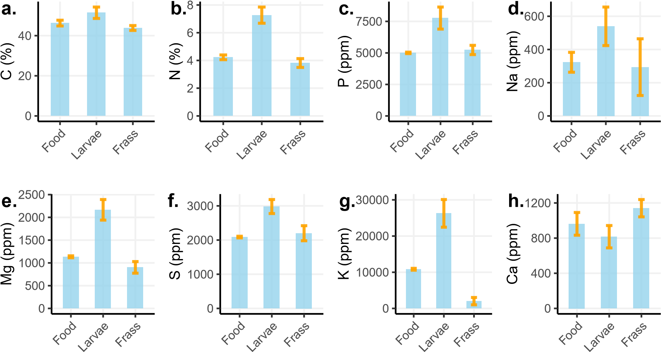

**Figure S1.** Differences in content between food, larvae (all conditions) and frass in the eight elements.

200

300

400

500

Nov

Dec

Jan

Feb

Date of the experiment

Bodymass at the start of 7th instar (mg fw)

**Figure S2.** Variation of larvae fresh body mass at the start of the experiment among the ten weeks of work (years: 2021-2022). Each point represents an individual. At the start, larvae are at the very beginning of their seventh larval stage. Only one week (4) shows a slightly higher body mass than the expected 300 mg.

200

300

400

500

120

240

360

480

900

Treatment (mg daily food)

Bodymass at the start of 7th instar (mg fw)

**Figure S3.** Variation of larvae fresh body mass at the start of the experiment among the five treatments. Each point represents an individual. At the start, larvae are at the very beginning of their seventh larval stage. F-test shows that there was bodymasses did not differ between treatment (p-value = 0.3022).

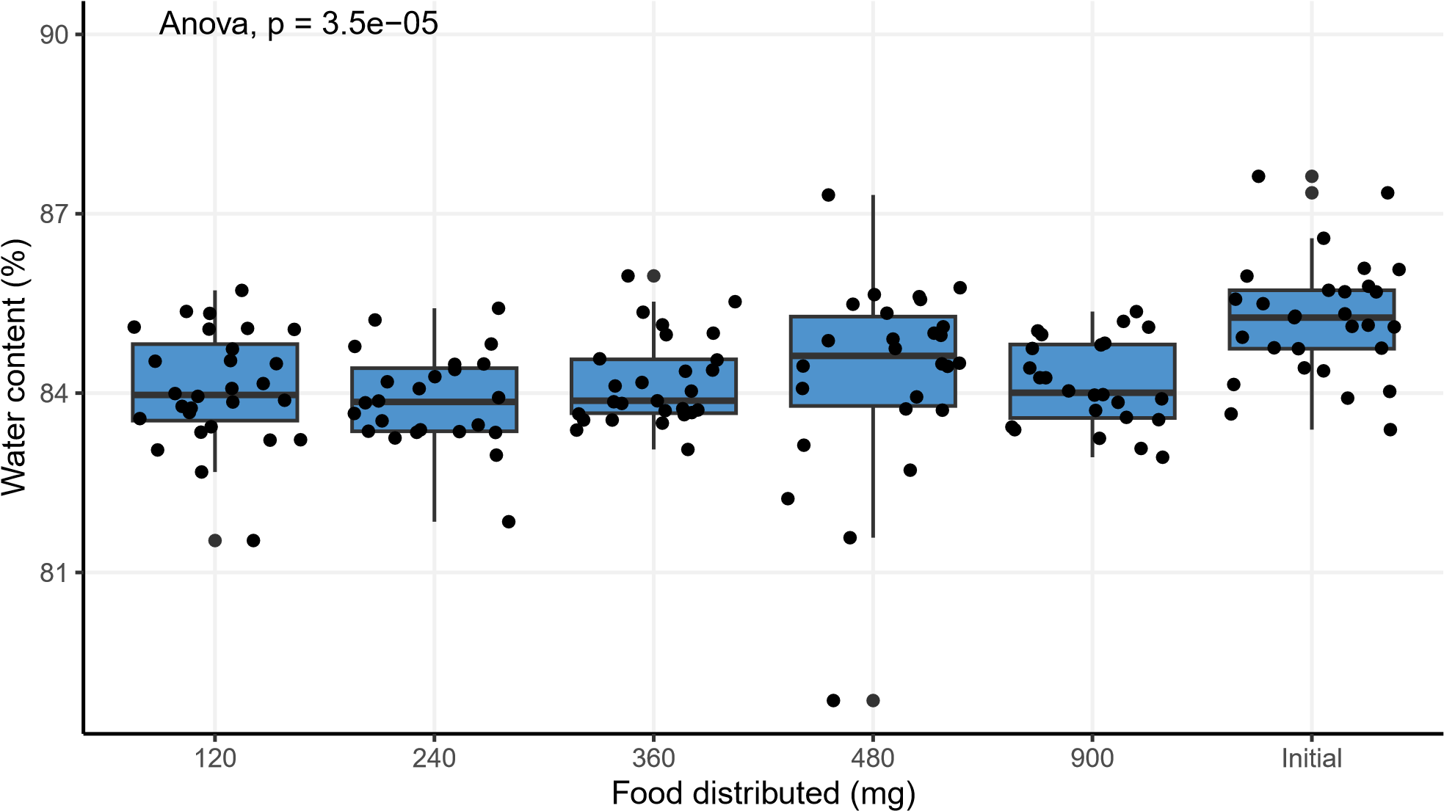

**Figure S4.** Variation of larvae water content among the five treatments and compared to the initial value. Each point represents an individual. At the start, larvae are at the very beginning of their seventh larval stage. F-test shows that there was bodymasses did not differ between treatment (p-value = 0.3022).

# Mass budget

Investigating the total mass budgets mainly consisted of analysing GAMs that were fitted between the various variables of interest and the MSIR. The models were fitted (fig. 2) and their first derivative was numerically computed to assess the complex effect of MSIR (fig. S5).

## GAM models

**Table 2.** Summaries of the four GAMs plotted in fig. 2. MSIR stand for mass-specific intake rate, GR for growth rate, GE for growth efficiency, and AE for assimilation efficiency, edf for effective degrees of freedom. TP refers to thin-plate splines, and AD to adaptive splines. The parameter *φ* for Beta regressions is indicated in parentheses (**?**)

|  |  |  |  |  |  |  |  |  |  |
| --- | --- | --- | --- | --- | --- | --- | --- | --- | --- |
| **Predictor** | **Response** | **n** | **edf** | **ref df** | **n parameters** | **p** | **Adjusted R**2 | **Family** | **Smoother** |
| MSIR | GR | 394 | 5.25 | 6.37 | 10 | <2e-16 | 0.94 | Scaled t(4.23,0.029) | TP |
| MSIR | AE | 394 | 5.04 | 6.15 | 10 | <2e-16 | 0.5 | Scaled t(5.664,0.038) | TP |
| MSIR | GE | 395 | 4.98 | 5.7 | 10 | <2e-16 | 0.34 | Scaled t(5.415,0.021) | AD |
| GR | GE | 393 | 4.83 | 5.52 | 10 | <2e-16 | 0.32 | Scaled t(10.325,0.023) | AD |

**Supplementary figures**

## a b

0.0

0.3

0.6

0.9

0.25

0.50

0.75

1.00

1.25

Intake

rate

*d*

*d*

*x*

Growth rate

−0.2

0.0

0.2

0.5

1.0

1.5

2.0

Intake

rate

*d*

*d*

*x*

Assimilation efficiency

(mgfood mgbody−1 day−1) (mgfood mgbody−1 day−1)

## c d

0.0

0.2

0.4

0.5

1.0

1.5

2.0

Intake

rate

*d*

*d*

*x*

Growth efficiency

0.0

0.5

1.0

1.5

2.0

0.25

0.50

0.75

Gowth

rate

*d*

*d*

*x*

Growth efficiency

(mgfood mgbody−1 day−1)

**Figure S5.** The derivatives, computed as finite differences, of each model plotted in fig. 2. Blue portions of the derivatives highlight domains where the derivative is significantly positive, whereas yellow portions highlight domains where it is negative. Black portions show domains where it is not significantly different from 0. The confidence interval is simultaneous and is computed using the gratia package in R.

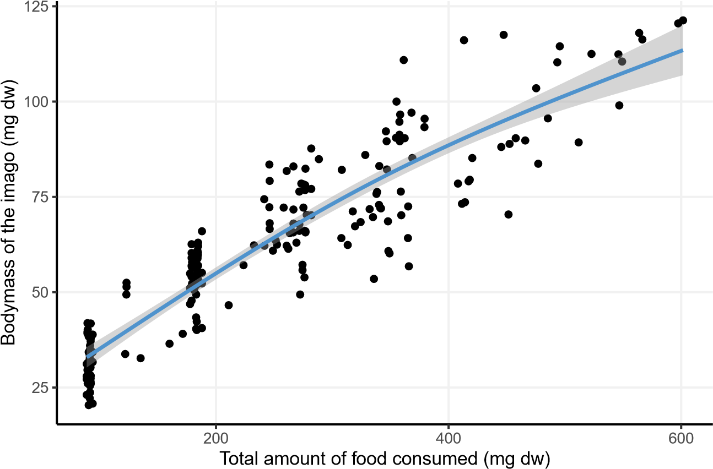

**Figure S6.** Variation of adult body mass according to food consumed during the experiment. Each point represents an individual.

# Nutrients budgets

In this section, we provide further information about the nutrient budget assessment. Individual GAMs for each of the four variables AE, RT, larval and frass nutrient content, all regressed versus MSIR are given in table 3. We proceed by representing these models in figs. S7, 3, S11, S12. For AE and RT, we also represent their first derivative computed numerically in figs.S8 and S10.

For both AE and RT, a GAM was run with both element and MSIR as dependent variables. Contrasts were estimated for pairs of elements on both the predictions of the model and the trends of the models, allowing to investigate differences between elemental AE (table 4) and RT (table 6) and the effect of MSIR thereupon (tables 4 and 7 respectively).

Finally, we provide two interesting figures related to the stoichiometric aspects of the experiment, although not intended at first, and specifically about the growth rate hypothesis (fig. S13) and the relationship between stoichiometric stocks in the consumer and its frass (fig.S14)

**Table 3.** Summaries of element-wise GAM models used to produce the plots in figs. 3, S7, S9, S11 and S12. AE stands for assimilation efficiency, and RT for retention time, edf for effective degrees of freedom. All models were fitted using thin-plate splines and with 10 parameters. The parameter *φ* for Beta regressions is indicated in parentheses (**?**)

## Response Element n edf ref df p Adjusted R2 Family Link function

|  |  |  |  |  |  |  |
| --- | --- | --- | --- | --- | --- | --- |
| Larvae | C | 92 | 1.03 | 1.06 | <2e-16 | 0.37 |
| N | 92 | 2.42 | 3.03 | <2e-16 | 0.37 |
| P | 94 | 2.8 | 3.49 | <2e-16 | 0.77 |
| Na | 94 | 4.53 | 5.54 | <2e-16 | 0.71 |
| Mg | 94 | 2.74 | 3.41 | 5e-03 | 0.14 |
| S | 94 | 4.63 | 5.65 | <2e-16 | 0.61 |
| K | 94 | 3.61 | 4.45 | 2.5e-04 | 0.21 |
| Ca | 94 | 3.24 | 4.01 | <2e-16 | 0.43 |
| Frass | C | 100 | 1 | 1 | 3.1e-05 | 0.15 |
| N | 100 | 1.95 | 2.44 | <2e-16 | 0.48 |
| P | 100 | 5.81 | 6.96 | 3.6e-06 | 0.31 |
| Na | 98 | 1.52 | 1.88 | 1.2e-03 | 0.13 |
| Mg | 100 | 1.01 | 1.02 | <2e-16 | 0.41 |
| S | 100 | 1.45 | 1.77 | 1.4e-03 | 0.12 |
| K | 100 | 4.2 | 5.15 | <2e-16 | 0.54 |

gaussian identity

Ca 100 3.35 4.15 3.8e-04 0.19

|  |  |  |  |  |  |  |
| --- | --- | --- | --- | --- | --- | --- |
| C | 100 | 3.55 | 4.39 | <2e-16 | 0.66 | Beta regression(216.21) |
| N | 100 | 4.19 | 5.14 | <2e-16 | 0.77 | Beta regression(188.025) |
| P | 100 | 4.59 | 5.61 | <2e-16 | 0.66 | Beta regression(119.23) |
| Na | 98 | 1 | 1 | <2e-16 | 0.37 | Beta regression(7.454) |
| Mg | 100 | 2.71 | 3.38 | <2e-16 | 0.61 | Beta regression(74.326) |
| S | 100 | 3.45 | 4.26 | <2e-16 | 0.57 | Beta regression(75.659) |
| K | 100 | 4.18 | 5.13 | <2e-16 | 0.59 | Beta regression(76.537) |

AE

logit

Ca 100 2.48 3.1 <2e-16 0.43 Beta regression(43.478)

|  |  |  |  |  |  |
| --- | --- | --- | --- | --- | --- |
| C | 92 | 4.16 | 5.1 | <2e-16 | 0.96 |
| N | 92 | 4.27 | 5.23 | <2e-16 | 0.95 |
| P | 94 | 4.09 | 5.02 | <2e-16 | 0.94 |
| Na | 92 | 2.46 | 3.07 | <2e-16 | 0.33 |
| Mg | 94 | 3.93 | 4.83 | <2e-16 | 0.88 |
| S | 94 | 4.29 | 5.26 | <2e-16 | 0.97 |
| K | 94 | 3.58 | 4.42 | <2e-16 | 0.74 |

RTGamma log

Ca 94 4.04 4.96 <2e-16 0.88

## Absorption efficiencies

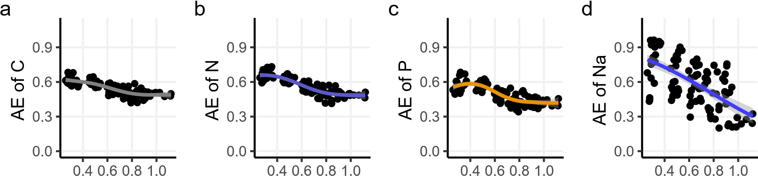

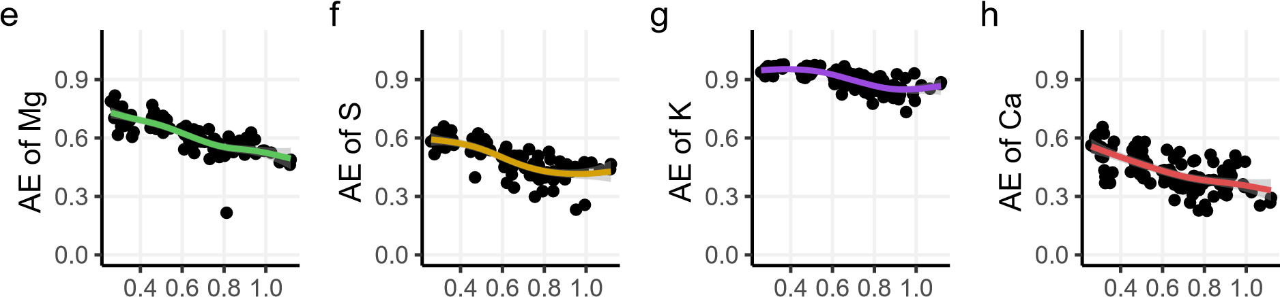

## Intake rate (mgfood mg−body1 (fw) day−1)

**Figure S7.** Assimilation efficiencies of the eight tested elements as a function of mass-specific intake rate. Each point is a measurement done on four larvae. Lines are GAMs.

**Table 4.** Pairwise comparisons of elemental absorption efficiencies predictions outputed by the general GAM model. From left to right: elements being compared, the average difference is their estimate, the standard error associated. The z value for the test followed by the p- and the S- values. Finally, the confidence interval of the difference.

|  |  |  |  |  |  |  |  |
| --- | --- | --- | --- | --- | --- | --- | --- |
| **Term** | **Estimate** | **Std. Error** | **z** | **Pr(>|z|)** | **S** | **2.5 %** | **97.5 %** |
| C - N | -0.0193 | 0.01150 | -1.680 | 0.09297 | 3.4 | -0.0419 | 0.00322 |
| **C - P** | 0.0461 | 0.01156 | 3.992 | **< 0.001** | 13.9 | 0.0235 | 0.06880 |
| **C - S** | 0.0512 | 0.01155 | 4.435 | **< 0.001** | 16.7 | 0.0286 | 0.07388 |
| **C - Na** | -0.0489 | 0.01128 | -4.340 | **< 0.001** | 16.1 | -0.0710 | -0.02684 |
| **C - Mg** | -0.0695 | 0.01138 | -6.105 | **< 0.001** | 29.9 | -0.0918 | -0.04719 |
| **C - K** | -0.3573 | 0.00938 | -38.080 | **< 0.001** | Inf | -0.3757 | -0.33893 |
| **C - Ca** | 0.1099 | 0.01150 | 9.553 | **< 0.001** | 69.4 | 0.0873 | 0.13240 |
| **N - P** | 0.0655 | 0.01151 | 5.688 | **< 0.001** | 26.2 | 0.0429 | 0.08803 |
| **N - S** | 0.0706 | 0.01150 | 6.134 | **< 0.001** | 30.1 | 0.0480 | 0.09311 |
| **N - Na** | -0.0296 | 0.01123 | -2.638 | **0.00834** | 6.9 | -0.0516 | -0.00761 |
| **N - Mg** | -0.0502 | 0.01133 | -4.427 | **< 0.001** | 16.7 | -0.0724 | -0.02796 |
| **N - K** | -0.3380 | 0.00932 | -36.255 | **< 0.001** | 953.7 | -0.3563 | -0.31972 |
| **N - Ca** | 0.1292 | 0.01145 | 11.282 | **< 0.001** | 95.6 | 0.1067 | 0.15163 |
| P - S | 0.0051 | 0.01156 | 0.441 | 0.65927 | 0.6 | -0.0176 | 0.02775 |
| **P - Na** | -0.0951 | 0.01128 | -8.427 | **< 0.001** | 54.7 | -0.1172 | -0.07297 |
| **P - Mg** | -0.1156 | 0.01139 | -10.153 | **< 0.001** | 78.0 | -0.1380 | -0.09332 |
| **P - K** | -0.4035 | 0.00939 | -42.966 | **< 0.001** | Inf | -0.4219 | -0.38506 |
| **P - Ca** | 0.0637 | 0.01151 | 5.538 | **< 0.001** | 25.0 | 0.0412 | 0.08627 |
| **S - Na** | -0.1002 | 0.01128 | -8.883 | **< 0.001** | 60.4 | -0.1223 | -0.07808 |
| **S - Mg** | -0.1207 | 0.01138 | -10.606 | **< 0.001** | 84.9 | -0.1431 | -0.09843 |
| **S - K** | -0.4086 | 0.00938 | -43.539 | **< 0.001** | Inf | -0.4270 | -0.39017 |
| **S - Ca** | 0.0586 | 0.01150 | 5.097 | **< 0.001** | 21.5 | 0.0361 | 0.08117 |
| Na - Mg | -0.0206 | 0.01110 | -1.852 | 0.06401 | 4.0 | -0.0423 | 0.00120 |
| **Na - K** | -0.3084 | 0.00904 | -34.112 | **< 0.001** | 844.8 | -0.3261 | -0.29066 |
| **Na - Ca** | 0.1588 | 0.01122 | 14.151 | **< 0.001** | 148.6 | 0.1368 | 0.18080 |
| **Mg - K** | -0.2878 | 0.00917 | -31.371 | **< 0.001** | 715.2 | -0.3058 | -0.26983 |
| **Mg - Ca** | 0.1794 | 0.01133 | 15.830 | **< 0.001** | 185.1 | 0.1572 | 0.20158 |
| **K - Ca** | 0.4672 | 0.00932 | 50.139 | **< 0.001** | Inf | 0.4489 | 0.48545 |

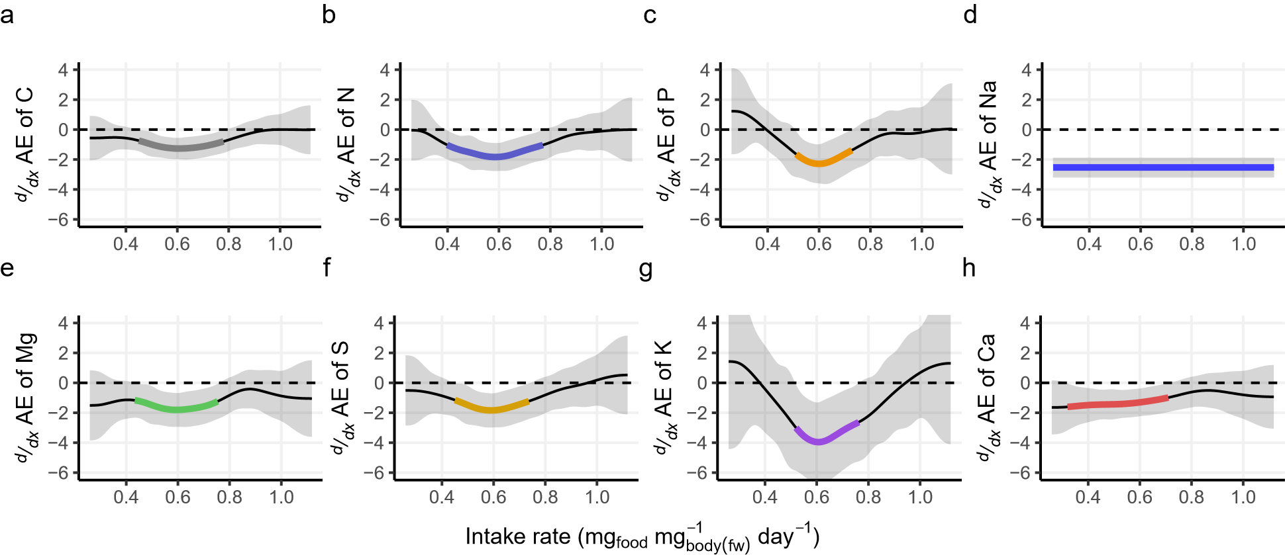

**Figure S8.** First derivatives of assimilation efficiencies of the eight tested elements as a function of mass-specific intake rate, estimated through finite difference quotient. The confidence interval is of the simultaneous type, coloured are the intervals over which the derivative is significantly different from 0.

**Table 5.** Pairwise comparisons of the effect of intake rate on elemental absorption efficiencies predictions outputed by the general GAM model. From left to right: elements being compared, the average difference is their estimate, the standard error associated.

The z value for the test followed by the p- and the S- values. Finally, the confidence interval of the difference.

|  |  |  |  |  |  |  |  |
| --- | --- | --- | --- | --- | --- | --- | --- |
| **Term** | **Estimate** | **Std. Error** | **z** | **Pr(>|z|)** | **S** | **2.5 %** | **97.5 %** |
| C - Ca | 0.04593 | 0.0315 | 1.457 | 0.14520 | 2.8 | -0.015868 | 0.1077 |
| C - K | -0.03652 | 0.0260 | -1.406 | 0.15960 | 2.6 | -0.087410 | 0.0144 |
| C - Mg | 0.05767 | 0.0297 | 1.940 | 0.05239 | 4.3 | -0.000596 | 0.1159 |
| C - N | 0.04256 | 0.0304 | 1.401 | 0.16118 | 2.6 | -0.016977 | 0.1021 |
| **C - Na** | 0.26265 | 0.0280 | 9.385 | **< 0.001** | 67.1 | 0.207801 | 0.3175 |
| C - P | 0.00797 | 0.0345 | 0.231 | 0.81745 | 0.3 | -0.059704 | 0.0756 |
| C - S | 0.03066 | 0.0325 | 0.944 | 0.34534 | 1.5 | -0.033016 | 0.0943 |
| **Ca - K** | -0.08245 | 0.0276 | -2.988 | **0.00280** | 8.5 | -0.136525 | -0.0284 |
| Ca - Mg | 0.01174 | 0.0312 | 0.377 | 0.70626 | 0.5 | -0.049328 | 0.0728 |
| Ca - N | -0.00337 | 0.0318 | -0.106 | 0.91559 | 0.1 | -0.065652 | 0.0589 |
| **Ca - Na** | 0.21672 | 0.0295 | 7.347 | **< 0.001** | 42.2 | 0.158904 | 0.2745 |
| Ca - P | -0.03796 | 0.0358 | -1.061 | 0.28853 | 1.8 | -0.108062 | 0.0321 |
| Ca - S | -0.01527 | 0.0338 | -0.452 | 0.65133 | 0.6 | -0.081520 | 0.0510 |
| **K - Mg** | 0.09419 | 0.0255 | 3.692 | **< 0.001** | 12.1 | 0.044187 | 0.1442 |
| **K - N** | 0.07908 | 0.0263 | 3.011 | **0.00261** | 8.6 | 0.027602 | 0.1306 |
| **K - Na** | 0.29917 | 0.0235 | 12.754 | **< 0.001** | 121.3 | 0.253195 | 0.3451 |
| K - P | 0.04449 | 0.0310 | 1.436 | 0.15089 | 2.7 | -0.016216 | 0.1052 |
| **K - S** | 0.06717 | 0.0287 | 2.342 | **0.01916** | 5.7 | 0.010967 | 0.1234 |
| Mg - N | -0.01511 | 0.0300 | -0.504 | 0.61438 | 0.7 | -0.073896 | 0.0437 |
| **Mg - Na** | 0.20498 | 0.0276 | 7.436 | **< 0.001** | 43.1 | 0.150948 | 0.2590 |
| Mg - P | -0.04970 | 0.0342 | -1.454 | 0.14601 | 2.8 | -0.116715 | 0.0173 |
| Mg - S | -0.02702 | 0.0321 | -0.841 | 0.40036 | 1.3 | -0.089985 | 0.0359 |
| **N - Na** | 0.22009 | 0.0283 | 7.787 | **< 0.001** | 47.0 | 0.164693 | 0.2755 |
| N - P | -0.03459 | 0.0348 | -0.995 | 0.31957 | 1.6 | -0.102711 | 0.0335 |
| N - S | -0.01191 | 0.0327 | -0.364 | 0.71599 | 0.5 | -0.076049 | 0.0522 |
| **Na - P** | -0.25468 | 0.0327 | -7.792 | **< 0.001** | 47.1 | -0.318740 | -0.1906 |
| **Na - S** | -0.23200 | 0.0305 | -7.602 | **< 0.001** | 45.0 | -0.291810 | -0.1722 |
| P - S | 0.02269 | 0.0366 | 0.620 | 0.53549 | 0.9 | -0.049071 | 0.0944 |

### Retention times

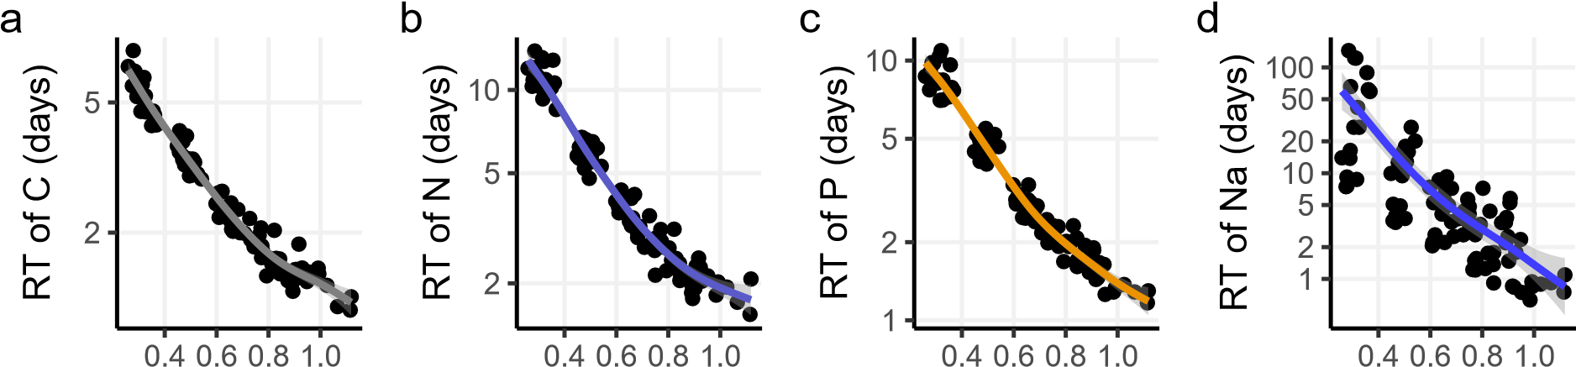

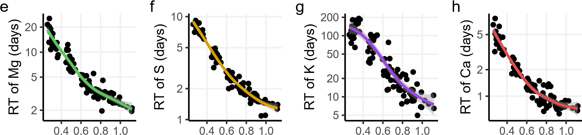

## Intake rate (mgfood mg−body1 (fw) day−1)

**Figure S9.** Retention times of the eight tested elements as a function of mass-specific intake rate. Each point is a measurement done on four larvae. Lines are GAMs.

**Table 6.** Pairwise comparisons of elemental retention times predictions outputed by the general GAM model. From left to right: elements being compared, the average difference is their estimate, the standard error associated. The z value for the test followed by the p- and the S- values. Finally, the confidence interval of the difference.

|  |  |  |  |  |  |  |  |
| --- | --- | --- | --- | --- | --- | --- | --- |
| **Term** | **Estimate** | **Std. Error** | **z** | **Pr(>|z|)** | **S** | **2.5 %** | **97.5 %** |
| **C - N** | -2.191 | 0.212 | -10.35 | **<0.001** | 81.0 | -2.6062 | -1.777 |
| **C - P** | -1.046 | 0.174 | -6.01 | **<0.001** | 29.0 | -1.3876 | -0.705 |
| **C - S** | -0.655 | 0.161 | -4.06 | **<0.001** | 14.3 | -0.9720 | -0.339 |
| **C - Na** | -9.995 | 0.708 | -14.13 | **<0.001** | 148.1 | -11.3822 | -8.608 |
| **C - Mg** | -3.682 | 0.264 | -13.95 | **<0.001** | 144.4 | -4.1996 | -3.165 |
| **C - K** | -47.632 | 2.033 | -23.43 | **<0.001** | 400.8 | -51.6170 | -43.647 |
| **C - Ca** | 0.943 | 0.123 | 7.68 | **<0.001** | 45.8 | 0.7022 | 1.183 |
| **N - P** | 1.145 | 0.235 | 4.87 | **<0.001** | 19.7 | 0.6837 | 1.606 |
| **N - S** | 1.536 | 0.226 | 6.79 | **<0.001** | 36.4 | 1.0926 | 1.979 |
| **N - Na** | -7.804 | 0.725 | -10.76 | **<0.001** | 87.3 | -9.2252 | -6.383 |
| **N - Mg** | -1.491 | 0.308 | -4.84 | **<0.001** | 19.6 | -2.0942 | -0.887 |
| **N - K** | -45.441 | 2.039 | -22.28 | **<0.001** | 363.0 | -49.4377 | -41.444 |
| **N - Ca** | 3.134 | 0.200 | 15.64 | **<0.001** | 180.8 | 2.7414 | 3.527 |
| **P - S** | 0.391 | 0.191 | 2.04 | **0.0412** | 4.6 | 0.0156 | 0.766 |
| **P - Na** | -8.949 | 0.715 | -12.52 | **<0.001** | 117.0 | -10.3505 | -7.548 |
| **P - Mg** | -2.636 | 0.283 | -9.30 | **<0.001** | 66.0 | -3.1912 | -2.080 |
| **P - K** | -46.586 | 2.036 | -22.88 | **<0.001** | 382.6 | -50.5758 | -42.596 |
| **P - Ca** | 1.989 | 0.160 | 12.42 | **<0.001** | 115.2 | 1.6752 | 2.303 |
| **S - Na** | -9.340 | 0.712 | -13.12 | **<0.001** | 128.1 | -10.7355 | -7.944 |
| **S - Mg** | -3.027 | 0.276 | -10.97 | **<0.001** | 90.7 | -3.5672 | -2.486 |
| **S - K** | -46.977 | 2.035 | -23.09 | **<0.001** | 389.4 | -50.9646 | -42.989 |
| **S - Ca** | 1.598 | 0.146 | 10.92 | **<0.001** | 89.8 | 1.3114 | 1.885 |
| **Na - Mg** | 6.313 | 0.742 | 8.51 | **<0.001** | 55.6 | 4.8588 | 7.768 |
| **Na - K** | -37.637 | 2.148 | -17.52 | **<0.001** | 225.9 | -41.8471 | -33.426 |
| **Na - Ca** | 10.938 | 0.704 | 15.53 | **<0.001** | 178.3 | 9.5578 | 12.319 |
| **Mg - K** | -43.950 | 2.045 | -21.49 | **<0.001** | 337.8 | -47.9589 | -39.941 |
| **Mg - Ca** | 4.625 | 0.255 | 18.13 | **<0.001** | 241.7 | 4.1250 | 5.125 |
| **K - Ca** | 48.575 | 2.032 | 23.90 | **<0.001** | 417.1 | 44.5922 | 52.558 |

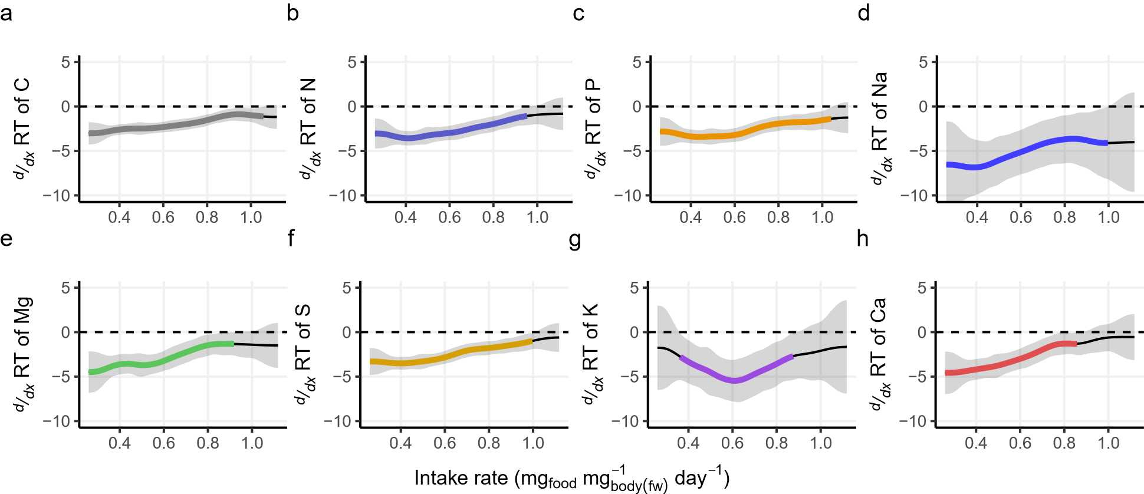

**Figure S10.** First derivatives of retention time of each element as a function of mass-specific intake rate, estimated through finite difference quotient. The confidence interval is of the simultaneous type, coloured are the intervals over which the derivative is significantly different from 0.

**Table 7.** Pairwise comparisons of the effect of intake rate on elemental retention times predictions outputed by the general GAM model. From left to right: elements being compared, the average difference is their estimate, the standard error associated. The z value for the test followed by the p- and the S- values. Finally, the confidence interval of the difference.

|  |  |  |  |  |  |  |  |
| --- | --- | --- | --- | --- | --- | --- | --- |
| **Term** | **Estimate** | **Std. Error** | **z** | **Pr(>|z|)** | **S** | **2.5 %** | **97.5 %** |
| C - Ca | 0.0636 | 0.700 | 0.0908 | 0.92762 | 0.1 | -1.309 | 1.436 |
| **C - K** | 81.9584 | 15.847 | 5.1719 | **< 0.001** | 22.0 | 50.899 | 113.017 |
| **C - Mg** | 9.1689 | 1.676 | 5.4700 | **< 0.001** | 24.4 | 5.884 | 12.454 |
| **C - N** | 5.0965 | 1.187 | 4.2931 | **< 0.001** | 15.8 | 2.770 | 7.423 |
| **C - Na** | -60.3468 | 9.324 | -6.4721 | **< 0.001** | 33.3 | -78.622 | -42.072 |
| **C - P** | 3.0777 | 0.910 | 3.3826 | **< 0.001** | 10.4 | 1.294 | 4.861 |
| **C - S** | 2.2309 | 0.873 | 2.5558 | **0.01060** | 6.6 | 0.520 | 3.942 |
| **Ca - K** | 81.8948 | 15.848 | 5.1674 | **< 0.001** | 22.0 | 50.832 | 112.957 |
| **Ca - Mg** | 9.1053 | 1.692 | 5.3811 | **< 0.001** | 23.7 | 5.789 | 12.422 |
| **Ca - N** | 5.0329 | 1.209 | 4.1613 | **< 0.001** | 14.9 | 2.662 | 7.403 |
| **Ca - Na** | -60.4104 | 9.327 | -6.4769 | **< 0.001** | 33.3 | -78.691 | -42.130 |
| **Ca - P** | 3.0141 | 0.939 | 3.2107 | **0.00132** | 9.6 | 1.174 | 4.854 |
| **Ca - S** | 2.1672 | 0.903 | 2.4002 | **0.01639** | 5.9 | 0.397 | 3.937 |
| **K - Mg** | -72.7895 | 15.921 | -4.5718 | **< 0.001** | 17.7 | -103.995 | -41.584 |
| **K - N** | -76.8619 | 15.877 | -4.8410 | **< 0.001** | 19.6 | -107.981 | -45.743 |
| **K - Na** | -142.3052 | 18.375 | -7.7447 | **< 0.001** | 46.6 | -178.319 | -106.292 |
| **K - P** | -78.8807 | 15.859 | -4.9738 | **< 0.001** | 20.5 | -109.964 | -47.797 |
| **K - S** | -79.7275 | 15.857 | -5.0279 | **< 0.001** | 20.9 | -110.807 | -48.648 |
| **Mg - N** | -4.0724 | 1.945 | -2.0941 | **0.03625** | 4.8 | -7.884 | -0.261 |
| **Mg - Na** | -69.5157 | 9.451 | -7.3557 | **< 0.001** | 42.3 | -88.038 | -50.993 |
| **Mg - P** | -6.0912 | 1.789 | -3.4049 | **< 0.001** | 10.6 | -9.597 | -2.585 |
| **Mg - S** | -6.9380 | 1.770 | -3.9188 | **< 0.001** | 13.5 | -10.408 | -3.468 |
| **N - Na** | -65.4433 | 9.376 | -6.9798 | **< 0.001** | 38.3 | -83.820 | -47.066 |
| N - P | -2.0188 | 1.342 | -1.5047 | 0.13240 | 2.9 | -4.648 | 0.611 |
| **N - S** | -2.8656 | 1.317 | -2.1762 | **0.02954** | 5.1 | -5.447 | -0.285 |
| **Na - P** | 63.4245 | 9.345 | 6.7869 | **< 0.001** | 36.3 | 45.108 | 81.741 |
| **Na - S** | 62.5776 | 9.342 | 6.6988 | **< 0.001** | 35.5 | 44.269 | 80.887 |
| P - S | -0.8469 | 1.074 | -0.7888 | 0.43022 | 1.2 | -2.951 | 1.257 |

### Frass and larvae

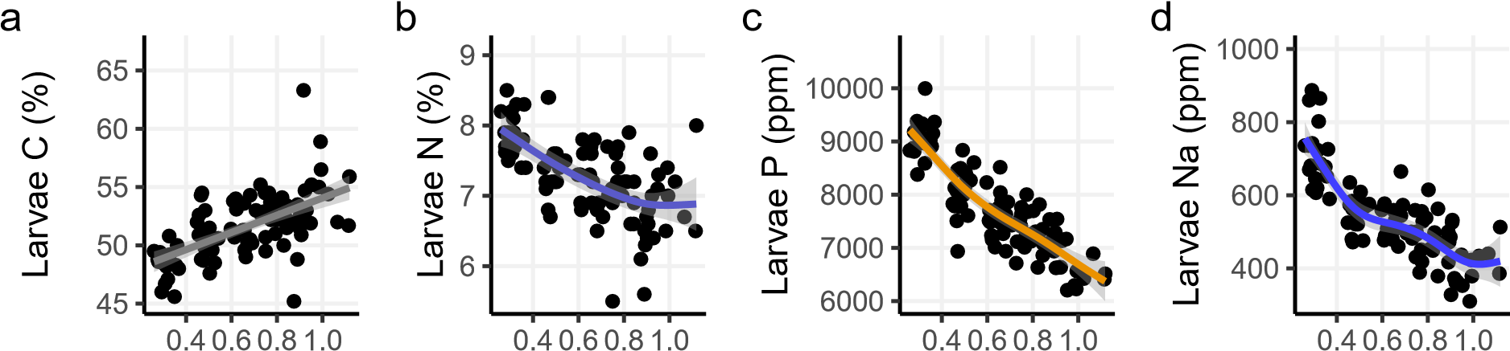

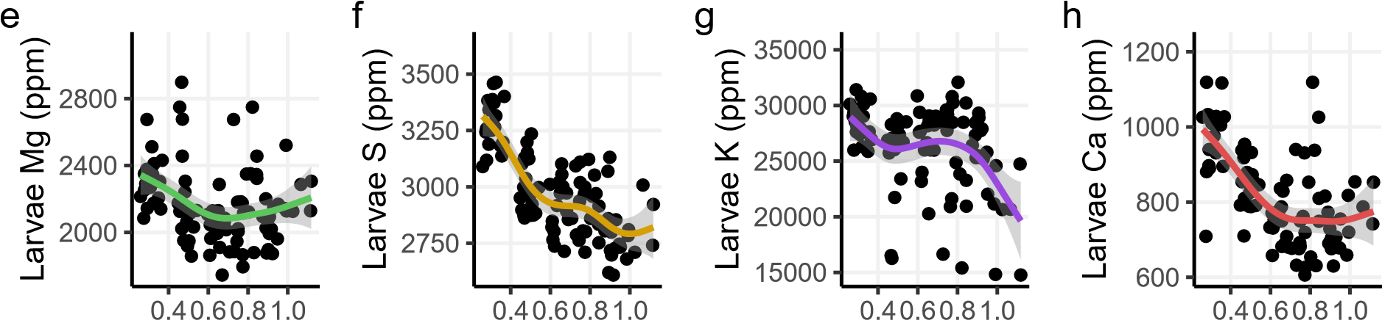

## Intake rate (mgfood mg−body1 (fw) day−1)

**Figure S11.** Body content in the eight tested elements as a function of mass-specific intake rate. Each point is a measurement done on four larvae. Lines are GAMs.

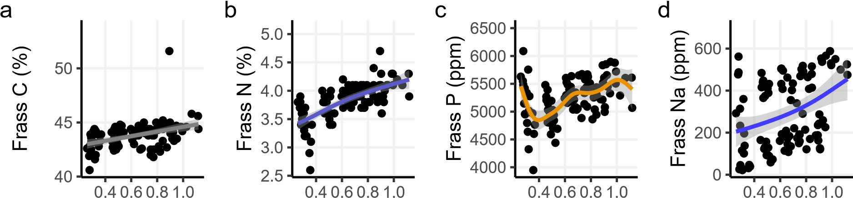

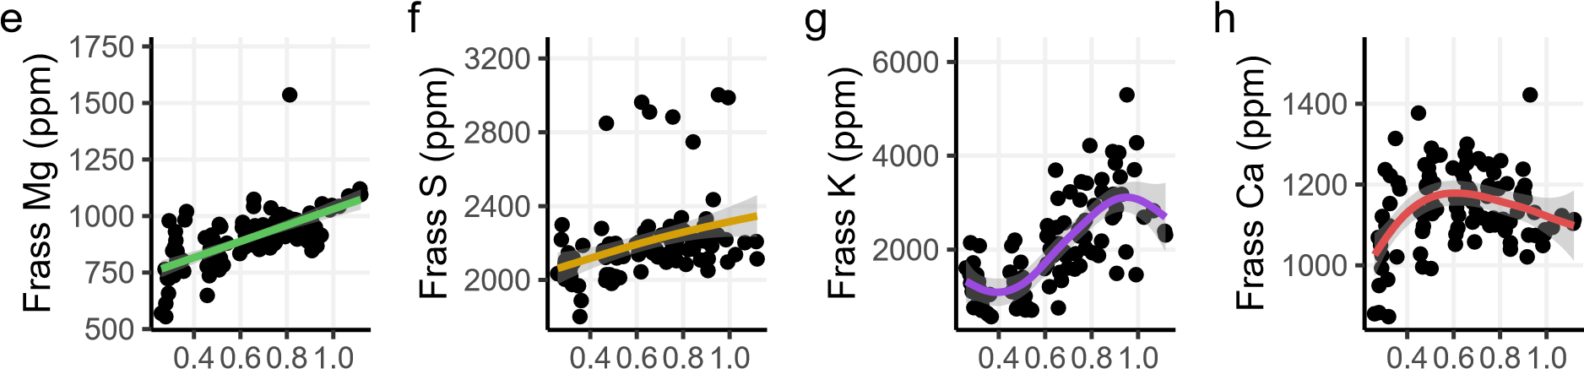

## Intake rate (mgfood mg−body1 (fw) day−1)

**Figure S12.** Frass (egestion) content in the eight tested elements according to the mass-specific intake rate. Each point is a measurement done on four larvae. Lines are GAMs

### Stoichiometry

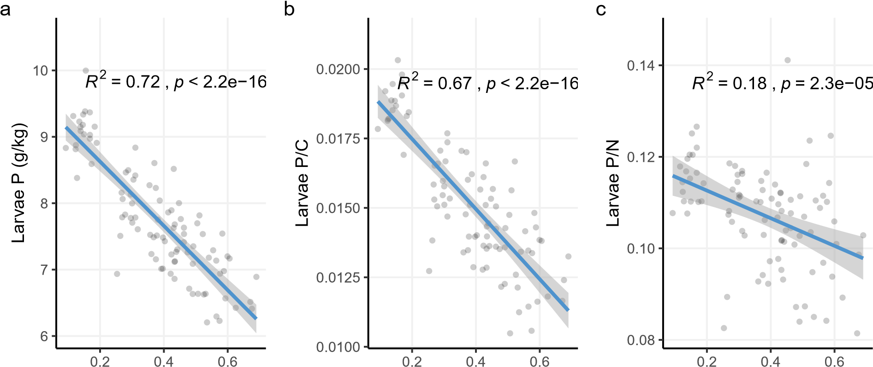

Growth rate

**Figure S13.** Relationship between larval P, P/C and P/N and growth rate. Each point represents a group of four larvae. The regression line is a linear model, of which R2 and Pearson correlation p-values are shown.

ρ

=

0.22

,

*p*

=

0.035

6

7

8

7

8

9

10

11

12

Larvae N:P

Frass N:P

Intake level



0.3

0.5

0.7

0.9

1.1

**Figure S14.** Relationship between larvae and frass N/P. Each point represents a group of four larvae. The regression line represents a cubic spline. In colour is shown intake level measured as mass-specific intake rate (mg *×* mg *−*1 *×* day *−*1 in fresh weight).