Spinal Chordoma
Evidence-based best practices for multimodal treatment
Surgery, radiotherapy (protons, photons and carbon ions) and systemic therapy, with guideline-integrated decision pathways for adults and children
Evidence current to | 12 November 2026
Sources | MEDLINE/PubMed and PubMed Central (NCBI E-utilities); Europe PMC (including preprints and open-access full text); guideline publishers and professional societies (Chordoma Global Consensus Group, NCCN, ESMO, British Sarcoma Group, ASTRO, SIOPE, NCI PDQ); trial registries. Google Scholar and The Lens could not be queried directly (see Section 1).
Reference style | NLM / PubMed citation format with PMID and PMCID
Intended use | Clinical and research reference to support multidisciplinary decision-making. Not a substitute for individualized assessment by an experienced chordoma team or for the full text of the cited guidelines.

Contents
Key conclusions
1. Scope, methods and strength of evidence
2. Disease overview
3. Guidelines and consensus statements
4. Diagnostic evaluation and treatment planning
5. Surgical management
6. Radiotherapy
7. Systemic therapy
8. Integrated decision pathways
9. Pediatric versus adult chordoma
10. Follow-up and survivorship
11. Evidence gaps and ongoing research
References
Appendix A. Search strategy
Tables: 1 Guidelines and consensus · 2 Surgical outcomes · 3 Radiotherapy dose and volumes · 4 Protons vs photons vs carbon ions · 5 Systemic-therapy trials · 6 Pediatric vs adult. Figures 1–5: decision pathways (Section 8).

Key conclusions
- Centralize care from the first suspicion. Refer before biopsy or surgery to a high-volume center with a chordoma/sarcoma multidisciplinary team (MDT). The first treatment offers the best chance of cure, and recurrent disease is rarely curable [1–3]. In the US National Cancer Database, high-volume facilities achieved more margin-negative resections (62.5% vs 47.9%) and better survival (HR 0.43) [4].
- Surgery. En bloc resection with negative (Enneking-appropriate) margins is the cornerstone for mobile-spine and sacral chordoma. Intralesional or margin-violating resection raises local-recurrence risk several-fold (HR ≈7) [5–7]. When en bloc resection would cost unacceptable function (typically high sacral tumors needing bilateral S1–S2/S2–S3 root sacrifice, or many cervical tumors), the alternatives are definitive high-dose particle radiotherapy or planned maximal safe resection followed by high-dose radiotherapy [2,8,9].
- Radiotherapy: dose is what matters. Chordoma needs at least 70–74 Gy(RBE) in conventional fractions (74–78 Gy[RBE] to gross disease) or a biologically equivalent hypofractionated schedule: carbon ions 64–70.4 Gy(RBE) in 16 fractions, or single-fraction SBRT 24 Gy. Low-dose conventional radiotherapy adds wound and fracture toxicity without improving control [3,10,11].
- Protons vs photons. No randomized trial compares them. A Cochrane review rates the comparative evidence as very low certainty [12]. Protons, or carbon ions, are preferred where available because they deliver the required dose with less dose to the spinal cord, cauda equina, bowel and skin, and with lower integral dose. This matters most for large, sacral, paraspinal, definitive, re-irradiation and pediatric cases. High-dose photon IMRT or SBRT is an acceptable alternative when it meets the same dose goals within constraints, for example small mobile-spine lesions [13,14]. In the only randomized trial, protons and carbon ions gave similar outcomes (ISAC; sacral; 64 Gy[RBE]/16 fractions) [15].
- Systemic therapy. No drug is approved. Cytotoxic chemotherapy is inactive in conventional chordoma. Across 12 prospective trials (328 patients), the objective response rate was 4.7% and median PFS 10.8 months [16]. Off-label targeted agents (imatinib ± everolimus/sirolimus, other TKIs) and PD-1 inhibitors are for progressive advanced disease, preferably within trials. The newest signal is camrelizumab plus apatinib (phase II; ORR 24%; median PFS 28 months) [17]. Dedifferentiated and poorly differentiated (SMARCB1-deficient) chordomas behave like different diseases and warrant sarcoma-type chemotherapy and/or EZH2-directed or immunotherapy approaches [18–20].
- Children vs adults. Children account for <5% of chordomas. Their tumors are more often skull-base/cervical, are more often poorly differentiated, and metastasize more often [21,22]. Conventional pediatric spinal chordoma does very well with maximal safe surgery plus proton therapy (20-year OS 94% at MGH) [23]. Poorly differentiated chordoma (median age about 11) needs aggressive multimodal therapy including chemotherapy [19,24]. Protons are strongly favored in children to limit growth disturbance and second cancers [25,26].

1. Scope, methods and strength of evidence
This review covers chordoma of the mobile spine (cervical, thoracic and lumbar) and the sacrum/coccyx. It addresses surgery, radiotherapy (including the proton–photon question and carbon ions), systemic therapy, guideline-based integration of these modalities, and differences between pediatric and adult care. Skull-base chordoma is covered only where evidence is shared, for example pediatric series that pool sites.
Searches. PubMed/MEDLINE was searched through the NCBI E-utilities interface. Europe PMC was searched through its REST API; it indexes PubMed, PubMed Central full text and preprint servers. Both searches were run on 12 November 2026. Chordoma was combined with terms for anatomical site, treatment modality (en bloc, margin, radiotherapy, proton, carbon ion, stereotactic, IMRT, chemotherapy, targeted therapy, immunotherapy, named drugs and trials), population (pediatric, adolescent, poorly differentiated, SMARCB1/INI1) and document type (consensus, guideline, systematic review, meta-analysis, clinical trial). Guidelines from NCCN, ESMO, the British Sarcoma Group, ASTRO, SIOPE and NCI PDQ were identified through PubMed and targeted web searches. Search strings are listed in Appendix Table A1.
Coverage limitation. Google Scholar and The Lens could not be queried directly: the network policy of the environment used to prepare this report blocked automated access to both, as well as to some publisher sites (JAMA Network, NCCN). Their content was covered as far as possible through Europe PMC and general web searching. Readers with institutional access may wish to run a confirmatory search there. The full text of the 2026 JAMA Oncology Global Consensus could not be retrieved, so its content below comes from the published abstract and secondary summaries. Consult the full article for its graded, site-specific recommendations.
Selection and appraisal. Priority went to: (1) guidelines and formal consensus statements; (2) randomized and prospective trials; (3) systematic reviews and meta-analyses; (4) large multicenter, registry and population-based cohorts; and (5) landmark single-institution series with long follow-up. Full text was reviewed for open-access documents, including the 2017 Global Consensus on recurrent chordoma and the 2023 Spine Tumor Academy radiotherapy guide. Other data were taken from PubMed abstracts. All references were generated programmatically from PubMed records in NLM (PubMed) citation format: the first six authors followed by 'et al.', with PMID and, where available, PMCID.
Strength of evidence. Chordoma is ultra-rare (about 1 case per million people per year). Apart from one randomized phase II radiotherapy trial (protons vs carbon ions) and a few randomized phase II drug trials, the evidence is retrospective (levels III–IV), and most recommendations are consensus-based. Outcome figures come from heterogeneous, selected cohorts and should not be compared directly across studies.

2. Disease overview

2.1 Epidemiology and natural history
Chordoma arises from notochordal remnants. In SEER (1973–1995), the US age-adjusted incidence was 0.08 per 100,000. Chordoma was more common in men and rare before age 40. Of all cases, 32% were cranial, 32.8% spinal and 29.2% sacral. Median survival was 6.3 years, with 5- and 10-year relative survival of 67.6% and 39.9% [27]. In a contemporary SEER analysis of 896 spinal and sacral chordomas (2000–2020), 5-year overall survival (OS) was 72% for conventional and 33% for dedifferentiated chordoma. Gross-total resection (HR 0.22) and radiotherapy (HR 0.69) were associated with longer survival [28].
Local recurrence is the dominant failure pattern. Distant metastases (lung, bone, liver, skin and soft tissue) develop in 40–60% of patients over the course of the disease [2]. Relapses occur late. In 99 resected sacral chordomas followed for a median of 8.7 years, cumulative local recurrence reached 30%, 46% and 56% at 5, 10 and 15 years, with no plateau [6]. Because recurrent chordoma is rarely curable, the initial treatment plan is decisive [3,10].

2.2 Pathology and subtypes
The WHO classification recognizes conventional chordoma (including the chondroid pattern), poorly differentiated chordoma and dedifferentiated chordoma [29]. The 6th edition (2026) refines essential and desirable diagnostic criteria and separates clinically meaningful subtypes from morphological patterns [30]. Nuclear brachyury (TBXT) expression together with cytokeratin positivity establishes the diagnosis [31].
- Conventional/chondroid (most cases): slow-growing and locally aggressive; resistant to cytotoxic chemotherapy and to conventional radiotherapy doses.
- Poorly differentiated (PDC): loss of SMARCB1/INI1, usually by deletion. Occurs mainly in children and young adults (median age 11 years in the MGH series), more often at the clivus and cervical spine than the sacrum. Survival is markedly worse [19,32,33].
- Dedifferentiated: a high-grade sarcomatous component, arising de novo or after treatment. In one cohort, metastasis was more frequent than in conventional chordoma (57% vs 5%) and median OS was shorter (20 vs 155 months) [18]. Gross-total resection and radiotherapy were associated with longer survival [34].

2.3 Prognostic factors
In an integrative analysis of 682 spinal chordomas and in multicenter cohorts, adverse factors included: intralesional or Enneking-inappropriate resection; prior surgery or recurrence at presentation; large tumor volume (≥100 cm³); dedifferentiated histology; older age (for overall survival); and bowel/bladder dysfunction at presentation [5,35–37]. After radiotherapy, gross residual disease, metallic stabilization hardware and focal (rather than comprehensive) target volumes predicted local failure [3,38,39]. Facility volume independently predicted both R0 resection and survival. Better margins explained only about 17% of that survival benefit, which suggests that wider multidisciplinary expertise accounts for most of it [4].

3. Guidelines and consensus statements
No guideline rests on randomized evidence. Nevertheless, the major documents agree on the core principles. Care belongs in expert centers. Biopsy should be planned and core-needle. Resection should be en bloc with negative margins wherever function allows. Radiotherapy should be high-dose and highly conformal, given adjuvantly, pre-operatively or definitively. Systemic therapy is reserved for advanced disease, preferably in trials. Table 1 summarizes the most relevant documents.
Table 1. Guidelines and consensus statements relevant to spinal chordoma
Document (year) | Scope | Key positions for spinal chordoma
Chordoma Global Consensus Group (ESMO + Chordoma Foundation), Lancet Oncol 2015 [1] | Primary and metastatic chordoma, all sites | Management at reference centers by an experienced MDT; image-guided core biopsy with the tract excised at surgery; en bloc resection with negative margins as standard for mobile-spine and sacral tumors; high-dose conformal radiotherapy (particles where available) after incomplete resection, or definitively when surgery would be unduly morbid; no role for cytotoxic chemotherapy in conventional chordoma; targeted agents (e.g., imatinib) for progressive advanced disease.
Chordoma Global Consensus Group, Ann Oncol 2017 [10] | Local-regional recurrence | En bloc re-resection with negative margins when feasible (IV-B); no curative re-resection for multifocal disease (IV-B); salvage radiotherapy at first-line doses (≥74 GyE in 1.8–2 GyE fractions, V*-A; carbon ions 60–70.4 Gy[RBE] in 3–4.4 Gy[RBE] fractions); re-irradiation only within estimated organ tolerance, with carbon ions an option after prior low-LET radiotherapy; caution with surgery after high-dose radiotherapy (IV-C); consider carbon-fiber implants; MRI every 3–6 months for at least 3 years.
Global Chordoma Consensus Group, JAMA Oncol 2026 [2] | Primary localized chordoma in adults and children, stratified by skull base, mobile spine and sacrum (305 articles; Milan, June 2025) | Update of the 2015 consensus. Central principle: treatment at experienced multidisciplinary centers with maximally safe surgery followed by high-dose, highly conformal radiotherapy. Site-specific guidance on diagnosis, surgical approach and radiotherapy planning; systemic therapy options; risk-adapted long-term follow-up; supportive, palliative and rehabilitative care. Levels of evidence and grades of recommendation assigned (consult full text).
NCCN Guidelines: Bone Cancer, v2.2025 (JNCCN) and v2.2026 (online) [40–42] | Bone cancers including chordoma (US) | Chordoma pathways by histologic subtype; wide excision ± radiotherapy for resectable disease; radiotherapy with specialized techniques (protons/carbon ions, IMRT, SRS) to doses ≥70 Gy for unresectable disease; off-label systemic options for recurrent/metastatic disease, including imatinib alone or combined with cisplatin or sirolimus, dasatinib, sunitinib, sorafenib, erlotinib, and lapatinib for EGFR-positive tumors. Verify against the current online version.
ESMO–EURACAN–GENTURIS–ERN PaedCan Bone Sarcoma Guideline 2021 [43] | Bone sarcomas in adults and children (Europe) | Chordoma section aligned with the Global Consensus: referral to reference centers, en bloc surgery, high-dose radiotherapy, and off-label targeted therapy for advanced disease.
British Sarcoma Group UK guidelines 2025 [44] | Primary malignant bone tumors (UK) | Suspected primary bone tumors referred to and managed by an accredited bone sarcoma MDT; recommendations by tumor type for localized, metastatic and recurrent disease; follow-up schedules.
Spine Tumor Academy practical guide 2023 [3] | Radiotherapy for mobile-spine and sacral chordoma | Consensus (>75% of experts): MDT involvement at diagnosis; CT plus co-registered T2 MRI; comprehensive target volumes (MGH schema); acceptable schedules of 75.6–77.4 Gy(RBE) in 1.8–2 Gy fractions (protons ± photons), SBRT 24 Gy × 1 or 40–50 Gy × 5, or carbon ions ≥70.4 Gy(RBE) in 2.2–4.4 Gy fractions; skin dose <66 Gy(RBE).
AO Spine Knowledge Forum Tumor systematic review 2016 [45] | Locally recurrent spinal chordoma | En bloc resection when feasible with acceptable morbidity (strong recommendation, low-quality evidence); partial resection otherwise (weak); high-dose conformal postoperative radiotherapy, which may also serve as primary therapy (strong, very low-quality evidence).
ASTRO Model Policy: Proton Beam Therapy [46] | US coverage indications | Group 1 indications include primary or metastatic spine tumors where cord tolerance may be exceeded with conventional treatment, skull-base tumors such as chordoma, re-irradiation, and pediatric tumors treated with curative intent.
SIOPE Radiotherapy Working Group 2019 [25] | Vertebral dose in children | Deliver homogeneous vertebral dose in children who have not completed the pubertal growth spurt; include the whole vertebra (body and arch) when it is partly in the field; age-specific limits on dose gradients when fall-off is unavoidable.
NCI PDQ: Childhood Chordoma Treatment [47] | Pediatric | Peer-reviewed, regularly updated NCI summary of the pediatric evidence.

4. Diagnostic evaluation and treatment planning
- Early referral. Every suspected chordoma should be referred before biopsy or surgery to a center with chordoma expertise [1,2,44], because facility volume affects outcomes [4].
- Imaging. Contrast-enhanced MRI of the primary and the whole spine; CT of the primary (bone destruction, fracture risk, surgical planning); CT of the chest (± abdomen/pelvis). PET/CT, bone scan or whole-body MRI in selected cases, such as suspected dedifferentiation or metastasis [1].
- Biopsy. CT-guided core-needle biopsy, performed at or coordinated with the treating center, along a route the surgeon can excise en bloc. Avoid transrectal biopsy of sacral tumors and open or intralesional 'excisional' biopsy. Tumor seeding along surgical and biopsy tracts is well documented and can turn a curable tumor into an incurable one [1,48].
- Pathology. Brachyury, cytokeratins and SMARCB1/INI1 immunohistochemistry, reviewed by a bone-tumor pathologist. INI1 is essential in children and young adults. In advanced disease, molecular profiling (e.g., CDKN2A/MTAP, PI3K/PTEN, EGFR) informs trial eligibility [31,49].
- Surgical staging. Use Enneking oncologic staging and the Weinstein–Boriani–Biagini (WBB) sector system to plan en bloc resection. 'Enneking-appropriate' resection (achieved margin matching the recommended margin) predicts lower local recurrence [5,50,51].
- Function and counseling. Record baseline neurological, bowel, bladder and sexual function and pain. Discuss the expected functional cost of each option (Section 5.3). Offer fertility-preservation counseling before pelvic or sacral radiotherapy in young patients [52].
- Implant planning. If stabilization is needed, carbon-fiber–reinforced PEEK (CFR-PEEK) implants reduce CT/MRI artifacts and dosimetric uncertainty, especially for proton therapy [10,53].

5. Surgical management

5.1 Evidence for en bloc resection with negative margins
En bloc resection with negative margins is the treatment most consistently associated with durable local control [1,2]. The evidence is entirely observational but consistent:
- Rizzoli Institute, 50-year mobile-spine series. In the older cohort, every patient treated with radiotherapy alone, intralesional excision, or both recurred within 2 years. With extracapsular intralesional excision plus radiotherapy, 12 of 16 recurred (mean 30 months) [54].
- AO Spine Knowledge Forum Tumor, 166 mobile-spine chordomas. Enneking-inappropriate resection increased local-recurrence risk (HR 7.02; 95% CI 2.96–16.6). Median postoperative survival was 8.4 vs 6.4 years for appropriate vs inappropriate resection [5].
- AO Spine, 167 sacral chordomas. Previous surgery and intralesional resection independently predicted local recurrence [36].
- Two reference centers, 99 sacral chordomas (median follow-up 8.7 years). Fifteen-year disease-free survival was 49% after R0 vs 7% after R1 resection. Tumor size and margin were the only independent predictors [6].
- Pooled sacral evidence. In a meta-analysis (12 studies, 436 patients), wide margins reduced recurrence (RR 0.42) and mortality (RR 0.49) [7]. In a pooled analysis of 1,235 resected sacral chordomas, local and distant recurrence occurred in 42.6% and 22.4% [55].
- Enneking principles across primary spinal tumors. A validation study supported applying Enneking principles to reduce local recurrence [51].

5.2 Mobile spine
En bloc spondylectomy, single- or multilevel, posterior-only or combined, is feasible for many thoracic and lumbar tumors. It often requires nerve-root sacrifice and carries substantial complication rates. In the cervical spine, the vertebral arteries, functionally critical roots and the craniocervical junction frequently preclude true en bloc resection [56,57]. In the prospective AO Spine PTRON registry (38 cervical chordomas), true en bloc resection gave better local recurrence-free survival (92% vs 83% vs 63%) and overall survival than deliberate intralesional resection or failed/secondary en bloc attempts. However, adverse events within 1 year occurred in 100% vs 39% vs 75% of patients [58].
When en bloc resection is not feasible at acceptable morbidity, the accepted alternative is planned maximal safe intralesional resection followed by high-dose particle radiotherapy. In 33 mobile-spine chordomas, local control did not differ between en bloc resection and intralesional resection plus adjuvant charged-particle therapy. Macroscopic residual tumor and pathological fracture predicted recurrence [9]. In a Vancouver cohort of 62 patients, 5-year local recurrence-free survival was 82% after Enneking-appropriate resection, 88% after Enneking-inappropriate en bloc resection plus radiotherapy, and only 52% without radiotherapy. All patients with planned intralesional resection died within 5 years [59]. In 101 patients from a quaternary center, mobile-spine location (HR 7.73) and tumor volume ≥100 cm³ (HR 5.89) predicted local recurrence, while neoadjuvant radiotherapy was protective (HR 0.09) [37]. An international AO Spine survey found wide practice variation, mainly over radiotherapy after negative margins [60].
Instrumentation. Titanium stabilization within the radiation field was associated with worse local control after pencil-beam proton therapy [38,39]. CFR-PEEK implants reduce artifacts [53], although carbon-fiber-only constructs had more mechanical complications in one series [9]. Implant choice should be agreed with the radiation oncologist before surgery.

5.3 Sacrum: level of resection, function and the surgery-vs-radiotherapy decision
The cranial extent of the tumor determines which sacral roots must be sacrificed, and therefore bowel, bladder and sexual function. Todd et al. reported normal bowel and bladder function in:
- 87% and 89% of patients after unilateral root sacrifice;
- 100% and 69% when both S3 roots were preserved;
- 67% and 60% when at least one S3 root was preserved;
- none of the patients after bilateral S2–S5 sacrifice [61].
The prospective AO Spine PTRON registry (81 sacrectomies, 2026) confirmed this pattern. Bilateral S1–S2 sacrifice caused complete bowel/bladder dysfunction, and preserving at least one S3 root preserved function in more than half of patients. About one-third of distal S4–S5 resections still caused dysfunction, which was associated with worse EQ-5D and spine-oncology quality-of-life scores and more leg pain [62]. In an earlier series of high (S1/S2) sacrectomies, only 1 of 16 patients kept normal continence, only 3 walked unaided, and 12 recurred [63]. Postoperative sacral fracture occurred in 27% after non-instrumented partial sacrectomy, mainly with S1–S2 amputation levels, combined approaches and low S1 bone density [64]. Wound complications are frequent, and plastic-surgical reconstruction is often needed [65].
Practical implication. For sacral tumors that can be resected at or below S3, en bloc sacrectomy is generally preferred. When wide margins require bilateral S2 (or higher) root sacrifice, definitive high-dose particle radiotherapy offers similar survival with better preservation of function (Section 6.3). It should be presented as a primary option in a shared decision, particularly for older or comorbid patients [1,2,8,66].

5.4 Surgery for local recurrence
For recurrent disease, en bloc re-resection is recommended when feasible, and partial resection when it is not, followed by high-dose radiotherapy if none was given previously [10,45]. Outcomes are poor: 5-year OS was 39% after recurrent mobile-spine chordoma, and positive margins at re-resection predicted further relapse (HR 7.92) [67]. Surgery in previously high-dose irradiated fields carries a markedly higher complication risk [10].
Table 2. Selected surgical outcome studies in spinal and sacral chordoma
Study | Design / population | Principal findings
Boriani 2006 [54] | Single center; 52 mobile-spine chordomas over 50 years | All patients with radiotherapy alone or intralesional excision recurred within 2 years; best outcomes after en bloc resection.
Gokaslan 2016 [5] | AO Spine multicenter; 166 mobile spine | Enneking-inappropriate resection: local recurrence HR 7.02; median survival 8.4 vs 6.4 years.
Varga 2015 [36] | AO Spine multicenter; 167 sacral | Previous surgery and intralesional resection predicted local recurrence; age and motor deficit predicted survival.
Radaelli 2016 [6] | Two centers; 99 sacral; median follow-up 8.7 y | 15-y DFS 49% (R0) vs 7% (R1); local recurrence 30%, 46% and 56% at 5, 10 and 15 years.
Yu 2020 [7] | Meta-analysis; 12 studies, 436 sacral | Wide vs inadequate margin: recurrence RR 0.42; mortality RR 0.49.
Kerekes 2019 [55] | Systematic review, pooled 1,235 sacral | Local recurrence 42.6%, distant recurrence 22.4%; wide margins reduced local recurrence.
Zaldivar-Jolissaint 2026 [58] | Prospective PTRON registry; 38 cervical | True en bloc vs intralesional vs failed en bloc: LRFS 92/83/63%; 1-year adverse events 100/39/75%.
Chu Kwan 2026 [59] | Single center; 62 spinal/sacral (chordoma, low-grade chondrosarcoma) | 5-y LRFS: Enneking-appropriate 82%; inappropriate + RT 88%; inappropriate without RT 52%.
Xia 2025 [37] | Single center; 101 spinal/sacral; 20 years | LRFS: volume ≥100 cm³ HR 5.89; mobile spine HR 7.73; neoadjuvant RT HR 0.09. OS: age ≥65 HR 16.7.
Hirase 2026 [68] | Single center; 113 sacral; IPTW-weighted | OS best with surgery + RT (vs surgery alone HR 2.01; definitive RT HR 3.73); local recurrence similar across groups; higher BED lowered recurrence (HR 0.92).
Todd 2002 [61]; PTRON 2026 [62] | Function after sacrectomy (53 and 81 patients) | Bilateral S3 preservation keeps most bowel/bladder function; bilateral S1–S2 sacrifice causes complete dysfunction; dysfunction worsens patient-reported outcomes.

6. Radiotherapy

6.1 Dose is the key determinant
Chordoma is relatively radioresistant, and local control depends on dose. At least 70–74 Gy(RBE) in conventional fractionation, or a biologically equivalent hypofractionated schedule, is required [1,3]. Supporting evidence:
- Low-dose adjuvant radiotherapy is harmful without benefit. In 193 sacral chordomas from four centers, adjuvant radiotherapy averaging 61.8 Gy did not reduce recurrence. It did increase wound complications (HR 2.76) and sacral stress fractures (HR 4.73). Doses ≥70 Gy trended toward benefit (HR 0.52) [11].
- Completing ≥70 Gy is associated with better outcomes. In 76 operated patients with at least 5 years of follow-up, those who received ≥70 Gy had better 5-year OS (82% vs 63%) and local recurrence-free interval (93% vs 78%) [69].
- Higher BED lowers recurrence. In a 30-year sacral cohort, each unit increase in biologically effective dose reduced the risk of local recurrence (HR 0.92) [68].
- Dose escalation is associated with survival. In the National Cancer Database, doses ≥70 Gy were associated with improved overall survival [70].

6.2 Timing: pre-operative, post-operative and definitive radiotherapy
Pre-operative radiotherapy treats an undisturbed, better-oxygenated tumor with smaller volumes, may sterilize margins and reduce seeding, and allows a post-operative boost. In the MGH phase II trial (50 patients; 29 chordomas), pre- and/or post-operative photon/proton radiotherapy gave 5- and 8-year local control of 94% and 85% for primary tumors. Recurrent tumors did far worse (7 of 14 recurred). The 8-year risk of grade 3–4 late morbidity was 13%, with no myelopathy; sacral neuropathy occurred only at 76.6–77.4 Gy(RBE) [71,72]. In 126 spinal chordomas treated with proton-based radiotherapy, primary tumors that received pre-operative radiotherapy had 85% local control vs 56% without it. None of the 28 patients treated with pre-operative radiotherapy plus en bloc resection recurred [73]. Neoadjuvant SBRT (median 40 Gy in 5 fractions) enabled negative-margin en bloc resection in 15 of 17 patients, with 12% wound complications [74]. Even so, most surgeons surveyed do not routinely use neoadjuvant radiotherapy when en bloc resection is feasible [60].
Post-operative radiotherapy is indicated after R1/R2 or contaminated resections [1,2,75]. Its benefit after a true R0 resection is uncertain. An individual-patient-data review of 132 gross-totally resected spinal chordomas found no association between adjuvant radiotherapy and PFS or OS [76]. Margin-stratified series, however, show that adjuvant radiotherapy offsets the risk of narrow margins: in sacral chordoma with margins <1.5 mm, local recurrence was 14% with vs 61% without radiotherapy [77]. It also offsets Enneking-inappropriate margins [59]. With high-dose pencil-beam scanning (PBS) protons (median 74 Gy[RBE]) at the Paul Scherrer Institute, 5-year local control was 63–65% and OS 78–81%. Gross residual disease and titanium stabilization predicted failure [38,39].

6.3 Definitive (radiotherapy-alone) treatment
Definitive radiotherapy is used when resection would cause unacceptable deficits, when the patient is medically inoperable, or when the patient prefers it:
- Protons (MGH). In unresected spinal and sacral chordomas, 5-year local control was 85.4% in 40 patients [78]. In a larger series of 67 patients (median 77.4 Gy[RBE]), 5- and 8-year local control was 81.8% and 63.6%, OS 83.5% and 65.9%, and disease-free survival trended better above 78 Gy(RBE). Insufficiency fracture was the most common late effect [79,80].
- Carbon ions (Japan). In 188 unresectable sacral chordomas treated at NIRS, 5-year local control was 77.2% and OS 81.1%, and 97% of patients remained ambulatory [66]. In a 219-patient nationwide study, 5-year local control was 72%, OS 84% and PFS 48%, with grade ≥3 late toxicity in 6% [81].
- Carbon ions (Heidelberg). In 68 mixed primary, recurrent and postoperative sacral cases, 5-year local control was 53% [82]. In 157 patients, 64 Gy(RBE)/16 fractions and 66 Gy(RBE)/22 fractions gave similar local control, but insufficiency fractures were more frequent with 16 fractions (47% vs 24%) [83].
- Photon SBRT. At MSKCC, 24 Gy in a single fraction (35 primary chordomas, mostly combined with surgery) gave 5-year local recurrence-free survival of 80.5% overall and 89.9% with 24 Gy [13,84]. At MDACC, 24 Gy single-fraction SBRT gave 5-year local control of 90%, with late grade 3 fracture after 23% of treatments [14]. A meta-analysis estimated pooled local control of 82% for chordoma [85].
- Radiotherapy vs surgery. In propensity-matched comparisons, carbon-ion radiotherapy and en bloc resection gave similar overall survival (HR 0.71), with much less motor neuropathy after carbon ions (OR 0.13) [8]. A small Japanese comparison (17 patients) found no local recurrence at 5 years and preserved urinary–anorectal function after carbon ions, versus 62.5% local recurrence-free survival and frequent functional loss after surgery [86]. By contrast, a 2026 IPTW-weighted cohort found shorter OS after definitive radiotherapy than after surgery plus radiotherapy (HR 3.73), with similar local recurrence, a difference probably confounded by selection of older and inoperable patients [68]. Systematic reviews of particle therapy report outcomes comparable to historical surgical cohorts [87,88]. Prospective comparative studies are ongoing (SACRO, NCT02986516; PROSPER) [89,90].
Salvage and re-irradiation. Proton re-irradiation (median 75.6 Gy[RBE]) of recurrent chordoma achieved 2-year local control of 85% in 16 patients, with some serious late toxicities [91]. Re-irradiation should be given with curative intent only if organ-at-risk constraints can be respected. Carbon ions are an option after prior low-LET radiotherapy [10].
Table 3. Typical radiotherapy dose, fractionation and target volumes for spinal chordoma (adults)
Setting | Protons ± photons (conventional fractionation) | Carbon ions / photon SBRT
Pre-operative | CTV1 (microscopic risk) 19.8–50.4 Gy(RBE) in 1.8 Gy fractions before en bloc resection; post-operative boost planned (MGH schema) | Neoadjuvant SBRT: 40 Gy in 5 fractions (median) in reported series
Post-operative, R0 with high-risk features | High-risk CTV2 (original GTV + ~5 mm, anatomically constrained) to ~70.2 Gy(RBE) | Carbon ions: ≥64–70.4 Gy(RBE) in 16 fractions; SBRT: 24 Gy × 1 or 40–50 Gy × 5 to high-risk volume
Post-operative R1/R2, or definitive (gross disease) | Gross residual/definitive GTV 73.8–78 Gy(RBE) at 1.8–2 Gy; MGH definitive median 77.4 Gy(RBE) | Carbon ions 64–70.4 Gy(RBE) in 16 fractions (Japanese and Heidelberg practice); SBRT 24 Gy × 1 for small targets
Salvage (RT-naive) | Same dose as first-line, ≥74 Gy(RBE) | Carbon ions 60–70.4 Gy(RBE) at 3–4.4 Gy(RBE) per fraction
Re-irradiation | Individualized; proton re-irradiation to ~75 Gy(RBE) reported | Carbon ions favored after prior low-LET RT; SBRT for small volumes
Key constraints | Skin <66 Gy(RBE) to limit wound breakdown; sacral nerves (neuropathy risk rises >76–77 Gy[RBE]); spinal cord/cauda per standard limits; bowel/rectum (consider surgical spacer); account for metal hardware | Sacral insufficiency fractures (up to ~25–47% after hypofractionated carbon ions); vertebral compression fracture after SBRT

6.4 Are protons better than photons?
Physical rationale. Protons deposit most of their dose in the Bragg peak and have no exit dose. This allows the 74–78 Gy(RBE) that chordoma requires to be delivered next to the spinal cord, cauda equina, sacral plexus, bowel and skin while staying within their tolerance, at a lower integral (whole-body) dose. Protons are not biologically more potent than photons (RBE about 1.1). Their advantage is that the necessary dose becomes deliverable more safely. Carbon ions add high linear energy transfer (LET), with greater biological effectiveness and less dependence on oxygen. This is theoretically attractive for large, hypoxic sacral tumors: FMISO-PET detected hypoxic subvolumes in 60% of spinal chordomas, mostly the larger ones [92].
Clinical evidence. Table 4 summarizes the comparative data. There is no randomized proton-vs-photon trial. The Cochrane review (6 observational studies, 187 adults; all at high risk of bias) could not determine whether protons improve local control (HR 5.34; 95% CI 0.66–43.43), mortality (HR 0.44; 0.13–1.57) or recurrence (HR 0.34; 0.10–1.17) [12]. Registry and institutional comparisons favor protons, but they are confounded by dose, era, access and selection [70,93]. Photon SBRT series show high local control in small, selected lesions [13,14]. The only randomized trial in spinal chordoma compared protons with carbon ions, not with photons, and found no difference [15].
Table 4. Comparative evidence: protons, photons and carbon ions in spinal/sacral chordoma
Study | Design | Result / interpretation
El Sayed 2021, Cochrane [12] | Systematic review; 6 observational studies, 187 adults | Very low-certainty evidence; no reliable difference in local control, mortality, recurrence or toxicity between protons and photons.
Palm 2019 [70] | NCDB; 715 chordomas (with chondrosarcomas, 1,578 total) | Definitive RT: protons associated with better 5-y OS on multivariable analysis; doses ≥70 Gy associated with better OS. Confounded by selection and limited follow-up.
Ghaith 2024 [93] | Mayo Clinic; 53 resected spinal chordomas with adjuvant RT | Recurrence 40% with protons vs 88% with non-proton RT (adjusted OR 0.1). Small, retrospective, era-confounded.
Pennington 2021 [87] | Systematic review of charged-particle therapy (38 studies) | Proton, proton/photon and carbon-ion results broadly similar (5-y local control ~53–100%); no direct photon or surgical comparisons.
Pennicooke 2016 [75] | Systematic review (40 studies) | Low-quality evidence; best control with early adjuvant RT for primary disease; photon IGRT, protons or carbon ions all considered reasonable.
Jin 2020; Sherry 2023 [13,14] | Photon single-fraction SBRT, 24 Gy (35 and 15 patients) | 5-y local control ~80–90% in small, selected lesions; vertebral fracture is the main late toxicity.
Dastgheyb 2024 [94] | Prospective phase I/II; protons ± IMRT up to 79.2 Gy (54 skull-base/spine patients) | Feasible and safe; 5-y OS 83%, local failure-free survival 72%.
Seidensaal 2024, ISAC [15] | Randomized phase II; 82 sacral chordomas; protons vs carbon ions, both 64 Gy(RBE)/16 fx | No difference between arms; 2-/4-y local PFS 84%/70%; 6% grade 4 wound-healing disorders. Control was not sustained, so better fractionation is needed.
Dong 2023 [95] | Meta-analysis of carbon-ion RT (11 studies) | Pooled 5-y local control 76% and OS 85%; acceptable toxicity.
Xiang 2020 [26] | NCDB; 450,373 patients, all tumor types | Second-cancer risk lower after proton therapy than after IMRT (adjusted OR 0.31), relevant to children and young adults.

Answer to the proton–photon question. For spinal chordoma, particle therapy (protons, or carbon ions where available) is the preferred technique. The reason is that it achieves the required high dose with less normal-tissue exposure, not that its tumoricidal effect has been shown to be greater. The preference is strongest for children and young adults, for bulky or sacral tumors, for definitive treatment of unresected disease, for tumors abutting cord, bowel or plexus, and for re-irradiation [1,3,46]. High-dose photon techniques are reasonable when they can reach an equivalent biologically effective dose within constraints. Examples are single-fraction 24 Gy SBRT for small mobile-spine lesions and IMRT when particle therapy is unavailable or titanium hardware compromises proton planning. Conventional-dose photon radiotherapy (about 50–65 Gy) should not be used with curative intent [11]. Protons and carbon ions appear equivalent at 64 Gy(RBE)/16 fractions [15].

6.5 Radiotherapy toxicity
- Sacral insufficiency fractures are the most common late effect of high-dose sacral radiotherapy, especially hypofractionated carbon ions: 47% after 64 Gy(RBE)/16 fractions vs 24% after 66 Gy(RBE)/22 fractions [79,83,96].
- Skin and wound complications: keep skin dose below 66 Gy(RBE) [3]. Skin ulceration was reported in 29% of hadron-therapy-treated sacral chordomas in a 2025 systematic review [88]. Pre- or post-operative radiotherapy increases wound complications after sacrectomy [11].
- Neuropathy: sacral neuropathy appeared at 76.6–77.4 Gy(RBE) but not at ≤72 Gy(RBE) in the MGH trial [72]. Peripheral motor neuropathy is far less frequent after carbon-ion radiotherapy than after en bloc sacrectomy [8].
- Myelopathy is rare when standard cord constraints are respected [72]. Bowel injury can be reduced with surgical spacers before particle therapy.
- Second malignancies are lower with protons than with IMRT in population data, which is most relevant for children [26].

7. Systemic therapy

7.1 Principles
- No systemic therapy is approved for chordoma. Cytotoxic chemotherapy has no established role in conventional chordoma, and there is no evidence supporting neoadjuvant or adjuvant systemic therapy for localized conventional disease [1,2].
- Systemic therapy is for unresectable, progressive local disease not amenable to further local therapy, or for progressive metastatic disease. Slowly growing, asymptomatic disease can be observed with serial imaging [10].
- Confirm progression before starting. Response is best judged by volumetric or Choi criteria in addition to RECIST, because chordomas seldom shrink by RECIST [97,98].
- Enrollment in a clinical trial is preferred. Across 12 prospective trials (328 patients, reconstructed individual data), the pooled objective response rate was 4.7% and median PFS 10.8 months. Only imatinib plus everolimus showed significantly longer PFS (14.0 months; HR 0.50) [16]. In a 2026 European retrospective series, first-line targeted therapy (84% imatinib) gave median PFS of 6.5 months and OS of 29.5 months [99].
Table 5. Prospective systemic-therapy studies in advanced conventional chordoma (adults)
Agent / study | Design (n) | Efficacy | Comment
Imatinib 800 mg/day; Stacchiotti 2012 [97] | Phase II (56) | RECIST ORR 2%; clinical benefit 64%; median PFS 9 mo | Most-used first-line off-label agent (PDGFR-directed).
Imatinib + everolimus; Stacchiotti 2018 [98] | Phase II (43) | Choi ORR 20.9%, RECIST 2.3%; median PFS 14 mo | Best PFS in pooled analysis; 30% stopped for toxicity. Imatinib + sirolimus: Choi responses in 7 of 9 imatinib-resistant patients [100].
Sorafenib; Bompas 2015 [101] | Phase II (27) | ORR 3.7%; 9-mo progression-free rate 73% | Frequent grade 3 toxicity.
Lapatinib (EGFR-positive); Stacchiotti 2013 [102] | Phase II (18) | Choi PR 33%, RECIST 0%; median PFS 8 mo | EGFR-directed; erlotinib activity only in case reports.
Dasatinib; Schuetze 2016 (SARC009) [103] | Phase II indolent-sarcoma cohort (109 total) | Objective response 18% in chondrosarcoma/chordoma combined | Prolonged stable disease in >10%.
Regorafenib; Le Cesne 2023 (REGOBONE) [104] | Randomized, placebo-controlled phase II (27) | Median PFS 8.2 vs 10.1 mo (placebo) | Negative; not recommended.
Apatinib; Liu 2020 [105] | Phase II (30) | RECIST ORR 3.7%, Choi 25.9%; median PFS 18 mo | VEGFR2 TKI (mainly available in China).
Palbociclib (CDKN2A/p16 loss); Teleanu 2025 [49] | Phase II (28) | Disease control 39% at 6 cycles; no objective responses; median PFS 5.6 mo | Met its primary endpoint; modest activity; combinations needed.
Pembrolizumab; Blay 2023 (AcSé) [106] | Phase II basket (97; 34 chordomas) | ORR 6.2% across ultra-rare sarcomas at week 12 | Retrospective ICI series: 1 CR, 3 PR, 11 SD in 17 patients; median PFS 14 mo [107].
Camrelizumab + apatinib; Yang 2026 [17] | Phase II, single center (33) | RECIST ORR 24.2%, Choi 48.5%; median PFS 28.4 mo | Most active regimen reported to date; grade 3–4 transaminase rises in ~35–40%; CDKN2A loss associated with worse outcome; needs confirmation.
BN-Brachyury vaccine + RT; Cote 2024 [108] | Phase II (29) | ORR 7.7% (irradiated lesions) | Did not meet its endpoint.
Yeast-brachyury vaccine (GI-6301) + RT; DeMaria 2021 [109] | Randomized, placebo-controlled phase II (24) | No difference (PFS HR 1.02) | Stopped early.

7.2 Dedifferentiated chordoma
Dedifferentiated chordoma behaves like a high-grade sarcoma. In one cohort, 36% of patients had metastases at presentation and median OS was 20 months [18]. Gross-total resection and radiotherapy are associated with longer survival [34]. Durable remissions with sarcoma-type chemotherapy (ifosfamide-based or multi-agent regimens) were described as early as 1993 [110]. Chemotherapy active in high-grade bone and soft-tissue sarcomas (e.g., doxorubicin- and ifosfamide-based) is therefore reasonable for the dedifferentiated component, alongside aggressive local therapy, preferably within trials [1,2].

7.3 Poorly differentiated (SMARCB1/INI1-deficient) chordoma
Poorly differentiated chordoma is a distinct, aggressive entity of children and young adults with SMARCB1 loss [19,32]. Treatment is multimodal (Section 9). Responses to multi-agent chemotherapy and chemoradiotherapy have been reported, for example ifosfamide/doxorubicin and conventional chemotherapy with radiotherapy [111,112]. The NIH pediatric chordoma clinic documented PDC patients responding to systemic therapy, but no standard regimen exists [24]. EZH2 inhibition is biologically rational. In the tazemetostat phase II basket trial, the PDC cohort (n=18) had an objective response rate of 6% [20], and one patient had an exceptional abscopal response when radiotherapy followed tazemetostat [113]. Immune checkpoint inhibition produced a response in an INI1-deficient pediatric chordoma [114]. In NCI-COG Pediatric MATCH, tazemetostat produced little objective response in SMARCB1-deficient pediatric tumors (ORR 5%) but prolonged stable disease in 25% [115].

7.4 Emerging directions
Current priorities are immunotherapy combinations, especially PD-1 blockade with anti-angiogenic agents [17], biomarker-selected targeted therapy (CDKN2A/CDK4/6, PI3K/mTOR, EGFR) [16,49], brachyury-directed strategies [108], and EZH2 inhibition for SMARCB1-deficient tumors [20]. Pooled historical benchmarks (ORR about 5%, median PFS about 11 months) should be used when interpreting single-arm trials [16].

8. Integrated decision pathways
Figures 1–5 combine the guideline recommendations and outcome data above into practical decision trees. They are meant to structure multidisciplinary discussion and are not a substitute for it. Each branch assumes treatment at an experienced center with access to particle therapy.
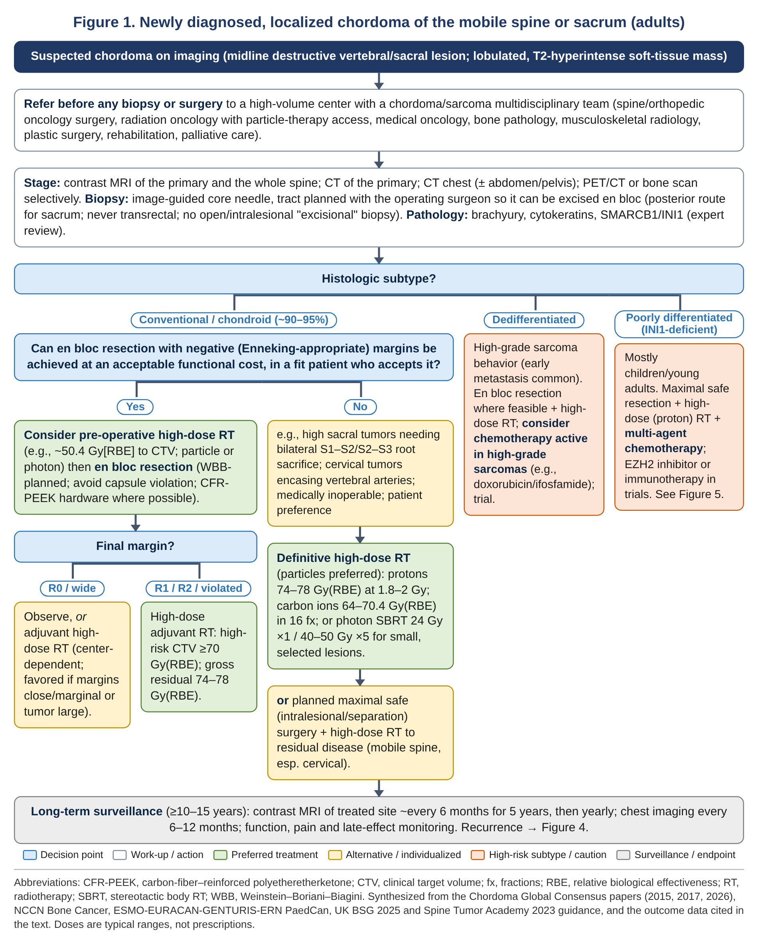
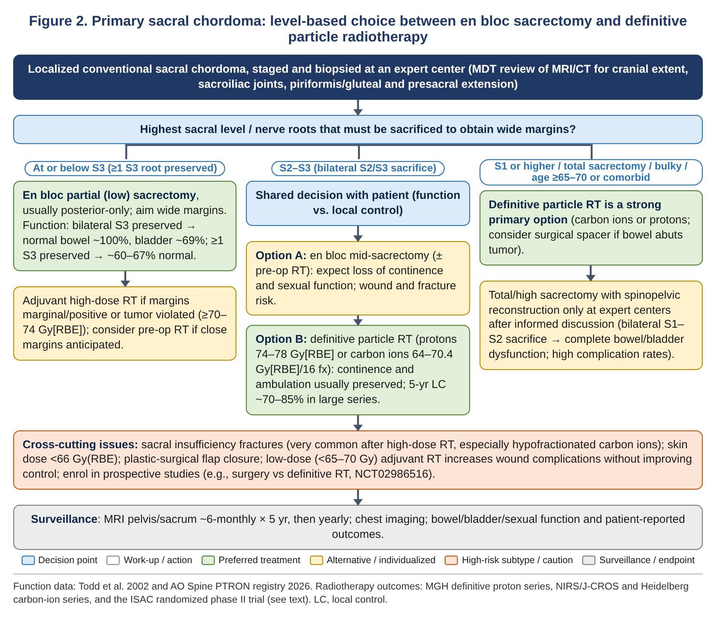
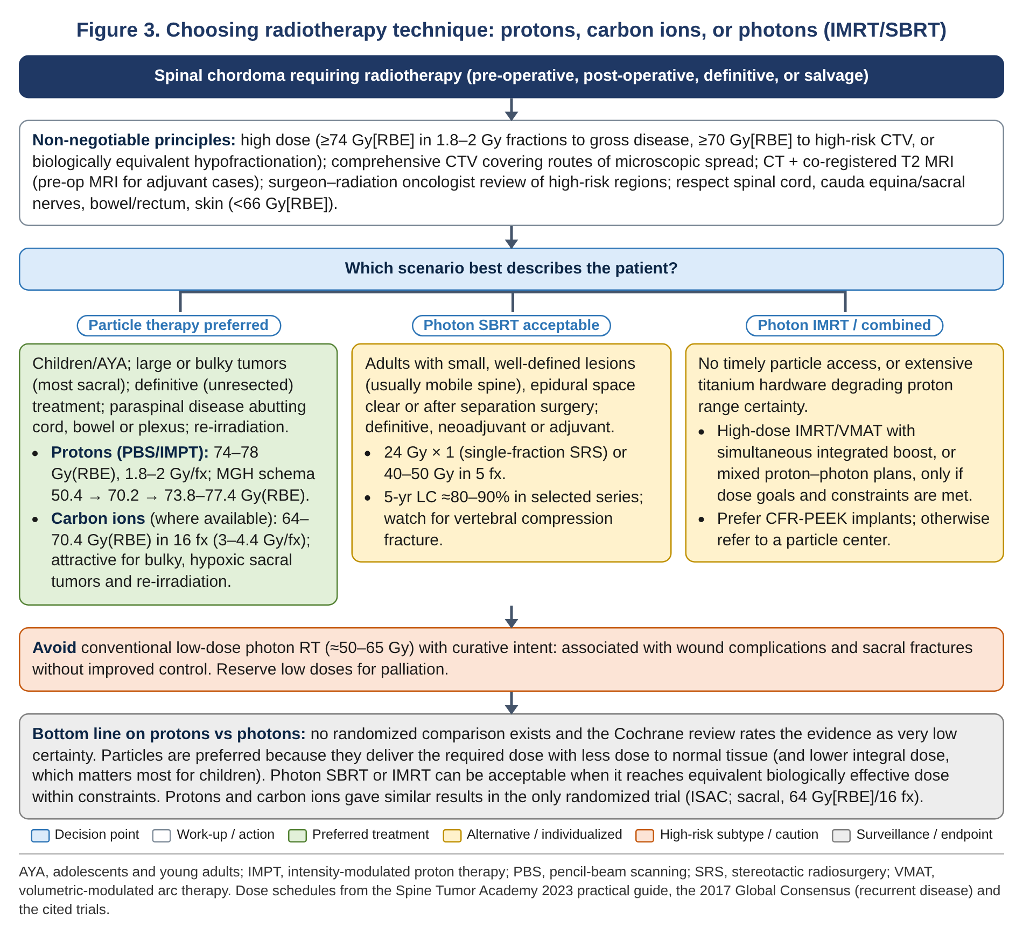
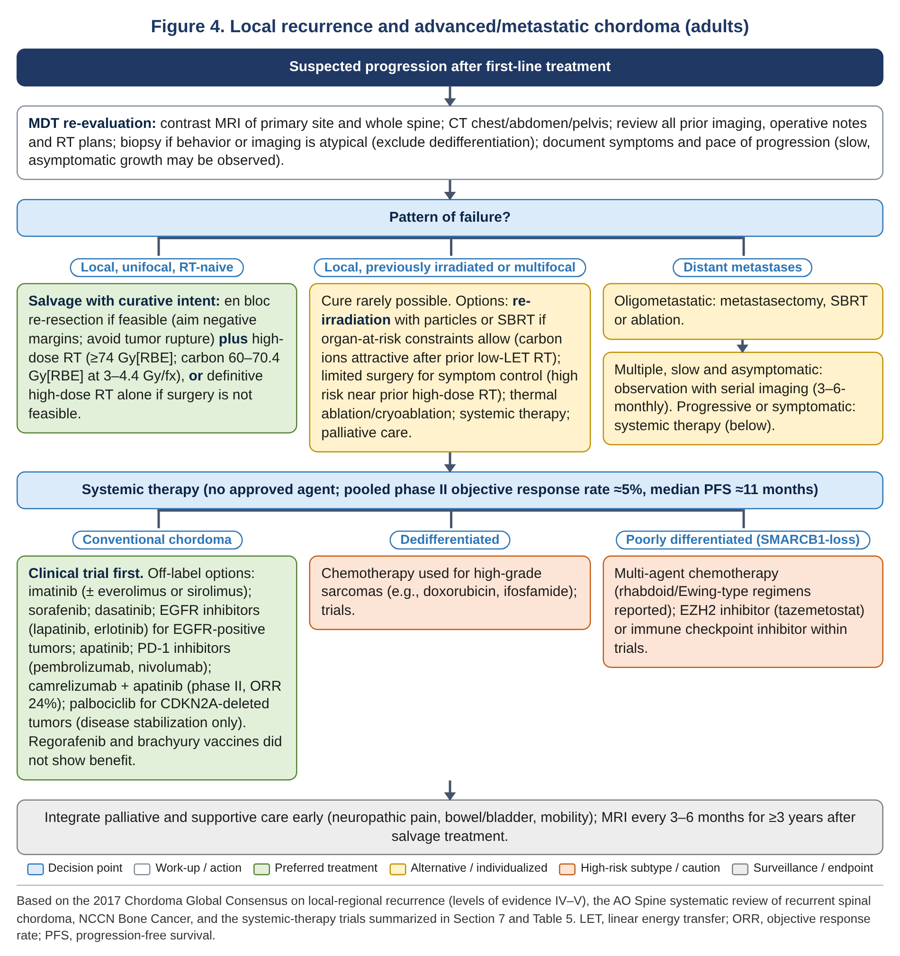
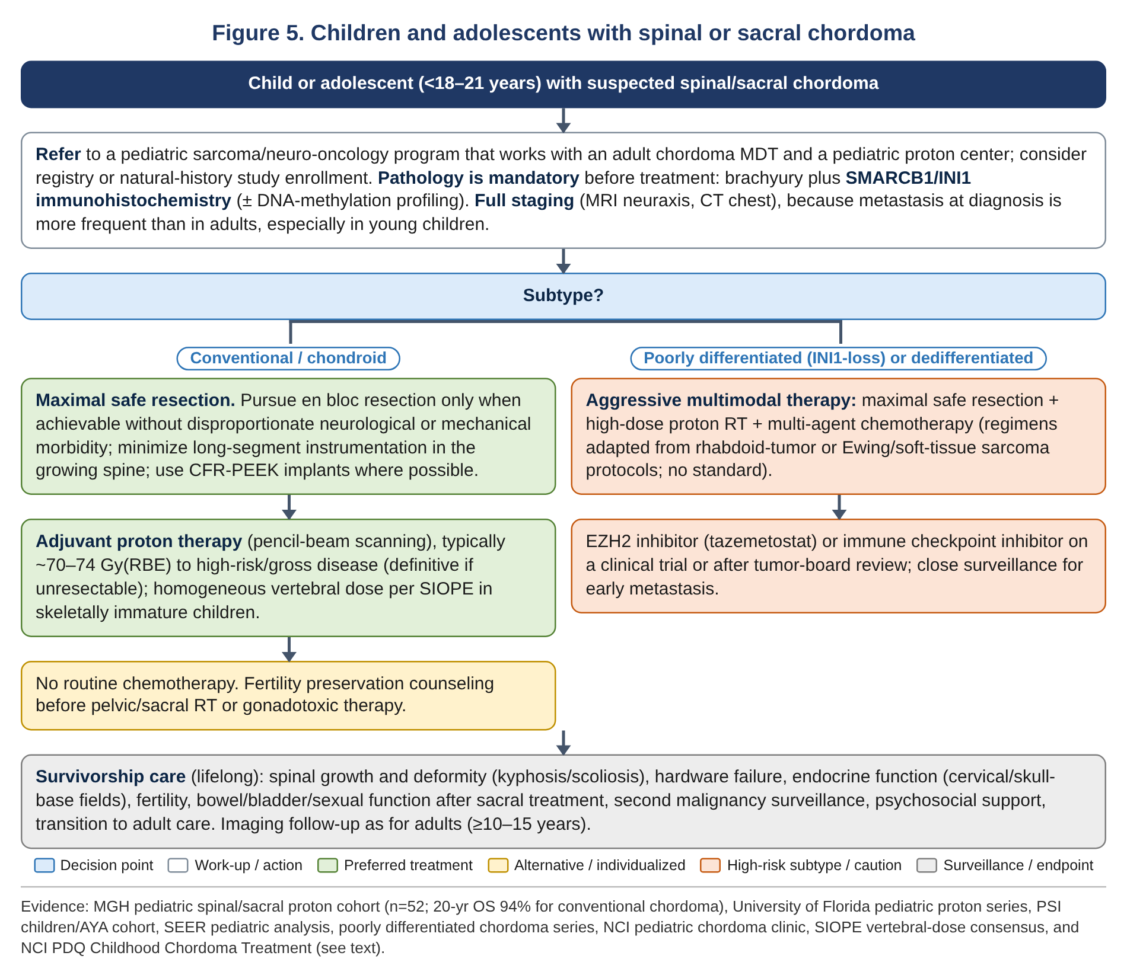

9. Pediatric versus adult chordoma

9.1 How pediatric chordoma differs
Children and adolescents account for fewer than 5% of chordomas [21,116]. Compared with adults, pediatric tumors are more often cranial or cervical. Among 86 pediatric cases in SEER, distant disease was more common (14.8% vs 9.2%) and cancer-specific mortality higher, yet overall survival was longer (17.2 vs 12.6 years) and surgery was associated with better survival [22]. In an integrative analysis of spinal chordoma, pediatric age was associated with shorter PFS and OS than adult age [35]. In 658 skull-base chordomas in the NCDB, children had larger tumors but similar overall survival [117]. Histology drives prognosis. In 73 pediatric skull-base chordomas, survival was 81% overall, but almost all patients with poorly differentiated tumors died of disease [21]. Pediatric PDC carries SMARCB1 loss, presents at a median age of about 11 years and has significantly shorter survival [19,118]. Germline ARID1B indels and mitochondrial-genome alterations are enriched in pediatric chordoma [119]. SMARCB1 alterations have also been found in some pediatric conventional-looking tumors [120].

9.2 Treatment outcomes in children
- MGH, spinal/sacral, 52 patients ≤22 years (43 chordomas; median 74.5 Gy[RBE] proton-based radiotherapy; median follow-up 11.4 years). 5-, 10- and 20-year OS were 82.7%, 72.3% and 72.3%. For conventional chordoma, 20-year OS, disease-specific survival and PFS were 93.9%, 97% and 87.9%. Poorly differentiated histology, pre-radiotherapy chemotherapy (a marker of aggressive disease) and low performance status predicted worse outcome. Only two late grade 3 toxicities occurred [23].
- University of Florida, 29 children (24 clivus/cervical, 5 lumbosacral; median 73.8 Gy[RBE] passively scattered protons). 5-year local control was 85% (92% for well-differentiated tumors), with no progression after 3 years. The authors concluded that complete resection may be unnecessary for local control and that destabilizing operations requiring instrumentation can add complications [121].
- Paul Scherrer Institute, 76 children/AYA (64% chordoma; median 73.8 Gy[RBE] PBS protons). 7-year OS was 86.3% and local control 87.7%. Resection rather than biopsy alone improved local control (87.1% vs 67.7%). Recurrent tumors did much worse, and children had worse distant control than AYAs. Quality of life matched healthy peers at 2 years; 3.9% developed secondary tumors [122].
- Pediatric clival series. Gross-total resection plus proton radiotherapy gave durable cure, consistent with Collins' law [123].

9.3 Pediatric-specific management principles
- Pathology first. Brachyury and SMARCB1/INI1 immunohistochemistry are mandatory before treatment, ± DNA-methylation profiling, which separates PDC from conventional chordoma and from atypical teratoid/rhabdoid tumor [118,120].
- Surgery. Maximal safe resection, with en bloc resection when achievable without disproportionate neurological or mechanical cost. Avoid long-segment fusion in the growing spine where possible, because instrumentation-related complications are common [121].
- Radiotherapy. Proton therapy is the modality of choice: about 70–75 Gy(RBE) to high-risk or gross disease, following SIOPE vertebral-dose principles (homogeneous dose across growing vertebrae) [23,25,122]. Protons substantially reduce integral dose and second-cancer risk [26].
- Systemic therapy. None for conventional chordoma. For PDC and dedifferentiated tumors, use multi-agent chemotherapy plus local therapy, with EZH2 inhibitors or immune checkpoint inhibitors within trials [20,24,114].
- Fertility and late effects. Fertility counseling and preservation before pelvic/sacral radiotherapy [52]. Lifelong surveillance for spinal deformity, endocrine dysfunction, hardware failure, second cancers and psychosocial needs [47].
- Organization. Care should be coordinated between pediatric oncology and adult chordoma experts. Natural-history programs such as the NIH pediatric/young adult chordoma clinic (NCT03739827) offer expert review and research enrollment [24].
Table 6. Pediatric vs adult spinal chordoma: key differences in presentation and management
Domain | Children / adolescents | Adults
Frequency and site | <5% of chordomas; skull base and cervical spine predominate; sacral tumors uncommon | Peak age 50–70 years; mobile spine (~33%) and sacrum (~29%) together account for about two-thirds of cases
Histology | Higher share of poorly differentiated (SMARCB1-deficient) tumors, especially in young children | Overwhelmingly conventional/chondroid; dedifferentiated tumors rare (de novo or post-treatment)
Metastatic behavior | More distant disease at diagnosis and higher cancer-specific mortality, driven by PDC | Distant metastases in 40–60% over the disease course, usually late
Surgical goal | Maximal safe resection; en bloc only if achievable without disproportionate morbidity; minimize instrumentation in the growing spine | En bloc resection with negative margins whenever function allows; definitive particle RT as an alternative for high sacral tumors
Radiotherapy | Protons strongly preferred; ~70–75 Gy(RBE); homogeneous vertebral dosing; fertility preservation | Particles preferred; photons (SBRT/IMRT) acceptable for selected cases; 74–78 Gy(RBE) or carbon-ion/SBRT equivalents
Systemic therapy | Multi-agent chemotherapy plus local therapy for PDC/dedifferentiated tumors; EZH2 inhibitor/ICI trials; none for conventional | Off-label targeted agents/ICIs for progressive advanced disease; sarcoma chemotherapy for dedifferentiated tumors
Outcomes | Conventional: excellent (20-y OS ~94% after surgery + protons). PDC: poor | 5-y OS ~70–80%; long-term local control 50–70%; older age (≥65) independently worse
Survivorship priorities | Growth, spinal deformity, endocrine, fertility, second cancers, neurocognition (cervical/skull base), transition care | Bowel/bladder/sexual function, mobility, pain, sacral fractures, late recurrence

10. Follow-up and survivorship
- Imaging. Contrast MRI of the treated site about every 6 months for the first 5 years, then annually, plus periodic chest imaging (every 6–12 months). Follow-up should extend to at least 10–15 years because recurrences continue to appear late, with no plateau to 15 years [1,6,44]. After treatment of a recurrence, MRI every 3–6 months for at least 3 years [10]. The 2026 consensus recommends risk-adapted long-term follow-up [2].
- Response assessment after radiotherapy. Chordomas regress slowly and incompletely. Volumetric MRI analysis is more reliable than RECIST, with soft-tissue volume falling by a median of about 70% while the bony component changes little [78].
- Function and quality of life. Track bowel, bladder, sexual and motor function and patient-reported outcomes. Surgeon and patient reports agree only moderately [62]. Provide neuropathic pain management, rehabilitation and early palliative care for advanced disease [10].

11. Evidence gaps and ongoing research
- No randomized comparison of surgery vs definitive radiotherapy. The prospective SACRO study (NCT02986516) and the PROSPER pragmatic trial (carbon ions vs surgery vs protons for pelvic bone sarcomas, including chordoma) are addressing this [89,90].
- No randomized proton-vs-photon comparison; observational comparisons are confounded by dose [12].
- Optimal particle fractionation remains open. ISAC showed that local control after 64 Gy(RBE)/16 fractions is not sustained [15], and the fractionation/fracture trade-off with carbon ions is unresolved [83].
- The role of adjuvant radiotherapy after true R0 resection, and of routine neoadjuvant radiotherapy, is unclear [60,73,76].
- Effective systemic therapy is lacking. Priorities include randomized confirmation of PD-1/anti-angiogenic combinations [17], biomarker-driven combinations [49] and standardized multimodal protocols for pediatric PDC [24].
- Prospective registries (e.g., AO Spine PTRON) and patient-reported outcome tools are needed to compare functional outcomes across strategies [58,62].

References
Numbered in order of first citation. Format: NLM/PubMed citation style generated from PubMed records (first six authors, then 'et al.'), with DOI, PMID and PMCID where available.
1. Stacchiotti S, Sommer J; Chordoma Global Consensus Group. Building a global consensus approach to chordoma: a position paper from the medical and patient community. Lancet Oncol. 2015 Feb;16(2):e71-83. doi: 10.1016/S1470-2045(14)71190-8. PMID: 25638683.
2. Radaelli S, Frezza AM, Fossati P, Baldi GG, Akiyama T, Asencio JM, et al; Global Chordoma Consensus Group. Global Consensus on the Management of Primary Localized Chordoma. JAMA Oncol. 2026 Sep 1;12(9):1018-1026. doi: 10.1001/jamaoncol.2026.2054. PMID: 42424068.
3. Redmond KJ, Schaub SK, Lo SL, Khan M, Lubelski D, Bilsky M, et al. Radiotherapy for Mobile Spine and Sacral Chordoma: A Critical Review and Practical Guide from the Spine Tumor Academy. Cancers (Basel). 2023 Apr 18;15(8):2359. doi: 10.3390/cancers15082359. Epub 2023 Apr 18. PMID: 37190287; PMCID: PMC10136664.
4. Singh S, Kim JH, Vattipally VN, Shah S, Khalilullah T, Barreto D, et al. Impact of facility volume on margin-negative resection and survival in spinal chordoma: A mediation analysis of the National Cancer Database. Spine J. 2026 Nov 10:S1529-9430(26)00753-9. doi: 10.1016/j.spinee.2026.11.009. Epub 2026 Nov 10. PMID: 43008895.
5. Gokaslan ZL, Zadnik PL, Sciubba DM, Germscheid N, Goodwin CR, Wolinsky JP, et al. Mobile spine chordoma: results of 166 patients from the AOSpine Knowledge Forum Tumor database. J Neurosurg Spine. 2016 Apr;24(4):644-51. doi: 10.3171/2015.7.SPINE15201. Epub 2015 Dec 18. PMID: 26682601; PMCID: PMC4818185.
6. Radaelli S, Stacchiotti S, Ruggieri P, Donati D, Casali PG, Palmerini E, et al. Sacral Chordoma: Long-term Outcome of a Large Series of Patients Surgically Treated at Two Reference Centers. Spine (Phila Pa 1976). 2016 Jun;41(12):1049-1057. doi: 10.1097/BRS.0000000000001604. PMID: 27054448.
7. Yu X, Kou C, Bai W, Yu W, Zhu B, Zhang M, et al. Comparison of Wide Margin and Inadequate Margin for Recurrence in Sacral Chordoma: A Meta-Analysis. Spine (Phila Pa 1976). 2020 Jun 15;45(12):814-819. doi: 10.1097/BRS.0000000000003386. PMID: 31977678.
8. Yolcu YU, Zreik J, Wahood W, Bhatti AUR, Bydon M, Houdek MT, et al. Comparison of Oncologic Outcomes and Treatment-Related Toxicity of Carbon Ion Radiotherapy and En Bloc Resection for Sacral Chordoma. JAMA Netw Open. 2022 Jan 4;5(1):e2141927. doi: 10.1001/jamanetworkopen.2021.41927. Epub 2022 Jan 4. PMID: 34994795; PMCID: PMC8742192.
9. De Robertis M, Ghermandi R, Pipola V, Griffoni C, Cianchetti M, Rotondi M, et al. Therapeutic strategies for mobile spine chordoma: en bloc Versus intralesional surgery with adjuvant charged-particle therapy. J Neurooncol. 2025 Jan;171(1):229-240. doi: 10.1007/s11060-024-04841-w. Epub 2024 Oct 17. PMID: 39417983.
10. Stacchiotti S, Gronchi A, Fossati P, Akiyama T, Alapetite C, Baumann M, et al. Best practices for the management of local-regional recurrent chordoma: a position paper by the Chordoma Global Consensus Group. Ann Oncol. 2017 Jun 1;28(6):1230-1242. doi: 10.1093/annonc/mdx054. PMID: 28184416; PMCID: PMC5452071.
11. Houdek MT, Rose PS, Hevesi M, Schwab JH, Griffin AM, Healey JH, et al; Other Members of the Sacral Tumor Society. Low dose radiotherapy is associated with local complications but not disease control in sacral chordoma. J Surg Oncol. 2019 Jun;119(7):856-863. doi: 10.1002/jso.25399. Epub 2019 Feb 7. PMID: 30734292; PMCID: PMC6746225.
12. El Sayed I, Trifiletti DM, Lehrer EJ, Showalter TN, Dutta SW. Protons versus photons for the treatment of chordoma. Cochrane Database Syst Rev. 2021 Jul 1;7(7):CD013224. doi: 10.1002/14651858.CD013224.pub2. Epub 2021 Jul 1. PMID: 34196007; PMCID: PMC8245311.
13. Jin CJ, Berry-Candelario J, Reiner AS, Laufer I, Higginson DS, Schmitt AM, et al. Long-term outcomes of high-dose single-fraction radiosurgery for chordomas of the spine and sacrum. J Neurosurg Spine. 2020 Jan 1;32(1):79-88. doi: 10.3171/2019.7.SPINE19515. Epub 2019 Oct 18. PMID: 31628294.
14. Sherry AD, Maroongroge S, De B, Amini B, Conley AP, Bishop AJ, et al. Management of chordoma and chondrosarcoma with definitive dose-escalated single-fraction spine stereotactic radiosurgery. J Neurooncol. 2023 Sep;164(2):377-386. doi: 10.1007/s11060-023-04432-1. Epub 2023 Sep 4. PMID: 37667065; PMCID: PMC11917496.
15. Seidensaal K, Froehlke A, Lentz-Hommertgen A, Lehner B, Geisbuesch A, Meis J, et al. Hypofractionated proton and carbon ion beam radiotherapy for sacrococcygeal chordoma (ISAC): An open label, randomized, stratified, phase II trial. Radiother Oncol. 2024 Sep;198:110418. doi: 10.1016/j.radonc.2024.110418. Epub 2024 Jun 27. PMID: 38944346.
16. Cote GM, Elliott CF, Lipplaa A, Gelderblom H, Blay JY, Le Cesne A, et al. A pooled analysis of phase 2 clinical trials in advanced chordoma. Eur J Cancer. 2026 Aug 26;244:116875. doi: 10.1016/j.ejca.2026.116875. Epub 2026 Jun 10. PMID: 42302352.
17. Yang C, Jia Q, Zhao C, Yang X, Wei H, Liu T, et al. Efficacy and Safety of Camrelizumab Plus Apatinib in Patients With Refractory Chordoma: A Phase II Clinical Trial. J Clin Oncol. 2026 Jul;44(19):1822-1832. doi: 10.1200/JCO-25-02719. Epub 2026 May 13. PMID: 42127327.
18. Nachwalter RN, Rothrock RJ, Katsoulakis E, Gounder MM, Boland PJ, Bilsky MH, et al. Treatment of dedifferentiated chordoma: a retrospective study from a large volume cancer center. J Neurooncol. 2019 Sep;144(2):369-376. doi: 10.1007/s11060-019-03239-3. Epub 2019 Jul 23. PMID: 31338785; PMCID: PMC7594172.
19. Shih AR, Cote GM, Chebib I, Choy E, DeLaney T, Deshpande V, et al. Clinicopathologic characteristics of poorly differentiated chordoma. Mod Pathol. 2018 Aug;31(8):1237-1245. doi: 10.1038/s41379-018-0002-1. Epub 2018 Feb 26. PMID: 29483606.
20. Gounder M, Schöffski P, Jones RL, Stacchiotti S, Demetri GD, Cote GM, et al. Tazemetostat, an EZH2 inhibitor, in solid tumors harboring SWI/SNF alterations: a phase II basket study. Nat Commun. 2026 Mar 25;17(1):7120. doi: 10.1038/s41467-026-69708-2. Epub 2026 Mar 25. PMID: 41882006; PMCID: PMC13396634.
21. Hoch BL, Nielsen GP, Liebsch NJ, Rosenberg AE. Base of skull chordomas in children and adolescents: a clinicopathologic study of 73 cases. Am J Surg Pathol. 2006 Jul;30(7):811-8. doi: 10.1097/01.pas.0000209828.39477.ab. PMID: 16819322.
22. Lau CS, Mahendraraj K, Ward A, Chamberlain RS. Pediatric Chordomas: A Population-Based Clinical Outcome Study Involving 86 Patients from the Surveillance, Epidemiology, and End Result (SEER) Database (1973-2011). Pediatr Neurosurg. 2016;51(3):127-36. doi: 10.1159/000442990. Epub 2016 Feb 17. PMID: 26881831.
23. Ioakeim-Ioannidou M, Niemierko A, Mukhammadov T, Giantsoudi D, Konieczkowski DJ, Kim DW, et al. Long-term Outcomes Following Proton-based Radiation Therapy for Pediatric Chordomas and Chondrosarcomas of the Mobile Spine and the Sacrum. Int J Radiat Oncol Biol Phys. 2025 Sep 1;123(1):63-73. doi: 10.1016/j.ijrobp.2025.03.075. Epub 2025 Apr 7. PMID: 40204245.
24. John L, Smith H, Ilanchezhian M, Lockridge R, Reilly KM, Raygada M, et al. The NIH pediatric/young adult chordoma clinic and natural history study: Making advances in a very rare tumor. Pediatr Blood Cancer. 2023 Jun 22:e30358. doi: 10.1002/pbc.30358. Epub 2023 Jun 22. PMID: 37347686; PMCID: PMC10739575.
25. Hoeben BA, Carrie C, Timmermann B, Mandeville HC, Gandola L, Dieckmann K, et al. Management of vertebral radiotherapy dose in paediatric patients with cancer: consensus recommendations from the SIOPE radiotherapy working group. Lancet Oncol. 2019 Mar;20(3):e155-e166. doi: 10.1016/S1470-2045(19)30034-8. PMID: 30842059.
26. Xiang M, Chang DT, Pollom EL. Second cancer risk after primary cancer treatment with three-dimensional conformal, intensity-modulated, or proton beam radiation therapy. Cancer. 2020 Aug 1;126(15):3560-3568. doi: 10.1002/cncr.32938. Epub 2020 May 19. PMID: 32426866.
27. McMaster ML, Goldstein AM, Bromley CM, Ishibe N, Parry DM. Chordoma: incidence and survival patterns in the United States, 1973-1995. Cancer Causes Control. 2001 Jan;12(1):1-11. doi: 10.1023/a:1008947301735. PMID: 11227920.
28. Agner KE, Larkins MC. Population-based survival analysis of primary spinal chordoma in the US from 2000 to 2020. J Neurooncol. 2024 Nov;170(2):397-405. doi: 10.1007/s11060-024-04807-y. Epub 2024 Sep 27. PMID: 39331221; PMCID: PMC11538232.
29. Choi JH, Ro JY. The 2020 WHO Classification of Tumors of Bone: An Updated Review. Adv Anat Pathol. 2021 May 1;28(3):119-138. doi: 10.1097/PAP.0000000000000293. PMID: 33480599.
30. Hornick JL, Bovee JVMG, Antonescu CR, Baumhoer D, Creytens D, Dei Tos AP, et al; WCT Standing Editorial Board. The 2026 World Health Organization Classification of Tumors of Soft Tissue and Bone: 6th Edition. Am J Surg Pathol. 2026 Dec 1;50(12):e48-e64. doi: 10.1097/PAS.0000000000002624. Epub 2026 Oct 7. PMID: 42839882; PMCID: PMC13742349.
31. Ulici V, Hart J. Chordoma. Arch Pathol Lab Med. 2022 Mar 1;146(3):386-395. doi: 10.5858/arpa.2020-0258-RA. PMID: 34319396.
32. Hasselblatt M, Thomas C, Hovestadt V, Schrimpf D, Johann P, Bens S, et al. Poorly differentiated chordoma with SMARCB1/INI1 loss: a distinct molecular entity with dismal prognosis. Acta Neuropathol. 2016 Jul;132(1):149-51. doi: 10.1007/s00401-016-1574-9. Epub 2016 Apr 11. PMID: 27067307.
33. Yeter HG, Kosemehmetoglu K, Soylemezoglu F. Poorly differentiated chordoma: review of 53 cases. APMIS. 2019 Sep;127(9):607-615. doi: 10.1111/apm.12978. PMID: 31243811.
34. Vuong HG, Le MK, Nguyen TPX, Eschbacher K. De novo Versus Secondary Dedifferentiated Chordomas: A Population-Based Analysis and Integrated Individual Participant Data Meta-Analysis. World Neurosurg. 2023 May;173:208-217.e7. doi: 10.1016/j.wneu.2023.02.062. Epub 2023 Feb 16. PMID: 36804481.
35. Zhou J, Sun J, Bai HX, Huang X, Zou Y, Tan X, et al. Prognostic Factors in Patients With Spinal Chordoma: An Integrative Analysis of 682 Patients. Neurosurgery. 2017 Nov 1;81(5):812-823. doi: 10.1093/neuros/nyx081. PMID: 28368502.
36. Varga PP, Szövérfi Z, Fisher CG, Boriani S, Gokaslan ZL, Dekutoski MB, et al. Surgical treatment of sacral chordoma: prognostic variables for local recurrence and overall survival. Eur Spine J. 2015 May;24(5):1092-101. doi: 10.1007/s00586-014-3728-6. Epub 2014 Dec 23. PMID: 25533857.
37. Xia Y, Papali P, Al-Mistarehi AH, Hansen LJ, Azad TD, Ahmed AK, et al. Outcomes After Definitive Surgery for Spinal and Sacral Chordoma in 101 Patients Over 20 Years. Neurosurgery. 2025 Mar 1;96(3):494-504. doi: 10.1227/neu.0000000000003130. Epub 2024 Aug 5. PMID: 39101708.
38. Snider JW, Schneider RA, Poelma-Tap D, Stieb S, Murray FR, Placidi L, et al. Long-Term Outcomes and Prognostic Factors After Pencil-Beam Scanning Proton Radiation Therapy for Spinal Chordomas: A Large, Single-Institution Cohort. Int J Radiat Oncol Biol Phys. 2018 May 1;101(1):226-233. doi: 10.1016/j.ijrobp.2018.01.060. Epub 2018 Feb 2. PMID: 29619966.
39. Murray FR, Snider JW, Schneider RA, Walser M, Bolsi A, Pica A, et al. Prognostic factors for spinal chordomas and chondrosarcomas treated with postoperative pencil-beam scanning proton therapy: a large, single-institution experience. J Neurosurg Spine. 2020 Jun 1;32(6):921-930. doi: 10.3171/2019.11.SPINE1927. Epub 2020 Jan 31. PMID: 32005008.
40. Biermann JS, Hirbe A, Ahlawat S, Bernthal NM, Binitie O, Boles S, et al. Bone Cancer, Version 2.2025, NCCN Clinical Practice Guidelines In Oncology. J Natl Compr Canc Netw. 2025 Apr;23(4):e250017. doi: 10.6004/jnccn.2025.0017. PMID: 40203873.
41. National Comprehensive Cancer Network. NCCN Clinical Practice Guidelines in Oncology (NCCN Guidelines®): Bone Cancer. Version 2.2026 [Internet]. Plymouth Meeting (PA): NCCN; 2026 [cited 2026 Nov 12]. Available from: https://www.nccn.org/guidelines/category_1
42. Li R, He M, Zheng J, Wang Z, Fang B. [Interpretation of National Comprehensive Cancer Network (NCCN) Clinical Practice Guidelines in Bone Cancer (Version 2.2026): Updates in diagnosis and treatment strategies for giant cell tumor of bone, osteosarcoma, and Ewing sarcoma]. Zhongguo Xiu Fu Chong Jian Wai Ke Za Zhi. 2026 Jun 15;40(6):860-866. doi: 10.7507/1002-1892.202603049. PMID: 42324180; PMCID: PMC13283926.
43. Strauss SJ, Frezza AM, Abecassis N, Bajpai J, Bauer S, Biagini R, et al; ESMO Guidelines Committee, EURACAN, GENTURIS and ERN PaedCan. Electronic address: clinicalguidelines@esmo.org. Bone sarcomas: ESMO-EURACAN-GENTURIS-ERN PaedCan Clinical Practice Guideline for diagnosis, treatment and follow-up. Ann Oncol. 2021 Dec;32(12):1520-1536. doi: 10.1016/j.annonc.2021.08.1995. Epub 2021 Sep 6. PMID: 34500044.
44. Gerrand C, Amary F, Anwar HA, Brennan B, Dileo P, Kalkat MS, et al. UK guidelines for the management of bone sarcomas. Br J Cancer. 2025 Jan;132(1):32-48. doi: 10.1038/s41416-024-02868-4. Epub 2024 Nov 16. PMID: 39550489; PMCID: PMC11723950.
45. Ailon T, Torabi R, Fisher CG, Rhines LD, Clarke MJ, Bettegowda C, et al. Management of Locally Recurrent Chordoma of the Mobile Spine and Sacrum: A Systematic Review. Spine (Phila Pa 1976). 2016 Oct 15;41 Suppl 20(Suppl 20):S193-S198. doi: 10.1097/BRS.0000000000001812. PMID: 27753782; PMCID: PMC5552168.
46. American Society for Radiation Oncology. Model Policies: Proton Beam Therapy (PBT) [Internet]. Arlington (VA): ASTRO; [cited 2026 Nov 12]. Available from: https://www.astro.org/daily-practice/reimbursement/model-policies
47. PDQ Pediatric Treatment Editorial Board. Childhood Chordoma Treatment (PDQ®): Health Professional Version. In: PDQ Cancer Information Summaries [Internet]. Bethesda (MD): National Cancer Institute (US); 2002-. PMID: 31909945.
48. Arnautović KI, Al-Mefty O. Surgical seeding of chordomas. J Neurosurg. 2001 Nov;95(5):798-803. doi: 10.3171/jns.2001.95.5.0798. PMID: 11702870.
49. Teleanu MV, Heilig CE, Pirmann S, Hamacher R, Bauer S, Gaidzik VI, et al. CDK4/6 inhibition in advanced chordoma: final results of the NCT PMO-1601 trial. ESMO Open. 2025 Jul;10(7):105498. doi: 10.1016/j.esmoop.2025.105498. Epub 2025 Jul 7. PMID: 40627883; PMCID: PMC12272896.
50. Boriani S, Weinstein JN, Biagini R. Primary bone tumors of the spine. Terminology and surgical staging. Spine (Phila Pa 1976). 1997 May 1;22(9):1036-44. doi: 10.1097/00007632-199705010-00020. PMID: 9152458.
51. Fisher CG, Saravanja DD, Dvorak MF, Rampersaud YR, Clarkson PW, Hurlbert J, et al. Surgical management of primary bone tumors of the spine: validation of an approach to enhance cure and reduce local recurrence. Spine (Phila Pa 1976). 2011 May 1;36(10):830-6. doi: 10.1097/BRS.0b013e3181e502e5. PMID: 20714276.
52. Oktay K, Harvey BE, Partridge AH, Quinn GP, Reinecke J, Taylor HS, et al. Fertility Preservation in Patients With Cancer: ASCO Clinical Practice Guideline Update. J Clin Oncol. 2018 Jul 1;36(19):1994-2001. doi: 10.1200/JCO.2018.78.1914. Epub 2018 Apr 5. PMID: 29620997.
53. Ringel F, Ryang YM, Kirschke JS, Müller BS, Wilkens JJ, Brodard J, et al. Radiolucent Carbon Fiber-Reinforced Pedicle Screws for Treatment of Spinal Tumors: Advantages for Radiation Planning and Follow-Up Imaging. World Neurosurg. 2017 Sep;105:294-301. doi: 10.1016/j.wneu.2017.04.091. Epub 2017 May 3. PMID: 28478252.
54. Boriani S, Bandiera S, Biagini R, Bacchini P, Boriani L, Cappuccio M, et al. Chordoma of the mobile spine: fifty years of experience. Spine (Phila Pa 1976). 2006 Feb 15;31(4):493-503. doi: 10.1097/01.brs.0000200038.30869.27. PMID: 16481964.
55. Kerekes D, Goodwin CR, Ahmed AK, Verlaan JJ, Bettegowda C, Abu-Bonsrah N, et al. Local and Distant Recurrence in Resected Sacral Chordomas: A Systematic Review and Pooled Cohort Analysis. Global Spine J. 2019 Apr;9(2):191-201. doi: 10.1177/2192568217741114. Epub 2018 May 30. PMID: 30984500; PMCID: PMC6448196.
56. Pennington Z, Ehresman J, McCarthy EF, Ahmed AK, Pittman PD, Lubelski D, et al. Chordoma of the sacrum and mobile spine: a narrative review. Spine J. 2021 Mar;21(3):500-517. doi: 10.1016/j.spinee.2020.10.009. Epub 2020 Oct 10. PMID: 33589095.
57. Mascarenhas L, Balzer B, Nguyen AT, Schwab JH. Contemporary Management of Standard Chordoma Arising in the Mobile Spine and Sacrum. J Am Acad Orthop Surg. 2026 Mar 15;34(6):e832-e840. doi: 10.5435/JAAOS-D-24-01119. Epub 2025 Dec 30. PMID: 41793771.
58. Zaldivar-Jolissaint JF, Chu Kwan W, Fisher CG, Rhines LD, Boriani S, Gasbarrini A, et al. Cervical spine chordomas: surgical outcome assessment in a multicenter cohort from the Primary Tumor Research and Outcomes Network. J Neurosurg Spine. 2026 Jan 30;44(4):607-617. doi: 10.3171/2025.9.SPINE25785. Epub 2026 Jan 30. PMID: 41616303; PMCID: PMC12874170.
59. Chu Kwan W, Dea N, Fisher CG, Kögl N, Goddard K, Holloway CL, et al. Impact of surgical margins and radiation therapy on survival in spinal chordoma and chondrosarcoma: a single-institution retrospective cohort study. J Neurosurg Spine. 2026 Jan 30;44(4):618-629. doi: 10.3171/2025.9.SPINE25965. Epub 2026 Jan 30. PMID: 41616319.
60. Dea N, Fisher CG, Reynolds JJ, Schwab JH, Rhines LD, Gokaslan ZL, et al; AOSpine Knowledge Forum Tumor. Current treatment strategy for newly diagnosed chordoma of the mobile spine and sacrum: results of an international survey. J Neurosurg Spine. 2019 Jan 1;30(1):119-125. doi: 10.3171/2018.6.SPINE18362. Epub 2018 Oct 19. PMID: 30497218.
61. Todd LT, Yaszemski MJ, Currier BL, Fuchs B, Kim CW, Sim FH. Bowel and bladder function after major sacral resection. Clin Orthop Relat Res. 2002 Apr;(397):36-9. doi: 10.1097/00003086-200204000-00006. PMID: 11953593.
62. Ludwig TE, Rhines LD, Reynolds J, Gokaslan ZL, Lazary A, Dea N, et al. Bowel and Bladder Dysfunction and Patient-Reported Outcomes in Patients Undergoing a Sacrectomy for a Primary Bone Tumor an Observational Study From the Primary Tumor Research and Outcomes Network (PTRON). Global Spine J. 2026 Nov 4:21925682261505882. doi: 10.1177/21925682261505882. Epub 2026 Nov 4. PMID: 42981593; PMCID: PMC13735763.
63. Hulen CA, Temple HT, Fox WP, Sama AA, Green BA, Eismont FJ. Oncologic and functional outcome following sacrectomy for sacral chordoma. J Bone Joint Surg Am. 2006 Jul;88(7):1532-9. doi: 10.2106/JBJS.D.02533. PMID: 16818979.
64. Mikula AL, Pennington Z, Lakomkin N, Prablek M, Amini B, Karim SM, et al. Risk factors for sacral fracture following en bloc chordoma resection. J Neurosurg Spine. 2023 Nov 1;39(5):611-617. doi: 10.3171/2023.3.SPINE221108. Epub 2023 Apr 14. PMID: 37060308.
65. Fourney DR, Rhines LD, Hentschel SJ, Skibber JM, Wolinsky JP, Weber KL, et al. En bloc resection of primary sacral tumors: classification of surgical approaches and outcome. J Neurosurg Spine. 2005 Aug;3(2):111-22. doi: 10.3171/spi.2005.3.2.0111. PMID: 16370300.
66. Imai R, Kamada T, Araki N; Working Group for Bone and Soft Tissue Sarcomas. Carbon Ion Radiation Therapy for Unresectable Sacral Chordoma: An Analysis of 188 Cases. Int J Radiat Oncol Biol Phys. 2016 May 1;95(1):322-327. doi: 10.1016/j.ijrobp.2016.02.012. Epub 2016 Feb 8. PMID: 27084649.
67. Kolz JM, Wellings EP, Houdek MT, Clarke MJ, Yaszemski MJ, Rose PS. Outcomes of Recurrent Mobile Spine Chordomas. J Am Acad Orthop Surg. 2023 Mar 1;31(5):e278-e286. doi: 10.5435/JAAOS-D-22-00621. Epub 2022 Dec 9. PMID: 36729745.
68. Hirase T, Lavery JA, Yamada Y, Bilsky MH, Vaynrub M, Boland PJ. Long-term outcomes of sacral and sacrococcygeal chordomas: a 30-year single-center experience comparing 3 treatment modalities. Spine J. 2026 Nov;26(11):2194-2206. doi: 10.1016/j.spinee.2026.06.009. Epub 2026 Jun 9. PMID: 42263856; PMCID: PMC13417899.
69. Tobert DG, Kelly SP, Xiong GX, Chen YL, MacDonald SM, Bongers ME, et al. The impact of radiotherapy on survival after surgical resection of chordoma with minimum five-year follow-up. Spine J. 2023 Jan;23(1):34-41. doi: 10.1016/j.spinee.2022.04.009. Epub 2022 Apr 22. PMID: 35470086.
70. Palm RF, Oliver DE, Yang GQ, Abuodeh Y, Naghavi AO, Johnstone PAS. The role of dose escalation and proton therapy in perioperative or definitive treatment of chondrosarcoma and chordoma: An analysis of the National Cancer Data Base. Cancer. 2019 Feb 15;125(4):642-651. doi: 10.1002/cncr.31958. Epub 2019 Jan 14. PMID: 30644538.
71. DeLaney TF, Liebsch NJ, Pedlow FX, Adams J, Dean S, Yeap BY, et al. Phase II study of high-dose photon/proton radiotherapy in the management of spine sarcomas. Int J Radiat Oncol Biol Phys. 2009 Jul 1;74(3):732-9. doi: 10.1016/j.ijrobp.2008.08.058. Epub 2008 Dec 25. PMID: 19095372; PMCID: PMC2734911.
72. DeLaney TF, Liebsch NJ, Pedlow FX, Adams J, Weyman EA, Yeap BY, et al. Long-term results of Phase II study of high dose photon/proton radiotherapy in the management of spine chordomas, chondrosarcomas, and other sarcomas. J Surg Oncol. 2014 Aug;110(2):115-22. doi: 10.1002/jso.23617. Epub 2014 Apr 19. PMID: 24752878.
73. Rotondo RL, Folkert W, Liebsch NJ, Chen YL, Pedlow FX, Schwab JH, et al. High-dose proton-based radiation therapy in the management of spine chordomas: outcomes and clinicopathological prognostic factors. J Neurosurg Spine. 2015 Dec;23(6):788-97. doi: 10.3171/2015.3.SPINE14716. Epub 2015 Sep 4. PMID: 26340383.
74. Chen X, Lo SL, Bettegowda C, Ryan DM, Gross JM, Hu C, et al. High-dose hypofractionated stereotactic body radiotherapy for spinal chordoma. J Neurosurg Spine. 2021 Nov 1;35(5):674-683. doi: 10.3171/2021.2.SPINE202199. Epub 2021 Aug 13. PMID: 34388713.
75. Pennicooke B, Laufer I, Sahgal A, Varga PP, Gokaslan ZL, Bilsky MH, et al. Safety and Local Control of Radiation Therapy for Chordoma of the Spine and Sacrum: A Systematic Review. Spine (Phila Pa 1976). 2016 Oct 15;41 Suppl 20(Suppl 20):S186-S192. doi: 10.1097/BRS.0000000000001831. PMID: 27509195; PMCID: PMC5572655.
76. Gendreau JL, Gowda K, Kazemi F, Horowitz M, Shalom M, Kuo CC, et al. Fractionated radiotherapy after gross-total resection of spinal chordoma: a systematic review of survival outcomes using individualized patient data. J Neurosurg Spine. 2024 Sep 1;41(3):428-435. doi: 10.3171/2024.4.SPINE2491. Epub 2024 Jun 7. PMID: 38848586.
77. Fujiwara T, Tsuda Y, Stevenson J, Parry M, Jeys L. Sacral chordoma: do the width of surgical margin and the use of photon/proton radiotherapy affect local disease control? Int Orthop. 2020 Feb;44(2):381-389. doi: 10.1007/s00264-019-04460-5. Epub 2019 Dec 20. PMID: 31863159.
78. Kabolizadeh P, Chen YL, Liebsch N, Hornicek FJ, Schwab JH, Choy E, et al. Updated Outcome and Analysis of Tumor Response in Mobile Spine and Sacral Chordoma Treated With Definitive High-Dose Photon/Proton Radiation Therapy. Int J Radiat Oncol Biol Phys. 2017 Feb 1;97(2):254-262. doi: 10.1016/j.ijrobp.2016.10.006. Epub 2016 Oct 13. PMID: 27986348.
79. Banfield W, Ioakeim-Ioannidou M, Goldberg S, Ahmed S, Schwab JH, Cote GM, et al. Definitive high-dose, proton-based radiation for unresected mobile spine and sacral chordomas. Radiother Oncol. 2022 Jun;171:139-145. doi: 10.1016/j.radonc.2022.04.007. Epub 2022 Apr 13. PMID: 35429502.
80. Chen YL, Liebsch N, Kobayashi W, Goldberg S, Kirsch D, Calkins G, et al. Definitive high-dose photon/proton radiotherapy for unresected mobile spine and sacral chordomas. Spine (Phila Pa 1976). 2013 Jul 1;38(15):E930-6. doi: 10.1097/BRS.0b013e318296e7d7. PMID: 23609202.
81. Demizu Y, Imai R, Kiyohara H, Matsunobu A, Okamoto M, Okimoto T, et al; Japan Carbon-Ion Radiation Oncology Study Group. Carbon ion radiotherapy for sacral chordoma: A retrospective nationwide multicentre study in Japan. Radiother Oncol. 2021 Jan;154:1-5. doi: 10.1016/j.radonc.2020.09.018. Epub 2020 Sep 14. PMID: 32941958.
82. Bostel T, Mattke M, Nicolay NH, Welzel T, Wollschläger D, Akbaba S, et al. High-dose carbon-ion based radiotherapy of primary and recurrent sacrococcygeal chordomas: long-term clinical results of a single particle therapy center. Radiat Oncol. 2020 Aug 24;15(1):206. doi: 10.1186/s13014-020-01647-8. Epub 2020 Aug 24. PMID: 32831113; PMCID: PMC7447564.
83. Waldsperger H, Harrabi S, von Nettelbladt B, Regnery S, Jotzo F, Meixner E, et al. Carbon Ion Radiation Therapy of Sacrococcygeal Chordomas: A Comparison of Different Fractionation Schemes. Int J Radiat Oncol Biol Phys. 2026 Nov 15;126(4):985-995. doi: 10.1016/j.ijrobp.2026.06.3081. Epub 2026 Aug 1. PMID: 42541495.
84. Yamada Y, Laufer I, Cox BW, Lovelock DM, Maki RG, Zatcky JM, et al. Preliminary results of high-dose single-fraction radiotherapy for the management of chordomas of the spine and sacrum. Neurosurgery. 2013 Oct;73(4):673-80; discussion 680. doi: 10.1227/NEU.0000000000000083. PMID: 23842548.
85. Nordin EOR, Sanker V, Heesen P, Dravid A, Hariharan S, Ciobanu-Caraus O, et al. Stereotactic radiosurgery (SRS) for primary spinal bone tumors: a systematic review and meta-analysis. Neurosurg Rev. 2025 Nov 5;48(1):760. doi: 10.1007/s10143-025-03848-9. Epub 2025 Nov 5. PMID: 41191153.
86. Nishida Y, Kamada T, Imai R, Tsukushi S, Yamada Y, Sugiura H, et al. Clinical outcome of sacral chordoma with carbon ion radiotherapy compared with surgery. Int J Radiat Oncol Biol Phys. 2011 Jan 1;79(1):110-6. doi: 10.1016/j.ijrobp.2009.10.051. Epub 2010 Apr 17. PMID: 20400242.
87. Pennington Z, Ehresman J, Elsamadicy AA, Shin JH, Goodwin CR, Schwab JH, et al. Systematic review of charged-particle therapy for chordomas and sarcomas of the mobile spine and sacrum. Neurosurg Focus. 2021 May;50(5):E17. doi: 10.3171/2021.2.FOCUS201059. PMID: 33932924.
88. Santoro A, Totti R, El Motassime A, Meschini C, Di Costa D, Gabrielli E, et al. Carbon Ion and Proton Therapy in Sacral Chordoma: A Systematic Review. J Clin Med. 2025 Aug 22;14(17):5947. doi: 10.3390/jcm14175947. Epub 2025 Aug 22. PMID: 40943706; PMCID: PMC12429672.
89. Sacral Chordoma: Surgery Versus Definitive Radiation Therapy in Primary Localized Disease (SACRO). ClinicalTrials.gov Identifier: NCT02986516 [Internet]. Bethesda (MD): National Library of Medicine (US); [cited 2026 Nov 12]. Available from: https://clinicaltrials.gov/study/NCT02986516
90. Hoppe BS, Petersen IA, Wilke BK, DeWees TA, Imai R, Hug EB, et al. Pragmatic, Prospective Comparative Effectiveness Trial of Carbon Ion Therapy, Surgery, and Proton Therapy for the Management of Pelvic Sarcomas (Soft Tissue/Bone) Involving the Bone: The PROSPER Study Rationale and Design. Cancers (Basel). 2023 Mar 8;15(6):1660. doi: 10.3390/cancers15061660. Epub 2023 Mar 8. PMID: 36980545; PMCID: PMC10046156.
91. McDonald MW, Linton OR, Shah MV. Proton therapy for reirradiation of progressive or recurrent chordoma. Int J Radiat Oncol Biol Phys. 2013 Dec 1;87(5):1107-14. doi: 10.1016/j.ijrobp.2013.09.038. PMID: 24267972.
92. Cheney MD, Chen YL, Lim R, Winrich BK, Grosu AL, Trofimov AV, et al. [18F]-Fluoromisonidazole positron emission tomography/computed tomography visualization of tumor hypoxia in patients with chordoma of the mobile and sacrococcygeal spine. Int J Radiat Oncol Biol Phys. 2014 Dec 1;90(5):1030-6. doi: 10.1016/j.ijrobp.2014.08.016. PMID: 25539367; PMCID: PMC4280072.
93. Ghaith AK, Nguyen R, El-Hajj VG, Montaser A, De Biase G, Ravindran K, et al. Proton versus photon adjuvant radiotherapy: a multicenter comparative evaluation of recurrence following spinal chordoma resection. Neurosurg Focus. 2024 May;56(5):E9. doi: 10.3171/2024.2.FOCUS23927. PMID: 38691864.
94. Dastgheyb SS, Dreyfuss AD, LaRiviere MJ, Mohiuddin JJ, Baumann BC, Shabason J, et al. A Prospective Phase I/II Clinical Trial of High-Dose Proton Therapy for Chordomas and Chondrosarcomas. Adv Radiat Oncol. 2024 May;9(5):101456. doi: 10.1016/j.adro.2024.101456. Epub 2024 Feb 8. PMID: 38550376; PMCID: PMC10972808.
95. Dong M, Liu R, Zhang Q, Wang D, Luo H, Wang Y, et al. Efficacy and safety of carbon ion radiotherapy for chordomas: a systematic review and meta-analysis. Radiat Oncol. 2023 Sep 13;18(1):152. doi: 10.1186/s13014-023-02337-x. Epub 2023 Sep 13. PMID: 37705083; PMCID: PMC10500892.
96. Bostel T, Nicolay NH, Welzel T, Bruckner T, Mattke M, Akbaba S, et al. Sacral insufficiency fractures after high-dose carbon-ion based radiotherapy of sacral chordomas. Radiat Oncol. 2018 Aug 23;13(1):154. doi: 10.1186/s13014-018-1095-x. Epub 2018 Aug 23. PMID: 30139357; PMCID: PMC6108137.
97. Stacchiotti S, Longhi A, Ferraresi V, Grignani G, Comandone A, Stupp R, et al. Phase II study of imatinib in advanced chordoma. J Clin Oncol. 2012 Mar 20;30(9):914-20. doi: 10.1200/JCO.2011.35.3656. Epub 2012 Feb 13. PMID: 22331945.
98. Stacchiotti S, Morosi C, Lo Vullo S, Casale A, Palassini E, Frezza AM, et al. Imatinib and everolimus in patients with progressing advanced chordoma: A phase 2 clinical study. Cancer. 2018 Oct 15;124(20):4056-4063. doi: 10.1002/cncr.31685. Epub 2018 Sep 14. PMID: 30216418.
99. Lipplaa A, Hindi N, Teterycz P, Young RJ, Boukonavis I, Cruz J, et al. Systemic Treatment of Advanced Chordoma With Molecular Targeted Therapies: A Large Multicentre European Retrospective Case Series. Cancer Rep (Hoboken). 2026 Jun;9(6):e70596. doi: 10.1002/cnr2.70596. PMID: 42274206; PMCID: PMC13255151.
100. Stacchiotti S, Marrari A, Tamborini E, Palassini E, Virdis E, Messina A, et al. Response to imatinib plus sirolimus in advanced chordoma. Ann Oncol. 2009 Nov;20(11):1886-94. doi: 10.1093/annonc/mdp210. Epub 2009 Jul 1. PMID: 19570961.
101. Bompas E, Le Cesne A, Tresch-Bruneel E, Lebellec L, Laurence V, Collard O, et al. Sorafenib in patients with locally advanced and metastatic chordomas: a phase II trial of the French Sarcoma Group (GSF/GETO). Ann Oncol. 2015 Oct;26(10):2168-73. doi: 10.1093/annonc/mdv300. Epub 2015 Jul 22. PMID: 26202596; PMCID: PMC4576908.
102. Stacchiotti S, Tamborini E, Lo Vullo S, Bozzi F, Messina A, Morosi C, et al. Phase II study on lapatinib in advanced EGFR-positive chordoma. Ann Oncol. 2013 Jul;24(7):1931-1936. doi: 10.1093/annonc/mdt117. Epub 2013 Apr 4. PMID: 23559153.
103. Schuetze SM, Bolejack V, Choy E, Ganjoo KN, Staddon AP, Chow WA, et al. Phase 2 study of dasatinib in patients with alveolar soft part sarcoma, chondrosarcoma, chordoma, epithelioid sarcoma, or solitary fibrous tumor. Cancer. 2017 Jan 1;123(1):90-97. doi: 10.1002/cncr.30379. Epub 2016 Oct 3. PMID: 27696380.
104. Le Cesne A, Chevreau C, Perrin C, Italiano A, Hervieu A, Blay JY, et al. Regorafenib in patients with relapsed advanced or metastatic chordoma: results of a non-comparative, randomised, double-blind, placebo-controlled, multicentre phase II study. ESMO Open. 2023 Jun;8(3):101569. doi: 10.1016/j.esmoop.2023.101569. Epub 2023 Jun 6. PMID: 37285716; PMCID: PMC10265601.
105. Liu C, Jia Q, Wei H, Yang X, Liu T, Zhao J, et al. Apatinib in patients with advanced chordoma: a single-arm, single-centre, phase 2 study. Lancet Oncol. 2020 Sep;21(9):1244-1252. doi: 10.1016/S1470-2045(20)30466-6. PMID: 32888455.
106. Blay JY, Chevret S, Le Cesne A, Brahmi M, Penel N, Cousin S, et al. Pembrolizumab in patients with rare and ultra-rare sarcomas (AcSé Pembrolizumab): analysis of a subgroup from a non-randomised, open-label, phase 2, basket trial. Lancet Oncol. 2023 Aug;24(8):892-902. doi: 10.1016/S1470-2045(23)00282-6. Epub 2023 Jul 7. PMID: 37429302.
107. Bishop AJ, Amini B, Lin H, Raza SM, Patel S, Grosshans DR, et al. Immune Checkpoint Inhibitors Have Clinical Activity in Patients With Recurrent Chordoma. J Immunother. 2022 Oct 1;45(8):374-378. doi: 10.1097/CJI.0000000000000431. Epub 2022 Aug 4. PMID: 35943386; PMCID: PMC9452485.
108. Cote GM, Conley AP, Attia S, Van Tine BA, Seetharam M, Chen YL, et al. A phase 2 study of a brachyury-targeting vaccine in combination with radiation therapy for the treatment of advanced chordoma. Cancer. 2024 Nov 15;130(22):3845-3854. doi: 10.1002/cncr.35477. Epub 2024 Jul 10. PMID: 38985843.
109. DeMaria PJ, Bilusic M, Park DM, Heery CR, Donahue RN, Madan RA, et al. Randomized, Double-Blind, Placebo-Controlled Phase II Study of Yeast-Brachyury Vaccine (GI-6301) in Combination with Standard-of-Care Radiotherapy in Locally Advanced, Unresectable Chordoma. Oncologist. 2021 May;26(5):e847-e858. doi: 10.1002/onco.13720. Epub 2021 Mar 9. PMID: 33594772; PMCID: PMC8100546.
110. Fleming GF, Heimann PS, Stephens JK, Simon MA, Ferguson MK, Benjamin RS, et al. Dedifferentiated chordoma. Response to aggressive chemotherapy in two cases. Cancer. 1993 Aug 1;72(3):714-8. doi: 10.1002/1097-0142(19930801)72:3<714::aid-cncr2820720314>3.0.co;2-1. PMID: 8334623.
111. Scimeca PG, James-Herry AG, Black KS, Kahn E, Weinblatt ME. Chemotherapeutic treatment of malignant chordoma in children. J Pediatr Hematol Oncol. 1996 May;18(2):237-40. doi: 10.1097/00043426-199605000-00032. PMID: 8846149.
112. Miyahara H, Nodomi S, Umeda K, Itasaka S, Waki K, Imai T. Chemoradiotherapy for Unresectable INI1-negative Chordoma in a Child. J Pediatr Hematol Oncol. 2020 Jan;42(1):65-68. doi: 10.1097/MPH.0000000000001318. PMID: 30281526.
113. Gounder MM, Zhu G, Roshal L, Lis E, Daigle SR, Blakemore SJ, et al. Immunologic Correlates of the Abscopal Effect in a SMARCB1/INI1-negative Poorly Differentiated Chordoma after EZH2 Inhibition and Radiotherapy. Clin Cancer Res. 2019 Apr 1;25(7):2064-2071. doi: 10.1158/1078-0432.CCR-18-3133. Epub 2019 Jan 14. PMID: 30642912; PMCID: PMC9165752.
114. Williamson LM, Rive CM, Di Francesco D, Titmuss E, Chun HE, Brown SD, et al. Clinical response to nivolumab in an INI1-deficient pediatric chordoma correlates with immunogenic recognition of brachyury. NPJ Precis Oncol. 2021 Dec 20;5(1):103. doi: 10.1038/s41698-021-00238-4. Epub 2021 Dec 20. PMID: 34931022; PMCID: PMC8688516.
115. Chi SN, Yi JS, Williams PM, Roy-Chowdhuri S, Patton DR, Coffey BD, et al. Tazemetostat for tumors harboring SMARCB1/SMARCA4 or EZH2 alterations: results from NCI-COG pediatric MATCH APEC1621C. J Natl Cancer Inst. 2023 Nov 8;115(11):1355-1363. doi: 10.1093/jnci/djad085. PMID: 37228094; PMCID: PMC11009504.
116. Reardon T, Marsh C, Rippe P, Ruzys D, Ayres B, Cline D, et al. Clinical management of pediatric chordomas: a comprehensive review. Acta Neurol Belg. 2021 Dec;121(6):1407-1414. doi: 10.1007/s13760-021-01821-z. Epub 2021 Oct 14. PMID: 34648142.
117. Xu JC, Lehrich BM, Yasaka TM, Fong BM, Hsu FPK, Kuan EC. Characteristics and overall survival in pediatric versus adult skull base chordoma: a population-based study. Childs Nerv Syst. 2021 Jun;37(6):1901-1908. doi: 10.1007/s00381-021-05046-6. Epub 2021 Jan 18. PMID: 33459820.
118. Duan Z, Feng J, Wang H, Yang J, Ma Z, Han S, et al. Comprehensive profiling of paediatric chordoma: poorly differentiated and conventional subtypes. Brain Commun. 2026;8(3):fcag207. doi: 10.1093/braincomms/fcag207. Epub 2026 Jun 3. PMID: 42293322; PMCID: PMC13263051.
119. O'Halloran K, Hakimjavadi H, Bootwalla M, Ostrow D, Kerawala R, Cotter JA, et al. Pediatric Chordoma: A Tale of Two Genomes. Mol Cancer Res. 2024 Aug 2;22(8):721-729. doi: 10.1158/1541-7786.MCR-23-0741. PMID: 38691518; PMCID: PMC11296893.
120. Antonelli M, Raso A, Mascelli S, Gessi M, Nozza P, Coli A, et al. SMARCB1/INI1 Involvement in Pediatric Chordoma: A Mutational and Immunohistochemical Analysis. Am J Surg Pathol. 2017 Jan;41(1):56-61. doi: 10.1097/PAS.0000000000000741. PMID: 27635948.
121. Indelicato DJ, Rotondo RL, Mailhot Vega RB, Holtzman AL, Looi WS, Morris CG, et al. Local Control After Proton Therapy for Pediatric Chordoma. Int J Radiat Oncol Biol Phys. 2021 Apr 1;109(5):1406-1413. doi: 10.1016/j.ijrobp.2020.11.051. Epub 2020 Nov 27. PMID: 33253819.
122. Vazquez M, Cherchik A, de Angelis C, Pica A, Calaminus G, Weber DC. Long-Term Clinical Outcome and Quality of Life of Children, Adolescents, and Young Adults With Chordoma or Chondrosarcoma Treated With Pencil Beam Scanning Proton Therapy. Pediatr Blood Cancer. 2025 Oct;72(10):e31898. doi: 10.1002/pbc.31898. Epub 2025 Jul 18. PMID: 40682267.
123. Rassi MS, Hulou MM, Almefty K, Bi WL, Pravdenkova S, Dunn IF, et al. Pediatric Clival Chordoma: A Curable Disease that Conforms to Collins' Law. Neurosurgery. 2018 May 1;82(5):652-660. doi: 10.1093/neuros/nyx254. PMID: 28521059.

Appendix A. Search strategy
Table A1. Databases, queries and coverage (all searches run 12 November 2026)
Source | Query / approach | Use
PubMed / MEDLINE (NCBI E-utilities) | chordoma[ti] AND (consensus[ti] OR guideline*[ti] OR "position paper"[ti] OR recommendation*[ti]) | Guidelines, consensus
PubMed | chordoma[ti] AND (spine[ti] OR spinal[ti] OR sacral[ti] OR sacrum[ti] OR "mobile spine"[ti]) AND (review[pt] OR systematic[ti] OR meta-analysis[ti]) | Systematic reviews
PubMed | chordoma AND ("en bloc" OR margin*) AND (spine OR spinal OR sacral OR sacrum) AND (outcome* OR recurrence OR survival); chordoma AND (AOSpine OR "Knowledge Forum" OR Enneking OR WBB); chordoma AND (preoperative OR neoadjuvant) AND (radiation OR proton) | Surgery, sequencing
PubMed | chordoma AND (spine OR sacral OR sacrococcygeal) AND (proton[ti] OR particle[ti] OR "pencil beam"[ti] OR carbon[ti] OR "heavy ion"[ti]); chordoma AND proton AND (photon* OR IMRT) AND (compar* OR versus OR NCDB); chordoma AND (stereotactic OR radiosurgery OR SBRT OR SABR) AND (spine OR sacral) | Radiotherapy modality comparisons
PubMed | chordoma AND ("Clinical Trial"[pt] OR phase[ti] OR trial[ti]); chordoma AND (imatinib OR sorafenib OR regorafenib OR palbociclib OR afatinib OR lapatinib OR dasatinib OR erlotinib OR anlotinib OR apatinib OR tazemetostat OR nivolumab OR pembrolizumab OR ipilimumab OR brachyury vaccine) | Systemic therapy
PubMed | chordoma[ti] AND (pediatric[ti] OR paediatric[ti] OR child*[ti] OR adolescen*[ti] OR young[ti]); "poorly differentiated chordoma" OR (chordoma AND (SMARCB1 OR INI1)); chordoma AND dedifferentiated[ti] | Pediatric, subtypes
PubMed | Targeted look-ups of landmark studies by author/title (e.g., Boriani 2006, DeLaney 2009/2014, Imai 2016, Stacchiotti 2012) and guideline series (NCCN Bone Cancer, ESMO bone sarcoma, UK BSG) | Landmark studies
Europe PMC (REST API) | chordoma AND (spine OR sacral OR sacrum OR pediatric OR proton OR trial) AND FIRST_PDATE:[2025-06-01 TO 2026-12-31] | Recency check incl. PMC and preprints
Europe PMC / PubMed Central full text | PMC10136664 (Spine Tumor Academy RT guide); PMC5452071 (2017 Global Consensus, recurrent chordoma) | Full-text extraction of recommendations
Web search | Current NCCN Bone Cancer version; 2026 Global Consensus summaries; ASTRO proton model policy; trial registry entries | Guideline currency
Google Scholar; The Lens | Direct automated access blocked by the network policy of the preparation environment | Not queried directly; covered indirectly via Europe PMC and web search

