# DRAFT

# Diagnostic Protocol *Conotrachelus nenuphar*

# International Standards for Phytosanitary Measures

# Pest Information

The plum curculio, *Conotrachelus nenuphar* Herbst (Coleoptera: Curculionidae), is a native fruit pest in the United States and Canada. Its geographic range extends from the eastern Rockies to the Atlantic and from southern Canada to the Gulf Coast. The plum curculio is an agricultural pest of orchard fruit—especially plums, peaches, nectarines, apples, cherries, and blueberries (Quaintance & Jenne 1912; Chapman 1938).

The adults feed on and the larvae develop within the fruit of these plants. Crop damage comes from oviposition sites and from adult and larval feeding on fruits. The adult feeding punctures often deform the fruit and open up the skin to further damage by other insect pests or fungal attacks. The developing larvae consume the flesh of the fruit and cause the fruit to drop from the tree before ripening. Both forms of damage are problems for fresh market fruits, and premature drop prevents the fruit from being used as a processed food item.

The plum curculio is endemic and native to North America. Native hosts include hawthorn trees (*Crataegus spp.*), crabapple trees (*Malus spp.*), and wild plum (*Prunus spp.*). The adult beetles will feed on the fruits of a great many kinds of rosaceous and ericaceous plants: plums, apples, peaches, nectarines, cherries, apricots, pears, strawberries, quince, blueberries, haws, huckleberry, as well as grape (Vitaceae), gooseberry and currant (both Grossulariaceae), persimmon (Ebenaceae), and if given the opportunity will even feed on tropical fruits not available within its current range (Quaintance & Jenne 1912; Chapman 1938; Hallman & Gould 2004). The beetle discriminates among these potential food sources and prefers stone and pome fruits–especially plums, peaches, cherries, apricots, apples, and pears (Jenkins, Cottrell, et al. 2006b; Leskey & Wright 2007). Females will oviposit in these fruits, and larvae can successfully develop in any of them. Larvae have even been known to develop in fungal black knot (Plowrightia morbosa) on cherry trees (Quaintance & Jenne 1912; Jenkins, Cottrell, et al. 2006b).

The geographic range of the plum curculio is limited to the United States and Canada east of the Rocky Mountains. There are no established populations of plum curculio in the western United States, except for an infestation in Box Elder County, Utah dating to the 1980’s, primarily of fruit trees in home yards and wild plums (Alston et al. 2005). There are no known established populations of the plum curculio outside of North America.

There are two phenological strains of plum curculio, a northern strain and a southern strain. The number of generations per year is a defining characteristic of the strains. The northern strain plum curculio must diapause to become reproductively mature (obligate diapause) and has a single brood per year, with adults entering diapause in the late summer and early fall before female reproductive features have developed. The southern strain plum curculio often has only one brood per year but has the ability to develop reproductively and have a second or even in rare cases a third generation in a single season (facultative diapause) (Smith & Salkeld 1964). For this reason, summer and fall harvested fruit may have viable larvae in them in the southeastern United States, though this is rare.

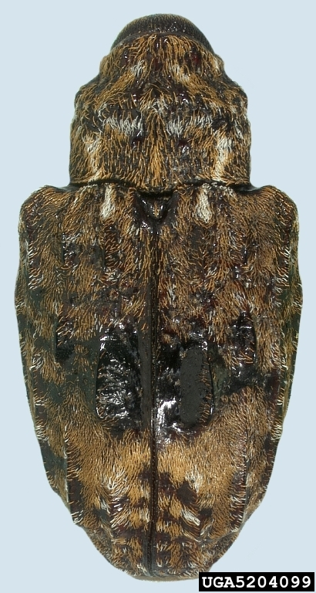  
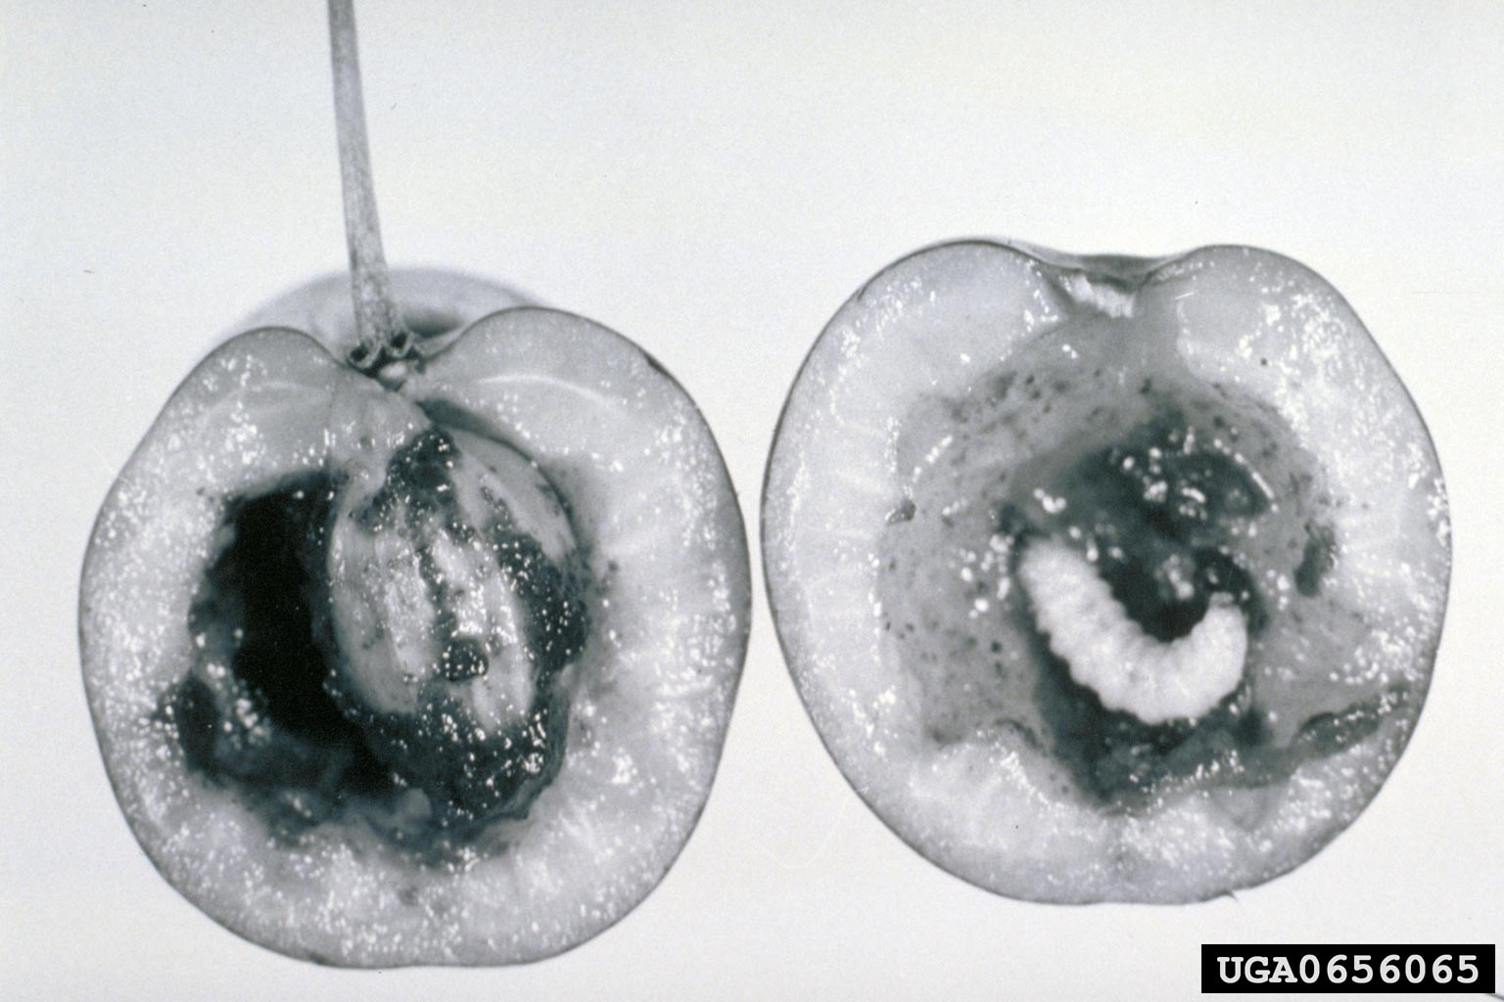

# Taxonomic Information

Name:  
*Conotrachelus nenuphar* Herbst, 1797

Synonyms:  
*Curculio nenuphar* Herbst, 1797  
*Conotrachelus nenuphar* (Hbst.) Leconte and Horn, 1876  
*Rhynchaenus argula* Fabricius, 1801  
*Cryptorhynchus argula* (Fab.) Say, 1831  
*Rhynchaenus cerasi* Peck, 1819

Taxonomic position:  
Insecta, Coleoptera, Curculionidae

Common name:  
Plum curculio

# Detection

The larvae are the life stage most likely to be transported in late season fruit, especially from the southern extent of its range. Pupae may be transported in soil along with tree seedlings or transplants. Adults express thanotosis behavior and are less likely to be transported.

### *C. nenuphar* is commonly found on the follow plant parts and plant-associated media depending on life stage:

* Eggs: immature fruit tissue, mature fruit tissue (if from southern range)
* Larvae: immature fruit tissue, mature fruit tissue
* Pupae: in the soil
* Adults: on the leaves, branches, flowers, and fruits

### Signs of eggs and larvae:

In immature fruit, a small crescent-shaped cut and scar is indicative of oviposit. To lay an egg, a female must puncture the skin of the developing fruit with her mandible (on the distal end of the rostrum) and excavate a small, shallow cavity. A single egg will be deposited in the center of this cavity. A single female may lay multiple eggs on a single fruit.

In mature fruit, the oviposition scar will become more diffuse and take on a corky appearance. These can look like mottled fans with a small scar at the base of the fan.

### Signs of adult action:

Adults will feed on fruit. In immature fruit, punctures will look circular (not crescent shaped) and extend up to 3mm into the fruit. On mature fruit, punctures will also appear circular and can tend to cluster around the calyx of the fruit.

### Methods of insect recovery from plants and plant products:

Larvae: Larvae can be recovered from fruit by splitting the fruit and looking for signs of larval feeding and for larvae. Larvae will only exit the fruit after fruit drop, and so any fruit still on the stem may yield live larvae.

Pupae: Pupae can be recovered from soil by sifting and hand searching with visual inspection of the soil associated with any plant product. Pupae tend to be found within 20mm of the soil surface. Pupae can also be reared from soil, following established guidelines (citation needed).

Adults: Adults can be found by visual inspection of any plant part, including flowers, leaves, and branches. Adults are well camouflaged and will tend to appear as a small piece of bark. Plum curculio exhibit thanatosis, or tonic immobility, when disturbed. Collection in the field is often done by jarring or disturbing the medium on which the adults are found (branches and trunks) over a white sheet, followed by visual inspection for immobile adults. Immobile adults will fold their legs under their body and bend the rostrum under the prothorax, and appear as an oblong shape.

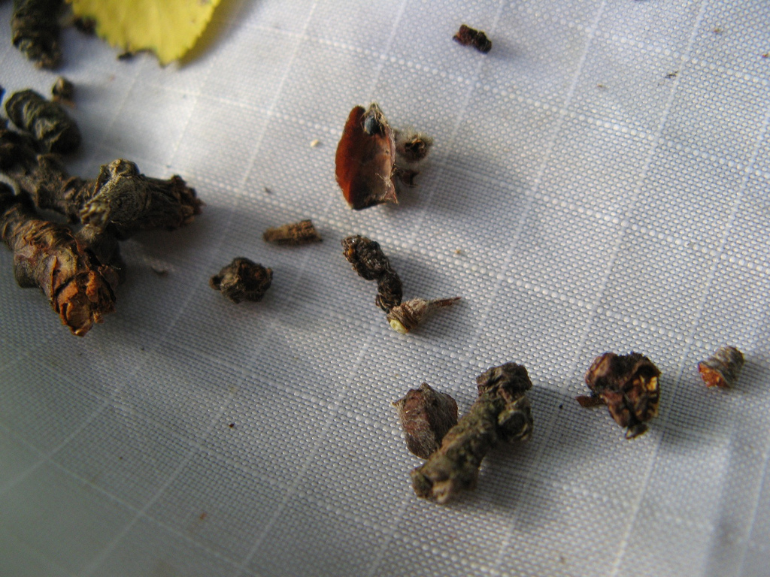

An adult plum curculio exhibiting mimicry via tonic immobility

### Similar signs due to other insect sources:

TBD

# Identification

Identification of *Conotrachelus nenuphar* by morphological examination is restricted to adult specimens because there are no adequate keys for the identification of eggs, larvae or pupae. A guide to identification of adult plum curculio is given below.

Larval and pupal life stages are especially a risk for misidentification because of the lack of reliable identification diagnostics or keys for them. Molecular assays can be applied to all life stages including the immature stages for which morphological identification to species is not possible and to specimen fragments. Molecular approaches can also be used to narrow the identification of the phonological strain and the geographic region of origin for the sample.

## Preparation of adult beetles for microscopic examination

Adult weevils in the genus *Conotrachelus* are generally less than 9mm and may be examined for morphological identification under 10x to 60x magnification. Most diagnostic characters can be observed at this level of magnification. For routine identification, dissection of genitalia is usually not necessary.

The typical size for adult *Conotrachelus nenuphar* specimens is between 4mm and 6mm, allowing for pin mounting directly through the hind thorax. There are several important diagnostic characters on the legs, so spreading the legs while mounting is highly suggested.

## Morphological identification of adult weevils

TBD

## Morphological identification of adult *Conotrachelus*

*Conotrachelus* is a New World beetle genus with approximately 1,200 named species (Dejean 1837; O’Brien & Wibmer 1982). The majority of species diversity is concentrated in South America and there are many species found only in South America. The *Conotrachelus* diversity found in the United States and Canada (where *Conontrachelus nenuphar* is endemic) is limited to approximately 90 of 1,200 described species. Of these, roughly 40 to 50 species are sympatric with *C. nenuphar*. Of those *Conotrachelus* species found in the same geographic regions as *C. nenuphar*, none are known to use commerical fruit tress as hosts. The potential for confusion with other fruit pests is greater than with congenerics. The generic name is based on the cone-shaped thorax typical of the group. Of critical importance in diagnosing *Conotrachelus* species is the postmedian elytral band. This is a region in the middle of the elytra and there are diagnostic differences between groups of species.

…TBD

## Morphological identification of adult *Conotrachelus nenuphar*

Appendages: Tarsal claws divergent, not close together.

Prothorax: No median ridge or furrow.

Elytra: Two distinct costae (or ridges), one on each elytron on interval 3. Region between and around costae is devoid of vestiture, smooth, and black. Costae themselves are devoid of vestiture, smooth, and black. Postmedian band has distinctly reddish-brown to reddish-yellow vestiture, with distinct lines of white recumbent setae.

Thorax: The mesoscutellum is gently sloped, depressed and flat on the basal side and not prominent all both sides.

## Morphological identification of voltinic strains of adult *Conotrachelus nenuphar*

Smith and Salkeld (1964) dissected the maturing ovaries of northern and southern strain plum curculio adult females and laid out how the breeding behavior of the two strains was related to their diapause behavior. They established that northern strain females do not develop mature oocytes prior to diapause, and that southern strain females do. This was the first demonstration that the diapause behavior between the strains was different, with the northern strain required to diapause to develop oocytes. To this day, this is the only reliable method to distinguish the strains and their diapause behavior.

## Molecular assays for identifying *Conotrachelus nenuphar*

There are several methods available for molecular diagnostic identification of the plum curculio. The *COI* gene is a useful marker for diagnosing *Conotrachelus nenuphar* from its congeners as well as identifying certain regional variants within the species. The northern and southern regions are readily diagnosable from each other, and within the southern populations, genetic variants found west of the Mississippi and in the mid-Atlantic are also diagnosable from the broader southern distribution.

### DNA isolation

To preserve external and internal morphological characters of museum specimens, the head and prothorax of each individual was separated from the body and subjected to a modified version of the Qiagen® DNeasy® 96 Blood & Tissue Kit extraction protocol (Pinzon-Navarro et al. 2010). Whole tissue was soaked in lysis buffer without homogenization. This semi- destructive protocol allows for digestion of the soft internal tissue of the head and prothorax for isolation of nucleic acids while preserving the hard sclerotized external anatomy. After lysis of internal soft tissue, the head and prothorax was reattached to each specimen.

### 3’ COI sequence-based identification of *Conotrachelus nenuphar* and its geographic strains

The 3’ COI gene fragment is able to diagnose regional variation within *Conotrachelus nenuphar*. Two geographically distinct mitochondrial groups are resolvable with purely diagnostic single nucleotide variants and enable the diagnosis to identify regional source populations in the case of mid-Atlantic (Sb haplotypes) and Midwestern (Sa haplotypes).

Target Locus: 3’ end of the COI mitochondrial gene

Expected Amplicon Size: 826bp

Primers:

|  |  |  |  |
| --- | --- | --- | --- |
| Primer Name | Marker | Sequence (5’ - 3’) | Direction |
| C1-J-2183 Jerry | COI | CAACATTTATTTTGATTTTTTGG | F |
| TL2-N3014 Pat | COI | TCCAATGCACTAATCTGCCATATTA | R |

PCR Conditions: TBD

DNA sequencing was done using the BigDye® Terminator v3.1 Cycle Sequencing kit (Applied Biosystems, Inc.) on an ABI PrismTM 3730 DNA Analyzer.

The DNA sequences produced by this method can be analyzed via multiple sequence alignment and subsequent character analysis. Figure XX provides species-level molecular diagnostic characters for identification of closely-related *Conotrachelus species*.

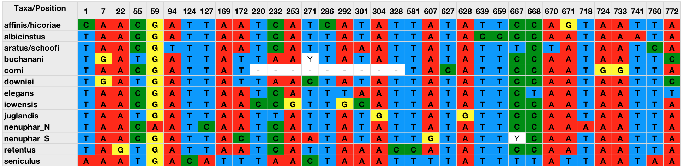

3’ COI *Conotrachelus nenuphar* species-level diagnostic characters

### 5’ COI sequence-based identification of *Conotrachelus nenuphar* and some congeneric species

Target Locus: 5’ end of the COI mitochondrial gene

Expected Amplicon Size: 658bp

Primers: (Folmer et al. 1994).

|  |  |  |  |
| --- | --- | --- | --- |
| Primer Name | Marker | Sequence (5’ - 3’) | Direction |
| LCO1490 | COI | GGTCAACAAATCATAAAGATATTGG | F |
| HCO2198 | COI | TAAACTTCAGGGTGACCAAAAAATCA | R |

PCR Conditions: TBD

DNA sequencing was done using the BigDye® Terminator v3.1 Cycle Sequencing kit (Applied Biosystems, Inc.) on an ABI PrismTM 3730 DNA Analyzer.

The DNA sequences produced by this method can be analyzed and a species designation made using the Barcode of Life database.

### RFLP

TBD