I) Indications

• Swelling ? ganglion

• ? effusion/synovitis

• ? tendon tea

II) Protocol

• extensor and flexor tendons for tendinopathy, tenosynovitis, tears, calcification;

• finger pulleys for triggering;

• joints of the hand/wrist for synovitis or effusion;

• bony cortex for erosions;

• ligaments of the thumb/fingers for sprains or tears;

• carpal or Guyon’s tunnel for nerve compression

III) Transducer Placement and Findings

Transverse View of the wrist

1, long abductor tendons and short extensor of the thumb; 2, radial extensor tendons of the carpus;

3, long extensor tendon of the thumb; 4, extensor tendons of the fingers; 5, extensor tendon of the ­fifth fi­nger; 6, ulnar extensor tendon of the carpus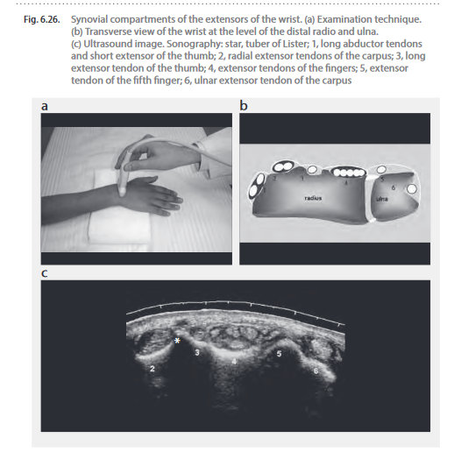

Whilst evaluating tendons and sheaths, remember to also use a longitudinal view with colour box to show the absence of neovascularity;

Also view tendons in transverse, distal tendon insertion in longitudinal to exclude tear/tendonopathy/tenosynovitis/calcification and compare with contralateral side;

• dorsal and volar wrist joints with and without colour box to show the absence of effusion or synovitis;

• finger ligaments in longitudinal, in stressed and relaxed positions if appropriate.