I) Indications

•? effusion/synovitis;

• ? bursitis;

• ? hamstring tear;

• ? enthesopathy

II) Protocol

• anterior hip joint for synovitis (joint effusion and/or synovial hypertrophy

# Show with and without colour box for effusion or synovitis

• anterior hip/psoas tendon for tendonopathy, bursitis;

• anterior thigh tendons for enthesopathy, tears, tendonopathy, calcification;

• greater trochanteric area for bursitis, gluteal enthesopathy, tendonopathy/tears/calcification;

• adductor tendons for enthesopathy, tears, tendonopathy, calcification;

• posterior hamstring tendons enthesopathy, tears, tendonopathy, calcification.

Hip sonography can also be used for ultrasound-guided needle puncture

III) Transducer Placement, imaging and annotation

Longitudinal scans

•Gluteus minima (C arrow)

• Gluteus media (D arrow)

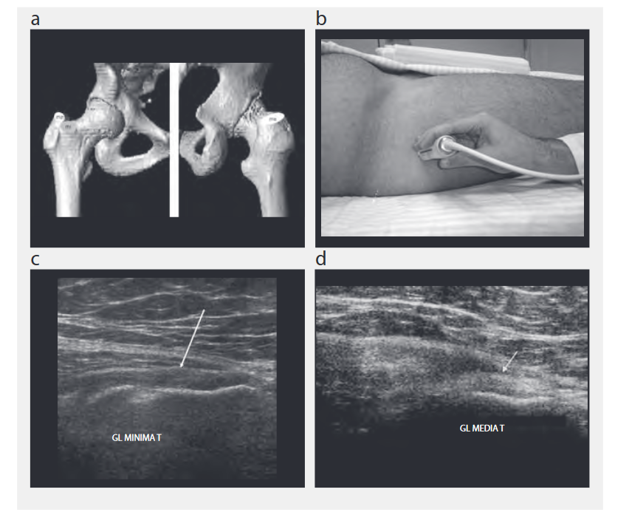

Bursitis of medium subglutaneous

