Vmware MP for SCOM

Inhoud

Install the Management Pack 1

Monitoring Folders 1

Alerts 2

Esx Hosts 2

Datastores 3

Virtual Machines 4

Monitors and Alerts (Aspex Baseline) 4

# Install the Management Pack

* Import the vmware.mp file into your SCOM environment.
* Create an overrides Management Pack (i.e. vmware.overrides)
* Add an account to the “Vmware ViConnection Profile”. The account needs read rights on your vCenter database and must be distributed as a “run as account” to the Vcenter server.
* enable the “Vmware vCenter Discovery” for “a specific object of Class:Windows computer”. Here you choose your vCenter server.
  + In the overrides set the parameter “Enabled” to “True”
  + Vcenter Database Name to your vcenter db name
  + Vcenter Sql Server Instance like present in your environment

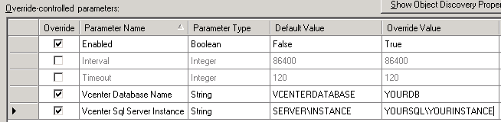

* Restart the Health service on your vcenter server.

# Monitoring Folders

The following Folder and Sub items are created after importing the Management Pack in SCOM.

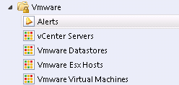

## Alerts

The management Pack is based upon Alerts that are configured in your vCenter environment. Within the MP there is a rule which collects all active vcenter alerts and places them in an AlertSourceFile on de vcenter Server. This is done every 10 minutes by default. Subsequently there are monitors who scan the alertsourcefile to generate realtime alerts into SCOM.

The Alert View contains all alerts for which monitors exist and that are currently active.

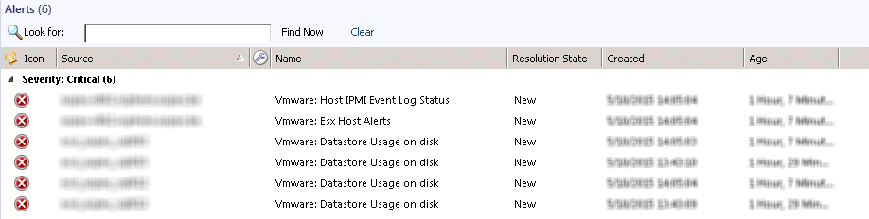

## Esx Hosts

This view will show all discovered hosts and their properties. The discovery of the Hosts is done on a daily basis, it displays Servernames, amount of memory, esx version and build, Ip address, …

There are a number of monitors active on the host instances, such as…:

* Connection and power state
* Connection Failure
* Cpu Usage
* Memory Usage
* IPMI Status
* Network Connectivity State

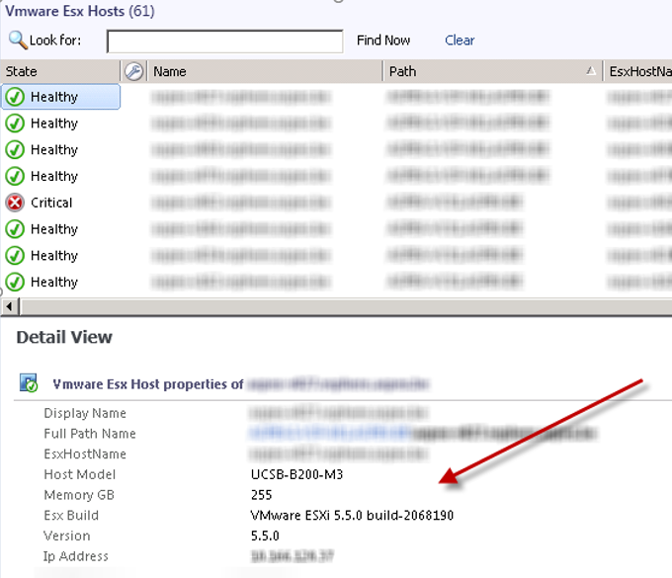

## Datastores

Monitors that apply on datastores are:

* Datastore Usage on Disk

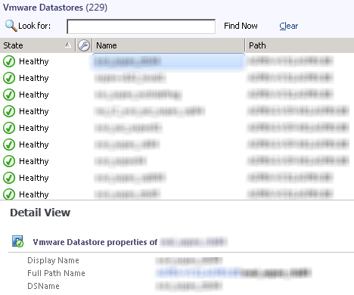

## Virtual Machines

Virtual Machines are discovered automatically, including their numerous properties (cpu’s, memory, operating system, vmware tools version,…). However vm’s not monitored by default, this must be done through overrides.

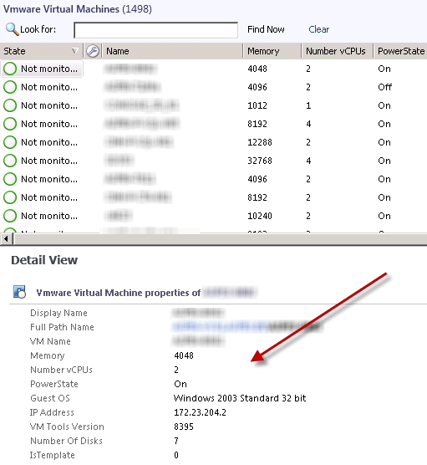

# Monitors and Alerts (Baseline)

Most of the monitors are captured through vCenter, so to change thresholds you need to change thresholds configured in vCenter.

|  |  |  |  |  |
| --- | --- | --- | --- | --- |
| SCOM | vCenter | Critical | Time | Scom Interval |
| Vmware: Host CPU Usage | Host Cpu Usage | 90% | 5 min | 5 min |
| Vmware: Host Connection Failure | Host Connection Failure | Cannot connect host   * Network error * Time-out * Connection lost | Real-time | 5 min |
| Vmware: Host connection and power state | Host connection and power state | Host connection state = Not responding  Host  AND  Host Power State <> Stand By | Real-time | 5 min |
| Vmware: Host Memory Usage | Host memory usage | 95% | 5 min | 5 min |
| Vmware: Datastore usage on disk | Datastore usage on disk | 98% | Real-time | 5 min |
| Vmware: Vm Cpu Ready Time | ASPEX: Vm Cpu Ready Time | 8000 ms | 5 min | 5 min |