Mekelle University
Department of Software Engineering



Project Documentation
Local Freelance Marketplace Web Application

Submitted to:
Instructor G.Michael
Submitted by:
Nahom Mulualem
Samuel Embaye
Teame G/her

TABLE OF CONTENTS: PART I (PROJECT PROPOSAL)
Chapter 1: Introduction
1.1 Background of the Project ..................................................................... 3
1.2 Problem Statement ................................................................................. 3
1.3 Objectives of the Project ........................................................................ 4
1.3.1 General Objective .......................................................................... 4
1.3.2 Specific Objectives ........................................................................ 4
1.4 Significance of the Project ..................................................................... 4
1.5 Scope of the Project ............................................................................... 4
Chapter 2: Methodology and Feasibility
2.1 Software Development Methodology ................................................... 6
2.2 Tools and Technologies (Tech Stack) ................................................... 6
2.2.1 Frontend (Presentation Layer) ...................................................... 6
2.2.2 Backend (Application Layer) ....................................................... 6
2.2.3 Database (Persistence Layer) ........................................................ 7
2.2.4 Development Tools ....................................................................... 7
2.3 Feasibility Analysis ............................................................................... 7
Chapter 3: Project Plan and Timeline
3.1 Work Breakdown Structure (WBS) ...................................................... 8
3.2 Resource Allocation ............................................................................... 9

PART I: PROJECT PROPOSAL
Chapter 1
Introduction
1.1 Background of the Project
This project, titled Tibeb: Skill Marketplace, aims to bridge this gap by developing a dedicated, web-based freelance marketplace tailored specifically for the. The platform is designed to serve as a centralized digital intermediary that facilitates secure, transparent, and efficient interactions between local clients and freelancers. By localizing the freelance experience, it seeks to democratize access to work opportunities and provide a structured environment for professional service exchange.
1.2 Problem Statement
Despite the abundance of skilled labor in Ethiopia, there is a critical lack of a trusted, centralized platform to orchestrate freelance work. Currently, the local freelance ecosystem operates in a fragmented and informal manner.
The primary challenges identified are:
- Fragmentation of Opportunity: The majority of local freelance interactions occur through decentralized and unstructured channels such as Telegram groups, Facebook pages, or word-of-mouth referrals. This fragmentation makes it difficult for clients to find qualified professionals and for freelancers to discover relevant projects, leading to high search costs and market inefficiency.
- Lack of Trust and Verification: In the absence of a formal platform, neither clients nor freelancers have a reliable mechanism to verify identities or skills. This anonymity breeds mistrust, as there are no immutable records of past performance, ratings, or professional history to guide hiring decisions.
- Inefficiency of Workflow: Current ad-hoc methods lack essential project management tools. There is no standardized way to submit proposals, track project progress, or manage deliverables, resulting in disorganized communication and frequent misunderstandings regarding project scope and deadlines.

1.3 Objectives of the Project
1.3.1 General Objective
The primary objective of this project is to design and develop a robust, full-stack web application that facilitates the discovery, negotiation, and execution of freelance services. The system aims to create a secure digital environment that connects Service Seekers (Clients) with Service Providers.
1.3.2 Specific Objectives
To achieve the general objective, the project will focus on the following specific technical and functional goals:
- To Implement Secure Identity Management: Develop a Role-Based Access Control (RBAC) system using JWT (JSON Web Tokens) to strictly differentiate between Client and Freelancer privileges, ensuring data security and privacy.
- To Develop a Job Orchestration Engine: Create a comprehensive job management module allowing clients to post, edit, and close job listings with detailed requirements (budget, timeline, skills).
- To implement a Proposal Submission System: Implement an atomic transaction system for freelancers to submit sealed proposals.
- To Enable Real-Time Communication: Integrate a persistent messaging subsystem to facilitate instant, secure negotiation between parties without relying on external third-party apps.
- To Facilitate Efficient Information Retrieval: Implement a composite search and filtering algorithm allowing freelancers to query job feeds based on categories, budget ranges, and keywords.
- To Simulate Financial Workflows: Design a logical ledger system to simulate escrow functionalities (Deposit, Hold, Release) to model the financial lifecycle of a contract without requiring banking license compliance for the prototype.
1.4 Significance of the Project
The successful implementation of this project will offer substantial value to multiple stakeholders:
- For Freelancers: It provides a centralized hub to showcase portfolios and access a consistent stream of work opportunities, reducing the time spent marketing services on informal social media channels.
- For Clients: It reduces the risk associated with hiring by offering a structured platform where project requirements are clearly defined, and proposals can be compared side-by-side.
1.5 Scope of the Project
The scope defines the boundaries of the system to ensure the project is achievable within the academic semester.
In-Scope (Deliverables):
The project will deliver a fully functional Responsive Web Application accessible via desktop and mobile browsers. Key functional modules include:
- User Registration and Authentication.
- Job Board (Posting, Browsing, Searching).
- Proposal and Bidding Management.
- In-App Chat System (Text-based).
- Profile Management (Portfolios, Skills).
Out-of-Scope (Exclusions):
- Native Mobile Applications: Dedicated Android (.apk) or iOS (.ipa) applications are not part of this release; the system relies on Web App standards.
- Live Payment Gateway Integration: Due to the regulatory complexities of integrating real-time banking APIs (e.g., Telebirr, Chapa) in a student project, financial transactions will be simulated using a logical ledger system.

Chapter 2
Methodology and Feasibility
2.1 Software Development Methodology
To ensure the project is delivered on time and meets the evolving requirements of a modern web platform, the team will adopt the Agile Scrum Methodology. This iterative approach is chosen over the traditional Waterfall model for the following reasons:
- Iterative Delivery: The project is broken down into two-week "sprints." This allows for the rapid prototyping of core features (like Auth and Job Posting) before moving to complex modules (Messaging).
- Flexibility: Agile allows the team to adapt to feedback from the project advisor or testing phases without requiring a complete system redesign.
- Continuous Testing: Testing is integrated into every stage of development, ensuring that bugs are identified and resolved early in the lifecycle.
The development process will follow these phases:
- Inception: Requirement gathering and defining the SRS (completed).
- Elaboration: Architectural modeling and database design (SDD phase).
- Construction: Coding the backend API and frontend interfaces.
- Transition: Integration testing, deployment to the staging environment, and final presentation.
2.2 Tools and Technologies (Tech Stack)
The "Tibeb" platform utilizes a modern Stack (PostgreSQL, Express, Next.js, Node.js), selected for its scalability, performance, and strong community support.
2.2.1 Frontend (Presentation Layer)
- Framework: Next.js 14 (built on React). Selected for its Server-Side Rendering (SSR) capabilities, which are crucial for Search Engine Optimization (SEO) and fast initial page loads on slower networks.
- Styling: TailwindCSS. A utility-first framework that ensures rapid UI development and mobile responsiveness.
2.2.2 Backend (Application Layer)
- Runtime: Node.js (v20 LTS). Its non-blocking, event-driven architecture is ideal for handling concurrent requests and real-time features.
- Framework: Express.js. A minimal and flexible web application framework used to build the RESTful API endpoints.
- Real-Time Engine: Socket.io. Used to establish full-duplex WebSocket connections for the messaging system.
2.2.3 Database (Persistence Layer)
- DBMS: PostgreSQL 16. Chosen for its strict ACID compliance and support for complex relational data modeling, which is essential for managing contracts and financial states.
- ORM: Prisma. Used as a type-safe interface between the Node.js backend and the database, preventing SQL injection and simplifying schema migrations.
2.2.4 Development Tools
- Version Control: Git and GitHub for source code management and collaboration.
- API Testing: Postman for verifying REST endpoints.
- Design/Prototyping: Figma for UI wireframing.
2.3 Feasibility Analysis
- Technical Feasibility: The team possesses the necessary proficiency in JavaScript/TypeScript and the selected stack
- Operational Feasibility: The proposed system runs on standard web browsers (Chrome, Firefox, Safari), requiring no special hardware for the end-user, ensuring high accessibility.

Chapter 3
Project Plan and Timeline
3.1 Work Breakdown Structure (WBS)
The project execution is organized into distinct phases to ensure systematic progress and resource allocation. The Work Breakdown Structure (WBS) divides the complex development process into manageable tasks:
- Planning Phase:
  - Literature review of existing freelance platforms.
  - Definition of functional and non-functional requirements.
  - Feasibility study and risk analysis.
- Design Phase:
  - Architectural design (Modular Monolith pattern).
  - Database schema modeling (ER Diagrams).
  - User Interface (UI) wireframing and high-fidelity prototyping in Figma.
- Implementation Phase (Backend):
  - Setup of Node.js/Express environment and Prisma ORM.
  - Implementation of Authentication .
  - Development of Job Management and Proposal APIs.
  - Integration of Real-Time Socket.io Gateway.
- Implementation Phase (Frontend):
  - Setup of Next.js framework and TailwindCSS configuration.
  - Development of Client and Freelancer dashboards.
  - Integration of API endpoints with frontend forms.
- Testing Phase:
  - Unit testing of individual components.
  - Integration testing of API and Database interactions.
  - User Acceptance Testing (UAT) to validate workflows.
- Deployment & Documentation:
  - Deployment to staging environments (Vercel/Render).
  - Compilation of Final Technical Report (Proposal, SRS, SDD).
3.2 Resource Allocation
- Human Resources: The team of three members will share full-stack responsibilities. Specific module ownership (e.g., Auth, Chat, Database) will be assigned based on individual strengths during the Sprint Planning sessions.
- Hardware/Software: Development will be conducted on personal laptops. The project relies on free-tier cloud services (GitHub, Vercel,) to maintain zero financial cost.

TABLE OF CONTENTS: PART II (SRS)
Chapter 1: Introduction
1.1 Purpose .................................................................................................. 11
1.2 Scope ...................................................................................................... 11
1.3 Definitions, Acronyms, and Abbreviations .......................................... 12
Chapter 2: Overall Description
2.1 Product Perspective ............................................................................... 13
2.2 User Classes and Characteristics ........................................................... 13
2.3 Operating Environment ......................................................................... 14
2.4 Design and Implementation Constraints ............................................... 14
2.5 Assumptions and Dependencies ........................................................... 14
Chapter 3: Specific Requirements
3.1 External Interface Requirements ........................................................... 15
3.1.1 User Interfaces .............................................................................. 15
3.1.2 Hardware Interfaces ...................................................................... 15
3.1.3 Software Interfaces ....................................................................... 15
3.1.4 Communication Interfaces ............................................................ 15
3.2 Functional Requirements ....................................................................... 16
3.2.1 Authentication & Session Management (FR-01) ......................... 16
3.2.2 Job Lifecycle Management (FR-02) ............................................ 16
3.2.3 Advanced Search & Filtering (FR-03) ......................................... 16
3.2.4 Proposal Submission Engine (FR-04) .......................................... 17
3.2.5 Real-Time Messaging Subsystem (FR-05) ................................. 17
3.2.6 Transaction State Simulation (FR-06) ......................................... 18
3.3 Non-Functional Requirements .............................................................. 18
3.3.1 Performance Requirements ........................................................... 18
3.3.2 Security Requirements .................................................................. 18
3.3.3 Reliability and Availability .......................................................... 18
Chapter 4: System Models
4.1 Use Case View ...................................................................................... 20
4.1.1 Actors ............................................................................................ 20
4.1.2 Use Case Descriptions .................................................................. 20
4.2 Sequences .............................................................................................. 22
4.2.1 Sequence: Job Creation Workflow ............................................... 22
4.2.2 Sequence: Proposal Submission Workflow .................................. 23
4.3 Domain Model (Logical Data View) .................................................... 23
4.4 State Transition Models ........................................................................ 25
Chapter 5: Requirement Traceability Matrix ......................................... 27
PART II: SOFTWARE REQUIREMENTS SPECIFICATION (SRS)
Chapter 1
Introduction
1.1 Purpose
The purpose of this Software Requirements Specification (SRS) is to provide a comprehensive and authoritative description of the Skill Marketplace web application. It details the functional and non-functional requirements, external interface controls, and design constraints that govern the system's development. This document serves as the primary agreement between the stakeholders (academic advisors, end-users) and the development team, ensuring a shared understanding of the technical deliverables required to build a scalable, secure, and high-availability distributed web platform.
1.2 Scope
It is designed as a centralized digital intermediary platform connecting Service Seekers and Service Providers. The system is engineered as a Modular Monolith utilizing a three-tier architecture:
- Presentation Layer: A Server-Side Rendered (SSR) Single Page Application (SPA) built on Next.js 14, ensuring optimized SEO and distinct dashboards for different user roles.
- Application Layer: A RESTful API service developed in Node.js (v20 LTS) and Express.js, implementing the Controller-Service-Repository pattern.
- Persistence Layer: A relational data store using PostgreSQL 16, managed via Prisma ORM for type-safe database access and schema migrations.
Key Functional Boundaries (MVP):
- Identity & Access Management (IAM): implementation with JWT-based stateless sessions and Role-Based Access Control (RBAC).
- Job Orchestration: A state-machine-driven engine managing the lifecycle of jobs (Draft → Open → Contracted → Closed).
- Proposal System: A transactional workflow allowing atomic submission of sealed bids.
- Real-Time Communication: A low-latency messaging subsystem using WebSockets (Socket.io).
- Search Engine: A query-optimized interface utilizing PostgreSQL full-text search vectors.
1.3 Definitions, Acronyms, and Abbreviations
- ACID: Atomicity, Consistency, Isolation, Durability; properties ensuring reliable database transactions.
- API: Application Programming Interface; specifically RESTful endpoints using HTTP methods.
- DTO: Data Transfer Object; an object carrying data between processes to validate payloads .
- Idempotency: A property where multiple identical requests produce the same result (crucial for proposal submissions).
- JWT: JSON Web Token (RFC 7519); a URL-safe, self-contained token used for stateless authentication.
- ORM: Object-Relational Mapping; specifically Prisma, mapping TypeScript objects to SQL tables.
- RBAC: Role-Based Access Control; restricting system access based on user roles (Client vs. Freelancer).
- SPA: Single Page Application; a web app that interacts with the user by dynamically rewriting the current web page.
- SSR: Server-Side Rendering; rendering web pages on the server to improve performance and SEO.

Chapter 2
Overall Description
2.1 Product Perspective
The platform is a new, self-contained software product designed to replace the decentralized and informal methods currently used for local freelancing (e.g., social media groups). It operates within a distributed Client-Server Architecture, ensuring a clear separation of concerns between the user interface, business logic, and data storage.
System Interfaces:
- User Interface (Frontend): A responsive web interface built with Next.js, communicating with the backend exclusively via JSON payloads over HTTPS. It manages local state and provides specific views for "Client" and "Freelancer" actors.
- API Gateway (Backend): A stateless Node.js service acting as the central processing unit. It enforces security policies validates requests and orchestrates data flow.
- Persistence Interface: The backend connects to a PostgreSQL cluster via a connection pool managed by Prisma, ensuring efficient handling of concurrent database queries.
2.2 User Classes and Characteristics
The system implements a strict Role-Based Access Control model. User roles are immutable during an active session and determine API accessibility.
1. Client (Service Requester)
- Role: The initiator of workflows. They are responsible for creating Job entities, reviewing proposals, and simulating financial state
- Capabilities: Write access to the Jobs table; Read access to Proposals linked to their jobs.
- Technical Profile: Web-literate users accessing the platform via desktop or mobile browsers to source talent.
2. Freelancer (Service Provider)
- Role: The responder. They browse the system for opportunities and initiate contract bids.
- Capabilities: High-frequency Read access to Job Feeds; Write access to create Proposals. Restricted from viewing competitor bids (row-level security logic).
- Technical Profile: Users with marketable skills, likely to utilize advanced search filters and upload portfolio artifacts.
2.3 Operating Environment
- Client Side: The application is supported on all modern, JavaScript-enabled web browsers (Chrome v90+, Firefox v88+, Safari v14+, Edge).
- Server Side: The backend requires a Node.js runtime environment.
- Database: Requires a PostgreSQL instance with support for standard full-text search extensions.
2.4 Design and Implementation Constraints
- Protocol Standards: All data in transit must be encrypted .
- Payload Limits: API request bodies are capped at 100KB for standard JSON data. File uploads (e.g., resumes) are restricted to 5MB and specific MIME types (PDF, PNG).
- Latency Budget: The system targets a Time to First Byte (TTFB) of < 300ms for read operations and a Largest Contentful Paint (LCP) of < 2.
- Concurrency: The Node.js single-threaded event loop must not be blocked by CPU-intensive tasks. Heavy computations must be offloaded or optimized to ensure the system can handle concurrent active users.
2.5 Assumptions and Dependencies
- Connectivity: The architecture assumes an "Always-Online" model. No offline-first synchronization logic is implemented for the MVP.

Chapter 3
Specific Requirements
This section details the functional behaviors and external interfaces required to satisfy the project objectives. These requirements are the fundamental inputs for the system design and validation phases.
3.1 External Interface Requirements
3.1.1 User Interfaces
The user interface (UI) is architected as a Responsive Single Page Application to ensure seamless state transitions without full page reloads.
- Front-End Standard: The UI shall be rendered using the Next.js 14 framework.
- Layout: The application shall provide two distinct dashboards: a "Client Dashboard" for job management and a "Freelancer Dashboard" for job discovery.
- Responsiveness: The layout engine must support viewports ranging.
3.1.2 Hardware Interfaces
- Client Side: The application is device-agnostic but requires a device capable of running a modern web browser with JavaScript execution enabled.
- Server Side: The backend services are designed to be container-native, abstracting physical hardware dependencies. It requires a virtualized environment with a minimum of 1 vCPU and 512MB RAM.
3.1.3 Software Interfaces
- Database Engine: The system requires PostgreSQL 16+ for data persistence.
- Runtime: The backend logic executes within a Node.js (v20 LTS) environment.
- ORM Layer: Prisma Client serves as the software interface between the Node.js application and the database, abstracting raw SQL queries.
3.1.4 Communication Interfaces
- RESTful API: Primary data exchange occurs over HTTP. All endpoints must adhere to REST principles (Resource-oriented URLs, standard HTTP Verbs).
- WebSockets: Real-time features (Messaging) utilize the WebSocket Protocol (wss://) via the Socket.io library to maintain persistent full-duplex connections.
3.2 Functional Requirements
The following requirements define the specific behaviors of the system, mapped to the system modules.
3.2.1 Authentication & Session Management (FR-01)
- Description: The system shall implement a secure authentication subsystem using the OAuth 2.0 standard.
- Input: JSON payload containing email and raw password string.
- Processing:
  - Sanitize input.
  - Retrieve user record by email.
  - Compare input password against stored .
  - Generate a JSON Web Token (JWT) containing user_id and role claims.
- Output: HTTP 200 OK with Bearer Token; HTTP 401 Unauthorized on failure.
- Constraint: A user entity must be strictly provisioned with a single role attribute (Client or Freelancer) upon registration.
3.2.2 Job Lifecycle Management (FR-02)
- Description: The system shall provide a CRUD (Create, Read, Update, Delete) interface for Clients to manage job postings.
- Input: Job title, category ID, detailed description, budget range (min/max), and expiry timestamp.
- Processing:
  - Validate request body against the defined schema.
  - Verify the authenticated user holds the 'Client' role.
  - Create a new Job entity with status OPEN.
  - Index text fields for search optimization.
- Output: HTTP 201 Created with the generated UUID of the job.
- Post-condition: The job is persisted in the PostgreSQL database and becomes queryable via the public feed.
3.2.3 Advanced Search & Filtering (FR-03)
- Description: The system shall expose a queryable interface allowing Freelancers to retrieve paginated job listings. The search logic must support filtering by category, budget range, and keyword matching.
- Input: Query parameters: keywords, category_id, min_budget, page.
- Processing:
  - Sanitize query parameters to prevent SQL injection.
  - Construct a parameterized SQL query utilizing WHERE clauses for filters and ILIKE for keyword matching (or PostgreSQL tsvector for full-text search).
  - Apply LIMIT and OFFSET logic for pagination.
- Output: JSON array of job summary objects and pagination metadata (total count, current page).
- Performance Constraint: The search query must return results in < 300ms for datasets under 10,000 records.
3.2.4 Proposal Submission Engine (FR-04)
- Description: The system shall allow authenticated Freelancers to submit a formal proposal for a specific job. This operation must be atomic and enforce uniqueness.
- Input: target_job_id, bid_amount, cover_letter_text, estimated_duration.
- Processing:
  - Pre-flight Check: Verify target_job_id exists and its status is strictly OPEN.
  - Idempotency Check: Verify that the specific (user_id, job_id) pair does not already exist in the Proposals table.
  - Persistence: Insert the proposal record into the database.
- Output: HTTP 201 Created with Proposal ID.
- Error Handling: If a proposal already exists, return HTTP 409 Conflict.
3.2.5 Real-Time Messaging Subsystem (FR-05)
- Description: The system shall facilitate low-latency text communication between a Client and a Freelancer. The architecture must support WebSocket connections for instant delivery, falling back to HTTP REST for history retrieval.
- Input: receiver_id, content_body.
- Processing:
  - Context Validation: Validate that a business relationship (active Proposal or Contract) exists between the sender and receiver.
  - Persistence: Write the message to the Messages table with a timestamp.
  - Broadcasting: Emit a WebSocket event to the receiver’s active socket ID.
- Output: WebSocket new_message event; HTTP 201 for REST fallbacks.
3.2.6 Transaction State Simulation (FR-06)
- Description: The system shall model the escrow workflow via logical state transitions. This simulates the movement of funds without integrating a real payment gateway.
- Input: job_id, action (e.g., "HIRE", "RELEASE_FUNDS").
- Processing:
  - Verify the authenticated user is the owner (Client) of the job.
  - Validate the state transition is legal (e.g., OPEN → CONTRACTED is valid; OPEN → COMPLETED is invalid).
  - Update the status column in the Jobs table.
  - Create an entry in the TransactionLogs table recording the logical event.
- Output: HTTP 200 OK with the updated Job object.
3.3 Non-Functional Requirements
3.3.1 Performance Requirements
- Response Time: 95% of API read operations must complete within 200ms.
- Throughput: The backend architecture must support a baseline of 100 concurrent active connections without exceeding 80% CPU utilization on the host container.
3.3.2 Security Requirements
- Encryption at Rest: Sensitive user secrets (specifically passwords) must be hashed.
- Input Sanitization: All API layers must implement global input validation middleware to reject malformed payloads before they reach business logic.
3.3.3 Reliability and Availability
- Availability: The system targets an uptime of 99.5% during operational hours.
- Fault Tolerance: The Node.js runtime must implement a global error handling middleware to catch unhandled promise rejections, ensuring the process does not crash unexpectedly.
- Data Integrity: Critical write operations (e.g., Proposal Submission) must be wrapped in ACID-compliant transactions.

Chapter 4
System Models
This section presents the visual modeling artifacts that define the system's static structure and dynamic behavioral patterns. These models serve as the blueprint for the implementation phase.
4.1 Use Case View
The Use Case View illustrates the functional boundaries of the system and the interaction patterns between primary actors and the application modules.
4.1.1 Actors
The system defines the following primary actors:
- Guest: An unauthenticated user who can only view the landing page and public marketing content.
- Client (Service Seeker): An authenticated user authorized to post jobs, review proposals, and manage contracts.
- Freelancer (Service Provider): An authenticated user authorized to browse jobs, manage their professional profile, and submit proposals.
4.1.2 Use Case Descriptions
The following high-level use cases represent the core functionality of the platform:
- UC-01: Identity Management
  - Actors: Guest, Client, Freelancer.
  - Description: Covers the registration and authentication workflows. It includes strict validation of credentials (email/password) and the issuance of secure session tokens (JWT).
  - Precondition: User must have a valid email address.
- UC-02: Job Orchestration
  - Actors: Client.
  - Description: A specialized use case allowing Clients to create, modify, and close Job entities. It involves inputting job details (Title, Budget, Deadline) and saving them to the database.
  - Post-condition: A new Job entity is visible in the public feed.
- UC-03: Proposal Submission
  - Actors: Freelancer.
  - Description: An atomic transaction initiated by the Freelancer to bind a bid (Price, Cover Letter) to an open Job entity.
  - Constraint: A Freelancer cannot submit more than one proposal for the same job (Idempotency).
- UC-04: Secure Messaging
  - Actors: Client, Freelancer.
  - Description: A bidirectional communication flow allowing actors to exchange text payloads in real-time via WebSockets.
  - Precondition: Users must have an active context (Proposal or Contract) to initiate a chat.
- UC-05: Transaction Simulation
  - Actors: Client.
  - Description: Represents the logical flow of funds (Deposit/Release) triggered by the Client. This changes the contract state (e.g., from OPEN to IN_PROGRESS) without interacting with an external banking gateway.

Figure 4.1: System Use Case Diagram
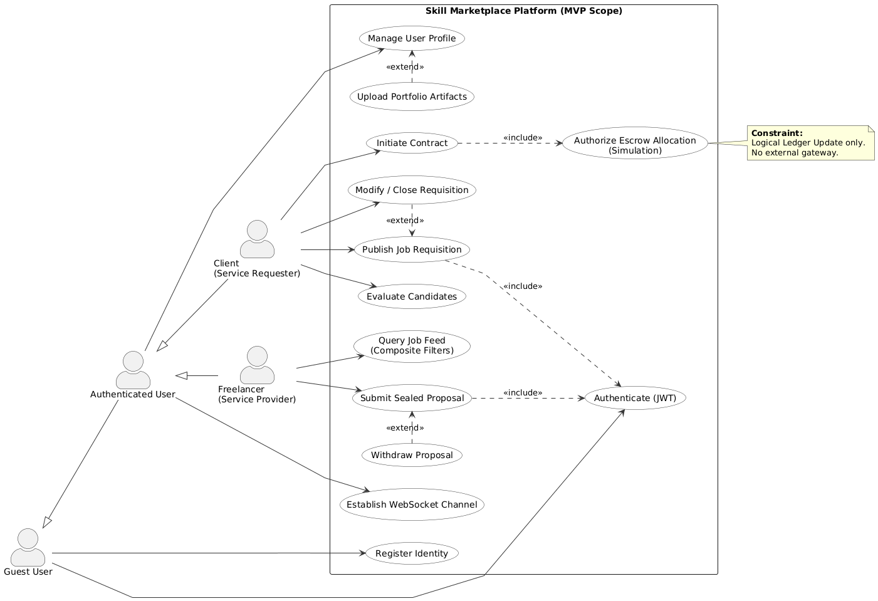
4.2 Sequences
4.2.1 Sequence: Job Creation Workflow
This logic models the synchronous flow of a job posting request:
- Client Application (Frontend): Constructs a JSON payload containing job parameters and transmits a POST request to the API Gateway.
- API Controller: Intercepts the request, strictly validates the Authorization: Bearer token, and sanitizes the input using schema validation middleware.
- Job Service: Executes business logic, ensuring the user has the 'Client' role and that budget parameters are logically valid.
- Data Repository: Constructs the SQL INSERT statement and executes it against the PostgreSQL database.
- Database: Returns the generated UUID and confirmation.
- API Controller: Returns a 201 Created status code to the frontend.
4.2.2 Sequence: Proposal Submission Workflow
This logic illustrates the validation and persistence of a bid:
- Freelancer Application: Initiates a POST request to the proposals endpoint with bid amount and cover letter.
- Proposal Service: Performs a pre-flight check to ensure the target Job ID exists and its status is currently OPEN.
- Concurrency Check: The service verifies that the specific Freelancer has not already submitted a proposal for this specific Job.
- Persistence: If valid, the proposal is written to the database inside a transaction.
- Event Emission: The system triggers an asynchronous notification event to alert the Job Owner (Client).
4.3 Domain Model (Logical Data View)
The Domain Model describes the conceptual classes and their relationships, representing the static structure of the system's problem domain. This model maps directly to the business entities managed by the Tibeb platform.
Key Structural Components:
- User Entity:
  - Description: The root entity representing an identity within the system. It utilizes a Strategy Pattern to handle role-specific behaviors (Client vs. Freelancer).
  - Attributes: UUID, Email, PasswordHash,Role (Enum), CreatedAt.
  - Relationships: One-to-One with Profile; One-to-Many with Messages.
- Profile Entity:
  - Description: Segregates detailed user metadata from the lightweight authentication entity to optimize login performance.
  - Attributes: Bio, Skills (Array), PortfolioURL, Rating.
  - Relationships: Belongs to User.
- Job Entity:
  - Description: Represents the core unit of work in the marketplace. It encapsulates financial data, temporal constraints, and state.
  - Attributes: Title, Description, BudgetMin, BudgetMax, Deadline, Status.
  - Relationships: Owned by Client (User); One-to-Many with Proposals.
- Proposal Entity:
  - Description: Represents a tentative contract offer submitted by a Freelancer. It stores the bid value and reference keys linking the service provider to the scope of work.
  - Attributes: BidAmount, CoverLetter, EstimatedDuration, Status (Pending/Accepted/Rejected).
  - Relationships: Belongs to Job; Owned by Freelancer.
- Message Entity:
  - Description: An append-only log of communication.
  - Attributes: Content, Timestamp, IsRead.
  - Relationships: Linked to Sender and Receiver (Users).

Figure 4.2 Class Diagram
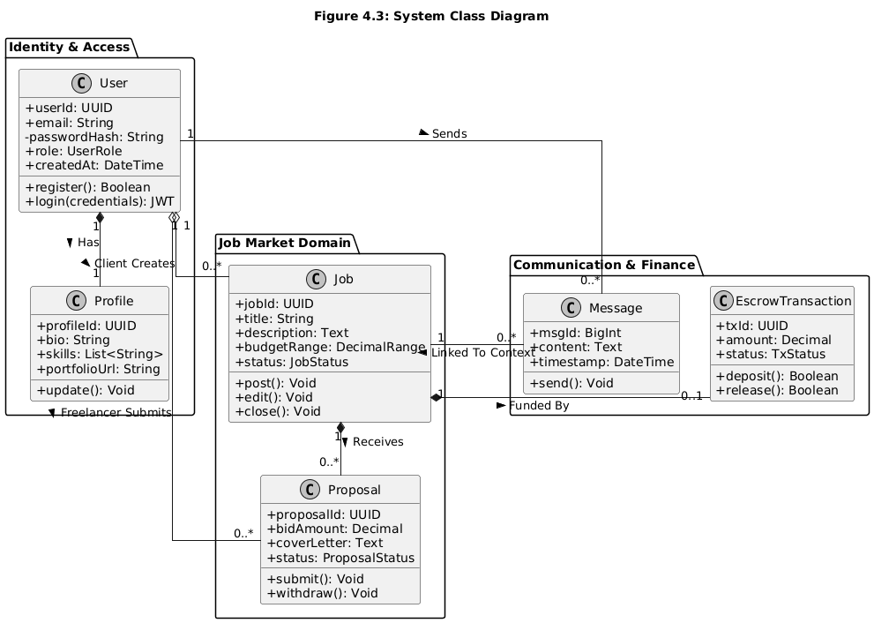
4.4 State Transition Models
To ensure data integrity, the system enforces strict state machine logic for the Job entity. The valid transitions are defined as follows:
- State: OPEN
  - Entry Condition: Client successfully posts a new job.
  - Allowed Actions: Freelancers can submit proposals; Client can edit details.
  - Next Valid States: CONTRACTED (if a proposal is accepted), CLOSED (if manually cancelled).
- State: CONTRACTED
  - Entry Condition: Client accepts a specific Proposal.
  - System Side-Effect: All other proposals for this job are automatically marked as REJECTED. The job is removed from the public search feed.
  - Allowed Actions: Messaging between Client and Hired Freelancer.
  - Next Valid States: COMPLETED.
- State: COMPLETED
  - Entry Condition: Client triggers the "Release Funds" action (simulated).
  - Next Valid States: None (Terminal State).

Chapter 5
Requirement Traceability Matrix
The Requirement Traceability Matrix maps the Functional Requirements (FR) to specific Test Cases (TC) to ensure full coverage during the Quality Assurance (QA) phase.

Req ID | Requirement Name | Test Case ID | Validation Criteria
FR-01 | Authentication | TC-01 | Verify JWT generation, expiration, and rejection of invalid signatures.
FR-02 | Job Lifecycle | TC-02 | Verify database persistence of job fields and enforcement of 'Client' role.
FR-03 | Search & Filtering | TC-03 | Verify SQL query performance (<300ms) and correctness of category filters.
FR-04 | Proposal Engine | TC-04 | Verify constraint violation when submitting duplicate proposals for the same job.
FR-05 | Real-Time Messaging | TC-05 | Verify Socket.io event delivery and simultaneous persistence to PostgreSQL.
FR-06 | Transaction Sim | TC-06 | Verify the logic governing job status transitions (Open → Contracted).

TABLE OF CONTENTS: PART III (SDD)
Chapter 1: Introduction ........................................................................................................ 30
1.1 Purpose .................................................................................................................................. 30
1.2 Scope ...................................................................................................................................... 30
1.3 Definitions and Acronyms ..................................................................................................... 30
Chapter 2: Architectural Design ..................................................................................... 31
2.1 Architectural Overview .......................................................................................................... 31
2.2 Architectural Patterns ............................................................................................................. 31
2.2.1 Modular Monolith ............................................................................................................... 31
2.2.2 Layered Architecture ........................................................................................................... 31
2.3 Design Rationale .................................................................................................................... 31
Chapter 3: System Decomposition and Component Design ............................................ 33
3.1 Identity Management Component (AuthModule) ................................................................. 33
3.2 Job Orchestration Component (JobModule) ......................................................................... 33
3.3 Real-Time Messaging Component (ChatGateway) ............................................................... 33
Chapter 4: Data Design ......................................................................................................... 35
4.1 Database Schema (Physical Data Model) .............................................................................. 35
Chapter 5: Algorithm Design ............................................................................................... 37
5.1 Composite Search & Filtering Algorithm .............................................................................. 37
5.2 Proposal Idempotency Check ................................................................................................ 37
Chapter 6: Interface Design .................................................................................................. 38
6.1 API Design (REST) ................................................................................................................ 38
6.2 Communication Protocols ...................................................................................................... 39
Chapter 7: Behavioral Design .............................................................................................. 39
7.1 Sequence Diagrams ................................................................................................................ 40
7.1.1 User Authentication Sequence ............................................................................................ 41
7.1.2 Real-Time Message Sequence ............................................................................................ 41
Chapter 8: Deployment Design ........................................................................................... 41
8.1 Deployment Architecture ....................................................................................................... 41
8.2 Environment Strategy ............................................................................................................ 42
Chapter 9: Operational Design ............................................................................................ 42
9.1 Logging Strategy .................................................................................................................... 42
9.2 Monitoring and Health Checks .............................................................................................. 42
9.3 Configuration Management ................................................................................................... 43
Chapter 10: Detailed Quality Attributes ........................................................................... 43
10.1 Security Design (Defense in Depth) .................................................................................... 43
10.2 Maintainability ..................................................................................................................... 43
Chapter 11: Design Constraints and Compliance ............................................................. 43
11.1 Standards Compliance .......................................................................................................... 44
11.2 Legal and Regulatory Requirements .................................................................................... 44
References ................................................................................................................................ 44
Appendices ............................................................................................................................... 45
Appendix A: Glossary of Terms ................................................................................................... 45
Appendix B: List of Figures ........................................................................................................ 45

Chapter 1
Introduction
1.1 Purpose
The purpose of this Software Design Document (SDD) is to provide a detailed architectural blueprint and low-level design specification for the platform. It translates the functional requirements defined in the SRS into concrete technical structures, data models, and interface definitions.
1.2 Scope
The design encompasses the full-stack architecture of the system, specifically focusing on:
- High-Level Architecture: The adoption of a Modular Monolith pattern to balance development velocity with code organization.
- Subsystem Decomposition: Detailed design of the Identity Management (RBAC), Job Lifecycle Engine, Proposal Transaction Logic, and Real-Time Messaging modules.
- Data Persistence: Third Normal Form database schema design using PostgreSQL.
- Interface Design: Specification of RESTful API endpoints and WebSocket event definitions.
1.3 Definitions and Acronyms
- DTO (Data Transfer Object): Simple objects used to transfer data between subsystems without containing business logic.
- Middleware: Software components assembled into the application pipeline to handle requests (e.g., logging, authentication) before they reach the controller.
- MVC: Model-View-Controller; a software design pattern separating internal representation from information presentation.

Chapter 2
Architectural Design
2.1 Architectural Overview
The system is architected as a Three-Tier Web Application following the Client-Server model. The physical distribution is divided across three distinct logic tiers:
- Presentation Tier (Client): A Single Page Application responsible for user interaction, state management, and view rendering. It runs in the user's browser.
- Logic Tier (Server): An Application Server acting as the centralized API Gateway and business logic processor. It is stateless and handles all data processing, authentication, and authorization.
- Data Tier (Persistence): A Relational Database Management System (RDBMS) that stores all persistent data and enforces referential integrity.
2.2 Architectural Patterns
The system implements the following architectural patterns to ensure maintainability and scalability:
2.2.1 Modular Monolith
The backend is deployed as a single executable unit (Node.js process), but the internal code structure is strictly divided into isolated domain modules (e.g., AuthModule, JobModule, ChatModule).
2.2.2 Layered Architecture
Within each module, the codebase is organized into horizontal layers to enforce Separation of Concerns (SoC):
- Controller Layer: Handles HTTP request parsing, input validation (Zod), and response formatting. It contains no business logic.
- Service Layer: Contains the core business logic, rules, and transaction boundaries. It interacts with the repository layer.
- Data Access Layer (Repository): Abstractions using Prisma ORM to interact with the database, ensuring business logic is not coupled to raw SQL queries.
2.3 Design Rationale
Why Node.js & Express?
The choice of Node.js is driven by its event-driven, non-blocking I/O model. This is architecturally superior for the platform, which is I/O heavy handling simultaneous chat messages and frequent database reads for job feeds rather than CPU intensive.
Why PostgreSQL over MongoDB (NoSQL)?
The core domain relies heavily on structured relationships (Clients have Jobs; Jobs have Proposals) and data integrity. PostgreSQL provides ACID compliance, ensuring that a Proposal is never "orphaned" if a Job is deleted (via Cascading Deletes) and that financial simulations are transactionally safe.
Why Next.js (SSR)?
Server-Side Rendering (SSR) is critical for a job board. Unlike a standard React SPA, Next.js renders the initial HTML on the server, ensuring that job listings are indexable by search engines (SEO) and load faster on low-bandwidth connections common in the target region.

Chapter 3
System Decomposition and Component Design
This section details the internal design of the high-level subsystems identified in the architectural overview. Each component is designed to operate autonomously within the monolithic structure, communicating via strictly typed interfaces.
3.1 Identity Management Component (AuthModule)
- Responsibility: Manages User Registration, JWT Issuance/Verification, and RBAC Policy Enforcement.
- Dependencies: bcrypt (Hashing), jsonwebtoken (Signing), PrismaClient (Database).
- Interface Contracts:
  - POST /auth/register: Accepts RegisterDTO, returns UserResponse.
  - POST /auth/login: Accepts LoginDTO, returns AuthToken.
- Internal Logic:
  - Middleware Strategy: Implements a custom middleware function that intercepts HTTP headers, extracts the Authorization: Bearer string, validates the JWT signature, and attaches the decoded user object to the Request context.
  - Password Security: Utilizes bcrypt.hash()during registration and bcrypt.compare() during login to ensure credential security.
3.2 Job Orchestration Component (JobModule)
- Responsibility: Manages the lifecycle of Job entities and executes search queries.
- Dependencies: JobRepository (Data Access), AuthMiddleware (RBAC).
- Interface Contracts:
  - JobController: Handles HTTP requests mapping to CRUD operations.
  - JobService: Implements business rules (e.g., "Only users with role CLIENT can create jobs").
- Validation Logic: The JobService validates that budget_max >= budget_min and that the deadline is a future timestamp before invoking the Repository to persist data.
3.3 Real-Time Messaging Component (ChatGateway)
- Responsibility: Manages WebSocket connections, handles room subscriptions (based on proposal_id or user_id), and persists chat history.
- Dependencies: Socket.io (Transport), MessageRepository.

Chapter 4
Data Design
The Data Design follows a Relational Model optimized for transactional integrity. The schema is normalized to the Third Normal Form (3NF).
4.1 Database Schema (Physical Data Model)
The PostgreSQL database is managed via the Prisma Schema definition.
1. Users Table (Identity Entity)
- Primary Key: id (UUID v4) - GUIDs are used to prevent enumeration attacks.
- Attributes: email (VARCHAR(255), Unique, Indexed), password_hash (VARCHAR), role (ENUM: 'CLIENT', 'FREELANCER'), created_at (TIMESTAMPTZ).
- Constraint: Unique index on email.
2. Profiles Table (Extended Data)
- Primary Key: id (UUID).
- Foreign Key: user_id (References Users, On Delete: CASCADE).
- Attributes: skills (JSONB — allows flexible, indexable arrays of skill tags), portfolio_url (VARCHAR), rating (DECIMAL, Default 0.0).
- Rationale: Vertical partitioning of User and Profile data optimizes authentication query performance by loading heavy profile data only when necessary.
3. Jobs Table (Transactional Entity)
- Primary Key: id (UUID).
- Foreign Key: client_id (References Users).
- Attributes: title (VARCHAR(150)), description (TEXT), budget_min (NUMERIC(10,2)), budget_max (NUMERIC(10,2)), status (ENUM: 'OPEN', 'CONTRACTED', 'CLOSED'), deadline (TIMESTAMPTZ).
- Indices: Composite index on [status, created_at] to optimize feed sorting. search_vector (TSVECTOR) for full-text search.
4. Proposals Table (Transactional Entity)
- Primary Key: id (UUID).
- Foreign Keys: job_id (References Jobs), freelancer_id (References Users).
- Attributes: bid_amount (NUMERIC(10,2)), cover_letter (TEXT), status (ENUM: 'PENDING', 'ACCEPTED', 'REJECTED').
- Constraint: @@unique([job_id, freelancer_id]) — Enforces idempotency (one proposal per freelancer per job).
5. Messages Table (Append-Only Log)
- Primary Key: id (BIGINT — Sequential ID preferred for chat ordering).
- Foreign Keys: sender_id, receiver_id.
- Attributes: content (TEXT), is_read (BOOLEAN), sent_at (TIMESTAMPTZ).

Chapter 5
Algorithm Design
This section describes the specific algorithmic logic used to solve complex computational problems within the application components.
5.1 Composite Search & Filtering Algorithm
- Problem: Efficiently retrieving relevant jobs from the database based on multiple optional criteria (keywords, category, budget) provided by the user, while maintaining low latency.
- Component: JobService.search()
- Logic:
  - Initialization: Instantiate a dynamic query builder object (Prisma where clause).
  - Keyword Parsing:
    - If query string is present, sanitize input.
    - Convert input into a TSVECTOR formatted string (e.g., "web & design").
    - Append full-text search condition: search_vector @@ plainto_tsquery(input).
  - Filter Application:
    - If category_id is present, append strict equality check: AND categoryId = input.
    - If min_budget is present, append range check: AND budget_max >= input.
  - Pagination:
    - Calculate skip value: (page_number - 1) * page_size.
    - Apply take (limit) and skip (offset) to the database query.
  - Execution: Run the query against the PostgreSQL index.
  - Metadata Generation: Run a parallel count() query to determine total_pages for frontend pagination UI.
5.2 Proposal Idempotency Check
- Problem: Preventing "Race Conditions" where a freelancer accidentally submits a proposal twice for the same job (e.g., due to network lag or double-clicking), ensuring data consistency.
- Component: ProposalService.submit()
- Logic:
  - Request Reception: Receive POST /proposals with job_id and freelancer_id (from session).
  - Pre-Check (Read): Query the Proposals table:
SELECT id FROM proposals WHERE job_id = input_job AND freelancer_id = input_user.
  - Branching:
    - If Record Exists: Immediately throw ConflictException (HTTP 409). Terminate process.
    - If Null: Proceed to Step 4.
  - Transaction Start: Open Prisma Interactive Transaction.
  - Job Status Validation: Lock the Job row and verify status === 'OPEN'. If not, rollback.
  - Persistence (Write): Insert new Proposal record.
  - Commit: Finalize transaction.

Chapter 6
Interface Design
6.1 API Design (REST)
The Application Programming Interface (API) follows REST Level 2 maturity, ensuring predictability and standard compliance.
Resource Naming Conventions:
- Resources are nouns (e.g., /jobs, /users), not verbs (e.g., /getJobs).
- Hierarchy is represented by path nesting (e.g., /jobs/:id/proposals).
Standard HTTP Verbs:
- GET: Read resources (Idempotent).
- POST: Create new resources (Non-idempotent).
- PATCH: Partially update a resource (e.g., changing job status).
- DELETE: Remove a resource.
Status Code Strategy:
- 200 OK: Successful synchronous request.
- 201 Created: Successful creation (includes Location header).
- 400 Bad Request: Validation failure (Zod error).
- 401 Unauthorized: Missing or invalid JWT.
- 403 Forbidden: Valid JWT but insufficient role permissions (RBAC).
- 404 Not Found: Resource ID does not exist.
- 500 Internal Server Error: Unhandled exception (Log to stdout).
6.2 Communication Protocols
- Transport Security: All HTTP traffic is tunneled via TLS 1.2+ (HTTPS).
- Real-Time Transport: The system uses the WebSocket Protocol (RFC 6455) over TLS (wss://). The server performs a handshake verification using the JWT passed in the query string or Authorization header before upgrading the connection.

Chapter 7
Behavioral Design
7.1 Sequence Diagrams
Sequence Diagram 1. Job Posting
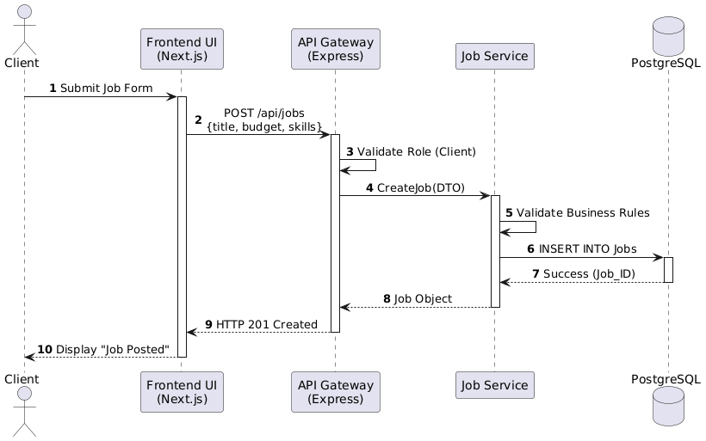
Sequence Diagram 2. Real time Message Delivery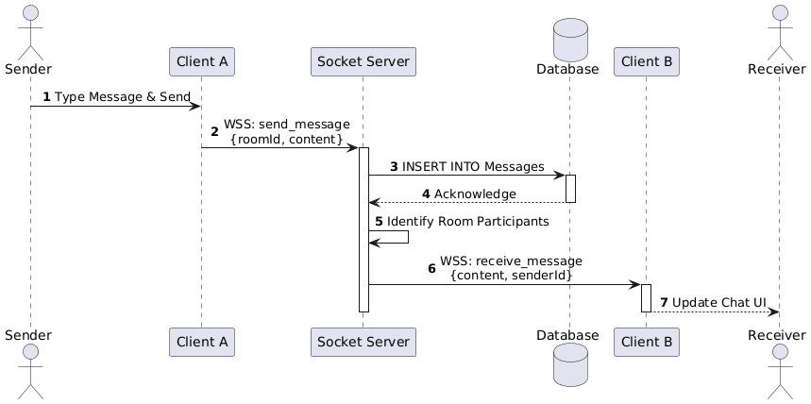

7.1.1 User Authentication Sequence
- Frontend sends POST /login.
- AuthMiddleware applies rate limiting.
- AuthController delegates to AuthService.
- AuthService queries Database for user by email.
- AuthService compares password hash.
- AuthService generates JWT.
- AuthController returns 200 OK.
7.1.2 Real-Time Message Sequence
- Sender emits send_message event.
- Socket Server validates payload and sender identity.
- ChatService persists message to Database (Async).
- Socket Server identifies Recipient's active socket ID.
- Socket Server emits new_message event to Recipient.
- Recipient Client updates UI state.
Chapter 8
Deployment Design
8.1 Deployment Architecture
The platform utilizes a Platform-as-a-Service (PaaS) architecture. This approach abstracts the underlying infrastructure management, allowing the engineering team to focus on application logic while leveraging cloud-native scalability.
The deployment is split into three decoupled environments:
1. Frontend / Edge Tier:
- Host: Vercel (Specialized for Next.js).
- Function: Hosts the static assets (HTML/CSS/JS) on a Global CDN and executes Server-Side Rendering (SSR) functions at the network edge for low latency.
- Benefits: Automatic DDoS protection, global caching, and CI/CD integration.
2. Application Tier:
- Host: Render or Railway (Container Platform).
- Function: Runs the Node.js/Express backend as a stateless Docker Container.
- Process Management: Utilizes a process manager (e.g., PM2) within the container to handle auto-restarts on failure.
8.2 Environment Strategy
To ensure stability and testing rigor, the system implements a strict Multi-Environment Strategy:
- Development (Local):
  - Infrastructure: Local developer machines.
  - Database: Local PostgreSQL instance.
  - Config: .env.development.
- Staging (UAT):
  - Infrastructure: Free-tier PaaS.
  - Database: Cloud-hosted development DB (seeded with synthetic data).
  - Config: .env.test.
  - Purpose: User Acceptance Testing (UAT) and Instructor Demonstrations.
9. Operational Design
9.1 Logging Strategy
To ensure system observability and rapid root-cause analysis, the application utilizes Structured Logging. Instead of unstructured text, logs are emitted as JSON objects, making them machine-parsable for future aggregation tools.
- Log Levels:
  - ERROR: System failures requiring immediate attention (e.g., DB Connection Lost).
  - WARN: Runtime abnormalities that are not fatal (e.g., 401 Unauthorized spikes).
  - INFO: High-level operational events (e.g., "Job Posted," "Proposal Submitted").
  - DEBUG: Detailed flow information (disabled in Production).
- Output: Logs are written to stdout (Standard Output), which is captured by the container runtime logs.
9.2 Monitoring and Health Checks
The system implements a proactive monitoring strategy to detect outages before they impact end-users.
- Health Check Endpoint:
  - Route: GET /health
  - Logic: The API performs a lightweight query (SELECT 1) to the database.
  - Response: Returns HTTP 200 { status: "UP" } if successful, or HTTP 503 if the DB is unreachable. This endpoint is polled by the hosting provider's load balancer.
9.3 Configuration Management
- Secrets: Sensitive credentials (Database URLs, JWT Secrets, SMTP Keys) are never committed to version control.
- Injection:
  - Development: Loaded from a local .env file using the dotenv library.
  - Production: Injected as Environment Variables by the PaaS provider at runtime.
- Validation: On application startup, a Configuration Schema (Zod) validates that all required environment variables are present. If a variable is missing, the application fails fast (crashes immediately) to prevent undefined behavior.
Chapter 10
Detailed Quality Attributes
10.1 Security Design (Defense in Depth)
- JWT Strategy: Access tokens are short-lived. The system relies on the client to handle token refresh logic (if implemented) or re-login. This minimizes the window of opportunity if a token is stolen.
10.2 Maintainability
- Type Safety: The entire backend is written in TypeScript. Shared DTOs and Interfaces ensure that a change in the Database Schema triggers compile-time errors in the Application Layer, catching regressions before runtime.
- Code Style: The project enforces a strict ESLint and Prettier configuration. This ensures that code written by different team members follows a consistent style, improving readability for the academic advisor and future maintainers.
Chapter 11
Design Constraints and Compliance
11.1 Standards Compliance
The software design adheres to the following standards:
- IEEE 1016-2009: The structure of this SDD follows the IEEE Standard for Information Technology—Systems Design—Software Design Descriptions.
- RFC 7519: JWT implementation adheres strictly to the Request for Comments standard for JSON Web Tokens.
11.2 Legal and Regulatory Requirements
- Data Privacy: The design aligns with the principles of the Ethiopian Personal Data Protection Proclamation regarding data minimization. The schema is designed to store only essential data required for service delivery.
- Right to Erasure: The database design supports "Soft Delete" mechanisms that can be converted to "Hard Delete" (scrubbing PII) upon user request, satisfying the "Right to be Forgotten."

References
- IEEE Computer Society. (1998). IEEE Recommended Practice for Software Requirements Specifications (IEEE Std 830-1998). New York, NY: Institute of Electrical and Electronics Engineers.
- IEEE Computer Society. (2009). IEEE Standard for Information Technology—Systems Design—Software Design Descriptions (IEEE Std 1016-2009). New York, NY: Institute of Electrical and Electronics Engineers.
- Internet Engineering Task Force (IETF). (2015). JSON Web Token (JWT), RFC 7519. Available: https://tools.ietf.org/html/rfc7519. [Accessed: Oct 10, 2025].
- Next.js. (2024). Next.js Documentation: App Router & Server Actions. Vercel Inc. Available: https://nextjs.org/docs. [Accessed: Oct 8, 2025].
- Node.js Foundation. (2024). Node.js v20.x Documentation. Available: https://nodejs.org/en/docs/. [Accessed: Oct 8, 2025].
- Prisma. (2024). Prisma ORM Reference & Schema API. Available: https://www.prisma.io/docs. [Accessed: Oct 9, 2025].
- PostgreSQL Global Development Group. (2024). PostgreSQL 16.1 Documentation: Concurrency Control. Available: https://www.postgresql.org/docs/16/.

Appendix A: Glossary of Terms
- API Gateway: A server that acts as an API front-end, receiving API requests, enforcing throttling and security policies, passing requests to the back-end service, and passing the response back to the requester.
- Idempotency: A property of operations whereby they can be applied multiple times without changing the result beyond the initial application (e.g., submitting the same proposal twice results in only one record).
- JWT (JSON Web Token): An open standard (RFC 7519) that defines a compact and self-contained way for securely transmitting information between parties as a JSON object.
- Middleware: Software that provides common services and capabilities to applications outside of what is offered by the operating system, often used in Node.js for logging, auth, and validation.
- ORM (Object-Relational Mapping): A technique for converting data between incompatible type systems using object-oriented programming languages. This project uses Prisma.
- PaaS (Platform as a Service): A cloud computing model where a third-party provider delivers hardware and software tools to users over the internet (e.g., Vercel, Render).
- RBAC (Role-Based Access Control): A policy-neutral access-control mechanism defined around roles and privileges.
- SSR (Server-Side Rendering): The process of rendering web pages on the server and sending them to the client (browser) ready to be displayed, improving performance and SEO.
- Webhook: A method of augmenting or altering the behavior of a web page or web application with custom callbacks.
Appendix B: List of Figures
- Figure 4.1: System Use Case Diagram
- Figure 4.2: Domain Class Diagram
- Sequence Diagram 1: Job Posting Workflow
- Sequence Diagram 2: Real-Time Message Delivery

