Mekelle University
Department of Software Engineering



Software Requirements Specification
For Tibeb: skill marketplace
Submitted to:
Instructor G.Michael
Submitted by:
Nahom Mulualem
Samuel Embaye
Teame G/her

Contents
1. Introduction 4
1.1 Purpose 4
1.2 Scope 4
1.3 Definitions, Acronyms, and Abbreviations 5
1.4 Overview of Document 5
2. Overall Description 6
2.1 System Context 6
2.2 User Types and Characteristics 6
2.3 User Needs / Problem Statement 7
2.4 Product Perspective 7
2.5 Constraints 8
2.6 Assumptions and Dependencies 8
3. System Requirements 9
3.1 Business Rules 9
3.2 Functional Requirements 9
3.3 Requirement Traceability 12
4. System Models 14
4.1 Use-Case Diagrams and Descriptions 14
4.2 Sequence Diagrams 15
4.3 Domain Model / Class Diagram 17
5. Non-Functional Requirements 19
5.1 Performance Requirements 19
5.2 Security Requirements 19
5.3 Reliability and Availability 20
5.4 Maintainability and Extensibility 20
5.5 Usability Requirements 21
6. External Interface Requirements 22
6.1 User Interface (UI) Specifications 22
6.2 Hardware Interface 22
6.3 Software Interface 23
6.4 Communication Interface 23
7. Data Requirements 25
7.1 Data Model / ER Diagram 25
7.2 Data Storage Requirements 27
7.3 Data Validation Rules 27
8. System Constraints and Limitations 29
8.1 Project-Scope Constraints 29
8.2 Technical Constraints 29
8.3 Operational Limitations 29
8.4 Regulatory and Compliance Constraints 30
9. Acceptance Criteria 31
9.1 Acceptance Overview 31
9.2 Functional Acceptance Criteria (Critical Path) 31
9.3 Performance & Reliability SLOs 32
9.4 Security & Compliance Criteria 32
9.5 Deliverables 32
9.6 Acceptance Procedure & Sign-Off 33
10. References 34
11. Appendices 35
11.1 Glossary 35
11.2 Figures / Diagrams 35

1. Introduction

1.1 Purpose
This Software Requirements Specification (SRS) serves as the authoritative architectural blueprint for the Skill Marketplace Platform. It defines the specific behavioral requirements, interface standards, data structures, and operational constraints required to build a scalable, high-availability distributed web application.

1.2 Scope
System Architecture & Core Capabilities
The Skill Marketplace is designed as a Modular Monolith, utilizing a three-tier architecture:
- Presentation Layer: A Server-Side Rendered (SSR) Single Page Application (SPA) built on Next.js 14 (React), providing optimized SEO and distinct dashboards for "Client" and "Freelancer" actors.
- Application Layer: A RESTful API service developed in Node.js (v20 LTS) and Express.js, implementing the Controller-Service-Repository pattern to ensure separation of concerns.
- Persistence Layer: A relational data store using PostgreSQL 16, managed via Prisma ORM for type-safe database access and schema migrations.
Functional Boundaries (MVP)
The initial release targets a "Production Pilot" scope, delivering:
- Identity & Access Management (IAM): Implementation of OAuth 2.0 flows and JWT (JSON Web Token) stateless sessions with Role-Based Access Control (RBAC) middleware.
- Job Lifecycle Orchestration: A state-machine-driven engine for managing Job entities (Draft → Open → Contracted → Closed) with strict validation logic.
- Proposal & Bidding System: A transactional workflow allowing atomic submission of proposals, enforcing referential integrity between Users and Jobs.
- Real-Time Communication: A persistent, low-latency messaging subsystem utilizing WebSockets (Socket.io) for bidirectional event-based communication.
- Search Engine: A query-optimized search interface utilizing PostgreSQL full-text search vectors and composite indexing for high-performance filtering.
Explicit Exclusions
- Mobile Native Binaries: The frontend is a Responsive Web App (PWA compliant); native iOS/Android builds are out of scope.

1.3 Definitions, Acronyms, and Abbreviations
- API (RESTful): Representational State Transfer; an architectural style for the backend endpoints utilizing standard HTTP methods (GET, POST, PUT, DELETE).
- DTO (Data Transfer Object): An object that carries data between processes, used here to validate API request payloads (e.g., via Zod or Joi libraries).
- Idempotency: A property of certain operations where multiple identical requests produce the same result (crucial for the Proposal Submission and Payment logic).
- JWT: JSON Web Token; a URL-safe, self-contained token used for stateless authentication, signed using HMAC SHA-256 (HS256) or RS256.
- Middleware: Software components assembled into an application pipeline to handle requests and responses (e.g., logging, authentication, rate limiting).
- ORM: Object-Relational Mapping; specifically Prisma, used to map TypeScript objects to PostgreSQL relational tables.
- RBAC: Role-Based Access Control; a mechanism that restricts system access to authorized users based on their assigned role (Client vs. Freelancer).
- SSR / CSR: Server-Side Rendering / Client-Side Rendering; rendering strategies employed by Next.js for performance optimization.

1.4 Overview of Document
The remainder of this document defines the technical specifications:
- Section 2: architectural context, user persona technical profiling, and operational constraints.
- Section 3: detailed functional requirements mapped to specific API endpoints and business logic.
- Section 4: UML system models (Use Case, Sequence, Class).
- Section 5: non-functional quality attributes including latency budgets, security protocols (OWASP), and reliability targets.
- Section 6: external interface contracts (API definitions).
- Section 7: database schema normalization and storage requirements.
- Sections 8-11: constraints, acceptance testing matrices, and appendices.

2. Overall Description

2.1 System Context
The Skill Marketplace operates as a distributed N-Tier Web Application designed to decouple presentation, application logic, and data persistence. The system functions as a centralized Digital Intermediary Platform, orchestrating interactions between Service Seekers (Clients) and Service Providers (Freelancers).
Architectural Boundaries and Interfaces:
- Presentation Layer (Frontend): A Next.js 14 Single Page Application (SPA) consuming API endpoints. It handles client-side routing, state management (via React Context/Redux), and renders UI components using TailwindCSS. It communicates with the backend exclusively via JSON over HTTPS.
- Application Layer (Backend): A stateless Node.js/Express service acting as the primary API Gateway and business logic processor. It implements middleware for Rate Limiting (express-rate-limit), CORS policies, and Request Validation (Zod/Joi).
- Persistence Layer: A PostgreSQL 16 database cluster. The backend connects via Prisma ORM, utilizing connection pooling (pg-pool) to manage concurrent database access efficiently.
- External Interfaces (Simulation): The system interacts with a mocked Payment Service interface.

2.2 User Types and Characteristics
The system implements a strict Role-Based Access Control (RBAC) model. User roles are immutable during an active session and determine API accessibility.
- Client (Service Requester)
Architectural Role: Data Originator (Jobs) and State Mutator (Contracts).
  - Capabilities: Authorized to initiate INSERT operations on the Jobs table, UPDATE contract states (e.g., initiate_escrow, release_funds), and access read-only views of submitted Proposals.
  - Technical Profile: Web-literate users accessing the platform via desktop or mobile browsers.
- Freelancer (Service Provider)
  - Architectural Role: Responder and Data Consumer.
  - Capabilities: High-frequency READ access to Job Feeds. Authorized to initiate INSERT operations on the Proposals table. Restricted from viewing proposals of competing freelancers (row-level security logic).
  - Technical Profile: High technical literacy; likely to utilize advanced search filters and upload portfolio artifacts.

2.3 User Needs / Problem Statement
The current operational environment for local freelancing relies on decentralized, unstructured channels (e.g., Telegram groups, direct social media messaging). This architecture presents critical systemic failures:
- Data Fragmentation: Transaction history and project requirements are scattered across volatile chat logs, preventing atomic record-keeping.
- Lack of Non-Repudiation: Informal agreements lack digital signatures or immutable audit trails, making dispute resolution impossible.
- Security Vulnerabilities: Direct P2P file sharing exposes users to malware without intermediate scanning or sanitization.
System Solution:
The Skill Marketplace creates a trusted execution environment where:
- Job requirements are structurally defined (typed data fields).
- Proposals are linked to authenticated user identities.
- Communication is tunneled through a persisted, auditable messaging layer.

2.4 Product Perspective
The Skill Marketplace is a standalone, greenfield software product.
- Architectural Pattern: Modular Monolith. The system is deployed as a single functional unit (API + Frontend serve) to minimize DevOps overhead during the MVP phase, but structured internally with clear domain boundaries (Auth Domain, Job Domain, Chat Domain) to facilitate extraction into Microservices as scaling demands increase.
- State Management: The backend is designed to be Stateless. User sessions are managed via client-side tokens (JWT), allowing the backend to be horizontally scaled behind a load balancer (e.g., NGINX) without sticky sessions.
- Data Sovereignty: This system ensures that structured employment data is hosted in a controlled relational environment, compliant with planned local hosting requirements.

2.5 Constraints
Technical & Implementation Constraints
- Protocol Standards: All data in transit must be secured.
- Payload Limits: API request bodies are capped at 100KB for standard JSON data to mitigate Denial of Service (DoS) attacks. File uploads (e.g., resumes) are restricted to specific MIME types (application/pdf, image/png).
- Latency Budget: The system must achieve a Time to First Byte (TTFB) of < 300ms and a Largest Contentful Paint (LCP) of < 2.5s on 4G networks.
- Concurrency: The Node.js event loop must not be blocked by CPU-intensive tasks; heavy computations (if any) must be offloaded to worker threads or background queues (e.g., BullMQ).

2.6 Assumptions and Dependencies
- Runtime Environment: It is assumed the hosting environment supports Node.js v18+ and provides a persistent PostgreSQL instance (e.g., AWS RDS, Supabase, or self-hosted VPS).
- Client Capabilities: The user base is assumed to operate modern, Javascript-enabled web browsers (Chrome v90+, Firefox v88+, Safari v14+). IE11 support is explicitly dropped.
- Third-Party Services: The system relies on external SMTP providers (e.g., SendGrid/Nodemailer) for transactional emails (password resets).
- Machine Learning Matchmaker: Replacement of the SQL-based keyword search with a Vector Database (e.g., pgvector) for semantic matching of resumes to job descriptions.

3. System Requirements
This section specifies the functional behaviors and logical constraints of the Skill Marketplace. The requirements are defined in terms of system inputs, processing logic, and expected outputs, mapped to specific API interactions and database states.

3.1 Business Rules
The following business logic rules enforce system integrity and compliance constraints:
- BR-1 — Identity Isolation: A user entity must be strictly provisioned with a single role attribute (Client or Freelancer) upon registration. Cross-role behavior (e.g., a Client account submitting a proposal) is prohibited at the API authorization level.
- BR-2 —Proposal Validity: Proposals can only be submitted to job entities holding an 'OPEN' status. If a job transitions to 'CLOSED' or 'CONTRACTED', all subsequent write operations to the proposal table for that job ID must be rejected.
- BR-3 — Communication Encapsulation: To preserve audit trails, all pre-contract negotiations must occur within the system's messaging infrastructure. The system does not expose user email addresses or phone numbers publicly to prevent platform circumvention.
- BR-4 — Logical Escrow Simulation: Financial state transitions (Deposit, Hold, Release) are implemented as logical flags within the database transaction log.
- BR-5 — Immutability of Contracts: Once a proposal is accepted and a contract is instantiated, the core terms (Budget, Deliverables) become immutable. Any modification requires a formal contract termination and re-initiation.

3.2 Functional Requirements
FR-3.2.1 — Authentication & Session Management
- Description: The system shall implement a secure authentication subsystem using the OAuth 2.0 standard (Resource Owner Password Credentials flow).
- API Endpoint: POST /api/v1/auth/login
- Inputs: JSON payload containing email and raw password string.
- Processing:
  - Sanitize input to prevent SQL injection.
  - Retrieve user record by email.
  - Compare input password against stored password
  - Generate JWT signed with HS256 algorithm containing user_id and role claims.
- Outputs: HTTP 200 OK with Bearer Token; HTTP 401 Unauthorized on failure.
- Preconditions: User account exists and is active.
- Postconditions: Client device stores the token for subsequent authenticated requests.
FR-3.2.2 — Job Lifecycle Management
- Description: The system shall provide a CRUD interface for Clients to manage job postings. The backend must validate that the authenticated user holds the Client role before permitting write operations.
- API Endpoint: POST /api/v1/jobs
- Inputs: Job title, category ID, detailed description, budget range (min/max), and expiry timestamp.
- Processing:
  - Validate request body against the defined schema
  - Create a new Job entity with status 'OPEN'.
  - Index text fields for search optimization.
- Outputs: HTTP 201 Created with the generated UUID of the job.
- Preconditions: Valid Bearer Token with Client scope.
- Postconditions: The job is persisted in the PostgreSQL database and becomes queryable via the search API.
FR-3.2.3 — Advanced Search & Filtering
- Description: The system shall expose a queryable interface allowing Freelancers to retrieve paginated job listings. The search logic must support filtering by category, and keyword matching.
- API Endpoint: GET /api/v1/jobs?q=keyword&category=id
- Inputs: Query parameters for keywords, category_id, min_budget, and page number.
- Processing:
  - Construct a parameterized SQL query with WHERE clauses matching the filters.
  - Apply Limit and Offset logic for pagination.
  - Execute query against the Jobs table index.
- Outputs: JSON array of job summary objects and pagination metadata (total count, current page).
- Preconditions: None (public endpoint) or Authenticated Freelancer (depending on privacy config).
- Postconditions: None (Read-only operation).
FR-3.2.4 — Proposal Submission Engine
- Description: The system shall allow authenticated Freelancers to submit a proposal for a specific job. This operation must be atomic and enforce uniqueness (one proposal per freelancer per job).
- API Endpoint: POST /api/v1/proposals
- Inputs: target_job_id, bid_amount, cover_letter_text, estimated_duration.
- Processing:
  - Verify target_job_id exists and status is 'OPEN'.
  - Check if a proposal already exists for this (user_id, job_id) pair.
  - Persist the proposal record.
  - Trigger a notification event for the Client.
- Outputs: HTTP 201 Created with Proposal ID.
- Preconditions: User role must be Freelancer.
- Postconditions: Proposal count on the Job entity is incremented.
FR-3.2.5 — Real-Time Messaging Subsystem
- Description: The system shall facilitate low-latency text communication between a Client and a Freelancer. The architecture should support WebSocket connections for instant delivery, falling back to HTTP REST for history retrieval.
- API Endpoint: POST /api/v1/messages and WS /socket.io
- Inputs: receiver_id, content_body.
- Processing:
  - Validate that a connection context (Proposal or Contract) exists between the two users.
  - Persist message to the Messages table with a timestamp.
  - Emit WebSocket event to the receiver's active socket ID.
- Outputs: HTTP 201 Created; WebSocket 'new_message' event.
- Preconditions: Sender and Receiver must have an established business relationship context.
- Postconditions: Message is permanently stored in the chat history log.
FR-3.2.6 — Transaction State Simulation
- Description: The system shall model the escrow workflow. The backend handles state transitions for the Job entity from 'OPEN' to 'IN_PROGRESS' (Escrow Deposit) and finally to 'COMPLETED' (Funds Released).
- API Endpoint: PATCH /api/v1/jobs/{id}/status
- Inputs: new_status (e.g., 'IN_PROGRESS'), action_token.
- Processing:
  - Verify the authenticated user is the owner of the job.
  - Validate the state transition is legal (e.g., cannot go from OPEN directly to COMPLETED).
  - Update the status column.
  - Create a Transaction Log entry recording the virtual movement of funds.
- Outputs: HTTP 200 OK with updated Job object.
- Preconditions: A proposal must have been accepted prior to this action.
- Postconditions: The Job is locked from further proposals.

3.3 Requirement Traceability
The following Requirement Traceability Matrix (RTM) maps functional requirements to specific test cases to ensure full coverage during Quality Assurance (QA).
- FR-3.2.1 maps to TC-01 (Auth Flow): Verify JWT generation, expiration, and rejection of invalid signatures.
- FR-3.2.2 maps to TC-02 (Job CRUD): Verify database persistence of job fields and enforcement of required parameters.
- FR-3.2.3 maps to TC-03 (Search Logic): Verify SQL query performance and correctness of filter application.
- FR-3.2.4 maps to TC-04 (Bidding Logic): Verify constraint violation when submitting duplicate proposals or bidding on closed jobs.
- FR-3.2.5 maps to TC-05 (Messaging): Verify real-time socket event delivery and history persistence.
- FR-3.2.6 maps to TC-06 (State Machine): Verify the logic governing job status transitions and transaction logging.

4. System Models
This section presents the visual modeling artifacts that define the system's static structure and dynamic behavioral patterns. These models serve as the blueprint for the implementation phase.

4.1 Use-Case Diagrams and Descriptions
The Use-Case Diagram (Figure A.1) illustrates the functional boundaries of the system and the interaction patterns between primary actors and the application modules.
Primary Actors and Generalization
The system implements an actor generalization pattern where Client and Freelancer inherit from a base Authenticated User abstract actor. This ensures shared capabilities (such as Login, Logout, and Profile Management) are centralized, while role-specific actions are distinct.
Core Use Cases
- UC-01 — Identity Management: Covers the registration and authentication workflows. It includes strict validation of credentials and the issuance of session tokens.
- UC-02 — Job Orchestration: A specialized use case for the Client actor involving the creation, modification, and state management of Job entities.
- UC-03 — Proposal Submission: An atomic transaction initiated by the Freelancer actor to bind a bid to an open Job entity.
- UC-04 — Secure Messaging: A bidirectional communication flow allowing actors to exchange payloads in real-time.
- UC-05 — Transaction Simulation: Represents the logical flow of funds (Deposit/Release) triggered by the Client, changing the contract state without external gateway interaction.

Figure A.1
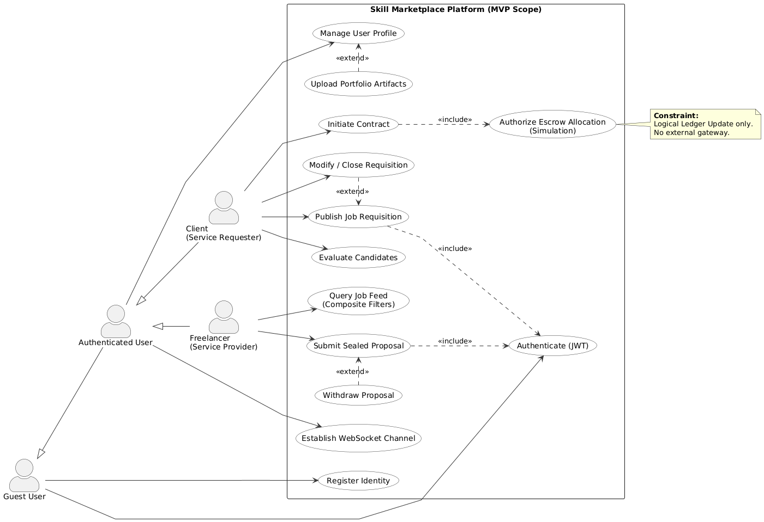

4.2 Sequence Diagrams
The sequence diagrams detail the runtime message passing between system components (View, Controller, Service, Persistence)
4.2.1 Sequence: Job Creation Workflow
(Figure A.2)
This diagram models the synchronous flow of a job posting request:
- Client Application (Frontend) constructs a JSON payload containing job parameters and transmits a POST request to the API Gateway.
- API Controller intercepts the request, strictly validates the Authorization Bearer Token, and sanitizes the input using the schema validation middleware.
- Job Service executes business logic, ensuring the user has sufficient privileges and the budget parameters are logically valid.
- Data Repository constructs the SQL INSERT statement and executes it against the PostgreSQL database.
- Database returns the generated UUID and confirmation.
- API Controller returns a 201 Created status code with the location header of the new resource.
Figure A.2
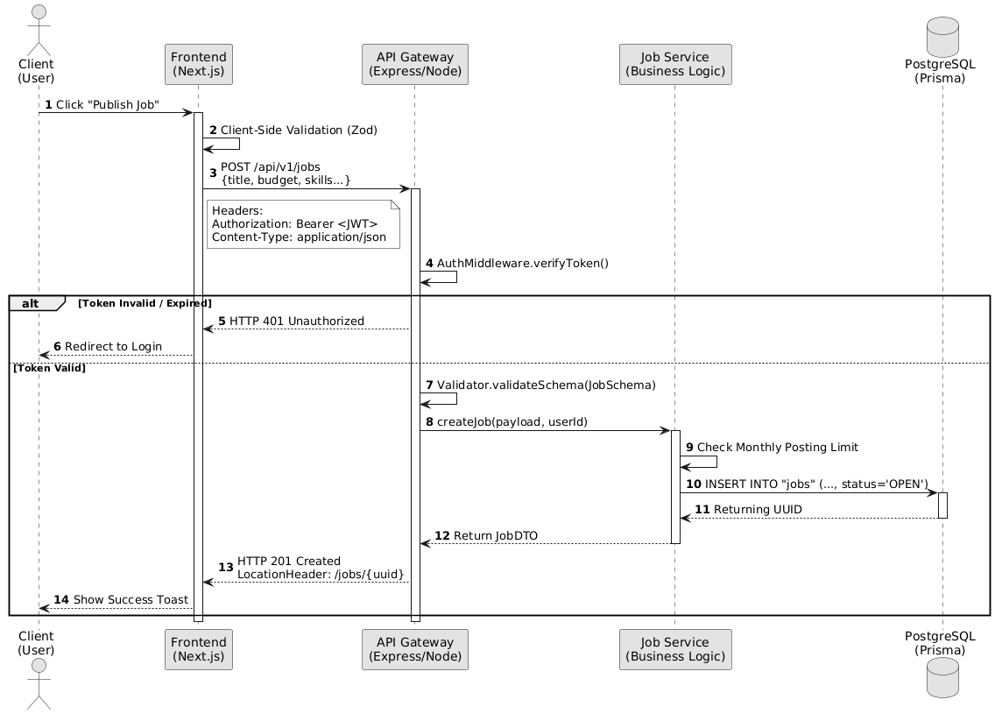
4.2.2 Sequence: Proposal Submission Workflow
(Figure A.3)
This diagram illustrates the validation and persistence of a bid:
- Freelancer Application initiates a POST request to the proposals endpoint with bid amount and cover letter.
- Proposal Service performs a pre-flight check to ensure the target Job ID exists and its status is currently 'OPEN'.
- Concurrency Check: The service verifies that the specific Freelancer has not already submitted a proposal for this specific Job (idempotency check).
- Persistence: If valid, the proposal is written to the database.

- Event Emission: The system triggers an asynchronous notification event to alert the Job Owner (Client).
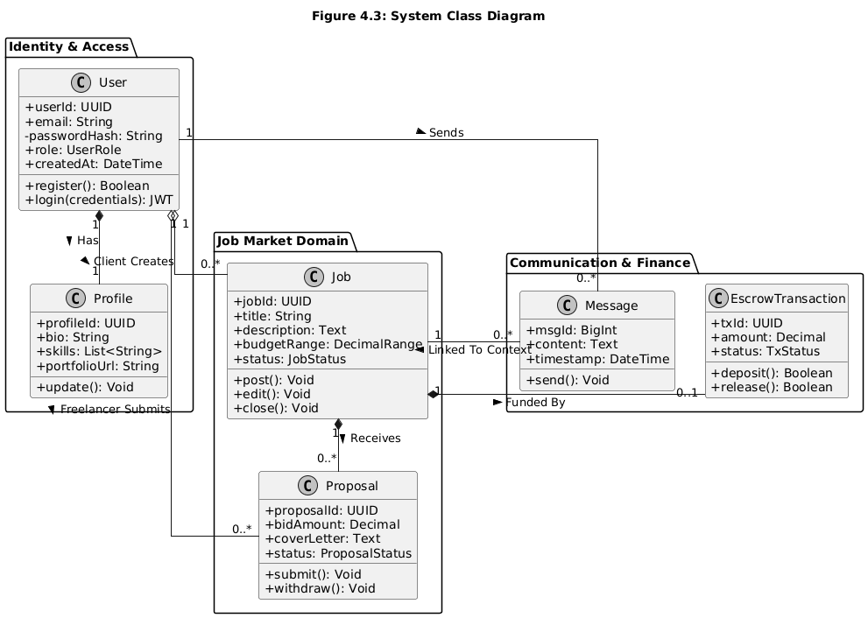

4.3 Domain Model / Class Diagram
The Class Diagram (Figure A.4) defines the object-oriented structure of the backend application, mapping directly to the database schema and ORM definitions.
Key Structural Components
- User Class: The root entity containing authentication credentials (password_hash) and global identifiers (UUID). It utilizes a Strategy pattern to handle role-specific behaviors.
- Profile Class: Segregates detailed user metadata (bio, skills array, portfolio) from the lightweight User authentication entity to optimize login performance.
- Job Entity: Represents the core unit of work. It encapsulates attributes for financial data (budget), temporal constraints (deadlines), and state enums (OPEN, CLOSED). It maintains a one-to-many relationship with the Proposal entity.
- Proposal Entity: Represents a tentative contract. It stores the bid value and reference keys linking the Service Provider (Freelancer) to the Scope of Work (Job).
- Message Entity: An append-only log of communication, containing timestamped content and foreign keys to the sender and receiver entities.

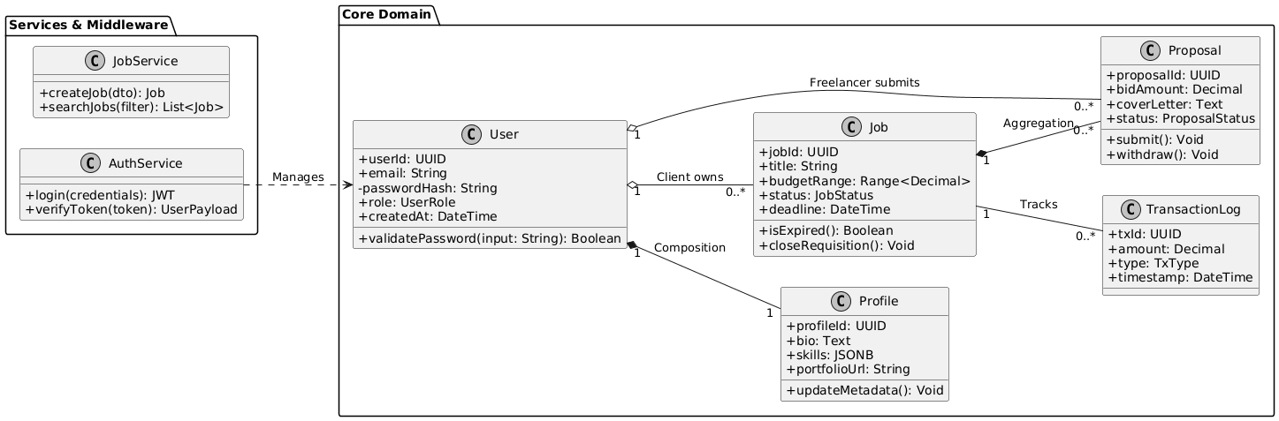

5. Non-Functional Requirements
This section defines the quality attributes (QAs) of the system, establishing strict engineering constraints regarding performance, security, reliability, and maintainability.

5.1 Performance Requirements
The system shall be optimized to ensure responsiveness under load, adhering to the following metrics.
- Latency Budgets:
  - API Response Time: 95% of read operations (GET) must complete within 200ms (Time to First Byte). Write operations (POST/PUT) involving database transactions must complete within 500ms.
  - Frontend Rendering: The Next.js application must achieve a "Good" Core Web Vitals score, specifically a Largest Contentful Paint.
- Throughput & Concurrency:
  - The backend architecture must support a baseline of 100 concurrent active connections per container instance without exceeding 80% CPU utilization.
  - Database connection pooling (via pg-pool) shall be configured with a maximum of 20 active clients per instance to prevent connection exhaustion.
- Resource Optimization:
  - Static assets (images, CSS, JS chunks) must be served with Cache-Control headers (max-age=31536000) to leverage browser caching and CDN edge caching.
  - Database queries must be optimized using composite B-Tree indexes on high-cardinality columns (e.g., job_category, user_id) to ensure O(log n) retrieval complexity.

5.2 Security Requirements
Security is implemented using a "Defense in Depth" strategy, aligning with OWASP Top 10 standards:
- Authentication Standards:
  - Session management relies on Stateless JWTs signed with the HS256 algorithm.
- Data Protection:
  - At Rest: Sensitive user secrets (passwords) must be hashed using Bcrypt with a minimum salt work factor of 10. Plaintext storage of credentials is strictly prohibited.
- Input Sanitization:
  - The API layer must implement global input validation middleware (e.g., Zod) to reject malformed payloads.
  - To prevent SQL Injection, all database interaction must occur via the Prisma ORM query builder, avoiding raw string concatenation.
- Rate Limiting:
  - The API Gateway shall enforce a rate limit (e.g., 100 requests per 15 minutes per IP) using a sliding window algorithm to mitigate Brute Force and DDoS attempts.

5.3 Reliability and Availability
- Service Level Objective (SLO): The system targets an availability of 99.5% during the operational hours (08:00–20:00 EAT), accommodating scheduled maintenance windows.
- Fault Tolerance:
  - The Node.js runtime must implement a global error handling middleware to catch unhandled promise rejections, ensuring the process does not crash unexpectedly.
  - Critical database transactions (e.g., Proposal Submission) must be wrapped in ACID-compliant transactions (prisma.$transaction) to ensure data consistency; if any step fails, the entire operation rolls back.
- Statelessness: The backend services are designed to be stateless, storing no session data in local memory. This allows for horizontal scaling and rapid recovery (restart) without data loss.

5.4 Maintainability and Extensibility
- Architectural Pattern: The backend shall follow a strict Layered Architecture (Controller -> Service -> Data Access). This Separation of Concerns ensures that business logic is decoupled from HTTP transport details.
- Code Standards: Development must adhere to strict linting rules .
- Documentation:
  - API endpoints must be documented
  - specifications, auto-generated from code annotations where possible.
  - Database schema changes must be version-controlled using Prisma Migrations, ensuring reproducible deployments across environments.
- Modular Design: Functional modules (Auth, Jobs, Chat) should be directory-isolated, allowing future refactoring into independent microservices if domain complexity increases.

5.5 Usability Requirements
- Responsive Breakpoints: The User Interface uses a utility-first CSS framework (Tailwind) to enforce responsive behavior across standard breakpoints.
- Accessibility: The interface shall adhere to WCAG 2.1 Level AA guidelines, ensuring sufficient color contrast ratios and semantic HTML tags (ARIA labels) for screen reader compatibility.
- Feedback Loops: The system must provide immediate visual feedback for all user interactions (e.g., loading spinners during async requests, toast notifications for success/error states).

6. External Interface Requirements
This section defines the rigorous interface specifications for the user, hardware, software, and communication channels. It serves as the integration contract for the system's deployment and interaction.

6.1 User Interface (UI) Specifications
The User Interface is architected as a Responsive Single Page Application (SPA), rendered via Next.js (React) to ensure seamless state transitions without full page reloads.
- Front-End Architecture:
  - Component Library: UI elements (buttons, inputs, modals) are built as reusable functional components using TailwindCSS for utility-first styling, ensuring strict visual consistency.
  - State Management: Application state (User Session, Active Job Data) is managed via React Context API or Zustand to minimize prop-drilling and ensure reactive UI updates.
- Layout Standards:
  - Dashboard View: A persistent sidebar navigation layout for authenticated users, implementing lazy-loading for heavy modules (e.g., Message History) to optimize the JavaScript bundle size.
  - Public Views: Landing pages and public job feeds utilize Server-Side Rendering (SSR) to ensure search engine indexability (SEO) and fast First Contentful Paint (FCP).
- Interaction Design:
  - Forms utilize client-side validation (e.g., React Hook Form) to provide real-time feedback before network transmission.
  - Critical actions (e.g., "Submit Proposal", "Delete Job") require modal confirmation dialogs to prevent accidental state mutation.

6.2 Hardware Interface
Client-Side Requirements
The application is device-agnostic but imposes minimal computational requirements to handle the JavaScript runtime execution.
- Device Support: Desktop workstations, laptops, tablets, and smartphones.
- Display Resolution: The layout engine supports viewports from 320px (Mobile Portrait) up to 2560px (4K Desktop) using responsive grid systems.
- Browser Engine: Chromium-based (Chrome/Edge v90+), WebKit (Safari v14+), or Gecko (Firefox v88+).
Server-Side Requirements (Deployment)
The backend services are designed to be container-native (Docker), abstracting physical hardware dependencies.
- Compute: Minimum instance specification of 1 vCPU / 512MB RAM free services.
- Storage: Ephemeral filesystem for the application container; persistent Block Storage for the PostgreSQL database volume (minimum 10GB IOPS-optimized).
- Network: High-throughput virtual network interface supporting TCP/IP traffic with open ingress on ports 80 (HTTP) and 443 (HTTPS).

6.3 Software Interface
Runtime Environment
- Backend Runtime: Node.js v18 (LTS) or higher, executing the Express.js application framework.
- Database Engine: PostgreSQL 15+ relational database management system.
- ORM Layer: Prisma Client serves as the software interface between the Node.js application and the Database, abstracting raw SQL queries into type-safe method calls.
External API Integrations
- Payment Gateway Interface (Mock): A standardized IPaymentProvider interface class is defined in the codebase. For the MVP, a SimulationAdapter implements this interface.

6.4 Communication Interface
Transport Protocols
- RESTful API: Primary data exchange occurs over HTTP/1.1 (upgradable to HTTP/2). All endpoints adhere to REST principles (Resource-oriented URLs, standard HTTP Verbs).
- WebSockets: Real-time features (Messaging, Notifications) utilize the WebSocket Protocol (ws:// / wss://) via the Socket.io library, maintaining persistent full-duplex connections for event broadcasting.

Data Serialization & Formatting
- Payload Format: All request bodies and response payloads are strictly formatted as JSON (application/json) using UTF-8 encoding.
- Date/Time Format: All timestamps are serialized in ISO 8601 UTC format (e.g., 2025-10-15T14:30:00Z) to ensure timezone consistency across distributed clients.
Security Protocols
- Encryption: All external traffic is tunneled over TLS 1.2+. The load balancer or reverse proxy (e.g., NGINX/Vercel Edge) handles TLS termination.
- Authorization Headers: Protected API calls must include the standard HTTP header: Authorization: Bearer <JWT_TOKEN>.

7. Data Requirements
This section defines the logical and physical data models, storage strategies, and validation protocols required to ensure the integrity, availability, and confidentiality of system data.

7.1 Data Model / ER Diagram
The system utilizes a Relational Database Management System (RDBMS), specifically PostgreSQL, designed in accordance with Third Normal Form (3NF) to minimize redundancy and ensure referential integrity. The conceptual Entity-Relationship (ER) Diagram is visualized in Figure A.5
Core Entities and Schema Definitions:
- Users (Identity Entity)
  - Primary Key: user_id (UUID v4) GUIDs are used to prevent enumeration attacks.
  - Attributes: email (VARCHAR(255), Unique, Indexed), password_hash (VARCHAR, Bcrypt), role (ENUM: 'CLIENT', 'FREELANCER'), created_at (TIMESTAMPTZ).
  - Constraint: Unique index on email.
- Profiles (Extended Data Entity)
  - Primary Key: profile_id (UUID).
  - Foreign Key: user_id (References Users, On Delete: CASCADE).
  - Attributes: bio (TEXT), skills (JSONB — allows flexible, indexable arrays of skill tags), portfolio_url (VARCHAR), rating (DECIMAL, Default 0.0).
  - Rationale: Vertical partitioning of User and Profile data optimizes authentication query performance by loading heavy profile data only when necessary.
- Jobs (Transactional Entity)
  - Primary Key: job_id (UUID).
  - Foreign Key: client_id (References Users).
  - Attributes: title (VARCHAR(150)), description (TEXT), budget_min (NUMERIC(10,2) — Fixed precision for financial data), budget_max (NUMERIC(10,2)), status (ENUM: 'OPEN', 'CONTRACTED', 'CLOSED'), deadline (TIMESTAMPTZ).
  - Indices: Composite index on [status, created_at] to optimize feed sorting.
- Proposals (Transactional Entity)
  - Primary Key: proposal_id (UUID).
  - Foreign Keys: job_id (References Jobs), freelancer_id (References Users).
  - Attributes: bid_amount (NUMERIC(10,2)), cover_letter (TEXT), status (ENUM: 'PENDING', 'ACCEPTED', 'REJECTED').
  - Constraint: Unique constraint on (job_id, freelancer_id) ensures idempotency (one proposal per freelancer per job).
- Messages (Append-Only Log)
  - Primary Key: message_id (BIGINT — Sequential ID preferred for chat ordering).
  - Foreign Keys: sender_id, receiver_id.
  - Attributes: content (TEXT), is_read (BOOLEAN), sent_at (TIMESTAMPTZ).

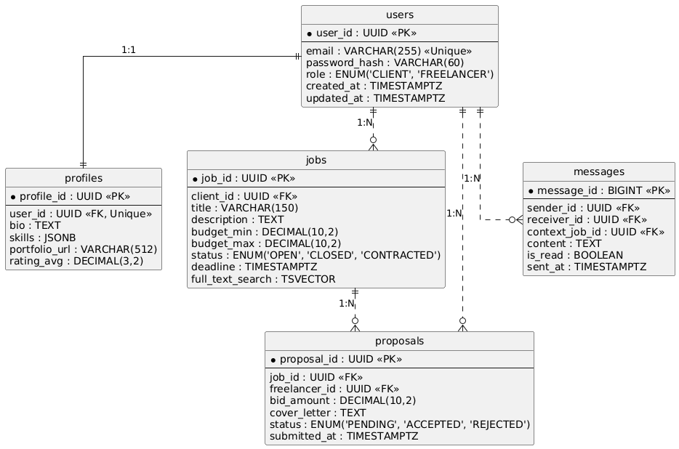

7.2 Data Storage Requirements
Persistence Strategy
- Primary Store: PostgreSQL 16 is the designated system of record. It allows for strict ACID (Atomicity, Consistency, Isolation, Durability) transactions, which are critical for the Proposal and Job state transitions.
- Connection Management: Database access is mediated via Prisma Client utilizing a connection pool (configured max: 20 connections) to handle concurrent API requests efficiently without exhausting database resources.
Redundancy and Backups
- Replication: In a production environment, the database shall utilize a Primary-Replica topology. Writes are directed to the Primary; high-volume Reads (e.g., Job Feed) can be load-balanced to Replicas.
Capacity Planning (MVP Estimates)
- Database Size: Estimated < 5GB
- Growth Strategy: Tables are designed with future partitioning in mind (e.g., partitioning Messages by created_at month) to support terabyte-scale growth.

7.3 Data Validation Rules
Data integrity is enforced at two architectural layers: the Application Layer (Zod Schemas) and the Database Layer (SQL Constraints).
Validation Logic:
- Type Safety: The backend utilizes TypeScript interfaces generated from the Prisma Schema to ensure compile-time type checking of all data flow.
- Input Sanitation:
  - String fields (Name, Bio) are trimmed and sanitized of HTML tags to prevent stored XSS.
  - Email addresses must pass RFC 5322 regex validation.
- Business Logic Constraints:
  - Date Validation: deadline must be a future timestamp relative to created_at.
  - Status Transitions: A Proposal cannot be created for a Job where status != 'OPEN'.
Error Handling:
- Database constraint violations (e.g., duplicate email) must be caught by the global error handler and transformed into user-friendly HTTP 409 (Conflict) responses, masking the raw SQL error details for security.

8. System Constraints and Limitations
This section delineates the boundaries of the Skill Marketplace project, specifying the operational, technical, and regulatory constraints that influence the architectural design and implementation strategy.

8.1 Project-Scope Constraints
- Minimum Viable Product (MVP) Definition: The current release is strictly scoped as a functional MVP. It encompasses the core workflows: Identity Management, Job Orchestration, Proposal Bidding, and Direct Messaging.
- Platform Target: The system is engineered exclusively as a Responsive Web Application (PWA). Native mobile binaries (.apk/.ipa) are explicitly out of scope.
- Simulated Financial Layer: To decouple the engineering complexity from financial licensing requirements, the system implements a Logical Ledger Simulation

8.2 Technical Constraints
- Connectivity Dependency: The architecture is Online-Only. The frontend SPA requires an active WebSocket connection for messaging and HTTP access for API calls. No offline-first capabilities (e.g., local PouchDB sync) are implemented in this iteration.
- Infrastructure Limits (Prototype Phase):
  - Compute: The backend service is provisioned on shared-resource containers (e.g., Render Free Tier / Vercel Serverless). This imposes a hard execution timeout of 10 seconds per API request.
  - Storage: The database is capped at 500MB storage capacity for the pilot phase. Binary assets (User Avatars, Proposal PDFs) are restricted to 2MB per file to conserve bandwidth and object storage costs.
- Concurrency Limits: The single-threaded Node.js event loop model, combined with limited pilot infrastructure, constrains the system to support approximately 50-100 concurrent active users. Load testing beyond this threshold may result in increased latency or 503 Service Unavailable errors.

8.3 Operational Limitations
- Support Availability: The platform operates without a dedicated 24/7 Site Reliability Engineering (SRE) team. Support and maintenance are performed on a "best-effort" basis during academic business hours.
- Data Ephemerality: As a non-production pilot environment, data durability is not guaranteed beyond the academic evaluation period.
- Audit Trail Granularity: While critical actions (Job Posting, Hiring) are logged, granular read-access logs (e.g., "User X viewed Job Y") are not persisted to minimize database write throughput.

8.4 Regulatory and Compliance Constraints
- Data Privacy & Sovereignty:
  - PII Handling: The system implements standard cryptographic hashing (Bcrypt) for credentials.
  - Test Data Mandate: For the purpose of academic evaluation, users are strictly advised to utilize Synthetic Data (fictitious names and contacts) rather than real Personally Identifiable Information (PII).

9. Acceptance Criteria
This section establishes the strict Definition of Done (DoD) for the Skill Marketplace project. It enumerates the verifiable conditions that the software must satisfy to be accepted by the project stakeholders. Acceptance testing is performed against the deployed Staging Environment.

9.1 Acceptance Overview
The system is deemed ready for delivery only when:
- 95% Pass Rate is achieved on all Critical Path test cases (TC-01 to TC-07).
- Zero Critical Bugs (Severity Level 1) and Zero High Bugs (Severity Level 2) remain in the issue tracker.
- Service Level Objectives (SLOs) regarding latency and availability are met under nominal load.

9.2 Functional Acceptance Criteria (Critical Path)
The following test scenarios must be executed successfully to validate the architectural integrity of the system:
- TC-01 — Identity & RBAC Enforcement:
  - Input: Valid and Invalid credential sets.
  - Success Condition: The Identity Provider issues a valid, signed JWT containing correct role claims (Client/Freelancer) upon success. Access to protected routes without a token returns 401 Unauthorized.
- TC-02 — Job State Machine Integrity:
  - Input: Client creating, editing, and closing a job.
  - Success Condition: Job entities are persisted to PostgreSQL. Status transitions adhere to the logic flow (e.g., OPEN → CLOSED). Attempting to edit a closed job returns 403 Forbidden.
- TC-03 — Query Engine Performance:
  - Input: Search query with composite filters (Category + Budget).
  - Success Condition: The API returns a JSON array strictly matching the filter criteria within 300ms. Pagination metadata (total_pages, current_page) is accurate.
- TC-04 — Proposal Idempotency:
  - Input: Freelancer attempting to submit a second proposal for the same job.
  - Success Condition: The database unique constraint violation is caught, and the API returns a handled 409 Conflict error, preventing duplicate entries.
- TC-05 — WebSocket Reliability:
  - Input: Two connected clients (Client/Freelancer) exchanging messages.
  - Success Condition: Message payloads are delivered in real-time (< 100ms latency) via the Socket.io channel and are simultaneously persisted to the Messages table for history retrieval.
- TC-06 — Escrow Logic Simulation:
  - Input: Client triggering "Hire" and "Release Funds" actions.
  - Success Condition: The Job status updates to IN_PROGRESS and then COMPLETED. The Transaction Log table records the logical timestamp of the fund movement.

9.3 Performance & Reliability SLOs
- SLO-1 (Latency): The API Gateway must maintain a Time to First Byte (TTFB) of < 200ms for cached read operations and < 500ms for write operations under a load of 50 concurrent users.
- SLO-2 (Frontend Metrics): The Next.js application must achieve a Google Lighthouse Performance Score of > 90 on desktop simulations, with a Largest Contentful Paint (LCP) of under 2.5 seconds.
- SLO-3 (Stability): The application container must not restart or crash (OOM Kill) during a continuous 30-minute stress test loop.

9.4 Security & Compliance Criteria
- Sec-1 (Encryption): Verify that no plain-text traffic is permitted. HTTP requests are automatically redirected to HTTPS (TLS 1.2+).
- Sec-2 (Credential Hashing): Direct inspection of the Users database table confirms that password columns contain Bcrypt hashes, not plain text.

9.5 Deliverables
Acceptance is contingent upon the submission of the following artifacts:
- Production Release Artifacts: The full source code repository (GitHub) tagged with version v1.0.0
- API Documentation: A document detailing all endpoints, request schemas, and response types.
- Final Technical Report: A comprehensive PDF summarizing the architecture, implementation challenges, and test results.
- Admin Credentials: Secure delivery of the root administrator credentials and database connection strings.

9.6 Acceptance Procedure & Sign-Off
- Deployment Verification: The engineering team deploys the build to the Staging environment.
- Live Demonstration: A rigorous walkthrough of workflows is performed
- Code Review: A partial audit of critical modules (Auth, Payment Simulation) to verify coding standards.
- Sign-Off: Upon satisfaction of all Must criteria, the Project Advisor signs the Acceptance Certificate, formally closing the development phase.

10. References
The following documents, standards, and technical specifications were cited in the preparation of this SRS or are considered binding for the system implementation.
- IEEE Computer Society, IEEE Recommended Practice for Software Requirements Specifications, IEEE Std 830-1998.
- Internet Engineering Task Force (IETF), The OAuth 2.0 Authorization Framework, RFC 6749, October 2012.
- Internet Engineering Task Force (IETF), JSON Web Token (JWT), RFC 7519, May 2015.
- Vercel Inc., Next.js Documentation (App Router & Server Actions). Available: https://nextjs.org/docs [Accessed: Dec 10, 2025].
- Prisma, Prisma ORM Reference & Schema API. Available: https://www.prisma.io/docs [Accessed: Dec 12, 2025].
- The PostgreSQL Global Development Group, PostgreSQL 16.1 Documentation (Concurrency Control & Transaction Isolation). Available: https://www.postgresql.org/docs/16/ [Accessed: Dec 12, 2025].
OWASP Foundation, OWASP Top 10:2025 – The Ten Most Critical Web Application Security Risks. Available: https://owasp.org/www-project-top-ten/ [Accessed: Dec 14, 2025].

11. Appendices

11.1 Glossary
- API Gateway: A server that acts as an API front-end, receiving API requests, enforcing throttling and security policies, passing requests to the back-end service, and passing the response back to the requester.
- Idempotency: A property of operations whereby they can be applied multiple times without changing the result beyond the initial application (e.g., submitting the same proposal twice results in only one record).
- JWT (JSON Web Token): An open standard (RFC 7519) that defines a compact and self-contained way for securely transmitting information between parties as a JSON object.
- Middleware: Software that provides common services and capabilities to applications outside of what is offered by the operating system, often used in Node.js for logging, auth, and validation.
- ORM (Object-Relational Mapping): A technique for converting data between incompatible type systems using object-oriented programming languages. This project uses Prisma.
- PWA (Progressive Web App): A type of application software delivered through the web, built using common web technologies including HTML, CSS, and JavaScript, intended to work on any platform that uses a standards-compliant browser.
- RBAC (Role-Based Access Control): A policy-neutral access-control mechanism defined around roles and privileges.
- SPA (Single Page Application): A web application or website that interacts with the user by dynamically rewriting the current web page with new data from the web server, instead of the default method of a browser loading entire new pages.
- SSR (Server-Side Rendering): The process of rendering web pages on the server and sending them to the client (browser) ready to be displayed, improving performance and SEO.
- Webhook: A method of augmenting or altering the behavior of a web page or web application with custom callbacks.

11.2 Figures / Diagrams
The following UML diagrams illustrate the system architecture as described in Section 4 and Section 7.
Figure A.1 — Use-Case Diagram
Figure A.2 — Sequence Diagram: Job Posting Workflow
Figure A.3 — Sequence Diagram: Proposal Submission Workflow
Figure A.4 — Class Diagram
Figure A.5 — Entity Relationship (ER) Diagram

