MMB (MacroMoleculeBuilder) workshop

If you are interested in macromolecular modeling, you are invited to attend a workshop on MMB taught by its author. MMB is a modeling tool which can help you combine disparate and fragmentary pieces of information to build up the 3D structure and dynamics of macromolecules. Key to its effectiveness is its internal coordinate mechanics engine, Simbody, which allows you to focus computer power on regions of interest while rigidifying well-understood regions of the complex for cost savings. You can use 3D structural fragments from the same or related molecules. You also have access to a wide variety of constraints and base pairing and interatomic forces that can be applied to represent experimental information or hypotheses. You can do threading, morphing, semiflexible fitting to low-resolution density maps, turn biochemical constraints into 3D structure, and much more.

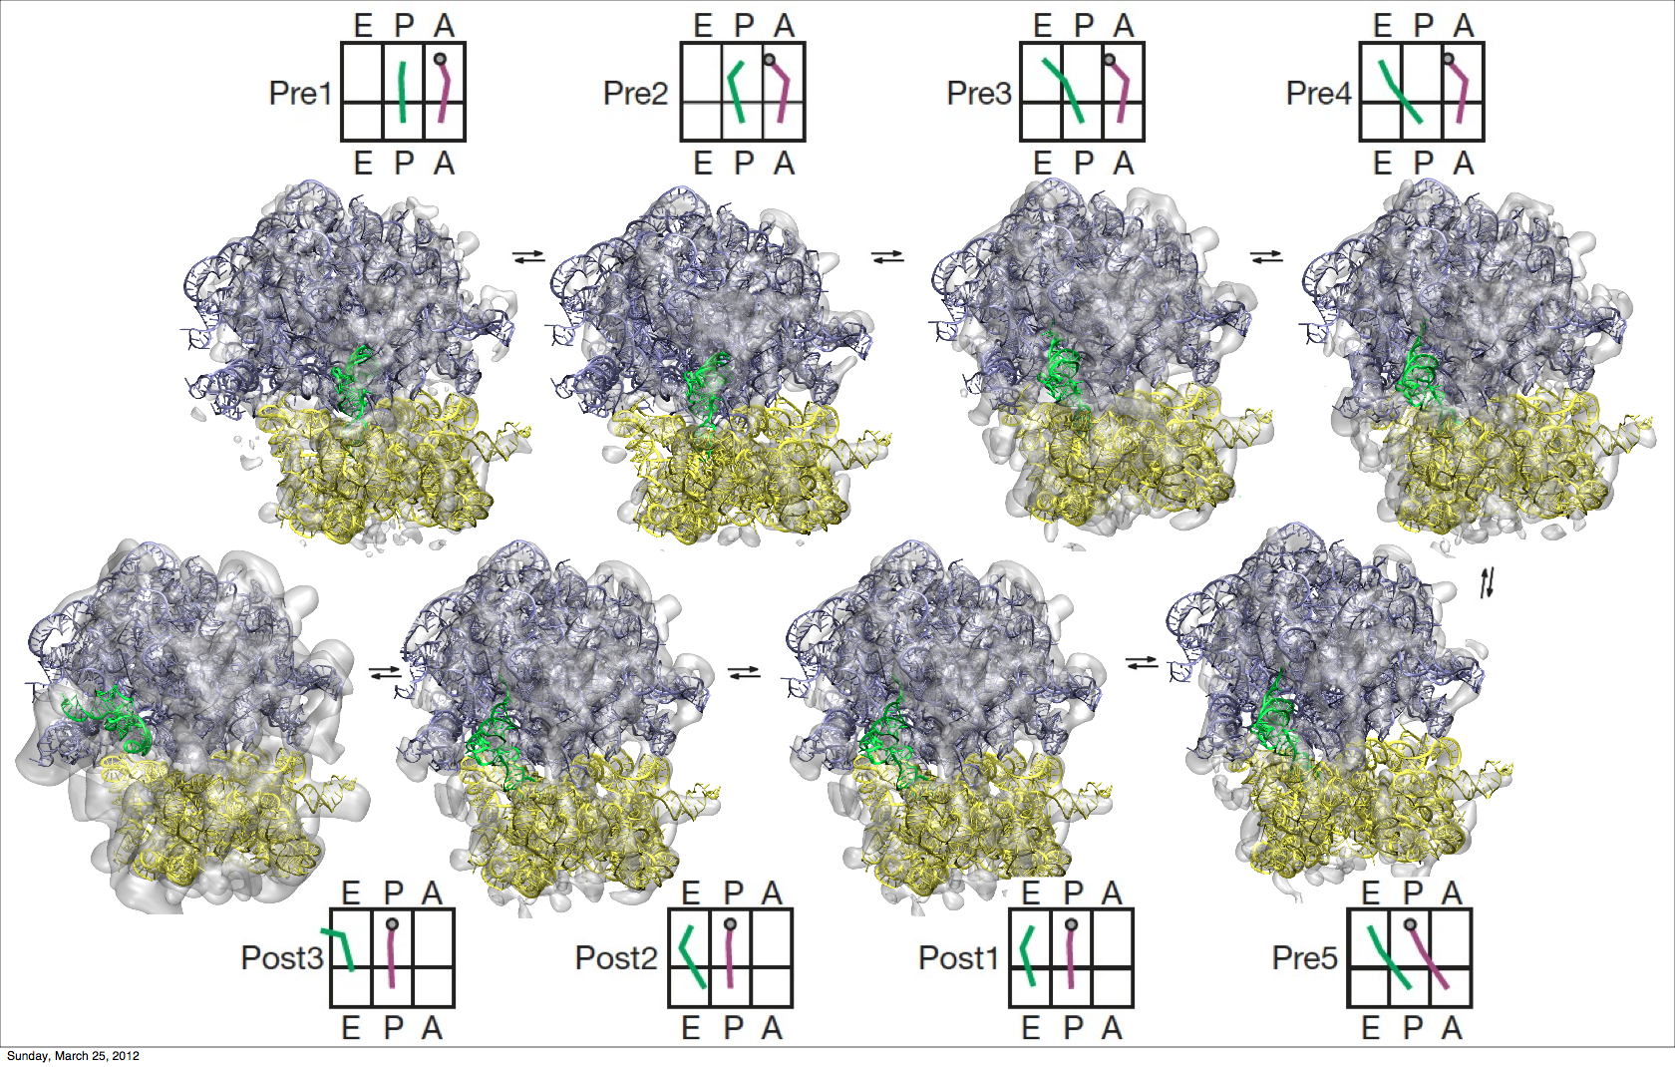

MMB has been used to successfully recapitulate the structure of known molecules such as tRNA and the Tetrahymena and Azoarcus ribozymes. We have also used it to predict the unknown structure of the Bangia ribozyme and part of the Telomerase complex, as well as to design antibodies. In ongoing work, we are modeling the dynamics of ribosomal translocation (Illustration at right).

To attend you should download MMB 2.10 for Linux, Mac, or Windows. Unzip it into a convenient directory on your laptop and read the tutorial. Please set your library path (Mac/Linux) and do exercise 0. Once you’re done send me an email saying “My name is (e.g.) Jim Bob, I have installed the tutorial on my laptop and completed exercise 0”. Also please start thinking about a problem from your research and we will work on it as an exercise.

About the speaker: Samuel Coulbourn Flores developed MMB as a Distinguished Fellow in Russ Altman's lab at Stanford. As a graduate student, he built the HingeMaster and Conformation Explorer hinge and motion prediciton servers, hosted on MolMovDB.org. He is now a professor at Uppsala University, Sweden, working on ribosomal mechanics, antibody design, and viral genome packaging.

