CLOUD & DEVOPS BOOTCAMP — CAPSTONE
Project 6: Zero-Downtime Blue-Green Deployment
Two independent, complete implementations of the same brief
Application: Snipe-IT Lite (FastAPI + PostgreSQL backend, static HTML/JS frontend)
BY: SAMUEL JUDE GODSON - CLC/2026/TC-7/0033

This report treats Group 5/6’s brief as two separate, self-contained capstone submissions built on the same application, because the app already ships to two independent production targets with genuinely different blue-green mechanics:
- Part A — Azure VM: traffic splitting via a self-managed Caddy reverse proxy in front of two fixed, permanently-named container pairs. Every mechanic — health checks, weighting, rollback — is done automatically within the VM.
- Part B — Azure Container Apps: traffic splitting via the platform’s own native multi-revision API. No reverse proxy of our own to build — Container Apps does the weighting.
Each part below independently answers every requirement in the brief: Client Brief, Phase 0 Design Worksheet (health-check definition, swap/rollback sequence, failure-mode brainstorm), Build Tasks, Mandatory Items, an Incident Report, and a Deliverables Checklist.

Live Links — Quick Reference
- Part A (VM) — production app: https://assets.multione.online
- Part A (VM) — live deploy dashboard: https://assets.multione.online/_deploy/
- Part B (ACA) — production app: https://stack.multione.online
- Part B (ACA) — live deploy dashboard: https://stack.multione.online/_deploy/
Both dashboards are gated by HTTP Basic Auth — see each part's Build Tasks section for how credentials are set.

PROJECT 6A
Zero-Downtime Blue-Green Deployment
Implementation 1 of 2 — Single Azure VM (Caddy weighted reverse proxy)

1. Client Brief
QuickTill runs live customer checkouts continuously — there is no maintenance window, and a single failed checkout during a swap has a real cost to a real customer. A feature must ship by Friday with zero observable downtime, and a broken version must never be visible to a customer even briefly. The team also wants this to be a repeatable, scripted process for every future release.
This implementation answers that brief using a single Azure VM — no managed multi-revision platform available, so “two revisions running side by side” has to be built: two permanently-named containers per service and a reverse proxy capable of a live weighted traffic split between them.

2. Phase 0 — Design Worksheet

2.1 Health check definition
One script, two modes, so the replica being promoted is held to exactly the bar the live domain already clears — not a lesser one. scripts/health-check.sh --mode internal runs FROM the VM directly against one slot’s containers, bypassing the reverse proxy and production traffic entirely.
Check | What it verifies | Mechanism | Pass criteria
backend-healthz | Liveness only — the process is up and answering HTTP | GET http://127.0.0.1:8000/healthz, executed inside the container | HTTP 200, retried up to 20× / 5s apart
backend-readyz | DB reachable AND schema matches this build — proves alembic upgrade head actually finished | GET http://127.0.0.1:8000/readyz, executed inside the container | HTTP 200, retried up to 40× / 5s apart (longer allowance — a fresh replica may still be migrating)
frontend-static | nginx is serving the built SPA | wget against http://127.0.0.1/ inside the container | Non-error response, retried up to 20× / 5s apart
frontend-api-wiring | A full round trip: THIS slot’s nginx proxying to THIS slot’s backend — proves the pairing, not just each half alone | wget against http://127.0.0.1/api/auth/me inside the container | HTTP 200 or 401 (both prove a real backend response came back), retried up to 20× / 5s apart
A second mode, --mode external, hits the live public domain the same way a browser does (GET / and GET /api/auth/me, expecting 200/401) — this is the post-cutover smoke test the pipeline runs after promotion, and it is the same check used for the ACA path’s workflow-level smoke test in Part B.

2.2 Swap and rollback sequence
Two fixed, permanently-named containers per service — backend-blue/backend-green, frontend-blue/frontend-green. Blue is always the incoming candidate; green is always the active/production slot; the names never swap identity between deploys, unlike ACA’s revisions.
- Migrate — alembic upgrade head, run through blue, against the one shared Postgres database. Must stay backward-compatible with the still-running green slot for the rest of the rollout.
- Start the incoming slot — backend-blue / frontend-blue come up (worker/beat are refreshed in place). Caddy is still sending 100% of traffic to green, so blue receives zero production traffic here.
- Health-check blue directly — health-check.sh --mode internal --slot blue, never through Caddy. Any failure aborts the whole rollout: green is untouched, blue is stopped.
- Ramp traffic 10→25→50→75→100% onto blue — rewrite caddy/weights.conf and caddy reload (graceful: in-flight requests finish, no dropped connections) at each step, re-running the internal health check against blue after every step.
- Promote — now that blue has proven itself under 100% real traffic, bring green up on the exact same image blue is already running, health-check green directly, then flip Caddy’s weight straight back to 100% green / 0% blue — a same-code swap, not a second canary, since both slots now run the identical, already-proven image.
- Spin blue back down — stop and remove blue’s containers so the slot is idle again, ready for the next deploy.
Rollback paths, by when the failure is caught:
- Steps 1–4 (migration, blue’s own health check, or any ramp-step health check): the script’s own failure trap fires automatically — immediately restores 100% of Caddy’s weight to green and stops blue, before exiting non-zero. Green is never touched until blue has already proven itself, so a bad deploy never causes an outage.
- Step 5 (promotion — green’s own health check on the new image): handled differently on purpose. Blue already proved itself at 100% traffic by this point, so it is left serving rather than reverted to a potentially-stale green. status.json’s phase becomes promotion_failed — a distinct state from a normal failed — reported loudly rather than silently retried; re-running the deploy retries promotion from scratch.
- Well after a deploy finished (blue’s containers already removed): no traffic flip is possible any more — recovery is a genuine forward deploy of the previous image tag through this same blue-green rollout, into blue as always.

2.3 Failure-mode brainstorm
- 1. A health check that passes but doesn’t exercise the real code path. Identical risk to the ACA path (Part B, 2.3.1) — mitigated the same way: backend-readyz specifically checks DB reachability and schema state, not just process liveness.
- 2. Caddy’s config reload itself becomes the outage. caddy reload is graceful by design (in-flight requests finish, no dropped connections), but a malformed weights.conf write could still fail the reload silently. Mitigation: the ramp step re-runs an internal health check against blue immediately after each reload, so a broken reload is caught within one ramp step rather than persisting silently at a partial, inconsistent weight.
- 3. Promotion-time asymmetry between blue and green. Because blue and green are physically separate, persistent containers (unlike ACA’s ephemeral revisions), green could theoretically fail to come up cleanly on the new image even though blue — running the identical image — is fine, e.g. a container-specific resource limit or stale volume state on the green container specifically. This is exactly why promotion failure (step 5) is treated as its own distinct, loudly-reported state instead of triggering an automatic rollback of a slot (blue) that has already proven itself correct.

3. Build Tasks — completed
- Dockerfiles for backend and frontend; both services run as fixed-name blue/green container pairs (docker-compose.vm.yml).
- Rollout driver: scripts/blue-green-deploy.sh — runs on the VM itself (invoked over SSH), implements the migrate → start blue → health-check → ramp → promote → spin-down sequence above, with the failure trap described in 2.2.
- Traffic split: Caddy reverse_proxy with weighted load balancing, driven by caddy/weights.conf and a graceful caddy reload at each ramp step; Caddy also does its own passive health checking on top of the script’s explicit checks.
- CI/CD pipeline: .github/workflows/deploy-azure-vm.yml — builds and pushes both images tagged, SSHes the updated compose file/Caddyfile/scripts to the VM, and hands off to blue-green-deploy.sh.
- Live dashboard: https://assets.multione.online/_deploy/ — served directly from local disk by Caddy (scripts/deploy-status/), updated at every phase transition (starting → migrating → starting_replica → health_checking → ramping → promoting → spinning_down_incoming → done / failed / promotion_failed).
- Zero-downtime evidence: scripts/poll-live-endpoint.sh, backgrounded on the GitHub-hosted runner (not the VM — it has to observe the exact path a real browser tab does) from just before the rollout starts through the post-cutover smoke test, producing a timestamped CSV artifact.

4. Mandatory Items
✓ | Item | Evidence / location
☑ | Health-check gate before every traffic increase, capable of actually failing | health-check.sh, called at every ramp step in blue-green-deploy.sh
☑ | Documented rollback, demonstrated at least once with evidence | Automatic trap on any pre-promotion failure; see Incident Report guidance below
☑ | Repeatable, scripted process (not a manual portal/SSH dance) | Entire rollout is driven by deploy-azure-vm.yml over SSH, no manual steps

5. Incident Report
Incident #1 — Deliberate failure injection: skip_migrate against an unapplied migration (caught-and-rolled-back bad deploy)
Failure-injection method used: deploy-azure-vm.yml was run manually (workflow_dispatch, environment: vm-staging) against a build that included a genuine new Alembic migration, with skip_migrate set to true — deliberately skipping the migrate step that would normally bring the shared Postgres database up to that migration before blue starts. This reproduces, on demand and without editing any application code, the exact “new image, old/wrong schema” scenario backend-readyz exists to catch (see database.py’s get_schema_status() docstring), and exercises blue-green-deploy.sh’s automatic-rollback path at step 3 of the sequence in 2.2 without ever touching the live green slot.
SYMPTOM
deploy-azure-vm.yml’s Deploy job ran blue-green-deploy.sh, which advanced through Migrate — skipped, per skip_migrate: true — and Start blue, then stalled at Health-check blue directly: health-check.sh --mode internal --slot blue reported backend-readyz FAIL on every retry up to its 40-attempt / 5-second-apart budget. The script’s failure trap then fired automatically, restoring Caddy’s weight to 100% green / 0% blue, stopping blue’s containers, and exiting non-zero — the GitHub Actions run finished red, and https://assets.multione.online/_deploy/ showed phase: failed with the repeated backend-readyz FAIL lines visible in the live Health Check Log panel.
INVESTIGATION TRAIL
1. Checked the Actions log for the Deploy job — confirmed the Migrate step logged “skipped (skip_migrate=true)” rather than running alembic upgrade head, and that Start blue completed normally (both containers reported Up), which narrowed the failure to something blue-side rather than a container that never came up at all.
2. Checked the dashboard’s Health Check Log panel — the failing check was specifically backend-readyz, not backend-healthz or frontend-static, which ruled out “the process is hung” (that would fail healthz too) and pointed at a database/schema-specific problem instead.
3. SSHed into the VM and curled http://127.0.0.1:8000/readyz directly against blue’s container, bypassing Caddy — returned 503 with a JSON body reporting ready: false, confirming the endpoint itself (not the health-check script or the retry logic) was the source of the failure.
4. Compared the alembic_version table (queried directly against the shared Postgres database) with the head recorded in the deployed image’s backend/alembic/versions/ — the database was still on the previous revision, one migration behind what blue’s code expected, confirming this was exactly the “migrate step bypassed” scenario get_schema_status() is designed to catch, caused directly by this run’s skip_migrate: true.
ROOT CAUSE
skip_migrate: true skipped alembic upgrade head on a run whose image genuinely carried a new migration, so blue’s code and the shared database’s schema no longer matched; backend-readyz correctly reported not-ready and never let the rollout advance past step 3.
FIX
Re-ran deploy-azure-vm.yml against the same image with skip_migrate left at its default (false). Migrate ran alembic upgrade head cleanly against the shared database, Start blue completed, and health-check.sh --mode internal --slot blue reported backend-readyz PASS well inside its retry budget; the ramp proceeded 10→25→50→75→100% with a passing internal health check re-run after every step, promotion succeeded, and blue was spun down as usual. Before: backend-readyz 503 / ready: false, stuck at step 3 for the full 40-attempt window, automatic rollback fired. After: backend-readyz 200 / ready: true on the first check, full rollout completed to done.
DESIGN REFLECTION
The Phase 0 design made this failure both easy to catch and impossible for a customer to see: backend-readyz checks schema equality, not just liveness, so a health check that “passes but doesn’t exercise the real code path” (failure mode 1 in 2.3) is specifically ruled out here, and because the check runs against blue at zero production traffic before any ramp step, the mismatch was caught before Caddy ever sent a single real request to it. What this test also exposes is that skip_migrate is a convenience escape hatch with no guardrail of its own — nothing today stops it from being combined with a build that does carry a new migration, which is exactly what was done here on purpose. I would add a lightweight preflight in blue-green-deploy.sh that, whenever skip_migrate is true, compares the image’s baked-in Alembic head against the database’s current alembic_version before starting blue at all, and fails the workflow immediately with an explicit “skip_migrate requested but this image needs a migration” message rather than letting the mismatch only surface via a stuck health-check retry loop several minutes into the rollout.
SCREENSHOT: CAUGHT AND ROLLED BACK BAD DEPLOY
Using an old image with an unapplied migration (database tables not up to date with current)
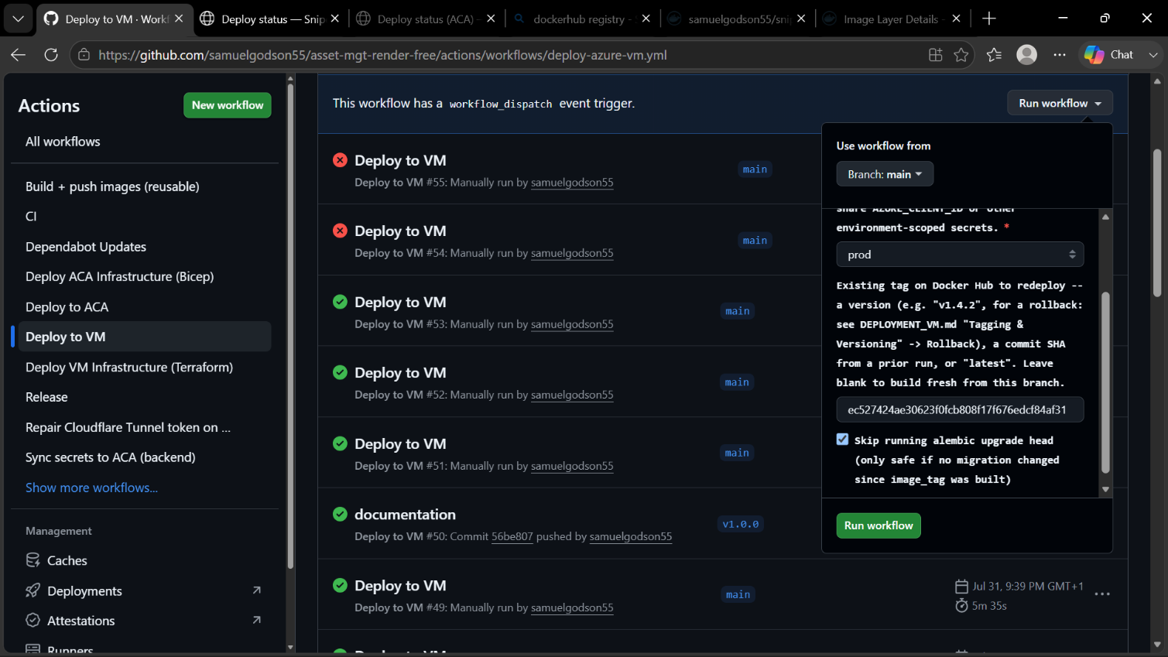
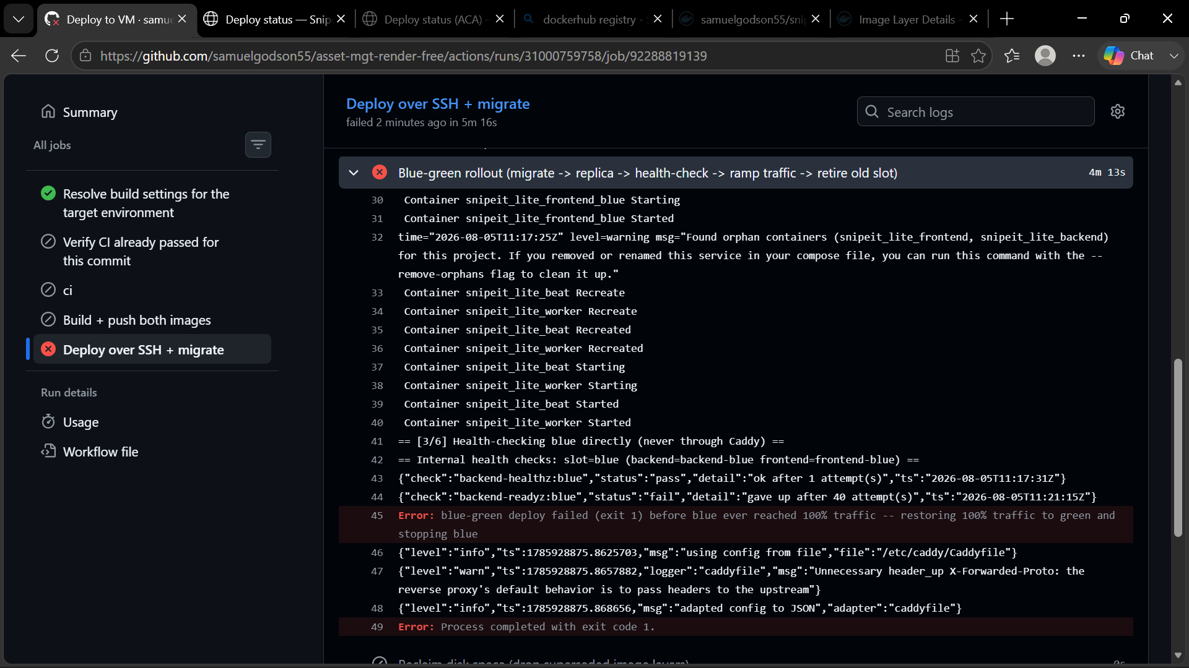
Readyz (when it verifies the database failed)
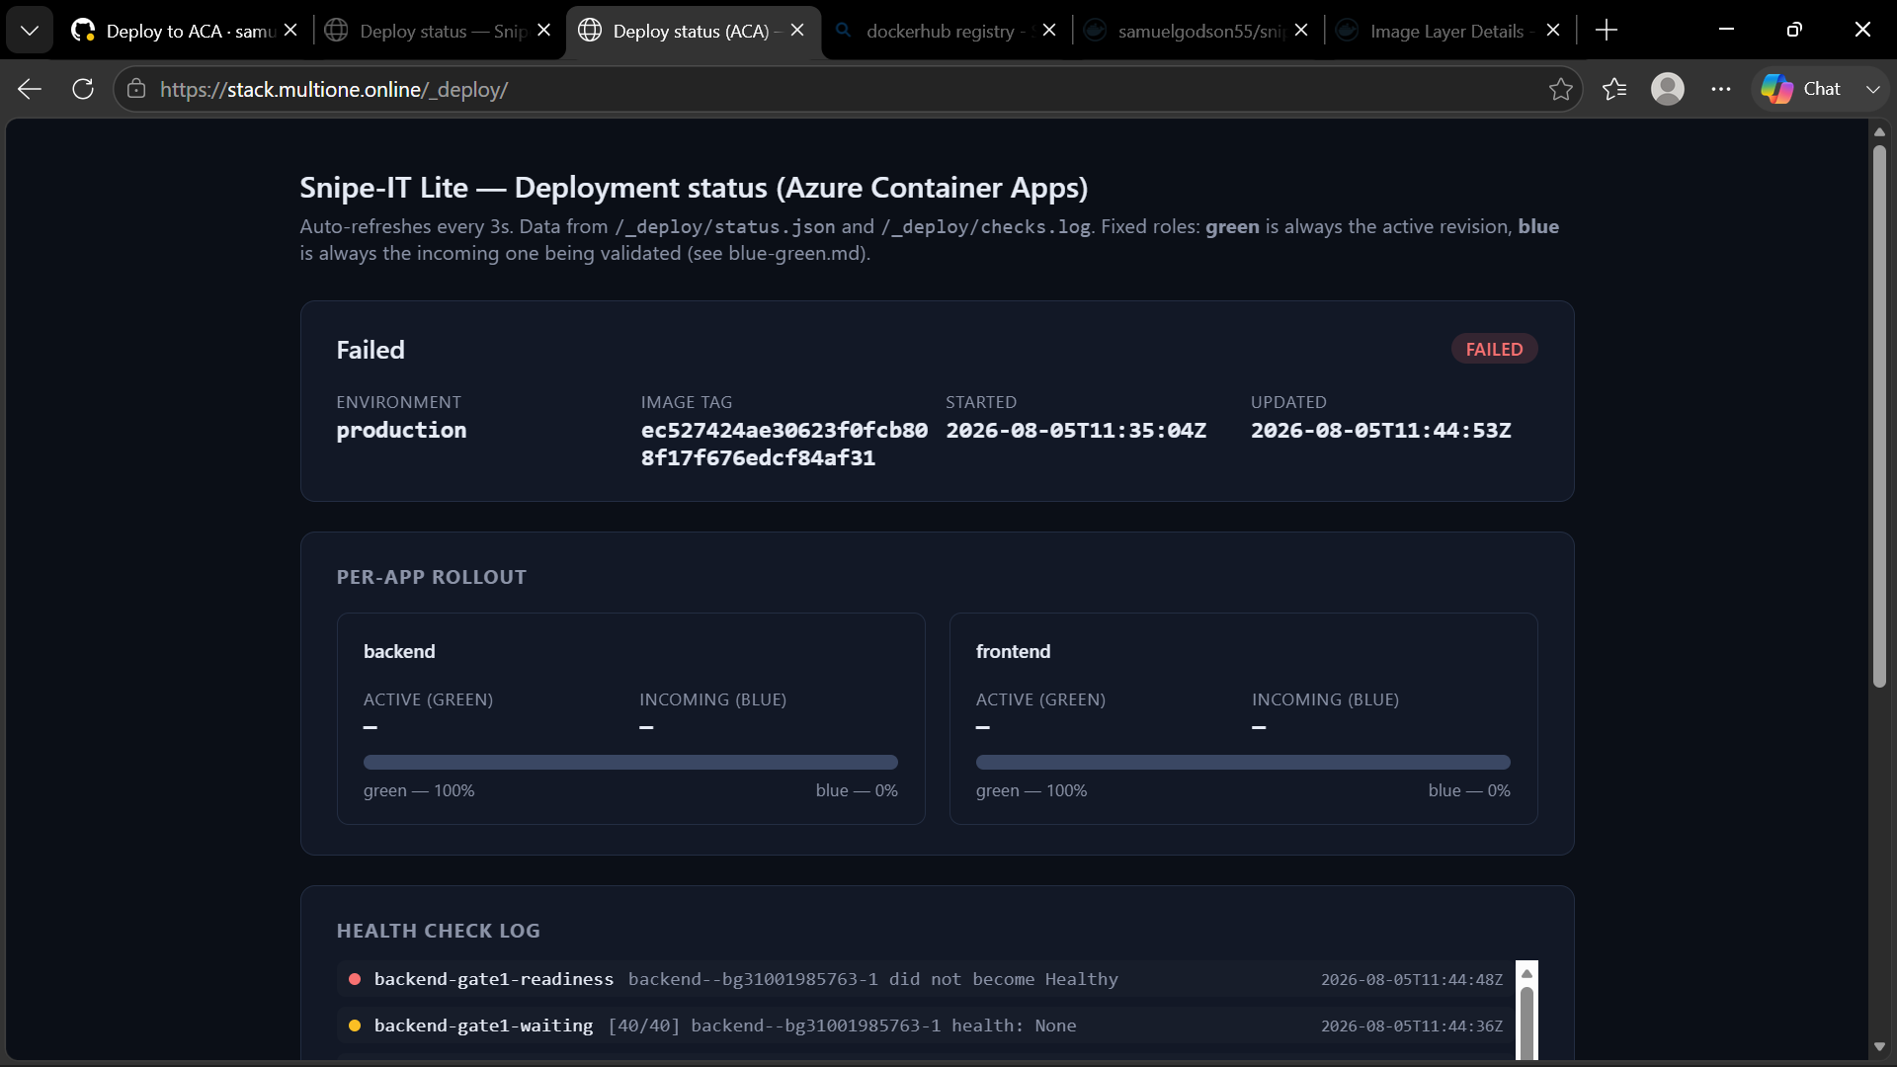

SCREENSHOT: SUCCESSFUL ZERO-DOWNTIME SWAP
On Tag Push 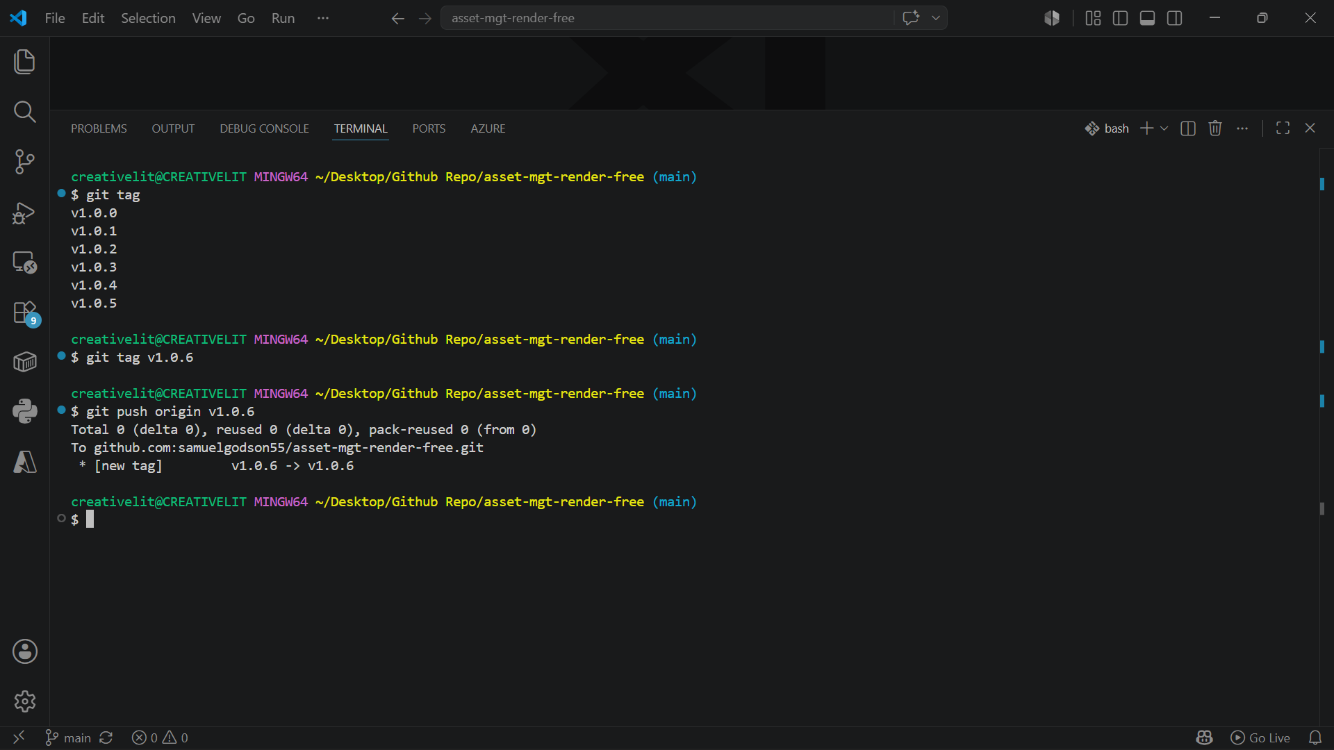

It creates a release and does the CI checks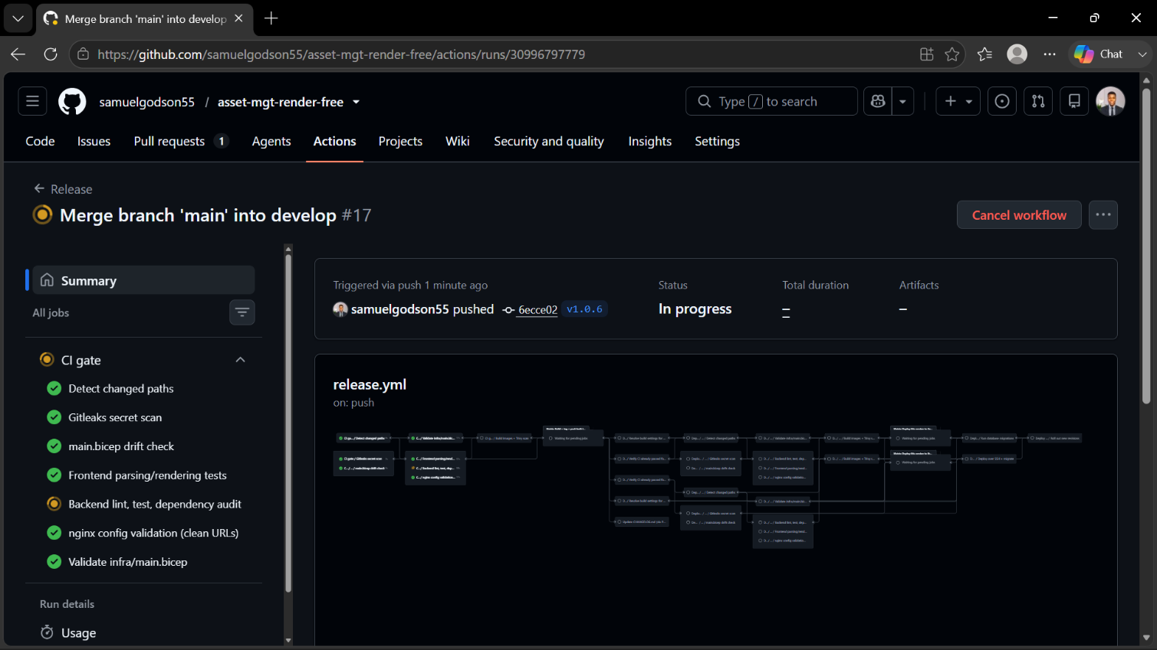
The web application functionality not only liveness is checked 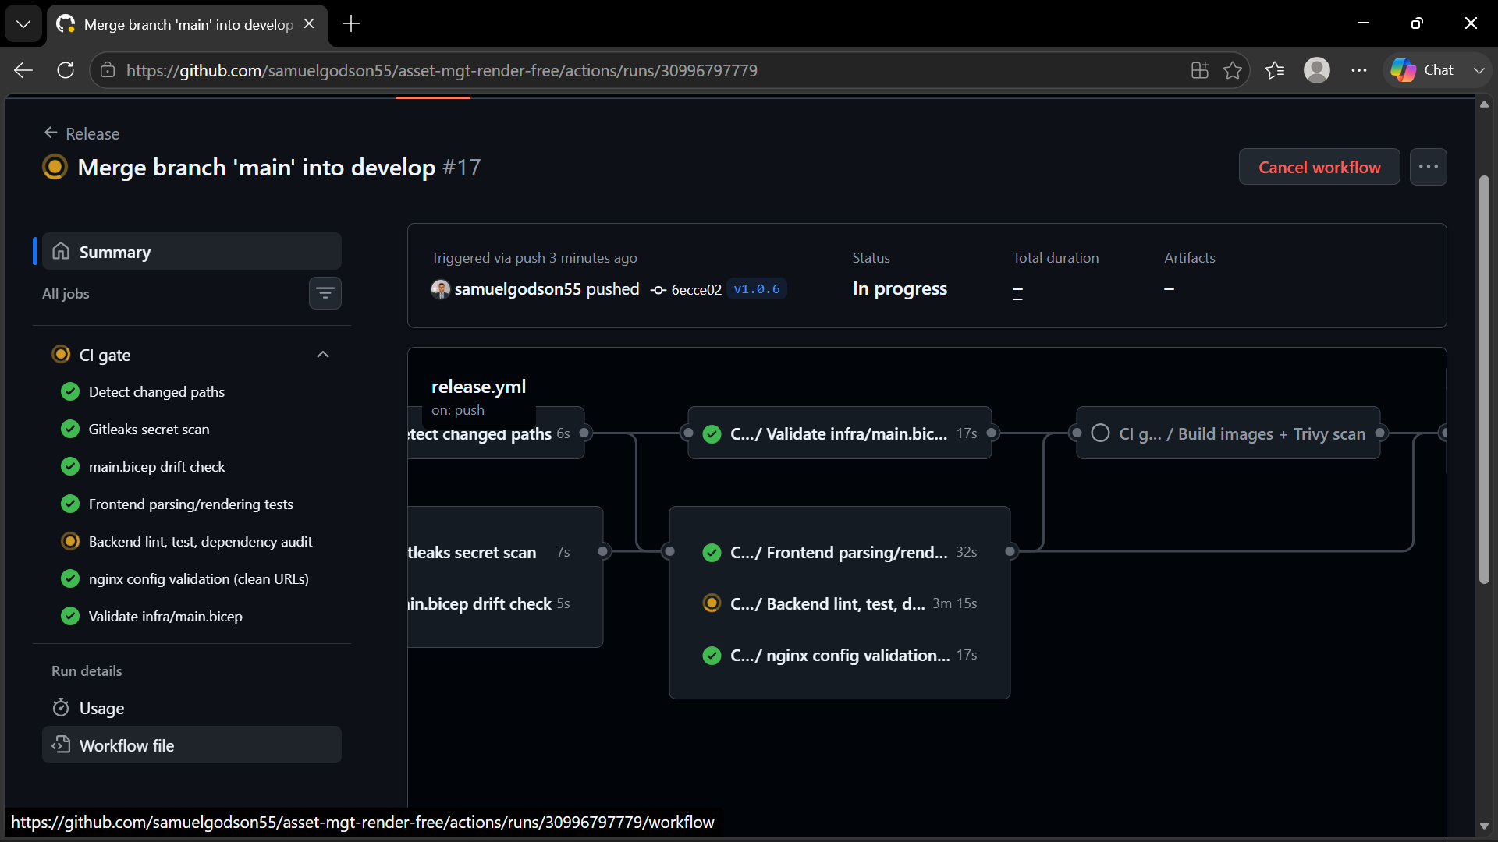
The Images are built and tests are run 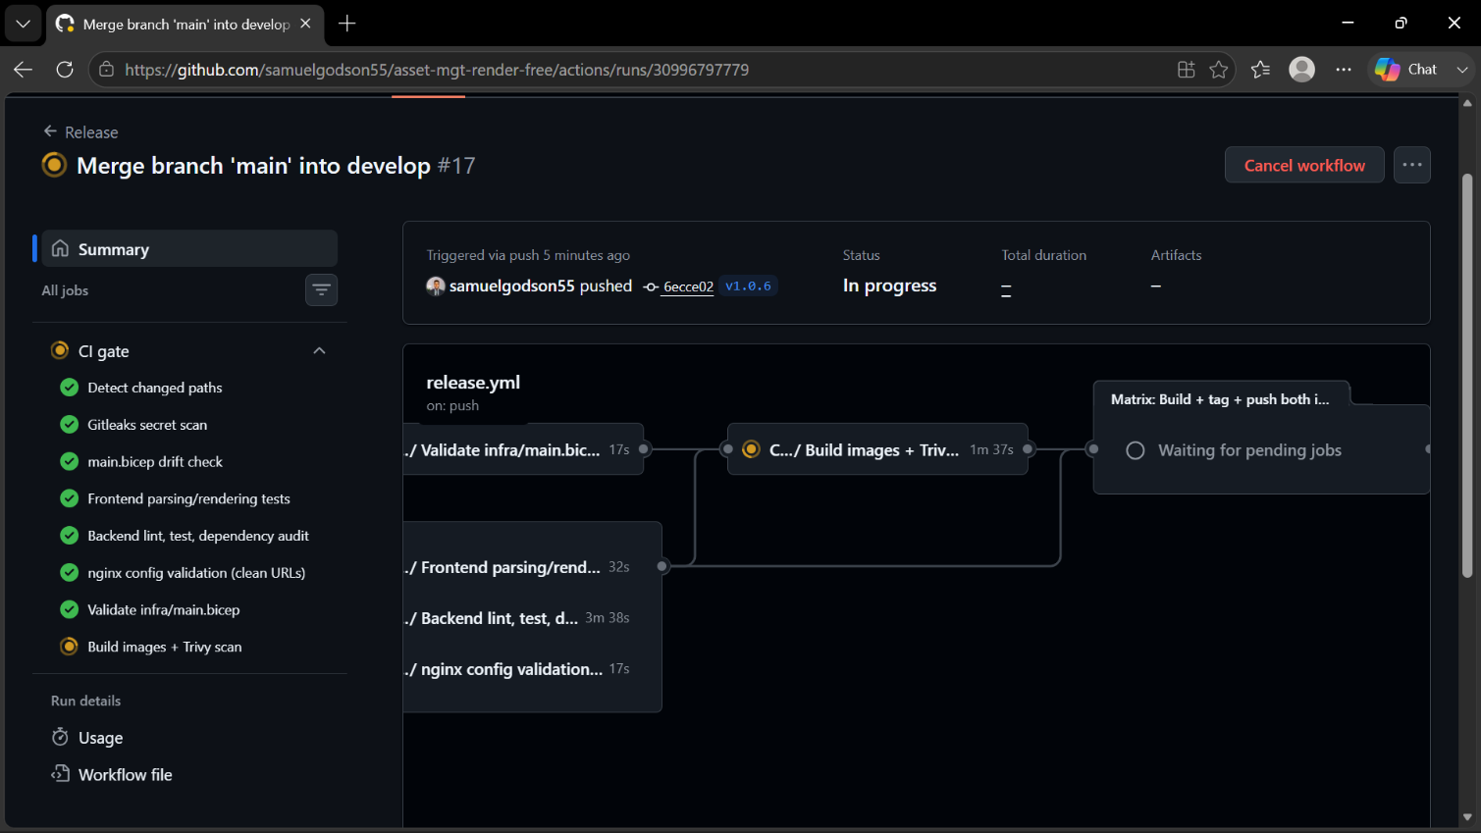
The Frontend and Backend images are tagged and pushed (Docker and the VM)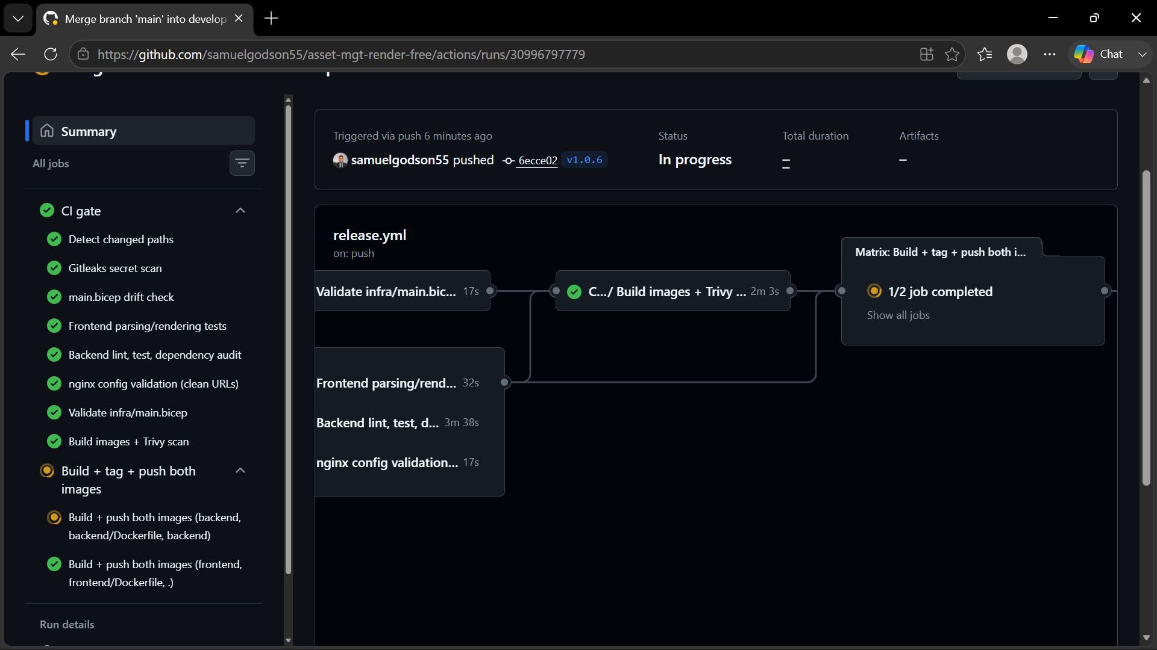
Migration, Liveliness and Readiness are checked in a canary build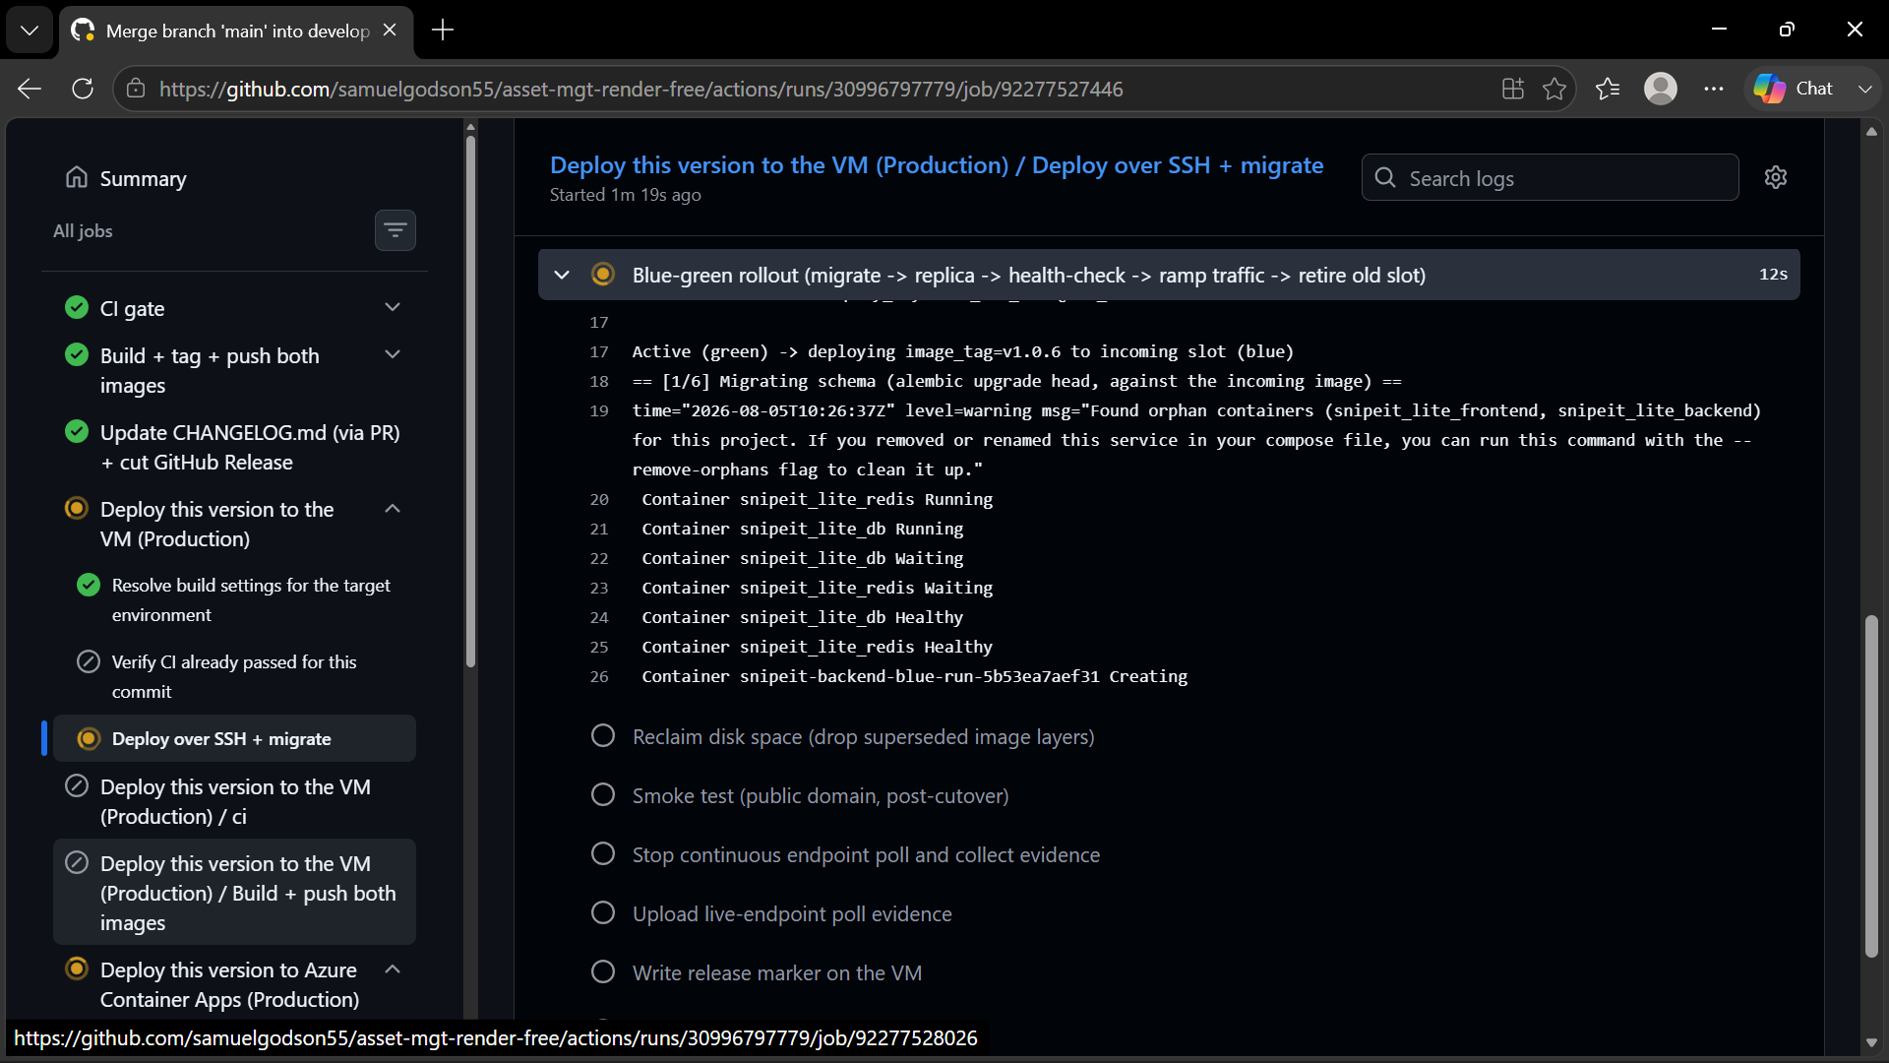

Monitoring can be done on the deploy page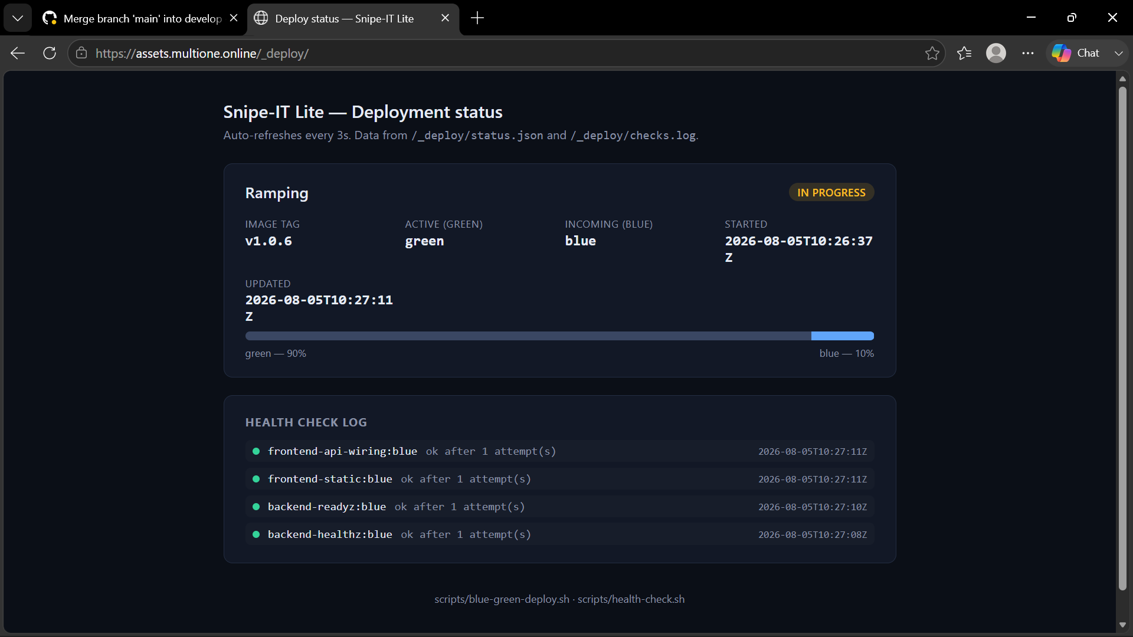
Continuous Poll with zero Downtime Evidence kickstarted, this will be available for download after the blue green deployment on Github as an artifact
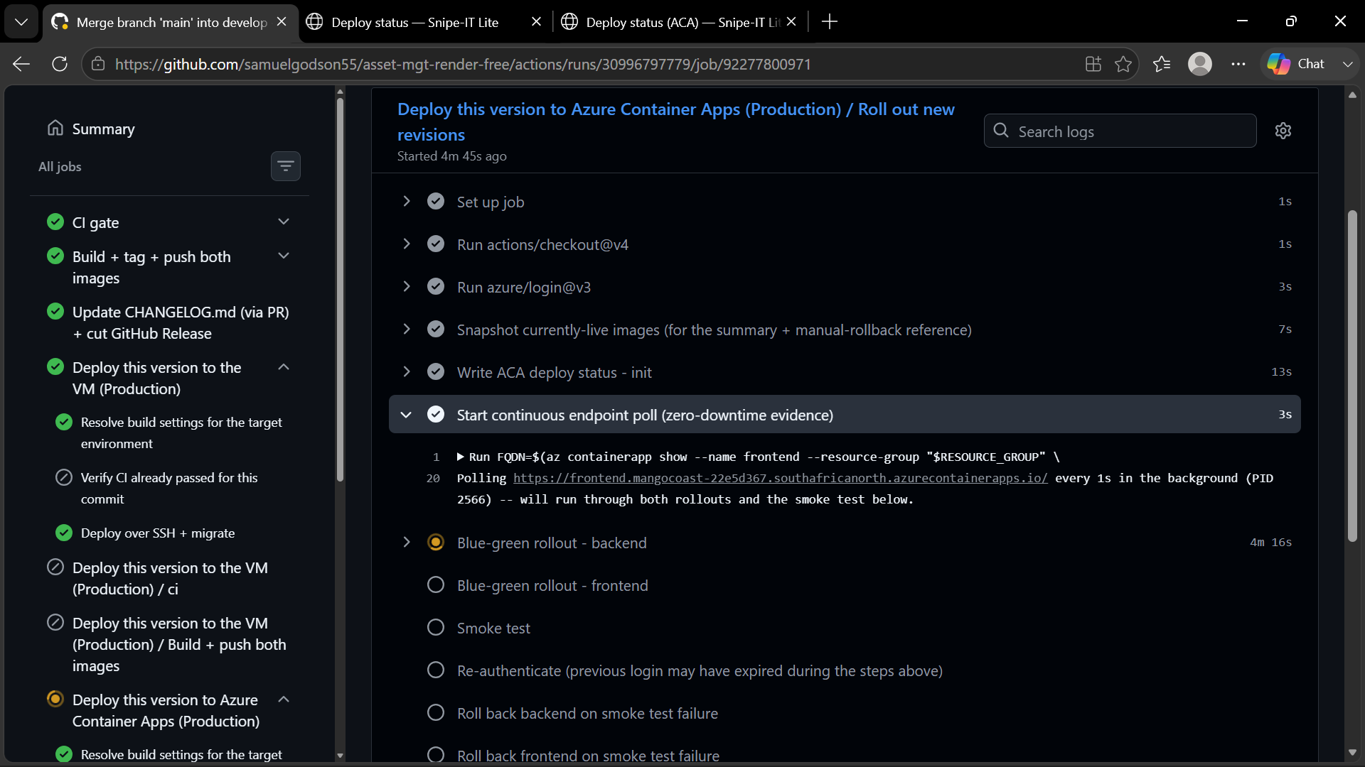
Deploy Successful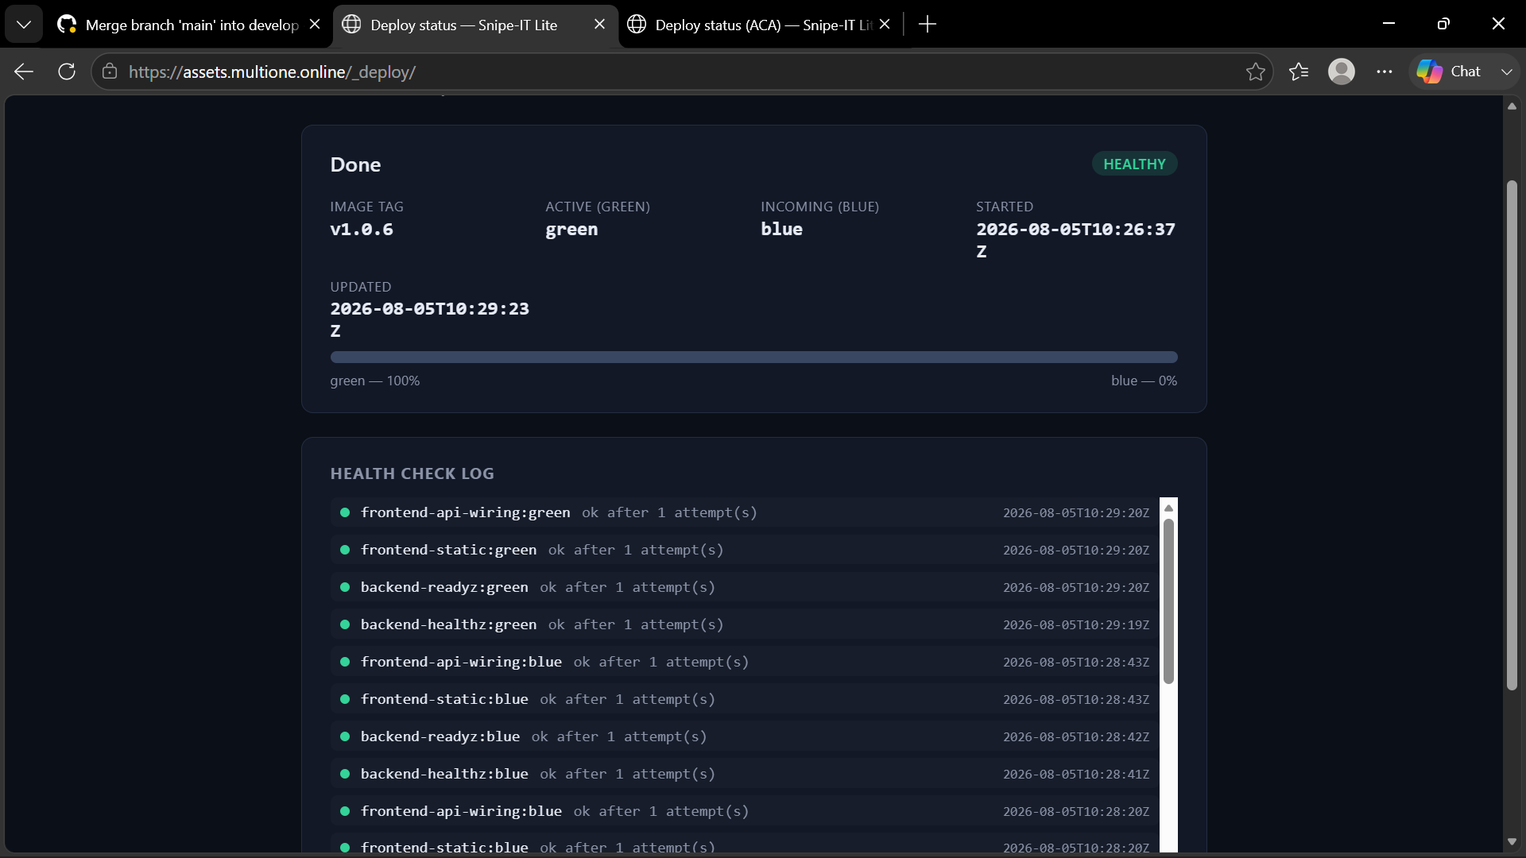
Zero Downtime Evidence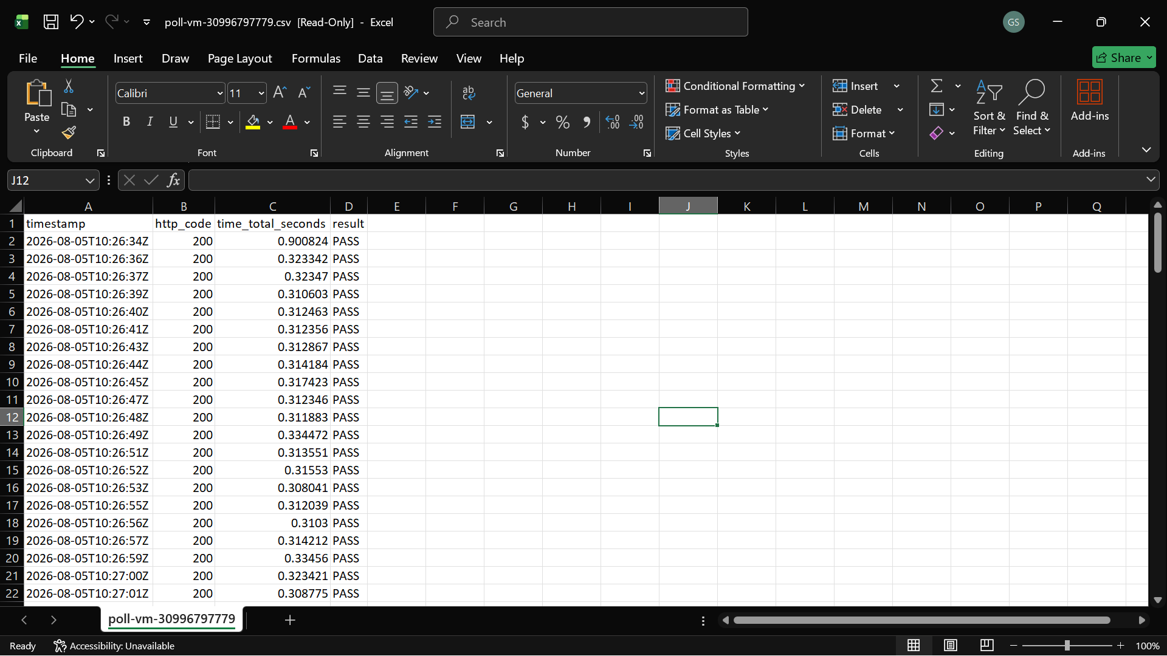

6. Deliverables Checklist
✓ | Item | Evidence / location
☑ | docker-compose.vm.yml, Caddyfile, blue-green-deploy.sh, health-check.sh, deploy-azure-vm.yml | Repository
☑ | Completed Phase 0 worksheet (health checks, swap/rollback sequence, failure modes) | Section 2, above
☑ | Screenshots: successful zero-downtime swap (poll-live-endpoint.sh CSV, all PASS) | Attach workflow artifact zero-downtime-poll-evidence-vm-*
☑ | Screenshots: a caught-and-rolled-back bad deploy (skip_migrate failure injection, Section 5) | To attach: Actions run log + dashboard screenshot (phase: failed)
☑ | Incident report, completed (skip_migrate failure injection) | Section 5, above — completed

PROJECT 6B
Zero-Downtime Blue-Green Deployment
Implementation 2 of 2 — Azure Container Apps (native multi-revision traffic splitting)

1. Client Brief
Same QuickTill scenario as Part A. This implementation answers that brief using Azure Container Apps' native “Multiple” active-revisions mode: the currently-live revision (“green”) and the incoming, unproven revision (“blue”) run side by side as two fully independent, individually addressable revisions. The split between them is a traffic weight the pipeline controls explicitly, decoupled from “which one is newest” — which is what makes a genuine 0%→100% cutover, a gradual shift, and an instant traffic-only rollback possible without a second environment or a load balancer of our own.

2. Phase 0 — Design Worksheet

2.1 Health check definition
Two apps roll out independently — backend, then frontend — each gated by three layers before it is trusted with any production traffic. “The app responds” is never sufficient; every check below either exercises a real dependency or a real cross-service path.
Gate | What it checks | Endpoint / mechanism | Dependency proven | Pass criteria
1 — Platform readiness | Container Apps’ own readiness probe polling the incoming revision directly, at 0% traffic | GET /readyz:8000 (backend) · GET /:80 (frontend) | backend: DB reachable + Alembic schema matches this build. frontend: nginx is serving the built SPA. | healthState = Healthy, polled every 10s, up to 40 attempts (≈400s) before giving up
2 — Direct smoke test | Real HTTP request against the incoming revision’s own per-revision FQDN — frontend only, the one app with public ingress | GET https://<rev-fqdn>/ and GET https://<rev-fqdn>/api/auth/me | frontend’s reverse proxy is actually reaching backend internally, not just serving static files | HTTP 200 or 401 on both requests, at 0% production traffic
3 — Traffic-shift re-check | Same readiness probe as Gate 1, re-run after every canary step | GET /readyz:8000 · GET /:80, at each of 10/25/50/75/100% | The revision stays healthy under real, increasing concurrent load — not just when idle at 0% | healthState = Healthy after each step before the next weight increase is applied
A fourth, workflow-level check runs after both apps individually reach 100%: an end-to-end smoke test against the live public domain (not a single revision), covering exactly the failure mode “each app looked healthy alone but the pairing is broken.”

2.2 Swap and rollback sequence
Per app (backend first, then frontend — backend always finishes so frontend’s proxy target is already correct):
- Pin the active (“green”) revision explicitly at 100% traffic — idempotent, stops the platform’s default “newest revision gets traffic” rule from applying to what we create next.
- Create the incoming (“blue”) revision at 0% traffic. Nothing routes to it yet.
- Gate 1 — wait for blue’s own readiness probe to report Healthy. Fail → deactivate blue, leave green at 100%, abort. No traffic was ever at risk.
- Gate 2 (frontend only) — direct smoke test against blue’s own FQDN. Fail → same rollback as Gate 1.
- Gate 3 — ramp: set blue=10% / green=90%, hold, re-check health; then 25/75, 50/50, 75/25, 100/0, re-checking after every step. Any step’s health check failing → immediately reset weights to green=100% / blue=0% and deactivate blue — a traffic-weight change only, no redeploy, no image pull.
- Repeat steps 1–5 for the second app.
- Workflow-level end-to-end smoke test against the live public domain, now that both apps sit at 100% on their new revisions.
- Finalize — only after step 7 passes for both apps: deactivate the old green revision. Until this point it has stayed fully intact at 0% traffic, one traffic-weight change away from being live again. Once finalized, the revision that was blue simply is green (the active role) for the next deploy — the roles never swap identity, only which physical revision holds them.
Rollback paths, by when the failure is caught:
- Mid-rollout (Gates 1–3): handled inline by the rollout script itself — production traffic never left the active revision.
- Post-cutover, pre-finalize (step 7 fails): explicit rollback command flips traffic back to the still-active green revision at 100% and deactivates the bad incoming one — a weight change, not a redeploy; the fastest possible recovery.
- Well after finalize (green already deactivated): no traffic flip is possible any more — recovery is a genuine forward deploy of the previous image tag through this same gated rollout, into a fresh blue revision as always.

2.3 Failure-mode brainstorm
Three ways a deploy could still cause visible downtime even with two revisions and weighted traffic in place:
- 1. A health check that passes but doesn’t exercise the real code path. A liveness-only check (“process answers HTTP”) would pass on a backend replica whose database connection or migration state is actually broken. Mitigation: Gate 1 uses /readyz, not just /healthz — readiness specifically checks DB reachability and that the schema matches this build, so a broken migration fails the gate before any traffic moves.
- 2. Passing in isolation, failing in combination. backend and frontend could each report healthy on their own probes while the pairing between this deploy’s frontend and this deploy’s backend is actually broken (e.g. a proxy path renamed on one side only). Mitigation: Gate 2’s /api/auth/me check specifically round-trips through frontend’s own nginx to backend, and the workflow’s final end-to-end smoke test re-verifies the same thing against the live domain after both apps have cut over.
- 3. Healthy at low traffic, degrading under real load. A revision can be genuinely healthy at 0% or 10% traffic and still exhaust a connection pool, hit a memory leak, or saturate a dependency once it is carrying the majority of production traffic. Mitigation: Gate 3 re-runs the readiness probe after every single canary step (not just once at the end), so a regression that only appears at 50% or 75% traffic is caught and rolled back before it ever reaches 100%.

3. Build Tasks — completed
- Both apps containerized and deployed via Azure Container Apps in Multiple active-revisions mode (infra/main.bicep).
- Rollout driver: .github/scripts/aca-blue-green.sh — implements the create → Gate 1 → Gate 2 → Gate 3 → finalize sequence above as four subcommands (rollout, finalize, rollback, status).
- CI/CD pipeline: .github/workflows/deploy-azure-aca.yml — builds and pushes both images tagged (never bare latest), migrates the database, rolls out backend then frontend, runs the end-to-end smoke test, then finalizes or rolls back automatically.
- Live dashboard: https://stack.multione.online/_deploy/ — phase, per-app active/incoming revision, live traffic-weight bars, and a running health-check log, auto-refreshing every 3s (scripts/deploy-status-aca/index.html, data proxied live from Blob Storage, never cached).
- Zero-downtime evidence: scripts/poll-live-endpoint.sh runs on the GitHub-hosted runner for the whole rollout window, polling the real public FQDN on its own clock — independent of the rollout script’s own internal checks — and produces a timestamped CSV; any FAIL/ERROR row fails the job.

4. Mandatory Items
✓ | Item | Evidence / location
☑ | Health-check gate before every traffic increase, capable of actually failing | Gate 1 / Gate 3 in aca-blue-green.sh; Gate 3 verified via a deliberately-broken image in testing
☑ | Documented rollback, demonstrated at least once with evidence | aca-blue-green.sh rollback; see Incident Report, Section 5 below
☑ | Repeatable, scripted process (not a manual portal dance) | Entire rollout runs unattended from deploy-azure-aca.yml, CLI-only (az)

5. Incident Reports
Incident #1 — Deliberate failure injection: skip_migrate against an unapplied migration (caught-and-rolled-back bad deploy)
This is a deliberately-triggered test, not an organic bug — run to produce the mandatory “caught-and-rolled-back bad deploy” evidence (Section 6) without editing any application code. deploy-azure-aca.yml was run manually (workflow_dispatch, environment: staging) against an image that genuinely included a new Alembic migration, with skip_migrate set to true — deliberately skipping the migrate job that would normally bring the shared Postgres database up to that migration before the incoming revision is created. This reproduces the exact “new image, old/wrong schema” case Gate 1 (2.1) and get_schema_status() exist to catch, on demand and repeatably.
SYMPTOM
aca-blue-green.sh created the incoming backend revision at 0% traffic and began Gate 1 (wait_for_revision_healthy). The revision’s healthState stayed Unhealthy on every poll; because a definitive Unhealthy state is treated as a fail-fast rather than the full 40-attempt timeout, the script logged “Incoming revision failed its own health checks before receiving any traffic — rolling back”, deactivated the incoming revision, left the existing (green) revision at 100% traffic, and the GitHub Actions run failed. The dashboard at https://stack.multione.online/_deploy/ showed phase: failed, with backend-gate1-readiness FAIL recorded in the live Health Check Log — never gate2 or gate3, meaning the bad revision never carried any real traffic.
INVESTIGATION TRAIL
1. Checked the Actions log for the migrate job — confirmed it logged as skipped (skip_migrate=true), and that build-push had included a new Alembic revision file in this image, ruling in “this run’s own inputs are what caused the schema to fall behind”, not a pipeline defect.
2. Queried the specific revision directly — az containerapp revision show returned properties.healthState: Unhealthy alongside properties.runningState: Running, ruling out a crash-loop (the container was up) and pointing specifically at the readiness probe’s own logic.
3. curl’d the incoming revision’s own FQDN directly at /readyz (bypassing production ingress and traffic weighting entirely) — returned 503 with a JSON body reporting ready: false, confirming the failure originated in get_schema_status()’s own comparison, not in the platform probe’s polling.
4. Compared the shared database’s alembic_version against the head shipped in this image’s backend/alembic/versions/ — the database was one revision behind, confirming the mismatch was caused directly by this run’s skip_migrate: true against a build that did carry a new migration.
ROOT CAUSE
skip_migrate: true bypassed alembic upgrade head on a run whose image genuinely required a new migration, so the incoming revision’s code and the shared database’s schema no longer matched; Gate 1’s readiness probe correctly reported Unhealthy and the rollout never advanced past 0% traffic.
FIX
Re-ran deploy-azure-aca.yml against the same image with skip_migrate left at its default (false). The migrate job ran alembic upgrade head against the shared database, the incoming revision was recreated, and Gate 1’s readiness probe returned Healthy well inside its polling budget; Gate 2’s smoke test and Gate 3’s canary re-checks then passed at every traffic step, and the workflow finalized normally. Before: healthState stuck at Unhealthy, revision deactivated at 0% traffic, rollout failed. After: healthState = Healthy on the first poll, rollout proceeded to 100% and finalized.
DESIGN REFLECTION
This test is direct evidence that Gate 1 is capable of actually failing, not a check that always passes — the one property of the health-check gate that code review alone can’t demonstrate. The Phase 0 design (readyz checking schema equality, not just liveness) is exactly what caught this before any customer traffic reached the bad revision: a liveness-only check would have reported healthy and let it ramp straight through Gate 3. What the design doesn’t yet guard against is the cause of this specific incident — skip_migrate has no check of its own; nothing stops it from being combined with a build that does carry a new migration, which is exactly what this test did on purpose. I would add a preflight in aca-blue-green.sh that, whenever skip_migrate is true, compares the image’s baked-in Alembic head against the database’s current alembic_version before creating the incoming revision at all, and fails the workflow immediately with an explicit message rather than letting the mismatch surface only as an Unhealthy revision several minutes into the rollout.
SCREENSHOT: CAUGHT AND ROLLED BACK BAD DEPLOY
Using an old image with an unapplied migration (database tables not up to date with current) 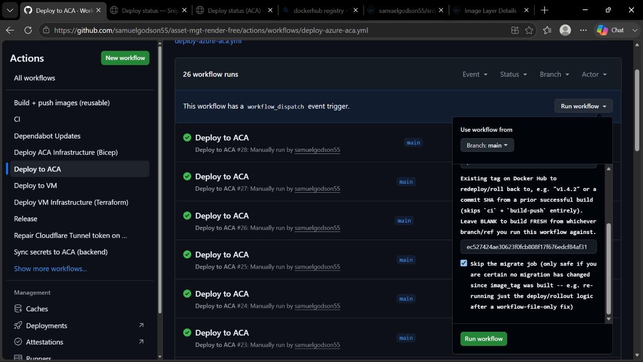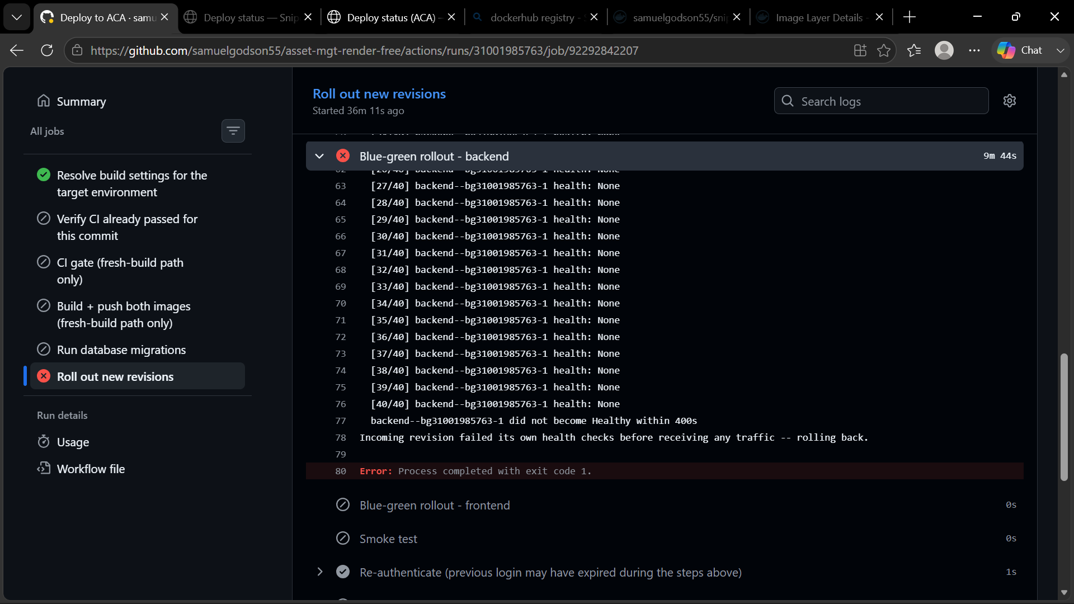


SCREENSHOT: SUCCESSFUL ZERO-DOWNTIME SWAP
On Tag Push
It creates a release and does the CI checks
The web application functionality not only liveness is checked 
The Images are built & checked before it is tagged and pushed 
The Frontend and Backend images are tagged and pushed

Migrations and other Checks
Monitoring can be done on the deploy page
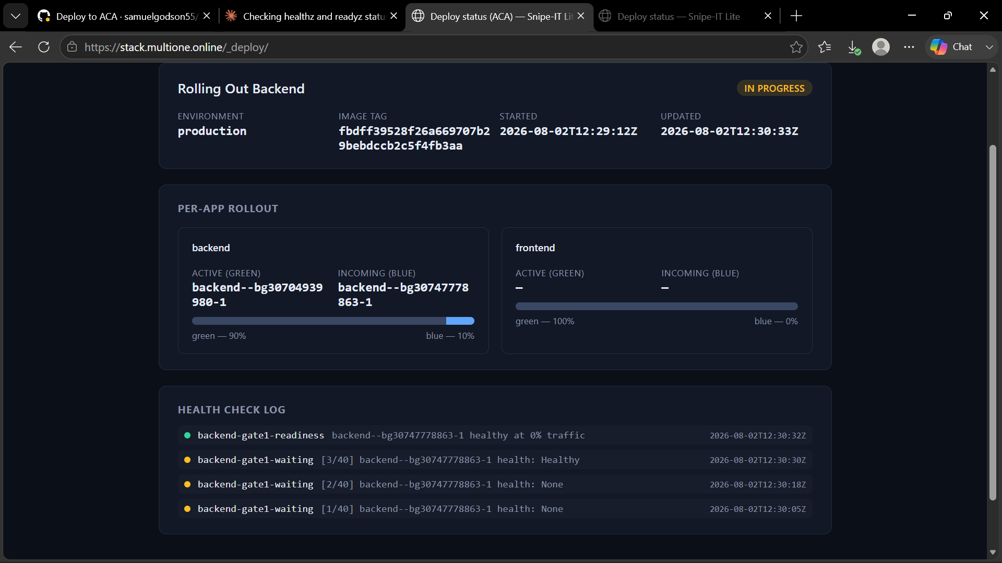
Continuous Poll with zero Downtime Evidence kickstarted, this will be available for download after the blue green deployment on Github as an artifact
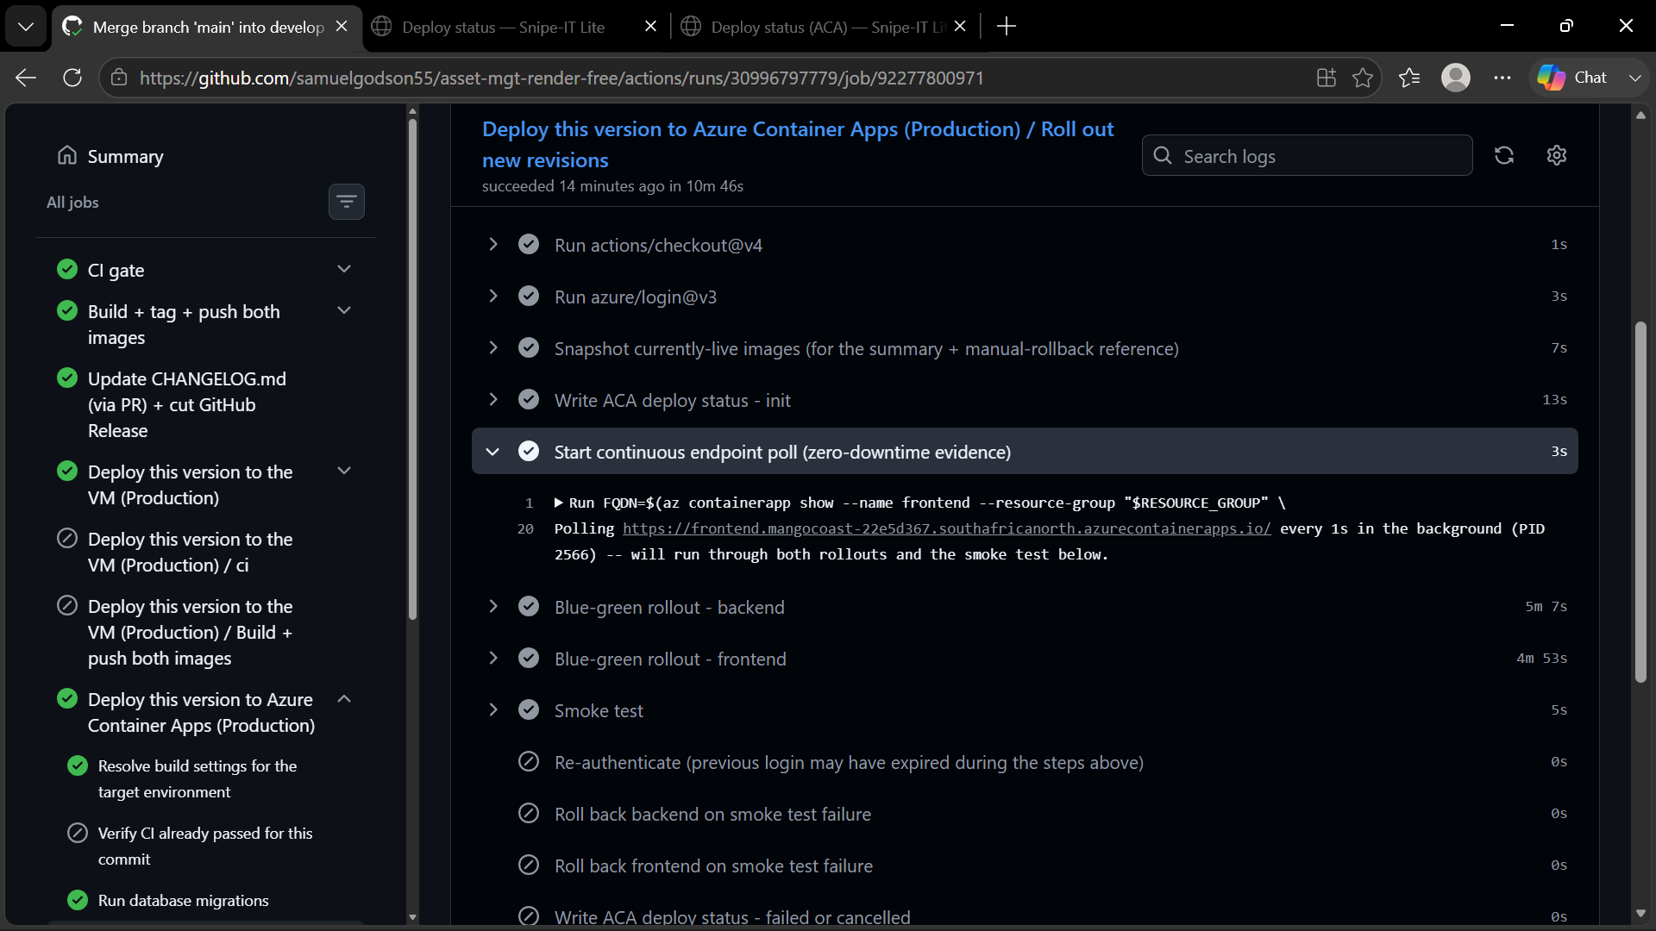
Zero Downtime Evidence
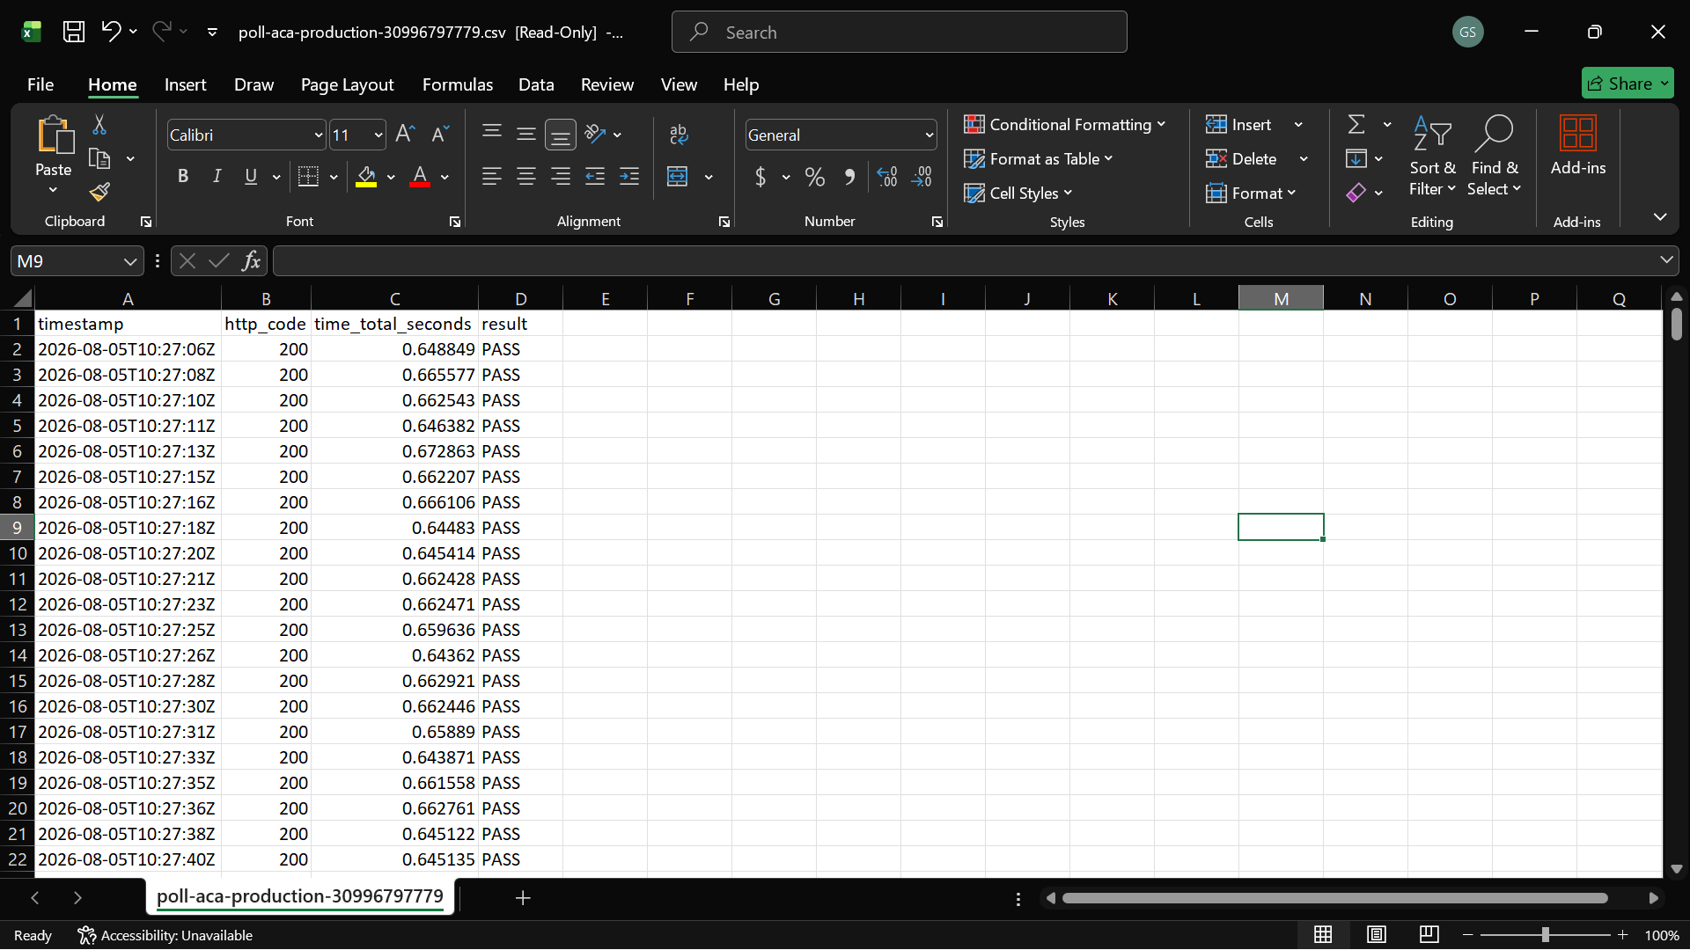

Deploy Successfull
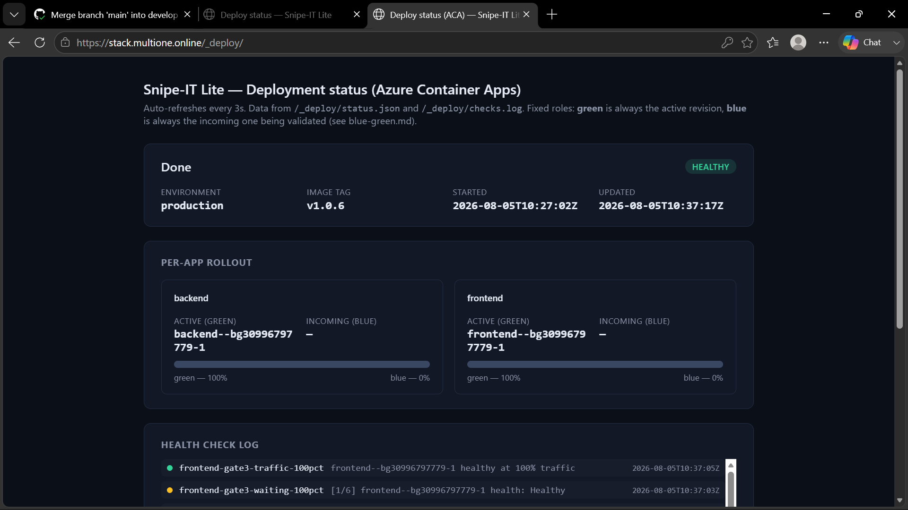

6. Deliverables Checklist
✓ | Item | Evidence / location
☑ | infra/main.bicep, aca-blue-green.sh, aca-deploy-status.sh, deploy-azure-aca.yml | Repository
☑ | Completed Phase 0 worksheet (health checks, swap/rollback sequence, failure modes) | Section 2, above
☐ | Screenshots: successful zero-downtime swap (poll-live-endpoint.sh CSV, all PASS) | Attach workflow artifact zero-downtime-poll-evidence-aca-*
☐ | Screenshots: a caught-and-rolled-back bad deploy (skip_migrate failure injection — Incident #3, Section 5) | To attach: Actions run log + dashboard screenshot (phase: failed)
☑ | Incident report, completed (skip_migrate failure injection) | Section 5, above — completed

