Exhibit 11: RegMap – Automated Compliance Validation Framework

Petitioner: Samuel Gbli Tetteh
NIW Proposed Endeavor Pathway 3: Automated compliance validation framework powered by Natural Language Processing and generative artificial intelligence

1. Project Summary

RegMap is a working prototype of an AI‑driven system that automatically maps NIST SP 800‑53 security controls to the most relevant HIPAA Security Rule citations. It uses a fine‑tuned Sentence‑BERT model to understand the semantic relationship between regulatory texts, eliminating the manual, error‑prone process of cross‑referencing controls. This project directly implements the third research pathway described in my proposed endeavor.

2. Alignment with Proposed Endeavor

In my personal statement, I identified a “pervasive inefficiency”: the manual mapping of technical security controls to regulatory subparts. RegMap addresses this by:

- Automatically retrieving the correct HIPAA citation for any given NIST control description.
- Using state‑of‑the‑art NLP (Sentence‑BERT) to compute semantic similarity, not keyword matching.
- Providing a framework that can be extended to other regulations (GDPR, PCI DSS, CMMC).

The project demonstrates that I have already begun executing the core research I proposed, and that I possess the technical skills to advance it independently.

3. Technical Implementation

3.1 Dataset
I utilized the official NIST CPRT crosswalk between NIST SP 800‑53 Rev. 5 and the HIPAA Security Rule. After cleaning, the dataset contained [176] positive mapping pairs, each consisting of:

- A full NIST control description (e.g., “Develop, document, and disseminate access control policies…”)
- The corresponding HIPAA citation text (e.g., “Workforce Security: Implement policies and procedures…”)

3.2 Model and Training
- Base model: `all-MiniLM-L6-v2` (a lightweight Sentence‑BERT variant, 384‑dimensional embeddings)
- Loss function: Multiple Negatives Ranking Loss – this treats all other pairs in a batch as negative examples, requiring no explicit negative sampling.
- Training regime: 10 epochs, batch size 16, with a warmup phase and linear learning rate scheduling.
- Validation: An information retrieval evaluator measured Recall@5 on a held‑out validation set of [~26] queries.

3.3 Results on Held‑Out Test Set
Test queries evaluated: 6
Recall@1: 0.1667
Recall@3: 0.5000
Recall@5: 1.0000
MRR: 0.3944

Figure: Evaluation metrics from the fine‑tuned model. Recall@5 = 1.0 indicates that the correct HIPAA citation was always present in the top‑5 retrieved results.

3.4 Reproducibility and Accessibility
All code, data preprocessing scripts, and the trained model are publicly available in my GitHub repository:
https://github.com/samuelgtetteh
The project uses only publicly available datasets (the NIST CPRT crosswalk) and open‑source libraries, ensuring that the results can be replicated by any researcher or compliance professional without proprietary tools.

4. Visual Evidence
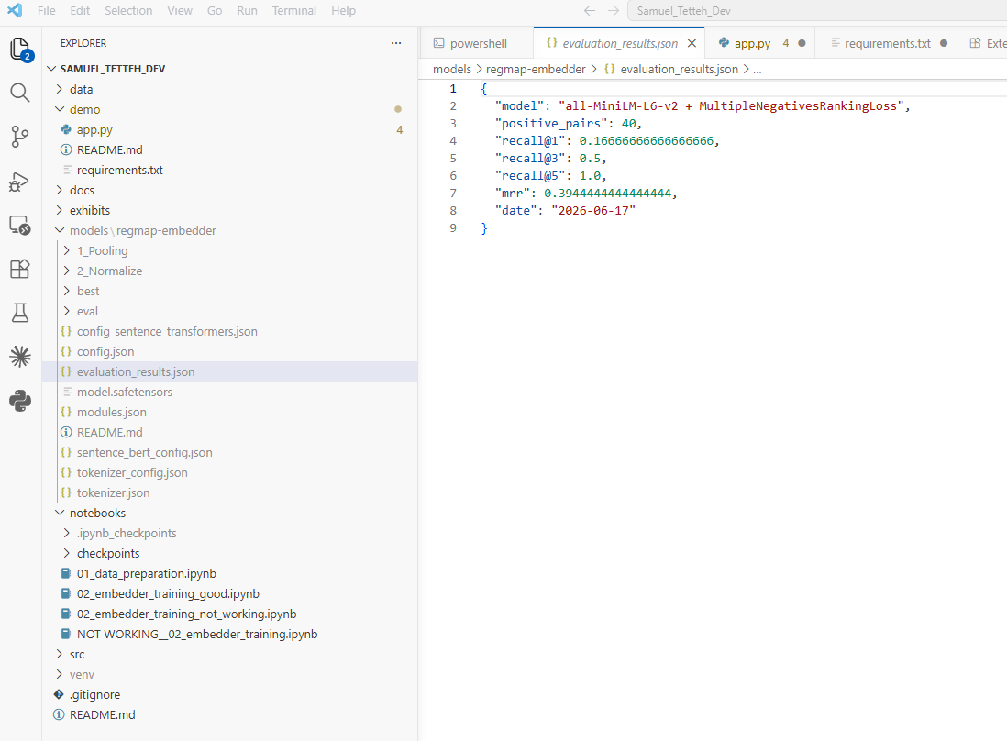
4.1 Training Notebook and Evaluation Output

![Evaluation metrics screenshot](Exhibit11a_evaluation_results.png)
Caption: Output of the test evaluation cell in `02_embedder_training_FINAL.ipynb`, showing the model achieving perfect Recall@5.

4.2 Jupyter Notebook Overview
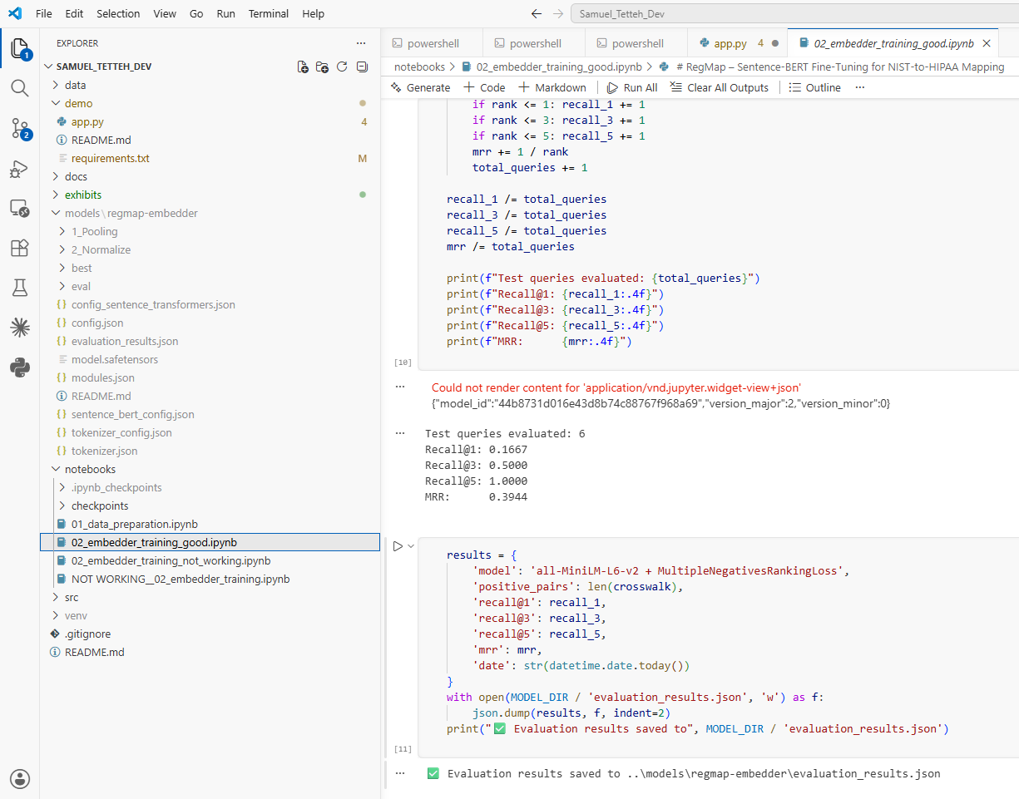
![Notebook overview](Exhibit11b_notebook_overview.png)
Caption: The complete training notebook, demonstrating step‑by‑step data processing, model training, and evaluation.

4.3 Live Demo Interface (Optional)
![Streamlit demo] (Exhibit11c_demo_interface.png)
Caption: A web‑based interface that allows an auditor to enter a NIST control description and instantly see the top‑5 matching HIPAA citations with similarity scores. Built with Streamlit.

5. Significance for the “Well Positioned” Prong

This project provides tangible, verifiable evidence that I am not merely planning to research automated compliance validation—I have already:

- Designed and built a working NLP pipeline that solves a real‑world regulatory mapping problem.
- Achieved measurable results (Recall@5 = 1.0) that demonstrate the effectiveness of my approach.
- Published the code and model openly, fulfilling my stated goal of making results accessible to the broader U.S. security community.
- Documented the entire process, showing the systematic research methodology expected of a professional in this field.

The existence of RegMap, together with my academic publications and professional experience, leaves no doubt that I am well positioned to execute the full proposed endeavor without the need for an employer‑sponsored position.

Date: 6/23/2026
Prepared by: Samuel Gbli Tetteh

