Lab 1: Project Setup

Summary
In this lab, we will be walking through how to create your own project to complete the following labs in the bootcamp. It is important we create a project in the right environment, or else it can cause issues down the line if done incorrectly!

Table of Contents
- Accept invitation to instance
- Log in to watsonx
- Check that you are in the right instance
- Create a new project
- Associate the correct WML instance
- Create an inventory

1. Accept invitation to instance

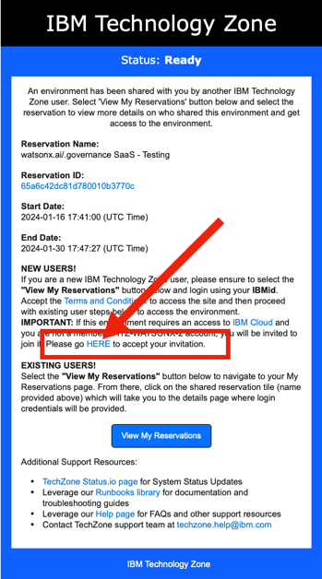
If you have been invited to the session, you should have received an email asking you to join an instance from noreply@techzone.ibm.com with subject "[EXTERNAL] A reservation has been shared with you on IBM Technology Zone."Join the instance by clicking HERE in "Please go HERE to accept your invitation" as inThe following web page may or may not display. If it does, click (1) to select the correct Notification then (2) click "Join Now".When this page displays, click the checkbox as in the image below then click "Join Account".
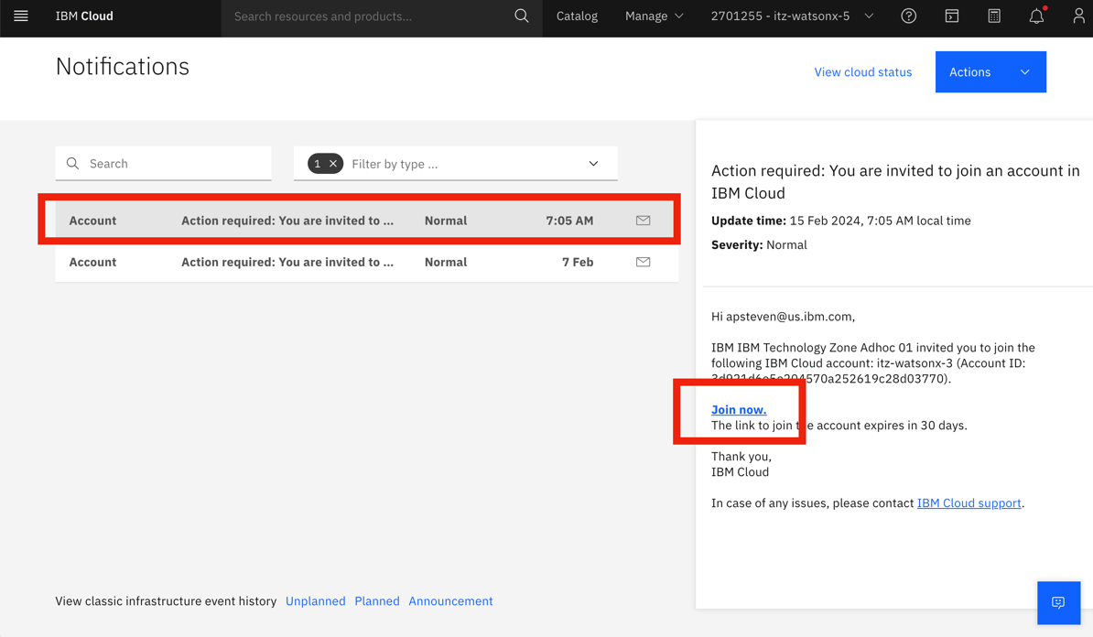

2. Log in to watsonx
Next, follow this link to log in to watsonx: https://dataplatform.cloud.ibm.com/wx/home?context=wx
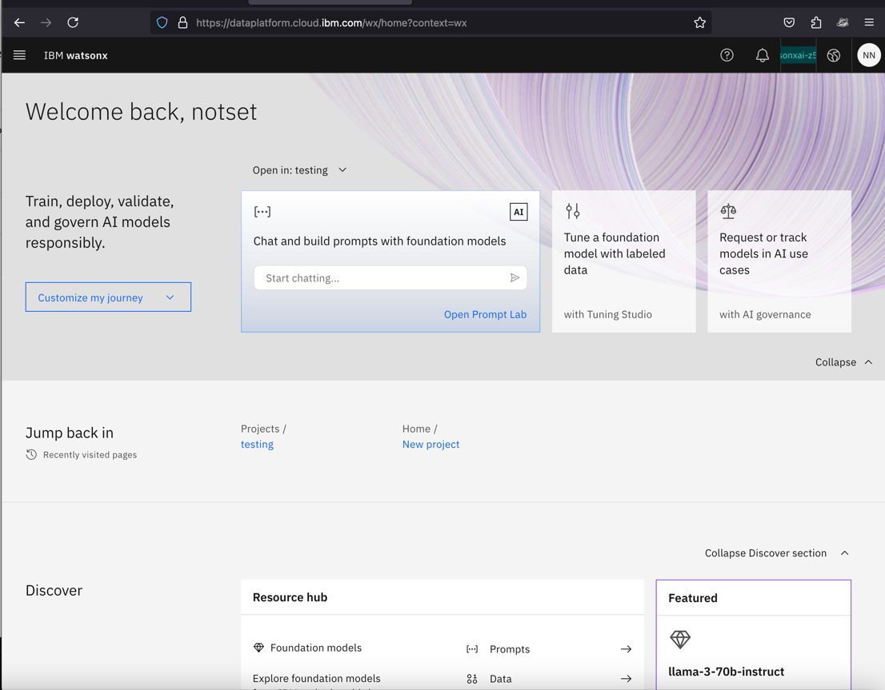

3. Check that you are in the right instance

You should now be taken to the watsonx home screen. Check at the top right that you are in the right instance, for this workshop it should read itz-watsonx-12._
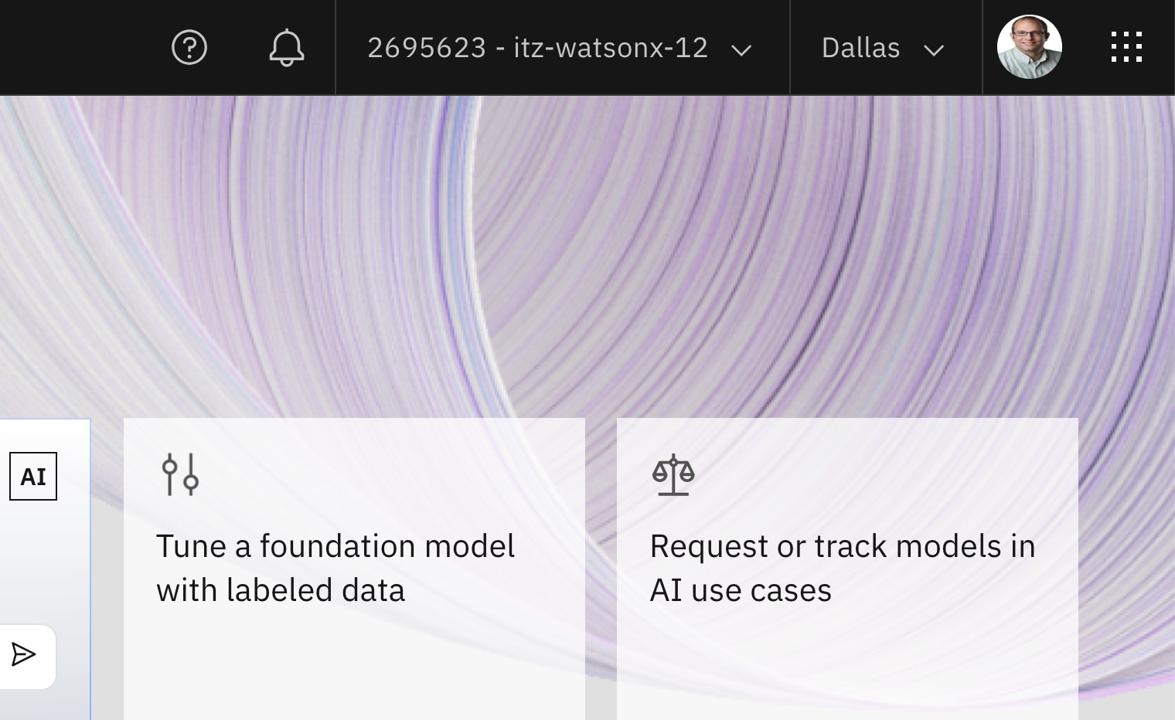
. If it does not show the right name of the instance, you can select it in the dropdown. For the entirety of the bootcamp, you will be working in that same instance!
Note: The instance at the top right tends to change to your default personal account every time you switch/go back to a new page. Thus, it's always good to check the top right corner every time you switch to a new page.

