
User and Operations Manual
Marketing Decision OS (MDOS), version 0.1.0
How to install MDOS on a computer or a server, how to use the Research Lab, the Strategy Simulator and the Journey Designer, and how to keep MDOS and its data safe.
29 September 2026
Released under the MIT License. Source: github.com/samuelhtampubolon/MDOS
The screens in this manual come from the Lake Toba demo, which uses synthetic (made-up) data.

Contents
1. About this manual 3
2. Before you start 4
3. Installing and starting the desktop app 4
4. Running the cloud version 7
5. Finding your way around 8
6. Projects 9
7. Research Lab 10
8. Strategy Simulator 15
9. Journey Designer 16
10. Experiments 18
11. Agents, approvals and the audit trail 18
12. Claude drafting (optional) 19
13. Security and privacy 20
14. Administration 21
15. Troubleshooting 22
16. Owner’s checklist: what to do by hand 23
17. Glossary 24
Appendix A. Settings reference 25
Appendix B. Where to find more 26
Each chapter title above is a link. Chapters 5 to 11 are for everyday use; chapters 2 to 4 and 12 to 16 are for the person who installs and looks after MDOS.

1. About this manual
Marketing Decision OS (MDOS) helps marketers, researchers and business owners go from a business question to evidence they can defend, to strategy scenarios they can compare, and to customer journey fixes they can test. This manual explains how to install MDOS, how to use every part of it, and how to run it safely.

1.1 Who this manual is for
- Everyday users who design research, analyze data, simulate strategy and improve customer journeys. Start with chapters 5 to 11.
- The owner or administrator who installs MDOS on a computer or a server, keeps it updated and protects its data. Start with chapters 2 to 4 and 12 to 16.
- Developers and AI coding agents who change the code. Read chapter 13.7 and the files SECURITY.md and AGENTS.md in the repository first.

1.2 What MDOS does
MDOS is one application with three connected modules and a closed loop between them:
Module | What it does for you
Research Lab | Turns a business question into a research design, a bilingual (English and Indonesian) questionnaire and a sampling and fieldwork plan. Then it checks and cleans the data, runs the statistics, and drafts insights and a report.
Strategy Simulator | Builds a market model from the research evidence and simulates what happens if you change the price, the media mix or the audience, with sensitivity analysis, risk simulation and a decision log.
Journey Designer | Maps the customer journey, finds friction in reviews and comments, simulates improvements and turns the best ones into A/B tests whose results flow back into research as evidence.

Four rules run through the whole product:
- Numbers always come from code. Every statistic is computed by tested methods and shows its sample size, assumption checks and limitations. AI never invents a number.
- People decide. Agents draft designs, insights, verdicts and reports, but only a person can approve them. Every approval is recorded.
- Evidence is cited. Insights, recommendations and reports must link to evidence records. Causal words such as “causes” or “drives” are blocked unless the evidence comes from an experiment.
- Assumptions are visible. Every number in the strategy model shows where it came from (research, benchmark, expert judgment or a guess) and how confident it is.

1.3 How to read this manual
Buttons, tabs and labels appear in bold, exactly as they appear on screen. Settings, commands, file names and addresses appear in code style. Prices follow Indonesian formatting, for example Rp 150.000. The screens shown come from the Lake Toba demo, which uses synthetic (made-up) data.
Tip: Every chart in MDOS has a Table button that shows the same numbers as a table. Use it when a chart is hard to read, when you need exact values, or when you use a screen reader.

2. Before you start

2.1 Choose how to run MDOS
 | Desktop app | Cloud version
Best for | One person working on their own computer | A team, or access from several computers
Where data lives | A private folder on your computer | A PostgreSQL database and a data volume on your server
Sign-in | No password: a private link opens it | Email and password accounts
Internet needed | No (only for optional Claude drafting) | Yes, for users to reach the server
Setup effort | Unzip and run (about 2 minutes) | Docker, a domain and a TLS proxy (about 1 hour)
Who maintains it | You | The owner of the server

2.2 What you need
- Desktop app: a 64-bit computer with Windows 10 or 11, macOS on Apple silicon, or a recent Linux (x86-64), about 1 GB of free disk space, and a current browser (Chrome, Edge, Firefox or Safari).
- Cloud version: a Linux server with Docker Engine and Docker Compose, 2 CPU cores and 4 GB of memory for a pilot, a domain name, and a TLS reverse proxy such as Caddy or Nginx.
- Optional Claude drafting: an Anthropic API key. Without it, MDOS works fully offline with deterministic drafting (see chapter 12).

2.3 Quick start in five minutes (desktop)
- Download the zip for your system and unzip it into a folder you own (chapter 3.1).
- Run MDOS (MDOS.exe on Windows). A small MDOS window opens and your browser opens MDOS.
- On the Home page, click Load the Lake Toba demo. The agents build a complete example project in a few seconds.
- Follow the Next step banner on the research dashboard, then explore Strategy and Journey from the sidebar.
- When you are ready, start your own project from the new project form on the Home page (chapter 6.1).

3. Installing and starting the desktop app

3.1 Download
The desktop app is built automatically for Windows, macOS and Linux by the repository’s Desktop build workflow. To download it:
- Sign in to GitHub and open the repository samuelhtampubolon/MDOS.
- Open Actions, choose the workflow Desktop build and open the newest run with a green check mark.
- Under Artifacts, download MDOS-Windows, MDOS-macOS or MDOS-Linux. Artifacts are kept for 30 days; when the owner publishes a release, the same zips are attached to it under Releases.
Important: Only download MDOS from the official repository or from a release published by its owner. Never run a copy that someone sent you by chat or email.

3.2 Install
MDOS needs no installer. Unzip the download into a folder that belongs to you, for example Documents\MDOS on Windows or ~/Applications/MDOS on macOS and Linux. Avoid shared or public folders, and do not unzip it into a folder that other people can write to.

3.3 First start
System | What to do
Windows | Double-click MDOS.exe. Because the app is not code-signed yet, Windows may show “Windows protected your PC”. Choose More info, then Run anyway, but only for a copy downloaded from the official repository.
macOS | Open the folder, right-click MDOS and choose Open. If macOS still blocks it, open System Settings, then Privacy and Security, and choose Open Anyway. A Terminal window opens and runs MDOS.
Linux | Open a terminal in the folder and run ./MDOS. If needed, first run chmod u+x MDOS.

The MDOS window shows three lines: that MDOS is running, a private link, and the data folder. Your browser opens MDOS automatically. Keep the MDOS window open while you work: closing it stops MDOS.
Marketing Decision OS is running.
Open this private link (it works until MDOS is closed): http://127.0.0.1:8765/#key=...
Data folder: C:\Users\you\AppData\Local\MDOS
Press Ctrl+C to stop.

3.4 The private link and the locked screen
Every time MDOS starts, it creates a new random key and gives it only to the browser it opens, through the private link. This stops other programs and other accounts on the same computer from opening your workspace. If you open http://127.0.0.1:8765 without the key, for example from a bookmark, MDOS shows a locked screen.
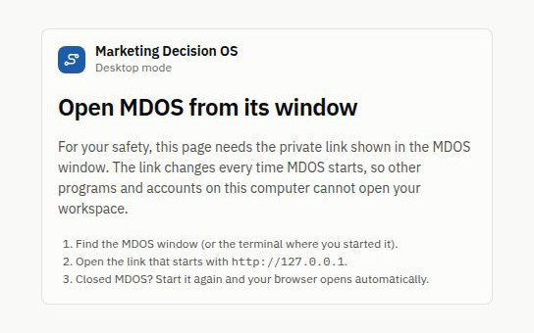
Figure 1. The locked screen appears when MDOS is opened without its private link.
To get in, copy the private link from the MDOS window into your browser. Bookmarks are safe to use for pages inside MDOS, because the key is removed from the address bar as soon as MDOS opens. After MDOS restarts, the old link stops working and pages that are still open ask for the new one.

3.5 Where your data lives
System | Data folder
Windows | %LOCALAPPDATA%\MDOS
macOS | ~/Library/Application Support/MDOS
Linux | ~/.local/share/mdos

The folder contains mdos.db (the database), files (your uploaded datasets and their versions) and secret.key (the key that signs sessions). On macOS and Linux, MDOS makes the folder readable only by your account. To back up your work, close MDOS and copy the whole folder. To use a different folder, start MDOS with --data-dir (chapter 3.8).

3.6 Stopping, updating and removing MDOS
- Stop: press Ctrl+C in the MDOS window or close the window. Closing only the browser tab does not stop MDOS. When MDOS stops, the session ends and the private link file it created is deleted.
- Update: back up the data folder, close MDOS, unzip the new version (you can replace the old app folder) and start it. Your data folder is reused, and any database changes are applied automatically at start.
- Remove completely: close MDOS, delete the app folder and delete the data folder. Nothing else is installed on your computer.

3.7 Running MDOS from source (for developers)
Developers can run MDOS from the repository with Python 3.11 or newer and Node.js 22 or newer. Exact, hash-checked Python dependencies are installed from backend/requirements.txt, and npm packages are installed without running package scripts:
cd backend && python -m venv .venv && source .venv/bin/activate
pip install --require-hashes -r requirements.txt && pip install -e ".[dev]"
cd ../frontend && npm ci --ignore-scripts && npm run build
cd ../backend && mdos

3.8 Start-up options
Option | What it does
--port 8765 | Preferred local port. If it is busy, MDOS picks another free port and shows it in the private link.
--strict-port | Stop with an error instead of choosing another port when the preferred port is busy.
--data-dir PATH | Use a different data folder, for example on an encrypted drive.
--no-browser | Do not open the browser automatically. Copy the private link from the MDOS window.

4. Running the cloud version

4.1 What you get
The cloud version runs the same application with email and password accounts, a PostgreSQL database and a data volume for uploaded files, packaged with Docker Compose. It is meant for a server that you control. The container runs as a non-root user with a read-only file system, no extra privileges and no Linux capabilities, and it is published only on the server’s own address (127.0.0.1) so that nothing reaches it except through your TLS proxy.

4.2 First start on a server
- Install Docker Engine and Docker Compose on the server.
- Download the repository (or a release) to the server.
- Copy the example settings: cp .env.example .env.
- Create a strong signing key and put it in SECRET_KEY: python3 -c "import secrets; print(secrets.token_urlsafe(48))". Choose a long random POSTGRES_PASSWORD too.
- Start everything: docker compose up --build -d.
- Open http://localhost:8000 on the server (or through an SSH tunnel) and create the first account. That account owns the workspace.
Important: Sign-up closes automatically after the first account. This stops strangers from creating workspaces on your server and using your Claude credit. Set ALLOW_REGISTRATION=true only if you run an open, multi-workspace service.

4.3 Putting it online for a team
Put a TLS reverse proxy in front of MDOS on the same server. With Caddy, this Caddyfile is enough; Caddy keeps the original host name and obtains the certificate automatically:
mdos.example.com {
reverse_proxy 127.0.0.1:8000
}
Then set these values in .env and apply them with docker compose up -d:
Setting | Value
ALLOWED_HOSTS | Your domain, for example mdos.example.com,localhost
COOKIE_SECURE | true, so the session cookie is only ever sent over https
FORWARDED_ALLOW_IPS | The address your proxy connects from, as the container sees it (see below)
ALLOW_REGISTRATION | Leave empty (first account only) or false

Inside Docker, a proxy on the same server does not appear as 127.0.0.1 but as the gateway of the Compose network. This command prints that address; put it in FORWARDED_ALLOW_IPS, and check it again if you ever recreate the network:
docker inspect -f '{{range .NetworkSettings.Networks}}{{.Gateway}}{{end}}' \
$(docker compose ps -q app)
Until it is set, MDOS ignores the proxy’s headers. That is safe, but MDOS then sees every visitor as the same address, so everyone shares one sign-in rate limit.

4.4 Backups and restore
Back up two things every day: the database and the uploaded files. Test a restore at least every three months.
docker compose exec -T db pg_dump -U mdos mdos > mdos-db.sql
docker compose exec -T app tar czf - -C /data . > mdos-files.tgz
To restore onto a fresh installation, start only the database, load both backups, then start everything. Keep backups encrypted and away from the server.
docker compose up -d --wait db
docker compose exec -T db psql -U mdos mdos < mdos-db.sql
docker compose run --rm --no-deps -T app tar xzf - -C /data < mdos-files.tgz
docker compose up -d

4.5 Updating
Back up first. Then download the new version and run docker compose up --build -d. Database changes are applied automatically when the app starts. If something goes wrong, restore the backup and start the previous version.

4.6 Accounts in version 0.1.0
Each sign-up creates its own workspace. The Members card in project settings can give another account a role on a project, but only for accounts that already belong to the same workspace. Invitations are planned for a later version, so in version 0.1.0 each account works in its own workspace.

5. Finding your way around
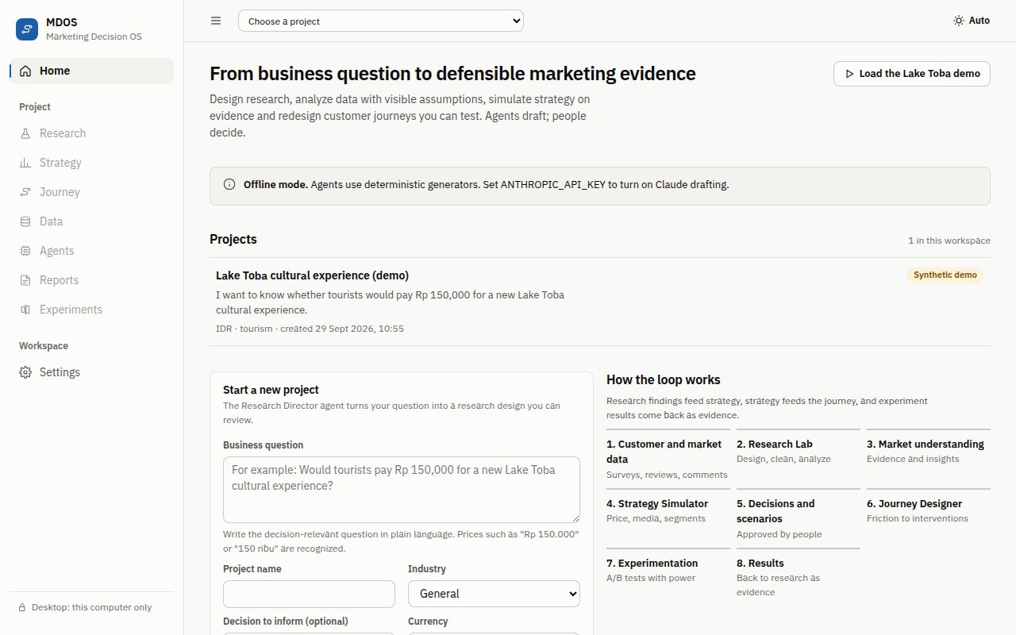
Figure 2. The Home page lists your projects first and lets you start a new one.

5.1 The sidebar
- Home: your projects, a new project form and a short explanation of the closed loop.
- Project: the modules of the current project: Research, Strategy, Journey, Data, Agents, Reports, Experiments and Approvals. The number next to Approvals shows how many decisions are waiting for you.
- Workspace: Settings for the theme, security information, AI drafting status, members, deletion and the audit log.
- The bottom line shows the mode, for example Desktop: this computer only.

5.2 The top bar
The project switcher at the top changes the current project and keeps you in the same module. The theme button cycles between Auto (follow your device), Dark and Light. On a phone, the menu button at the top left opens the sidebar.

5.3 How pages are organized
- A page title and one sentence that explains what the page is for.
- Tabs for the parts of a module. On phones, tabs wrap onto a second line.
- A Next step banner where a page asks you to act. It holds the page’s one main button.
- Key numbers in a row of boxes, then details, charts and tables below.
- Status labels such as Draft, Awaiting approval, Approved or Failed, always with an icon and a word, never color alone.

5.4 Loading, empty and error states
While a page loads, grey placeholder shapes show where content will appear. An empty module explains in one sentence what is missing and offers the button that fills it. If a project link is broken, MDOS says We can’t find this project and offers Go to your projects. If the server stops answering, MDOS says MDOS is not responding and offers Try again.

6. Projects

6.1 Start a project
On the Home page, fill in the new project form and click Create project. MDOS opens the research dashboard of the new project.
Field | What to enter
Business question | The decision-relevant question in plain language, at least 10 characters. Prices such as “Rp 150.000” or “150 ribu” are recognized.
Project name | A short name you will recognize in the project switcher.
Industry | General, Tourism and hospitality, Retail, Food and beverage, Education or Services. It selects suitable templates and benchmarks.
Decision to inform | Optional. The decision this research will support, for example “Set the launch price”.
Currency | IDR, USD, SGD, MYR or EUR.

6.2 Write a good business question
A good question names the offer, the audience, the decision and, where relevant, the price. The Research Director agent uses it to draft hypotheses, a questionnaire and a sampling plan.
Weak | Better
Is our tour good? | Would domestic and international tourists pay Rp 150.000 for a new Lake Toba cultural experience?
How to grow sales? | Which channel should carry our premium weekend package for Jakarta families at Rp 2.500.000: Instagram, TikTok or online travel agents?

6.3 The Lake Toba demo
Load the Lake Toba demo builds a complete example project in a few seconds: research design, a synthetic survey (326 responses, 294 after cleaning), 240 synthetic reviews, analyses, insights, a report, strategy scenarios and a journey map. The project is labeled Synthetic demo everywhere. Use it to learn MDOS, never as a basis for real decisions.

6.4 Project brief
The Project brief tab in Research holds the project’s name, business question, decision, context, industry, geography and currency. Edit them at any time and save. Changes are recorded in the audit log.

6.5 Delete a project
Open Settings inside the project, find Delete project and type the project name exactly as shown. Deletion removes the project, its data files and its history, and it cannot be undone. The audit log keeps a record that the project was deleted and by whom.

7. Research Lab
The Research Lab follows the full research process in eight tabs: Dashboard, Project brief, Research plan, Questionnaire, Data workspace, Analysis studio, Insights and evidence and Report builder.

7.1 Dashboard
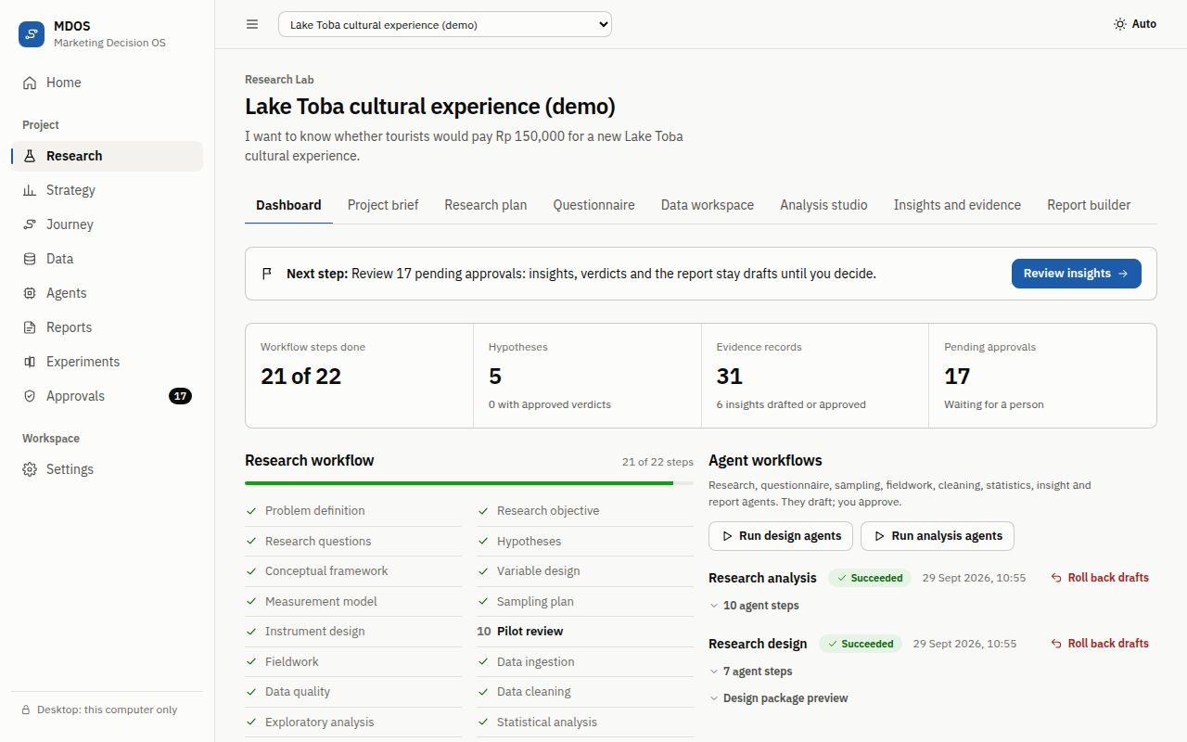
Figure 3. The research dashboard leads with the next step, then key numbers, the workflow checklist and the agent workflows.
- Next step tells you what to do now and has one button that takes you there.
- Four key numbers: Workflow steps done, Hypotheses, Evidence records and Pending approvals.
- Research workflow is a checklist of the research steps. Completed steps are marked, the next step is bold, and steps planned for a later version are struck through.
- Agent workflows runs the design agents (question to research design) and the analysis agents (data to insights and report). Each run can be opened to see every agent step, and Roll back drafts removes the drafts a run created while keeping everything a person approved.

7.2 Research plan
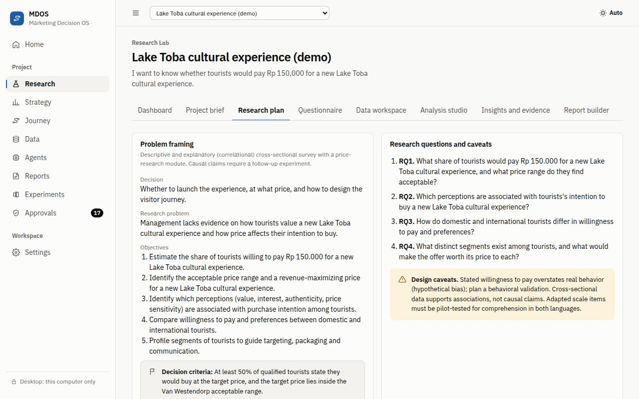
Figure 4. The research plan: problem framing, research questions, hypotheses, measurement model and sampling.
- Problem framing and Research questions and caveats restate the business question as research questions.
- Hypothesis canvas: use Add a hypothesis to write a statement, choose the independent and dependent variable and the Expected direction (Positive, Negative or No effect). Agents may propose verdicts from evidence; only a person can approve them, and an approved verdict locks the hypothesis.
- Measurement model lists constructs from a curated library with source citations; the Variable dictionary lists every variable.
- Sampling plan, Fieldwork plan and Interview guide (for 8 to 12 qualitative interviews that explain survey findings).
- Sample size calculator: choose what you want (estimate a share, estimate an average, compare groups or find the margin of error for a sample) and click Calculate. For example, a 50% share with a margin of plus or minus 5 points at 95% confidence needs n = 385.

7.3 Questionnaire
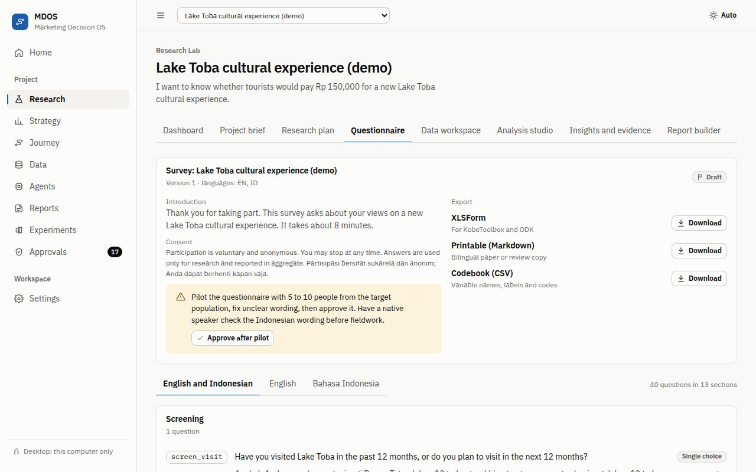
Figure 5. The bilingual questionnaire with sections, question types and export options.
The questionnaire is bilingual (English and Bahasa Indonesia). Use Add a question to set the code, section, type, both language versions, the options (one per line) or the scale points, and whether it is required. The questionnaire moves through clear states: draft, Approve after pilot, Mark as in the field and Close fieldwork (or Return to draft).
Download exports the questionnaire as XLSForm (for KoboToolbox, ODK and SurveyCTO), Markdown, a codebook (CSV) or JSON. Exported cells that start like a spreadsheet formula are neutralized, so a file cannot run formulas when opened.

7.4 Data workspace
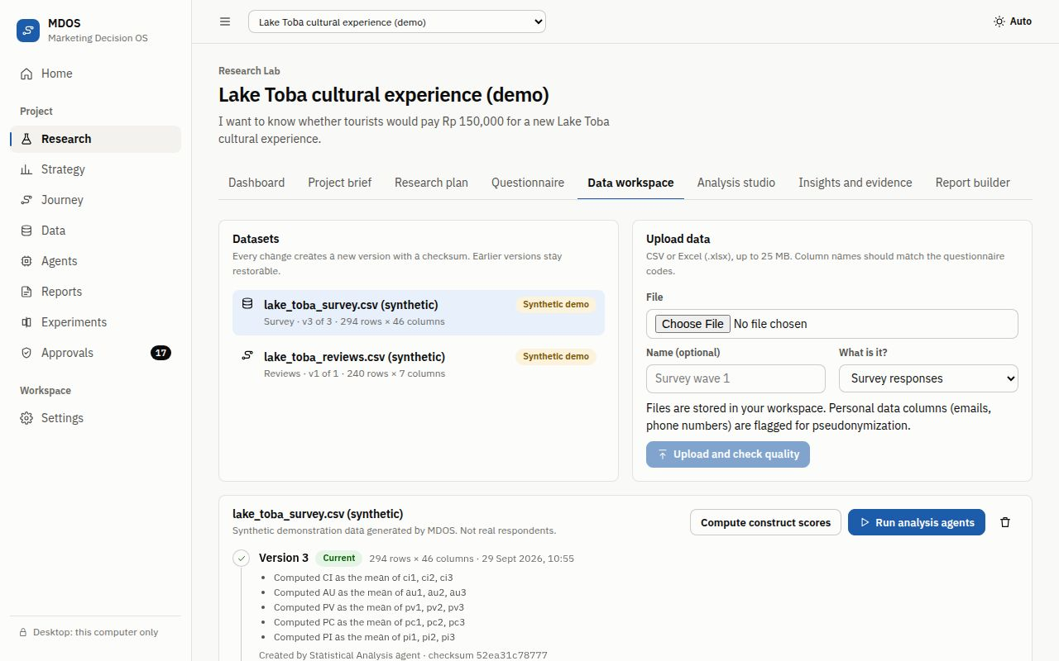
Figure 6. The data workspace: datasets, preview, column profiles, data quality and version history.
- Under Upload data, choose a CSV, TSV or XLSX file (up to 25 MB, 100,000 rows and 500 columns), give it a name if you like, say what it is (for example survey responses or reviews) and click Upload and check quality.
- Check Preview and Columns, where every column is profiled.
- Read Data quality: a Quality score out of 100, Flagged respondents, and issues by severity. Personal data such as email addresses and phone numbers is flagged as high severity.
- Click Propose cleaning plan. An agent proposes steps (for example removing speeders or failed attention checks, or pseudonymizing personal data). Nothing changes until a person approves.
- Each cleaning creates a new dataset version with a checksum and an operations log. Version history shows every version, and Restore brings back an earlier one.
- Use Compute construct scores for multi-item scales, then Run analysis agents. For review data, use Run journey agents.

7.5 Analysis studio
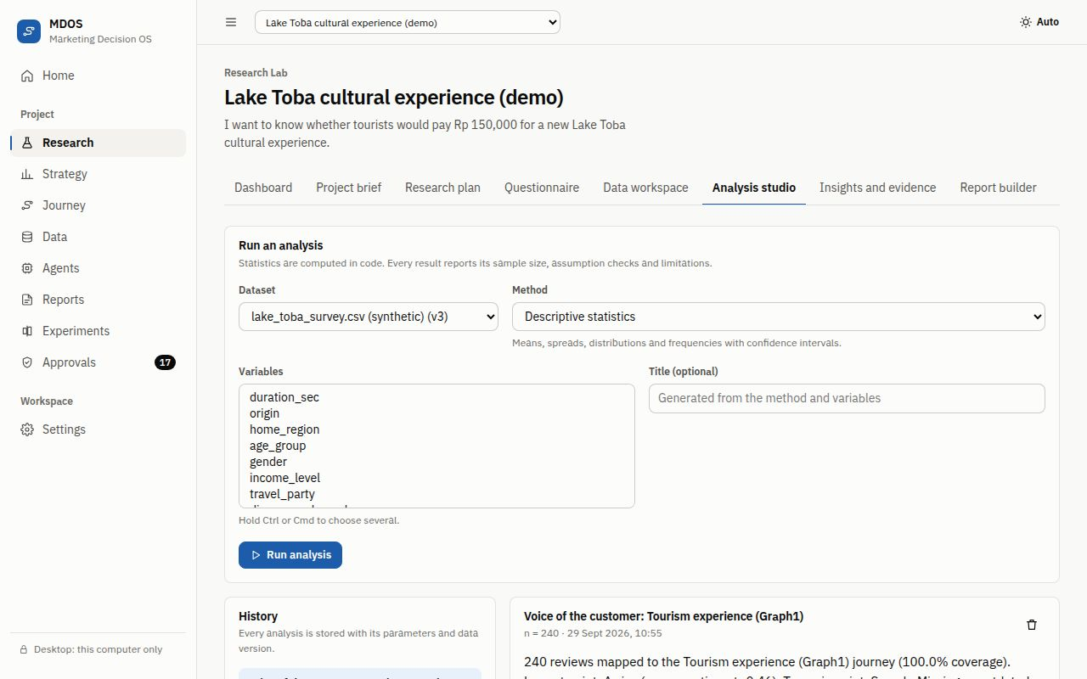
Figure 7. The analysis studio: choose a method and variables, then read the result with its assumption checks.
Under Run an analysis, choose the Dataset, the Method and its variables, and run it. Methods include descriptive statistics, cross-tabs with chi-square, correlation, linear and logistic regression, scale reliability, mediation and moderation, pricing research (Van Westendorp, Gabor-Granger and willingness to pay), segmentation, and text themes and sentiment.
Every result shows Assumption checks, Warnings and limitations and the sample size. Violations change how results are reported; they are never hidden. Evidence candidates lets you save a result as an evidence record, and History keeps every analysis with its parameters and data version.

7.6 Insights and evidence
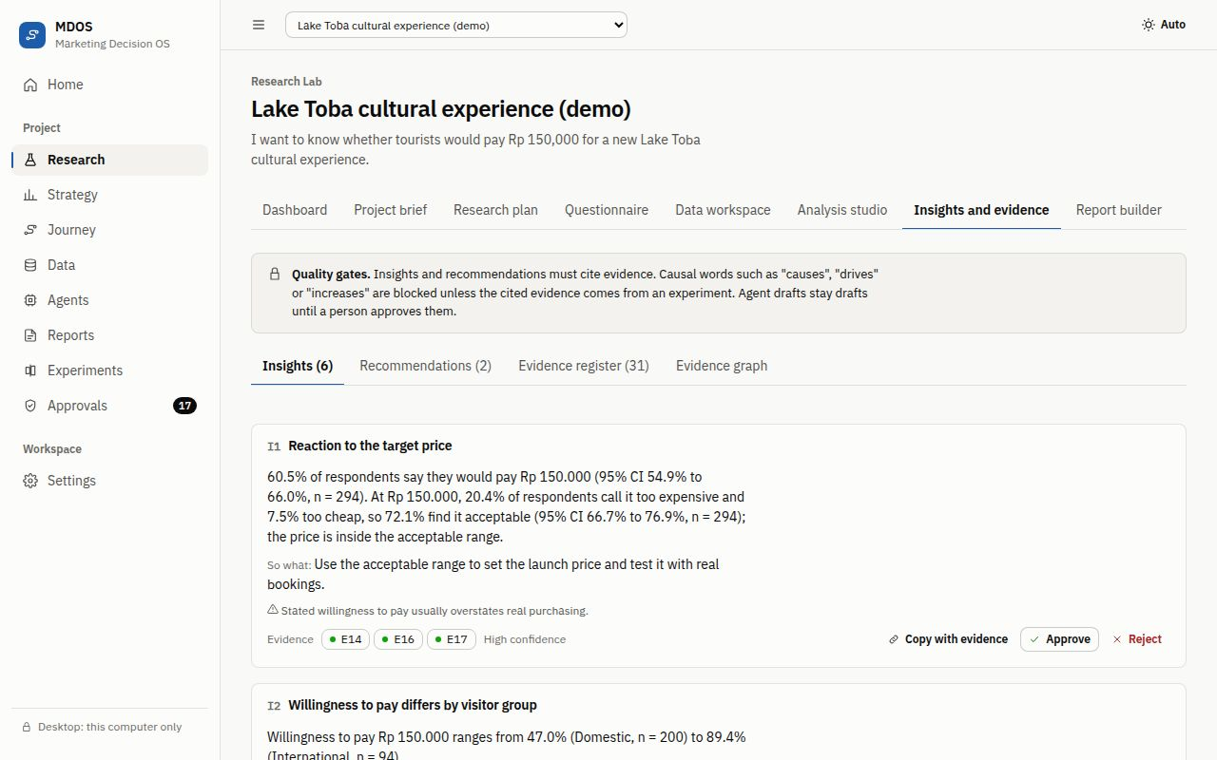
Figure 8. Insight cards with evidence codes, confidence, and approve or reject buttons.
This tab has four parts: Insights, Recommendations, Evidence register and Evidence graph. Each insight card shows its code (for example I1), the statement, a So what line, the main uncertainty, the evidence it cites (for example E14) and a confidence level. The dot next to each evidence code shows its strength: strong, moderate, weak or insufficient.
- Approve or Reject each draft. Only approved insights count as findings.
- Copy with evidence copies the insight with its evidence codes, ready to paste into a deck or an email.
- Write an insight lets you write your own from saved evidence. If you use causal words without experimental evidence, MDOS blocks the save and suggests associative wording, which you can accept with Use this wording.
- The Evidence graph traces any insight back to the analysis and dataset version it came from.

7.7 Report builder
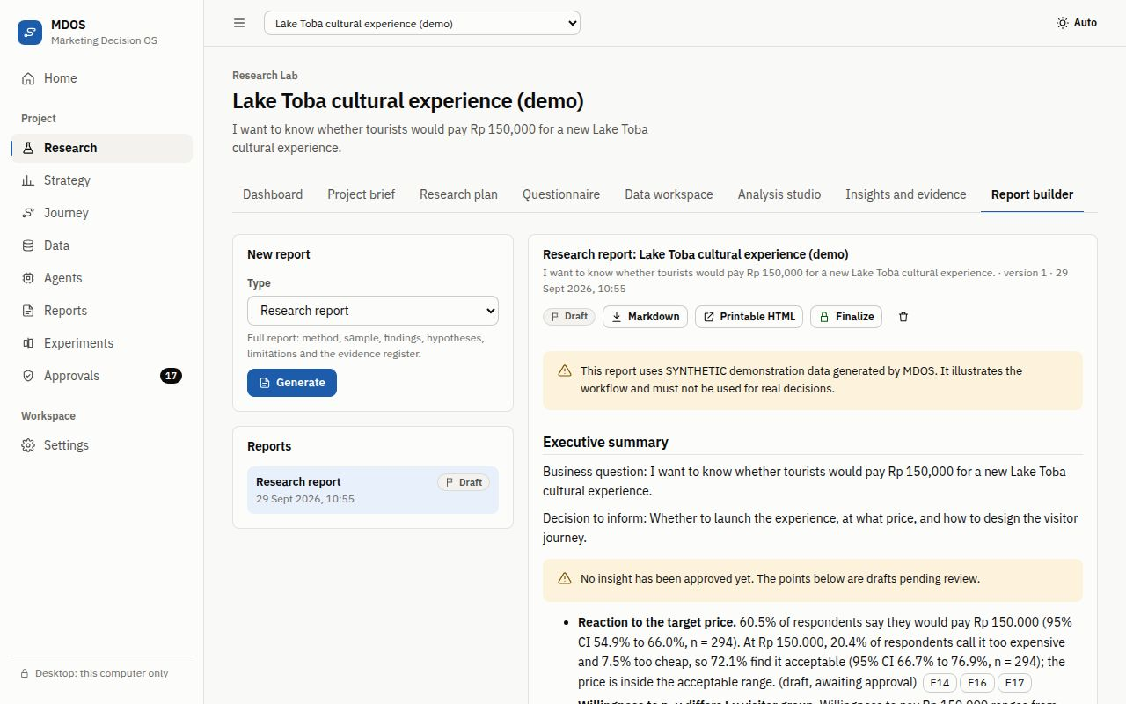
Figure 9. The report builder: generate, review, export and finalize reports that cite their evidence.
Under New report, choose a type (research report, executive summary, decision memo, methods appendix or experiment brief) and click Generate. Every statement links to an evidence record, drafts are labeled, and wording drafted by Claude is marked as model-generated.
Download a report as Markdown, or open Printable HTML in a new tab and print it to PDF from your browser. Finalize locks the report after approval. Reports built on the demo carry a clear synthetic-data warning.

8. Strategy Simulator
The Strategy Simulator answers “what happens if we change the price, the media mix or the audience?” on an explicit market model. Numbers are simulated from the model, not forecasts.

8.1 Build the market model
If a project has no model yet, click Run strategy agents to build a baseline from the research evidence and run standard scenarios, or Build baseline only. Gaps are filled with clearly labeled placeholders that you should replace with your own data.

8.2 Scenarios
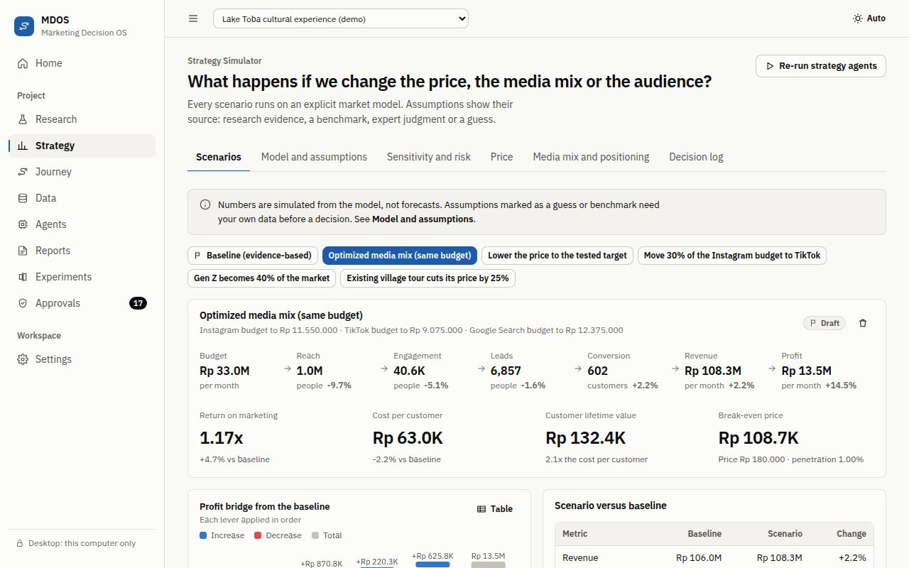
Figure 10. A scenario: the funnel from budget to profit, unit economics, and comparisons with the baseline.
- The scenario list shows the baseline and every scenario you built. Click one to open it.
- The funnel shows Budget, Reach, Engagement, Leads, Conversion, Revenue and Profit, with the change against the baseline.
- Below it: Return on marketing, Cost per customer, Customer lifetime value and Break-even price.
- Profit bridge from the baseline shows how each lever adds or removes profit, and Scenario versus baseline lists every metric side by side.
- Channels and Segments show spend, reach, customers and value by channel and by audience group.
- Build a scenario: give it a name, add levers (for example set the price, move budget between channels, change the audience mix or react to a competitor’s price) and click Simulate scenario.

8.3 Model and assumptions
This tab holds the whole model: Market and offer (addressable market, price, reference price, unit cost, fixed costs and word-of-mouth rate), Segments, Channels and Competitors. The Assumption register lists every number in the model, where it came from and how confident it is. Change values and click Save and re-run, or Discard changes.

8.4 Sensitivity and risk
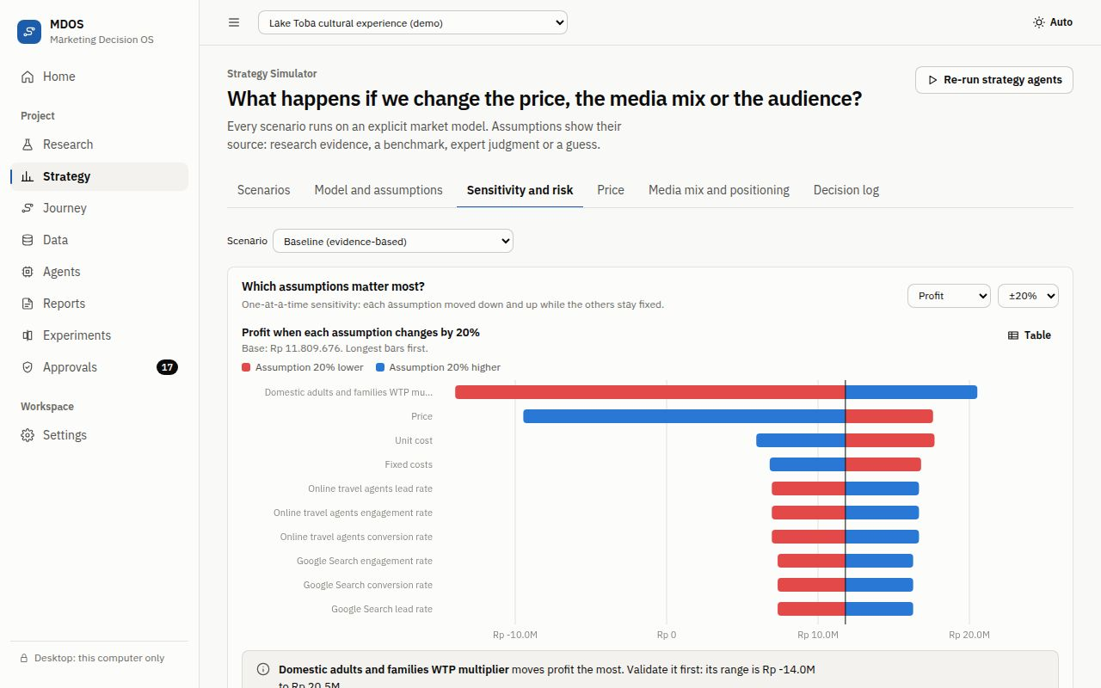
Figure 11. Which assumptions matter most: each assumption moved down and up while the others stay fixed.
Which assumptions matter most? moves each assumption down and up (plus or minus 20% by default) and shows the effect on profit, longest bars first. Validate the top assumptions before you decide. How likely is a profit? runs a Monte Carlo simulation and reports the Chance of a profit, a Bad case (10th percentile), the Typical profit (median) and a Good case (90th percentile); red bars in the distribution are losses.

8.5 Price
The price tab draws the demand curve implied by your research price-response data and shows Monthly revenue by price, Monthly profit by price and Customers per month by price. It marks the Revenue-maximizing price, the Profit-maximizing price and the Acceptable range (research). Save as scenario turns any price into a scenario.

8.6 Media mix and positioning
The Media mix optimizer spreads a Budget across channels to maximize the chosen outcome; compare the result under After optimizing and click Save as scenario. The Positioning map places your offer and competitors on the attributes your research measured.

8.7 Decision log
Use Log a decision to record a decision with its title, the scenario it relies on, the evidence and the rationale. A person approves or rejects it, and the log keeps who decided and when.

9. Journey Designer
The Journey Designer answers “where do customers struggle, and what should we fix first?”. It has four tabs: Journey map, Pain points, Interventions and Stages and settings.

9.1 Create a journey
Start from a template (for example the tourism experience journey) and click Create journey. To fill it with evidence, upload reviews in the data workspace and use Map from reviews with the agents: choose the Dataset, the Text column and optionally a Rating column, then Run journey agents. The agents map review sentences to stages, score their sentiment and find friction themes.

9.2 Journey map
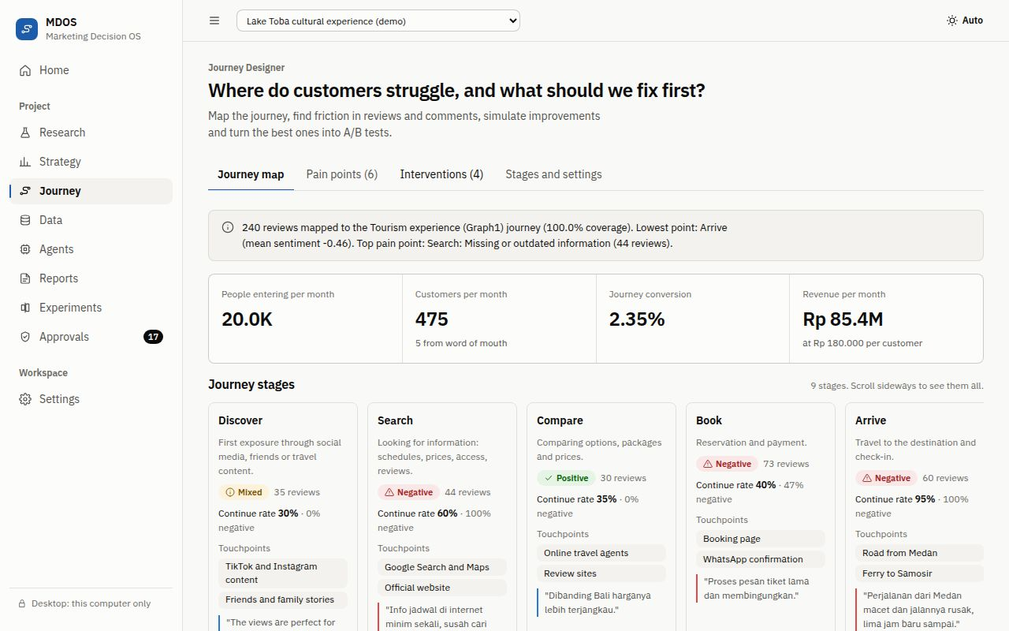
Figure 12. The journey map: key numbers, stages with emotions and touchpoints, and review quotes.
- A summary of the voice of the customer and four key numbers: People entering per month, Customers per month, Journey conversion and Revenue per month.
- Journey stages from discovery to recommendation. Scroll sideways to see them all. Each stage shows its emotion (positive, mixed or negative) with the number of reviews, its continue rate, its touchpoints and real quotes in their original language.
- Emotion along the journey plots mean sentiment per stage from minus 1 to plus 1; bigger dots mean more reviews.
- Where friction concentrates is a heatmap of negative mentions by stage and theme. Stages without negative mentions are listed in a note below it.
- Simulated funnel shows how many people continue at each stage with the current continue rates.

9.3 Pain points and interventions
Pain points are ranked by priority. Add your own with Add a pain point from observation or interviews and mark each as open, addressed or dismissed. Under Interventions, click Propose interventions to let the agents draft fixes, or Add an intervention with its stage, type, effort (small, medium or large) and the pain point it solves, then Add and simulate. The chart Extra customers per month by intervention shows the middle estimate with a low to high range. Design an A/B test turns an intervention into an experiment.

9.4 Stages and settings
Adjust Stage continue rates and the Journey settings (for example people entering per month and price per customer) and click Save and re-simulate. Add touchpoints with a Touchpoint name and a Channel.

10. Experiments
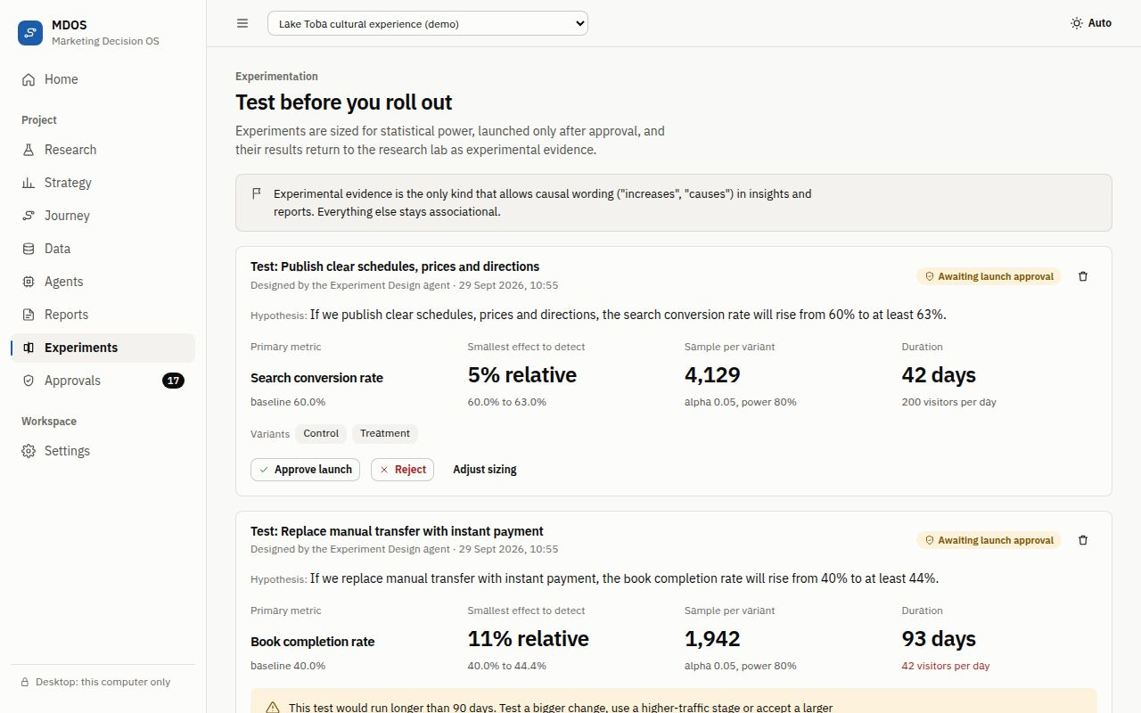
Figure 13. Experiments: sizing, launch approval, results and evidence.
The Experiments page, Test before you roll out, turns ideas into A/B tests whose results come back to research as experimental evidence. Experimental evidence is the only kind that allows causal wording in insights.
- Create an experiment from a journey intervention with Design an A/B test, or with Create an experiment (name, hypothesis, primary metric and visitors per day).
- MDOS sizes the test: Sample per variant and Duration, from the Smallest effect to detect and the Power you choose. Use Adjust sizing and Recalculate to try other values.
- A person clicks Approve launch (or Reject). Nothing is launched without approval.
- When the test ends, choose Enter results, type the visitors and conversions for control and treatment, and click Analyze results.
- MDOS reports the effect with its uncertainty and saves it as an evidence record, for example Saved as evidence E32, which you can cite in insights and reports.

11. Agents, approvals and the audit trail

11.1 What agents do
Agents are specialized helpers, such as the Research Director, the Questionnaire agent or the Data Quality agent, each allowed to use only the tools on its list. They draft; they never approve. Statistics come from tested code, and anything an agent drafts is validated before it is shown. The Agents page lists The agent team (the agents in the specification, marked In this version or Deferred) and the Agent run log with the latest 200 runs. Open a run to see its full output.

11.2 Approvals
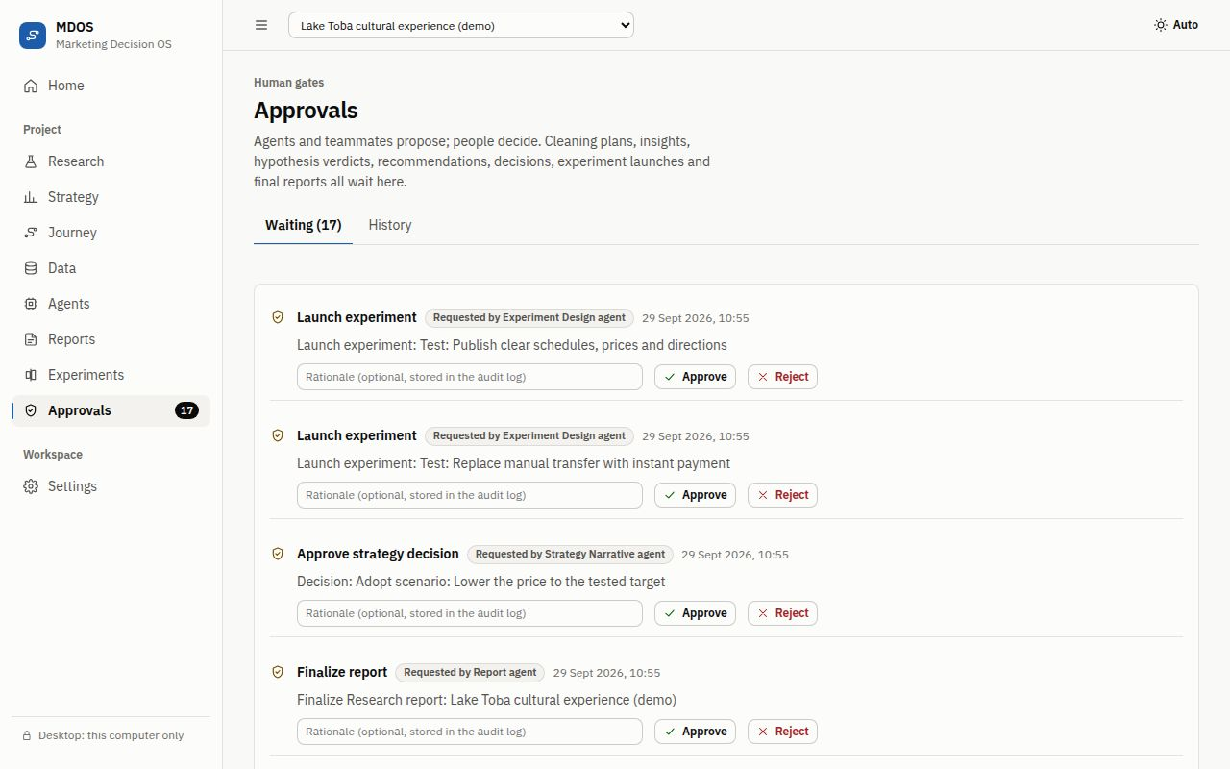
Figure 14. Approvals collects every decision that waits for a person.
The Approvals page collects everything that waits for a person: adopting a research design, applying a cleaning plan, insights and hypothesis verdicts, strategy decisions, report finalization and experiment launches. Each item can be approved or rejected, and the decision is recorded with the person and the time. When nothing is waiting, the page says Nothing is waiting for you.

11.3 The audit log
Settings, then Audit log, lists every change made by people and agents in the project, newest first, with a filter. Sign-ins, “sign out everywhere”, approvals and deletions are recorded too. The audit log cannot be edited from the app.

12. Claude drafting (optional)
MDOS works fully offline. With an Anthropic API key, Claude drafts wording for the agents (for example insight statements, report text or interventions). Statistics, simulations and approval gates never depend on it, and if Claude is unavailable the agents fall back to deterministic drafting.

12.1 Turn it on
Set ANTHROPIC_API_KEY where MDOS runs. For the cloud version, put it in the server’s .env or secret store and restart. For the desktop app, which ignores .env files for safety, set it in a terminal and start MDOS from that same terminal. The commands below ask for the key without showing it and without saving it in the command history; paste the key and press Enter.
Windows (PowerShell), in the MDOS folder:
$k = Read-Host "Anthropic API key" -AsSecureString
$env:ANTHROPIC_API_KEY = [System.Net.NetworkCredential]::new("", $k).Password
.\MDOS.exe
macOS and Linux, in the MDOS folder:
read -rs ANTHROPIC_API_KEY && export ANTHROPIC_API_KEY
./MDOS
Optional settings: MDOS_LLM_MODEL (default claude-opus-5-5), MDOS_LLM_EFFORT (low, medium or high) and MDOS_LLM_FALLBACKS (server-side fallback to another model, on by default). Settings, then AI drafting, shows whether Claude is on.

12.2 What is sent, and what is not
- Sent: the drafting context an agent needs, such as the business question, aggregated results and representative quotes. Email addresses, phone numbers and 16-digit ID numbers are replaced with placeholders before anything leaves the server.
- Never sent: your files, your database, passwords, keys or cookies.
- Claude has no tools inside MDOS. It cannot compute numbers, change data or approve anything; its text is checked against the computed results before use.
Important: Treat the API key like a password. Never paste it into chats, issues or documents. Create a dedicated key with a spending limit in the Anthropic Console, and replace it immediately if it is ever exposed.

13. Security and privacy
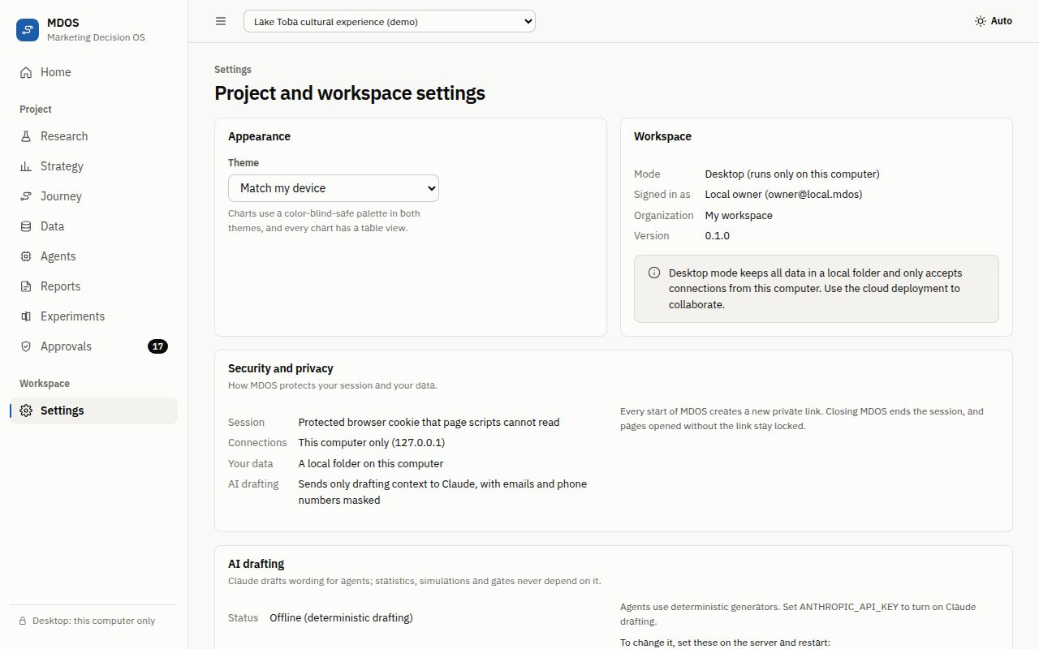
Figure 15. Settings shows how MDOS protects your session and your data.

13.1 Your session
After you sign in, the browser keeps the session in a protected cookie that page scripts cannot read and other websites cannot use. Every change also needs a special header that other websites cannot add. In the cloud version, Sign out on all devices in Settings ends every session of your account at once, for example after losing a laptop.

13.2 Desktop mode
- MDOS only accepts connections from your own computer (127.0.0.1) and refuses requests that pretend to come from another address.
- A new private link at every start keeps other programs and accounts on the same computer out.
- The data folder is readable only by your account, and a .env file in the folder MDOS starts from is ignored, so a planted file cannot redirect it.
- The session ends when you close the browser, and stops working when MDOS closes.

13.3 Cloud mode
- Only the first account can sign up unless the owner opens sign-up.
- Passwords are stored as Argon2id hashes, sign-ins are rate limited, and unknown emails take the same time to check as real ones.
- The server answers only its own domain, sends strict browser security headers, and keeps API responses out of browser caches.
- The container runs without privileges and publishes its port only to the local proxy.

13.4 Personal data
Survey answers and reviews can contain personal data. MDOS flags emails, phone numbers and name-like columns in the data quality check, can pseudonymize them in the cleaning plan, and masks them before any text reaches Claude. Before collecting real responses in Indonesia, review the consent text and privacy notice with your legal adviser for the Personal Data Protection Law (UU PDP).

13.5 Deleting data
- A project: Settings, then Delete project, and type its name.
- A dataset: the bin button (Delete dataset) next to the dataset’s actions in the data workspace.
- Everything on a desktop: close MDOS and delete its data folder (chapter 3.5).
- Remember that backups keep copies. Delete old backups according to your retention policy.

13.6 Report a security problem
Report vulnerabilities privately: open the repository’s Security tab and choose Report a vulnerability. Never open a public issue for a security problem, and never include real keys or personal data in a report.

13.7 Rules for developers and AI coding agents
SECURITY.md sets the sandbox rules for anyone who changes the code, including AI coding agents: write only inside the repository, no new outbound hosts, deletions, shell commands or dependencies without the checks it describes, no secrets or personal data in code, logs or commits, and run python scripts/check_secrets.py before committing. Continuous integration enforces the tests, audits and secret scan on every change.

14. Administration

14.1 Limits
Limit | Default | Setting
Upload size | 25 MB per file | MAX_UPLOAD_MB
Other requests | 5 MB | MAX_JSON_MB
Rows and columns per dataset | 100,000 rows, 500 columns | MAX_ROWS, MAX_COLS
Sign-in attempts | 10 per minute per address | RATE_LIMIT_AUTH_PER_MINUTE
Agent workflows | 30 per minute per address | RATE_LIMIT_AGENTS_PER_MINUTE
Uploads | 30 per minute per address | RATE_LIMIT_UPLOADS_PER_MINUTE
Session length (cloud) | 12 hours | ACCESS_TOKEN_MINUTES

14.2 Health and logs
/api/health answers with the status, version and mode, and is used by the Docker health check. Cloud logs are available with docker compose logs app; they record requests and errors but never passwords, cookies or keys. The audit log (chapter 11.3) records what people and agents changed.

14.3 The GitHub repository
Every change is checked automatically: backend tests on SQLite and PostgreSQL, frontend type checks, unit tests and build, end-to-end browser tests, a Docker image test, a secret scan, dependency audits and CodeQL code scanning. Dependabot proposes updates for GitHub Actions and minor npm updates; once Dependabot security updates are on (chapter 16), security fixes arrive as soon as advisories are published. The Desktop build workflow builds and tests the Windows, macOS and Linux apps; tag a version such as v0.1.1 to build a release.

15. Troubleshooting
What you see | Why | What to do
Open MDOS from its window (locked screen) | The page was opened without the private link, or MDOS restarted | Copy the private link from the MDOS window
The browser did not open | Started with --no-browser, or no default browser | Copy the private link from the MDOS window into your browser
Port 8765 is already in use | Another MDOS or program uses the port | Use the link shown (MDOS chose another port), or close the other program
“Windows protected your PC” or a macOS warning | The app is not code-signed yet | Allow it once, only for a copy from the official repository (chapter 3.3)
MDOS is not responding | The MDOS window was closed or stopped | Start MDOS again and use the new private link
We can’t find this project | The project was deleted, or the link belongs to another workspace | Click Go to your projects
This request is missing a required header | An old tab or a browser extension sent the request | Reload the page and try again
Your session has expired | The session ended or you signed out everywhere | Sign in again (desktop: open the private link)
Sign-up is closed on this server | Sign-up is open only for the first account | Ask the owner; see ALLOW_REGISTRATION
Too many requests | A rate limit was reached | Wait a minute and try again
File is larger than 25 MB | The upload limit | Split the file, remove unused columns, or ask the owner to raise the limit
The workbook expands to far more data than MDOS accepts | A very large or damaged Excel file | Save the sheet as CSV and upload that
Upload a CSV, TSV or XLSX file | Unsupported file type | Export your data as CSV or XLSX
AI drafting shows Offline | No API key, or the key is invalid | Set ANTHROPIC_API_KEY (chapter 12)
Cloud: Invalid host header | Your domain is not in ALLOWED_HOSTS | Add it and restart
Cloud: SECRET_KEY is required or too short | The key is missing or under 32 characters | Set a 48-character random key and restart
Cloud: Too many requests for everyone at once | MDOS sees every visitor as the proxy’s address | Set FORWARDED_ALLOW_IPS (chapter 4.3)

16. Owner’s checklist: what to do by hand
These steps need the owner’s own accounts or judgment, so they cannot be automated. Work through them once, then review them every few months.
# | Step | Where | Status on 29 Sept 2026
1 | Turn on secret scanning and push protection | GitHub: Settings, Code security | Check
2 | Turn on Dependabot alerts and Dependabot security updates | GitHub: Settings, Code security | Check
3 | Turn on private vulnerability reporting | GitHub: Settings, Code security | Check
4 | Check that code scanning with CodeQL completes without errors on every push | GitHub: Security, Code scanning; Actions | Check
5 | Choose the release branch (for example create main), make it the default, and protect it: pull requests, required checks, one review, code owner review, no force pushes or deletion | GitHub: Settings, Branches or Rules | To do
6 | Turn on “Automatically delete head branches”, and delete the leftover branch dependabot/npm_and_yarn/frontend/frontend-dev-tools-a948c343a0 | GitHub: Settings, General; Code, Branches | To do
7 | Publish release v0.1.0 with the three desktop zips and their SHA-256 checksums | GitHub: Releases | To do
8 | Sign the desktop apps (Windows code signing certificate; Apple Developer ID and notarization) | Certificate providers | To do
9 | For the cloud: set SECRET_KEY, ALLOWED_HOSTS, COOKIE_SECURE=true and FORWARDED_ALLOW_IPS, keep ALLOW_REGISTRATION empty, schedule backups | Your server | When deploying
10 | Create a dedicated Anthropic API key with a spending limit; store it only as a secret | Anthropic Console | When turning Claude on
11 | Review consent text, privacy notice and data retention for UU PDP with a legal adviser | Your organization | Before real data
12 | Confirm or change the answers marked Confirm in docs/18-interface-brief.md and docs/19-security-hardening-review.md | Repository | To do
13 | Optional: replace the GitHub handle in the LICENSE copyright line with your legal name | Repository | Optional

17. Glossary
Term | Meaning
Business question | The decision-relevant question a project starts from.
Evidence record (E1, E2...) | A saved result with its method, data version, design (observational or experimental) and strength.
Evidence strength | Strong, moderate, weak or insufficient, based on the method, sample and checks.
Insight (I1, I2...) | A finding written in plain language that cites evidence and needs a person’s approval.
Hypothesis and verdict | A testable statement, and the judgment (supported, not supported or inconclusive) that a person approves.
Construct | A concept measured with several questions, such as perceived value.
Dataset version | A snapshot of a dataset after upload or cleaning, with a checksum and an operations log.
Quality score | A 0 to 100 summary of data quality issues in a dataset version.
Agent | A specialized helper that drafts work using an allowed list of tools; it never approves.
Approval (human gate) | A decision only a person can make, recorded with the person and the time.
Scenario and lever | A what-if version of the market model, and one change applied to it (for example a new price).
Baseline | The market model built from research evidence, before any levers.
ROMI | Return on marketing: revenue per unit of media spend.
CAC and CLV | Cost per new customer, and the value a customer brings over their lifetime.
Break-even price | The lowest price at which the scenario stops losing money.
Sensitivity analysis | Moving one assumption at a time to see which ones change the result most.
Monte Carlo simulation | Running the model many times with uncertain inputs to estimate the chance of a profit.
Van Westendorp, Gabor-Granger, WTP | Survey methods that estimate acceptable prices, demand at several prices, and willingness to pay.
Journey stage and continue rate | A step in the customer journey, and the share of people who move on to the next step.
Touchpoint | A place where a customer meets the brand, such as a booking page or WhatsApp.
Pain point and intervention | A source of friction, and a proposed fix whose effect is simulated.
A/B test, smallest effect and power | A controlled experiment; the smallest change worth detecting; and the chance of detecting it if it is real.
Synthetic data | Made-up data used for the demo and tests; never for decisions.
Private link and launch key | The desktop address that carries a random key created at each start.

Appendix A. Settings reference
Settings are environment variables. In the cloud version they live in .env or your secret store; docker-compose.yml fixes MDOS_MODE, DATABASE_URL and CORS_ORIGINS, and the image sets MDOS_DATA_DIR. The desktop app sets its own and ignores .env files. Empty values count as not set.
Setting | Default | Purpose
MDOS_MODE | local | local (desktop) or cloud (accounts)
MDOS_DATA_DIR | Your user data folder; /data in Docker | Database, uploads and keys
DATABASE_URL | SQLite in the data folder | PostgreSQL address for the cloud
SECRET_KEY | Generated on the desktop | Signs sessions; 32+ characters required in cloud mode
ACCESS_TOKEN_MINUTES | 720 | Session length
ALLOW_REGISTRATION | Empty | Empty: first account only; true: open; false: closed
ALLOWED_HOSTS | localhost,127.0.0.1 | Host names the cloud server answers to
FORWARDED_ALLOW_IPS | 127.0.0.1 | The proxy address trusted for client IP and https (Docker; chapter 4.3)
COOKIE_SECURE | Empty | Empty: Secure cookie over https; true: always (use behind TLS)
CORS_ORIGINS | Empty | Other web origins allowed to call the API; * is refused
ENABLE_API_DOCS | false | Interactive API documentation at /api/docs
ANTHROPIC_API_KEY | Empty | Turns Claude drafting on
MDOS_LLM_MODEL | claude-opus-5-5 | Claude model for drafting
MDOS_LLM_EFFORT | medium | Drafting effort: low, medium or high
MDOS_LLM_FALLBACKS | true | Server-side fallback to another model
MDOS_LLM_TIMEOUT_SECONDS | 120 | Time limit for one drafting call
MAX_UPLOAD_MB, MAX_JSON_MB | 25, 5 | Request size limits
MAX_ROWS, MAX_COLS | 100000, 500 | Dataset size limits
RATE_LIMIT_*_PER_MINUTE | 10, 30, 30 | Sign-in, agent and upload rate limits
EXECUTION_MODE | thread | thread runs agents in the background; sync is for tests
MDOS_PORT | 8765 | Preferred desktop port; --port overrides it

Appendix B. Where to find more
Document | What it covers
README.md | Overview, quick start and repository layout
SECURITY.md | Security policy, reporting, safe settings and sandbox rules
THIRD_PARTY_NOTICES.md and LICENSE | Open-source components and the MIT License
docs/13-deployment.md | Cloud hosting options, required settings and backups
docs/12-security-threat-model.md | Threats, controls and how each is verified
docs/19-security-hardening-review.md | The latest security review, findings and proof
docs/09-design-system.md and docs/18-interface-brief.md | Interface rules and the design decisions behind them
docs/17-methods-reference.md | The statistical and simulation methods
AGENTS.md | Rules for contributors and AI coding agents

