TASK 1
Python File Handling & Automation
Python Internship Submission | F Samuel Jabanezer | 28/04/26
Project Overview
Task | Task 1 of 3
Topic | File Handling & Automation
Intern Name | F Samuel Jabanezer
Organization | Alfido Tech
Submission Date | 28/04/2026
Tools Used | Python 3.x — os (Standard Library)
Objective
This task demonstrates Python's built-in file handling capabilities through a Student File Manager. The program creates, reads, processes, renames, and verifies text files — with robust error handling throughout.
What This Program Does
- Creates students.txt and writes a list of student names
- Reads the file back and displays the original data
- Converts all names to uppercase and saves to a new file
- Renames the processed output file using os.rename()
- Verifies the final file exists using os.path.exists()
- Handles FileNotFoundError, PermissionError, and general exceptions
Step-by-Step Logic
Step | Action | Python Concept
1 | Write student names | open('w'), for loop, file.write()
2 | Read the file | open('r'), readlines()
3 | Process to uppercase | str.strip().upper(), open('w')
4 | Rename file | os.rename()
5 | Verify file | os.path.exists()
6 | Error handling | try / except with specific types
Complete Source Code
task1_file_handling.py
# Task 1: File Handling & Automation
# Intern: F Samuel Jabanezer | Organization: Alfido Tech

import os

try:
# Step 1: Create file and write student names
with open("students.txt", "w") as file:
names = ["John", "Alice", "Bob", "Eve", "Charlie"]
for name in names:
file.write(name + "\n")
print("[OK] students.txt created successfully.")

# Step 2: Read data back from file
with open("students.txt", "r") as file:
data = file.readlines()
print("Original Data:", [n.strip() for n in data])

# Step 3: Process - convert to uppercase and save
with open("updated_students.txt", "w") as file:
for name in data:
file.write(name.strip().upper() + "\n")
print("[OK] Processed and saved to updated_students.txt")

# Step 4: Rename file to final name
os.rename("updated_students.txt", "final_students.txt")
print("[OK] File renamed to final_students.txt")

# Step 5: Verify the file exists
if os.path.exists("final_students.txt"):
print("[OK] Verified: final_students.txt exists.")

except FileNotFoundError as e:
print("File not found:", e)
except PermissionError as e:
print("Permission denied:", e)
except Exception as e:
print("Unexpected error:", e)
Expected Terminal Output
[OK] students.txt created successfully.
Original Data: ['John', 'Alice', 'Bob', 'Eve', 'Charlie']
[OK] Processed and saved to updated_students.txt
[OK] File renamed to final_students.txt
[OK] Verified: final_students.txt exists.
Screenshots
Screenshot 1— Terminal Output
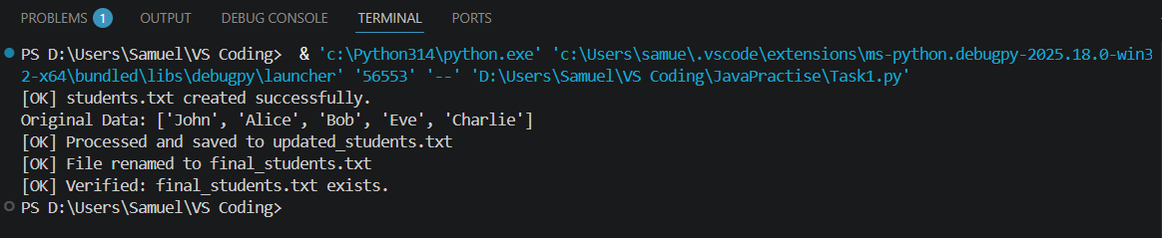
Screenshot 2 – File Explorer

Key Learnings
- File I/O is used in real-world data pipelines, logging systems, and automation scripts
- Context managers ('with' statement) guarantee safe file closing even if errors occur
- Catching specific exception types makes programs more robust and easier to debug
- The os module connects Python to the underlying OS for file/folder management
- String processing (strip, upper) is fundamental to data cleaning workflows

