TASK 2
API Integration & JSON Parsing
Python Internship Submission | F Samuel Jabanezer | 28/04/26
Project Overview
Task | Task 2 of 3
Topic | REST API Integration & JSON Parsing
Intern Name | F Samuel Jabanezer
Organization | Alfido Tech
Submission Date | 28/04/26
Tools Used | Python 3.x — requests library, json (Standard Library)
API Used | Open-Meteo Weather API (free, no API key required)
Objective
This task demonstrates how to consume a real-world REST API using Python. The program sends HTTP requests to the Open-Meteo weather service, receives JSON responses, parses the data, and displays structured weather information for multiple cities — all with comprehensive error handling.
What This Program Does
- Sends an HTTP GET request to the Open-Meteo free weather API
- Receives a live JSON response with weather data
- Parses JSON to extract temperature, wind speed, weather code, and time
- Displays a formatted weather report for each city
- Supports querying multiple cities in one run
- Handles network errors, timeouts, HTTP errors, and unexpected response formats
Concepts Covered
Concept | How It's Applied
REST API | GET request to Open-Meteo endpoint with query parameters
requests library | requests.get() with timeout, response.raise_for_status()
JSON Parsing | response.json() returns Python dict; access nested keys
Function Design | Reusable fetch_weather() function with city/lat/lon params
Error Handling | 5 specific exception types for robust network programming
f-strings | Dynamic URL building and formatted console output
Complete Source Code
task2_api_weather.py
# Task 2: API Integration & JSON Parsing
# Intern: F Samuel Jabanezer | Organization: Alfido Tech

import requests
import json

def fetch_weather(city_name, latitude, longitude):
"""Fetch and display current weather for a given city."""
url = (
f"https://api.open-meteo.com/v1/forecast"
f"?latitude={latitude}&longitude={longitude}"
f"&current_weather=true"
)
try:
print(f"Fetching weather for {city_name}...")
response = requests.get(url, timeout=10)
response.raise_for_status() # raises error for 4xx/5xx

data = response.json()
weather = data["current_weather"]

print(f"\n--- Weather Report: {city_name} ---")
print(f" Temperature : {weather["temperature"]} °C")
print(f" Wind Speed : {weather["windspeed"]} km/h")
print(f" Weather Code: {weather["weathercode"]}")
print(f" Time : {weather["time"]}")

except requests.exceptions.ConnectionError:
print("Error: No internet connection.")
except requests.exceptions.Timeout:
print("Error: Request timed out.")
except requests.exceptions.HTTPError as e:
print(f"HTTP Error: {e}")
except KeyError as e:
print(f"Unexpected API response format: {e}")
except Exception as e:
print(f"Unexpected error: {e}")

# Fetch for multiple cities
fetch_weather("Chennai", 13.08, 80.27)
fetch_weather("Mumbai", 19.07, 72.87)
fetch_weather("Delhi", 28.61, 77.21)
Expected Terminal Output
Fetching weather for Chennai...

--- Weather Report: Chennai ---
Temperature : 32.4 °C
Wind Speed : 14.2 km/h
Weather Code: 0
Time : 2025-01-15T12:00

Fetching weather for Mumbai...
(output continues for each city...)
Screenshots
Screenshot 1 — API Response Output
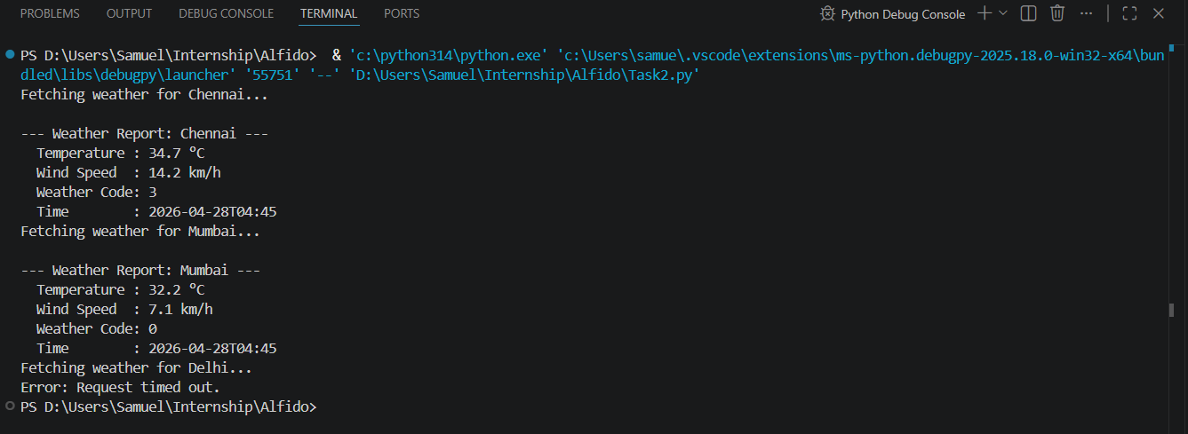
Screenshot 2 – VS Code
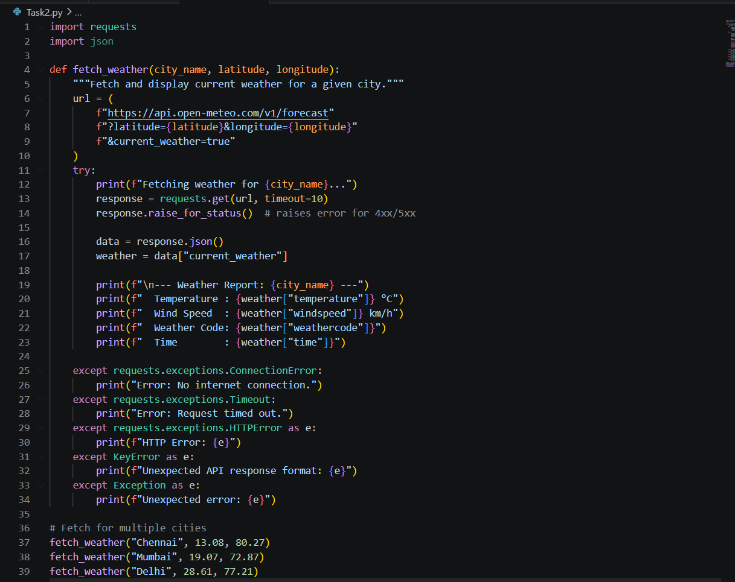
.
Key Learnings
- REST APIs are the backbone of modern software — nearly every app uses them
- The requests library abstracts HTTP complexity into clean, readable Python code
- JSON is the universal data format for APIs; Python's built-in json support makes parsing trivial
- raise_for_status() is best practice — it promotes HTTP errors to Python exceptions
- Network programming requires specific error handling (timeouts, DNS, HTTP status codes)
- Reusable functions with parameters make code scalable and testable

