TASK 3
Data Analysis with Pandas
Python Internship Submission | F Samuel Jabanezer | 28/04/26
Project Overview
Task | Task 3 of 3
Topic | Data Analysis with Pandas
Intern Name | F Samuel Jabanezer
Organization | Alfido Tech
Submission Date | 28/04/26
Tools Used | Python 3.x — pandas library
Dataset | students.csv — 10 records, 4 columns (name, subject, marks, grade)
Objective
This task demonstrates data analysis using the Pandas library — the industry standard for tabular data in Python. The program loads a student marks dataset, cleans it, and extracts 5 actionable insights: top scorer, averages by subject, above-average performers, grade distribution, and exports a filtered report.
Sample Dataset (students.csv)
Create this CSV file and save it in the same folder as the Python script:
students.csv
name,subject,marks,grade
John,Math,85,B
Alice,Math,92,A
Bob,Math,78,C
Eve,Math,96,A+
Charlie,Math,71,C
John,Science,88,B+
Alice,Science,94,A
Bob,Science,65,D
Eve,Science,91,A
Charlie,Science,80,B
What This Program Does
- Loads the CSV file using pd.read_csv() and inspects its shape and structure
- Cleans the data by removing nulls (dropna) and duplicate rows
- Finds the top scorer using idxmax() on the marks column
- Calculates average marks grouped by subject using groupby().mean()
- Filters students who scored above the overall class average
- Counts grade distribution using value_counts()
- Exports the top performers to a new CSV using to_csv()
Pandas Operations Reference
Pandas Method | Purpose in This Task
pd.read_csv() | Load data from CSV into a DataFrame
df.shape | Get number of rows and columns
df.head() | Preview the first 5 rows
df.info() | Show column types and null counts
df.dropna() | Remove rows with missing values
df.drop_duplicates() | Remove repeated rows
df.loc[df[col].idxmax()] | Get the row with the highest value
df.groupby().mean() | Compute averages per group
df[df[col] > value] | Filter rows by condition
df[col].value_counts() | Count occurrences of each unique value
df.to_csv() | Export filtered DataFrame to CSV
Complete Source Code
task3_pandas_analysis.py
# Task 3: Data Analysis with Pandas
# Intern: F Samuel Jabanezer | Organization: Alfido Tech

import pandas as pd

# ── Load Data ──────────────────────────────────────────
df = pd.read_csv("students.csv")
print("Dataset loaded successfully.")
print(f"Shape: {df.shape[0]} rows x {df.shape[1]} columns\n")

# ── Inspect Data ────────────────────────────────────────
print("=== First 5 Rows ===")
print(df.head())
print("\n=== Data Info ===")
print(df.info())

# ── Clean Data ──────────────────────────────────────────
before = len(df)
df.dropna(inplace=True)
df.drop_duplicates(inplace=True)
print(f"\nRows removed during cleaning: {before - len(df)}")

# ── Analysis ────────────────────────────────────────────
# 1. Top scorer overall
top = df.loc[df['marks'].idxmax()]
print(f"\nTop Scorer: {top['name']} — {top['marks']} marks ({top['subject']})")

# 2. Average marks per subject
avg_by_subject = df.groupby("subject")["marks"].mean().round(2)
print("\nAverage Marks by Subject:")
print(avg_by_subject)

# 3. Students with marks above average
overall_avg = df['marks'].mean()
above_avg = df[df['marks'] > overall_avg]
print(f"\nOverall Average: {overall_avg:.2f}")
print(f"Students above average: {len(above_avg)}")
print(above_avg[['name', 'subject', 'marks']])

# 4. Grade distribution
grade_count = df["grade"].value_counts()
print("\nGrade Distribution:")
print(grade_count)

# 5. Export summary
above_avg.to_csv("top_performers.csv", index=False)
print("\n[OK] Summary exported to top_performers.csv")
Expected Terminal Output
Dataset loaded successfully.
Shape: 10 rows x 4 columns

=== First 5 Rows ===
name subject marks grade
0 John Math 85 B
1 Alice Math 92 A
...

Top Scorer: Eve — 96 marks (Math)

Average Marks by Subject:
subject
Math 84.40
Science 83.60

Overall Average: 84.00
Students above average: 5

Grade Distribution:
A 3
B 2 ...

[OK] Summary exported to top_performers.csv
Screenshots
Screenshot 1 — Analysis Output
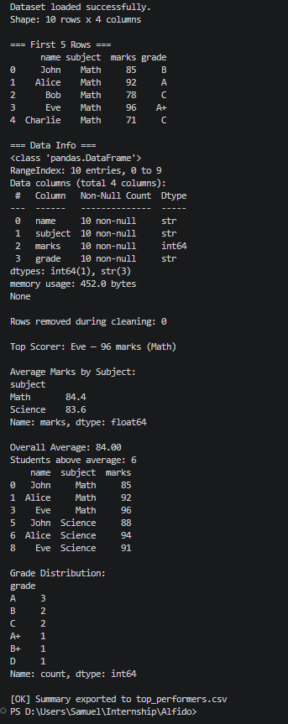
Screenshot 2 – new CSV file in Folder
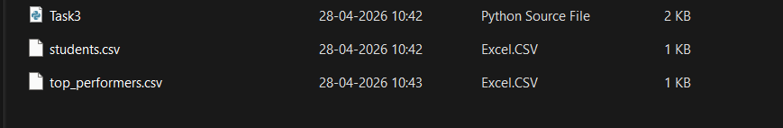
Key Learnings
- Pandas is the most widely used Python library for data analysis in industry
- DataFrames are like intelligent spreadsheets — faster, scriptable, and scalable
- Data cleaning (removing nulls and duplicates) is essential before any analysis
- groupby() enables SQL-style aggregations directly in Python
- Boolean indexing (df[condition]) is the Pandas way to filter rows
- Exporting to CSV with to_csv() closes the loop from raw data to deliverable report

