**1.1 CORONAVIRUS**

* A novel coronavirus was identified as the cause of a cluster of pneumonia cases in Wuhan , a city in Hubei province of China in December 2019 . Since its identification , it has spread rapidly , prompting WHO to declare it as a public health emergency in January 2020 and characterized it as pandemic in March 2020 .
* COVID 19 is the infection
* The virus causing it is designated as Severe acute respiratory syndrome coronavirus 2 (SARS -CoV-2 ) .

**SARS COV-2**

* SARS CoV – 2 is a betacoronavirus in the same subgenus as Severe acute respiratory syndrome (SARS ) virus (which caused a rapidly progressive respiratory illness in 2003 and which spread to multiple countries ).
* Full-length genome sequences show 79.6% sequence identity to SARS-CoV and 96% identical at the whole-genome level to a bat coronavirus , while Middle East Respiratory respiratory syndrome (MERS ) virus ( which caused another rapidly progressive respiratory illness in 2012 ) appears more distantly related.
* The virus uses the receptor angiotensin converting enzyme 2 (ACE 2 ) for cell entry.
* It appears that Bats are the primary source, however whether it was transmitted directly or through an intermediate host is not known.

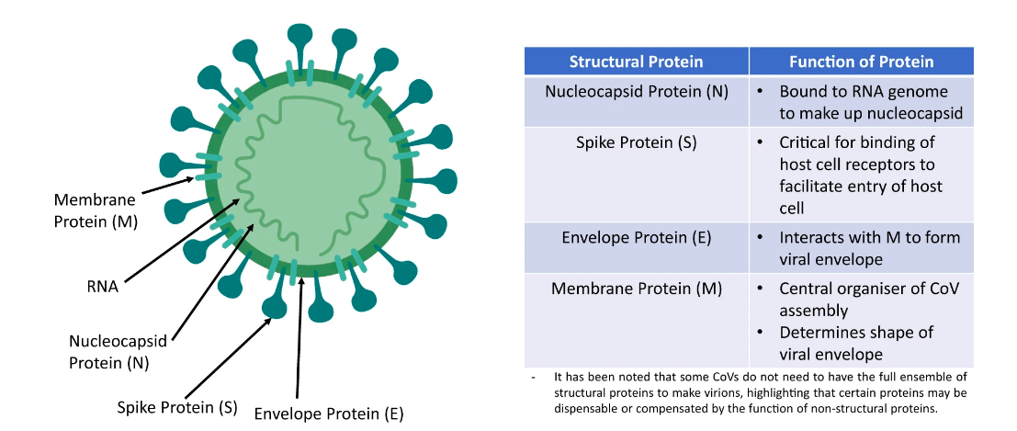*Source : Nature (Seah et al )*

**CASE DEFINITION   
( as per Ministry of Health and family welfare)**

