**2.3 SYMPTOMS AND WHAT TO EXPECT**

* Fever
* Cough
* Dyspnea
* Anosmia or other smell abnormalities
* Ageusia or other taste abnormalities
* Sore throat
* Myalgia s
* Chills / Rigors
* Headache
* Rhinorrhea
* Nausea /vomiting
* Diarrhea
* Fatigue
* Confusion
* Chest pain or pressure

**CLINICAL PRESENTATION OF COVID-19**

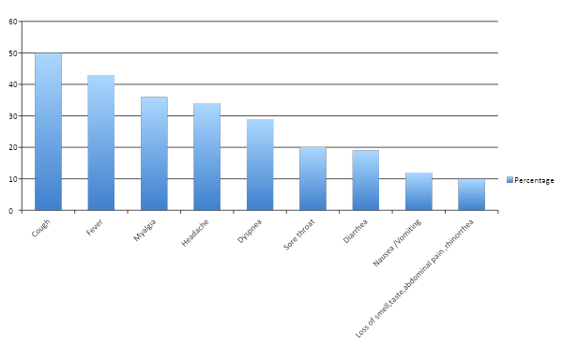

* Symptoms usually arise approximately 4 – 5 days after exposure and are mild in 80 % of the patients and includes fever, fatigue and dry cough. Symptoms like rhinorrhea and sore throat are less common
* Dyspnea affects 30 to 40 % of patients and develops 5 to 8 days after the onset of symptoms. Progression to Acute respiratory distress syndrome ( ARDS ) can be rapid. Thus onset of dyspnea is an important warning to have the patient admitted and managed further in a hospital setting.
* Pneumonia and ARDS are the manifestations of severe disease . ARDS is associated with cytokine release syndrome manifested clinically by fever, progressive hypoxia, hypotension and elevated inflammatory markers.
* According to epidemiological data provided by Chinese CDC in approximately 44,500 confirmed cases following was the spectrum of disease manifestation :

|  |  |
| --- | --- |
| Spectrum | Percentage |
| Mild ( no or mild pneumonia ) | 80 % |
| Severe Disease ( with dyspnea ,hypoxia , or >50 % lung involvement on imaging ) | 15 % |
| Critical Disease ( respiratory failure ,Multi organ dysfunction , Shock ) | 5 % |

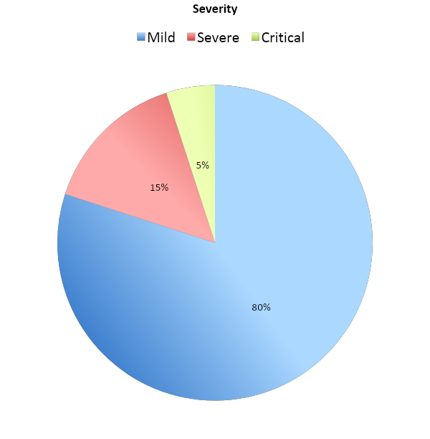

**COMPLICATIONS**

