**Code Manual**

*Last updated 1/15/2020*

**First Time Setup**

Unpack the Analysis Package ZIP file somewhere on the local computer. This file should contain the following folders:

**matlab_tracking:** Contains the programs and dependencies for processing and tracking the data movies

**matlab_traces:** Contains the programs and dependencies for plotting, proofreading, and analyzing the data

**mat_vol_viewer:** Contains tools for visualizing any movies in .mat format

Add all these folders to your MATLAB path. Make sure that the tracking folder is above the traces folder in the path, otherwise MATLAB might have trouble finding the bioformats package.

*Use a version of MATLAB 2018 or later.*

Open up Analysis Package CTX\matlab_tracking\CTX_analyze.m in MATLAB. This is the master analysis script, which calls all of the other programs. Open CTX_load_excel.m in the same folder as well. In CTX_load_excel.m, and Step 0 of CTX_analyze.m, add a line to the code which identifies the computer you are using, and points to the appropriate location of the Data Status Excel file (file_location) and your version of the annotator (annotator_root).

elseif strcmp(char(java.net.InetAddress.getLocalHost.getHostName),'SAMUELLAB21')

file_location = 'D:\Dropbox\NT Data NG\NT Data Status.xlsx';

**Assessing the Data**

Copy the data to the local computer. Add the movies to the Data Status Excel file.

**Raw Data Root:** Location of the raw data on the local computer

**Analyzed Data Root:** Location of the final data, “D:\Dropbox\Data\[Line]”

**Animal:** Give each animal a unique ID of the form “[Initials]_S_###”

**Stimulus:** Note the stimulus and the concentrations

**Run #:** The data run, “run###”

**Status of Steps:** Set all squares to “FALSE”, update them to “TRUE” when complete

**Initializing MATLAB**

Open CTX_analyze.m in MATLAB. At the top of the Step 0 cell, input the animal ID, matching the animal ID in the Data Status Excel file. Also, input the strain of the animal. With the cell highlighted, press Ctrl+Enter to run the cell. The Workspace should be populated with information about the animal, datasets, and the file and output locations.

Through the MATLAB analysis, you can exit the process and quit MATLAB whenever a cell is complete (but make sure if you’re quitting at later steps that MATLAB isn’t actually running anything—if it is, a “Busy” flag will appear in the lower left-hand corner). The next time you start MATLAB, rerun the Step 0 cell with the appropriate animal ID, and then pick up where you left off.

*If for any reason you need to force MATLAB to stop its processes, use Ctrl+C.*

**Processing the Movies**

In CTX_analyze.m, run the Step 1 cell (click in the cell to highlight it, then press Ctrl+Enter to run it). The scripts called in this cell converts the ND2 files of the datasets into several formats: raw TIFF files, .mat volumes at two compressions (16 bit and 8 bit), and JPEG images for the annotator. It also extracts time and stimulus information from the movies and the stimulus text file. When this cell is done running, flip the “Volumes Made” field on the Excel sheet to “TRUE”.

**Annotating the Neurons**

Add the animal to the datasets.json file in the annotator folder on Dropbox. Open the datasets.json in Notepad, and add a line for the new animal.

"S_001": {

"id": "S_001",

"shape_x": 256,

"shape_y": 128,

"shape_z": 21,

"shape_c": 2,

"shape_t": 5,

"pixel_size_x": 2,

"pixel_size_y": 2,

"pixel_size_z": 8

}

Change the initial name and the “id” field to match the animal ID. Change the “shape_t” field to match the number of datasets this animal has.

*Install Web Server for Chrome:*

[*https://chrome.google.com/webstore/detail/web-server-for-chrome/ofhbbkphhbklhfoeikjpcbhemlocgigb?hl=en*](https://chrome.google.com/webstore/detail/web-server-for-chrome/ofhbbkphhbklhfoeikjpcbhemlocgigb?hl=en)

Start Web Server for Chrome, click CHOOSE FOLDER, and select your annotator folder. Then click on the Web Server URL to launch the annotator. In the “Select a dataset” dropdown, select the animal, and the JPEG images should appear. If no datasets show up in the dropdown, there is probably a mistake in the datasets.json, either a missing comma or bracket.

We will now annotate the neurons in the head volume. The annotator has three windows: an XY projection, XZ projection, and YZ projection. Each window has four options, Selection (Default), Pan, Zoom In, Zoom Out, and Fit to Viewer. Use these to move about, but stay in Selection mode when making annotations. The sliders will move through the volume in X, Y, and Z, with the gray lines indicating the planes of view. The hotkeys for the annotator (active when the XY projection window is selected) are:

D: previous dataset F: next dataset

C: up one frame in Z V: down one frame in Z

E: green channel R: red channel

We want to annotate the animal’s first dataset. The computer will then attempt to carry those annotations over to the other datasets, using a handful of manually landmarked neurons in the remaining dataset. Make sure you start on the first dataset by hitting D until you reach the first set.

To annotate a neuron, move in Z in the green channel until you find a location that you think is close to the center of the nucleus of the neuron in X, Y, and Z. Double click to create an annotation. This should appear as a red dot. A red dot is an annotated but unidentified neuron. To label the neuron, click the red dot, and a text box will appear. Write down your best guess for the name of the neuron (already used labels appear in grey in the dropdown, while unused neurons appear in white). To delete a bad annotation, hit the trash can button. Annotate all of the neurons in the amphid region of the animal. Animals with a good dorsal-ventral orientation are easiest to annotate, but still, distortions due to the microfluidics chamber and individual-to-individual variability make the task of identification not easy. Use a combination of neuron location, neuron shape and brightness, and the wCherry landmarks in the red channel to make your identification. It’s okay if you’re not 100% sure about the IDs, we can change the IDs when we proofread. However, it is important to **annotate all the neurons**, even if they aren’t all labeled!

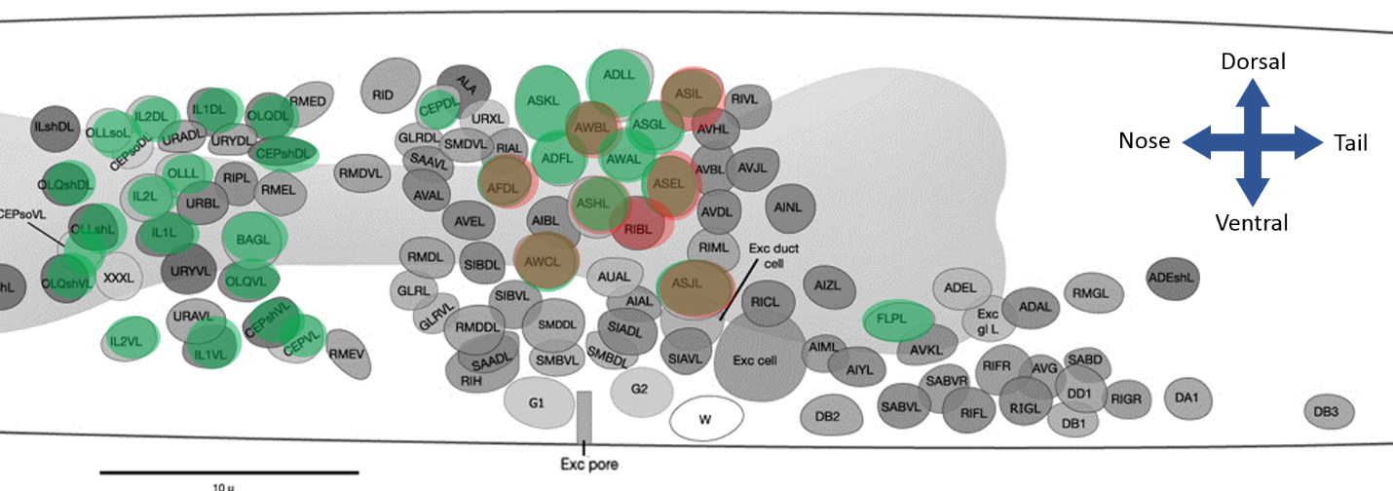

*Labeled neurons in green and red in ZM10104*

When all the neurons are annotated in the first dataset, decide on a handful of landmark neurons (3-6) which you can ID with confidence. These neurons will be used by the computer to try and morph the annotations map from the first dataset onto the other datasets, so ideally these neurons are spread widely in X, Y, and Z. Moving through the remaining datasets, annotate and label these landmark neurons (and *only* these landmark neurons). Make sure that for the remaining datasets, the same neurons are labeled. When this is complete for all remaining datasets for the animal, save the annotations in the annotator folder, overwriting the old annotations.json file. Flip the “ID-ed” field on all datasets for the animal on the Excel sheet to “TRUE”.

**Tracking the Neurons**

To track the neurons, first re-run the Step 0 cell, to get the most up-to-date ID status from the Excel sheet. Then highlight the Step 3: Track cell and run (click in the cell to highlight it, then press Ctrl+Enter to run it). This cell will take the position data from the annotator, track all of the neurons across the datasets, pull out calcium activity traces, and generate rough plots.

The tracking script, CTX_track_neurons.m, will generate plots at the end of each dataset, showing the results of the tracking. It will also continuously be outputting fit numbers for each frame—the higher these numbers are, the better the tracking is likely to be. The tracking parameters are set in this script.

This code takes some time to run, so it is a good candidate to run overnight, or while doing experiments. When it is complete, if there are no issues, flip the Tracked, Traces, and Plots fields on the Excel sheet to “TRUE”.

**Proofreading and Postprocessing**

Proofreading the traces gives us the opportunity to remove traces which have been mistracked (wrong nucleus, have gaps in time, etc.), adjust the computer-determined F0 baseline, and also to correct or add to our nuclear IDs.

To proofread the traces, open the CTX_dataset_proofreader.m script in MATLAB. Set the dataset run ID and the analyzed root, the location on Dropbox where the processed data is stored. Then run the first cell, which loads the traces.mat and generates a proofread data structure (run###_prfrd_data.mat). The second cell will plot all of the traces, labeled with their tracked IDs.

Running the third cell starts the Proofreader GUI. The controls for the GUI are as follows:

**Left Arrow:** Previous Neuron

**Right Arrow:** Next Neuron

**E:** Edit neuron identity (Enter the corrected neuron name in the popup)

**B:** Adjust the baseline Fo value (Computer makes an automatic best guess at Fo, to adjust it up or down, input a positive or negative number in the popup)

**G:** Flag a trace as green (These traces will be used in further analysis)

**F:** Unflag a trace (yellow)

**D:** Flag a trace as unusable (red)

**S:** Save

**Esc:** Save and exit

When you are done proofreading a set, save it exit the proofreader (Esc). This generates a prfd_data.mat file for that dataset. Flip the Proofread column on the Data Status spreadsheet to “TRUE”. Repeat for all datasets for a given animal.

When you have completed proofreading for all of the datasets for a given animal, open the NG_avg_traces.m script. Input the animal ID and line in Step 0, then run the Step 0 cell. Run the second cell, which loads the proofread data, and then the third cell, which filters for green flags. Then run the fourth cell, which compiles the data from multiple runs into a single data structure.

The next cell (optional) allows you to manually inspect neurons by plotting their traces individually. Run the final cell (Plot all) to generate average and individual trace plots, and save a large avg_data.mat data structure.