**ATOC 5560**

Lab #3 (Mie)

By Samuel LeBlanc

**1.** The following are taken in the Mie Code, and their corresponding subroutine name are indicated:

1. Compute *a*n and *b*n for *n* =1 ... *N* from size parameter *x* and index of refraction *m* (uses recursion relations for the spherical Bessel functions). *N* ≈ *x*+ 4*x*1/3 + 2.

*MIECALC*

For this Mie calculation the amount of loop times is dependent on the size parameter using this formula: N = x+4x0.3334+2

2. Compute *Q*ext, *Q*sca, and *g* from *a*n and *b*n.

*MIECROSS*

The same amount of loop iterations is seen here: N = x+4x0.3334+2

3. Compute *S*1(Θ) and *S*1(Θ) at desired scattering angles from *a*n and *b*n and *π*n(Θ) and *τ*n(Θ). Compute phase matrix elements *P*11, *P*12, *P*33, *P*34 from *S*1, *S*2.

*MIEANGLE*

The same amount of loop iterations is seen here: N = x+4x0.3334+2

4. Integrate numerically over a size distribution *n*(*r*) to get volume extinction *β*, single scattering albedo ϖ0, and phase function *P*(Θ).

*MIEDIST*

**2.** Mie Calculations done with a drop size distribution starting from ¼ the effective radius to 4 times the effective radius for each case.

|  |  |  |  |  |  |
| --- | --- | --- | --- | --- | --- |
| **Case** | **Wavelength (μm)** | **Extinction (km-1)** | **Single Scattering Albedo** | **Asymmetry Parameter** | **Number of Legendre Terms** |
| Liquid Cloud Water droplets  (N = 100cm-3, reff=10μm) | 0.87 | 48.015 | 0.999954 | 0.3333487 | 507 |
| 1.64 | 49.576 | 0.994149 | 0.331383 | 264 |
| 2.13 | 50.515 | 0.978537 | 0.326179 | 202 |
| 11.0 | 38.867 | 0.474768 | 0.158256 | 39 |
| Cloud (reff=5μm) | 1.64 | 13.065 | 0.997056 | 0.332352 | 130 |
| Mineral Layer  (N = 200cm-3, reff=0.7μm) | 0.65 | 0.32094 | 0.888017 | 0.296006 | 73 |

**3.**  From the simple equation for Liquid Water Content (LWC) the next equation can be derived:

$β=2πN{r_{eff}}^{2}$

|  |  |  |  |  |  |
| --- | --- | --- | --- | --- | --- |
| **Case** | **Wavelength (μm)** | **Extinction (Mie Calculations) (km-1)** | **Single Scattering Albedo** | **Extinction (Geometric) (km-1)** | **Single Scattering Albedo (Geometric)** |
| Liquid Cloud Water droplets  (N = 100cm-3, reff=10μm) | 0.87 | 48.015 | 0.999954 | 6.283 | 0.99995839 |
| 1.64 | 49.576 | 0.994149 | 6.283 | 0.994678464 |
| 2.13 | 50.515 | 0.978537 | 6.283 | 0.979826266 |
| 11.0 | 38.867 | 0.474768 | 6.283 | 0.136152513 |
| Cloud (reff=5μm) | 1.64 | 13.065 | 0.997056 | 3.14159 | 0.997339232 |
| Mineral Layer  (N = 200cm-3, reff=0.7μm) | 0.65 | 0.32094 | 0.888017 | 0.8796 | 0.859256649 |

It can be seen that the values for the single scattering albedo measured by the geometric optics agree fairly closely with the values derived from the Mie Calculations, except in the case for the smallest size parameter (largest wavelength) there is a considerable difference, which leads us to see that at that point Mie Calculations must be used. As for the Geometric Extinction there is a significant departure from the Mie Calculations. From this, the simple single scattering albedo can be seen to be used at large size parameters, but not for small ones which is expected as the geometric limit is at large size parameters. As for the Geometric Extinction there does not seem to have a valid area, except maybe for the mineral layer (small effective radius), this result is not what is expected, as we would imagine the geometric limit to be represented in the extinction coefficient.

**4.** Phase function for all six cases:

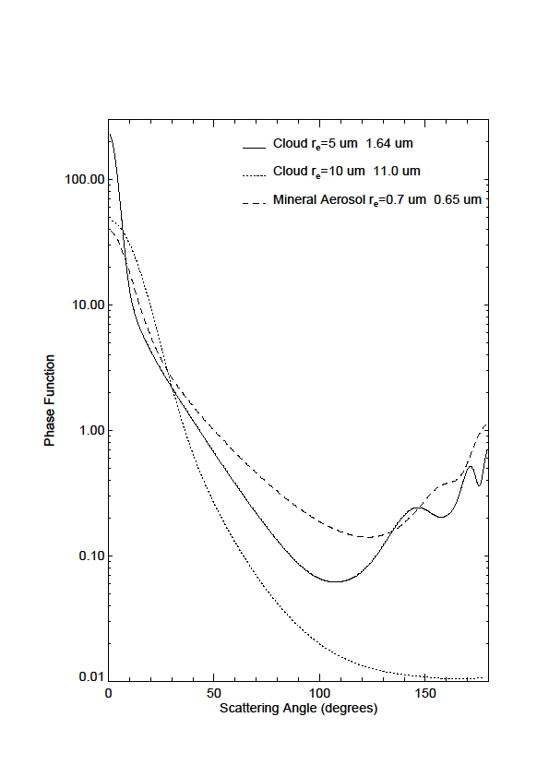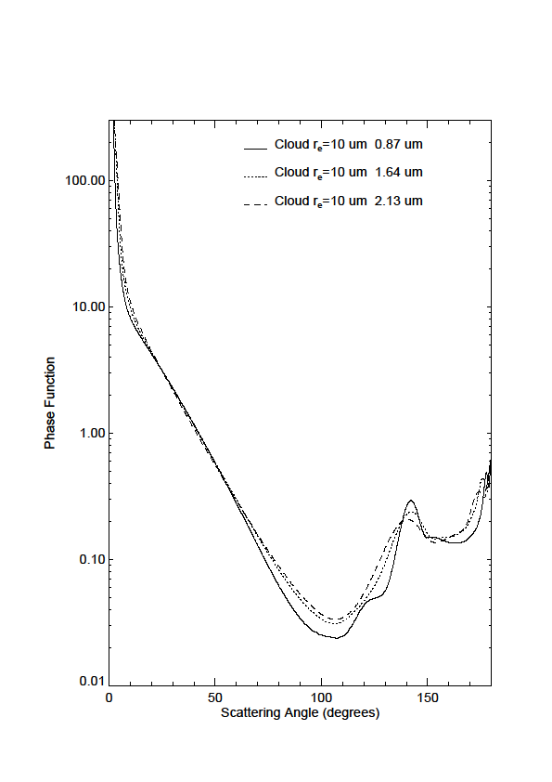

|  |  |  |  |  |
| --- | --- | --- | --- | --- |
| **Case** | **Wavelength (μm)** | **xeff** | **P(0)** | **Θ1/2 (°)** |
| Liquid Cloud Water droplets  (N = 100cm-3, reff=10μm) | 0.87 | 72.22 | 2927.05 | 1.06 |
| 1.64 | 38.31 | 857.045 | 1.91 |
| 2.13 | 29.499 | 527.516 | 2.42 |
| 11.0 | 5.712 | 46.7827 | 14.09 |
| **Cloud (reff=5μm)** | 1.64 | 19.156 | 229.887 | 4.47 |
| **Mineral Layer** | 0.65 | 6.767 | 38.7023 | 9.46 |

The relationship between these values are supposed to be that as x gets larger, the peak Phase function gets higher and narrower. The largest effective size parameter is in fact the highest phase function, and the narrowest (1st case). They all follow the relationship of the largest size parameter with the highest phase function except for the mineral Layer. The width and size parameter do in fact work for all cases (the largest size parameter is the smallest angle at half phase function peak)

**4.** The asymmetry parameter for the λ=11μm case seems to show that in fact there is a much more uniform nature of the phase function at this wavelength. Since at this wavelength (as shown in the previous table) the size parameter is the smallest giving the largest angle at half phase function peak. A Large angle at half phase function can be described as having a less forward scattering property and a more uniform scattering, which is characterized by a low asymmetry parameter.

**5.** The Stokes phase matrix for the λ=0.87μm case at an angle of 125° is:

$$\left(\begin{matrix}\begin{matrix}0.04896 & -0.0234 \\ -0.0234 & 0.04896\end{matrix} & \begin{matrix}0 & 0 \\ 0 & 0\end{matrix} \\ \begin{matrix}0 & 0 \\ 0 & 0\end{matrix} & \begin{matrix}0.00458 & 0.02325 \\ 0.02325 & 0.00458\end{matrix}\end{matrix}\right)$$

For the resulting Stokes vector the relationship of Iout=MIin is used, where Iin= for unpolarized light.

$$I_{out}= \left(\begin{matrix}\begin{matrix}0.04896 & -0.0234 \\ -0.0234 & 0.04896\end{matrix} & \begin{matrix}0 & 0 \\ 0 & 0\end{matrix} \\ \begin{matrix}0 & 0 \\ 0 & 0\end{matrix} & \begin{matrix}0.00458 & 0.02325 \\ 0.02325 & 0.00458\end{matrix}\end{matrix}\right)\left(\begin{matrix}\begin{matrix}1 \\ 0\end{matrix} \\ \begin{matrix}0 \\ 0\end{matrix}\end{matrix}\right)=\left(\begin{matrix}0.04896 \\ -0.0234 \\ \begin{matrix}0 \\ 0\end{matrix}\end{matrix}\right)$$

Which once normalized is equal to Iout=

The degree of linear polarization of the scattered light is equivalent to $\frac{\sqrt{Q^{2}+U^{2}}}{I}= \frac{\sqrt{{(-0.47794)}^{2}+{(0)}^{2}}}{(1)}=0.47794$

Since an incidence of 125° is equivalent to an angle of 55° with the surface, it can be seen that this is in fact near the Brewster angle, and therefore a large degree of linear polarization is expected.