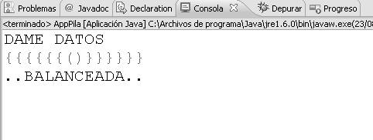
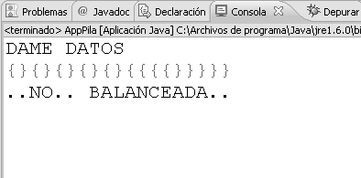
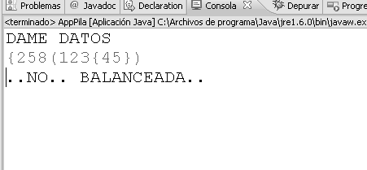
Nombre: Loza Ramírez Samuel Rene. CI: 8448507 LP
Docente: Lic. Honny Felipez Paralelo: C
class DoubleLinkList<E> {
Node<E> first;
Node<E> last;
public DoubleLinkList() {
first = null;
last = null;
}
public boolean isEmpty() {
return first == null;
}
public void insertFirst(E e) {
Node<E> aux = new Node<E>(e);
if (isEmpty()) {
last = aux;
} else {
first.prev = aux;
}
aux.next = first;
first = aux;
}
public void insertLast(E e) {

Node<E> aux = new Node<E>(e);
if (isEmpty()) {
first = aux;
} else {
last.next = aux;
aux.prev = last;
}
last = aux;
}
public Node<E> deleteFirst() {
Node<E> aux = first;
if (first.next == null)
last = null;
else {
first.next.prev = null;
}
first = first.next;
return aux;
}
public Node<E> deleteLast() {
Node<E> aux = last;
if (first.next == null)
first = null;
else
last.prev.next = null;
last = last.prev;
return aux;
}

public boolean insertAfter(E d, E dd) {
Node<E> aux = first;
while (aux.item != d) {
aux = aux.next;
if (aux == null) {
return false;
}
}
Node<E> aux2 = new Node<E>(dd);
if (aux == last) {
aux2.next = null;
last = aux2;
} else {
aux2.next = aux.next;
aux.next.prev = aux2;
}
aux2.prev = aux;
aux.next = aux2;
return true;
}
public Node<E> deleteKey(E key) {
Node<E> aux = first;
while (aux.item != key) {
aux = aux.next;
if (aux == null) {
return null;
}
}
if (aux == first) {
first = aux.next;
} else {
aux.prev.next = aux.next;

}
if (aux == last) {
last = aux.prev;
} else {
aux.next.prev = aux.prev;
}
return aux;
}
public void displayForwad() {
Node<E> aux = first;
while (aux != null) {
aux.displayLink();
aux = aux.next;
}
}

public void displayBackWard() {
Node<E> aux = last;
while (aux != null) {
aux.displayLink();
aux = aux.prev;
}
}
}
class Node<E> {
E item;
Node next;
Node<E> prev;

public Node(E dd) {
this.item = dd;
}

public void displayLink() {
System.out.println(item + " ");
}
}
class Linked {
public static void main(String[] args) {
DoubleLinkList<String> aux = new DoubleLinkList<String>();
aux.insertLast("hola");
aux.insertLast("casa");
aux.insertLast("hola....");
aux.insertAfter("hola", "como ");
aux.displayBackWard();
System.out.println("<---------------------->");
DoubleLinkList<Integer> aux2 = new DoubleLinkList<Integer>();
aux2.insertLast(1);
aux2.insertFirst(3);
aux2.insertFirst(4);
aux2.insertFirst(5);
aux2.insertFirst(7);
aux2.insertAfter(7, 2011);
aux2.displayForwad();
} }

