THE DAILY PULSE
Your Community. Your News. Your World.
Website Planning & Documentation Report
Student Name | Samuel Madikwe
Student ID | CSE25-373
Programme | BSc Computer Systems Engineering
Module | Web & Multimedia Development
Year / Semester | Year 1 / Semester 2
Submission Date | 20 May 2026
Institution | Botswana Accountancy College

1. Website Specifications
The Daily Pulse is a community-driven digital news publication built for Botswana and the wider African region. This section outlines the purpose of the site, its goals, the audiences it serves, and the type of platform it represents.

1.1 Objective
The Daily Pulse is built to give readers one reliable destination for news across multiple categories without needing to switch between platforms. Every design and content decision on the site traces back to a single principle: make quality information easy to find, easy to read, and worth returning to every day. The site is designed to be fast, clean, and accessible to anyone with a phone or browser regardless of their technical background.

1.2 Business Goals
- Establish The Daily Pulse as a credible and trusted news source that readers return to daily.
- Build an inclusive community by covering general news, technology, sports, and weather so every visitor finds something relevant.
- Grow an active newsletter subscriber base through a simple, friction-free signup experience on every page.
- Demonstrate high standards in web development by adhering fully to W3C HTML5 and CSS3 specifications throughout the codebase.
- Lay the foundation for future monetisation through display advertising or sponsored content partnerships as the audience grows.

1.3 Target Audience
The Daily Pulse is open to everyone with no gender targeting. Different sections of the site naturally attract different types of readers, and understanding them shapes how each page is designed and written.

General News
Adults aged 25 to 55 looking for balanced daily coverage of local, national, and world events. Comfortable browsing the web but not particularly technical. They expect a site that loads quickly, looks clean, and is easy to navigate. Readable text and a straightforward layout matter more to them than advanced features.

Technology
Students and working professionals aged 16 to 35 who actively follow AI, gadgets, fintech, and digital innovation. Very comfortable online and will immediately notice if a website performs poorly or has layout issues. They expect a fast, modern interface.

Sports
Passionate followers aged 16 to 45 who check scores and read match reports regularly. They browse casually and care most about finding what they came for quickly. Clear layout and well-organised content matters most to them.

Weather
The widest audience on the site spanning all age groups. The weather section inside the homepage is kept as simple and direct as possible, showing current conditions immediately on load with no scrolling required.

Newsletter Subscribers
Engaged readers aged 20 to 50 who prefer a curated digest in their inbox. Confident with technology and comfortable signing up for online services. They expect the process to be quick with no unnecessary steps.

All groups share one common expectation: mobile accessibility. Over 63% of global web traffic comes from mobile devices, so The Daily Pulse is built mobile-first with responsive layouts that work on any screen size.

1.4 Website Type
The Daily Pulse is a content and media website, specifically a digital news publication with community engagement features. It draws its visual and editorial identity from newsletter-style publications like Morning Brew. Content types include headline news articles by category, a weather section embedded in the homepage, a newsletter signup form, an About and team page, and a validated HTML5 contact and feedback form.

2. Information Design & Taxonomy

2.1 Site Architecture
The Daily Pulse follows a three-level site hierarchy. The homepage sits at the root at Level 0. At Level 1, the main category pages (News, Tech, Sports) and the About page sit as direct children of the homepage. Weather is not a separate page — it lives as a dedicated section inside the homepage. At Level 2, each category has its own full article listing page where readers are taken when they click Read Full Story, and the page automatically scrolls to the specific article using an anchor link. Every page is reachable within three clicks from the homepage.

2.2 Site Map
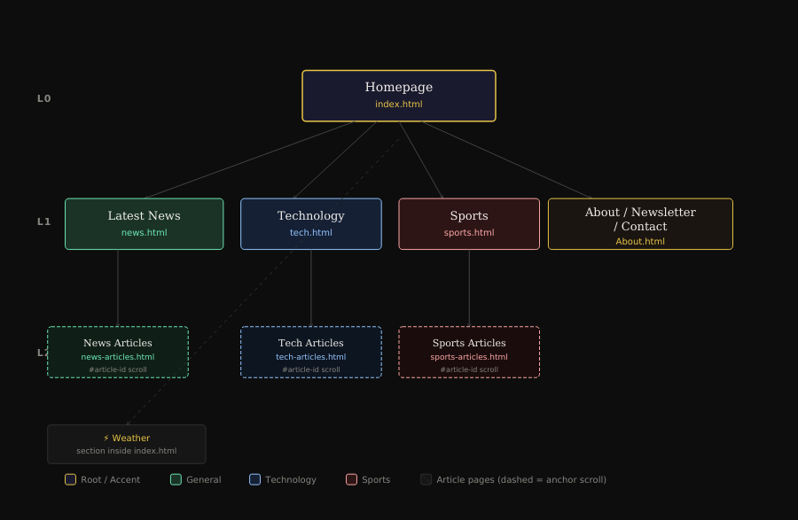

Level | File | Page Title | Parent | Nav Label
Level 0 | index.html | Homepage | None (Root) | Home
Level 1 | news.html | Latest News | index.html | News
Level 1 | tech.html | Technology | index.html | Tech
Level 1 | sports.html | Sports | index.html | Sports
Level 1 | About.html | About / Newsletter / Contact | index.html | About
Level 2 | news-articles.html | General News Articles | news.html | Read Full Story
Level 2 | tech-articles.html | Technology Articles | tech.html | Read Full Story
Level 2 | sports-articles.html | Sports Articles | sports.html | Read Full Story
— | index.html #weather | Weather Section | Inside Homepage | Scroll anchor

2.3 Navigation Paths
All user journeys complete within three clicks from the homepage. Clicking Read Full Story on any card takes the reader directly to the article page and auto-scrolls to that specific story via an anchor link in the URL.

User Type | Navigation Path
Breaking news reader | Homepage > Latest News > news-articles.html#story-id
Tech follower | Homepage > Technology > tech-articles.html#story-id
Sports fan | Homepage > Sports > sports-articles.html#story-id
Weather checker | Homepage > scrolls to #weather section
Newsletter subscriber | Homepage > About.html#newsletter
Feedback provider | Homepage > About.html#contact

3. Page Template Design

3.1 Design Style — Ink & Ivory
The Daily Pulse uses the Ink & Ivory colour scheme: a near-black background with warm ivory text and yellow-gold accents. All colour combinations pass WCAG AA contrast requirements. The typography pairing uses DM Serif Display for headlines and DM Sans for body text, both designed for screen readability. Bootstrap 5.3 provides the responsive 12-column grid. The site supports a dark and light mode toggle that remembers the reader's preference in localStorage.

Element | Value | Purpose
Background | #0D0D0D | Near-black. Reduces glare and sets editorial tone.
Surface | #161616 | Card backgrounds. Subtle lift from the page background.
Accent Gold | #E8C547 | Headlines, active nav links, buttons, and dividers.
Body Text | #F0EEE9 | Warm ivory. Softer than pure white, reduces eye strain.
Muted Text | #888580 | Dates, tags, captions, and secondary information.
General Tag | #6EE7B7 / #1A3326 | Category colour for General News.
Tech Tag | #93C5FD / #152035 | Category colour for Technology.
Sports Tag | #FCA5A5 / #2D1515 | Category colour for Sports.
Headline Font | DM Serif Display | Editorial serif for all headings.
Body Font | DM Sans | Sans-serif optimised for screen reading.

3.2 Shared Page Elements
- Sticky navigation bar with DP logo mark, page links, and dark/light mode toggle. Collapses to hamburger menu on mobile.
- 2px gold bottom border on the navigation bar as a consistent visual anchor.
- Main content area using Bootstrap 12-column responsive grid.
- Dark footer with site logo, quick links, tagline, and copyright.

3.3 Video Hover Feature
Any card, featured story, hero slide, or article image that has both an image and a video source will play the video silently on hover and return to the static photo when the cursor leaves. Cards without a video file are unaffected. To activate, simply uncomment the video tag already present in each HTML file and drop the video into the /videos/ folder.

3.4 Page Wireframes
Low fidelity wireframes show structural layout zones. High fidelity wireframes reflect the actual Ink & Ivory design with real content, gold accents, and DM Serif Display typography.

Homepage (index.html)
Low Fidelity  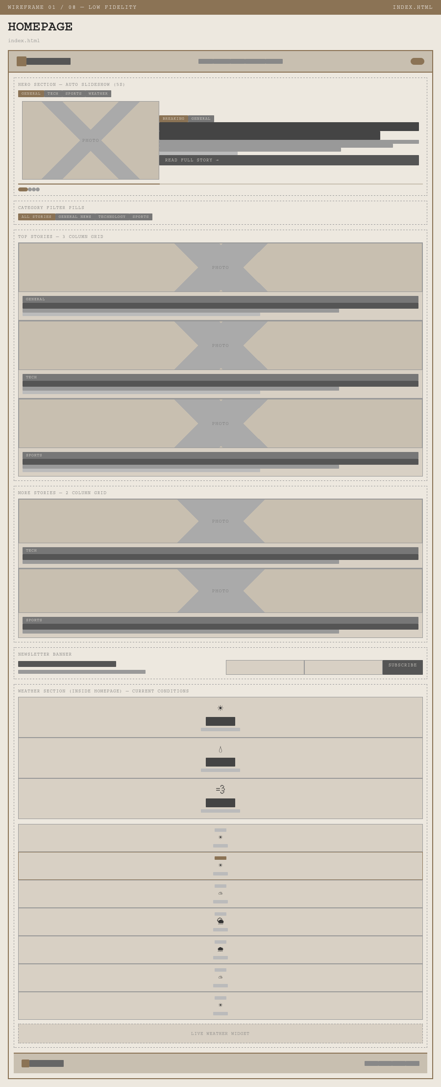 | High Fidelity  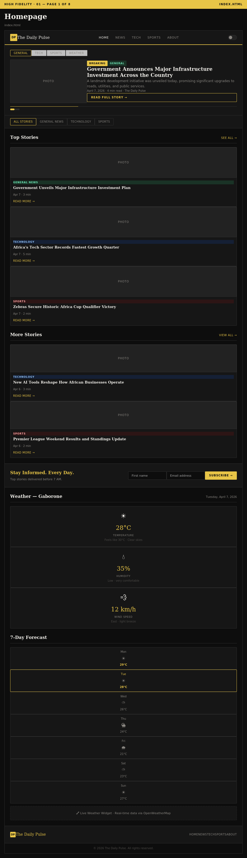

Latest News (news.html)
Low Fidelity  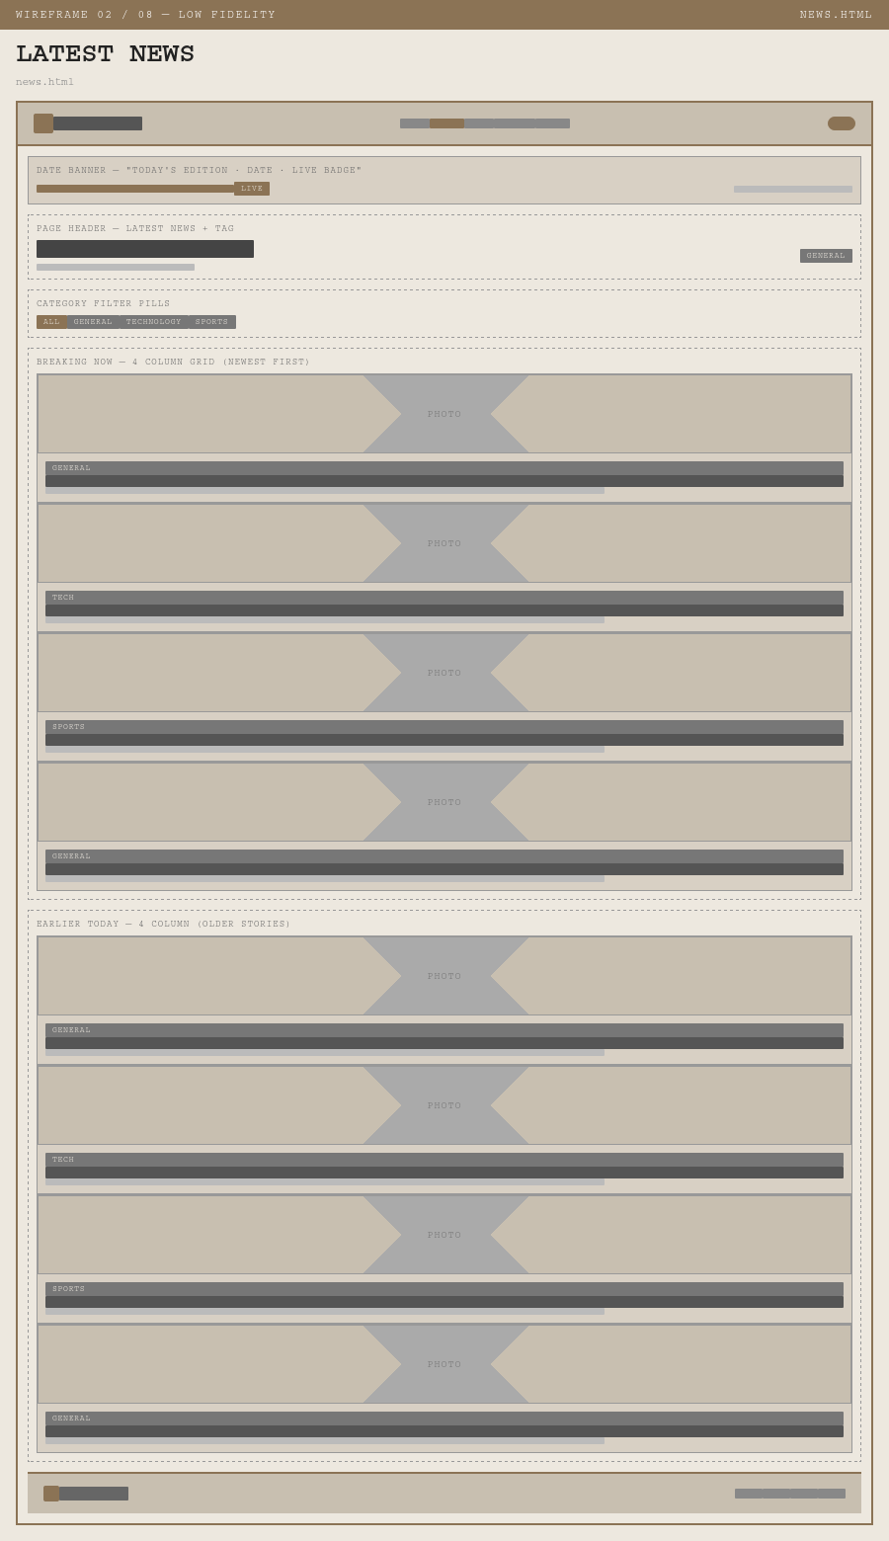 | High Fidelity  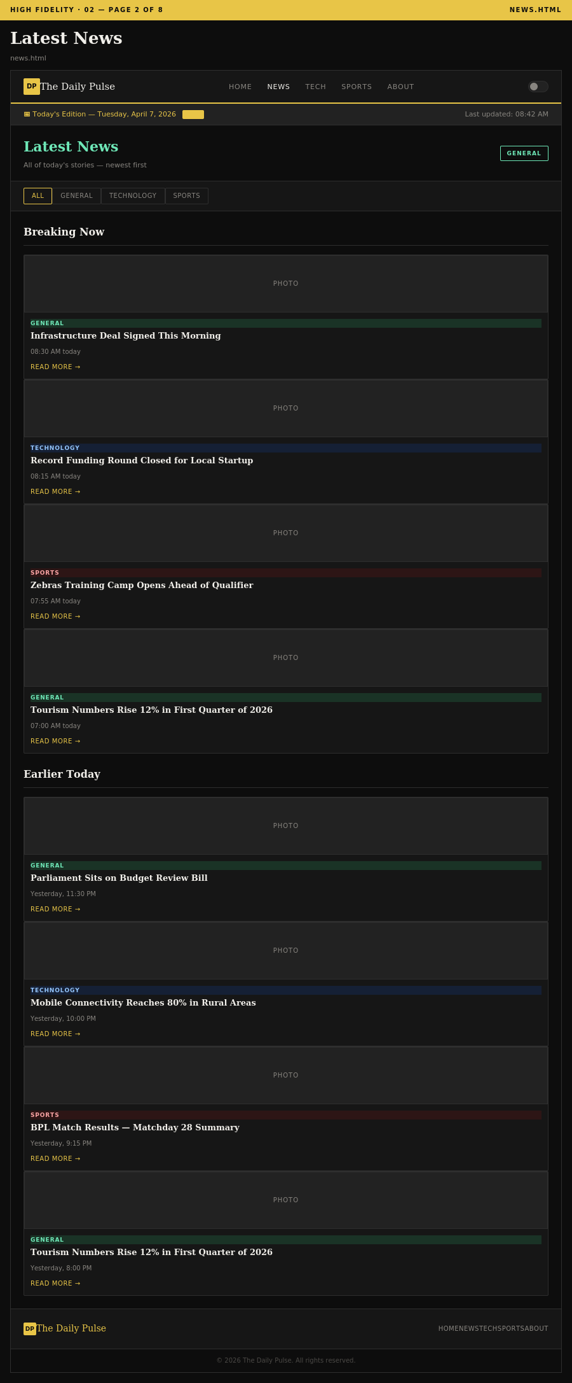

Technology (tech.html)
Low Fidelity  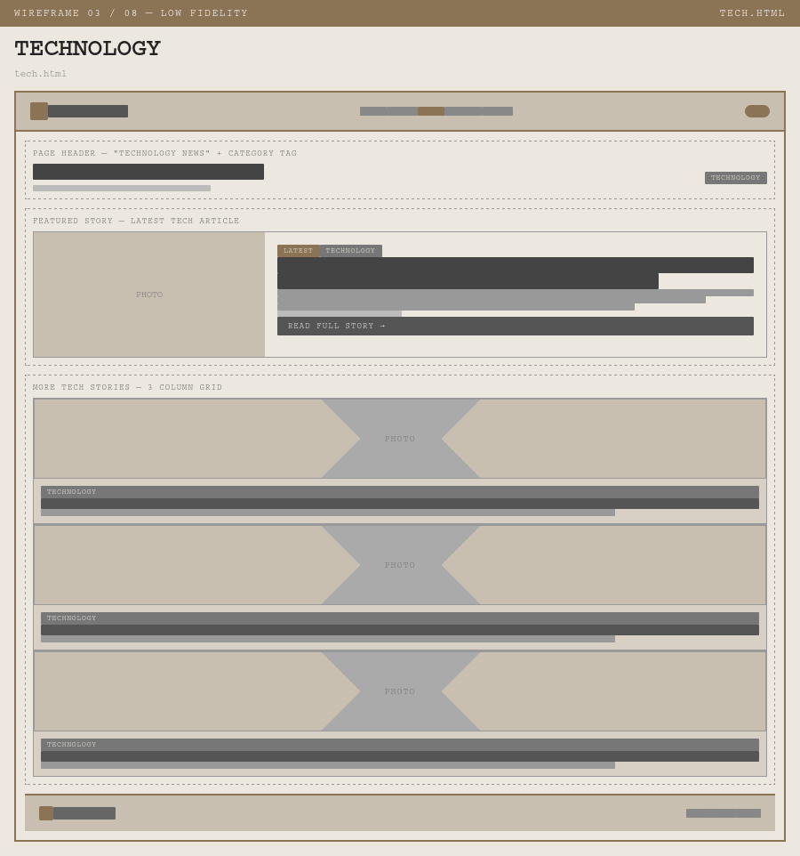 | High Fidelity  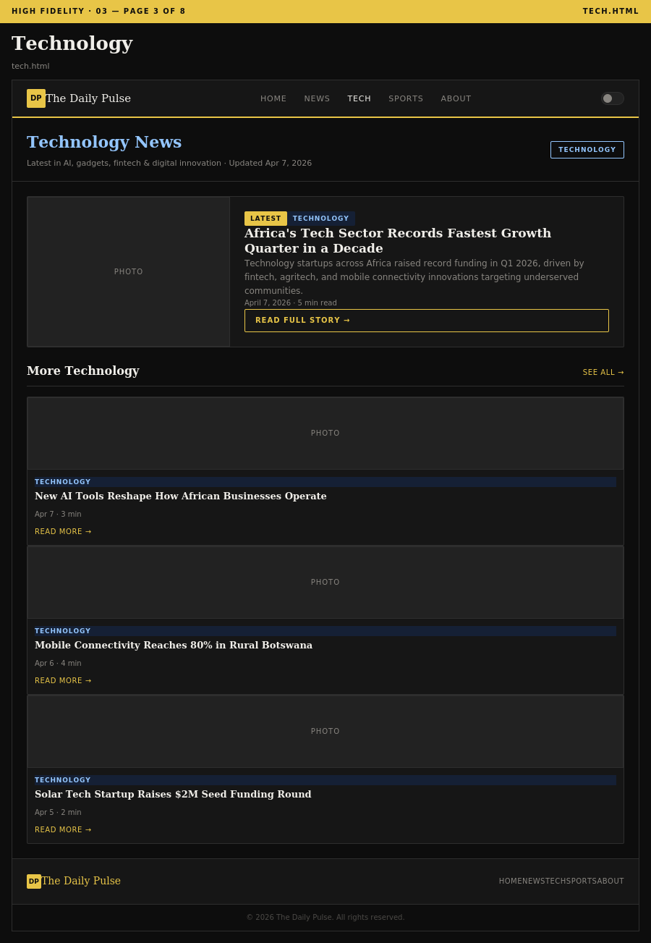

Sports (sports.html)
Low Fidelity  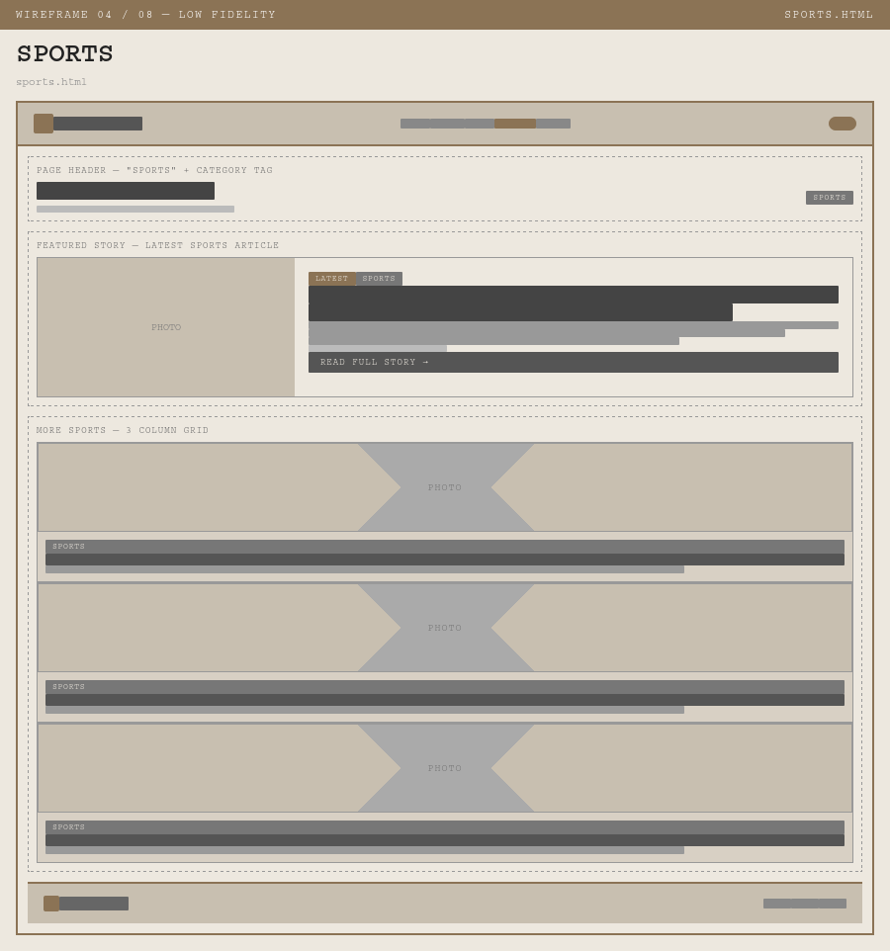 | High Fidelity  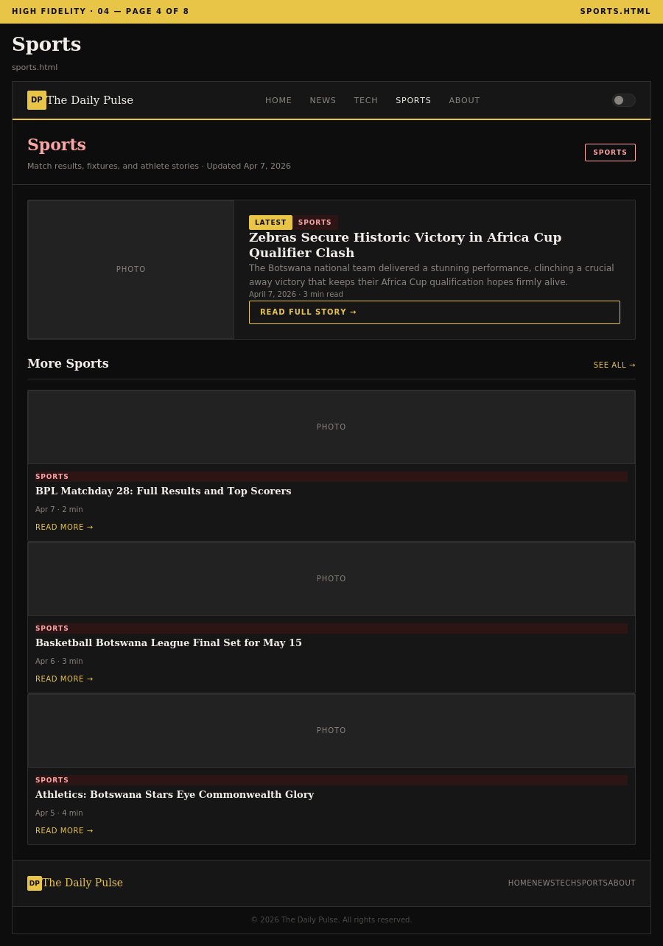

About / Newsletter / Contact (About.html)
Low Fidelity  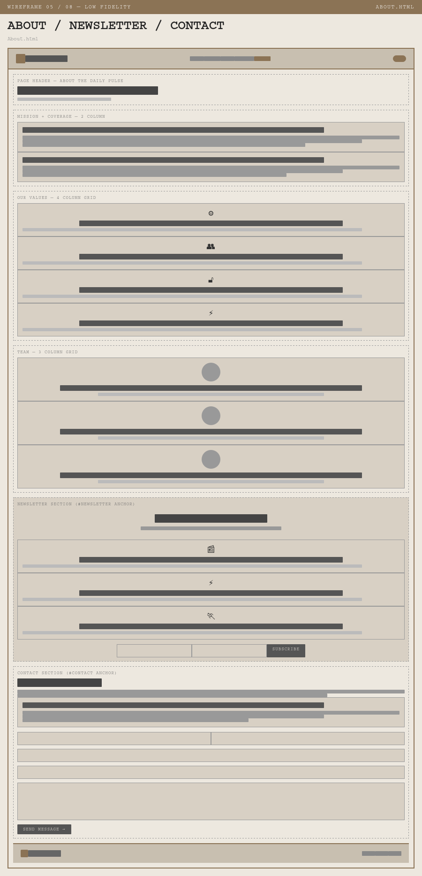 | High Fidelity  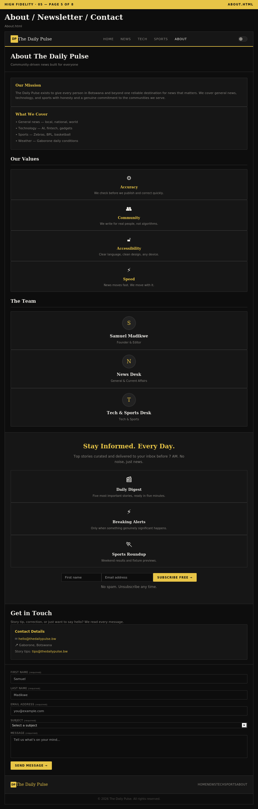

News Articles (news-articles.html)
Low Fidelity  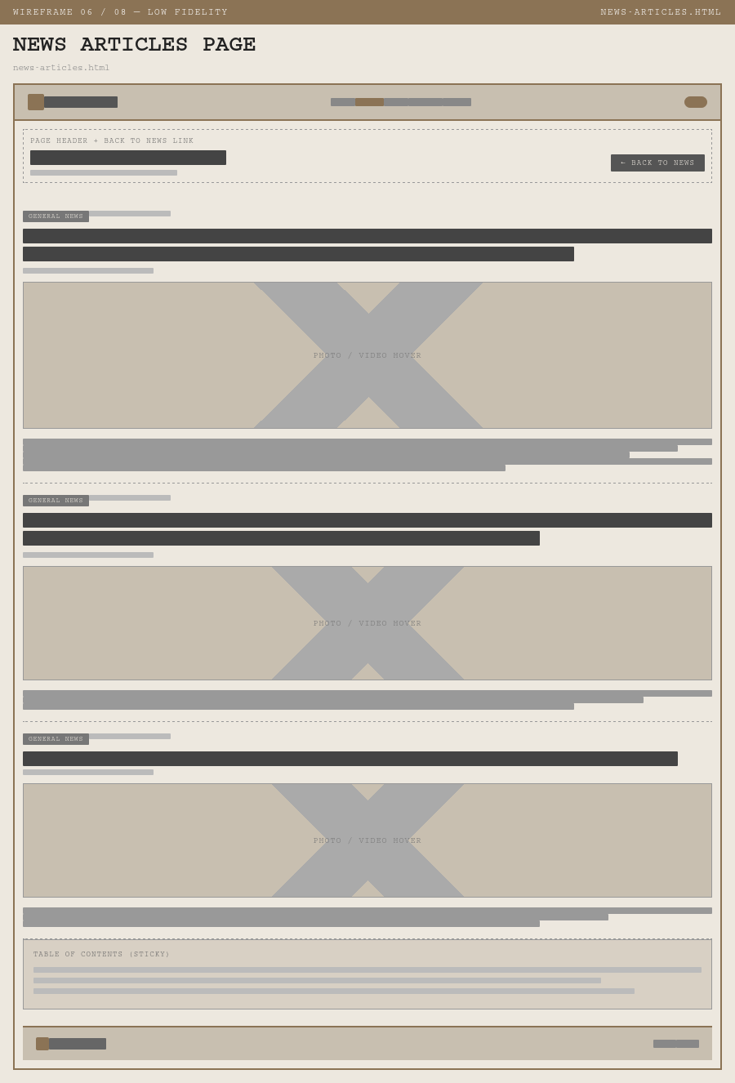 | High Fidelity  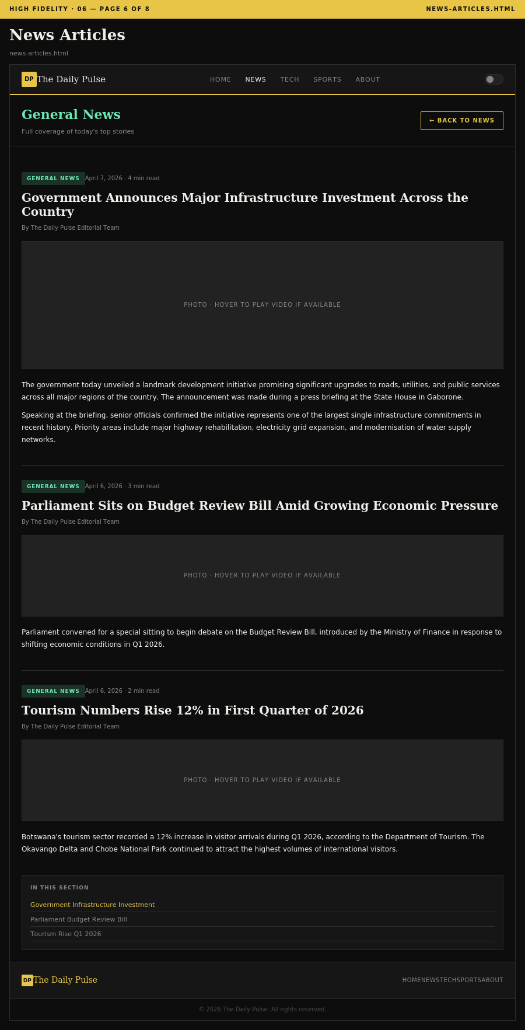

Tech Articles (tech-articles.html)
Low Fidelity  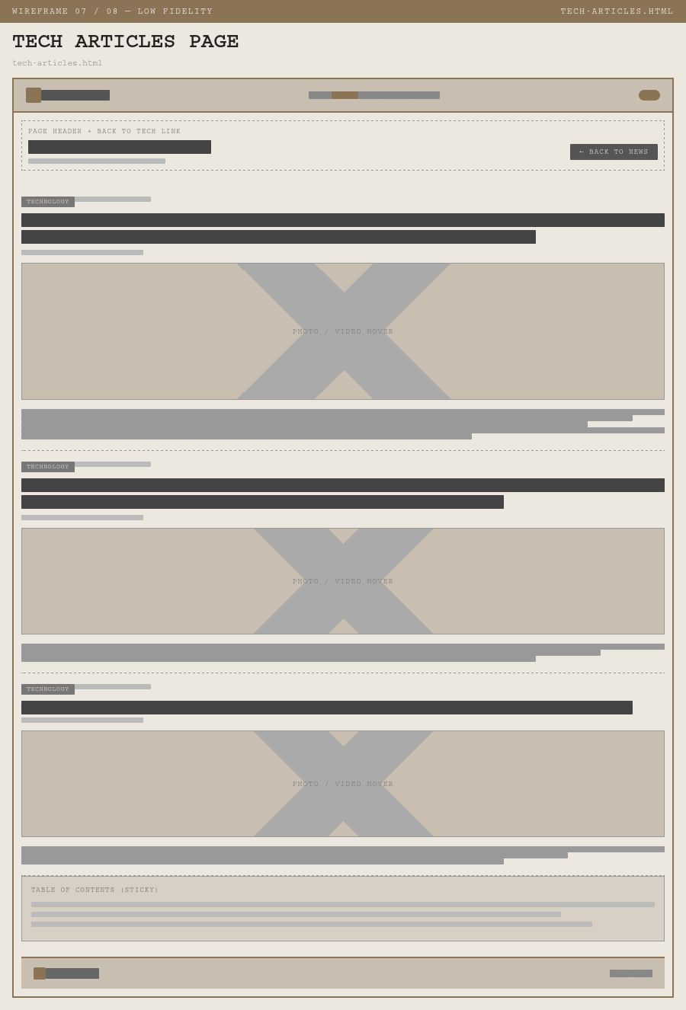 | High Fidelity  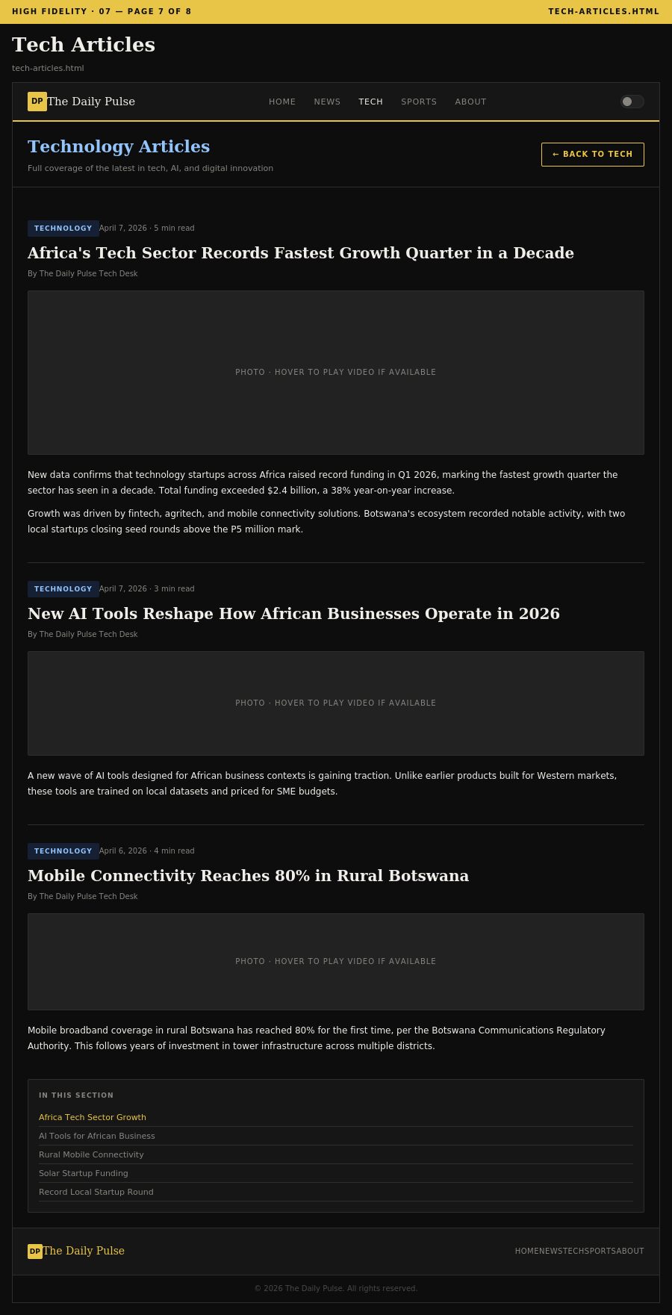

Sports Articles (sports-articles.html)
Low Fidelity  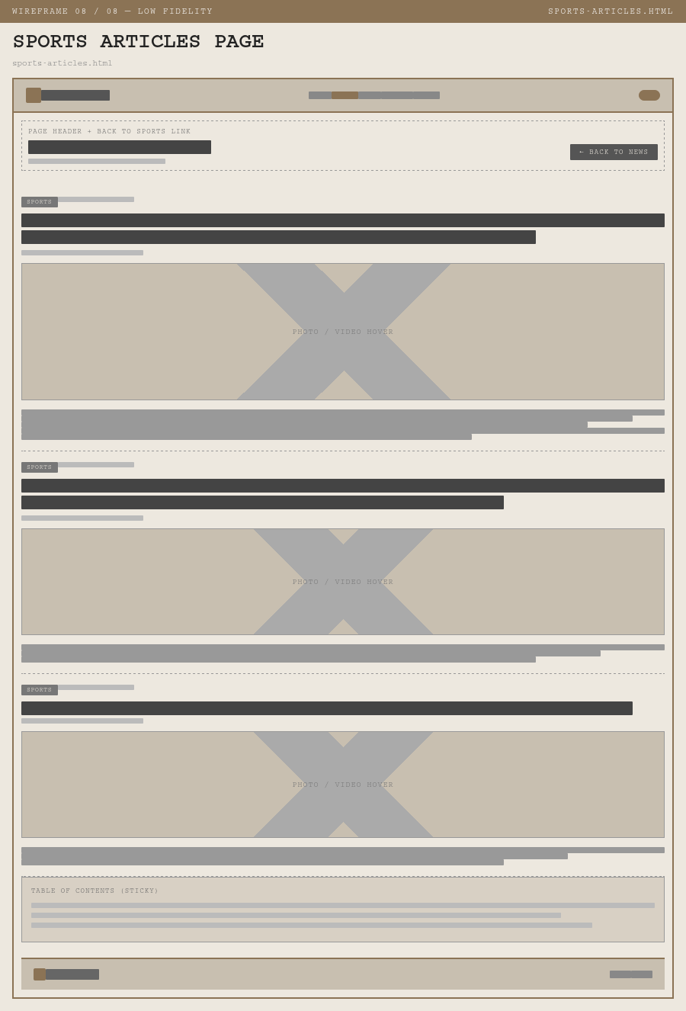 | High Fidelity  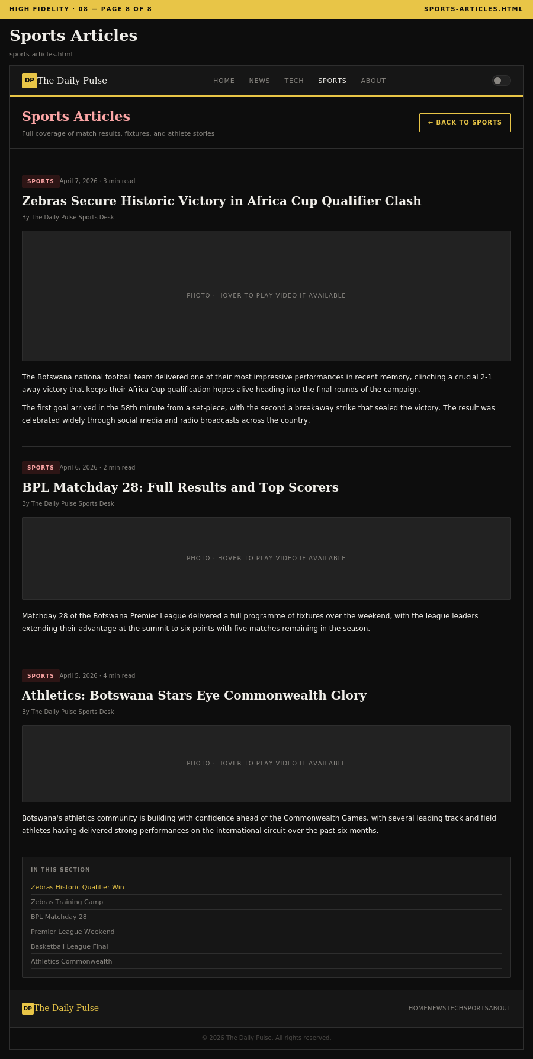

4. Technical Brief

4.1 Technologies
Technology | Version / Standard | Role
HTML5 | HTML Living Standard (W3C) | Structural layer. Semantic elements define all page content, layout regions, forms, and navigation.
CSS3 | CSS Level 3 (W3C) | Presentation layer. Single external stylesheet handles the Ink & Ivory theme, CSS custom properties for dark/light mode, Flexbox, and responsive breakpoints.
JavaScript ES6+ | ECMAScript 2015+ | Behavioural layer. Handles theme toggle, mobile nav, fixed hero slideshow, video hover-to-play, category filtering, anchor scroll, TOC highlighting, and form validation.
Bootstrap 5.3 | v5.3.0 (via CDN) | Responsive 12-column grid used across all pages for card layouts and content structure.

4.2 Tools
Tool | Category | How it is used
Visual Studio Code | Code Editor | Primary development environment for all HTML, CSS, and JavaScript files.
GIMP 2.10 | Image Editing | Creating and optimising site graphics including the logo mark, hero banners, article images, and category icons.
Git & GitHub | Version Control | All source code version-controlled with descriptive commit messages. Site deployed and hosted on GitHub Pages.
Google Fonts CDN | Typography | DM Serif Display and DM Sans imported via a single CDN link in each page head.
Bootstrap CDN | CSS Framework | Bootstrap 5.3 CSS and JS bundle loaded via jsDelivr CDN.
W3C HTML Validator | Code Quality | All HTML pages validated at validator.w3.org throughout development.
W3C CSS Validator | Code Quality | External stylesheet validated at jigsaw.w3.org to confirm CSS3 compliance.
Chrome DevTools | Testing & Debugging | Used to simulate device viewports, inspect layout, debug JavaScript, and audit performance.

4.3 File Structure
- index.html — Homepage and GitHub Pages entry point
- news.html — Latest news page with category filter
- tech.html — Technology news page
- sports.html — Sports news page
- About.html — About, newsletter, and contact combined page
- news-articles.html — Full general news articles with anchor navigation
- tech-articles.html — Full technology articles with anchor navigation
- sports-articles.html — Full sports articles with anchor navigation
- css/style.css — Single external stylesheet with all styles and CSS custom properties
- js/main.js — Single JavaScript file handling all behavioural layer features
- images/ — Optimised site images including hero banners, story cards, and logo
- videos/ — Optional video clips for hover-to-play (uncomment video tags to activate)

