CDACL-001: Automobile Insurance Complaints Rankings
Final Project Analysis Report
- Project Overview:
This project focuses on analyzing automobile insurance complaints recorded for insurance companies operating in New York State. The purpose is to understand complaint patterns, compare insurance companies, examine premium trends, and identify areas where customer service and complaint handling could improve.
The analysis uses insurance complaint records covering 2009 to 2016. SQL was used to explore the dataset, while Power BI was used to visualize complaint trends, company performance, complaint categories, and premium amounts.
2. Dataset and Tools Used:
Dataset: Automobile Insurance Complaints Rankings
Source: Insurance company complaint data described in the DataMites CDACL-001 project.
Tools Used:
- SQL and phpMyAdmin for database exploration and queries.
- CSV export for transferring the dataset.
- Power Query for preparing data for analysis.
- Power BI for calculations, visualizations, and dashboards.
- Microsoft Word for documenting findings and recommendations.
- The important dataset fields include Company Name, NAIC, Filing Year, Complaint Ratio, Total Complaints, Upheld Complaints, Not Upheld Complaints, Question of Fact Complaints, Premiums Written, and Ranking.
3. Overall Insurance Complaints Analysis:
The dashboard covers 35,919 complaints across 223 insurance companies,
with 4,216 upheld complaints.
The yearly complaints chart shows that the overall number of complaints declined between 2009 and 2016, although there were some fluctuations during this period.
The dashboard reports a median complaint ratio of 0.0164. This value is presented in the dataset's original ratio units, rather than as a percentage.
The three complaint outcome categories help show how many cases were upheld, not upheld, or classified as questions of fact.
Main Power BI Dashboard:

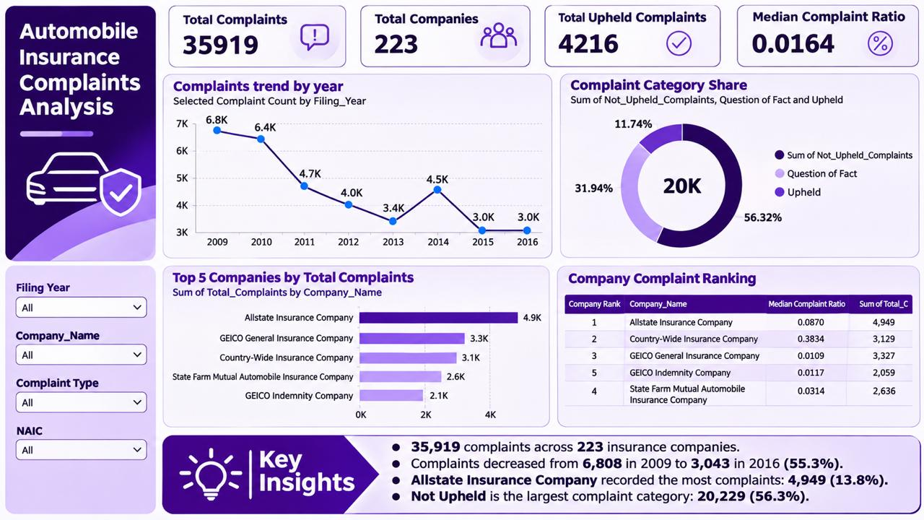

4. Company Complaint Diagnostic — Allstate Insurance Company
Allstate Insurance Company was selected for a detailed analysis of its complaints and premium trends.
The company recorded 4,949 complaints during the period covered by the dataset.
Complaint Category Analysis
Complaint category | Number of complaints
Upheld | 760
Not Upheld | 2,301
Question of Fact | 1,888
Total | 4,949
Not Upheld complaints formed the largest category, accounting for approximately 46.5% of Allstate's recorded complaints. Questions of Fact represented approximately 38.1%, while Upheld complaints accounted for approximately 15.4%.
This distribution shows that a significant share of complaints were not upheld or required consideration of disputed facts. However, these categories alone do not explain why individual customers raised their complaints.
Yearly Complaint Trend
Allstate recorded its highest yearly complaint count in 2010, with 1,350 complaints. By 2016, the count had fallen to 237.
The trend shows a substantial reduction in recorded complaints over the study period, with some fluctuations along the way.
This is a positive change in complaint volume, but it should not automatically be treated as proof of improved customer satisfaction. Changes in business volume, the number of policies, or complaint-reporting patterns could also influence the results.
Suggested Improvement
Allstate could benefit from reviewing the complaint categories and identifying recurring issues behind customer dissatisfaction.
Clearer communication during claims processing, better documentation, timely complaint updates, and regular reviews of unresolved issues could help improve its complaint-handling process.
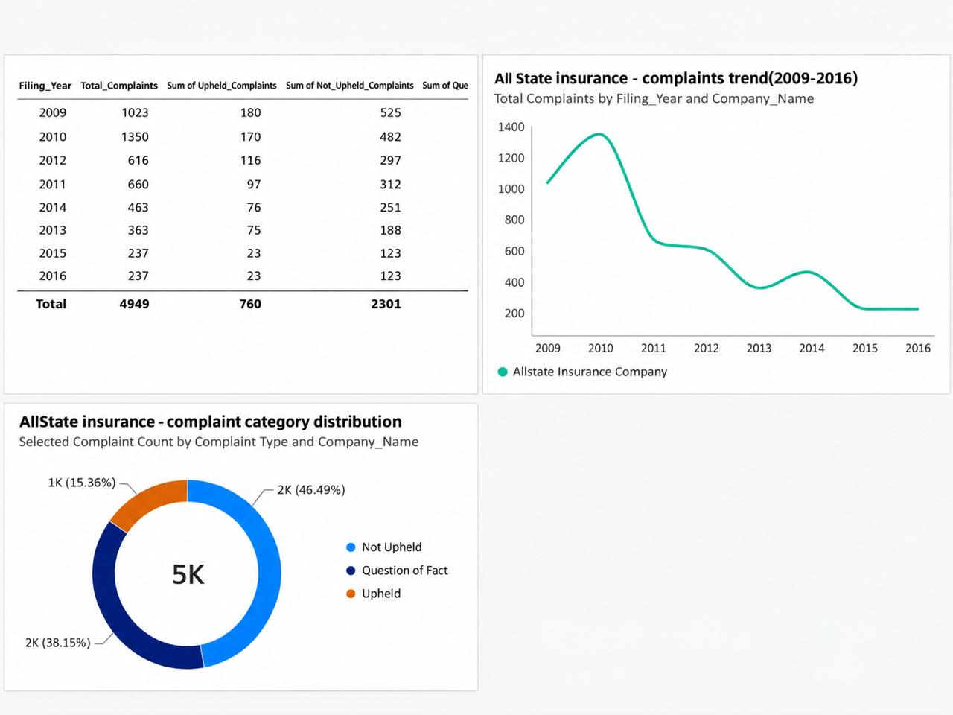

2: Allstate Company Complaint Diagnostic Page]

5. Premium Trend Analysis
The premium analysis examines Allstate Insurance Company's Premiums Written from 2009 to 2016.
According to the dataset description, this field represents the average of the company's current and previous year's premiums written directly in New York State, expressed in millions of US dollars.
The Power BI analysis shows approximately $1,269.44 million in 2009, compared with $747.43 million in 2016.
This represents a decrease of approximately 41.1% between the starting and ending values displayed in the analysis.
The premium values generally declined through the period and remained at the
same displayed level in 2015 and 2016.
Possible Reasons for Premium Changes
Several factors could contribute to changes in insurance premiums, including:
- Changes in the number of active insurance policies.
- Increased competition between insurance providers.
- Changes in insurance pricing and underwriting decisions.
- Economic conditions affecting customer purchasing decisions.
- Changes in claims experience, regulatory requirements, or market conditions.
The available dataset does not provide enough evidence to identify which of these factors caused Allstate's premium decline. Additional information would be needed to confirm the reasons.
Future Premium Outlook
Historical data shows a declining premium pattern for Allstate over the observed period.
If similar business and market conditions continued, premium levels could remain under pressure. However, premiums could also recover if the company's policy volume, pricing, or market position improved.
The historical trend is useful for understanding past performance, but it is not sufficient to make a reliable numerical forecast of future premiums.

3: Allstate Premium Analysis Page

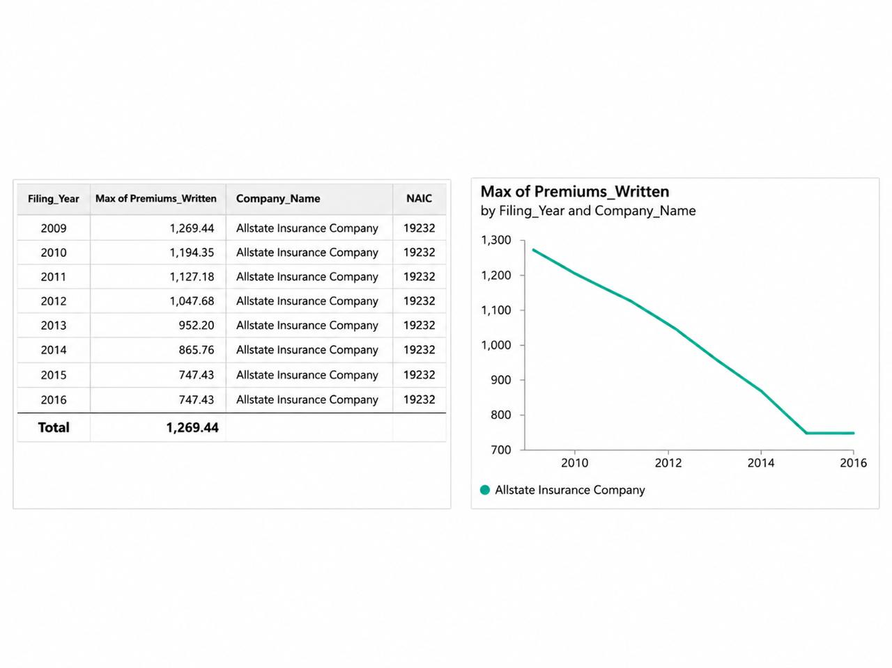6. Comparison of Five Insurance Companies
The main Power BI dashboard compares five companies with the highest total complaint counts in the analyzed records:
- Allstate Insurance Company
- GEICO General Insurance Company
- Country-Wide Insurance Company
- State Farm Mutual Automobile Insurance Company
- GEICO Indemnity Company
Allstate had the highest total complaint count among these five companies, followed by GEICO General and Country-Wide.
The comparison highlights differences in complaint volume between insurers.
However, a company with more complaints is not necessarily the company with the poorest complaint-handling performance. Differences in business size and premium volume should also be considered.
The complaint ratio and company ranking provide additional context when assessing the companies' relative complaint performance.

7. Key Findings and Recommendations

Key Findings
- The dataset contains 35,919 complaints across 223 companies.
- Overall complaint volumes declined over the period shown in the dashboard.
- Allstate recorded 4,949 complaints between 2009 and 2016.
- Not Upheld was the largest complaint category for Allstate.
- Allstate's yearly complaints fell substantially after their 2010 peak.
- Allstate's displayed premium values decreased between 2009 and 2016.
- Complaint totals and complaint ratios should be considered together when comparing insurance companies.
Recommendations
Insurance companies should regularly monitor complaint patterns to identify possible service issues early.
For Allstate, a detailed review of the complaints recorded during its higher-volume years could help identify areas where the customer experience can be improved.
Complaint outcomes should be tracked alongside premium trends, policy volumes, and company rankings. This would support a more balanced understanding of business performance.
It would also be useful to review recurring complaint reasons, improve communication with policyholders, and monitor complaint resolution over time.

8. Conclusion
This project demonstrates how insurance complaint data can be analyzed using SQL and Power BI to support business decisions.
The analysis identified important changes in complaint volumes, differences between insurance companies, and a declining premium trend for the selected company.
The main dashboard provides an overall industry comparison, while the company diagnostic and premium analysis offer a closer look at Allstate Insurance Company.
The findings suggest that insurance companies can benefit from regular complaint monitoring, clear customer communication, and closer examination of business performance.
Overall, the project shows how structured data analysis and visualization can turn insurance records into useful information for understanding trends and identifying potential areas for improvement.

