**Overview**

The Pin Align program (pin_align_amx.sh/pin_align_fmx.sh) is designed to aid in automated data collection at the Brookhaven National Laboratory MX Beamlines. Because there are significant differences in the pins used at the beamline, a software solution that was ambiguous enough to account for the changing pins was needed. The Pin Align program utilizes the package ImageMagick® (<https://imagemagick.org/script/index.php>) for image processing and, using Machine Vision methods, aids in automation by centering the tip of a pin into the beam. This allows users to automatically generate diffraction patterns without the need for any input or oversight. Within the Pin Align program, additional safety features to check for tilted caps and missing pins were added to further aid in automation and, to protect any hardware.

The Pin Align program starts by taking two images during the mounting process, one at the 0-degree position and one at the 90-degree position. These are taken during the mounting process to conserve time. The resulting two images each have two layers of contrast added (<https://imagemagick.org/script/command-line-options.php#contrast>) and are moved to a temporary directory. Once the images are moved, they are each split into three separate Region of Interest (ROI) images. The first ROI contains the Pin Tip, the second contains the Pin Body, and the third contains the Pin Base.

Pin Tip

Pin Base

Pin Body

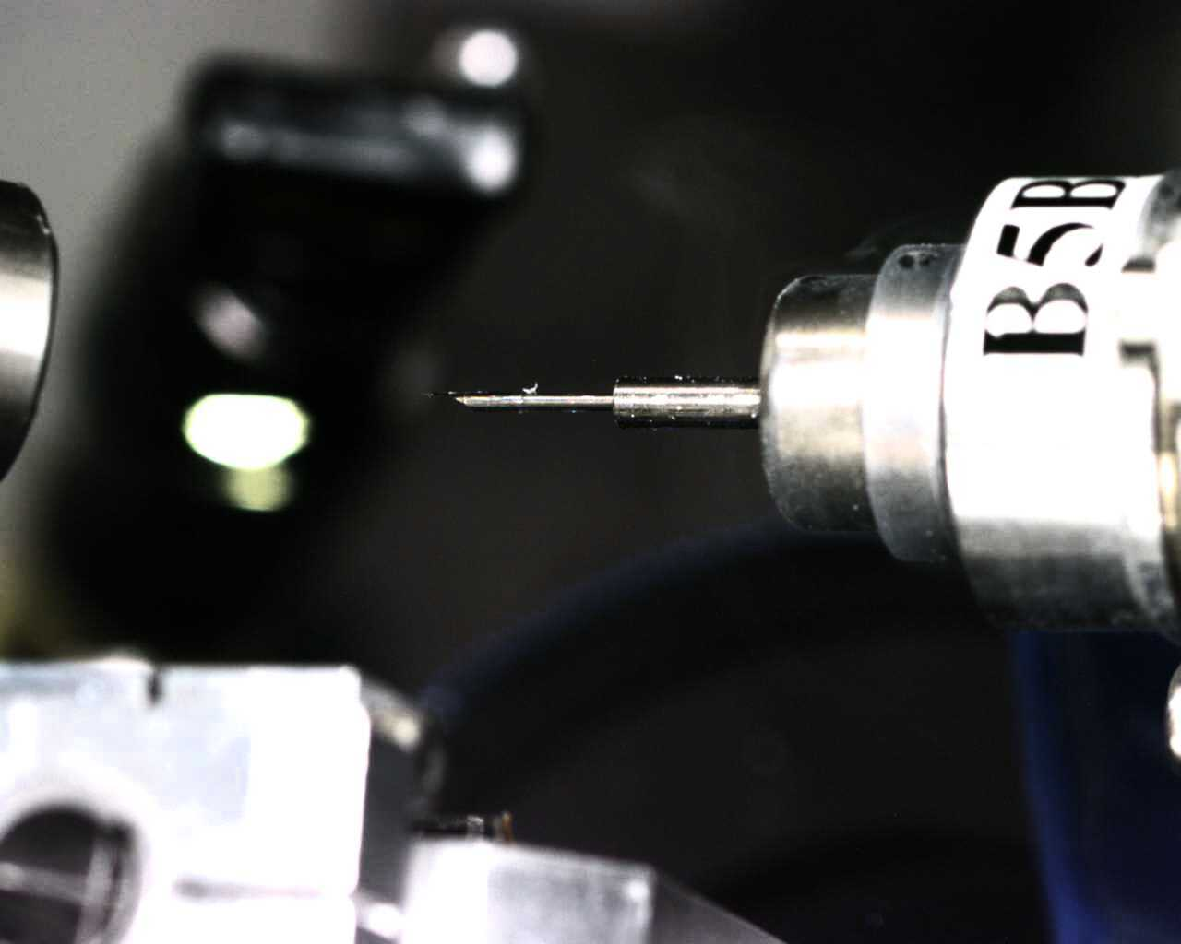

These three ROIs are each cropped, converted to binary and, first eroded (<https://legacy.imagemagick.org/Usage/morphology/#erode>) than dilated (<https://legacy.imagemagick.org/Usage/morphology/#dilate>) using a 2x2 cross octagon filter (<https://legacy.imagemagick.org/Usage/morphology/#octagon>). After this processing, a 2x1 Canny Edge Detection (<https://imagemagick.org/script/command-line-options.php#canny>) filter is applied to each image with each edge ROI being written into the temporary directory.

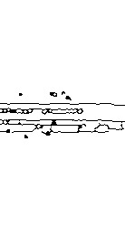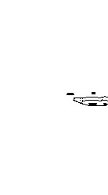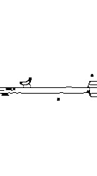

Pin Tip

Pin Body

Pin Base

**Pin Tip**

**Pin Tip ROI: ${PIN_ALIGN_ROI_WIDTH}x${PIN_ALIGN_ROI_HEIGHT}+${PIN_TIP_X1}+${DEFAULT_ROI_Y1}**

Using the Pin Tip ROI, Pin Align gets all the necessary information needed to center a mis-aligned pin. After the Pin Tip ROI is created, the program uses the defined X and Y Center Points (pin_align_config_amx.sh / pin_align_config_fmx.sh) to create a new ROI called Pin Left. It uses the defined Default Height and Default Height offset for Y1 and Y2, and for X1 and X2 it finds those by X1 = X – 10 and X2 = X + x1_clip (raw image width + Default Width). From here, the program uses ImageMagick’s® fuzz (<https://imagemagick.org/script/command-line-options.php#fuzz>) and trim (<https://imagemagick.org/script/command-line-options.php#trim>) methods to further process the ROI. The focus of the fuzz method is to give the trim method a little bit of leniency when looking for matching color pixels. It does this because, within the MX Beamline environment, changes occur that cause changes within the image. These changing variables can make finding the pin tip very difficult so, to contest this, the fuzz method accounts for any background or noise pixels by giving trim a threshold for keeping wanted edges that do not exactly match the target pixel. This also allows trim to automatically remove the unwanted edges of the pin, remove unwanted artifacts and, any abstractions from the image.

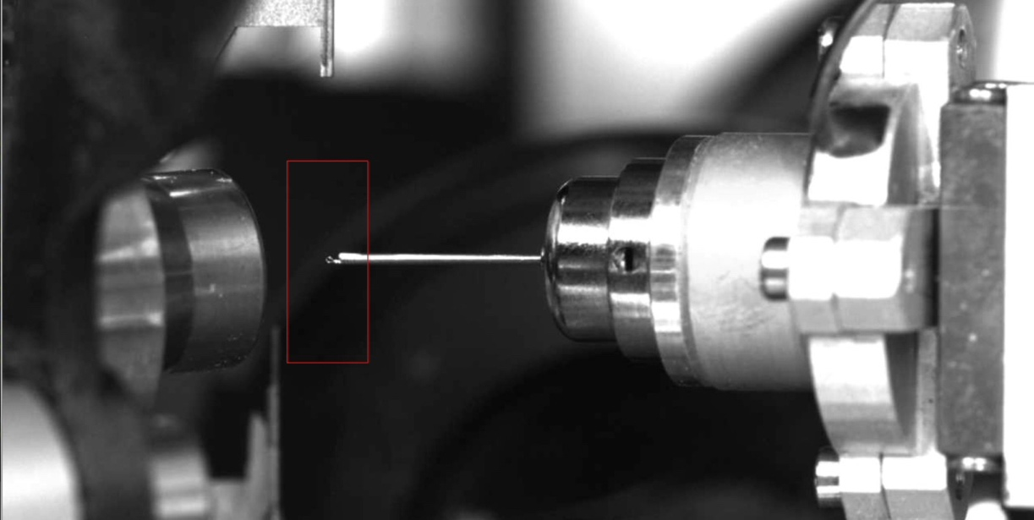

**Pin Body**

**Pin Body ROI:** **${PIN_ALIGN_ROI_WIDTH}x${PIN_ALIGN_ROI_HEIGHT}+${PIN_BODY_X1}+${DEFAULT_ROI_Y1}**

**Pin Check Top: ${PIN_CHECK_ROI_WIDTH}x${PIN_CHECK_TOP_HEIGHT}+0+0**

**Pin Check Bottom: ${PIN_CHECK_ROI_WIDTH}x${PIN_CHECK_TOP_HEIGHT}+0+$((${PIN_CHECK_BOTTOM_Y1}-${PIN_CHECK_TOP_Y1}))"**

From the Pin Body ROI, two new ROIs are created to check for a missing pin. The two new ROIs, called Pin Check Top and Pin Check Bottom, are both defined within the configuration file (pin_align_config_amx.sh / pin_align_config_fmx.sh). If the Pin Body ROI does not contain any suitable edges for detection, ImageMagick® creates randomized edges throughout the ROI. Because of this, both Pin Check Top and Pin Check Bottom are positioned far enough from the pin so that only the randomized edges created by ImageMagick® can enter the ROI. With this thinking, Pin Align checks both ROIs for the presence of any black pixels and, if there are any black pixels in either ROI, it is returned as having no pin.

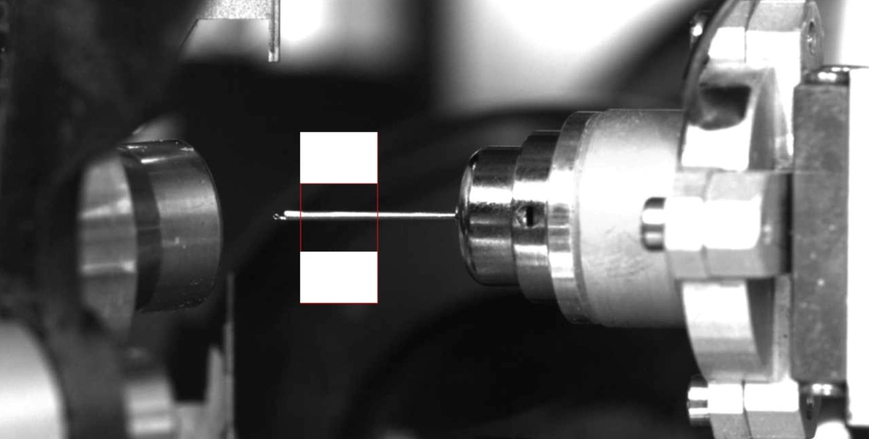

**Pin Base**

**Pin Base ROI: ${PIN_ALIGN_ROI_WIDTH}x${PIN_ALIGN_ROI_HEIGHT}+${PIN_BASE_X1}+${DEFAULT_ROI_Y1}**

**Tilt Check Top: ${TILT_CHECK_ROI_WIDTH}x${TILT_CHECK_TOP_HEIGHT}+$((${TILT_CHECK_X1}-${PIN_BASE_X1}))+$((${TILT_CHECK_TOP_Y1} - ${DEFAULT_ROI_Y1}))**

**Tilt Check Bottom: ${TILT_CHECK_ROI_WIDTH}x${TILT_CHECK_TOP_HEIGHT}+$((${TILT_CHECK_X1} - ${PIN_BASE_X1}))+$((${TILT_CHECK_BOTTOM_Y1} - ${DEFAULT_ROI_Y1}))**

Tilt Check follows similar methodology as Pin Check and varies only in the positioning of the new ROIs. Two new ROIs are created from the Pin Base ROI. These two ROIs are defined as Tilt Check Top and Tilt Check Bottom and are both defined within the configuration file (pin_align_config_amx.sh / pin_align_config_fmx.sh). Like Pin Check, both Tilt Check Top and Tilt Check Bottom are positioned far enough away from the pin as to not be triggered by them but, Tilt Check ROIs are both placed on the X2 side of the Pin Base ROI.

**Conclusion:**

Pin Align aids in automating the data collection process at Brookhaven National Laboratory’s MX Beamlines by creating a software solution to centering samples to the beam. It takes the images during the rotations to save time during the centering process. Pin Align takes three separate ROI’s which all have a separate use. The Pin Tip ROI is used to find the centering calculations, the Pin Body ROI is used to check for a pin and, the Pin Cap ROI is used to check for any tilted caps. While the Pin Tip ROI is important for the main functionality and purpose for this project, the tilt and pin check safety features add other tools essential to safe automated data collection. Without those three parts working together, Pin Align would not have been successful in assisting Brookhaven National Laboratory with their mission in creating a safe, fast, and automated data collection process.