This framework is designed to serve as a simulator for Magnetic Resonance Fingerprinting (MRF). Additionally, it generates numerical phantoms and simulates data acquisition of real scanners through the application of Inversion-Recovery Balanced Steady-State Free Precession (IR-bSSFP) pulse sequence.

Numerical phantoms, pulse sequences, and the sampling trajectory are provided as inputs to the Bloch simulator. The simulator outputs a series of 1000 undersampled data. These undersampled data are then reconstructed using the non-uniform Fast Fourier Transform (NUFFT) algorithm. Subsequently, signal evolutions for each pixel are constructed by extracting the pixel value from all series images. A pattern matching step identifies the best match for each pixel from the dictionary and stores the index of the entry with the best match. Utilizing this index, quantitative maps are generated for each property and visually represented. The general block diagram of the framework is given below

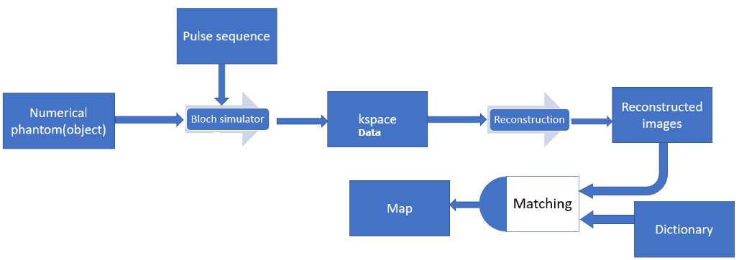

**demo.m**

Starter file that calls all necessary functions.

**spiral_trajectory.m**

This function generates a variable density spiral trajectory along with the corresponding gradient and k-space locations. The main constraints for designing the trajectory are the field of view and slew rate. The design is based on the paper by Dong-hyun Kim et al., titled "Simple Analytic Variable Density Spiral Design," published in Magnetic Resonance in Medicine 50:214-219 (2003). This approach has been utilized by Matthieu Guerquin-Kern in 2012.

**rewinder.m**

The function is employed to nullify the 0th moment of the gradients, as outlined in Krishna S. Nayak et al.'s paper titled "Spiral Balanced Steady-State Free Precession Cardiac Imaging," published in Magnetic Resonance in Medicine 53:1468–1473 (2005).

**generate_all_trajectories.m**

This function is used to generate the rotated version of the first spiral for all trajectories with a linear rotation angle.

**MRF_sampling.m**

Here, the function generates a series of undersampled data using discrete Bloch simulation, which is subsequently reconstructed to generate the MRF series images. The inputs for this process include numerical phantoms, off-resonance frequencies, and the pulse sequence.

**Recon_image.m**

This function employs Jeff Fessler's NUFFT (Non-Uniform Fast Fourier Transform) toolbox to reconstruct the sampled data.

**dict_true**

This function generates MRF dictionary with pseudo-random TRs and flip angles for a given T1, T2 and off resonance values of tissues.

Customized from: <https://github.com/mgolbabaee/CoverBLIP>

**fast_matching.m**

This function conducts dot product-based pattern matching between a normalized dictionary and the acquired images, resulting in T1, T2, off-resonance frequency, and proton density parameter maps. This custom implementation is adapted from Dan Ma et al.'s work titled "Magnetic Resonance Fingerprinting," published in Nature, vol. 495, p. 187–192, 2013.

**Note**

The simulator requires approximately 16 hours to complete on a computer equipped with a Core i7 CPU @ 2.20GHz and 16GB RAM.

The results of the simulator can be viewed on the next page.

**Results**



Ground truth cylindrical phantoms: (a) proton density, (b) T1, (c) T2, (d) off-resonance

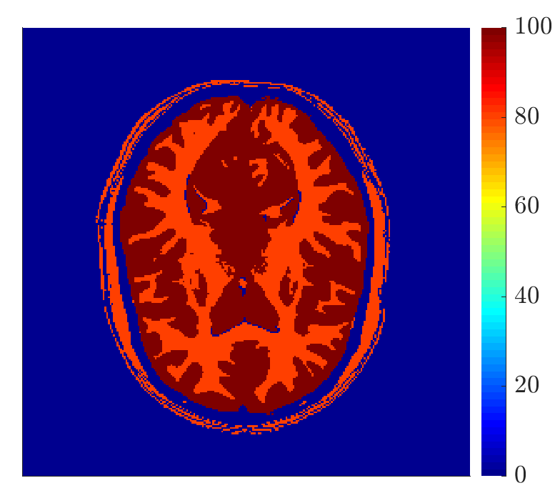**a  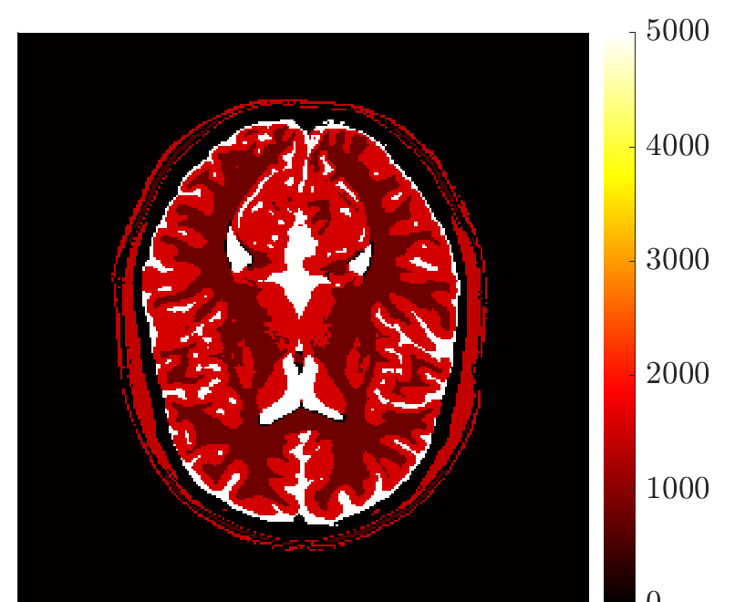b**

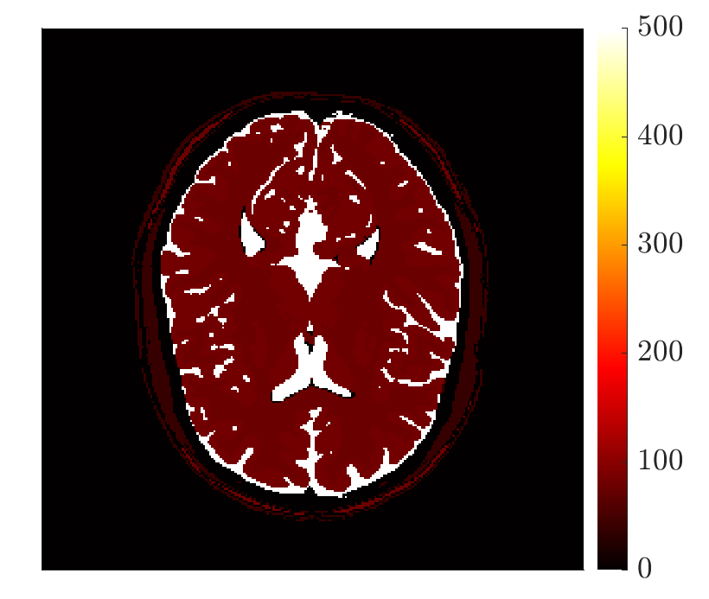 **c  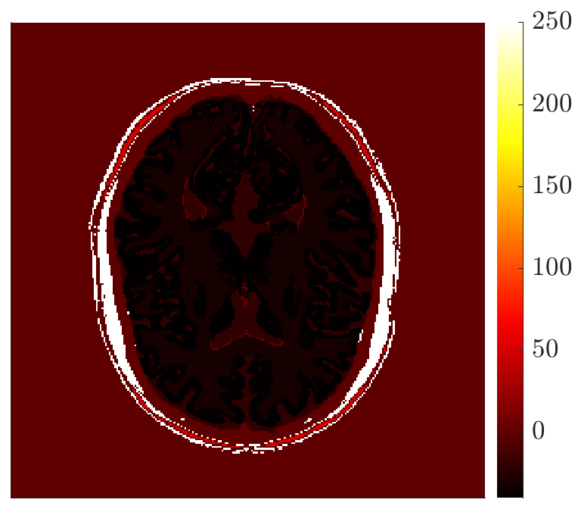 d**

Ground truth brain phantoms:(a) proton density, (b) T1, (c) T2, (d) off-resonance



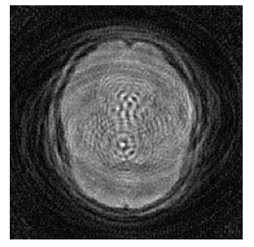 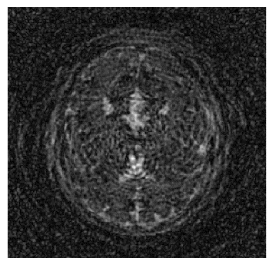 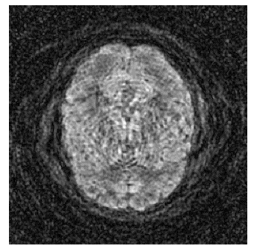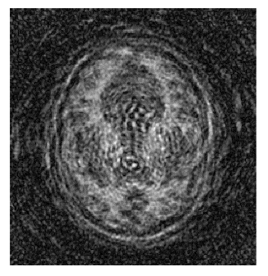

Four of the highly aliased time series images acquired for custom (top row) and brain (bottom row) phantoms

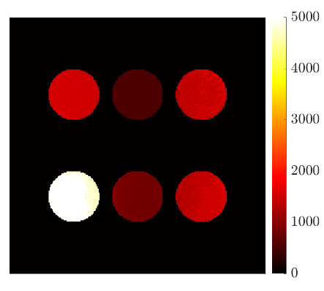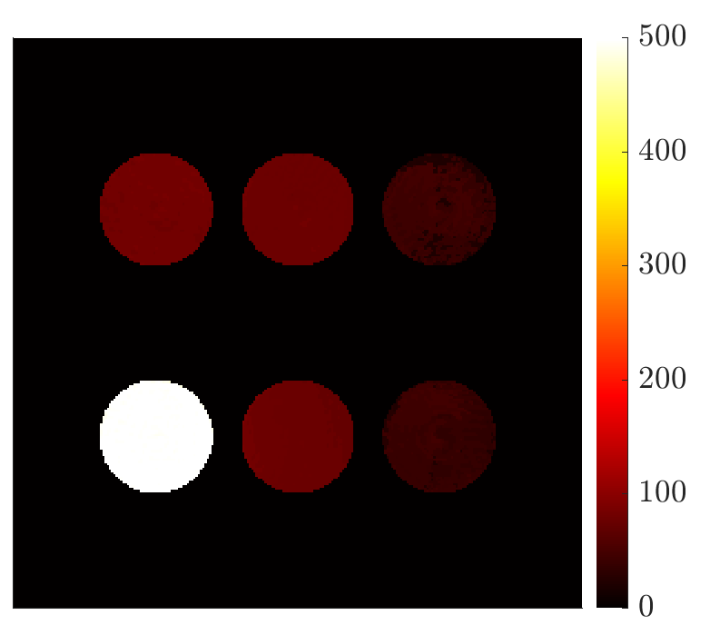 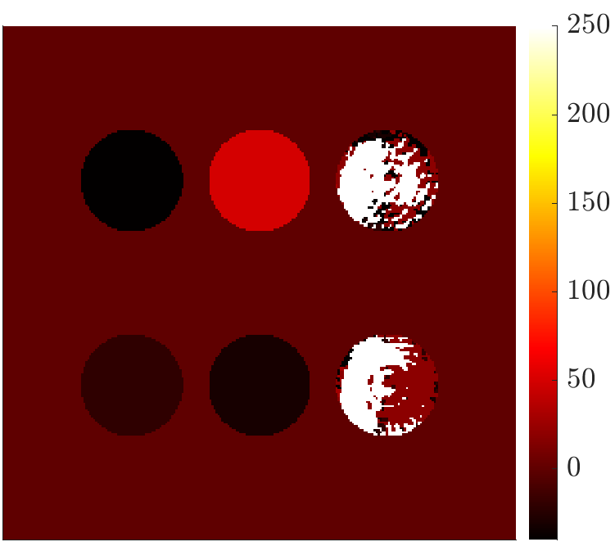

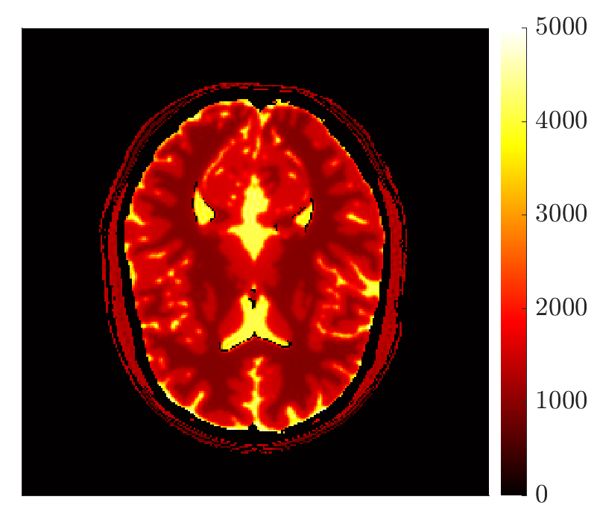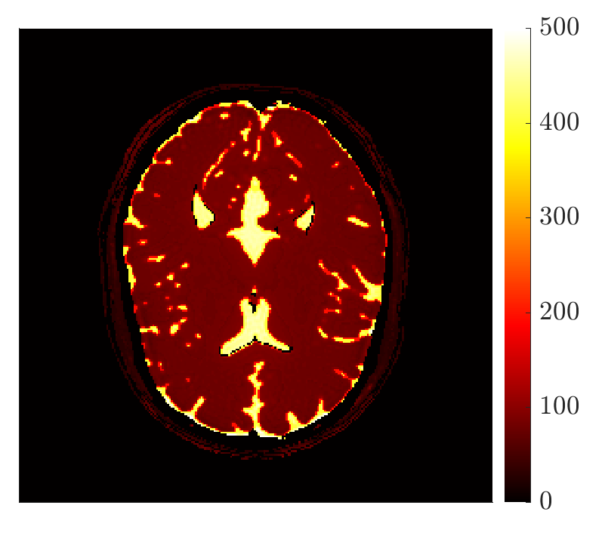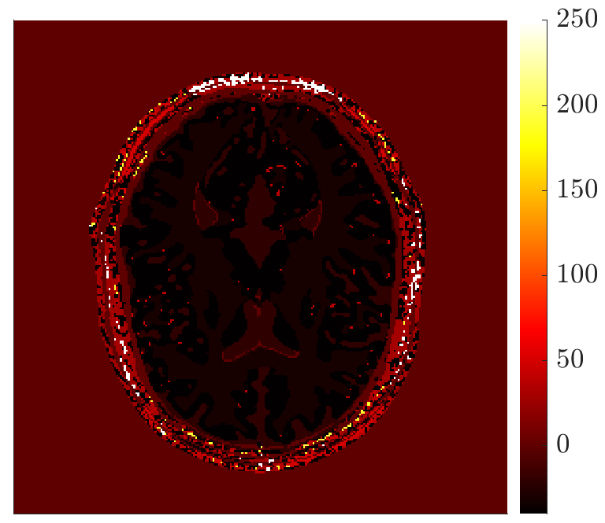

T1 map T2 map df map

Maps generated after pattern matching for custom (top row) and brain (bottom row) phantoms.