The Missing Trophy Styling Plan

Overall vibe and tone
Quiet, mysterious, simple. I want the game to feel like exploring an empty school after class. A slightly eerie mood will make players curious about the missing trophy. The design will stay simple so they can focus on clues and conversations.

Inspiration websites
Nancy Drew Warnings at Waverly Academy — inspiration for a school mystery setting.
Rusty Lake — inspiration for a quiet, eerie atmosphere while exploring rooms.

Fonts
Title: Special Elite for a detective typewriter feel.
Body and buttons: Open Sans for clear, easy reading. Both are on Google Fonts.

Color scheme
Dark blue gray #1F2937 for the background.
Cream #F5F1E8 for text.
Gold #D4A017 for buttons, with dark blue gray labels, to match the trophy.

Layout
One centered column, with the image and story above stacked choice buttons.
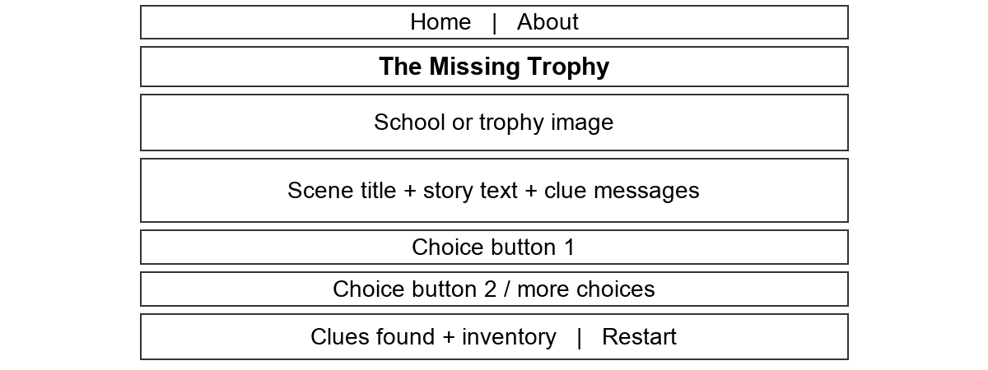

Basic font accessibility
Use at least 18px for body text, 16px for buttons, and 32px for the title. Keep paragraphs left aligned with 1.5 line spacing. Use Special Elite only for the main title and Open Sans for everything else.
Cream on dark blue gray has about 13:1 contrast. Dark labels on gold have about 6.2:1. Both exceed the 4.5:1 text contrast minimum. Keep text on solid backgrounds.

