
Information Technology Division

Medicaid Enterprise Systems
Data Lake Implementation

Version 0.01
May 16, 2022

Version Summary
Version | Date | Version Summary | Prepared by
0.01 | 05/16/2022 | Draft | Michael Kagori

Table of Contents
Introduction 4
What is a data lake? 4
Why do you need a data lake? 4
Data lake architecture: Hadoop, AWS, and Azure 5
Data lakes on google cloud 5
Hadoop 6
Data lakes on AWS 7

Data lakes on Azure 8
Azure data lake vs AWS data lake 9

Cloud portability in AWS vs Azure Vs GCP 10
- Market Shares and Growth Rate 11
- Clients 12
- Services 12
- Key Cloud Tools 15
- Hybrid and Multi Cloud Options 16
- Pricing 17

Data Lakes comparison 18
Data Lakes compared to Data Warehouses 19
Cloud data lakes or on-premises? 20
Data Lakes vs Data Lakehouse vs Data Warehouses 21

The essential elements of a Data Lake and Analytics solution 22
What are some data lake use cases? 23
What are the benefits of a data lake? 24
Data lake challenges 25
How a lake house solves those challenges 26

INTRODUCTION

What is a data lake?
A data lake is a centralized repository that allows you to store all your structured and unstructured data at any scale. You can store your data as-is, without having to first structure the data, and run different types of analytics—from dashboards and visualizations to big data processing, real-time analytics, and machine learning to guide better decisions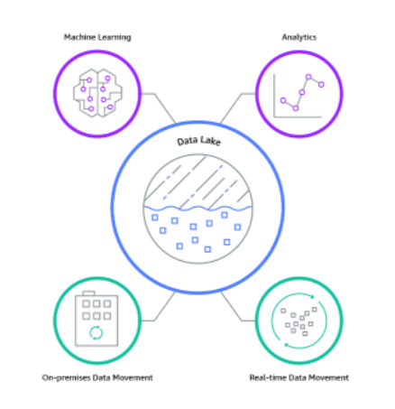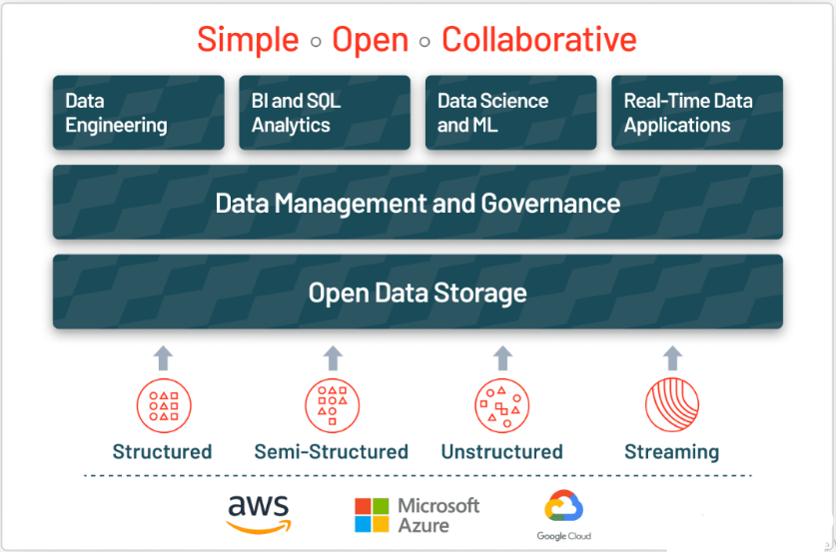

Why do you need a data lake?
Medicaid Data Lake (MDL) solutions are essential to achieving the State’s near-term goals for a Medicaid Data Warehouse and Analytics Solution (MDWAS). The State of Vermont, Agency of Digital Services (ADS) is currently working on Medicaid Data Lake (MDL) and Data Analytics and Reporting (DAR) capabilities with a goal of achieving the State’s near-term goals for a Medicaid Data Warehouse and Analytics Solution (MDWAS). This evidently show data lake has been adopted by different states and is proving to assist in optimizing State’s near-term goals for a Medicaid Data Warehouse and Analytics Solution (MDWAS).

Data lake architecture: Google cloud, Hadoop, AWS, and Azure

It’s important to remember that there are two components to a data lake: storage and compute. Both storage and compute can be located either on-premises or in the cloud. This results in multiple possible combinations when designing a data lake architecture.

Organizations can choose to stay completely on-premises, move the whole architecture to the cloud, consider multiple clouds, or even a hybrid of these options.

There is no single recipe here. Depending on the needs of an organization, there are several good options.

Data lakes on google cloud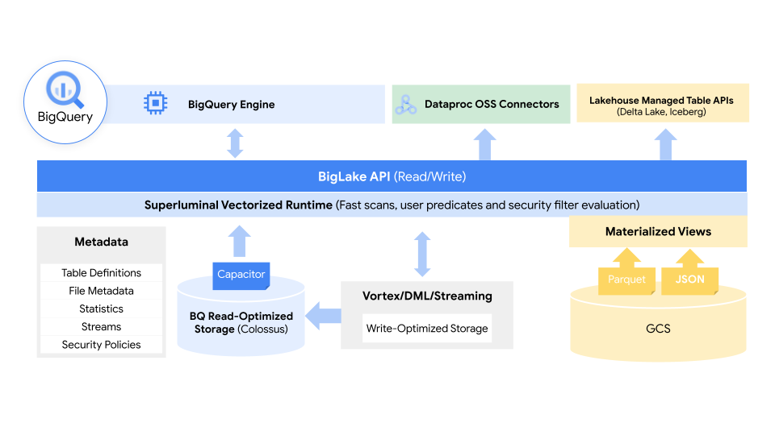

BigLake is built on BigQuery (BQ) and allows you to seamlessly analyze files of familiar formats (CSV, JSONL, Avro, Parque and ORC) that can be distributed in different cloud storage systems (GCP – cloud storage, AWS S3, Azure – Blob Storage) all from a centralized location. This allows for a single source of data “truth” across multiple cloud platforms without the need to duplicate or copy your data. As mentioned above, BigLake can also take advantage of BigQuery’s row- and column-level security, enabling you to share sensitive files the way you want to.

Using policy tags, BigLake allows admins to configure their security policies at the table, row and column level. This includes data stored in Google Cloud Storage, as well as the two supported third-party systems, where BigQuery Omni, Google’s multi-cloud analytics service, enables these security controls. Those security controls then also ensure that only the right data flows into tools like Spark, Presto, Trino and TensorFlow (Lardinois, 2022). The service also integrates with Google’s Dataplex tool to provide additional data management capabilities.

Google notes that BigLake will provide fine-grained access controls and that its API will span Google Cloud, as well as file formats like the open column-oriented Apache Parquet and open-source processing engines like Apache Spark.

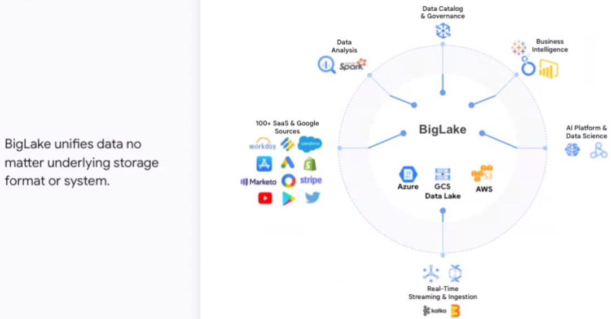

BigLake extends Google Cloud’s BigQuery data warehouse functions to data lakes on Google Cloud Storage, uses an API interface for greater access control on Google Cloud and open formats, such as Parquet, and open source processing engines, like Apache Spark. It eliminates what Kazmaier called the “artificial separation between managed warehouses and data lakes.”

BigLake, which is available in preview, is one of a number of new offerings and enhancements that Google Cloud is rolling out at the event that leverage the work the organization has done over the years with such data tools as BigQuery, Vertex AI – a collection of services for enabling enterprises to build and manage machine learning workloads – the Spanner distributed SQL database management and storage service and the Looker business intelligence platform.

Strengths
- Gather all of your raw data in Cloud Storage
- Use tools like the messaging service Cloud Pub/Sub or beam pipelines in Cloud Dataflow to extract, transform and load (ETL) data from Cloud Storage to a different serving layer (or back to Cloud Storage). Leverage the fact that you can access all the information of your company in one place and think creatively about what you can do with your unstructured data (How to build a Data Lake on google cloud platform: Cloud summit 2019 2021).
- Leverage this data in your serving layers. An example for such a serving layer could be a data mart. Present the data in the data mart to its end users and allow them to gain better insights with tools like Data Studio and Looker. Use this to improve your customer experience, gain profit and make your organization more efficient.

Hadoop

Many people associate Hadoop with data lakes.

A Hadoop cluster of distributed servers solves the concern of big data storage. At the core of Hadoop is its storage layer, HDFS (Hadoop Distributed File System), which stores and replicates data across multiple servers. YARN (Yet Another Resource Negotiator) is the resource manager that decides how to schedule resources on each node. MapReduce is the programming model used by Hadoop to split data into smaller subsets and process them in its cluster of servers.

Other than these three core components, the Hadoop ecosystem comprises several supplementary tools such as Hive, Pig, Flume, Sqoop, and Kafka that help with data ingestion, preparation, and extraction. Hadoop data lakes can be set up on-premises as well as in the cloud using enterprise platforms such as Cloudera and HortonWorks. Other cloud data lakes such as Azure wrap functionalities around the Hadoop architecture.

Strengths:
- More familiarity among technologists
- Less expensive because it is open-source
- Many ETL tools available for integration with Hadoop
- Easy to scale
- Data locality makes computation faster

Data lakes on AWS

AWS has an exhaustive suite of product offerings for its data lake solution.

Amazon Simple Storage Service (Amazon S3) is at the center of the solution providing storage function. Kinesis Streams, Kinesis Firehose, Snowball, and Direct Connect are data ingestion tools that allow users to transfer massive amounts of data into S3. There is also a database migration service that helps migrate existing on-premises data to the cloud.

In addition to S3, there is DynamoDB, a low-latency No-SQL database, and Elastic Search, a service that provides a simplified mechanism to query the data lake. Cognito User Pools define user authentication and access to the data lake. Services such as Security Token Service, Key Management Service, CloudWatch, and CloudTrail ensure data security. For processing and analytics, there are tools such as RedShift, Quick Sight, EMR, and Machine Learning.

The huge list of products offerings available from AWS come with a steep initial learning curve. However, the solution’s comprehensive functionalities find extensive use in business intelligence applications.

Strengths:
- Exhaustive and feature-rich product suite
- Flexibility to pick and choose products based unique requirements
- Low costs
- Strong security and compliance standards
- Separation of compute and storage to scale each one as needed
- Collaboration with APN (AWS Partner Network) firms such as Talend ensures seamless AWS onboarding

Data lakes on Azure

Azure is a data lake offered by Microsoft. It has a storage and an analytics layer; the storage layer is called as Azure Data Lake Store (ADLS) and the analytics layer consists of two components: Azure Data Lake Analytics and HDInsight.

ADLS is built on the HDFS standard and has unlimited storage capacity. It can store trillions of files with a single file larger than one petabyte in size. ADLS allows data to be stored in any format and is secure and scalable. It supports any application that uses the HDFS standard. This makes migration of existing data easier, and also facilitates plug-and-play with other compute engines.

HDInsight is a cloud-based data lake analytics service. Built on top of Hadoop YARN, it allows data to be accessed using tools such as Spark, Hive, Kafka, and Storm. It supports enterprise-grade security due to integration with Azure Active Directory.

Azure Data Lake Analytics is also an analytics service, but its approach is different. Rather than using tools such as Hive, it uses a language called U-SQL, a combination of SQL and C#, to access data. It is ideal for big data batch processing as it provides faster speed at lower costs (pay only for the jobs used).

Strengths:
- Both storage and compute in the cloud makes it simple to manage.
- Strong analytical services with powerful functionalities
- Easy to migrate from an existing Hadoop cluster
- Many big data experts are familiar with Hadoop and its tools, so it is easy to find skilled manpower.
- Integration with Active Directory ensures no separate effort to manage security

Azure data lake vs AWS data lake
 | Azure | AWS
Platforms Supported | Windows | SaaS
Audience | Developers, data scientist and analytics seeking to store data | Organizations looking for a data lake solution
Support | Business Hours, 24/7 Live Support, Online | Online
Categories | Data Lake, Object Storage | Data Analysis, Data Lake, Data Management
Integrations | Alpine IQ, Apache Atlas  Apache Hudi, Apache Pinot, Azure Data Factory,  Azure Data Lake Analytics,  Azure Data Lake Storage,  Azure Databricks,  Azure Synapse Analytics,  Azure Virtual Machines | No integrations

Cloud portability in AWS Vs Azure Vs GCP

Cloud portability is the ability to move applications and data from one cloud computing environment to another with minimal disruption (AWS vs azure vs google cloud - detailed cloud comparison 2021). Cloud portability enables the migration of cloud services from one cloud provider to another or between a public cloud and a private cloud.

In 2018, Washington’s Health Care Authority (HCA) became America’s first agency to transition all its production MMIS applications and infrastructure into a public cloud. The results of the migration demonstrate how cloud computing can transform MMIS processes and improve the delivery of Medicaid benefits.

To understand why modernizing MMIS systems with cloud is important, GovLoop partnered with Amazon Web Services (AWS) and Client Network Services, Inc. (CNSI). AWS is an on-demand cloud platform provider, while CNSI is a health care IT solutions provider. HCA revitalized Washington’s Medicaid services by transferring its MMIS network to a CNSI platform based in AWS’s public cloud.

An in-depth investigation of the following was conducted in order to determine the most optimal cloud service:
- Market Shares and Growth Rate
- Clients
- Services
- Key Cloud Tools
- Hybrid and Multi Cloud Options
- Pricing
- Pros and Cons
- Regions
- Availability
- High-Profile Customers
- Containers and serverless
- Big data, analytics, and machine learning
- Security and compliance
- Support and user-friendliness
- Partnership ecosystems

Market Shares and Growth Rate
According to the reported quarterly earnings for 2021, Microsoft’s Azure cloud revenue has been observed to, once again, outperform both AWS and Google Cloud combined.
In spite of the Goliath-like stature of Amazon’s AWS, Microsoft’s Azure cloud outperformed its competitors with its US$17.7 billion (50% revenue growth over the previous quarter) in commercial-cloud revenue as per the fiscal earnings report. While Amazon’s AWS reported US$13.5 billion in cloud business revenue for the quarter (revenue grew 32% in the quarter), Google Cloud had a modest US$4.05 billion.
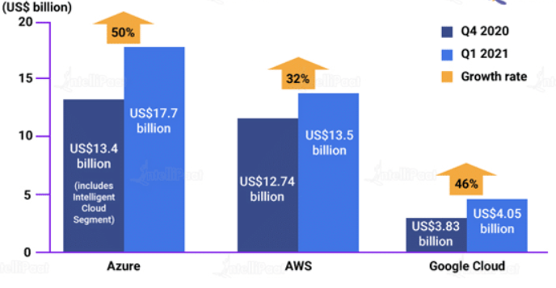

Reports by Canalys mentions that as of April 2021, the global cloud market grew 35% this quarter to $41.8 billion. AWS covers 32% of the market, followed by Azure at 19% and Google at 7%.

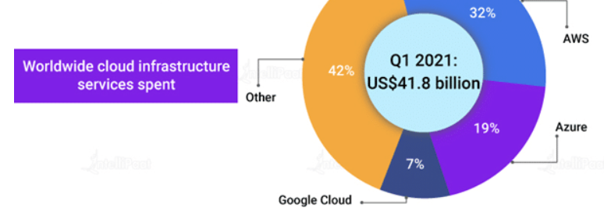

Clients

AWS
Since AWS is the oldest player in the cloud market, it comparatively has a bigger community support and user base. Therefore, AWS has more high-profile and well-known customers like Netflix, Airbnb, Unilever, BMW, Samsung, MI, Zynga, etc.

Azure
Azure is also gaining its share of high-profile customers with time. As of now, Azure has almost 80 percent of Fortune 500 companies as its customers. Some of its major customers are Johnson Controls, Polycom, Fujifilm, HP, Honeywell, Apple, etc.

Google
Google, on the other hand, shares the same infrastructure as that of Google Search and YouTube and, as a result, many high-end companies have put their faith in Google Cloud. Major clients of Google Cloud are HSBC, PayPal, 20th Century Fox, Bloomberg, Dominos, and more.

Services
AWS offers around 200+ services, whereas Azure offers up to 100+ services. Google Cloud, on the other hand, is catching up with Azure and AWS offering around 60+ services.

Compute Services

Services | AWS | Azure | GCP
IaaS | Amazon Elastic Compute Cloud | Virtual Machines | Google Compute Engine
PaaS | AWS Elastic Beanstalk | App Service and Cloud Services | Google App Engine
Containers | Amazon Elastic Compute Cloud Container Service | Azure Kubernetes Service (AKS) | Google Kubernetes Engine
Serverless Functions | AWS Lambda | Azure Functions | Google Cloud Functions

Database Services

Services | AWS | Azure | GCP
RDBMS | Amazon Relational Database Service | SQL Database | Google Cloud SQL
NoSQL: Key–Value | Amazon DynamoDB | Table Storage | Google Cloud DatastoreGoogle Cloud Bigtable
NoSQL: Indexed | Amazon SimpleDB | Azure Cosmos DB | Google Cloud Datastore

Storage Services

Services | AWS | Azure | GCP
Object Storage | Amazon Simple Storage Service | Blob Storage | Google Cloud Storage
Virtual Server Disks | Amazon Elastic Block Store | Managed Disks | Google Compute Engine Persistent Disks
Cold Storage | Amazon Glacier | Azure Archive Blob Storage | Google Cloud Storage Nearline
File Storage | Amazon Elastic File System | Azure File Storage | ZFS/Avere

Networking Services

Services | AWS | Azure | GCP
Virtual Network | Amazon Virtual Private Cloud (VPC) | Virtual Networks (VNets) | Virtual Private Cloud
Elastic Load Balancer | Elastic Load Balancer | Load Balancer | Google Cloud Load Balancing
Peering | Direct Connect | ExpressRoute | Google Cloud Interconnect
DNS | Amazon Route 53 | Azure DNS | Google Cloud DNS

Service offerings from AWS, Azure, and GCP that come under the domains other than those discussed above can be found by clicking on the link below. Comparison.
The link provide information on available Google Cloud services and maps them to similar offerings in Amazon Web Services (AWS) and Microsoft Azure. You can filter the table with keywords, such as a service type, capability, or product name.

Key Cloud Tools

AWS Key Tools

Artificial Intelligence and Machine learning
From its list of diversified AI-oriented services, AWS offers DeepLens, an AI-powered camera for developing and deploying machine learning algorithms to use them for optical character recognition and image or object recognition. AWS has announced an open-source deep learning library called Gluon, which can be utilized by developers and non-developers to quickly build neural networks without any knowledge of AI.
SageMaker to Severless
AWS has a long list of services in the areas of machine learning and AI. AWS’s list of services also includes SageMaker, which is used to train and deploy machine learning models. It also has the Lex conversational interface that powers Alexa services, Greengrass IoT messaging service, and Lambda serverless computing service.

Azure Key Tools
Cognitive Services
Heavily investing in the fields of machine learning and AI, Microsoft offers machine learning and a bot service on Azure. Apart from this, it also has cognitive services that include Bing Web Search API, Text Analytics API, Face API, Computer Vision API, and Custom Vision Service. Furthermore, for IoT, Microsoft has several management and analytics services, and its serverless computing service is known as Functions.
Supporting MSFT Software
Azure has several tools that help in supporting on-premises Microsoft software. Azure Backup is a service that links Windows Server Backup, in Windows Server 2012 R2, and Windows Server 2016. Visual Studio Team Services hosts Visual Studio projects on Azure.

Google Cloud Key Tools
IoT to Serverless
Out of all the advanced technologies, Google Cloud has offerings in APIs for natural language, speech, translation, and more. In addition to these offerings, it offers IoT and serverless services but beta previews.
Big On AI
Google Cloud is currently the leader in AI development. The credit of which goes to TensorFlow, an open-source software library for building machine learning applications. TensorFlow is highly popular among developers.

Comparison:

Vendor | AL/ML | IoT | Serverless
AWS | •Comprehend •Lex •Polly •Rekognition •Machine Learning •Translate •Transcribe •DeepLens •Deep Learning AMIs •SageMaker •Apache MXNet on AWS •TensorFlow on AWS | •IoT Core •FreeRTOS •Greengrass •IoT 1-Click •IoT Analytics •IoT Button •IoT Device Defender •IoT Device Management | •Lambda •Serverless Application Repository
Azure | •Machine Learning •Azure Bot Service •Cognitive Services | •IoT Hub •IoT Edge •Stream Analytics •Time Series Insights | •Functions
Google Cloud | •Cloud Machine Learning Engine •Dialogflow Enterprise Edition •Cloud Natural Language •Cloud Speech API •Cloud Translation API •Cloud Video Intelligence •Cloud Job Discovery (Private Beta) | •Cloud IoT Core (Beta) | •Cloud Functions (Beta)

Hybrid and Multi Cloud Options
All three vendors are not yet significantly into hybrid and multi cloud offerings, but offer different tools to give customers more flexibility.

AWS Hybrid and Multi Cloud

AWS Snowball
- AWS Snowcone
- AWS Outposts
- AWS Local Zones
- VMware Cloud on AWS
- AWS Wavelength
- Amazon ECS Anywhere

Azure Hybrid And Multi Cloud
- Azure Arc
- Azure Backup
- Azure Active Directory
- Azure Security Center
- Azure Blob Storage
- Azure Stack
- Azure Centinel

Google Cloud Hybrid and Multi Cloud
- Anthos
- Traffic Director
- Looker
- Cloud Build
- Operations
- Cloud Run for Anthos

Pricing
Following is a comparison among the pricing models of AWS, Azure, and GCP on the basis of the machine type that they offer:
Machine Type | AWS | Azure | GCP
Smallest Instance | In the case of AWS, a very basic instance that includes 2 virtual CPUs and 8 GB of RAM will cost you around US$69 per month. | For the same type of instance, i.e., an instance with 2 vCPUs and 8 GB of RAM, in Azure, will cost you around US$70/month. | Compared to AWS, GCP will provide you the most basic instance, containing 2 virtual CPUs and 8 GB of RAM at a 25 percent cheaper rate. So, it will cost you around US$52/month.
Largest Instance | The largest instance offered by AWS that includes 3.84 TB of RAM and 128 vCPUs will cost you around US$3.97/hour. | The largest instance offered by Azure includes 3.89 TB of RAM and 128 vCPUs. It costs around US$6.79/hour. | GCP takes the lead here with its largest instance that includes 3.75 TB of RAM and 160 vCPUs. It will cost you around US$5.32/hour.

Data Lakes compared to Data Warehouses – two different approaches
Depending on the requirements, a typical organization will require both a data warehouse and a data lake as they serve different needs, and use cases.
A data warehouse is a database optimized to analyze relational data coming from transactional systems and line of business applications. The data structure, and schema are defined in advance to optimize for fast SQL queries, where the results are typically used for operational reporting and analysis. Data is cleaned, enriched, and transformed so it can act as the “single source of truth” that users can trust.
A data lake is different, because it stores relational data from line of business applications, and non-relational data from mobile apps, IoT devices, and social media. The structure of the data or schema is not defined when data is captured. This means you can store all of your data without careful design or the need to know what questions you might need answers for in the future. Different types of analytics on your data like SQL queries, big data analytics, full text search, real-time analytics, and machine learning can be used to uncover insights.
As organizations with data warehouses see the benefits of data lakes, they are evolving their warehouse to include data lakes, and enable diverse query capabilities, data science use-cases, and advanced capabilities for discovering new information models. Gartner names this evolution the “Data Management Solution for Analytics” or “DMSA.”

Data Warehouse vs Data Lake
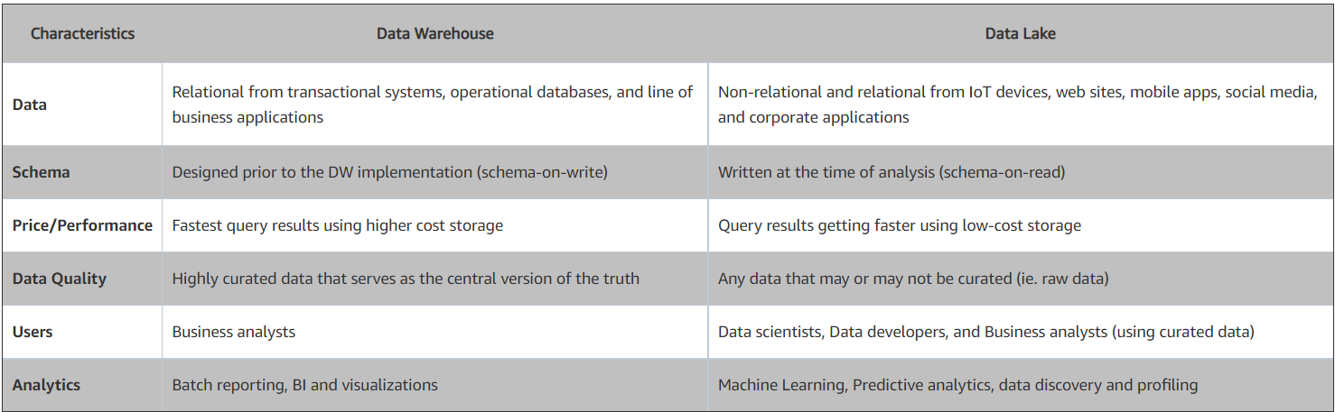

Cloud data lakes or on-premises?
Data lakes are traditionally implemented on-premises, with storage on HDFS and processing (YARN) on Hadoop clusters. Hadoop is scalable, low-cost, and offers good performance with its inherent advantage of data locality (data and compute reside together).
However, there are challenges to creating an on-premises infrastructure:
- Space — Bulky servers occupy real-estate that translates to higher costs.
- Setup — Procuring hardware and setting up data centers isn’t straightforward and can take weeks or months to take off.
- Scalability — If there is a need to scale up the storage capacity, it takes time and effort, due to increased space requirement and cost approvals from senior execs.
- Estimating requirements — Since scalability isn’t easier on-premises, it becomes important to estimate the hardware requirements correctly at the beginning of the project. As data grows unsystematically every day, this is a tough feat to achieve.
- Cost — Cost estimations have proven to be higher on-premises than the cloud alternatives.
Cloud data lakes, on the other hand, help overcome these challenges. A data lake in the cloud is:
- Easier and quicker to get started. Rather than a big bang approach, the cloud allows users to get started incrementally.
- Cost-effective with a pay-as-you-use model.
- Easier to scale up as needs grow, which eliminates the stress of estimating requirements and getting approvals.

Building a lake house with Delta Lake
To build a successful lake house, organizations have turned to Delta Lake, an open format data management and governance layer that combines the best of both data lakes and data warehouses. Across industries, enterprises are leveraging Delta Lake to power collaboration by providing a reliable, single source of truth. By delivering quality, reliability, security and performance on your data lake — for both streaming and batch operations — Delta Lake eliminates data silos and makes analytics accessible across the enterprise. With Delta Lake, customers can build a cost-efficient, highly scalable lake house that eliminates data silos and provides self-serving analytics to end users.

Azure data lake vs AWS data lake

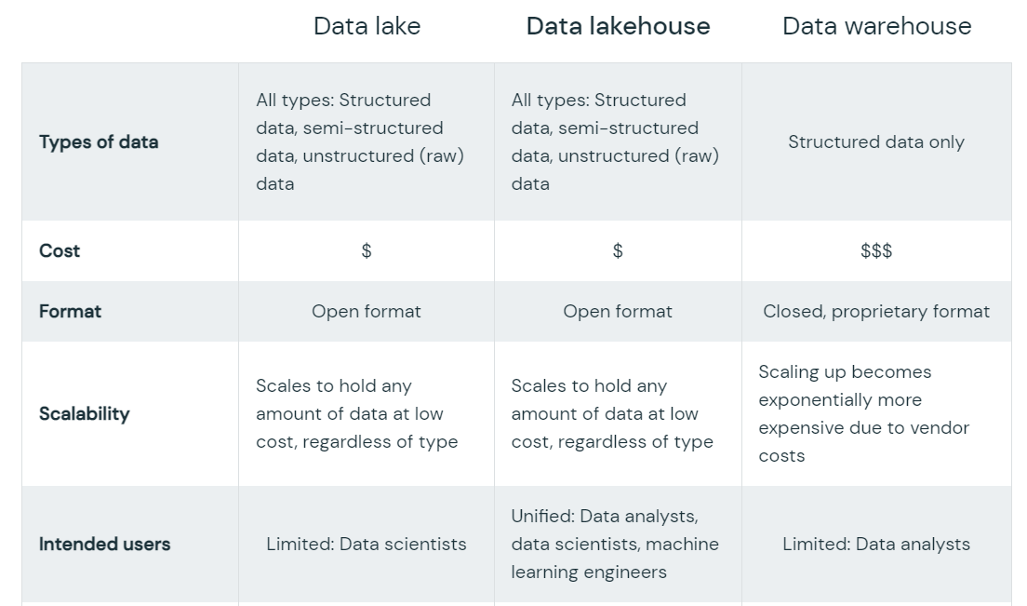
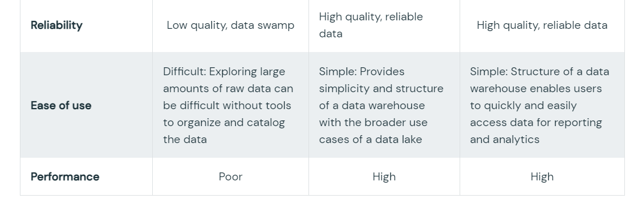

The essential elements of a Data Lake and Analytics solution
As organizations are building Data Lakes and an Analytics platform, they need to consider a number of key capabilities including:
Data movement
Data Lakes allow you to import any amount of data that can come in real-time. Data is collected from multiple sources, and moved into the data lake in its original format. This process allows you to scale to data of any size, while saving time of defining data structures, schema, and transformations.
Securely store, and catalog data
Data Lakes allow you to store relational data like operational databases and data from line of business applications, and non-relational data like mobile apps, IoT devices, and social media. They also give you the ability to understand what data is in the lake through crawling, cataloging, and indexing of data. Finally, data must be secured to ensure your data assets are protected.

Analytics
Data Lakes allow various roles in your organization like data scientists, data developers, and business analysts to access data with their choice of analytic tools and frameworks. This includes open source frameworks such as Apache Hadoop, Presto, and Apache Spark, and commercial offerings from data warehouse and business intelligence vendors. Data Lakes allow you to run analytics without the need to move your data to a separate analytics system.

What are some data lake use cases?
Analyze Electronic health records
Electronic health records are one of the most common use cases for big data in healthcare. EHRs track and record your patient's health data like pre-existing conditions and allergies, reducing the need for unnecessary tests and the associated costs. Sharing patient data between healthcare providers as they treat patients can reduce duplicate tests and improve patient care. However, medical data is usually siloed due to security reasons, but big data and analytics for EHR data can improve the quality of care while reducing costs.
Deploy evidence-based medicine
When a patient is admitted to a hospital, doctors usually run a battery of tests to identify the symptoms and the underlying disease. Evidence-based medicine enables healthcare providers to gather evidence of a patient's health and compare the symptoms to a bigger patient database, enabling faster, more accurate, and effective diagnosis and treatment. Big data helps consolidate and analyze information from this large patient database generated from multiple, disparate sources.
Reduce Hospital readmission.
Hospitals’ costs increase due to high patient readmission rates within a
month of release. Using big data, healthcare providers can identify at-risk
patients based on patient trends, medical history, diagnostic information,
and real-time data from medical equipment. Hospitals can then offer these
patients a lower readmission rate, allowing patients to focus on their
treatment instead of their healthcare expenses.
Detect and prevent fraud.
In the US alone, the National Healthcare Anti-Fraud Association estimates
the loss to health care fraud to be about $80 billion annually, accounting for
around 3 to 10 percent of the total annual spending on healthcare. Fraud in
healthcare can range from genuine errors in billings to false claims that
result in wrong payments. Hospitals have to store and navigate through
massive amounts of claims, billings, and other information. Due to the
volume, velocity, and variety of data, claim verification and processing could
take weeks or months. Detecting fraud and collecting evidence for legal
action also take a long time and could result in huge financial losses for the
organization. Big data analytics can help detect anomalies much faster and
notify you instantly. significantly reducing the potential for healthcare fraud.
Provide real time information
Physicians need access to real-time information about their patients to
improve patient care — including their visits to an emergency room, length of
hospital stay, new diagnoses, progress in treatment, etc. These real-time
insights are derived from data collected using technologies like loT sensors,
which can optimize the hospital's clinical, business, and administrative
workflows. Using big data and advanced analytics, you can analyze real-
time information to enable proactive patient care and ensure data-driven
decision-making, improving the quality of care, and lowering costs.
Optimize supply chain process
Hospitals spend almost one-third of their overall operating expenses on
managing their supply chains. Big data plays a major role across the
healthcare supply chain from placing the order, to order fulfillment and
invoicing. Real-time visibility into supply chain operations can help hospitals
avoid supply round-tripping and wastage that are both expensive and affect
care delivery. You can also use supply chain data combined with procedural
data to improve your forecasting capabilities, ensuring that products are
available at the right time, at the right place, and at the right cost. Analyzing
supply chain data can also help automate routine procurement tasks to free
up staff to focus on strategic initiatives.
Predicting HealthCare Cost
Typical analysis of healthcare data comes from reports or dashboards
developed against the EDW, which had extracted data from electronic
health records (EHR) that are commonly found in electronic medical
records (EMR) systems or in an EDW. The records (or facts) are cast
against dimensions such as time, place, diagnosis, or treatment category
where observations are measured performances that have a velocity or
rate of change based on past measurements.

With the advent of a data lake strategy, providers and health plans are
attempting to enrich their data and predict patterns of risk or greater cost
using an expanded data set. These new predictive measurements can
show a higher degree of relevance with added values. Advanced users
incorporate the new models into actionable change with factors that are
not always found in an EHR. for example patient-generated data or
personal health records (PHR).

What are the benefits of a data lake?
- Improved Outcomes

Big data analytics can improve the quality of patient care and safety levels by providing access to real-time patient information, reducing the possibility of human error and wrong diagnosis.

- Increase Operational Effencies

Combining your data from multiple sources improves visibility into resource utilization, inventory levels, and procurement, enabling you to improve cost efficiencies, minimize waste, reduce risks, and streamline their operations.
- Better Decision Making Due To Improved Data Quality And Availability

The amount of data available to companies is growing rapidly and many companies collecting this data aren't prepared for the challenges involved in handling big data.

By integrating their Source System data with loT, they can improve data quality and availability, ensuring that any changes in asset health and utilization is directly reflected in the DSS system in real-time. All the concerned personnel will be notified of these events, enabling them to use this vital information to take immediate action as required.
- Real-Time Business Insights

Integrating ERP with loT data helps organizations to gain vital business insights instantaneously. The continuous stream of data from loT sensors and devices allows businesses to perform real-time analysis, helping them gain actionable insights to improve decision making. These actionable insights from loT data have the potential to transform your operations from a reactive to a proactive approach. You can also consider integrating ERP systems with Al and ML along with loT so that employees get the right suggestions at the right time, helping them make the right decisions.

DATA LAKES AND EVIDENCE-BASED CARE
- Evidenced-based care or practice (EBP) is the integration of clinical expertise, patient values, and the best research evidence into the decision-making process for patient care. Clinical expertise refers to a clinician's cumulative experience, education and clinical skills. The patient brings to the encounter his or her own personal preferences and unique concerns, expectations, and values. The best research evidence is usually found in clinically relevant research that has been conducted using sound methodology.
- A data lake represents a cost-effective platform for EBP. The term “evidence- based” implies that some types of evidence are sufficient to guide general analysis but fail to offer the desired level of clinical rigor required for a broader approach to multivariant analysis, drawing on data from several areas outside of the EHR. Resources of evidence include EHR/EMR systems (reflecting internal-based records), clinical or trial published research (datasets, publications, and sometimes programs), government assets (surveys, publications, collective libraries), genomic research (GEO datasets and profiles), and of course PHR (patient-reported data, family medical history.

Data lake challenges
Despite their pros, many of the promises of data lakes have not been realized due to the lack of some critical features: no support for transactions, no enforcement of data quality or governance, and poor performance optimizations. As a result, most of the data lakes in the enterprise have become data swamps.
Reliability issues
Without the proper tools in place, data lakes can suffer from data reliability issues that make it difficult for data scientists and analysts to reason about the data. These issues can stem from difficulty combining batch and streaming data, data corruption and other factors.
Slow performance
As the size of the data in a data lake increases, the performance of traditional query engines has traditionally gotten slower. Some of the bottlenecks include metadata management, improper data partitioning and others.
Lack of security features
Data lakes are hard to properly secure and govern due to the lack of visibility and ability to delete or update data. These limitations make it very difficult to meet the requirements of regulatory bodies.

For these reasons, a traditional data lake on its own is not sufficient to meet the needs of businesses looking to innovate, which is why businesses often operate in complex architectures, with data siloed away in different storage systems: data warehouses, databases and other storage systems across the enterprise. Simplifying that architecture by unifying all your data in a data lake is the first step for companies that aspire to harness the power of machine learning and data analytics to win in the next decade.

How a lake house solves those challenges
The answer to the challenges of data lakes is the lake house, which adds a transactional storage layer on top. A lake house that uses similar data structures and data management features as those in a data warehouse but instead runs them directly on cloud data lakes. Ultimately, a lake house allows traditional analytics, data science and machine learning to coexist in the same system, all in an open format.
A lake house enables a wide range of new use cases for cross-functional enterprise-scale analytics, BI and machine learning projects that can unlock massive business value. Data analysts can harvest rich insights by querying the data lake using SQL, data scientists can join and enrich data sets to generate ML models with ever greater accuracy, data engineers can build automated ETL pipelines, and business intelligence analysts can create visual dashboards and reporting tools faster and easier than before. These use cases can all be performed on the data lake simultaneously, without lifting and shifting the data, even while new data is streaming in.

References
Lardinois, F. (2022, April 6). Google cloud cross-platform data storage engine, BigLake. TechCrunch. Retrieved May 24, 2022, from https://techcrunch.com/2022/04/05/google-cloud-launches-biglake-a-new-cross-platform-data-storage-engine/
How to build a Data Lake on google cloud platform: Cloud summit 2019. Devoteam G Cloud. (2021, December 6). Retrieved May 24, 2022, from https://gcloud.devoteam.com/blog/how-to-build-a-data-lake-on-google-cloud-platform-cloud-summit-2019/

