
Information Technology Division

Medicaid Enterprise Systems
Data Standards

Version 0.01
May 23, 2022

Version Summary
Version | Date | Version Summary | Prepared by
0.01 | 05/16/2022 | Draft | Michael Kagori

Table of Contents
Introduction 3
Purpose 4
Scope 5
Data Standard Overview 5
Benefits of Data Standard 6
Scope of data standard 7
Developing Data Standard 8
Model-Based Standards 11
Health SDOs and Standards 13
Content Standard 14
HIPAA X12 Administrative Transactions but not limited to: 14
HIPAA Pharmacy Related Transactions and Processing 15
HL7-FHIR 16
Terminology/Vocabulary Standards 16
CPT 16

HCPCS 16
CDT 16

SNOMED –CT 17
LOINC 17
NDC 17
RxNorm 17
Transport standards 18
EDI 18
FHIR 18
NCPDP SCRIPT standard 18

Development Standards and Maintenance Organizations 18

Introduction

This section provides a discussion of the use of data standards by the Medicaid IT

Architecture’s (MITA) Information Architecture (IA). The lack of shared data standards is one

of the most important issues facing Medicaid system and subsystem interoperability. This

issue goes well beyond the Medicaid Enterprise to include the private sector and other

government agencies. It adversely affects Medicaid systems in many ways:

Creates the need for translators.

Constrains automated processes.

Reduces the potential of business processes that use shared data.

Requires duplicate data, resulting in poor quality and wasted physical storage.

Increases paperwork and data collection burdens.

Reduces the analytic potential of health data.

Reduces the analytic potential of program integrity data.

Reduces the capability for data sharing, which in turn limits the usefulness of data used

internally or externally (e.g., with trading partners, other State Medicaid Enterprises,

other agencies, etc.).

The MITA initiative coordinates the identification and use of common data standards for the

Medicaid Enterprise. It addresses the need for a consensus on common data vocabularies,

assurances of privacy, and other issues surrounding electronic transmission of information.

The topics covered in this chapter include:

Data Standards

Benefits of Using Data Standards

Scope of Data Standards

Developing Data standards

Business Scenarios Showing the Use of Standards

Model-Based Standards

Health Standard Development Organizations (SDOs) and Standards

Using Data Standards

Part II – Information Architecture Chapter 5 – Data Standards

Purpose

Data standards are critical to the successful transformation and evolution of the Medicaid

Enterprise. Data standards help ensure that implementations are interoperable and plugand-play capable. With participation by States, partners, and other stakeholders, data

standards become a tool to enable seamless interoperability and data sharing. State

Medicaid Enterprises benefit with lower costs through elimination of redundant or

unnecessary operations, improved outcomes, reduced errors through access to quality and

outcome information, and improved stakeholder satisfaction through self-service. Data

standards allow both a syntactic and semantic understanding of this information.

Scope

Reviewers should read this chapter in conjunction with the technology standards section

found in Part III, Chapter 6, Technology Standards. The Framework uses data standards

produced by Designated Standard Maintenance Organizations (DSMOs), whenever

available. If such standards are not available, the Centers for Medicare & Medicaid Services

(CMS) will support collaboration efforts with industry groups across standards organizations

where appropriate. CMS continues to collaborate with other federal agencies and industry

groups in harmonizing data standards across disparate groups. Because data standards are

quite dynamic, States should conduct a periodic review of the available data standards and

versions to keep the data standards current.

Data Standards

Data standards are necessary when two or more parties exchange information. Medicaid

infrastructure and information system investments are made with the assurance that timely

and reliable adoption of industry standards and productive use of those standards are part

of the investments. Industry standards promote reuse, data exchange, and reduction of

administrative burden on patients, providers, and applicants. CMS will communicate

applicable standards to states. Standards are updated periodically to ensure conformance

with changes in the industry. States will be required to update systems and practices to

adhere to evolving industry standards in order to remain eligible for enhanced Federal

Funding Participation (FFP) funding.

Exchange partners need to enable the sharing or exchange of information in a way that

guarantees the mutual understanding of what is the representation within that information.

States can use data standards for their automated or manual processes. The key elements

of a data standard are data element names, definitions, qualifiers, data types, relationships,

semantics, and contextual rules. From a business point of view, data standards represent

agreements on the format and description of the shared data used by the Medicaid

Enterprise. Data standards describe objects, features, or items collected, automated, or

affected by the business processes of a State Medicaid Enterprise.

Data standards fall into two major categories – structure data standards and vocabulary

data standards:

1. Structure data standards – Specify how to format or structure data. Because

messages and data stores (e.g., flat files and databases) use structure data standards,

this enables two or more computer applications to exchange data. Traditional data

standards have focused on the structural aspect of data standards (e.g., Electronic Data

Interchange (EDI) and Accredited Standards Committee (ASC X12).

2. Vocabulary data standards – Conversely, deal with the content of the data elements

(i.e., the semantics of the data). Vocabulary data standards enable systems to

understand the meaning of the data. An example of a vocabulary data standard is the

International Classification of Diseases, Tenth Edition, Clinical Modification (ICD-10-

CM).

The IA focuses on both structure and vocabulary data standards in order to enable the

interoperability and distributed data-sharing objectives of the Medicaid Enterprise. To

facilitate the transition to these standards in as minimally a disruptive manner to the States

as possible, MITA defines the Medicaid Enterprise evolution across the MITA Maturity Model

(MMM) capability matrices for each of the architectures. The final maturity levels will support

seamless semantic operability of data and data sharing internally, as well as with external

partners.

Benefits of Using Data Standards

Historically, Medicaid has not taken full advantage of the efficiencies that some other

industries have achieved through EDI, the Internet, and process redesign and improvement.

The complexity and stovepipe nature of the current implementation of State Medicaid

Enterprises results in increased cost, lack of agility, and lack of interoperability. Although

payers and providers have used data standards for reimbursement for quite some time,

most of these standards differed depending on the parties with whom the State Medicaid

Agency (SMA) exchanged data. This problem will grow exponentially as Medicaid begins to

make use of Electronic Health Records (EHR) and shares data among State Medicaid

Enterprises and other groups as part of normal business processes. Consistent data

standards are an essential part of the Medicaid Enterprise realizing its vision of maturing

into a comprehensive knowledge-based network of interoperable systems capable of

providing information when and where necessary.

Some of the benefits of data standardization include the following:

Improvement in data availability to external users (e.g., public health and bioterrorism

detection) due to the seamless sharing of information.

Improvement in data quality and consistency, facilitating improvements in automation and

accuracy.

Identification of performance standards and evaluation plans to interact with communities

of interest for feedback of accessibility, ease of use, and appropriateness of decisions.

Reduction of medical errors, improving care quality and eliminating redundant costs with

standardized terminologies.

Improvement in consistency and efficiency of data collection, with a seamless flow of

information without the need for reformatting and transcription of the data.

Reduction of data redundancy (i.e., store data once in the enterprise or not at all, as in

the case of business processes that use data from an external enterprise).

Increased data comprehension.

Scope of Data Standards

The MITA Framework discusses the data standards used by data models and messages.

This chapter also addresses procedures for developing specific data standards, governance

procedures for data standards, repository information, and business cases. The following list

describes the scope of the data standards:

The Framework identifies the primary data needed by the defined MITA business process

and services. The data standards mapping includes the entities in the model.

The data standards are compatible with EHR and “meaningful use” standards. The data

standards are current with federal legislation and initiatives. Data standards do not map

to information for state-specific data and messages. The States are responsible for

supplementing the data standards with the information and interfaces required for unique

data messages.

Data standards associated with the physical data model, databases, and data files are

not a part of the MITA Framework. Each state is responsible for mapping or developing

data standards for its physical data model, databases, and files during implementation.

Developing Data Standards

The MITA team considers data standards using the following principles:

Identification of standards already in use by current Medicaid systems.

Alignment of data standards with data model entities/attributes and messages.

Development of new standards only when no alternatives exist.

MITA adopts harmonized data and standards where appropriate as developed or adopted for

use by the following entities:

American National Standards Institute (ANSI) ASC X12

Office of National Coordinator for Health Information Technology (ONC):

State-Level Health Initiatives – Initiatives designed to ensure that the efforts of

States and regional agencies achieve Health Information Exchange (HIE) align with

the national agenda.

Nationwide Health Information Network (NwHIN) – A collection of standards,

protocols, legal agreements, specifications, and services to enable secure Health

Information Exchange (HIE).

Federal Health Architecture (FHA) – An e-government line business initiative

responsible for the Federal Health Information Model (FHIM) that increases efficiency and effectiveness in all government operations. This includes the Veterans Health Information Model (VHIM) as the base.

Adoption – An initiative supporting two national health IT adoption surveys: one of physician offices, and one of hospitals.

Clinical Decision Support & the CDS Collaboratory – An initiative to provide

clinicians, staff, patients, or other individuals with knowledge and person-specific

information, intelligently filtered or presented at appropriate times, to enhance health

and health care.

Federal, State, Local, and Tribal Interagencies

International Classification of Diseases (e.g. ICD-10)

Industry/health care agencies (e.g., CMS, Social Security Administration (SSA))

Individual SMA

MITA adopts minimum standards that are usable by the maximum number of State Medicaid

Enterprises. Furthermore, MITA allows versioning of data standards and allocates the standard

to MITA maturity levels, enabling the data standard, along with technology and business

processes, to evolve over time as States progress along the MITA Maturity Model.

If the States determine there is a need for a new data standard, the MITA team will collaborate

with federal, state, and vendor representatives to support coordination with the National

Medicaid EDI Healthcare (NMEH) workgroups and Private Sector Technical Group Technical

Architecture Committee (PSTG-TAC) in submitting all standards to a SDO, whenever possible.

MITA uses data standards in developing business scenarios and models. The following

section describes these activities.

Business Scenarios Showing the Use of Standards

This section models the scenarios in which States exchange health care information. It

illustrates the importance of data standards, how they fit together, why they are of concern

for MITA, and how they contribute to the MITA distribution data-sharing infrastructure.

Additional information about particular standards is in Figure 5-1.

Figure 5-1. Scenarios Showing the Use of Data Standards
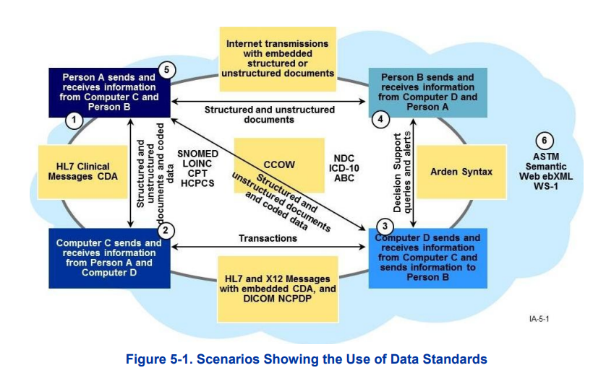

Model-Based Standards

To ensure interoperability of their artifacts, many information standards organizations derive

their emerging health care standards from models (or they are reverse engineering their

standards to models) such as the FHIM Reference Information Model (RIM) using Unified

Modeling Language (UML). This enables the SMA to create CPPs where it can describe its

conformance to a standard, any customizations, or constraints it has applied to the base

standard, and the effects of such customizations and constraints on interoperation with

other standard users. Profile owners can register their CPPs in registries so that potential

intra- or inter-enterprise trading partners can discover them and negotiate the CPAs

necessary to set up an information-exchange interface. The optimal interoperability among

interfaces require architecting data harmonization to a core model that supports refinements

for business-line specifications.

One of the key objectives for the modeling team is to utilize industry modeling standards to

assist with the sharing of knowledge while taking advantage of transformation technologies.

The Object Management Group (OMG) created UML and adopted Business Process Model

and Notation (BPMN) as modeling standards in the information technology industry.

The industry did not develop the ASC X12N and HL7 Version 3 message standards

according to precise rules from any core model. As a result, a harmonization process needs

to take place to synchronize structure and vocabulary data standards, along with data sets.

FHIM team is writing rules to transform models to the National Information Exchange Model

(NIEM), which is a national program supported by the Federal Government that provides a

community of users, tools, common terminology, governance, methodologies, and support

that enablers enterprise-wide information exchange. Once this is complete, it is the intent of

CMS to design and develop an information exchange model and tools that are fully

compliant with NIEM requirements as part of the Health Insurance Exchange (HIX),

Medicaid and CHIP operations. MITA supports the use of the related FHIM development

framework as the method that MITA users can demonstrate conformance to NIEM and

develop interfaces.

Figure 5-2 illustrates a life cycle in the development of model-based standards.
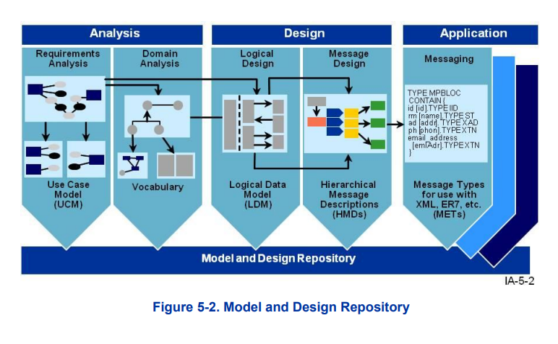

Health SDOs and Standards

This section discusses the key current and emerging health data standards, DSMOs, SDOs,

other standards including vocabulary domains and data sets, information structures for

communication, infrastructure and protocols, and lists other federal projects or programs.

Key Current and Emerging Health Data Standards

Health SDOs and the standards that they develop and maintain have existed for decades,

predating all electronic data exchange initiatives. Certain standards are so dominant that

they have become accepted nationally, and even internationally (e.g., the ICD or the

National Drug Codes (NDC)). Before HIPAA, the health care community adopted such

standards voluntarily, and individual payers were always free to redefine or create new

codes.

HIPAA changed this situation by mandating certain code sets. The legislation did not create

standards; rather, the HIPAA Transactions and Code Sets Rule adopted existing health care

standards. HIPAA mandates the data structure in that the transaction implementation guides

define internal codes in the implementation guides; however, outside organizations maintain

external code sets. In addition, the NwHIN has adopted clinical codes and information

structures. MITA references all HIPAA-mandated standards, including those that exist

currently as well as those that will exist in the near future.

Table 5-1 lists the DSMOs responsible for the major external medical codes required by

HIPAA, as well as, some major medical code maintenance organizations and other

standards development or advisory organizations that affect MITA.

Content Standards
Health Information Portability and Accountability Act (HIPAA X12 Administrative Transaction)
HIPAA X12 Administrative Transaction include Includes 837, 835, 270 or 271, 27B, 276 or 277, 834 or 820.
Managed by American National Standard Institute (ANSI) that created Accredited Standards Committee X12(ASC X12)
HIPAA X12 will be used primarily for interaction with external parties. Interaction between modules has not been established yet. Such a scenario is seen in sending authorization data to a claim’s module does not use 27B transaction. Claims data being sent does not use 837 Content.
Impact of HIPAA on Data Sharing Health Insurance Portability and Accountability Act
(HIPAA): is a federal law with specific requirements to maintain the privacy and security of “protected health information.” HIPAA applies to any data from a Covered Health Care Provider, Health Care Clearing House, or Health Information that is created, transmitted, stored or received.
This can include demographic information collected, including:
• Health data created by a health care provider, health plan, employer, or health care clearinghouse
• Data that identifies the individual
• Data relating to the past, present, or future physical or mental health or condition of an individual, the provision of health care to an individual, or the past, present, or future payment for the provision of health care to an individual.
When thinking about data sharing across NCDHHS, it is important to remember that we are a hybrid entity under HIPAA, meaning that not all Divisions and Offices are covered entities. This means that not all data owned by NCDHHS is subject to the requirements established under HIPAA.

HIPPA Pharmacy Related Transaction and Processing
HIPPA Pharmacy Related Transaction and Processing includes Telecommunication Standard Implementation Guide version D.0, Batch Standard Implementation Guide, Medicaid Subrogation Standard.
Governed by National Council for Prescription Drug Programs (NCPDP).
Pharmacy industry utilizes the X12 835(remittance advice),834 (enrollment),837(claim) and the 270/271 (eligibility).

HL7(Health Level Seven Version 2 (V2) and Version 3 (V3)
The HL7 Standard was created and is maintained by Health Level Seven, an American National Standards Institute (ANSI) accredited Standards Developing Organization (SDO) that operates in the healthcare arena.
The HL7 Standard is broadly divided into two categories – Version 2 (V2) and Version 3 (V3).
HL7 is also working on an emerging standard called HL7 Fast Health Interoperable Resources (FHIR).

Terminology/Vocabulary Standards
Current Procedural Terminology (CPT)
Current Procedural Terminology, more commonly known as CPT®, refers to a set of medical codes used by physicians, allied health professionals, nonphysician practitioners, hospitals, outpatient facilities, and laboratories to describe the procedures and services they perform.
Integral to billing medical services and procedures for reimbursement, CPT® is the language spoken between providers and payers.
Current Procedural Terminology is governed by American Medical Association (AMA).
HCPCS (Healthcare Common Procedure Coding System)
HCPCS is a collection of standardized codes that represent medical procedures, supplies, products and services. The codes are used to facilitate the processing of health insurance claims by Medicare and other insurers.
HCPCS is divided into two subsystems, Level I and Level II.
Current Dental Terminology (CDT)
Current Dental Terminology (CDT) is a reference manual published annually by Americans with Disabilities Act (ADA) and contains the Code on Dental Procedures and Nomenclature (CDT Code).
The CDT Code is a set of procedural codes for oral health and adjunctive services that are provided in dentistry.
Each procedural code consists of an alphanumeric character beginning with the letter “D” (the procedure code) and a title (the nomenclature). It also includes written narratives (descriptors) for some of the procedural codes.
The CDT Code categorizes codes by type of service: diagnostic, preventive, restorative, endodontics, periodontics, removable prosthodontics, maxillofacial prosthetics, implant services, fixed prosthodontics, oral and maxillofacial surgery, orthodontics and adjunctive general services. However, nothing in the CDT supports or indicates limitation of use by dentists — general dentists or specialists — to any categorical section(s) of the CDT Code.
SNOMED CT (Systematized Nomenclature of Medicine -- Clinical Terms)
SNOMED CT is one of suite of designated standards for use in U.S. Federal Government systems for the electronic exchange of clinical health information and is also a required standard in interoperability specifications of the U.S. Healthcare Information Technology Standards Panel.
The clinical terminology is owned and maintained by SNOMED International, a not-for-profit association.
Logical Observation Identifiers Names and Codes (LOINC)
Logical Observation Identifiers Names and Codes (LOINC) s clinical terminology that is important for laboratory test orders and results, and is one of a suite of designated standards for use in U.S. Federal Government systems for the electronic exchange of clinical health information.
New Drug Application (NDA)
The goals of the NDA are to provide enough information to permit Food and Drug Administration (FDA) reviewer to reach the following key decisions:

- Whether the drug is safe and effective in its proposed use(s), and whether the benefits of the drug outweigh the risks.
- Whether the drug's proposed labeling (package insert) is appropriate, and what it should contain.
- Whether the methods used in manufacturing the drug and the controls used to maintain the drug's quality are adequate to preserve the drug's identity, strength, quality, and purity.
New Drug Application (NDA) is managed by Food and Drug Administration (FDA).
RxNorm
RxNorm provides normalized names for clinical drugs and links its names to many of the drug vocabularies commonly used in pharmacy management and drug interaction software, including those of First Databank, Micromedex, and Gold Standard Drug Database.
By providing links between these vocabularies, RxNorm can mediate messages between systems not using the same software and vocabulary.
The NLM(National Library of Medicine), in consultation with the FDA and the HL7 Vocabulary Technical Committee, created RxNorm in 2001 to facilitate development of electronic medical records.

TRANSPORT STANDARDS
Electronic Data Interchange (EDI)
Electronic Data Interchange (EDI) is the electronic interchange of business information using a standardized format; a process which allows one company to send information to another company electronically rather than with paper.
Electronic Data Interchange (EDI) is used for all HIPAA Transactions.
Fast Healthcare Interoperability Resource (FHIR)
FHIR (Fast Healthcare Interoperability Resource) standard defines how healthcare information can be exchanged between different computer systems regardless of how it is stored in those systems.
The Fast Healthcare Interoperability Resource is a draft data standard developed and nurtured by HL7 International.
FHIR (Fast Healthcare Interoperability Resource) standard is required for CMS Interoperability use cases for phase 1 and beyond.
FHIR (Fast Healthcare Interoperability Resource) standard explores the possibility of using the model when using the data using APIs between modules.
NCPDP SCRIPT standard
The National Council for Prescription Drug Programs (NCPDP) SCRIPT standard covers electronic transfer of prescription data between retail pharmacies and prescribers for new prescriptions, prescription changes, prescription refill requests, prescription fill status notifications, and cancellation notifications.

Appendix A:

Development Standards and Maintenance Organizations

DSMO Organization | Purpose
American Dental Association (ADA)  (Statutory Advisory Group) | Works with others to develop and maintain the Code on Dental Procedures and Nomenclature (CDT).
Accredited Standards Committee (ASC) X12N – Insurance Subcommittee  (DSMO) (SDO) | Develops and maintains ASC X12N EDI and XML standards, standards interpretations, and guidelines as they relate to all aspects of insurance and insurance-related business processes.  Chartered by ANSI as a consensus-building organization.  Open to the public for input, but only paid members can vote.  Representation from CMS and State Medicaid Enterprises is increasing.  A Medicaid caucus held in conjunction with all ASC X12N meetings.
Dental Content Committee of the ADA (DeCC)  (DSMO) (DCC) | Sets standards for dental claim data content and maintains the CDT.  A committee of the ADA.
Health Level 7 (HL7)  (DSMO) (SDO) | Develops and publishes standards for communicating clinical information.  ANSI accredited.  It is developing standards for clinical and administrative information attached to claims.  Like ASC X12N, HL7 operates on a consensus basis.
National Council for Prescription Drug Programs (NCPDP)  (DSMO) (SDO) | Develops national standards for pharmacy payers and providers.  Industry specific and ANSI accredited.  Sets the standards for pharmacy claim transactions, claim status requests, and prior authorization requests. The Food and Drug Administration (FDA) is the custodian of the drug codes.
National Committee on Vital and Health Statistics (NCVHS)  (Statutory Advisory Group) | Acts as the public advisory body to Department of Health and Human Services (HHS) for health data and statistics.  Provides advice and assistance to HHS and serves as a forum for interaction with the public.  Serves as a national forum to foster collaboration and consensus on key data standards and privacy issues.  Named in HIPAA to advise the HHS Secretary on the adoption of transaction and privacy standards.  Conducts public hearings on HIPAA implementation and other health issues.
National Institute of Standards and Technology (NIST) | Tasked with the explicit mission of assisting U.S. industry to advance its development and application of technology.  The federal government agency with leading expertise in technology standards and industry standardization issues.  Its staff is actively developing voluntary consensus standards (www.nist.gov).
National Uniform Billing Committee (NUBC)  (DSMO) (DCC) (Statutory Advisory Group) | Maintains the data set for the institutional claim.  Formed to develop a single billing form and standard data set for national use by institutional providers.  Hosted by the American Hospital Association (AHA) since 1975.  Membership includes CMS, the SMA, the National Association of State Medicaid Directors (NAMD), and public health representatives.
National Uniform Claim Committee (NUCC)  (DSMO) (DCC) (Statutory Advisory Group) | Maintain the data set for the professional claim.  Chaired by the American Medical Association (AMA) in partnership with CMS.  Membership includes state and national level representatives from Medicaid (including CMS and NAMD) and public health representatives.

