  - SELF AND BODY: "Fit" "MINDFULNESS" "Balance” ” FOCUS” “Hydrate” “NOURISH” “REST” “BE” | 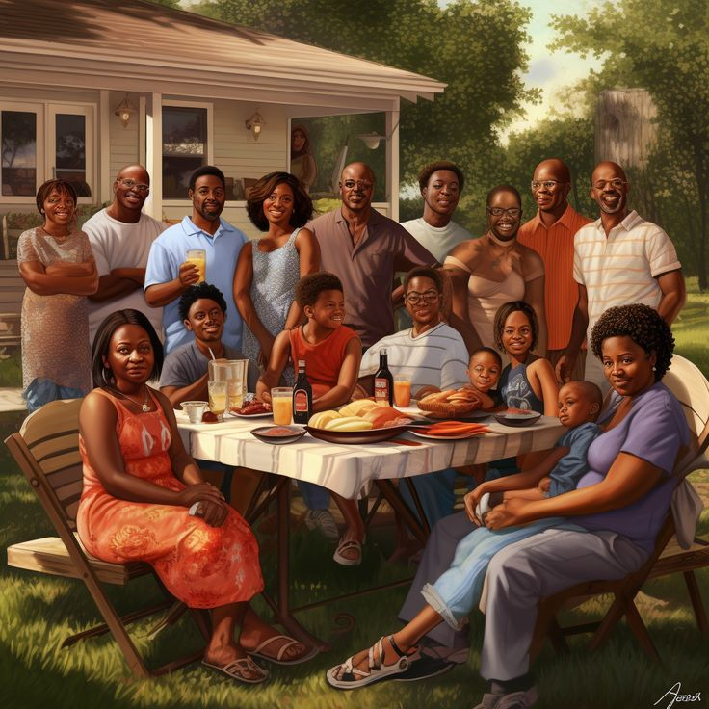  2. FAMILY: "Provide" "Love" "Understanding"
Vision: "To be an expert in health science research, a responsible family member, and a successful entrepreneur"
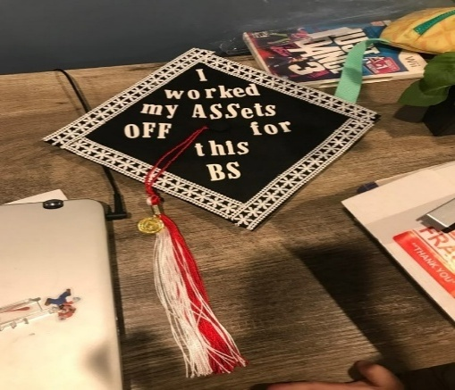
3. CAREER AND SCHOLARSHIP
"Expert," "Publish," “Graduate”
  4. ENTERPRENEURSHIP  "Create," "Establish," "Success". | 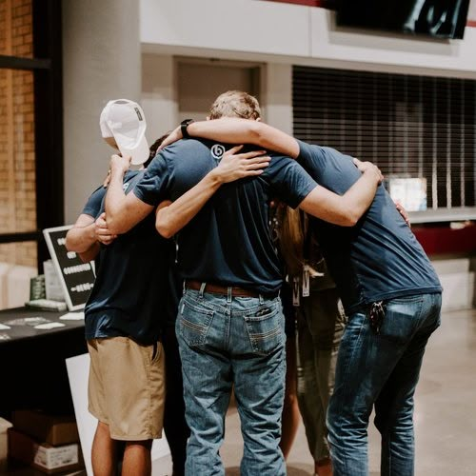  5. COMMUNITY IS BETTER TOGETHER  "Serve," "Give," or "Contribute"

How I Created My Vision Board This Year: A Step-by-Step Guide to Manifesting Your Dreams — The Twenties Detox
- Assess areas of my life: idea is to reflect in different aspects of my life, rate my performance in such areas and noting areas of excellence while identifying areas of improvement.

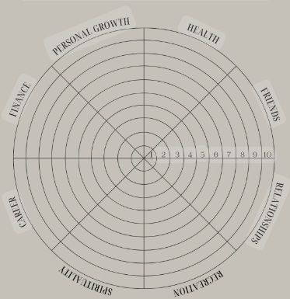
- Reflect and set goals in each area
With a clear understanding of where you stand, it's time to set goals. Identify 2-3 habits or objectives for each category. Celebrate what's working well and strategize on how to improve areas that need attention. For instance:
Health: Develop a better sleep schedule, take vitamins, and align workouts with my cycle.
Finances: Start budgeting, track expenses monthly, and cultivate a healthier mindset towards money.
Career: Acquire new skills, seek more education for potential promotion, and work on a side hustle.
Family: Enhance communication, respect boundaries, and engage in more family activities.
Friends: Embody quality > quantity.
Love: Plan more dates and nurture the relationship.
Fun: Explore a new hobby.
Spirituality: Practice morning meditation.
- Find pictures and quotes
Now, the fun begins. Use platforms like Pinterest to source aesthetically pleasing images related to your goals. Add quotes, sayings, or affirmations that resonate with your challenges or limiting beliefs. For example:
"Care for your body" to support my journey towards a healthier body image.
"Trust your creativity" as a reminder to channel my creative side more often, and release any doubts for the projects I want to finish this year.
"Mind your business" to emphasize the that the only thing we can control in life, is ourselves.
"A love that feels like summer" to keep the spark alive in my long-term relationship.
"You can, and you will" to dispel doubts about success.
"Keep your heart open" – probably my favourite of them all. To remind myself to not let pain, jealousy or anger consume me to the point of closing off. Let the negative emotions flow in an out rather than attach, and keep my heart open to attract more good in my life.
- Ready... Set ... Assemble
Bring your vision board to life. Whether digital on platforms like Canva or a tangible board using printed images and quotes on Bristol board, there's no wrong way to assemble. Play your favorite music, experiment with layouts, and enjoy the process. You might need to add or rearrange elements to enhance the aesthetic cohesion, and that's perfectly fine.

